 CHEMICAL ENGINEERING TRANSACTIONS  VOL. , 2024 | A publication of  
The Italian Association
of Chemical Engineering
Online at www.cetjournal.it

Guest Editors: Marco Bravi, Antonio Marzocchella, Giuseppe Caputo
Copyright © 2024, AIDIC Servizi S.r.l.
ISBN 979-12-81206-10-6; ISSN 2283-9216

Production of Alcohols from C1-waste Gas Fermentation by Clostridium carboxidivorans in a Continuous Gas Fed Bioreactor
Sara Pisacaneª, Fabiana Lanzilloª, Francesca Raganati^{a*}, Antonio Marzocchellaª
ª Department of Chemical, Materials and Production Engineering–Università degli Studi di Napoli Federico II, P.le V. Tecchio 80, 80125 Napoli – Italy

*Corresponding author
Dr. Francesca Raganati
Phone: +39 0817682218; fax: +39 0815936936.
E-mail address: francesca.raganati@unina.it
Syngas – a gas mixture of CO, CO₂, and H₂ – can be produced by gasification of C-based streams (e.g. biomass, plastics). It is as a cost-effective substrate for the production of numerous valuable products. Some microorganisms can thrive using CO or syngas as carbon and energy source, and just a few strains are able to converting CO/syngas into biofuels. Clostridium carboxidivorans is a microorganism known for its ability to produce short- and long-chain acids and alcohols, including acetic acid, butyric acid, hexanoic acid, ethanol, butanol and hexanol.
This contribution focuses on characterizing CO fermentation by C. carboxidivorans in a continuous gas-fed bioreactor. The bioreactor was continuously supplied with a 100% CO stream at a flow rate of 0.6 L/h. Fermentation tests were carried out at constant temperature with an without pH control. The fermentation process was characterized in terms of metabolites and cell production, CO conversion, specific rate of cells/metabolite production and yields.
Ethanol was the primary solvent produced and a shift towards longer-chain alcohols was observed under constant pH. The maximum cell concentration was 0.56 g_{DM}/L with and without pH control. The highest solvent concentrations was 1820 mg/L of ethanol without pH control, and 330 mg/L of butanol and 20 mg/L of hexanol with pH control.
The study highlithed the role of the substrate composition and the operating conditions on syngas. The reported results provides a first guidline for syngas fermentation for the production of biofuels and chemicals.
  - Introduction
Global concerns include not only the depletion of fossil deposits but also rising atmospheric carbon dioxide (CO₂) concentration, climate change, and the challenges associated with recycling waste. These issues are intricately linked to population growth and to the increasing industrialization of many countries. Indeed, in industrialized countries most fuels and a wide range of platform chemicals have historically been sourced from petroleum through oil refineries. The listed concerns press contemporary societies to explore novel production technologies and alternative sources of non-fossil resources fuel (Ahuja et al., 2023).
Biofuels – fuels produced from biological resources - have emerged as a promising alternative to replace fossil fuels. The fermentation of sugars or starch feedstocks to produce ethanol and butanol as value-added products raises concerns about competition with food resources (Kennes et al., 2016). The second generation biofuels opt for lignocellulosic biomass and offers a solution to the competition with feed/food resources (Fernández-Naveira et al., 2017a). However, the exploitation of lignocellulosic biomass via sugar fermentation path is limited to the polycarbohydrate fraction – cellulose and hemicellulose – while the lignin fraction is not fermentable (Kennes et al., 2016). Moreover, the energy required to destructure lignocellulosic biomass may be so high to make the energy balance of the process to produce biofuels negative.
A potential strategy to exploit all the lignocellulosic biomass is the gasification to convert biomass into syngas: a gas mixture of carbon monoxide (CO), hydrogen (H₂), and carbon dioxide (CO₂). Depending on the properties of the feedstock and gasification conditions, the presence of other compounds (e.g CH₄, C₂H₆, C₂H₂, C₆H₆, C₁₀H₈, NH₃, HCN, NO_{x}, SO₂, H₂S, COS) has been reported (Xu et al., 2011). Many industrial waste gases also contain one or more of these gases and can be utilized as feedstock, offering clear environmental advantages (Abubackar et al., 2011).
Syngas components may be substrate for some microorganisms able of synthesizing value-added products, including acetic acid, butyric acid, ethanol, butanol, and methane (Stoll et al., 2018). Biological catalysts play a crucial role in the conversion of syngas into chemicals/biofuels and have many advantages over metal-based catalysts. Indeed, bioconversion is characterized by high specificity, low operational costs (low temperature and pressure), good resistance to sulphur gas poisoning (Durre and Eikmanns, 2015). Only a few clostridia are recognized for both generating value-added products and thriving on syngas as primary carbon and energy sources (Liberato et al., 2019). Clostridium carboxidivorans is able to grow autotrophically on syngas, using the gaseous CO or CO₂ + H₂ as carbon and energy source. It can produce short and longer chain alcohols such as ethanol, butanol and hexanol (Bruant et al., 2010) through a variation of the Wood–Ljungdahl pathway (Ragsdale, 2008).
Design and operation of bioreactors under anaerobic conditions with CO-related gas as substrates is even more challenging when compared to traditional carbohydrate fermentation. As a matter of fact, the optimization of operating conditions is a crucial factor to maximize yield and selectivity of biochemical reactions (Fernández-Naveira et al., 2016).
The present study report results of the conversion of CO into value-added products by C. carboxidivorans in a stirred tank reactor (non-pressurized) operated under continuous gas feeding, with and without pH control. The aim is to assess the optimal fermentation conditions to enhance the production of alcohols.
  - Materials and methods
    - Microrganism and media
Deutsche Sammlung von Mikroorganismen und Zellkulturen (DSMZ) supplied Clostridium carboxidivorans DSM 15243 (strain designation P7) in form of dried pellets. Lanzillo et al. (2020) detailed the protocol for reactivating and storing the microorganism.
The composition of the fermentation medium was: 25 mL/L mineral solution; 10 mL/L trace metal solution; 10 mL/L vitamin solution; 1g/L yeast extract and 0.6 g/L of reducing agent (Fernández-Naveira et al., 2016).
Chemicals were from Sigma Aldrich (Milan, Italy). Vessels of CO were from Aircos srl (Naples, Italy).
    - Apparatus and operative conditions
Continuous fermentations were carried out in a MiniBio bioreactor (Applikon) equipped with a 0.25 L vessel, housed in an ATEX room. A microsparger was used for optimal gas dispersion at the bottom of the bioreactor. The pH control unit kept the pH at a preset value by delivering 1 M NaOH and 0.5 M HCl solutions by means of peristaltic pumps. The apparatus system used for continuous fermentation tests is illustrated in Figure 1. The bioreactor was filled with 0.12 L (V_{L}) of medium and autoclaved for 20 minutes at 121°C. The sterilized bioreactor-medium was N₂-flushed to remove oxygen from the headspace and the liquid medium. As the temperature dropped below 40°C, cysteine and vitamins were added to the medium. Upon achieving anaerobic conditions, the N₂ gas stream was replaced by the CO stream under gas flow differential conditions. The CO stream - sterilized by filtration (cut-off 0.2 µm, Millipore) - was continuously supplied to the reactor. The volumetric flow rate of the gas stream was measured and controlled by means of a mass flow controller (Applikon).
Temperature, pH and gas flow rate was continuously measured and recorded by the MiniBio acquisition unit. Temperature of 35°C, agitation speed of 250 rpm, pH of 5.75 were set as bioreactor operating conditions.

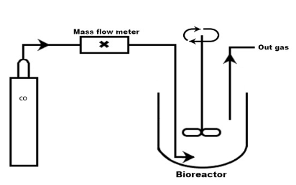
Figure 1: Sketch of the gas-fed fermenter.
The volumetric flow rate of the CO stream (Q_{G}) was set at 0.6 L/h to provide a gas dilution rate (D_{G}= Q_{G}/V_{L}) of 5 h⁻¹. Q_{G} was set to provide a differential behaviour of the reactor with respect to the CO.
The fermentation started by inoculating 500 μL of the stock culture into 15-mL Hungate tubes containing the pre-culture medium (Wilkins Chalgren anaerobic broth base medium). 5 mL of the active culture from a 2 days culture were inoculated into the bioreactor.
Tests were conducted in a mechanically stirred tank reactor continuously operated with respect to the gas phase. Each test was carried out in triplicates (biological replicates). Data reported in tables and figures are the mean values between them. The standard error was always lower than 5%.

    - Analytic methods
The pH of the culture was measured online by means of a pH probe. 1 mL liquid culture was periodically sampled to assess biomass growth and metabolite production as reported by Lanzillo et al. (2020). The optical density (OD_{λ}) of the culture was measured at 600 nm by using a UV– visible spectrophotometer (SPECORD 50 UV-VIS, Analytik Jena, Jena, Germany). The cell concentration (g_{DM}/L) was assessed by processing the measured absorbance according to a previously generated calibration curve (1 OD = 0.4 g_{DM}/L).
The sampled culture was centrifuged at 13,000 rpm for 10 minutes (Centrifuge MiniSpin®, Eppendorf Italia, Milan, Italy) to recover the liquid phase. The concentrations of soluble species (acids and alcohols - acetic acid, butyric acid, hexanoic acid, ethanol, butanol) were measured by using an HPLC (HP1100, Agilent Co., Santa Clara, CA, USA) equipped with Rezex ™ ROA-Organic Acid H+ column (8%), 150 × 7.8 mm, and a RID detector (Column Temperature Controller, ThermasphereTM TS-130). The mobile phase was 3 mM H₂SO₄ solution fed at 1 mL/min flow rate at 60°C.
  - Results
Tests to assess C. Carboxidivorans ability to ferment CO and the effect of pH on process performances were conducted in stirred tank reactor continuously operated with respect to the gas phase.
The first test campaign was carried out setting the pH at 5.75 and CO was the sole carbon source (Figure 2, A1, A2 and A3). The lag phase was not identified: cells started to grow immediately after inoculation and approached the maximum value 0.56 g_{DM}/L after about 50 hours. The acids were produced during the cell exponential growth. As a consequence of the acid reconversion, the acid concentrations reached a maximum at about 24 hours - AA = 760 mg/L, BA=210 mg/L, HA=130 mg/L – and approached a constant value after about 60 hours. The solvents were produced at the same time of the acid concentration peak and the concentration approached constant values after about 70 hours: 801 mg/L of ethanol, 330 mg/L of butanol, and 20 mg/L of hexanol. The fermentation process extinguished after about 80 hours: there was no further accumulation of cells, acids, and solvents. The absence of further fermentation can not be due to alcohol inhibition because the alcohol concentration did not exceed 2 g/L (Figure A2) lower than the inhibition threshold reported by Fernández-Naveira et al. (2016). It is expected that the operation under batch condition of the liquid phase may be characterized by starvation in the culture medium of one or more nutrients necessary for growth and production. The CO concentration in the medium is lower than the inhibition limit. Indeed, under the operating conditions (1 bar), the maximum CO concentration in the liquid phase (in equilibrium with pure gaseous CO at 1 bar) is 23 mg/L, just lower than 25 mg/L (CO concentration in the liquid phase in equilibrium at P_{CO}=1.1 atm) identified as the optimal condition for the growth rate of C. carboxidivorans in batch experiments (Lanzillo et al., 2020).
The second test campaign was carried out without pH control. Average data of the fermentation test are reported in the Figure 2B (B1, B2, and B3). The lag phase was still absent: cells started to growth immediately after inoculation, the concentration reached the maximum value after 48 hours (0.56 g_{DM}/L) and progressively decreased with the time. Within the first 30 hours, the concentrations of acids—AA, BA, and HA—reached their respective maxima (659, 106, and 36 mg/L). Solvents started to be produced as the acid concentration started to decrease. Metabolite concentrations stabilized after 70 hours. The decrease in biomass concentration after 80 hours could be due to the accumulation of acids and a reduction in pH that is not completely compensated by solventogenesis (reconversion of acids).
The growth rate of C. carboxidivorans in this study was calculated as the slope of the biomass growth curve in the exponential phase (between 0 and 48 h). The specific growth rate was 0.061 h⁻¹ in the experiment with pH control (pH=5.75). The rate was in agreement with data reported by Fernandez et al. (2019): specific growth rate 0.063 h⁻¹ assessed for a culture carried out in a bioreactor fed with a gas mixture - (CO:CO₂:H₂:N₂, 20:20:10:50) as a carbon and energy source - at flow rate of 0.6 L/h.
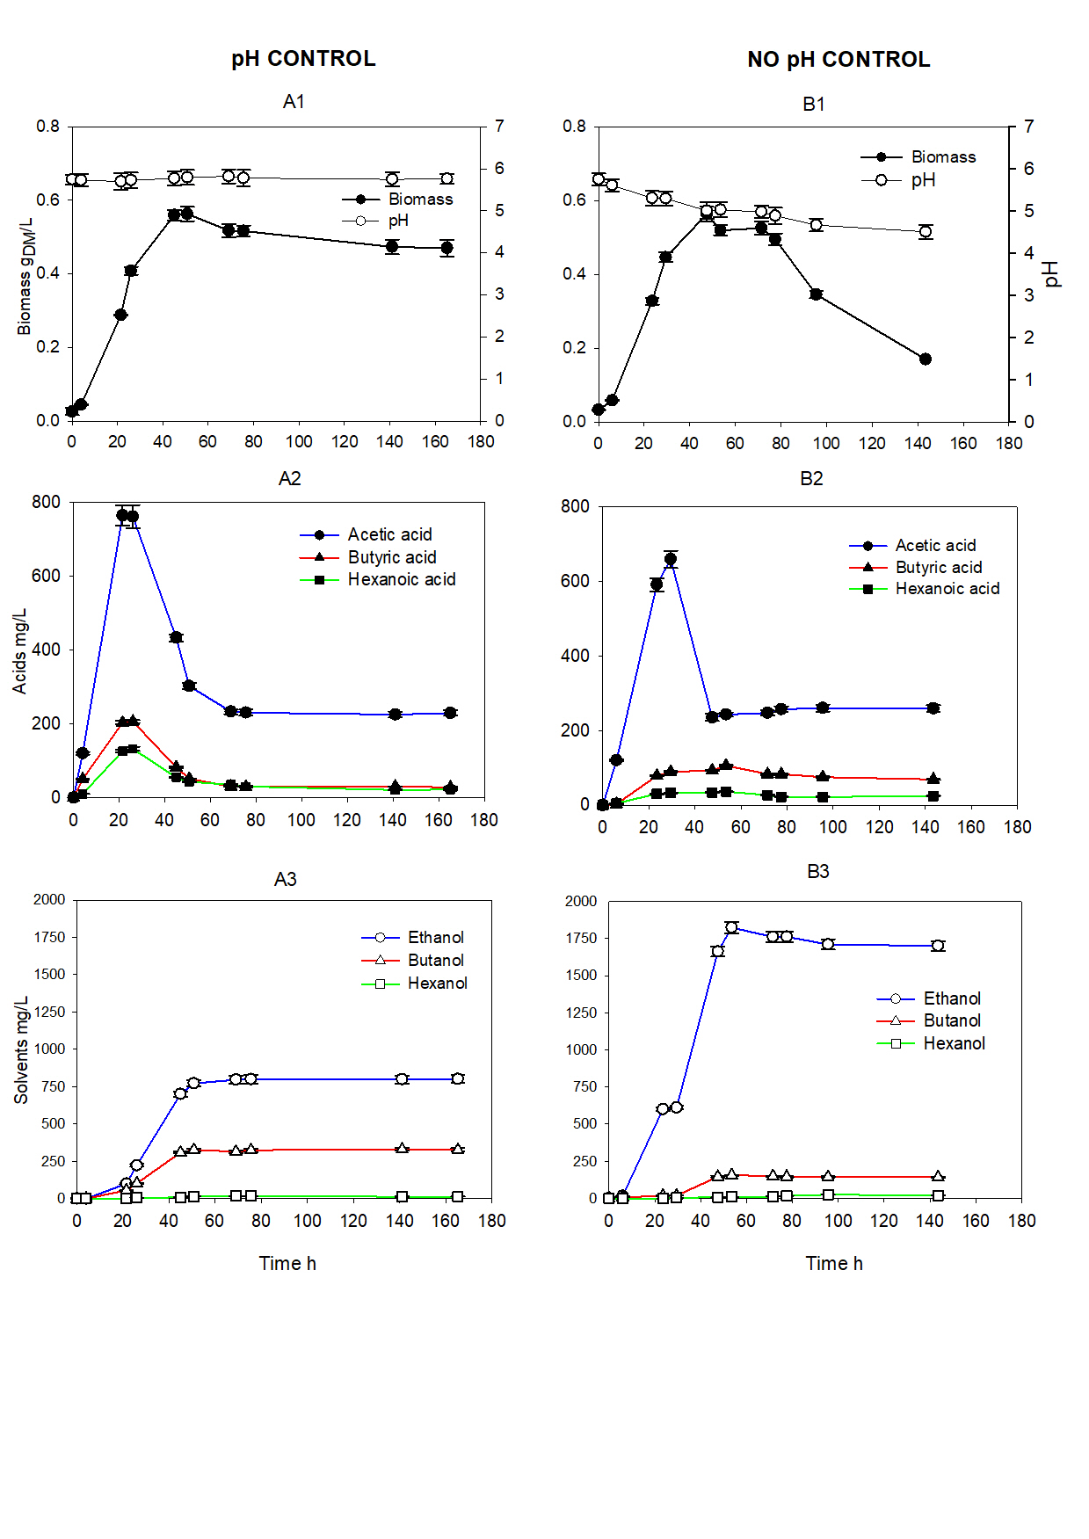
The specific growth rate assessed during the test carried out without the pH control was 0.083 h⁻¹. The result was smaller than the value assessed by Ukpong et al. (2012) - 0.098 h⁻¹ – during a test carried out without pH control. The main difference between the two set of operating conditions was the medium - modified basal medium (Liou et al., 2005) – the syngas composition (N₂:CO:CO₂:H₂, 60:20:15:5) and the gas flow rate (6 L/h).

Figure 2: Concentration of cells and metabolites vs. time measured during continuous CO-fed fermentation tests (CO volumetric flow rate 0.6 L/h). A) Fermentation with pH control: A1) biomass concentration and pH trend; A2) acid concentrations; A3) solvent concentrations. B) Fermentation without pH control: B1) biomass concentration and pH trend; B2) acid concentrations; B3) solvent concentrations.

Table 1 reports the maximum concentrations of acids and solvents obtained under controlled and uncontrolled pH fermentations. Benevenuti et al. (2021) reported maximum concentrations of 1.32 g/L acetic acid, 1.76 g/L ethanol, and 0.46 g/L butanol in a bioreactor continuously supplied with synthetic syngas (gas flow rate of 30 L/h) consisting of 20% CO, 5% H₂, 15% CO₂ and 60% N₂, using ATCC®2713 as a liquid medium with 0.15% Tween®80 and operated without pH control. The reported differences in operating conditions likely contribute to variations in the conversion of acids into solvents. In the present study, the conversion of acetic acid into ethanol is more pronounced than the conversion of butyric acid into butanol. Moreover, butyric acid conversion into butanol is less pronounced than in the fermentation reported by Benevenuti et al. (2021).
The comparison of the two test campaigns points out that under uncontrolled pH condition the bacterium initially produced acetic acid – at concentration larger than other acids (Figure 2B2) - leading to a drop in pH (Figure 2B1). In response to the pH decrease, solventogenesis occurred and the ethanol was the primary solvent produced, as indicated by the concentration in Table 1. Onset of ethanol production was recorded since the early hours of fermentation reaching the maximum after about 20 hours. This observed behavior of Clostridium is consistent with the findings of Fernández-Naveira et al. (2017b). They pointed out that without pH control the synthesis of alcohols starts simultaneously with the acidification of the medium, just after the inoculation. The reported observations suggest that under low pH conditions there is not a pronounced transformation of acids into solvents and both acidogenesis and solventogenesis coexist in C. carboxidivorans cultures.
Tests carried out under pH control at 5.75 point out that acids – acetic, butyric, and hexanoic – approached a maximum larger than that measured under uncontrolled pH tests (Table 1). The maximum ethanol concentration measured during pH-controlled test is lower than that obtained during the uncontrolled pH test. However, butanol reached higher concentration - from the conversion of a significant amount of butyric acid – than that measured during the uncontrolled pH test. The conversion of acids to solvents is expected through the Wood-Ljungdahl pathway, leading to the production of acetyl-CoA, which could be converted to both acetate and ethanol. Acetyl-CoA could also be enzymatically transformed into butyryl-CoA, from which butanol and butyric acid are obtained as end products. Regarding long-chain products, acetyl-CoA is converted into hexanoyl-CoA, which could be directly transformed into hexanoate or, alternatively, into hexanol (Fernández-Naveira et al., 2017a). At pH of 5.75, the ethanol production onset was delayed with respect to the test carried under uncontrolled pH test.
 |  | Acetic acid mg/L | Butyric acid mg/L | Hexanoic acid mg/L | Ethanol mg/L | Butanol  mg/L | Hexanol  mg/L
pH control |  | 760±26.7 | 210±4.3 | 130±5.4 | 801±26.4 | 330±10.9 | 20±0.6
no pH control |  | 659±23.1 | 106±2.2 | 36±0.8 | 1820±36.5 | 156±3.4 | 18±0.5

Table 1: Data of maximum concentrations of products
4 Conclusions
Fermentation tests were carried out in stirred tank reactors with continuous gas feeding to enhance the efficiency of solvent production by C. carboxidivorans during syngas fermentation. Tests demonstratied highly effective production of ethanol and butanol. The microorganism used both the direct and the indirect routes to produce alcohols, thereby limiting the final acid concentration. Under uncontrolled pH conditions, the maximum ethanol concentration was achieved, while under controlled pH conditions, maximum concentration values were also attained for longer chain solvents. After 80 h, the concentration of all metabolites approached a constant value, suggesting a potential deficiency of essential components for growth and production in the medium. To address this issue, a possible solution is the continuous liquid feeding to provide the presence of all necessary nutrients at the appropriate concentrations.
Nomenclature
AA – acetic acid concentration (mg/L)

B – butanol concentration (mg/L)
BA – butyric acid concentration (mg/L)
E – ethanol concentration (mg/L)
HA – hexanoic acid concentration (mg/L)
H – hexanol concentration (mg/L)
D_{g} – gas dilution rate (h⁻¹)
OD_{λ} – optical density
T – fermentation temperature (°C)
X – cell concentration (g_{DM}/L)
μ – specific cell growth rate (h⁻¹)
Q_{G} – gas flow rate (L/h)
V_{L} – volume of culture (L)
V_{G} – volume of gas inside the bioreactor (L)

Acknowledgments
We acknowledge financial support under the National Recovery and Resilience Plan (NRRP), Mission 4, Component 2, Investment 1.1, Call for tender No. 104 published on 2.2.2022 by the Italian Ministry of University and Research (MUR), funded by the European Union – NextGenerationEU– Project Title: STRONG STEELATION: Slags inerTization and valoRizatiON of the off-Gas from STEEL Industry through gas-fermentATION for bio-butanol production – CUP E53D23003940006 - Grant Assignment Decree No. n. 961 del 30/06/2023 adopted on PE - Physical Sciences and Engineering settore PE8 “Products and Processes Engineering" by the Italian Ministry of Ministry of University and Research (MUR).

References
Abubackar H.N., Veiga M.C. and Kennes C., 2011. Biological conversion of carbon monoxide: rich syngas or waste gases to bioethanol. Biofuels Bioprod Biorefin 5:93–114. DOI: 10.1002/bbb.256.
Ahuja V., Bhatt A.K., Ravindran B., Yang Y.H., Bhatia S.K, 2023. A Mini-Review on Syngas Fermentation to Bio-Alcohols: Current Status and Challenges. Sustainability, 15(4):1–21. https://doi.org/10.3390/su15043765.
Benevenuti C., Amaral P., Ferreira T. 2021. Impacts of syngas composition on anaerobic fermentation. Reactions, 2: 391–407. https://doi.org/10.3390/reactions2040025.
Bruant G., Lévesque M.J., Peter C., Guiot S.R., Masson L., 2010. Genomic analysis of carbon monoxide utilization and butanol production by Clostridium carboxidivorans strain P7T. PLoS One, 5, 13033.
Durre, P., Eikmanns, B.J., 2015. C1-carbon sources for chemical and fuel production by microbial gas fermentation. Curr. Opin. Biotechnol. 35, 63–72. https://doi.org/10.1016/j.copbio. 2015.03.008.
Fernández -Naveira A., Abubackar H.N., Veiga M.C., Kennes C., 2016. Carbon monoxide bioconversion to butanol-ethanol by Clostridium carboxidivorans: kinetics and toxicity of alcohols. Appl. Microbiol. Biotechnol, 100: 4231–4240. https://doi. org/10.1007/s00253-016-7389-8.
Fernández-Naveira A., Veiga M.C., Kennes C., 2017b. Effect of pH control on the anaerobic H-B-E fermentation of syngas in bioreactors. J Chem Technol Biotechnol, 92: 1178–1185. DOI 10.1002/jctb.5232.
Fernández-Naveira A., Veiga M.C., Kennes C., 2017a. H-B-E (hexanol-butanol-ethanol) fermentation for the production of higher alcohols from syngas/waste gas. J Chem Technol Biotechnol, 92: 712–731. DOI 10.1002/jctb.5194.
Fernandez-Naveira A., Veiga M.C., Kennes C. 2019. Effect of salinity on C1-gas fermentation by Clostridium carboxidivorans producing acids and alcohols. AMB Expr, 9: 110. https://doi.org/10.1186/s13568‐019‐0837‐y.
Kennes D., Abubackar H.N., Diaz M., Veiga M.C., Kennes C., 2016. Bioethanol production from biomass: carbohydrate vs syngas fermentation. J Chem Technol Bioetchnol 91:304–317. https://doi.org/10.1002/jctb.4842.
Lanzillo F., Ruggiero G., Raganati F., Russo M.E., Marzocchella A., 2020. Batch syngas fermentation by Clostridium carboxidivorans for production of acids and alcohols. Processes 8:1075. https://doi.org/10.3390/pr8091075.
Liou JSC, Balkwill DL, Drake GR, Tanner RS. 2005. Clostridium carboxidivorans sp. nov., a solvent-producing clostridium isolated from an agricultural settling lagoon, and reclassification of the acetogen Clostridium scatologenes strain SL1 as Clostridium drakei sp. nov. Int J Syst Evol Microbiol 55:2085–2091.
Liberato V., Benevenuti C., Coelho F., Botelho A., Amaral, P., Pereira, N., Ferreira, T., 2019. Chemicals production in a biorefinery context. Catalysts, 9, 962. doi:10.3390/catal9110962.
Ragsdale S.W., 2008. Acetogenesis and the Wood–Ljungdahl pathway of CO₂ fixation. Biochimica et Biophysica Acta, 1784: 1873–1898. https://doi:10.1016/j.bbapap.2008.08.012.
Stoll K.I., Herbig S., Sauer J., Neumann A., Oswald F., 2018. Fermentation of H₂ and CO₂ with Clostridium ljungdahlii at Elevated Process Pressure – First Experimental Results. Chem. Eng. Trans, 64: 2–7. https://doi.org/10.3303/CET1864026.
Ukpong M.N., Atiyeh H.K., De Lorme M.J.M., Liu K., Zhu X., Tanner R.S., Wilkins M.R., Stevenson B.S. 2012. Physiological response of Clostridium carboxidivorans during conversion of synthesis gas to solvents in a gas-fed bioreactor. Biotechnol Bioeng, 109: 2720–2728. https://doi.org/10.1002/bit.24549.
Xu D., Tree D.R., Lewis R.S., 2011. The Effects of Syngas Impurities on Syngas Fermentation to Liquid Fuels. Biomass Bioenergy, 35, 2690–2696. doi:10.1016/j.biombioe.2011.03.005.

