|  |  |
| --- | --- |
| cetlogo ***CHEMICAL ENGINEERING TRANSACTIONS***  ***VOL. , 2024*** | A publication of  aidiclogo_grande |
| The Italian Association  of Chemical Engineering  Online at www.cetjournal.it |
| Guest Editors: Marco Bravi, Antonio Marzocchella, Giuseppe Caputo  Copyright © 2024, AIDIC Servizi S.r.l. **ISBN** 979-12-81206-10-6; **ISSN** 2283-9216 | |

Valorisation proposal of Brewery Spent Grain: carotenoids and protein films production

Chiara Mollea\*, Francesca Bosco

Politecnico di Torino, Department of Applied Science and Technology, DISAT, C.so Duca degli Abruzzi 24, 10129 Torino, Italy

chiara.mollea@polito.it

The preliminary Brewery Spent Grain (BSG) valorisation proposed is based on the production of cultural media for the growth of the carotenogenic yeast *Rhodotorula mucilaginosa*; the realisation of protein-rich films is also presented. First experiments, carried out with three BSGs, allowed to define the best extraction set-up, realizing water extraction in agitation (ratio BSG/water= 0.05, at 25 °C, for 2 hrs). Then, using the same water extraction conditions, BSG with the highest total solid content was applied to produce a concentrated syrup (BSG/water= 0.2). Yeast growth and carotenoid production were tested on solid media prepared with water extracts and syrup. Later on, to define the best cultural medium, extracts and syrup were applied in different set of liquid cultures, carried out in 96-well plates, maintained at 25 °C, in agitation. Syrup was utilized as it is or supplemented with inorganic and organic N sources, and the addition of these latter returned better results. Afterward, a scale-up carried out into Erlenmeyer flasks (500 mL) allowed to evidence the possibility of using the syrup as it is for the growth of *R. mucilaginosa* and carotenoids production. Finally, a high protein content syrup (BSG/water= 0.2), prepared in autoclave (at 121 °C, 2 atm, for 20 min), was evaluated for the production of films: best filming conditions were investigated and amorphous semi-transparent films were obtained.

* 1. Introduction

Brewery Spent Grain (BSG) is the main residual solid fraction separated at the end of the mashing phase, during the beer production process. It may contain residues from malted barley and other non-malt fermentable sugars sources (Mussatto et al., 2006). It reaches approximately 85% of all the solid waste generated during the process; by this way, the worldwide estimated discharged BSG is 38.6 million tonnes/y, quantity expected to grow further (Oyedeji and Wu Tan, 2023). This will bring to increasing costs for the final disposal, which mainly depend on the generation of a huge mass quantity with related environmental problems (e.g. disposal in landfill) and storage difficulties (Assandri et al., 2021). Indeed, BSG is characterised by a high-water content (more than 70%) which, combined with the presence of proteins and fermentable sugars, makes it susceptible to microbial spoilage over limited time periods (7-10 days) (Gupta et al., 2010).

BSG is a typical lignocellulosic material, containing hemicellulose, cellulose, and lignin. The presence of proteins and polysaccharides is also relevant, while lipids, starch, and ash are minor components. This composition is variable, depending on factors such as the type of barley or the quality of the malt. Moreover, chemical modifications can also be brought by the additives supplemented during beer production or by the storage process (e.g. frozen BSG samples had a higher content of protein compared to oven-dried ones) (Zeko-Pivač et al., 2022). BSG is commonly sold at a low price or even given away, and destined to low added value applications, such as the combustion or as animal feed. In the last years, considering BSG chemical composition, low cost, and large availability, it has been enhanced as an interesting raw material for valuable application. For this reason, the possibility of a utilization in food, chemical, and biotechnological processes, such as for the extraction of compounds (e.g. proteins, phenolic compounds, lipids, and polysaccharides), has been investigated (de Paula et al., 2023). Among recent applications, the development of cost-effective media to support microbial growth is an interesting one. BSG, used as it is or for the production of extracts, represents a source of C and N, applicable in solid or liquid fermentations. It has already been exploited for the cultivation of both bacteria and fungi, often without the need of additional nutrients (Xiros and Christakopoulos, 2012; Ravindran et al., 2019; Leite et al., 2019). Moreover, considering liquid fermentations, BSG extracts could support fungal growth instead of expensive and conventionally used yeast extract-peptone dehydrated media (YPD). Cooray et al. (2017) investigated the application of BSG as a growth media for the yeast *Rhodosporidium toruloides* and found that it is able to sustain the production of fatty acid and carotenoids. Recently, in 2023, Casas-Godoy et al. studied the revalorization of BSG and BSG syrup using six yeast and fifteen fungal strains, in solid or liquid fermentations, for the production of value-added products. BSG contains a high amount of proteins (BSGP), from 18 to 30% w/w. Consequently, protein recovery from BSG has been extensively investigated (Zhao et al., 2011). Extraction methods have been developed to separate proteins from the spent grain and to promote their commercialization and industrial applications (Jaeger et al., 2021). In fact, BSGP are mostly used in the field of food industry as functional ingredients, thus increasing the added value of the products with economic benefits. They have been added to various products such as baked goods, edible films, fermented beverages (Wen et al., 2019). Among these applications, in the last years, numerous studies about the production of biodegradable BSGP films have been published. They mainly refer to composite films with enhanced mechanical and functional properties, and also with antimicrobial properties (Zhao et al., 2011), thus applicable in the antibacterial packaging field.

In the presented work, a preliminary BSG valorization process has been carried out; it is based on the production of water extracts and a concentrated syrup for the cultivation of the carotenogenic yeast *Rhodotorula mucilaginosa*. Moreover, the production of protein-based films is also proposed.

* 1. Material and Method
     1. BSG extracts and syrups production and characterization

BSG provided by three different breweries (E, L, F) was maintained frozen at -20 °C and, prior utilization, thawed and dried at 60 °C for 24 hours. Moisture content was evaluated with the gravimetric method, drying thawed BSG at 105 °C until the constant weight was reached; total solids content % was calculated as the complementary value of the water % one. In order to prepare water extracts (Ewe, Lwe, Few), 4 g of thawed and dried BSG were mixed with 75 mL of distilled water and maintained in agitation conditions, 150 rpm, for 2 hours at 25 °C; BSG was then separated by centrifugation (27670 x g, 20 min, 20 °C), followed by a filtration with qualitative filter paper. The syrup (Fs) was produced mixing 50 g of dried BSG with 242 mL of distilled water, with the same water extraction in agitation conditions (150 rpm, for 2 hours at 25 °C); it was separated by centrifugation (27670 x g, 10 min, 20 °C), preceded and followed by a filtration with a commercial gauze of non-woven fabric (TNT, 70% rayon and 30% polyester). Extracts and syrup were characterized in terms of pH values, °Br, and total protein content, spectrofometrically determined with a direct measure at 280 nm using a calibration curve, in the 0-1 g/L range, using commercial whey proteins (MILEI GmbH, Leutkirch im Allgäu).

* + 1. *R. mucilaginosa* cultures on solid and in liquid media

*R. mucilaginosa*, CBS 316, was cultivated in Petri dishes, on solid media, prepared adding 2% agar to Ewe, Lwe, or Fs, and on yeast-malt agar, YM agar, (Glucose 10 g/L, Peptone, PEP, 5 g/L, yeast extract, YE, 3 g/L, malt extract 3 g/L), inoculated with 100 µL withdrawn from a liquid culture of *R. mucilaginosa* grown in YM for 62 h. Preliminary cultures in liquid media were carried out in 96 multiwell plates; the cultural volume, 300 µL, consisted of autoclave sterilized (121 °C, 20 min, 2 atm) extracts or syrup and a standardized yeast inoculum (10% of the total volume, optical density at 600 nm, OD600, in the range 0.8-1.0). Microbial growth was compared with that obtained in the complex YM medium and in a synthetic syrup, SS, (Glucose 25 g/L, Xylose 5 g/L, NH4Cl 1,5 g/L, YE 2 g/L, PEP 5 g/L) (Casas-Godoy et al., 2023). Well plates were incubated in agitation conditions, 150 rpm, at 25 °C. Sampling were periodically carried out to obtain pH and °Br values, while OD600 and OD490 were determined with a microplate reader. The scale-up was carried out in 200 mL of cultural medium, into Erlenmeyer flasks (500 mL), maintained in agitation conditions, 150 rpm, at 25 °C. OD600, pH and °Br were periodically measured, while biomass was recovered centrifuging the entire medium volume of each flask at 7871 x g for 10 min, at +4 °C. The pellet was dried at 60 °C for the determination of the biomass dry weight, DW (g/L) and for the extraction of carotenoids (Cheng and Yang, 2016), spectrophotometrically evaluated at 490 nm.

* + 1. Films production and characterization

Films were prepared with a syrup produced in autoclave (at 121 °C, 2 atm, for 20 min) using both dried or humid BSG and maintaining the same ratio, 0.2, used for Fs preparation. pH was corrected to a value of 2 or 13, then syrup was treated at 45 °C for 30 min, finally added glycerol (35% w/w proteins) was mixed for 5 minutes. The film casting was carried out into round-shaped silicone moulds (Ø= 5 cm) with a ratio volume/surface equal to 0.135 or 0.27. Finally, films were dried at 60 °C for 4, or 5, or 6 h. A preliminary film characterization was carried out with visual inspection to check integrity, homogeneity, and easy detachability. Then film surface was inspected by means of attenuated total reflectance Fourier-transform infra-red spectroscopy (ATR-FTIR) and X-ray diffraction.

* 1. Results
     1. BSG, water extracts, and syrup characterization

Extraction experiments were performed with three BSGs (E, L, and F), of which E and L have an analogous total solid content (23.7% and 23.8%, respectively), while F has the highest % (31.1), (Table 1A). As reported by Kebede (2020), this variability can be due to both barley variety and brewing process conditions.

Table 1: Characterization of BSG samples (E, L, F), water extracts (Ewe, Lwe, Fwe), and syrup (Fs).

|  |  |  |  |  |
| --- | --- | --- | --- | --- |
| (A) | E | L | F | |
| Total solids % | 23.7 ±0.8 | 23.8 ±0.7 | 31.1 ±0.4 | |
|  |  |  |  | |
| (B) | Ewe | Lwe | Fwe | Fs |
| pH | 5.6 ±0.1 | 5.7 ±0.1 | 6.0 ±0.1 | 5.6 ±0.1 |
| °Br | 0.9 | 1.1 | 1.0 | 4.3 |
| Total Protein (mg/gdried BSG) | 38.9 ±0.1 | 34.5 ±0.2 | 19.3 ±0.2 | 70.19 ± 7.82 |

Water extracts Ewe, Lwe, and Fwe, produced with a ratio BSG/water= 0.05, were characterized in terms of pH, °Br, and protein content. As shown in Table 1B, the pH of Ewe and Lwe are similar and slightly more acidic than that of Fwe. °Br, ranging from 0.9 to 1.1, doesn’t vary among the three extracts. On the contrary, considerable differences can be evidenced for protein content among Ewe and Lwe, showing the highest concentration (38.9 and 34.5 mg/gdried BSG), and Fwe, with a content approximately equal to the half (19.3 mg/gdried BSG). The variable BSG composition, previously cited, could also have an effect on that of the extracts (Celus et al., 2006); their characterization is therefore essential to define which one may be more suitable as yeast culture medium. For this reason, considering the lowest total protein content of Few, it has not been applied in yeast growth experiments. At the same time, F, having the greatest total solids %, has been used for the production a concentrated water extract (ratio BSG/water= 0.2), called syrup, Fs, applying the same extraction conditions used for the production Ew, Lwe, and Few. As reported in Table 1B, Fs is characterized by protein and sugar contents about 4 times higher than those of Few, while the pH is in the range of those of all the water extracts.

* + 1. Preliminary growth of *R. mucilaginosa* on BSG extracts and syrup: solid media and multiwell tests.

In order to evaluate *R. mucilaginosa* capability to grow and synthetize carotenoids on BSG media, a preliminary test on Ewe, Lwe, and Fs agar was performed, using YM agar as control. The images reported in Figure 1, confirm the carotenoid production on both water extracts and syrup, but this last allows to perceive a more intense pink color, also respect to that on YM agar, probably in relation to the higher total sugar content, four-fold than that of Ewe and Lwe.

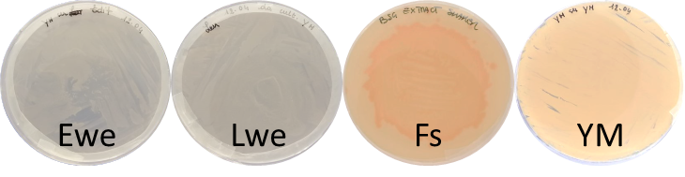

Figure 1: R. mucilaginosa growth on BSG and YM agar.

Yeast growth was then evaluated in small scale liquid cultures, i.e. multiwell experiments, which allowed to test, at the same time, different cultural conditions. First, the possibility to growth the yeast in Ewe, Lwe, and Fs was verified in a 90-h culture and compared to that obtained on YM. As reported in Figure 2(a), in the first 24 h, OD600 values are comparable for all the tested conditions. Then, for Ewe and Lwe media, the stationary phase begins with similar OD values (0.48 and 0.40, respectively), lower than those of the other cultures. On the contrary, Fs culture has a behaviour similar to that of YM: they are still in the exponential growth phase and reach the maximum at 72 h, with comparable OD600 (1.05 and 1.15, respectively). Initial pH of Ewe and Lwe is equal to 6.0, while that of Fs is slightly acidic, 5.6; in all cases, it grows and reaches values between 6.5 and 7.1. In this concern, Latha et al. (2005) indicate an initial pH value equal to 5.5 for the highest carotenoids production by *R. glutinis*, similar to that of the syrup applied in the present work. Initial sugar content of Ewe and Lwe is the lowest (°Br= 1 ±0.1) and remain almost unchanged till the 72nd h of incubation; on the contrary, that of Fs is about 2-fold higher than that of YM (°Br= 4.3 and 2.5, respectively), and it shows a decrement of 12%, lower than that obtained in YM control (39%). This probably indicates that not all Fs sugars are readily utilizable by *R. mucilaginosa* for the growth. Among the media evaluated in the preliminary test, Fs syrup returned better growth results, therefore it was chosen for the following optimization, during which carotenoid production was also investigated. Considering both the dependency of *R. mucilaginosa* on added N (Casas-Godoy et al., 2023) and the influence of C/N ratio on carotenoids production (Chreptowicz et al., 2019), Fs was used as it is or supplemented with different inorganic (NH4Cl) and organic (YE, and PEP) N sources, separately added or differently combined (i.e. YE+PEP or YE+PEP+NH4Cl). *R. mucilaginosa* growth was compared with that in the two control media, the complex YM and the synthetic syrup SS. Figure 2(b) shows OD600 curves; the growth was monitored for 90 h and, in all the cases, the maximum was reached at about 72 h. Best results, similar to those of YM and higher in comparison of Fs as it is, are obtained with the addition of the two organic sources together, followed by that of YE solely. On the contrary, adding the inorganic NH4Cl doesn’t provide a significative improvement; the OD600 curve obtained for Fs+NH4Cl is completely overlapped to that of Fs as it is (curve not shown in Figure 2(b)). Moreover, the addition of NH4Cl+YE+PEP gives OD600 values lower than those obtained by adding YE solely. At the end of the incubation, SS culture is still in exponential growth phase, with the lowest OD600 values, therefore nutrients of the concentrated syrup seem to be more advantageous, respect to those of the formulated medium, in promoting *R. mucilaginosa* growth. Carotenoids production, reported in Figure 2(c) as OD490 values, indicates the enhancement given by the addiction of YE and PEP, which allow a production similar to that of YM control, while the presence of the inorganic source doesn’t improve significantly carotenoid values respect to that obtained with Fs. Carotenoid presence in Fs, added or not with YE and PEP, is also revealed by the pigmentation obtained in multiwell cultures, as shown in Figure 2(d).

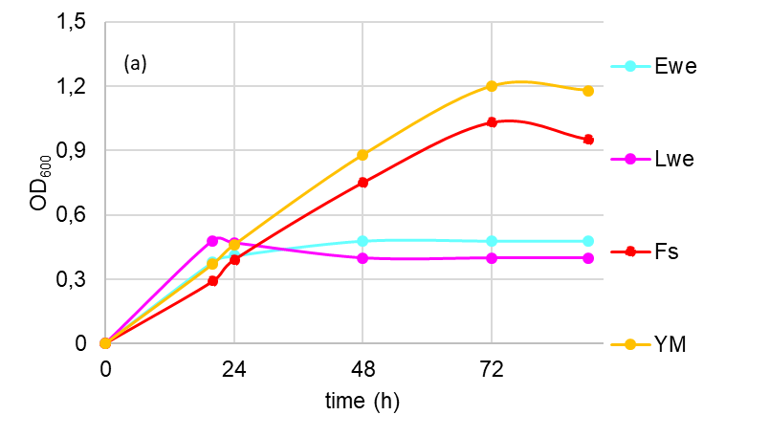 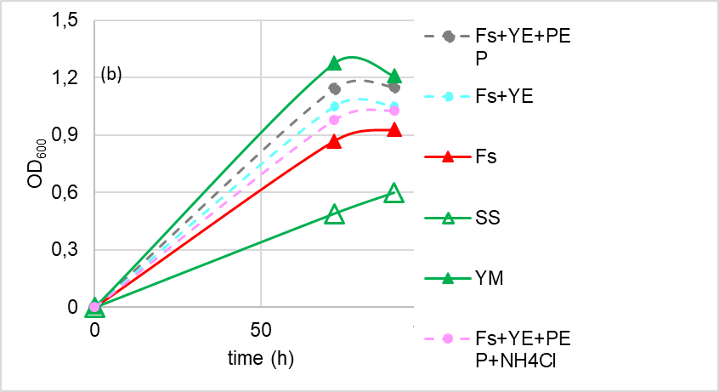

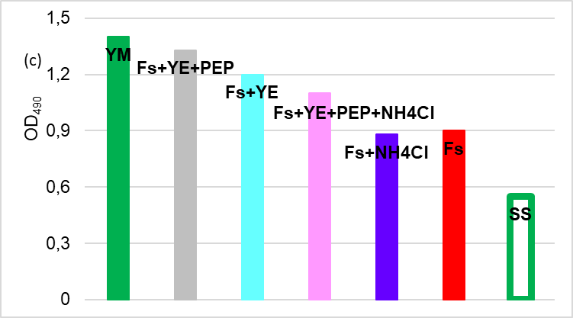 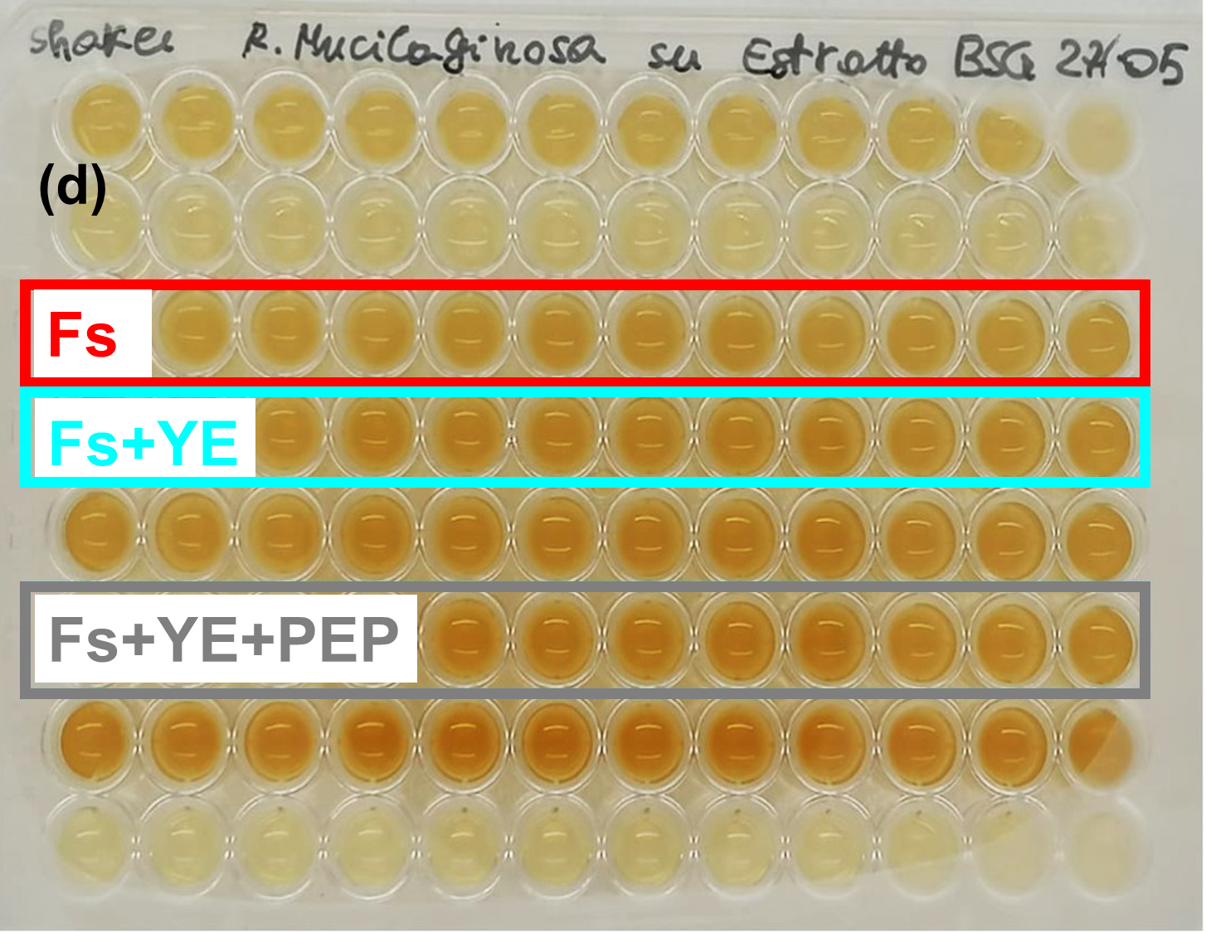

Figure 2: R. mucilaginosa growth in 96-multiwells: (a) and (b) OD600 values, (c)OD490 values (d) pigmentation in Fs (red frame), Fs+YE (light blue frame), and Fs+YE+PEP (grey frame) cultures.

* + 1. Growth of *R. mucilaginosa* on BSG water extracts and syrup: scale-up in Erlenmeyer flasks

A scale-up has then been carried out into Erlenmeyer flasks, at the same conditions of agitation and temperature of multiwell experiments (150 rpm and at 25 °C). First, in order to evaluate the influence of better agitation obtained in the scaled-up cultural system, also Ewe and Lwe media were tested. In flask cultures incubation was prolonged for 62 h and results compared to those obtained in YM. At the end, biomass concentration resulted 3.5 and 1.3 g/L, for Ewe and Lwe cultures, respectively, lower in comparison to that of YM, 14 g/L. In spite of that, carotenoids were produced also in the presence of Ewe and Lwe, as demonstrated by the pigmentation of the cultures (see Figure 3(a)). After that, yeast growth was monitored in Fs and Fs+YE+PEP media, which gave best results in multiwell experiments (see Figure 2(b)). Incubation was prolonged for 72 h and similar results were obtained for both media, thus, indicating that the addition of the two organic nitrogen sources, at the tested conditions, doesn’t bring substantial improvement for the growth of the yeast and the pigment production. In Figure 3(b) OD600, OD490, and pH curves of Fs are reported (curves of Fs+YE+PEP, which are similar, are not shown). The maximum value of biomass was obtained at 24 h of fermentation: values of 7.63 g/L and 5.03 g/L were determined for Fs cultures, added or not with YE+PEP, comparable with those reported by Chen and Yang (2016), 7.8 g/L, and Rodrigues et al. (2019), 7.9 g/L, for flask batch fermentations. As shown in Figure 3(b), after 24 h of incubation, also the highest OD490 value was obtained. This was probably influenced by the obtained pH value, 5.7, reported to be ideal for the carotenoid production (Latha et al., 2005).

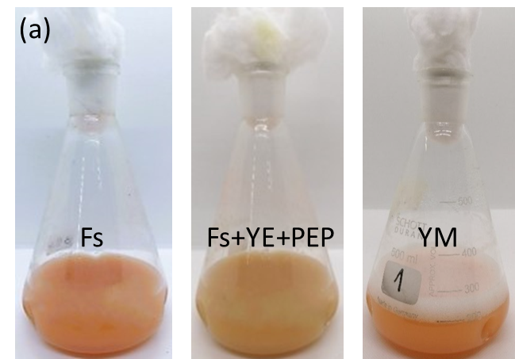 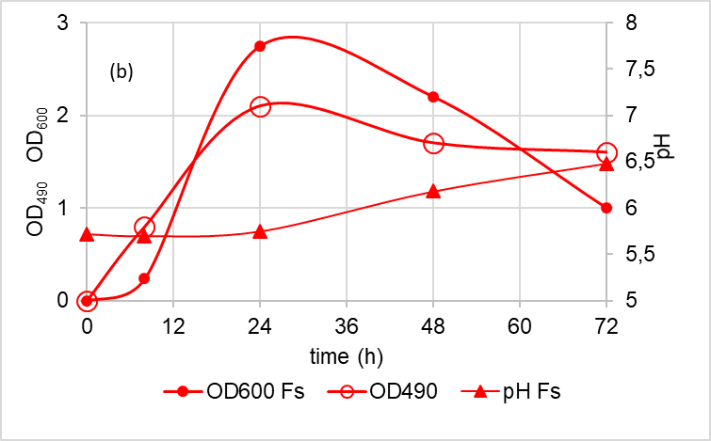

Figure 3:(a) Carotenoids production in flaks cultures of R. mucilaginosa grown on Fs media and YM; (b) OD600, OD490, and pH values of flask cultures on Fs medium.

* + 1. Production of films and their characterization

A preliminary investigation of film production, starting from the rich protein syrups produced in autoclave, has been carried out. In order to define the best set-up, different conditions have been investigated. As regard the use of dried BSG, instead of the wet one, it is favorable because the obtained films are more robust, probably thanks to a higher protein concentration. The pH correction to an acidic value, pH= 2, gives better results, while that at pH= 13 prevents the filmation, probably due to a precipitation of the proteins, appreciable as a white sediment on the bottom of the mold. Among the two tested V/S ratio, the highest one, 0.27, allows to obtain more robust and easily detachable films. Finally, the chosen drying time has been 5 h, necessary to reach a good solvent evaporation, preventing film brittleness. Considering the surface composition of the film obtained with the optimized conditions, shown in Figure 4(a), results similar to those reported by Castanho et al. (2022) have been obtained: the peak of the OH bonds can be observed at λ~3200 cm-1, a peak related to stretching of C-H bonds occurs at λ~2920 cm-1, while peaks at 1160-896 cm-1 are associated to the cellulosic fraction. In addition, as also reported by Shroti and Saini (2022), the peaks between 1700 and 1200 cm-1 are related to the presence of proteins, see Figure 4(b). As regard the results obtained with the X-ray diffraction, as shown in Figure 4(c), the absence of peak is evident, indicating that the analysed samples have an amorphous nature.

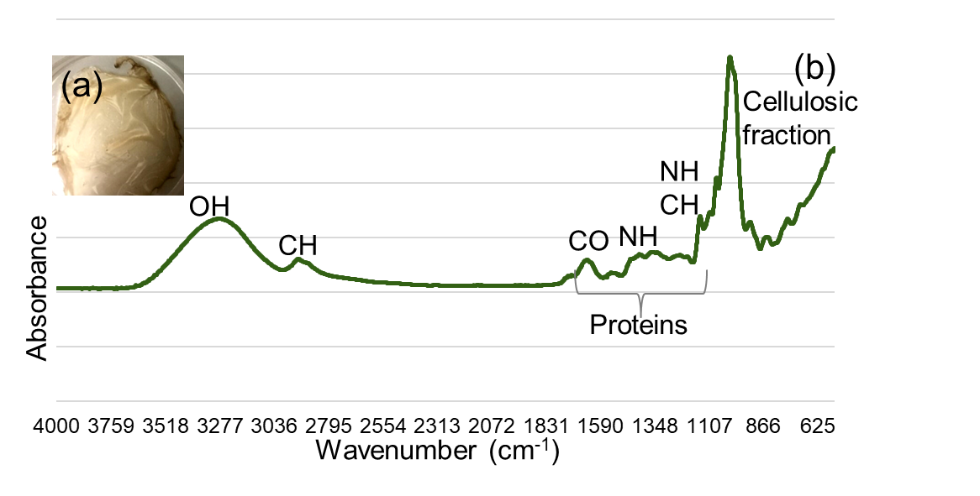 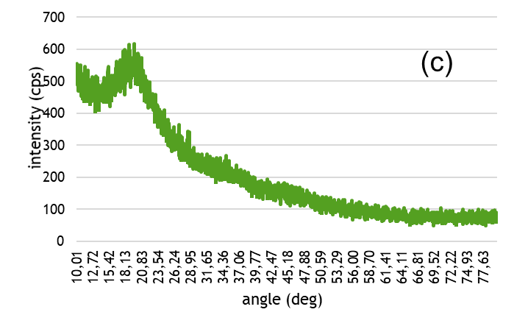

Figure 4:(a) Film obtained with optimized conditions; (b) ATR-FTIR and (c) X-ray diffraction spectra.

* 1. Conclusions

In the present work, BSG extracts, characterized by two different nutrient concentrations, have been prepared using distilled water as extraction solvent. Among them, the more concentrated extract, i.e. syrup, proved to be better for the growth of *R. mucilaginosa*, CBS 316, along with carotenoid production, also without the necessity to add nutrients, such as N sources. Moreover, the possibility to use the concentrated extract for protein-rich film production has been preliminary evaluated.

**Acknowledgments**

This publication is part of the NODES project which has received funding from the MUR – M4C2 1.5 of PNRR funded by the European Union - NextGenerationEU (Grant agreement no. ECS00000036).

Authors want to thank Ing. Paolo Pino, PhD, for his valuable contribution in the development of film production and characterization, along with Ing. Davide Forna and Ing. Giulia Cavallone, who took part at this work during the preparation of their Master thesis.

References

Assandri D., Pampuro N., Zara G., Cavallo E., Budroni M., 2021, Suitability of Composting Process for the Disposal and Valorization of Brewer’s Spent Grain, Agriculture, 11(1), 2.

Casas-Godoy L., González-Escobar J.L., Mathis A.G., et al., 2023, Revalorization of untreated Brewer’s spent grain: novel and versatile feedstock to produce cellulases, lipases, and yeast biomass in a biorefinery approach, Biomass Conversion and Biorefinery, 13, 1659–1670.

Castanho M.N., de Souza do Prado K., de Paiva J.M.F., 2022, Developing thermoplastic corn starch composites filled with brewer’s spent grain for applications in biodegradable films, Polymer Composites, 43(2), 811–826.

Celus I., Brijs K., Delcour J.A., 2006, The effects of malting and mashing on barley protein extractability, Journal of Cereal Science, 44(2), 203-211.

Cheng Y T., and Yang C.F., 2016, Using the strain *Rhodotorula mucilaginosa* to produce carotenoids using food wastes. Journal of Taiwan Institute of Chemical Engineers, 61, 270–275.

Chreptowicz K., Mierzejewska J., Tkáčová J., Młynek M., Čertik M., 2019, Carotenoid-producing yeasts: Identification and Characteristics of Environmental Isolates with a Valuable Extracellular Enzymatic Activity, Microorganisms, 7(12), 653.

Cooray S.T., Lee J.J.L., Chen W.N., 2017, Evaluation of brewers’ spent grain as a novel media for yeast growth, AMB Express, 7, 117.

de Paula M., Latorres J.M., Martins, V.G., 2023, Potential valorization opportunities for Brewer’s spent grain, European Food Research and Technology, 249, 2471–2483.

Gupta M., Abu-Ghannam N., Gallaghar E., 2010, Barley for brewing: Characteristic changes during malting, brewing and applications of its by-products, Comprehensive Reviews in Food Science and Food Safety, 9, 318–328.

Jaeger A., Zannini E., Sahin A.W., Arendt E.K., 2021, Barley Protein Properties, Extraction and Applications, with a Focus on Brewers’ Spent Grain Protein, Foods, 10(6), 1389.

Kebede Y., 2020, Analysis of the Physico-chemical Characteristics of Brewers Spent Grain (BSG), Journal of Natural Science Research, 11(18), 9–12.

Latha B.V., Jeevaratnam K., Murali H.S., Manja K.S., 2005, Influence of growth factors on carotenoid pigmentation of *R. glutinis* DFR-PDY from natural source, Indian Journal of Biotechnology, 4, 353-357.

Leite P., Silva C., Salgado J.M., Belo I., 2019, Simultaneous production of lignocellulolytic enzymes and extraction of antioxidant compounds by solid-state fermentation of agro-industrial wastes, Industrial Crops and Products, 137, 315–322.

Mussatto S.I., Dragone G., Roberto I.C., 2006, Brewers’ spent grain: generation, characteristics and potential applications, Journal of Cereal Science, 43, 1-14.

Oyedeji A.B., Wu J., 2023, Food-based uses of brewers spent grains: Current applications and future possibilities, Food Bioscience, 54, 102774.

Ravindran R., Williams G.A., Jaiswal A.K., 2019, Evaluation of brewer's spent grain hydrolysate as a substrate for production of thermostable α-amylase by Bacillus stearothermophilus, Bioresource Technology Reports, 5, 141-149.

Shroti G.K., Saini C.S., 2022, Development of edible films from protein of brewer's spent grain: Effect of pH and protein concentration on physical, mechanical and barrier properties of films, Applied Food Research, 2(1), 100043.

Wen C., Zhang J., Duan Y., Zhang H., Ma H., 2019, A Mini-Review on Brewer's Spent Grain Protein: Isolation, Physicochemical Properties, Application of Protein, and Functional Properties of Hydrolysates, Journal of Food Science, 84, 3330-3340.

Xiros C., Christakopoulos P., 2012, Biotechnological Potential of Brewers Spent Grain and its Recent Applications, Waste Biomass Valorisation, 3, 213–232.

Zeko-Pivač A., Tišma M., Žnidaršič-Plazl P., Kulisic B., Sakellaris G., Hao J., Planinić M., 2022, The Potential of Brewer’s Spent Grain in the Circular Bioeconomy: State of the Art and Future Perspectives, Frontiers in Bioengineering and Biotechnology, Section Bioprocess Engineering, 10, 1-15.

Zhao J., Tian Z., Chen, L., 2011, Effects of Deamidation on Aggregation and Emulsifying Properties of Barley Glutelin, Food Chemistry, 128, 1029–1036.