|  |  |
| --- | --- |
| cetlogo ***CHEMICAL ENGINEERING TRANSACTIONS***  ***VOL. , 2024*** | A publication of  aidiclogo_grande |
| The Italian Association  of Chemical Engineering  Online at www.cetjournal.it |
| Guest Editors: Marco Bravi, Antonio Marzocchella, Giuseppe Caputo  Copyright © 2024, AIDIC Servizi S.r.l. **ISBN** 979-12-81206-10-6; **ISSN** 2283-9216 | |

Performance enhancement of an air-cathode microbial fuel cell with subsequent carbon source removal

Khanyisile B. Malunga-Makatu\*, Sadaf A. Rahimi, Evans Chirwa, Shephard Tichapondwa

Water Utilisation and Environmental Engineering division, Department of Chemical Engineering, University of Pretoria 0002, South Africa

[K.Kalindalale@gmail.com](mailto:K.Kalindalale@gmail.com)

Microbial Fuel Cell (MFC) technology holds great promise for sustainability by simultaneously producing energy, recycling water, and degrading organic compounds. This study aimed to enhance MFC performance by introducing a biogenic air-cathode and marine bacteria. Marine bacteria were cultivated from estuarine seawater samples collected in Cape Town, South Africa, under optimal conditions (30 °C, pH 7). Additionally, the air-cathode was modified with biogenic palladium (bio-Pd(0)) as a catalyst to improve MFC performance. The open-loop cell potential was monitored every 24 h, and a maximum open-loop cell potential of 524.8 mV was recorded for the biogenic air-cathode compared to a value of 504.3mV for the control. The performance analysis of the MFC, which included recording closed-loop cell potential and assessing performance at various resistances, revealed that the biogenic cathode outperformed the control by reaching a peak power density of 4.94 mW/ $m^{3}$. Performance analysis of the MFC at different concentrations of naphthalene (5 ppm, 10 ppm, 20 ppm) also revealed improved MFC performance with increasing naphthalene concentration up to 10 ppm but exhibited inhibitory effects at 20 ppm. Carbon source removal, assessed through chemical oxygen demand (COD) analysis, coincided with peak cell potential output. These findings highlighted the potential of MFC technology for wastewater treatment and energy generation.

* 1. Introduction

In South Africa, the robust agricultural industry has brought about elevated pollution levels, primarily driven by the extensive use of pesticides to ensure crop quality (Nieuwoudt et al., 2011). Being one of the world's top ten crop producers, South Africa has emerged as the largest consumer of pesticides in Africa, responsible for a third of the continent's pesticide consumption (Degrendele at al., 2022). Furthermore, the country has grappled with an energy crisis, marked by frequent power outages, with 2022 alone experiencing 200 days of load shedding (Nhleko and Inambao, 2020). MFC technology, with its potential to produce sustainable energy and to remediate pollution by degrading contaminants, offers a promising solution to address these challenges. MFCs have gained attention in research fields due to their capacity to generate renewable energy through microbial metabolism. The technology leverages on electrogenic chemoorganotroph bacteria on the anode to facilitate electron transfer by consuming organic matter (Matsena et al., 2020). Electrons generated through this metabolic process are transferred to the electrodes via direct or mediated electron transfer mechanisms. For the electrochemical reaction to occur, an electrocatalyst is essential, and the most cost-effective option at present is palladium (Pd) (Matsena et al., 2020). However, the production of Pd catalysts involves toxic chemical processes. As an environmentally safer alternative, the production of Bio-Pd(0) from soluble palladium(II) (Pd(II)) has been explored in previous studies (Malunga-Makatu et al., 2023).

In addition previous research has explored the utilization of bio-Pd(0) in microbial fuel cell (MFC) applications. Matsena et al. (2020) employed Citrobacter to produce bio-Pd(0) and observed a significant performance enhancement, with a peak cell potential of 328.4 mV. In another study, Velden et al. (2022) investigated the halophilic characteristics of electrogenic bacteria, and their findings have provided valuable insights into enhancing MFC performance. While studies have explored individual aspects such as the use of bio-Pd to enhance performance, the utilization of marine bacteria to improve MFC performance, and the study of air-cathode performance improvement, an integrated approach combining these enhancements to achieve maximum performance enhancement remains unexplored.

This study aims to enhance the performance of a microbial fuel cell through the addition of a biogenic air- cathode while simultaneously degrading naphthalene - a carbon source which a polycyclic aromatic hydrocarbon (PAHs) pollutant, using electrogenic bacteria from marine estuary samples.

* 1. Materials and Methods

To conduct the experiments, various chemicals and reagents were employed.

* + 1. Materials

1 L Mineral Salts Medium (MSM) was prepared using the following components: 1.73 g dipotassium hydrogen phosphate (Roodepoort, South Africa), 0.68 g potassium dihydrogen phosphate (Roodepoort, South Africa), 0.1 g magnesium sulfate heptahydrate (Merk, Germany), 4 g sodium chloride (Roodepoort, South Africa), 0.03 g ferrous sulfate heptahydrate (Steinheim, Germany), 1 g ammonium nitrate (Merk, Germany), 0.02 g calcium chloride (Merk, Germany), and 5 g glucose. The pH of the medium was adjusted using 1N sodium hydroxide (NaOH) (Glassworld, Robertville, Johannesburg) and hydrochloric acid (HCl) solution (Glassworld, Robertville, Johannesburg). Furthermore, the following chemicals were used Methanol (Glassworld, Johannesburg), and Naphthalene (Steinheim, Germany).The MFC was constructed from: carbon cloth (Aerotech, Cape Town, South Africa), PVDF powder (Sigma Aldrich, Germany), n- dimethylacetamide (DMAc) (Sigma Aldrich, Germany), and activated carbon powder (ACP) (Glassworld, Robertville, Johannesburg).

* + 1. **Marine bacteria growth**

The growth of marine bacteria was investigated under a range of conditions, including temperatures from 25 °C to 40 °C, pH levels from 4 to 10, for 48h. The MSM medium was prepared and distributed into 100 mL vials, each representing a specific pH. Anoxic conditions were created in the vials by sparging them with nitrogen gas, followed by autoclaving for sterilization. After cooling to room temperature, 3 mL of sample water from the lagoon beach estuary was inoculated into each vial. Vials from pH 4 to 10 were incubated at different temperature ranges of 25 °C to 40 °C and assessed for bacterial growth using a WPA Lightwave II spectrophotometer (Labotec) to identify the optimal temperature and pH. The optimum temperature obtained from the above experiment was further used to test bacteria growth in the presence of naphthalene (carbon source) at different pH ranges, by replacing the glucose in the MSM solution with 1 g of naphthalene. The optimal conditions obtained from the marine bacteria experiment were used to grow the microbial culture utilized in the fuel cell (Igboamalu et al., 2019).

**2.3 Microbial fuel cell construction**

The bio-Pd(0) was prepared by introducing sulfur-reducing bacteria sourced from the Brits wastewater treatment plant to a solution of Pd(II), following the method outlined in (Malunga and Chirwa, 2019). A phase inverted polyvinylidene fluoride (PVDF) cathode with bio-Pd(0) as the catalyst was constructed by binding PVDF and bio-Pd(0) paste to a 5 × 5 cm carbon cloth. The PVDF paste was formed by stirring 1 g PVDF powder in 10 mL DMAc at room temperature. Furthermore, 0.3 g ACP, and 0.03 g of carbon black (CB) was mixed into the solution to form a paste according to the 10:30:3 (PVDF:ACP:CB) ratios. The paste was mixed with 6 mg of bio-Pd(0) and spread evenly on the carbon cloth. Thereafter, it was placed in de-mineralized water and air dried according to (Matsena et al., 2020).The anode chamber was prepared according to (Igboamalu et al., 2019). The air-cathode was separated from the anodic chamber via a nafion membrane. The control MFC was constructed as previously mentioned, however, it did not contain the bio-Pd(0).

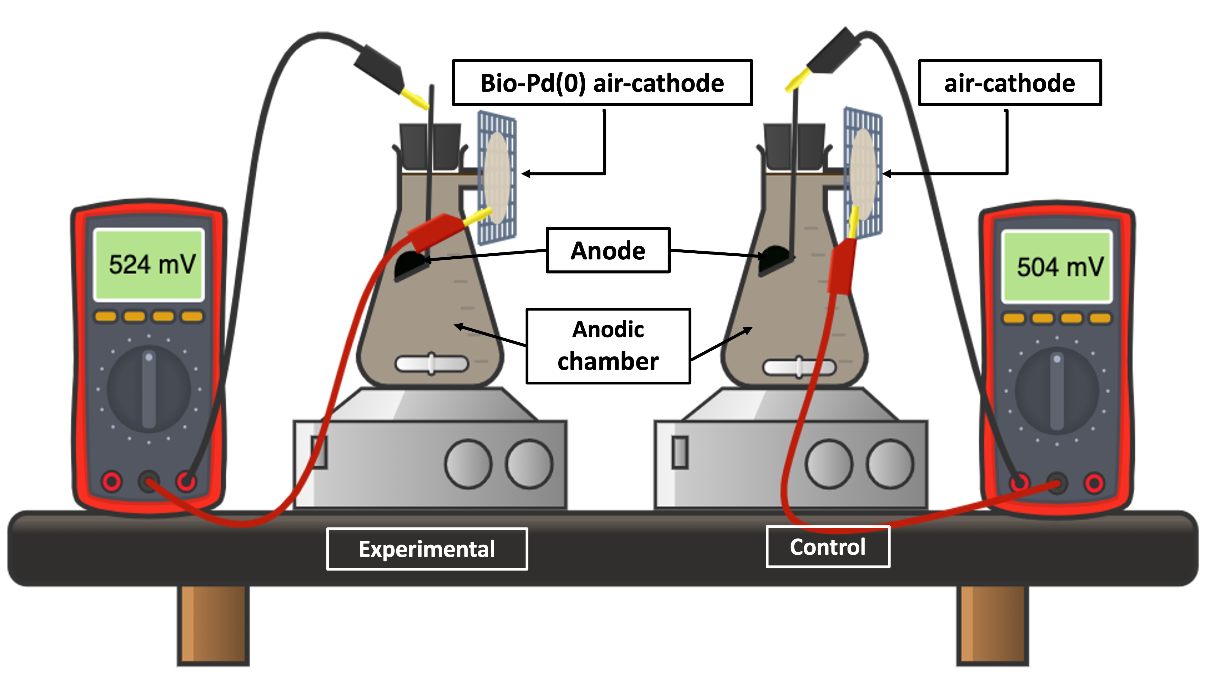

Figure 1: Microbial fuel cell setup

**2.4 Degradation analysis of microbial fuel cell**

Naphthalene has an allowable non-toxic concentration of 0.07 ppm, and a solubility limit of 32 ppm in water (Jia, and Batterman, 2010). Therefore, the concentrations of 5 ppm, 10 ppm, and 20 ppm of naphthalene were chosen for this study. To assess the removal of organic carbon under anaerobic conditions. 3 mL of the samples was combined with a standard solution Certified Reference Material (CRM) and subjected to a thermoreactor at 150 °C for 120 minutes. After treatment, the samples were analysed using a photometric device (Spectroquant CombiCheck 20) to measure the COD.

**2.5 Performance analysis of microbial fuel cell**

The output potential (Um) was recorded every 24 h from the fuel cell which was utilized to calculate the current and power densities at various resistances to create polarization curves. The current density (I) and power density (P) was calculated using equation 1 and 2 respectively, where Um is the cell potential (mV), Rext is the external varying resistance (Ω), and V is the volume of the constructed microbial fuel cell (Velden et al., 2022).

|  |  |
| --- | --- |
|  | (1) |

|  |  |
| --- | --- |
|  | (2) |

* 1. **Results and Discussion**
     1. **Marine microbial growth**

The results obtained after 48 h from the various temperatures revealed that at a temperature of 30 °C the microbial growth rate was the highest with an absorbance of 0.7 at a pH of 7, at 25 °C the temperature was too low and at 40 °C the temperature was too high for the bacteria to grow resulting in an absorbance of 0.58 and 0.05 respectively as seen in figure 2a. These results correlate with the results obtained in the experiments carried out by Velden et al. (2022), where the performance of the marine bacteria in the MFC was the best at 30 °C by producing a higher maximum power density of 0.0456 mW/m3 (Igboamalu et al., 2019). The marine bacteria grown with 10 ppm naphthalene in the absence of glucose, revealed that naphthalene can be considered as a carbon source for the bacteria since there was bacterial growth recorded. The results revealed that the naphthalene acclimatized bacteria grew best at a pH of 7 as seen in figure 2b.

**b**

**a**

Figure 2: Marine bacterial growth at different pH’s (4,7,8,10) and temperatures (25,30,40) (a), and 10 ppm naphthalene concentration bacterial growth (b)

* + 1. **Microbial fuel cell**

**3.2.1 5 ppm naphthalene concentration**

The fuel cell run at 5 ppm naphthalene concentration showed a gradual increase in cell potential for the experimental run as seen in figure 4. This is due to the lower toxicity exposure since acclimatization of the marine bacteria was done at 10 ppm of naphthalene prior to being introduced to the anodic chamber of the fuel cell. The experimental run where the catalyst was utilized revealed significantly more stabilized cell potentials across the duration of the fuel cell reaction time compared to the control which did not contain the Bio-Pd(0) catalyst. The peak cell potential achieved with the experimental run was drastically higher at 528.2 mV compared to the control at 363.2 mV this result represents the performance enhancement achieved with the addition of the bio-Pd(0) in the air-cathode. These result correlates with the study done by Malunga-Makatu et al., (2023). where a more stable output potential was achieved in the MFC with bio-Pd(0).

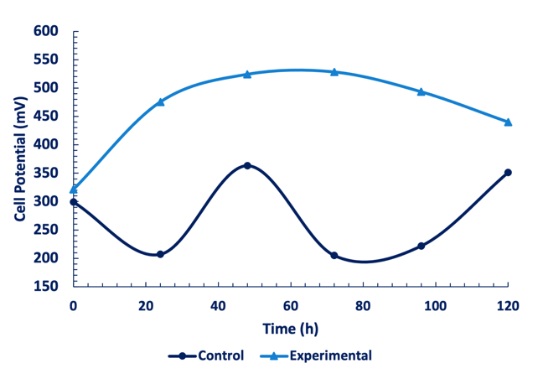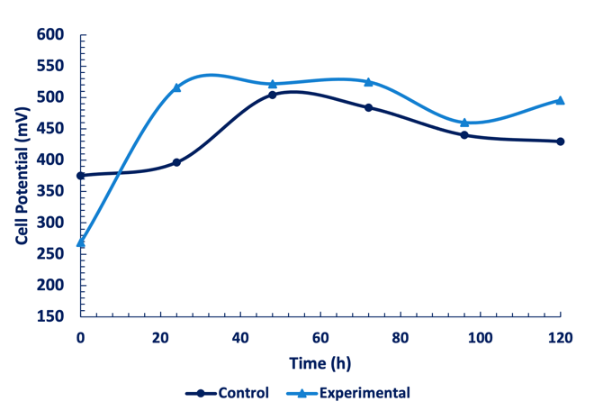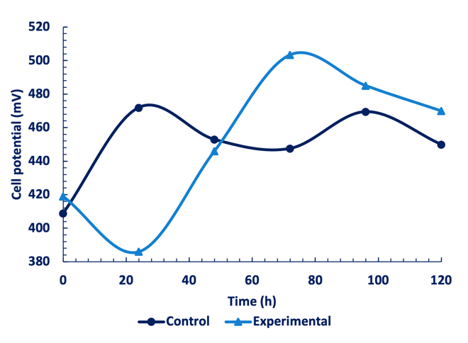

**a**

**b**

**c**

Figure 3: Open loop cell potential for microbial fuel cell runs at naphthalene concentrations of 5 ppm (a) 10 ppm (b) and 20 ppm (c)

The polarization curves as seen in figure 4a and b showed a peak power density of 0.967 mW/m3 at the current density of 5.02 mA/m3 for the control, and a maximum power density of 1.29 mW/m3 at a current density of 6.34 mA/m3 for the experimental. These results confirm that the bio-Pd(0) catalyst improved the

performance of the microbial fuel cell. This correlates with results obtained by Malunga-Makatu et al., (2023).

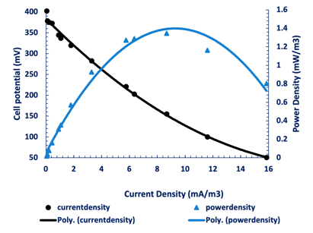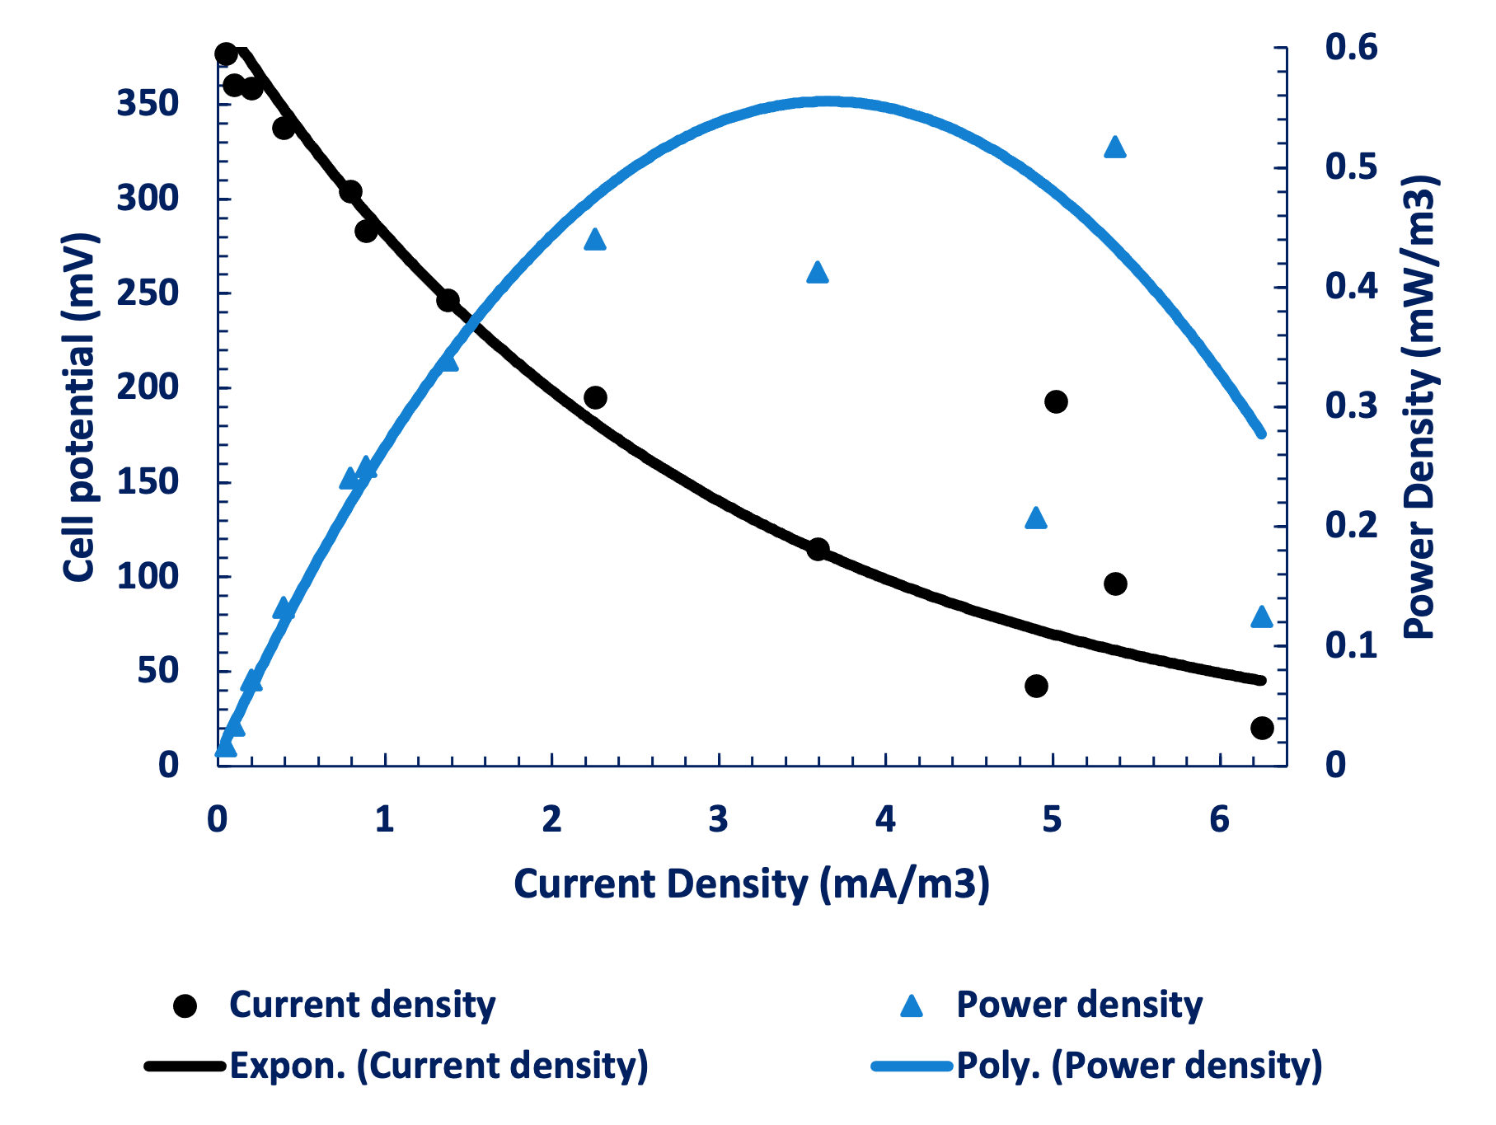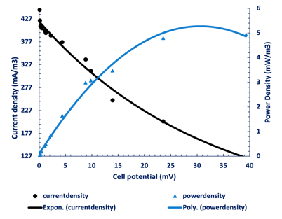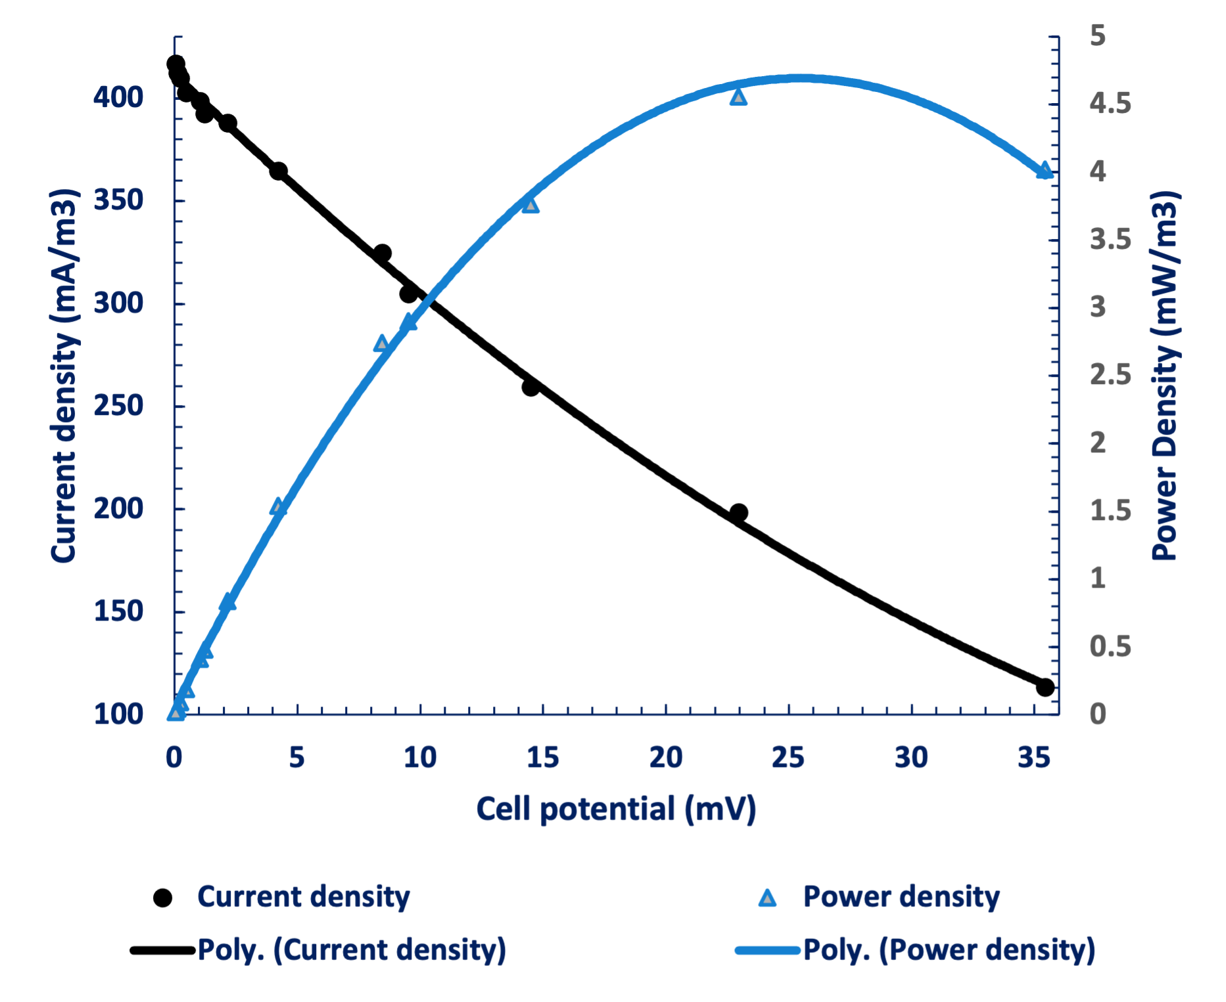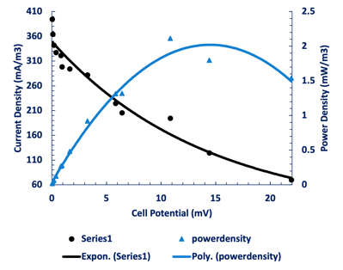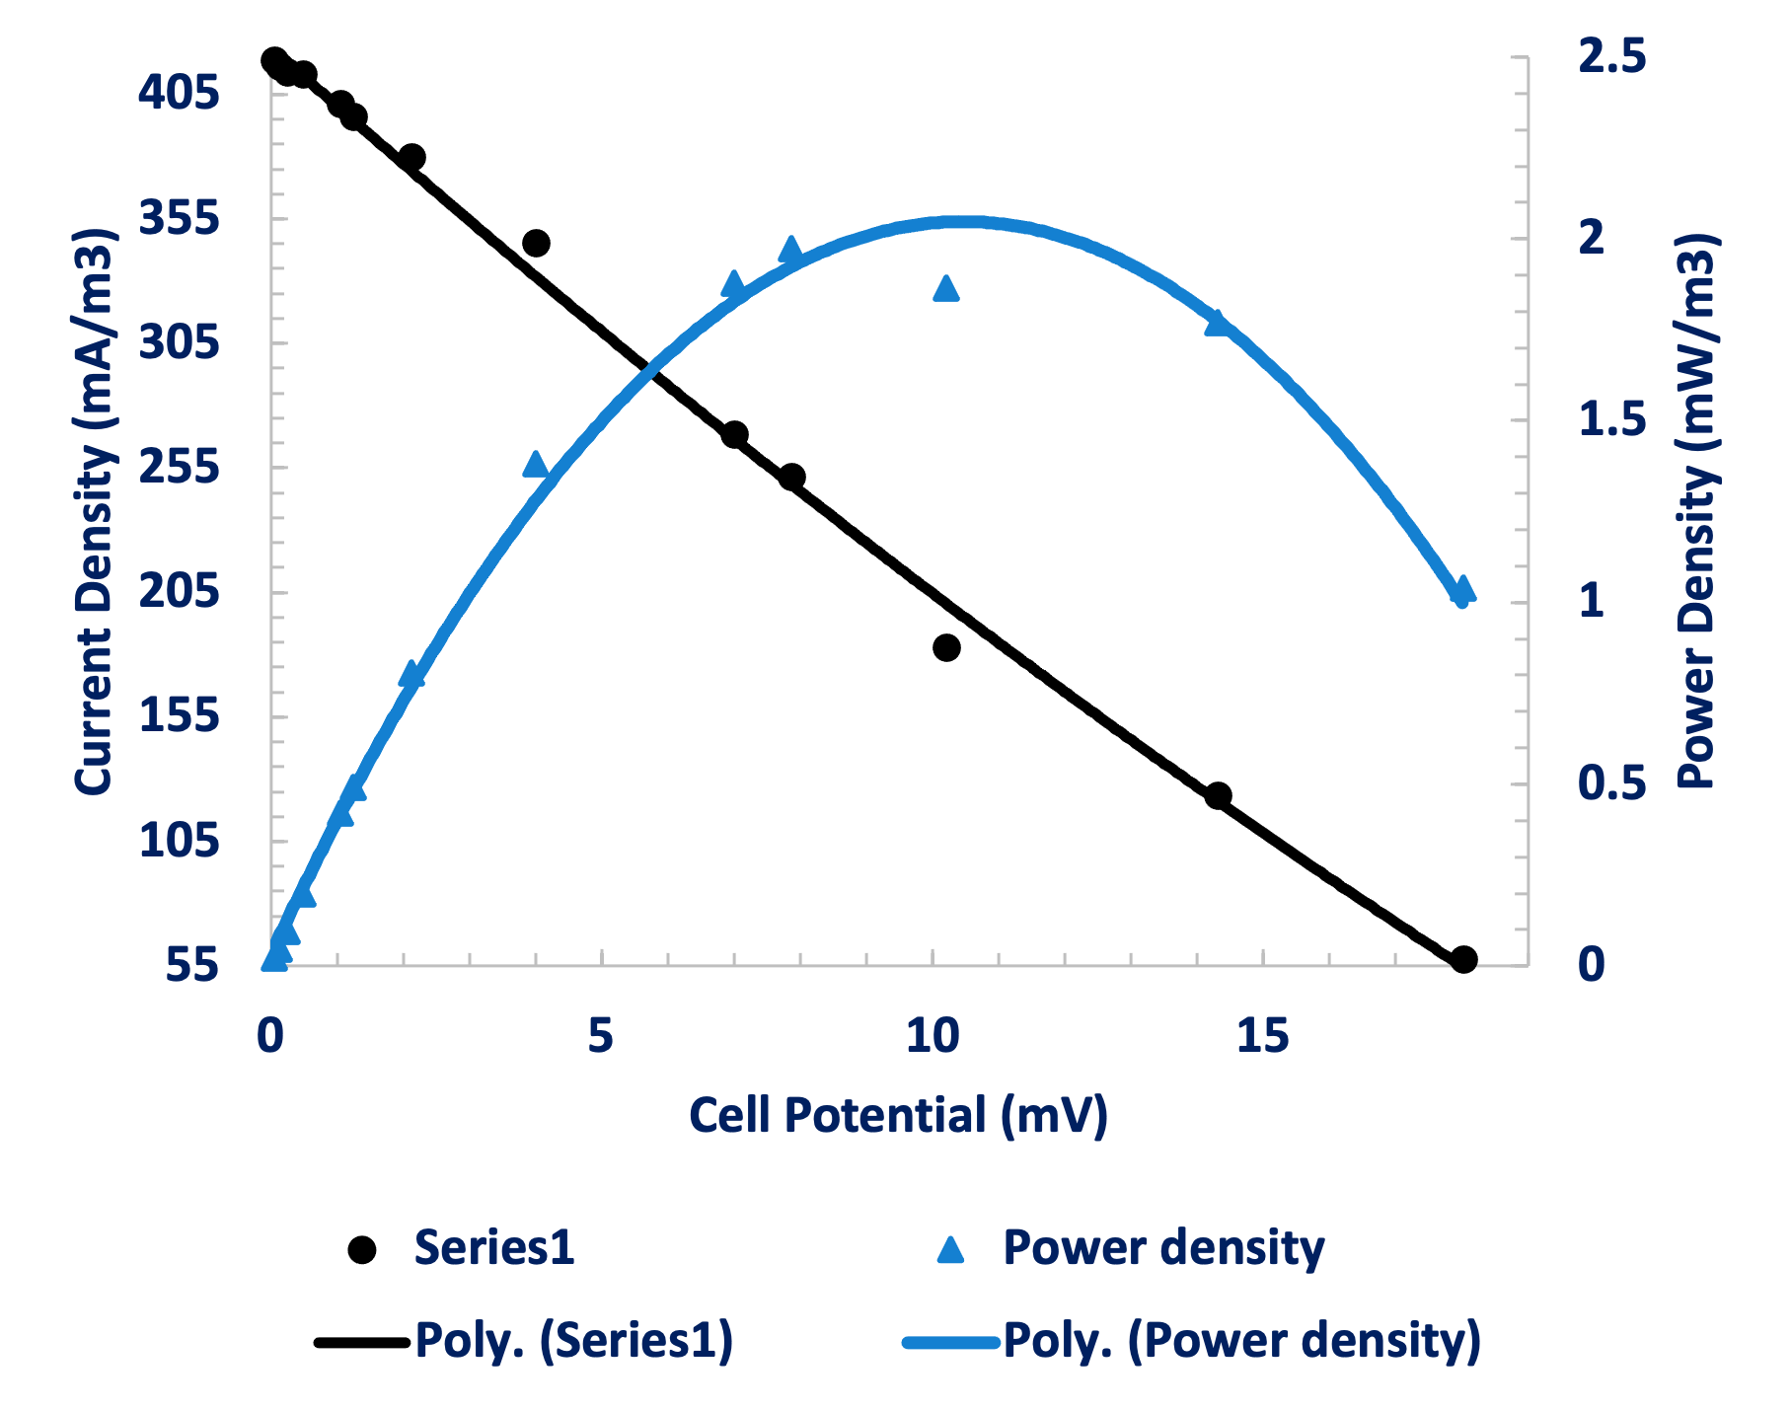

**a**

**b**

**c**

**d**

**e**

**f**

Figure 4: Polarization curve for microbial fuel cell runs at naphthalene concentrations of 5 ppm (a) experimental (b) Control, 10 ppm (c) experimental (d) control, 20 ppm (e) experimental (f) control.

**3.2.2 10 ppm naphthalene concentration**

At 10 ppm naphthalene concentration the MFC showed a drastic increase in cell potential for the experimental run as seen in figure 3b. This was due to the acclimatization of the bacteria to 10 ppm of naphthalene prior to the experimental run, which gave the bacteria an advantage with toxicity level tolerance. The peak open loop cell potential achieved with the experimental run was higher at 524.8 mV compared to the control at 504.3 mV. This result correlates with the study done by Matsena et al., (2020) which revealed the performance enhancement achieved with the addition of bio-Pd(0) nanoparticles. The polarization curves as seen in figure 4c and d showed a peak power density of 4.56 mW/m3 at a current density of 29.96 mA/m3 for the control, and a maximum power density of 4.94 mW/m3 at a current density of 39.28 mA/m3 for the experimental. These results confirmed that the bio-Pd(0) catalyst improved the performance of the microbial fuel cell which correlates with the results obtained in the 5 ppm run and the study conducted by Matsena et al., (2021).

**3.2.3 20 ppm naphthalene concentration**

At 20 ppm naphthalene concentration the was a drastic decrease in cell potential as seen in figure 3c. The high concentration of naphthalene was toxic to the bacteria causing the reaction to be unstable as compared to the 5 ppm and 10 ppm concentrations. The peak open loop cell potential achieved in the experimental run was drastically higher at 503.4 mV compared to the control at 472.0 mV revealing that the bio-Pd(0) enhanced the performance of the MFC. This result correlates with the study done by Malunga-Makatu et al. (2023) where the performance enhancement of the MFC was confirmed in the presence of bio-Pd(0) nanoparticles compared to the run with no nanoparticles in the air- cathode. The polarization curves as seen in figure 4e and c showed a peak power density of 1.97 mW/m3 at the current density of 7.85 mA/m3 for the control, and a maximum power density of 2.11mW/m3 at a current density of 10.86 mA/m3 for the experimental. These results confirm that the bio-Pd(0) catalyst improved the performance of the microbial fuel cell. This correlates with results obtained in the 5 ppm and 10 ppm concentrations as well as the study conducted by Matsena et al. (2020) which mentioned inhibition of enzymatic processes on bacterial cells which affected the performance of the MFC.

**3.3 Chemical oxygen demand (COD)**

The 10 ppm naphthalene concentration MFC study revealed the best performance analysis, therefore, samples of this run were analyzed for chemical oxygen demand. As seen in figure 5 there is confirmation that chemical oxygen demand was decreased revealing organic carbon degradation. The maximum percentage degradation occurred after 72 h, correlated with the maximum open loop cell potential obtained at 72 h from the MFC. This revealed a relationship between the removal of carbon sources and voltage produced in the MFC.

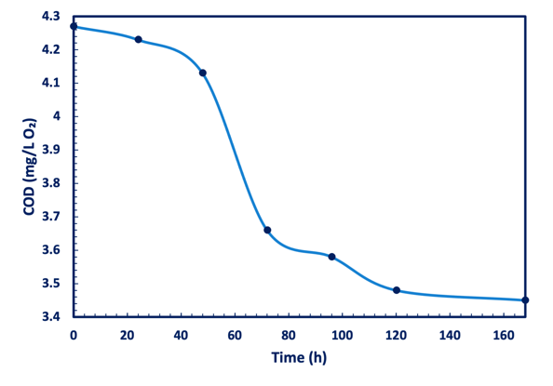

Figure 5: Chemical Oxygen Demand results

* 1. **Conclusions**

Marine bacteria that are acclimatized to a naphthalene rich environment grew best at 30 °C, and a pH of 7. They have proven to have electrogenic capabilities because a maximum open loop cell potential of 528.2 mV, 524.8 mV, and 503.4 mV was achieved for 5 ppm, 10 ppm, and 20 ppm runs respectively. However, a 20 ppm naphthalene concentration had a toxicity effect on the bacteria because there was a decrease in MFC performance from a power density of 4.56 mW/m3 to 1.97 mW/m3. A COD analysis of the 10-ppm run confirmed that organic carbon sources were degraded over the course of the MFC run. The addition of Bio-Pd(0) stabilized the reaction, potential output, and enhanced the performance of the air-cathode MFC. These findings highlighted the potential of MFC technology for wastewater treatment and energy generation.

**Nomenclature**

$I$– Current density, mA/m3

– Closed loop cell potential, mV

$R_{ext}$– External resistance, ohm

$V$– Volume of reactor, m3

– Power density, mW/

**Acknowledgments**

The authors would like to thank the Water Utilisation and Environmental Engineering Division of the University

of Pretoria for the financial support during the study. This research was funded by the National Research Fund (NRF) through the Grant number: MND210623615156 awarded to Khanyisile Malunga-Makatu and Grant number: SRUG2204072544 awarded to Prof Evans Chirwa of the Department of Chemical Engineering and auxiliary items financed by the Rand Water Chair in Water Utilisation (South Africa).

**References**

Al-Sheri, A. N. Z. (2015). Employment of microbial fuel cell technology to biodegrade naphthalene and benzidine for bioelectricity generation. International Journal of Current Microbiology and Applied Sciences, 4, 134–149.

Degrendele, C., Klánová, J., Prokeš, R., Příbylová, P., Šenk, P., Šudoma, M., Röösli, M., Dalvie, M. A., Fuhrimann, S. (2022). Current use pesticides in soil and air from two agricultural sites in South Africa: Implications for environmental fate and human exposure. Science of The Total Environment, 807, 150455.

Igboamalu, T., Chirwa, E., Needham-Clark, B., Matsena, M. (2019). Energy Output from a Dual Chamber Anoxic Biofilm Microbial Fuel Cell Subjected to Variation in Substrate Concentration. Chemical Engineering Transactions, 76, 1387.

Igboamalu, T., Chirwa, E., Bezuidenhout, N., Matsena, M. (2019). Microbial Fuel Cell power output and growth: Effect of substrate pH on anaerobic microbe consortium. Chemical Engineering Transactions, 76, 1381–1386.

Jia, C., Batterman, S. (2010). A Critical Review of Naphthalene Sources and Exposures Relevant to Indoor and Outdoor Air. International Journal of Environmental Research and Public Health. 7, 2903–2939.

Malunga, K.B, Chirwa, E.M.N. (2019). Redox Potential and Proton Demand in an Anaerobic Palladium (II) Reducing Culture of Desulfovibrio Desulfuricans Seroval. Chemical Engineering Transections, 76, 1309-1314.

Malunga-Makatu, K. B., Chirwa, E. N., Tichapondwa, S. M. (2023). The Application of Bio-pd(0) as a Biogenic Cathode in a Microbial Fuel Cell. Chemical Engineering Transactions, 99, 283–288.

Matsena, M., Tichapondwa, S., Chirwa, E. (2020). Synthesis of Biogenic Palladium Nanoparticles Using Citrobacter sp. for Application as Anode Electrocatalyst in a Microbial Fuel Cell. Catalysts, 10, 838.

Matsena, M.T., Tichapondwa, S.M., Chirwa, E.M.N., 2021, Improved chromium (VI) reduction performance by bacteria in a biogenic palladium nanoparticle enhanced microbial fuel cell. Electrochimica Acta, 368, 137640.

Nhleko, M., Inambao, F. (2020). Energy Crises in South Africa and New Ways of Fast-Tracking Remedial Actions Through Diversified and Decentralised Generation. International Journal of Engineering Research and Technology, 13, 2814.

Nieuwoudt, C., Pieters, R., Quinn, L. P., Kylin, H., Borgen, A. R., & Bouwman, H. (2011). Polycyclic Aromatic Hydrocarbons in Soil and Sediment from Industrial, Residential, and Agricultural Areas in Central South Africa. Soil and Sediment Contamination: An International Journal, 20, 188–204.

Velden, M., Matsena, M., Chirwa, E. (2022). The Impact of Marine Bacteria on the Performance of an Air-Cathode Microbial Fuel Cell. Chemical Engineering Transactions, 96, 331–336.