 CHEMICAL ENGINEERING TRANSACTIONS  VOL. , 2024 | A publication of  
The Italian Association
of Chemical Engineering
Online at www.cetjournal.it

Guest Editors: Marco Bravi, Antonio Marzocchella, Giuseppe Caputo
Copyright © 2024, AIDIC Servizi S.r.l.
ISBN 979-12-81206-10-6; ISSN 2283-9216

Glucose and Xylose Utilization by Bacillus Cereus AS1 During Anaerobic Fermentation
Nhlamulo G. Sibiya, Evans M.N. Chirwa, Michael Daramola, Hendrik G. Brink*
University of Pretoria, Department of Chemical Engineering, University of Pretoria Main Campus, Corner Lynwood & Roper Street, Hatfield, Pretoria, 0002, South Africa

The aim was to determine the growth potential of Bacillus cereus using glucose and xylose as the substrates. In this study a bacterial isolate was identified by 16s rRNA gene sequencing. Bacillus.cereus can metabolise glucose and xylose as the sole carbon sources during anaerobic fermentation. The biomass growth profile showed a lag of about 8 h, followed by an increase in the biomass. The growth profile was better on glucose than xylose. The maximum biomass concentration achieved was 3.64 g/L and 2.62 g/L using glucose and xylose, respectively. The higher the initial substrate concentration the higher the growth of the bacteria. The growth of B. cereus was accompanied by a decrease in the ORP. Its ability to metabolise xylose proves that it has the potential to convert biomass-derived feed for possible applications as a bio-fertilizer.

  - Introduction
Bacillus cereus is a rod-shaped, endospore-forming, facultative anaerobic bacteria that is mostly found in soil (Bursová et al., 2018, Luo et al., 2007). It is recognized as one of the major food-borne pathogenic bacteria that causes emetic and diarrheal food-poisoning symptoms (Wong and Chen, 1988). Its tolerance to environmental stressors is high because it forms spores that enable it survive in harsh environmental conditions such as pH (Ahmed et al., 2023), high pressures and extreme temperatures (Soria and Audisio, 2014). The non-pathogenic strains of B. cereus have been proven to be able to promote the growth of plants by increasing the shoot and root lengths of plants as well as increasing the seed germination percentage (Aktar et al., 2021). It is able to form biofilms which increases the plants resistance to chemicals heat, UV radiation and other environmental stresses (Kulkova et al., 2023, Kwon et al., 2017). It and can also be used as a biological control agent in the agricultural industry because of its ability to help plants fight off certain bacterial pathogens (Banerjee et al., 2018). The excessive use of fertilizers may cause agricultural pollution via leaching, runoff and erosion, which damages the soils physical, chemical and microbiological characteristics (Cardoso et al., 2021) and in turn can have an impact on the water quality. This makes this microorganism an environmentally friendly alternative to the chemically harsh fertilizers and pesticides that are currently used in the industry.
Nutritional factors, such as the carbon and nitrogen sources in the growth medium have a significant influence the growth and development of bacteria. Optimizing these parameters will enhance the production of B. cereus. Zigha et al. (2006) and Zhou et al. (2023) demonstrated that glucose can regulate the growth of B. cereus. However, glucose is expensive and using it in the industrial fermentation industry could potentially compete with the global food industry because it is derived from corn-starch. The use of agricultural wastes as sugar substrates for microbial growth could reduce fermentation production costs because they are abundant and inexpensive. Xylose is a major carbohydrate in hemicellulose found in woody or grassy biomass (Bradfield & Nicol, 2016). B. cereus can metabolize a number of carbon sources such as glycerol (Kwon et al., 2017), and a variety of dairy products (Ellouze et al., 2021).
The ORP (oxidoreduction potential) is a function of the pH, temperature, amount of dissolved oxygen present as well as the compounds dissolved in the medium (Husson et al., 2006). The ORP of the culture medium affects the growth capacity of microorganisms (Husson et al., 2006) and it has been used to study the carbon and energy flux in several microorganisms. Hamitouche et al. (2021) found that a decrease in ORP, in anoxic conditions, favoured the growth of B. cereus. However, according to Clair et al. (2012) a change in the initial ORP conditions did not affect the growth rate and metabolic activity of B. cereus, which indicates that this microorganism can maintain its intracellular redox state by responding effectively to reductive stress.
Another critical factor that affects bacterial growth is the pH of the fermentation medium as influences the cellular metabolism of the microorganism (Wang et al., 2012). Okanlawon et al. (2010) and Yasin and Al-Mayaly (2021) showed that the growth B. cereus was at near neutral pH. Metabolic analysis of B. cereus fermentation by Le Lay et al. (2015) showed that low pH modifies fermentative metabolism significantly by changing its by-product formation. Low redox potential in combination with low pH resulted in a decrease in the final biomass concentration compared to a low redox potential and neutral pH.
The current study will seek to evaluate the growth potential of B. cereus on glucose and xylose using MgCO₃ as a neutralizing agent.

  - Materials and methods
    - Microorganism and growth medium
Lactobacillus cereus strain AS1 was isolated in the laboratory and identified using 16s rRNA sequencing. This strain was used for all the fermentations. Stock cultures (1.5 mL) are stored at -40 °C in 66 % v/v glycerol solutions. Inoculum was prepared by transferring a stock culture to 15 mL of sterilised tryptone soy broth at 30 g/L and incubating at 37 °C and 150 rpm for 16 to 24 h.
    - Fermentation media
The fermentation medium was a replica of the medium developed by Bradfield and Nicol (2014). All chemicals were obtained from Merck KGaA (Darmstadt, Germany) unless otherwise stated. The medium consists of three parts: the nutrient and salt solution, a phosphate buffer, and the glucose/substrate solution. The nutrient and salts solution were composed of 6.0 g/L yeast extract, 10.0 g/L clarified corn steep liquor (Sigma-Aldrich, St Louis, USA), 0.5 g/L NaCl, 0.2 MgCl₂·6H₂O, 0.2 g/L CaCl₂·2H₂O and 1.0 mL/L of Antifoam SE-15 (Sigma-Aldrich, Germany). The phosphate buffer consisted of 1.6 g/L KH₂PO₄ and 0.8 g/L K₂HPO₄. The D-glucose (Futaste Pharmaceutical Co. Ltd, Shandong, China) and D-xylose concentrations were 70 and 80 g/L. MgCO₃ acted as the pH regulator and the final concentration in the fermenter was 40 g/L.
    - Experimental setup and operation
The three feed solutions were prepared in different bottles and diluted with distilled water until a 250 mL solution was obtained. The initial fermenter broth volume was 750 mL. All three bottles were connected in series with silicone tubing to a 1 L fermenter. The silicone tubing was clamped shut to prevent mixing and unwanted reactions from occurring during autoclaving and were separately sterilised by autoclaving at 121°C for 60 min. Once they had cooled down, the three solutions were added to the main reactor, aseptically.
The fermenter was placed on a hotplate stirrer and attached to a temperature measuring electrode. Temperature and stirring speed were controlled at a temperature of 37 °C and 300 rpm, respectively. Inoculum was added into the reactor under sterile conditions and anaerobic batch fermentations were carried out for a total of 48 hours. A sample was taken from the onset of the batch fermentation to note initial conditions for a batch run. Samples are taken every 2 hours for the first 12 hours and then the sampling time was increased.
    - Analytical methods
Each 4 mL sample was diluted with a 1 mol/L HCl solution to break down the carbonate solids that formed inside the reactor. The concentration of glucose (Glc) and xylose (Xyl) in the fermenter broth was determined by High-Performance Liquid Chromatography (HPLC). An Agilent 1260 Infinity HPLC (Agilent Technologies, USA), equipped with an RI detector and a 300 mm × 7.8 mm Aminex HPX-87H ion exchange column (Bio-Rad Laboratories, USA) was used. Two mobile phases were used for two methods of analysis. The method used a 20 mM H₂SO4 mobile phase solution fed at a flowrate of 0.6 mL min⁻¹. The HPLC operating conditions resemble the conditions stated in Mokwatlo et al. (2020).
The biomass concentration (X) in the reactor was assessed by performing absorbance readings using an Agilent Cary 60 UV-Visible Spectrophotometer (Agilent Technologies, USA) at a wavelength of 600 nm. The oxidation reduction potential (ORP) of the product stream was measured using an Ezdo PL-700 ALS probe (Ezdo, Taiwan).
    - Microorganism characterization and identification
The phylogenetic analysis was used to identify the bacterial strain. A BLAST program was used to analyze the bacterial stain by comparing it to the 16s rRNA sequence against the NCBI database.

  - Results and discussions
Based on 16 rRNA sequences, a phylogenetic tree of the AS1 strain was developed and represented in Figure 1. This strain was identified as a member of Bacillus cereus.

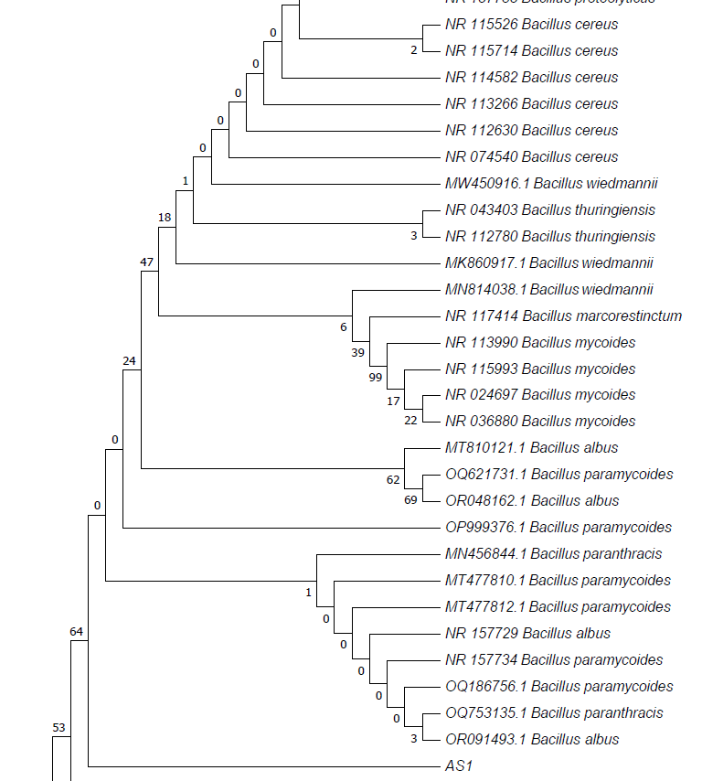
Figure 1: The phylogenetic tree of Bacillus cereus strain AS1

The growth rate profile shows that Bacillus cereus AS1 can utilize glucose and xylose as carbon sources for its metabolic functions represented in Figure 2a and Figure 2b. The growth rate profile is characterized by a lag phase of approximately 8 h, then a gradual increase thereafter. The cell growth also improved at higher initial glucose and xylose concentrations. At a higher, initial glucose concentration, the bacterial growth rapidly increases, whereas there is no rapid growth on xylose as a the sole carbon source. The maximum biomass concentration on glucose was 3.64 g/L and 2.62 g/L for xylose at an initial substrate concentration of 80 g/L. After 48 h, 69 % and 40 % of the substrate was consumed for glucose and xylose, respectively. An increase in substrate consumption, relates to an increase in biomass formation in the fermenter.
A study on yeasts has found that xylose fermentations are slower than glucose fermentations, because the microorganism might have an insufficient capacity in its metabolism for xylose utilisation (Johansson & Hahn-Häggerdal, 2002), which could also be the reason for B. cereus. This data validates the findings in Zhang et al. (2015), that glucose is a superior carbon- source to B. cereus AS1 than xylose its consumption rate is higher and because the growth rate was higher using glucose than xylose.

Figure 2: Bacterial growth of B. cereus AS1 in a) glucose and b) xylose
Figure 3 represents the effect of the ORP in the fermentation medium on the growth of the bacteria. Some studies have concluded that every microorganism has a preferable redox potential range, within which cell growth is possible. In this study, the decrease in the ORP facilitated the growth of B. cereus AS1. The point of the steepest decrease in ORP, occurs at greatest biomass increase. This could imply that the carbon is being used for bacterial growth.
Figure 3: The ORP and bacterial growth of B. cereus in a) glucose and b) xylose at 80 g/L.

Table 1 shows the maximum biomass growth and the change in ORP for the duration of the fermentation for Glc as well as Xyl. A low medium ORP signifies a higher availability of electrons (Tan et al., 2014), which could improve the production of biomass thereby promoting an increased production of biomass. There is only a small difference in the change of ORP using glucose and xylose.

Table 1: Summary of the initial substrate concentrations, biomass concentrations and ORP
Substrate/Product | Initial concentration (g/L) | Final biomass concentration(g/L) | Change in ORP (mV)
Glucose | 80.0 | 3.64 | -166
Xylose | 80.0 | 2.62 | -173

  - Conclusions
In this study, the bacteria isolated from the laboratory was identified to be Bacillus cereus by phylogenetic analysis. It has the ability to catabolise glucose as well as xylose as the sole carbon source under anaerobic, batch fermentation. This implies that B. cereus AS1 has the potential to be cultivated using plant-based renewable resources. Lower ORP conditions favoured the microbial growth of B. cereus AS1. A model to predict the growth kinetics of Bacillus cereus AS1 on glucose and xylose must be developed.

Nomenclature
Glc – Glucose
Xyl – Xylose
ORP – Oxidation reduction potential
X – Active biomass

References
Ahmed W.I., Kamar A.M., Hamad G.M., Mehany T., El-Desoki W.I., Ali E., Simal-Gandara J., 2023, Biocontrol of Bacillus cereus by Lactobacillus plantarum in Kareish cheese and yogurt. LWT – Food Science and Technology, 183: 114946
Aktar N., Ilyas N., Yasmin H., Sayyed R.Z., Hasnain Z. Elsayed E.A., El Enshasy H.A, 2021, Role of Bacillus cereus in improving the growth and phytoextractability of Brassica nigra (L.) K. Koch in chromium contaminated soil. Molecules, 26, 1569
Banerjee G., Gorti S., Chattopadhyay P., 2018, Beneficial effects of biocontrol agent Bacillus cereus IB113 on the agricultural crop production and its biomass optimization through surface methodology. Anais da Academia Brasileira de Ciencias, 90 (2 suppl. 1), 2149 – 2159.
Bradfield M. F. A. and Nicol W., 2014, Continuous succinic acid production by Actinobacillus succinogenes in a biofilm reactor: Steady-state metabolic flux variation. Biochemical Engineering Journal, 85, 1 - 7.
Bradfield M. F. A. and Nicol W., 2016, Continuous succinic acid production from xylose by Actinobacillus succinogenes. Bioprocess Biosyst Eng, 39, 233 - 244
Bursová S., Necidová L., Haruštiaková D., 2018, Growth and toxin production of Bacillus cereus strains in reconstituted initial infant milk formula. Food Control, 93, 334 – 343
Cardoso A.F., Alves E.C., da Costa S.D.A., de Mores A.J.G., da Silva G.B., 2021, Bacillus cereus improves performance of Brazilian green dwarf coconut palms seedling with reduced chemical fertilization. Front. Plant Sci., 12: 649487
Clair G., Armengaud J., Duport C., 2012, Restricting fermentative potential by proteome remodeling. Molecular & Cellular Proteomics, 11 (6)
Ellouze M., Buss Da Silva N.,Rouzeau-Szynalski K., Coisne L.,Cantergiani F., Baranyi J., 2021, Modelling Bacillus cereus growth and cereulide formation in cereal-,dairy-, meat-, vegetable-,based food and culture medium. Front. Microbiol., 12:639546
Hamitouche F., Gaillard J., Schmitt P., Armengaud J., Duport C.,Dedieu L., 2021, Redox proteomic study of Bacillus cereus thiol proteome during fermentative anaerobic growth. BMC Genomics,22:648
Housson F., Tu V., Santiago-Gomez M., Cachon R.,Feron G., Nicaud J.M., Kermasha S., Belin J.M., 2006, Effect of redox potential on the growth of Yarrowia lipolytica and the biosynthesis and activity of heterologous hydroperoxide lyase. Journal of the Molecular Catalysis B: Enzymatic, 39, 179 – 183
Johansson B., Hahn-Häggerdal B., 2002, The non-oxidative pentose phosphate pathway controls the fermentation rate of xylulose but not of xylose in Saccharomyces cerevisiae TMB3001. FEMS Yeast Research, 2(3), 277-282
Kulkova I., Dobrzyński J., Kowalczyk P., Bełżecki G., Kramkowski K., 2023, Plant growth promotion using Bacillus cereus. International Journal of Molecular Sciences, 24, 9759
Kwon M., Hussain M. S., Oh D.H., 2017, Biofilm formation of Bacillus cereus under food-processing-related conditions. Food Sci Biotechnology, 26 (4), 1103 – 1111
La Lay J., Bahloul H., Serino S., Jobin M., Schmitt P., 2015, Reducing activity, glucose catabolism and acid tolerance response of Bacillus cereus grown at various pH and oxydo-reduction potential. Food Microbiology, 46, 314 - 321
Luo Y., Vilain S., Voigt B., Albrecht D., Hecker M., Brözel, V.S., 2007, Proteomic analysis of Bacillus cereus growing in liquid soil organic matter, FEMS Microbiol Lett. 2007, 271 (1) :40-7
Mokwatlo S.C., Brink H.G.,Nicol W., 2020, Effect of shear on morphology, viability and metabolic activity of succinic acid-producing Actinobacillus succinogenes biofilms. Bioprocess and Biosystems Engineering, 43, 1253-1263
Okanlawon B.M., Ogunbanwo S.T., Okunlola A.O., 2010, Growth of Bacillus cereus isolated from some traditional condiments under different regimes. African Journal of Biotechnology, vol 8 (14), 2129 – 2135
Soria M.C. and Audisio M.C., 2014, Inhibition of Bacillus cereus strains by antimicrobial metabolites from Lactobacillus johnsonii CRL1647 and Enterococcus faecium SM21. Probiotics and Antimicrobial Proteins, 6, 208 – 216
Tan J. P., MD. Jahim J., Wu T. Y., Harus S., Kim B. H. & Mohammad A. W., 2014. Insight into biomass as a renewable carbon source for the production of succinic acid and the factors affecting the metabolic flux toward higher succinate yield. Industrial & Engineering Chemistry Research, 53, 16123 - 16134
Wang C. C., Zhu L. W., Li H. M., Tang Y. J., 2012, Performance analyses of a neutralizing agent combination strategy for the production of succinic acid by Actinobacillus succinogenes ATCC 55618, Bioprocess Biosyst. Eng, 35, 659 - 64.
Wong H., Chen Y., 1988, Effects of lactic acid bacteria and organic acids on growth and germination of Bacillus cereus. Applied and Environmental Microbiology, Vol 54:9, 2179 – 2184
Yasin A.R., Al-Mayaly I.K., 2021, Study of the fermentation conditions of the Bacillus cereus strain ARY73 to produce polyhydroxyalkanoate (PHA) from glucose. Journal of Ecological Engineering, 22(8), 47 – 53
Zhang Y., Zhu S., Yang J., He C., Zhou L., 2015, Characterization of a cellulose and xylose utilization Bacillus cereus Yc-A1. International Conference on Advances in Energy, Environment and Chemical Engineering, 2015
Zhou J., Wu Y., Liu D., Lv R., 2023, Effect of carbon source and temperature on the formation and growth of Bacillus licheniformis and Bacillus cereus biofilms. LWT- Food Science and Technology, 186, 115239
Zigha A., Rosenfeld E., Schmitt P., 2006, Anaerobic cells of Bacillus cereus F4430/73 respond to low oxidoreduction potential by metabolic readjustments and activation of enterotoxin expression. Arch Microbiol., 185, 222 – 233

