|  |  |
| --- | --- |
| cetlogo ***CHEMICAL ENGINEERING TRANSACTIONS***  ***VOL. , 2024*** | A publication of  aidiclogo_grande |
| The Italian Association  of Chemical Engineering  Online at www.cetjournal.it |
| Guest Editors: Marco Bravi, Antonio Marzocchella, Giuseppe Caputo  Copyright © 2024, AIDIC Servizi S.r.l. **ISBN** 979-12-81206-10-6; **ISSN** 2283-9216 | |

The Influence of Different Amendments in Parental Materials in Early Development of Technosols Bioremediation

Andani Mphinyanea, Evans M.N Chirwab,\*

abUniversity of Pretoria,Water Utilization and Environmental Engineering Division, Department of Chemical Engineering, University of Pretoria, Hatfield, 0002, South Africa

evans.chirwa@up.ac.za

The aim of this study was to develop a topsoil with ecological functionality to meet mine rehabilitation and re-establishment of the desired final ecosystem considering different technosols bioremediation configurations. The substrates were amended with compost and malt residue to provide the organic fraction of the soil. In terms of nutrient requirements for fertile soils to sustain plant cover, the best configurations were attained, and this implies that the different amendments were necessary in influencing soil properties. The presence *of Eragrostic tef* ensured absence of metal mobilisation and an improved soil structure. The results showed that amendments and pH have direct linear correlations to plant growth. It was identified that dolomite (3%), calcite (5%) and gypsum (4%) are indicative of both higher biomass accumulation and degree of germination. Technosols have an improved soil-plant-water relations compared to that of stockpiled soil, therefore displaying potential for land rehabilitation and repurposing of coal waste.

* 1. Introduction

The production of coal waste currently stands at approximately 6 Mt annually and it becomes increasingly important to manage the existing waste materials and the disposal of new wastes to alleviate its potential environmental and social burden (Hussieny et al., 2019). In regions such as the eMalahleni (Witbank) coal fields in South Africa, several local collieries approach the end of their productive lives or areas, where coal mining is being phased out in favour of renewable energy and the locus of production is shifting away from traditional coal processing. In this instance, coal waste can be seen as a multi-product resource that can provide economic, social opportunities and environmental benefits. Coal waste reprocessing in South Africa for thermal coal recovery is already a reality; however, repurposing of the non-combustible fraction is not generally practised. Therefore, soil characteristics and quality depend highly on the constituents’ parent materials. This applies to technosols, which are created for resilient and productive landscapes capable of supporting a growing human population and blemished mine landscapes in the context of global sustainability and change of circular economy (Bateman *et al.,* 2019). A review on technosols completed by Schad (2018) provides adequate information on soil taxonomy, that facilitate understanding of soil toxicological characteristics and improvements to be considered across. Technosols are diagnostic soils created and modified by humans from industrial processes and then brought to the surface, entirely not influenced by surface processes and deposited into the environment they do not commonly occur (Schad, 2018). In addition, their properties are substantially different from the environment where they are placed and with the same chemical and mineralogical properties when first excavated. Rokia *et al.* (2014), demonstrated the feasibility of producing technosols using urban wastes, including earth materials and organic wastes. In terms of using mine waste for technosols bioremediation, Ginocchio *et al.* (2016), has shown that organic wastes, when applied to mine waste speed-up soil formation and are critical for the establishment of a self-sustainable plant cover and for root development. Technosols bioremediation studies using coal waste as main parental material, have grown in recent years, however, few studies considered the ecotoxicological aspects in view of mine rehabilitation strategies (Shanmugasundaram *et al.,* 2014). Additionally, there has been little synthesis of research knowledge pertaining the ecotoxicological trends in chemical activity of metal trace elements in coal waste. Proving that the toxicity of some coal waste tailings is one of the major problems that are experienced during vegetation establishment. The study proposes the development of topsoil and the influence of amendments through repurposing of coal waste that will ensure improvement of soil properties, introduction of pioneer species and beginning of soil-forming and biological processes in technosols. The present paper assesses the sustainable potential use of technosols as an alternative material for topsoil. The feasibility of using technosols bioremediation in early development was investigated and suitability of ecotoxicity tests were carried out. For this purpose, the influence of amendments on different treatments was also assessed. This approach will minimise water-based environmental and terrestrial burdens and further seek to provide a new product in the form of technosols bioremediation.

* 1. Materials and methods

Coal tailings, slurry and local soils with a broad spectrum of topsoil requirements and a naturally acidic soils (control medium) were used in this study. Separation processes and sampling of the parent material was carried out simultaneously with the required amendments to provide an organic and nutrient source. Parent material was composed of tailings and slurry that was generated in the coal processing plant/unit during the extraction and beneficiation of coal; secondly, Virgin and stockpile soils were also utilized as control. The criteria of selection followed the adoption by the World Reference Base for Soil Resources from a mixture of Anthropic soils, regional availability, abundance and cost. The coal wastes were the tailings and the slurry, the amendments were the compost made off green waste and malt residue as by product from the beer industry after brewing. Parent materials and amendments were homogenised for obtainment of representative subsamples and then were oven dried at 30°C room for 72hours. Malt residue was then disaggregated, compost milled manually (comminution) and passed through a 5.6mm sieve analysis. Soils and coal waste as controls were passed through a 2mm sieve. The main materials and amendments of different organics were dried at a temperature of 30 oC for a minimum of 72 hours to prevent Nitrogen loss. By using a comprehensive set of analytical tools; the chemical and physical aspects required for a well-functioning soil were defined. Material characterization and analyses were performed based on the South African standards presented by The Non-Affiliated Analyses Work Committee (1990) and in accordance with the EPA 3050B (US EPA 1996). Parent materials were analysed for physico-chemical parameters and amendments analysed for CHNS as set out by the DME (2001).

For the procedure to be less complex, various proportions of waste with classical soil indicator attributes have been selected to determine appropriate ratios based on structural soil model and agronomic characteristics. The construction materials were prepared to feasibly create a fertile substrate that provided a variation in physico-chemical properties of mixtures constituted with the ability to support plant biomass production (Rokia et al., 2014). The standard NF EN 13041 method was adapted for the bulk density determination of samples. Table 1 showed the procedure followed during technosols preparations. Representative fractions were selected to efficiently contribute to the technosols creation: sustainable technosols structure, stimulate and activate microbial growth and stabilization of soil organic matter.

*Table 1: Soil mixes for material compositions and different ratios*

|  |  |  |  |  |  |  |  |  |  |  |
| --- | --- | --- | --- | --- | --- | --- | --- | --- | --- | --- |
| w/w | | Controls  C1 C2 C3 | | | 1 | 2 | 3 | 4 | 5 | 6 |
| CWT/SS/MR | CWT/MR (5%) | CWT/C (5%) | CWT/C (2.5%) | CWS/C (5%) | CWS/SS/MR |
| Main Material  (%w/w) | Stockpiled topsoil | - | - | 100% | 23.75% | - | - | - | - | 23.75% |
| Virgin topsoil | - | 100% | - | - | - | - | - | - |  |
| Coal tailings | 100% |  |  | 71.25% | 95% | 95% | 97.5% |  |  |
| Coal slurry | 100% | - | - | - |  |  |  | 95% | 71.25% |
| Amendments  (%w/w) | Malt residue | - | - | - | 5% | 5% | - | - | - | 5% |
| Compost | - | - | - | - | - | 5% | 2.5% | 5% |  |

Tap water was used for irrigation of technosols contained in columns. During germination period of the seeds, manual irrigation of 50% of field capacity was performed twice a week for 10 days. Then the pots were taken to the Nursery greenhouse gas chamber for 14 days.

**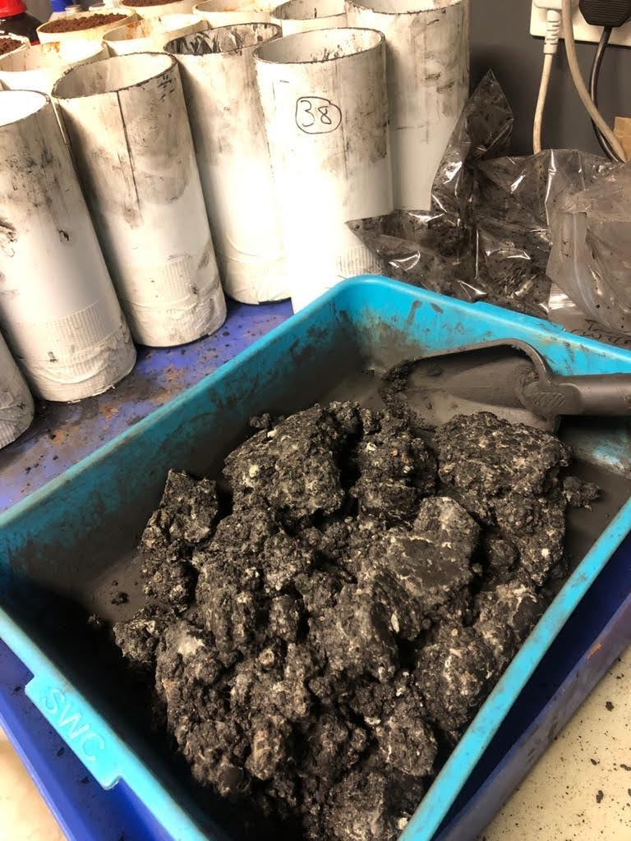**

Preparation of technosols Teff grass growth Root system

*Figure 1: Tef grass growth in technosol bioremediation experiment*

3. Results and discussions

Depending on the availability of topsoil during mine site rehabilitation, topsoil is often saved for establishing vegetation cover and given its relatively nutrient rich status for bioremediation (Gunathunga et al., 2023). Table 2 shows the latter scenario where topsoil (stockpile) that has been stored in pile for decades under sub optimal conditions losing its functional properties. Notable changes that can be seen include nutrients depletion for plants available, soil pH fluctuations heightened soil bulk density, decreased organic carbon occurring with increased age depth of the topsoil stockpile as compared to the virgin soil.

*Table 2: Primary analysis of soils available for mine rehabilitation*

|  |  |  |  |  |  |  |  |  |  |  |  |  |
| --- | --- | --- | --- | --- | --- | --- | --- | --- | --- | --- | --- | --- |
|  | **pH** | **P Bray II** | **Cu** | **Zn** | **Mn** | **B** | **Fe** | **S (Am. Acet.)** | **C** | **CEC (pH 7)** | **N** | **Bulk Density** |
|  | **kcl** | **mg/kg** | **mg/kg** | **mg/kg** | **mg/kg** | **mg/kg** | **mg/kg** | **mg/kg** | **%** | **cmol(+)/kg** | **%** | **mg/kg** |
| **Stockpiled soil** | 3,4 | 3,88 | 0,45 | 0,42 | 2,34 | 0,09 | 14,85 | 209,76 | 0,22 | 1,72 | 0,02 | 1,68 |
| **virgin soil** | 3,6 | 7,09 | 0,68 | 0,70 | 5,94 | 0,16 | 52,51 | 82,36 | 0,76 | 3,10 | 0,04 | 1,52 |

*Table 3: Relative abundance of crystalline phase (Mass %)*

|  |  |  |  |  |
| --- | --- | --- | --- | --- |
| **Mineral** | Tailings | Slurry | Stockpile soil | Virgin soil |
| quartz | 15 | 20 | 73 | 70 |
| pyrite | 2 | 1 | - | - |
| kaolinite | 52 | 57 | 24 | 26 |
| muscovite | 12 | 12 | 3 | 4 |
| feldspar | 4 | 2 | - | - |
| spinel | 2 | 2 | - | - |
| gypsum | 4 | 4 | - | - |
| anhydrite | - | <1 | - | - |
| calcite | 5 | <1 | - | - |
| dolomite | 3 | - | - | - |

Properties of the materials used to construct the technosols are illustrated in Table 3. Regarding the crystalline composition of coal wastes (tailings and slurry) are mainly composed of gypsum, calcite and dolomite while the control soils (stockpile and virgin) by abundance of quartz with less kaolinite and muscovite. The highest concentrations of quartz in virgin and stockpile soils can be attributed to quartz being undoubtedly the most common mineral at the earth surface whether in rock, sediments and soils, especially those in sandy structure (Wilson, 2020). Kaolinite is the most common clay mineral in coal (Yang et al., 2021). Results from CHNS analysis of all materials are shown in Table 4. The soils are lower in both carbon (0.97%) of virgin and (0.48%) of stockpile contents when compared to the coal waste slurry (53.9%) and tailings (41.25%). The sulfur contents are 1.43% and 1.19%, respectively. These figures enable its use as the parent material for technosols bioremediation. Pyritic resulted as the predominant sulfur content in the slurry, this compound could oxidise and generate acidity as can be seen in Figure 1. The parent materials’ metal content could be identified with the highest concentrations of Al, Ni, and Fe depicted in the slurry. The tailings showed high concentration of Ca and Mg and the malt residue resulted rich in N and P.

Acid forming and neutralizing minerals of the bulk contents were measured to evaluate the extent of the reaction of acid forming and neutralising minerals under various ARD characterisation test conditions. The combined Acid Base Accounting (ABA)-Net Acid Generation (NAG) classification plot in Figure 2 illustrates the classification of the tailings uncertain, with a negative Net Acid Production Potential (NAPP) and a NAG pH > 4.5. Conversely, the classification of the slurry remained potentially acid-forming with a positive NAPP and a NAG pH < 4.5 (Parbhakar-Fox & Lottermoser, 2015).

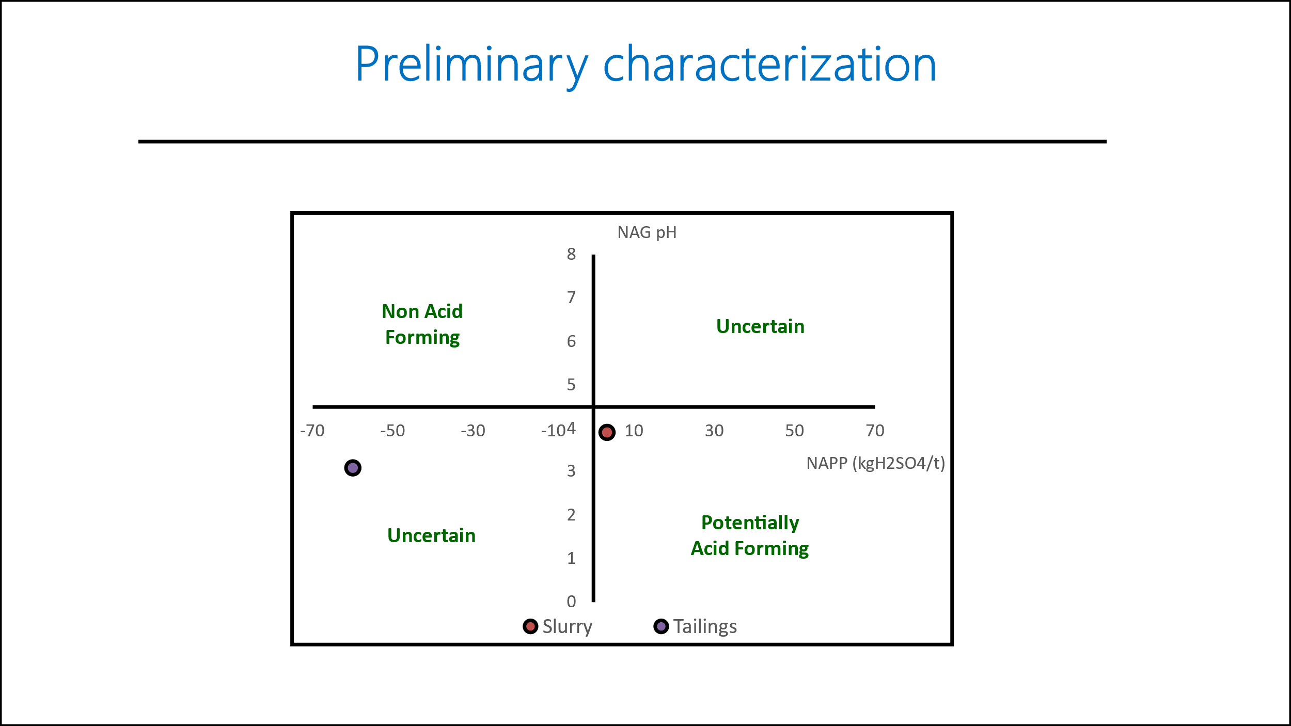

*Figure 2: ARD test*

Regarding the possibility of using technosols for mine rehabilitation and to accelerate soil cover on revegetation processes, the evaluation of early development plant growth using *eragrostis tef* is presented in Figure 1. All plants grew healthy with no signs of nutrients deficiency indicating that the amendment choice has had an overall positive effect on technosols. Results obtained were consistent with (Jordan et al., 2017; Moremo-Barriga et al., 2017; Santini & Fey, 2017 and Daniell & Van Deventer, 2018) encountered in the literature. Technsols presented in this study is adequate in terms of early development and the different amendment mixed. These conditions facilitated the fast development of plant germination and survival as indicated in Figure 3, thereby reducing the need for virgin and stockpile soils, and reduces exposure of the formation of AMD.

*Table 4: Elemental characterization*

|  |  |  |  |  |  |  |
| --- | --- | --- | --- | --- | --- | --- |
| **elements (%)** | virgin soil | stockpiled soil | coal tailings | coal slurry | compost | malt residue |
| Al | 3,39 | 1,64 | 3,35 | 5,34 | 2,15 | 0,02 |
| As | nq | nq | nq | nq | 0,01 | nq |
| Ba | 0,01 | nq | 0,05 | nq | 0,01 | nq |
| Ca | 0,11 | 0,11 | 2,91 | 0,89 | 3,28 | 0,3 |
| Cr | 0,01 | 0,04 | 0,01 | 0,01 | nq | nq |
| Cu | nq | nq | 0,01 | nq | 0,01 | 0,01 |
| Fe | 2,18 | 3,04 | 1,82 | 2,6 | 0,99 | 0,03 |
| Mg | 0,04 | 0,02 | 0,3 | 0,16 | 0,27 | 0,19 |
| Mn | 0,02 | 0,01 | 0,02 | 0,02 | 0,02 | nq |
| Ni | 0,01 | 0,01 | 0,01 | 0,02 | 0,03 | nq |
| K | 0,16 | 0,09 | 0,23 | 0,3 | 0,77 | 0,39 |
| Na | 0,02 | 0,02 | 0,04 | 0,04 | 0,25 | 0,08 |
| Sr | nq | nq | 0,04 | nq | 0,02 | nq |
| Zn | 0,01 | nq | 0,01 | nq | 0,01 | 0,01 |
| P | 0,02 | 0,04 | 0,09 | 0,1 | 0,16 | 0,7 |
| C | 0,97 | 0.48 | 53.9 | 41,25 | 21,79 | 42,64 |
| H | 0,28 | 0.44 | 3,09 | 2,62 | 2,87 | 6,49 |
| N | 0.05 | - | 1,45 | 1,13 | 1,05 | 3,61 |
| S | - | - | 1,19 | 1,43 | 0,21 | 0,67 |
|  |  |  |  |  |  |  |

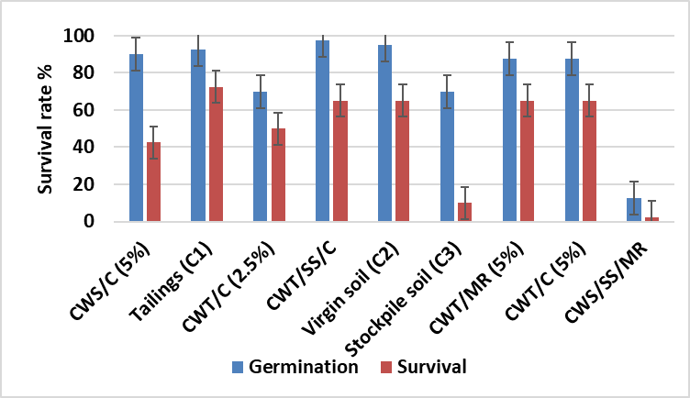

CWT – Coal Waste Tailings

CWS – Coal Waste Slurry

SS – Stockpile Soil

MR – Malt Residue

C – Compost

*Figure 3: Seedling emergence test*

* 1. Conclusions

The study confirms that technosols derived from parent material can be utilized successfully in early development of germination and survival in bioremediation and mine site rehabilitation processes. These amendments CWT/C (5%), CWT/MR (5%) and CWT/SS/C demonstrated their ability to maintain chemical and physical conditions suitable for introduction of new microbial and plant population with a survival rate of above 60%. Technosols and plants parameters was enhanced by high optimum rates of amendments of compost especially with tailings compared to malt residue amended with slurry which displayed inferior effect because of acidic conditions. Despite being a man-made soil, this approach provides a comprehensive industrial ecology strategy that drastically improves mine site rehabilitation outcomes in a relatively short period. The study indicated that technosols provide safe destination for waste management thereby improving mine rehabilitation with proven operational effective benefits.

Acknowledgments

The study was funded by the National Research Foundation (NRF) through Grant No’s. SRUG2204072544 and EQP180503325881 and Rand Water Company, through Grant No. RW01413/18 awarded to Prof E.M.N. Chirwa, and The NRF Thuthuka Fund Grant No. TTK18024324064 awarded to Prof S.M. Tichapondwa at the University of Pretoria.

References

Bateman, A.M., Erickson, T.E., Merritt, D.J., Muñoz-Rojas, M., 2019. Inorganic soil amendments alter seedling performance of native plant species in post-mining arid zone rehabilitation. Journal of Environmental Management, 241: 179-186.

Daniell, A, & Van Deventer, P.W, 2018. National Inventory Discard and Duff Coal. Summary report, Energy: 1-31, accessed 18.12.2023.

Department of Mineral and Energy (South Africa), 2001. National Inventory Discard and Duff Coal. Summary report, Energy: 1-31, accessed 18.12.2023.

Ginocchio, R., Arellano, E., Gandarillas, M., Sáez-Navarrete, C., van Ham, M. & Brown, S., 2016. Mixing residues allows multiple benefits beyond proper stabilization of tailings storage facilities at closure. Planning for Closure, 1-11.

Gunathunga, S.U., Gagen, E.M., Evans, P.N., Erskine, P.D. & Southan, G., 2023. Anthropedogenesis in coal mine overburden; the need for a comprehensive, fundamental biogeochemical approach. Science of the Total Environment, 892, 164515.

Hussieny M., Elagroudy S., Razik M.A., Gaber A., Bong C.P.C., Hassim M.H., Ho W.S., 2019. Optimising mixture of agricultural, municipal and industrial solid waste for the production of alternative fuel, Chemical Engineering Transactions, 72, 259-264 DOI: 10.3303/CET1972044

Jordán, M.M., García-Sánchez, E., Almendro-Candel, M.B., Pardo, F., Vincente, A.B., Sanfeliu, T. & Bech, J. 2017. Technosols designed for rehabilitation of mining activities using mine spoils and biosolids. Ion mobility and correlations using percolations columns. Catena, 148: 74-80.

Moreno-Barriga, F., Díaz, V., Acosta, J.A., Muňoz, M.Á., Faz, Á. & Zornoza, R, 2017. Creation of technosols to decrease metal availability in pyritic tailings with addition of biochar and marble waste. *Land Degradation & Development,* 28: 1943-1951.

Parbhakar-Fox, A. Lottermoser, B.G, 2015. A critical review of acid rock drainage prediction methods and practices. Minerals Engineering, 82: 107-124.

Rokia, S., Séré, G., Schwartz, C., Deeb, M., Fournier, F., Nehls, T., Damas, O., Vidal-Beaudet, L., 2014. Modelling agronomic properties of Technosols constructed with urban wastes. Waste Management, 34: 2155-2162.

Santini, T.C., & Fey, M.V, 2018. From tailings to soil: long-term effects of amendments on progress and trajectory of soil formation and in situ remediation in bauxite residue. *Journal of Soils and Sediments,*18(5): 1935-1949.

Schad, P., 2018. Technosols in the World Reference Base for Soil Resources – history and definitions. Soil Science and Plant Nutrition*,* 64(2): 138-144.

Shanmugasundaram, R., Jeyalakshmi, T., Sweatha, S.M., Saravanam, M., Goparaju, A. & Murthy, P.M 2014. Coco peat – An alternative artificial soil ingredient for the earthworm toxicity testing. Journal of Toxicology and Environmental Health Sciences, 6(1): 5-12.

The Non-Affiliated Soil Analyses Work Committee, 1990. Handbook of standard soil testingmethods for advisory purposes. Pretoria: Soil Science Society of South Africa.

Wilson, M.J., 2020, Dissolution and formation of quartz in soil environment: a review. *Soil Science Annual,* 71(2), 99-110.

Yang, C., Tang Y., Kang, H., Gou, M. & Yu, X., 2021. Occurrence of minerals in coal and its geological controlling factors-significance in evaluation of coal washability. American Chemical Society*,* 6, 24362-24376.