 CHEMICAL ENGINEERING TRANSACTIONS  VOL. , 2024 | A publication of  
The Italian Association
of Chemical Engineering
Online at www.cetjournal.it

Guest Editors: Marco Bravi, Antonio Marzocchella, Giuseppe Caputo
Copyright © 2024, AIDIC Servizi S.r.l.
ISBN 979-12-81206-10-6; ISSN 2283-9216

Biological Nitrate Removal in Household Slow Sand Filters Using Mixed Culture and Carbon Source Loading
Mahabe S. Mojela*, Shepherd M. Tichapondwa, Evans M. N. Chirwa
ªWater Utilisation and Environmental Engineering Division, Department of Chemical Engineering, University of Pretoria, Pretoria 0002, South Africa
mahabemojela@gmail.com

The objective of this work was to evaluate the use of pond bacteria paired with acetate and sawdust as viable inoculums for facilitating heterotrophic denitrification in household slow sand filters. This was achieved through culturing pond sediment bacteria and pairing it with both carbon sources in nitrate contaminated batch and filter column experiments. The inoculum culture tested positive for denitrifying bacteria including those of the Bacillus, Paraclostridium and Clostridium genera. Batch experiments conducted over 17 h with the acetate carbon source achieved complete denitrification for the C/N ratios of 2 and 5 at concentrations of 200 and 400 mg/L of nitrate. Incomplete denitrification was attained at C/N ratio of 0.5. Sawdust batches loaded with 1 g sawdust under similar concentration, volume, and time loading achieved incomplete denitrification with nitrite accumulation of up to 100 mg/L. In inoculated filter column experiments fed with 2 L of contaminated feed daily, the acetate carbon source fed filters achieved complete denitrification at feed concentrations of 200 and 400 mg/L nitrate, while sand/sawdust mixed columns only achieved complete denitrification for the 200 mg/L nitrate feed. 400 mg/L nitrate feed was reduced to 237 mg/L. No significant nitrite accumulation was observed in the filters. TOC readings in the control, sawdust and acetate filters were 7.072, 13.702 and 11.764 mg/L carbon at the 200 mg/L nitrate feed and 5.984, 6.630, and 7.142 mg/L carbon at the 400 mg/L nitrate feed.
  - Introduction
Groundwater is one of the world’s most vital resources with an estimated 2.5 billion people globally relying on it for their drinking water supply needs. This figure is only ever set to grow as global populations grow and scatter, climate change effects take hold, and advents in pumping and drilling technology make groundwater abstraction for domestic use easier and cheaper. This important resource however faces a range of threats of both anthropogenic and natural origin, that constrain its suitability for use. Among them, is the threat posed by nitrogen contamination in the form of nitrates (NO₃⁻). Nitrates are undesirable in drinking water because when they are consumed, microbes in the gut reduce them to nitrites, which are known to interfere with the body’s ability to transfer oxygen, a condition which could prove fatal in infants and other young users. It therefore becomes necessary to find ways of dealing with nitrate contamination in drinking water to minimise the harmful effects of its consumption.
In the environment, nitrate can be sourced from several different sources including fertilizer, atmospheric, soil, and manure derived sources. Nitrate pollution then occurs when the nitrate leaches into the soil and eventually finds its way to the water table where it accumulates until its concentration reaches levels that are unfit for consumption. Given the global extent of nitrate pollution, and the ever-increasing reliance on groundwater, it therefore becomes necessary to treat contaminated water to acceptable standards prior to use. Some of the commonly adopted approaches include the use of ion exchange, electrodialysis, reverse osmosis as well as biological denitrification techniques (Mohsenipour et al., 2014). Each of these approaches however has its own considerations ranging from energy demand, capital and operating costs, formation of by products, fouling, complexity of operation, and formation of concentrated waste streams. The result of the above being that only a handful of these approaches can find practical application in most settings with underserved and emerging communities losing out more often. In these communities, the focus lies on technologies that are readily accessible, sustainable, and are not too complex to operate. (Thomas et al., 2022). One such technology which is gaining interest for nitrate removal in drinking waters is the use of slow sand filters coupled with a carbon source to facilitate biological denitrification. (Mutsvangwa and Matope, 2017).
During biological denitrification, the nitrate and its intermediates are completely reduced to nitrogen gas (Chen et al., 2021). This occurs through either an autotrophic or a heterotrophic approach. In autotrophic denitrification, sulphur and hydrogen gas are used as electron donors for the reduction process, while organic carbon sources are used in heterotrophic denitrification. In heterotrophic denitrification, the carbon source is vital as it has a direct impact on the rate and extent of the denitrification. While a range of different carbon sources can be used, it is important to provide them in sufficient quantities so that the denitrification can be completed successfully. Other important factors surrounding the carbon source include its utilization rate, the specific metabolites active during its use, dosing requirements, operation cost, effluent quality, and sludge products, and to ensure a successful denitrification process, each of these parameters needs to be considered carefully prior to use
Equally important in the heterotrophic denitrification is having appropriate bacteria to drive the process. It can be sourced from several seeds as denitrifying bacteria are known to represent between 10 to 15 percent of the bacteria population in soil, water, and sediment. Municipal activated sludge has also proven a viable seed for denitrifying bacteria in previous works (De Filippis et al., 2013). Over 50 genera with 125 different denitrifying species have been identified.(Balows A. et al., 1992). These bacteria are characterised mainly by their ability to substitute nitrate and nitrite for oxygen as the terminal electron acceptor in the absence of oxygen. (Megonigal et al., 2004).
In this work, household slow sand filters inoculated with pond sediment derived bacteria and loaded with acetate and sawdust carbon sources were evaluated for their ability to remove nitrate from a synthetic contaminated stream. The two different carbon sources were chosen to evaluate the differences in filter performance when an external carbon source is used as opposed to an internally imbedded carbon source. The work was performed through a series of batch and filter column experiments. In the batch experiments the bacteria/carbon source pairing was evaluated for denitrifying capacity at different C/N loadings, and the results were used to inform filter experiment work. The key parameters monitored during the experimental runs were the rate of nitrate and nitrite removal, along with the quantity of carbon breakthrough in the filter effluent streams.
  - Materials and methods
    - Reagents
Lab grade reagents were used in preparing all the solutions used in the experimental works. All the glassware was also cleaned thoroughly and autoclaved at 121 ̊ C for 15 min prior to use. Sodium Nitrate (NaNO₃) was used to prepare a 1000 mg/L nitrate stock solution, which was further used to prepare a synthetic nitrate feed for the batch and filter experiments. This was achieved by dissolving 1.37 g of the reagent in 1 L of ultrapure water. Saline solution used for washing and harvesting bacterial cells was prepared by dissolving 8.5 g of sodium chloride (NaCl) in 1 L ultrapure water. 1000 mg/L acetate stock solution was prepared by dissolving 1.43 g of sodium acetate (CH₃COONa) in 1 L of ultrapure water. Luria-Bertani (LB) broth was prepared by dissolving 25 g of LB powder in ultrapure water in a 1 L volumetric flask, and then autoclaved at 121 ̊ C for 15 minutes prior to use. Working solutions for the experiments were then obtained by diluting stock solutions based on need.
    - Analytical methods (Nitrate, nitrite, and total organic carbon determination)
The nitrate and nitrite concentrations were determined using a 940 Professional IC Vario ion chromatograph (Metrohm, Herisau, Switzerland) with separation column Metrosep C 6-250/4.0 (Metrohm, Switzerland) and eluent mix of sodium carbonate, sodium hydrogen carbonate and sodium hydroxide.
Total organic Carbon measurements were obtained using a Shimadzu TOC-V analyzer. The mobile phases used by the instrument included a persulfate oxidizer solution and a phosphoric acid solution.
    - Bacteria culture
Sediment obtained from a pond in Gauteng, South Africa (25̊35’ 10.15” S; 28̊10’ 27.289” E) was used to provide the seed bacteria for the experimental works. Pond sediment was selected as it had proved viable for denitrification applications in works performed by (Erbanová et al., 2012). After collection, the sediment was transported to a cold room for storage at -5 ̊ C. The mixed cultures used for experimental works were obtained by inoculating 1 g of sediment into a 100 mL vial amended with 20 mg/L nitrate. After inoculation, the vial containing the mixture was purged for 3 minutes using inert gas to get rid of any dissolved oxygen. It was then sealed using a rubber stopper after which it was transferred to a rotary lab shaker where it was stored at 30 ̊C for 24 h to allow for culture development and growth. The bacteria cells were then harvested by centrifuging the solution at 4000 rpm for 10 min, and then washing the resultant pellet with 5% saline solution prior to inoculation in the batch experiments. The resulting pellet was used to prepare bacteria for subsequent experiments in a similar fashion. The microbial mixed culture developed was also taken to Inqaba Biotechnical Industries (Pty) Ltd for 16S rRNA analysis. Inqaba provided summarized metagenomic analysis of full length 16s gene amplicons. Samples were sequenced on the Sequel IIe system by PacBio (www.pacb.com). Raw sub-reads were processed through the SMRTlink (v11.0) Circular Consensus Sequences (CCS) algorithm to produce highly accurate reads (>QV40). These highly accurate reads were then processed through vsearch (https://github.com/torognes/vsearch) and taxonomic information was determined based on QIMME2.
    - Batch experimental setup
The batch experiments were all conducted in dark 100 mL serum vials sealed with a butyl rubber stopper and capped. Depending on the experiment taking place, a fixed volume of harvested cells, coupled with predetermined quantities of the prepared stock solutions were transferred to the serum bottles. Ultrapure water was then used to make up the final desired volume. Prior to sealing, the bottles were purged with inert gas for 3 min to get rid of any elemental oxygen. The bottles were then stored on a rotary lab shaker at 30 ̊ C for the duration of the experiment. Samples were drawn using a syringe and needle at the required time intervals.
    - Filter experimental setup
The filter experiments were conducted in sand filters constructed out of PVC with ports drilled along its length to allow for samples to be drawn for analysis. The diameter of the filter column was 110 cm, and it had a height of 1.2 m, with a 1 m standing water height. Each filter was equipped with a feed reservoir of 1 L volume where the synthetic contaminated stream was fed before it trickled down through an attached inlet diffuser and into the filter bed. The diffuser was attached to prevent the incoming feed from disrupting the filter bed below it. The three sample ports along the filter length were spaced equally at 25 cm intervals from each other. After gravity flowing through the filter, the effluent water was collected in an effluent tank placed within proximity of the filter. To stop the filter from running dry the effluent port was channeled from the base of the filter to its standing water height. In addition to the three sample ports, samples were also drawn from the feed and effluent streams for analysis. The filters were fed intermittently with 2 L of the synthetic contaminated water daily.
The three filters were loaded as follows: filter 1 with sand only, filter 2 with sand and harvested bacteria, filter three with a sand and sawdust mix, as well as harvested bacteria. The harvested bacteria were introduced to the system by first preparing the bacteria as described in 2.3, diluted with distilled water, and then added to the column until saturation and allowed to stand for 24 h. To ensure that initial variations in soil saturation did not affect the filters during the experimental runs, the control filter was filled with distilled water only and then also left to stand for 24 h prior to being fed with the contaminated water supply.
  - Results and discussion
    - Seed culture microbial analysis
The results from the metagenomics analysis conducted using 16S rRNA sequencing are given in Table 1.
Table 1: Genus abundance in inoculum culture
Genus | Abundance (%) | Genus | Abundance (%)
Unknown | 44.13 | Bacillus | 0.37
Terrisporobacter | 24.91 | Clostridium_sensu_stricto_13 | 0.16
Clostridium_sensu_stricto_1 | 14.92 | Paeniclostridium | 0.05
Paraclostridium | 8.05 | Epulopiscium | 0.04
Uncultured | 4.35 | Cellulosilyticum | 0.03
Romboutsia | 2.96 | Paenibacillus | 0.02
The genus analysis shows that while a significant proportion of the genera were of unknown identity, a significant proportion of the inoculated bacteria had denitrifying capabilities. This includes bacteria of the Bacillus, Clostridium, and Paraclostridium genera (Moloantoa et al., 2023). In addition to the denitrifying bacteria, there was also prevalence of anaerobic fermenters such as Romboutsia, which could prove beneficial in the production of biodegradable organic matters from refractory organic matter (Cheng et al., 2023). Given the abundance of strains found in the sediment, it should be noted that some such as those of the genus Terrisporobacter are known to be pathogenic. As such, care should be taken when choosing the source of seed bacteria in order for risks to users to be minimized.
    - Batch experiments
The first set of experiments was aimed at evaluating how the C/N loading affects denitrification, with the aim being to evaluate how the rate and extent of denitrification is affected by the carbon source loading. Experiments were run over a 17 hour time period which puts it well in range of the average hydraulic retention time observed by typical filters of 12 hours (Maiyo et al., 2023), with extra allowance for variations in feed rates. In addition to the experiments performed with the selected carbon sources, control experiments where no carbon source and bacteria inoculation took place. No significant variations in the nitrate and nitrite readings were observed in the control experiments and the results were excluded from this presentation. The results from the acetate batch experiments and the saw dust batch experiments are shown in Figure 1(a) and in Figure 1(b).

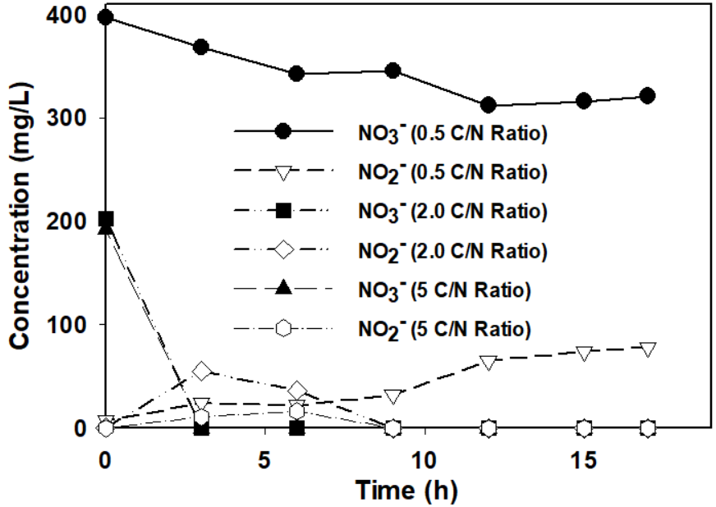 | 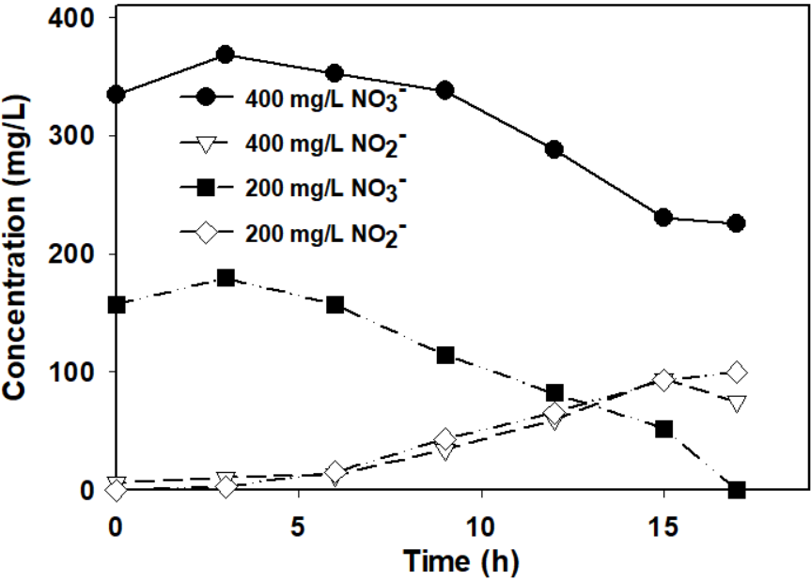
(a) | (b)
Figure 1: Acetate carbon source denitrification curve with varied C/N ratio (a), Sawdust carbon source denitrification curve with varied C/N ratio (b)
In carrying out the batch experiments, the C/N ratios were chosen around the ideal value of 2 as described for denitrification with acetate by works by (Oh and Silverstein, 1999). At the specified value, denitrification proceeded quickly with complete nitrate removal by 3 h and complete nitrite removal by 9 h, and at a C/N ratio of 5, the denitrification occurred much faster and complete nitrate and nitrite removal was observed within 6 h. These results are in stark contrast to those obtained at the lower 0.5 ratio. At this ratio, while the initial rate of nitrate removal was high, it soon slowed and complete denitrification was not achieved within the specified timeframe, indicating that the absence of insufficient carbon was a limiting factor in the experimental works. At this ratio, less than 100 mg/L nitrate was removed as opposed to 200 mg/L nitrate removal at higher ratios.
In the sawdust batch experiments, the saw dust loading was fixed at 1 g and the nitrate concentration varied between 200 and 400 mg/L. At the lower 200 mg/L concentration, complete nitrate removal was achieved however there was incomplete nitrite removal. The denitrification curve at 400 mg/L followed a similar trend with the rate of the nitrate removal, however due to the higher starting concentration it wasn’t removed completely at the end of the experimental phase. The incomplete removal of the nitrogen compounds indicates that insufficient carbon source was available for the denitrification process as denitrifying bacteria can use both nitrate and nitrite as an electron acceptor provided there is adequate carbon source (Megonigal et al., 2004). In denitrification applications using saw dust the amount of soluble carbon released for the denitrification varies significantly with age and condition of the sawdust, and as such the quantity and quality of the sawdust used both need to be carefully considered. Despite incomplete denitrification with the sawdust, the results ultimately proved that sawdust can be used as a carbon source for the denitrification experiments.
    - Denitrification filter experiments
The filter experiments were carried out over a month during which time the filters were fed a synthetic nitrate contaminated feed at concentrations of 200 mg/L and at 400 mg/L nitrate. During this time, all the filters were fed the same quantity of feed at the same time daily. The feed content varied between the filters with the control and sawdust carbon source filters receiving feed containing only the nitrate contaminant, while the acetate carbon source filter was fed with a mix of the nitrate contaminant as well as acetate at the predetermined 2.0 C/N ratio. This ratio was applied for the experimental runs at both the 200 mg/L and 400 mg/L nitrate feed concentrations. Feed was prepared in bulk and renewed when depleted. The filters were first fed at the lower 200 mg/L concentration and after samples were taken, were run for another week being fed at the higher 400 mg/L nitrate concentration before samples could be taken. The time allowance between measurements was intended to allow the entire filter to acclimatize to the use of a higher concentration of feed. The nitrate profiles from the experiments are given in Figure 2(a) and Figure 2(b).
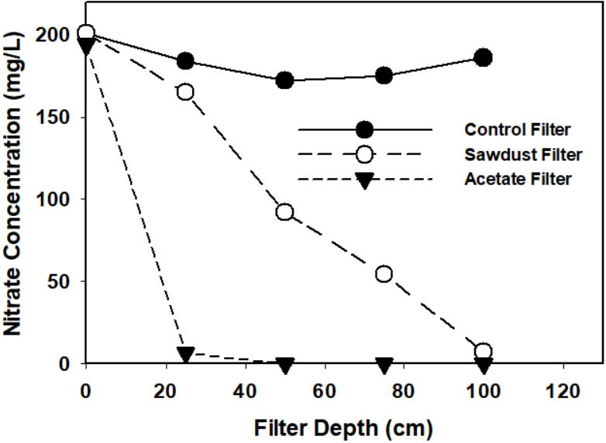 |  | 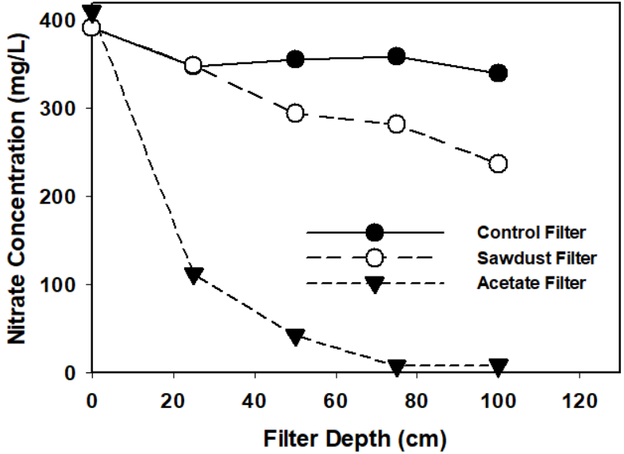
(a) |  | (b)
Figure 2: Filter column nitrate profiles at 200 mg/L feed (a), Filter column nitrate profiles at 400 mg/L feed (b)
In the filter column experiments, the filter fed with acetate as a carbon source was the only one to achieve complete denitrification for both the 200 mg/L and 400 mg/L nitrate feed. Additionally, unlike in the saw dust filter, most of the denitrification occurred within the first 25 cm of the filter bed. A possible driver behind the high denitrification rate observed can be the fact that acetate was thoroughly mixed in the feed stream and was readily available for nitrate reduction. This is in stark contrast to the denitrification observed in the sawdust carbon source filter. This filter was only able to achieve complete denitrification for the lower 200 mg/L nitrate feed. When the concentration was increased, the filter was unable to achieve complete denitrification indicating that carbon availability may have been a limiting factor in the reaction. No significant nitrite accumulation was observed during the experimental runs. These observations matched those in work by (Aslan and Cakici, 2007) and was attributed to the low filter feed rates.
Total organic carbon readings were taken for the filter effluent at the end of the two runs and the results are shown in Table 2.
Table 2: Total organic carbon readings in the filter effluent streams (mg/L Carbon)
 | Control Filter | Sawdust Filter | Acetate Filter
200 mg/L Nitrate Feed | 7.072 | 13.702 | 11.764
400 mg/L Nitrate Feed | 5.984 | 6.630 | 7.412

This was done to evaluate the amount of carbon breakthrough in the effluent streams. Carbon in the final effluent needs to be treated as elevated organic carbon in drinking water can contribute towards the formation of disinfection byproducts (Peterson et al., 2022). All the filter effluents indicated a low level of organic carbon within them including the control filter. The organic carbon content within the control filter can be attributed to background carbon that was present in the sand inoculum, with the low level observed attributed to washout from continued operation. This low level of carbon coupled with the natural abundance of denitrifying bacteria in soil could provide a possible explanation for the minor variations observed in nitrate concentration across the profile of the filter during the 200 and 400 mg/L nitrate feed experiments.
The complete nitrate removal during the 200 mg/L and 400 mg/L nitrate feed experiments coupled with low organic carbon levels in the filter effluent are an indication that in both experiments, the acetate carbon source was dosed optimally. The same cannot be assumed for the sawdust loading in the sawdust filter even in the case of the completely reduced 200 mg/L nitrate feed. This is because unlike in the case of the acetate feed which can be fed at constant rate in perpetuity, carbon release from the sawdust column will vary over time, which can result in variation of the observed results. In the case of the 400 mg/L nitrate feed, it should be stated that while an inadequate supply of soluble carbon was flagged as the primary driver behind the low denitrification rates observed, other factors including temperature, mixing, and channeling within the filter, as well as the availability and distribution of cellulose degrading bacteria could influence the carbon release from the sawdust. This is especially true during longer filtration runs where the initially available soluble carbon may have been washed out of the filter earlier on.
While the total organic carbon levels within the filter were deemed to be low, comparisons will however have to be made against the national quality limits applicable in the region of operation before the water can be declared of adequate total organic carbon content for use.
  - Conclusion
This work illustrated that denitrification can be achieved in household slow sand filter systems using pond sediment derived denitrifying bacteria, coupled with acetate or sawdust as a carbon source. This is evidenced by both filter systems achieving complete denitrification with no nitrite accumulation, when loaded with 200 mg/L of nitrate feed. While complete denitrification was achieved, it should be noted that the nature of the carbon source has a significant impact on the denitrification rates observed. The readily soluble acetate carbon source was able to facilitate complete denitrification faster during the batch runs, and earlier within the filter bed in filter experiments, while the saw dust carbon source took significantly longer to facilitate complete denitrification under similar loading conditions. The incomplete denitrification in the sawdust filter at the 400 mg/L nitrate loading, coupled with the low TOC reading of 6.630 mg/L, indicates that carbon was a limiting reagent during the experiment. As a result, it is recommended that the factors affecting carbon release from sawdust are investigated, and carefully managed during future works to ensure that they do not hinder the denitrification process. As the denitrification in these works is achieved through the addition of an organic carbon and a bacteria inoculum to the filter systems, the capability of the filter to remove the additional microbial and organic carbon load should be evaluated, so that appropriate remediation measures can be taken to ensure that the effluent water conforms with regulatory standards.
  - Acknowledgements
The study was funded by the National Research Foundation (NRF) through Grant No’s. SRUG2204072544 and EQP180503325881 and Rand Water Company, through Grant No. RW01413/18 awarded to Prof E.M.N. Chirwa, and The NRF Thuthuka Fund Grant No. TTK18024324064 awarded to Prof S.M. Tichapondwa at the University of Pretoria.
References
Aslan S.,Cakici H., 2007, Biological denitrification of drinking water in a slow sand filter, Journal of hazardous materials, 148, 253-258.
Balows A., Trüper H.G., Dworkin M., Harder W.,Schleifer K.H. (Eds.), 1992, The Prokaryotes: a A Handbook on the Biology of Bacteria: Ecophysiology, Isolation, Identification, Applications, Springer-Verlag, New York, USA.
Chen L., Huang F., Zhang C., Zhang J., Liu F.,Guan X., 2021, Effects of norfloxacin on nitrate reduction and dynamic denitrifying enzymes activities in groundwater, Environmental Pollution, 273, 116492.
Cheng Q., Liu Z., Huang Y., Feng S., Du E., Peng M.,Zhang J., 2023, Advanced nitrogen removal performance and microbial community structure of a lab-scale denitrifying filter with in-situ formation of biogenic manganese oxides, Journal of Environmental Management, 331, 117299.
De Filippis P., Di Palma L., Scarsella M.,Verdone N., 2013, Biological denitrification of high-nitrate wastewaters: a comparison between three electron donors, Chem. Eng, 32, 319-324.
Erbanová E., Palarčík J., Slezák M.,Mikulášek P., 2012, Removing of nitrates from waste water by using pond culture, Procedia Engineering, 42, 1552-1560.
Maiyo J.K., Dasika S.,Jafvert C.T., 2023, Slow Sand Filters for the 21st Century: A Review, International Journal of Environmental Research and Public Health, 20, 1019.
Megonigal J.P., Hines M.,Visscher P., 2004, Anaerobic metabolism: linkages to trace gases and aerobic processes, Biogeochemistry.
Mohsenipour M., Shahid S.,Ebrahimi K., 2014, Removal Techniques of Nitrate from Water, Asian Journal of Chemistry, 26.
Moloantoa K.M., Khetsha Z.P., Kana G.E., Maleke M.M., Van Heerden E., Castillo J.C.,Cason E.D., 2023, Metagenomic assessment of nitrate-contaminated mine wastewaters and optimization of complete denitrification by indigenous enriched bacteria, Frontiers in Environmental Science, 11, 1148872.
Mutsvangwa C.,Matope E., 2017, Use of an external organic carbon source in the removal of nitrates in bio-sand filters (BSFs), Drinking Water Engineering and Science, 10, 119-127.
Oh J.,Silverstein J., 1999, Acetate limitation and nitrite accumulation during denitrification, Journal of Environmental Engineering, 125, 234-242.
Peterson E.S., Johnson S., Shiokari S., Yu Y., Cook S.M.,Summers R.S., 2022, Impacts of carbon-based advanced treatment processes on disinfection byproduct formation and speciation for potable reuse, Water Research, 220, 118643.
Thomas B., Vinka C., Pawan L.,David S., 2022, Sustainable groundwater treatment technologies for underserved rural communities in emerging economies, Science of the Total Environment, 813, 152633.

