|  |  |
| --- | --- |
| cetlogo ***CHEMICAL ENGINEERING TRANSACTIONS***  ***VOL. , 2024*** | A publication of  aidiclogo_grande |
| The Italian Association  of Chemical Engineering  Online at www.cetjournal.it |
| Guest Editors: Marco Bravi, Antonio Marzocchella, Giuseppe Caputo  Copyright © 2024, AIDIC Servizi S.r.l. **ISBN** 979-12-81206-10-6; **ISSN** 2283-9216 | |

HYDROGEL DRESSINGS WITH EGG WHITE PROTEINS FOR WOUND HEALING

Federica Gulinoa, Emanuela Muscolino\*a, Sabina Alessia, Domenico Nuzzob, Pasquale Piconeb, Daniela Giacomazzac, Clelia Dispenzaa

aDipartimento di Ingegneria, Università degli Studi di Palermo, Viale delle Scienze 6, 90128 Palermo, Italy;

bIstituto per la Ricerca e l’Innovazione Biomedica, Consiglio Nazionale delle Ricerche, Via U. La Malfa 153, 90146 Palermo, Italy;

cIstituto di Biofisica, Consiglio Nazionale delle Ricerche, Via U. La Malfa 153, 90146, Palermo, Italy.

\*emanuela.muscolino@unipa.it

Diabetes and other pathologic conditions can disrupt the wound healing process, leading to chronic wounds, that are responsible for serious infections. Egg white proteins, such as lysozyme and ovotransferrin, are attracting interest especially because of their demonstrated antioxidant and antibacterial activities. These bioactive proteins can then be used to enrich advanced wound dressing films, which can help control wound oxidative stress and thereby accelerate wound healing and/or prevent bacterial infection.

The aim of this work is to develop novel hydrogel formulations, based on blends of a synthetic polymer and polysaccharides, and incorporating egg white proteins and/or their peptides, to investigate their applicability as advanced wound dressings. The rheological properties of the hydrogels were investigated to assess the viscoelastic properties and gelation behaviour. The microstructure of the hydrogel dressings was investigated by scanning electron microscopy. The erosion in PBS buffer was also evaluated. Flexible, skin-adhesive hydrogel films with potential applications in wound healing were obtained.

* 1. Introduction

The wound healing process is the result of complex and dynamic interactions among cytokines, growth factors, blood, and the extracellular matrix. (Dhivya et al., 2015) Due to certain physiological conditions, such as aging, or pathological conditions, like diabetes or cancer surgery, impaired angiogenesis can cause several complications during the wound healing process, leading to chronic wounds. (Nour et al., 2021) In chronic wounds, an excessive inflammatory response prevents the proliferation of the healthy tissue, causing a serious infection which can also result in an amputation. (Xu et al., 2020) A full-thickness chronic wound might even be life-threatening, not only due to the local loss of barrier functions, but also due to a systemic physiological response of fever and hypercatabolic metabolism. (Jain et al., 2013)

To treat severe skin damages, a proper skin dressing is needed to heal the wound rapidly and aesthetically. Different types of wound dressing exist; from the traditional ones, such as cotton bandages or gauze, to the most modern ones, made of polymeric foams, gels and films. Regardless of the type, a skin dressing should possess some general properties, like being biocompatible, sterile, protecting the wound against bacteria, removing the excess exudates, allowing gas exchange, maintaining or providing a moist environment. In fact, it has been proven that under wet conditions, the healing process of the wound is accelerated. (Jain et al., 2013)

Hydrogels are an important group of moist wound dressings that, due to their intrinsic properties, can fulfil most of the criteria of ideal dressings. Hydrogels, in fact, are three-dimensional hydrophilic networks that do not dissolve in water or aqueous solutions and are able to absorb water or other biological liquids. (Peppas et al., 2020) Furthermore, a hydrogel could be transparent, a desirable property for a dressing, and incorporate therapeutic agents, such as antibiotics. (Rafati et al., 2020)

Although antibacterial properties are necessary in many circumstances, the use of antibiotics may be ineffective against a growing number of antibiotic-resistant strains that have developed as a consequence of their overuse or misuse in many different fields, from agriculture to the medical field. (Zaman et al., 2017) In the past years, egg white has shown great potential as a biomaterial for various biomedical applications, particularly in the areas of wound healing, tissue engineering, *in vitro* cell culture, drug delivery. In fact, egg white proteins and their peptides have interesting biological activities, such as antimicrobial, anti-inflammatory, antioxidant and cell growth promotion properties. (Picone et al., 2022) Among egg peptides, lysozyme (LZ) exhibits strong antimicrobial properties, being able to catalyze the hydrolysis of peptidoglycans in cell walls of bacteria. The antibacterial action of LZ is not only efficient against Gram-positive bacteria, but it has been demonstrated also against Gram-negative bacteria. (Ferraboschi et al., 2021)

Egg white hydrogels show interesting properties, like self-healing and 3D printability, but also limitations, such as low mechanical resistance, uncontrolled dissolution and highly heterogeneous pore size. (Jalili-Firoozinezhad et al., 2020) In this work, lysozyme has been incorporated into a hydrogel made of a mixture of xyloglucan (XG), poly(vinyl alcohol) (PVA) and k-carrageenan (kC) for the development of advanced wound dressing formulations. XG is a natural, inexpensive polysaccharide with intrinsic anti-inflammatory properties and synergistic effects with other anti-inflammatory agents when used for topical administration to the skin or to the buccal mucosa. (Giori et al., 2011) It can be also conveniently tailored by radiation-induced modification of the molecular weight distribution modifying their chemical physical properties for different scopes. (Muscolino et a., 2024) Aqueous XG dispersions are able to form weak gels in the presence of mono- or poly-hydric alcohols and have been used in hydrogel wound dressings introducing chemical crosslinks with glutaraldehyde. (Ajovalasit at al., 2018) kC is also a natural polysaccharide, derived from red seaweeds, which is able to form a thermo-reversible three-dimensional network of double and triple helices. (Yegappan et al., 2018) PVA is a synthetic polymer with a very well documented biocompatibility, which acts as plasticizer, and can be physically crosslinked through freeze-thawing. The objective of this work is to demonstrate that hydrogel produced by mixing XG at 2%w, PVA at 4%w and kC at 1%w can provide the required mechanical and skin adhesion properties for a wound dressing. They can incorporate LZ, even in significant amounts (0.1 % w and 5%w are the two concentrations tested). The gelation behavior and mechanical properties in the linear viscoelastic regime, the swelling/erosion behavior in excess isotonic buffer phosphate at 37°C and the morphology of these hydrogels after freeze-drying have been investigated and discussed.

* 1. Experimental Section

2.1 Materials

PVA powder was provided by Sigma-Aldrich, with molecular weight of 146000-186000, 99+% hydrolyzed (PVA-HMW); kC polymer powder was provided by Gelcarin ME 8625 FCM BioPolymer; XG, was kindly provided by MP GOKYO FOOD & CHEMICAL CO., LTD; milliQ® water was produced in our laboratory with MILLI-Q HX 7000 SD and seeped with a membrane filter with a pore size of 0.22 μm. Sodium azide, ReagentPlus®, ≥ 99.5% and 4-morpholineethanesulfonic acid hydrate (MES) was also supplied by Sigma Aldrich. LZ (purity > 95%, Mw = 14.3 kDa) was provided by EPS Egg Powder Specialist S.p.A.

2.2 Methods

2.2.1 Hydrogel preparation

XG was dissolved in water overnight under stirring at room temperature, while PVA-HMW and kC were dissolved individually in water at 90°C under stirring conditions until homogeneity. Then, equal volumes of kC and PVA solutions were added to the XG solution and the final polymeric mixture was kept at 90°C in stirred conditions until complete homogenization. The mixture was autoclaved at 121°C for 20 minutes. Since this system becomes a gel when cooled down to room temperature, due to the presence of kC, LZ was incorporated as concentrated (and previously 0.22 mm filtrated) 0.1 M MES solution (pH 5.5) into the autoclaved formulation cooled down to 55°C. Stirring was provided until complete homogenization. Then, the final mixture was casted in Pyrex petri dishes (5 cm diameter) and let cool down to room temperature. Hydrogel films of ~2 mm thickness were produced. 0.02% of sodium azide was also added to prevent mould formation upon prolonged storage of the hydrogel films in non-sterile conditions. The final concentrations of LZ were 1 mg/ml and 50 mg/ml.

To improve the mechanical properties of the films, freeze-thawed (FT) cycles were performed. The FT cycle consists in freezing the solutions at -20 °C for 2 hours and thawing them at room temperature for 2 hours, twice a day. The samples were then stored overnight at room temperature. In the following table, the final polymer and protein concentrations in the systems are listed:

Table 1: Concentrations of the polymers and the protein in each system.

|  |  |  |  |  |  |
| --- | --- | --- | --- | --- | --- |
| Code | XG (%w) | PVA-HMW (%w) | kC (%w) | LZ (%w) | FT cycles |
| XG2PVA-HMW4kC1\_FT0 | 2 | 4 | 1 | - | - |
| XG2PVA-HMW4kC1\_FT1 | 2 | 4 | 1 | - | 1 |
| XG2PVA-HMW4kC1\_FT2 | 2 | 4 | 1 | - | 2 |
| XG2PVA-HMW4kC1\_LZ0.1\_FT0 | 2 | 4 | 1 | 0.1 | - |
| XG2PVA-HMW4kC1\_LZ5\_FT0 | 2 | 4 | 1 | 5 | - |
| XG2PVA-HMW4kC1\_LZ0.1\_FT1 | 2 | 4 | 1 | 0.1 | 1 |
| XG2PVA-HMW4kC1\_LZ5\_FT1 | 2 | 4 | 1 | 5 | 1 |
| XG2PVA-HMW4kC1\_LZ5\_FT2 | 2 | 4 | 1 | 5 | 2 |

2.3 Characterizations

2.3.1 Visual inspection

For a first qualitative evaluation of the hydrogels, their homogeneity, transparency, handiness, and skin adhesiveness from visual inspection were rated as follows:

|  |  |
| --- | --- |
| Excellent | +++ |
| Very good | ++ |
| Good | + |
| Sufficient/Reasonable | -/+ |
| Unsatisfactory | - |

A commercial hydrogel wound dressing, AquaGel® produced by KiK (Poland), was used as benchmark. This system was evaluated as excellent with respect to all the above properties. Also, the solubility was evaluated by immersing a hydrogel slab of approximately 1 cm x 1 cm area, cut from the film, into 1M PBS buffer (pH 7.4) at room temperature. If the slab dissolved within minutes, the solubility was evaluated as “yes”.

2.3.2 Rheological analysis

The viscoelastic behaviour of the hydrogels was studied with a stress-controlled Rheometer AR G2 and in Rheometer HR20, TA Instruments, equipped with a 20 mm and a 40 mm crosshatched plate geometry and a gap ~1500 μm.

*Temperature and time sweeps*

To assess the gelation temperature of the base formulation, the plate temperature was varied via a Peltier-controlled system, which allowed for a temperature cycle from the highest to the lowest temperature (from 80°C to 20°C), and back to the starting temperature. Before loading the sample, the Peltier plate was heated to 95 °C, long enough to eliminate hysteresis effects. The temperature cycles were performed at 10 °C/min, with frequency and strain of 1 Hz and 0.08%, respectively. The gel temperature was determined by the point of intersection of the storage modulus (G′) and loss modulus (G′′) curves. For the study of gelation time, the sample was melted at about 95 °C and placed on the Peltier plate, set at 25°C. The test was performed for 3600 s with the frequency set at 1 Hz and the same strain value of 0.08%.

*Strain and frequency sweeps*

Measurements were performed in “strain sweep” mode (in the 0.001% –100% range) at fixed frequency of 1 Hz, and in “frequency sweep” mode (in the 0.1-10 Hz range) at a fixed strain selected for each formulation so that the material was tested within its linear viscoelastic region (LVR). The temperature was kept constant at 37 °C.

2.3.3 Scanning Electron Microscopy

The morphology of the samples was performed using a FEI Quanta 200 FEG Scanning Electron Microscope (SEM) at an accelerating voltage values of 5 and 10 kV. Slabs of 1 cm x 1 cm were frozen in liquid nitrogen and freeze-dried to remove water. The freeze-dried samples were cut to expose their fracture surfaces, mounted on SEM aluminum stubs using a graphite adhesive layer and coated with a gold layer using the Sputter Coater Scan Coat Six (Edwards) for 120 s at 30 mA prior to scanning.

2.3.4 Swelling/erosion behavior

The 1 cm x 1 cm slabs were pre-weighed using a precision balance and immersed in PBS mixed with 0.02 % of NaN3 at human body temperature (37 °C). The medium volume was 10 times higher than the volume of the sample. The samples were taken from the swelling solution at predetermined time intervals, accurately blotted and weighted. The solvent was not changed or replenished during the experiment. The mass change (%SD) was determined as: $\frac{W_{f}-W_{i}}{W_{i}}×100$ where Wf is the final weight of the hydrogel and Wi is the initial weight.

* 1. Results and discussion

The XG2PVA-HMW4kC1\_FT0 is a hydrogel with a pasty consistency and is readily soluble in aqueous media at room temperature. Demoldable hydrogel films, with a smooth surface and cohesive properties, can be produced through FT cycling. FT1 and FT2 films are flexible, elastic, adhesive to the skin. While the XG2PVA-HMW4kC1\_FT0 is the films become slightly more opaque as the number of FT cycles increases. The incorporation of lysozyme into the hydrogel at the lowest concentration (1 mg/ml) has no visible impact on the gelation behavior while at highest concentration (50 mg/ml) impede gelation of kC, probably due to strong association with the negatively charged chains of the polysaccharide, making the FT cycles necessary to obtain a gel. Moreover, it leads to a change in the optical properties of the hydrogels, which become opaque and white. (Table 2).

Table 2: Visual inspection rating scale of the hydrogel wound dressing formulations.

|  |  |  |  |  |  |
| --- | --- | --- | --- | --- | --- |
| Code | Visual Inspection | | | | Solubility |
|  | Homogeneity | Transparency | Handiness | Skin adhesiveness |  |
| Aqua Gel® | +++ | +++ | +++ | +++ | No |
| XG2PVA-HMW4kC1\_FT0 | +++ | +++ | - | +++ | Yes |
| XG2PVA-HMW4kC1\_FT1 | +++ | ++ | +++ | +++ | No |
| XG2PVA-HMW4kC1\_FT2 | +++ | + | +++ | +++ | No |
| XG2PVA-HMW4kC1\_LZ0.1\_FT0 | +++ | + | +++ | +++ | Yes |
| XG2PVA-HMW4kC1\_LZ5\_FT0 | +++ | - | +++ | +++ | Yes |
| XG2PVA-HMW4kC1\_LZ0.1\_FT1 | +++ | -/+ | +++ | +++ | No |
| XG2PVA-HMW4kC1\_LZ5\_FT1 | +++ | - | ++ | +++ | No |
| XG2PVA-HMW4kC1\_LZ5\_FT2 | +++ | - | +++ | +++ | No |

The gelling behavior of the XG2PVA-HMW4kC1\_FT0 formulation has been investigated via rheological measurements in small angle oscillatory conditions. In the temperature ramp from 80°C to 20°C at 10°C/min, Tsol-gel is 32°C, while heating the same sample back to 80°C, provided a Tgel-sol=59°C (Figure 1a). The ~20°C of hysteresis is typical of k-carrageenan gelation. The time sweep (Figure 1b) shows a G’ value increase sharply with time within the first 30 min and then increase slowly without reaching a plateau, while G” values are relatively invariant with time. The fact that G' is always about an order of magnitude higher than G' (even at t=0 min) indicates that gelation of the XG2PVA-HMW1kC1\_FT0 system has already taken place during the rapid cooling from 95°C to 25°C. During the time sweep, the increase in storage modulus suggests that further structural rearrangements occur at this temperature, leading to a stronger network.

Figure 1. Storage modulus, G′ (triangle), and loss modulus, G′′ (circle) from temperature-sweep test at 10°C/min (a). Storage modulus, G′ (triangle), and loss modulus, G′′ (circle), as a function of time (b).

Strain (Figure 2a) and frequency (Figure 2b) sweeps have been carried out on the base formulations, after solvent-casting (FT0), and after also one (FT1) and two (FT2) FT cycles, respectively. As expected, the higher the physical crosslinking of PVA achieved through FT cycles, the higher the moduli, G’ and G”, while the LVR is reduced. All formulations show frequency-dependence that is characteristic of physical gels, which are structurally heterogeneous.

Figure 2. Storage modulus, G′ (full mark), and loss modulus, G′′ (hollow mark) for XG2PVA-HWM4kC1 systems (a,b) with a different number of FT cycles and for the LZ loaded formulation (c,d) as a function of strain (a,c) and frequency (b,d). Swelling/erosion tests for the previous systems at 37°C in PBS (pH 7) (Figure 2e).

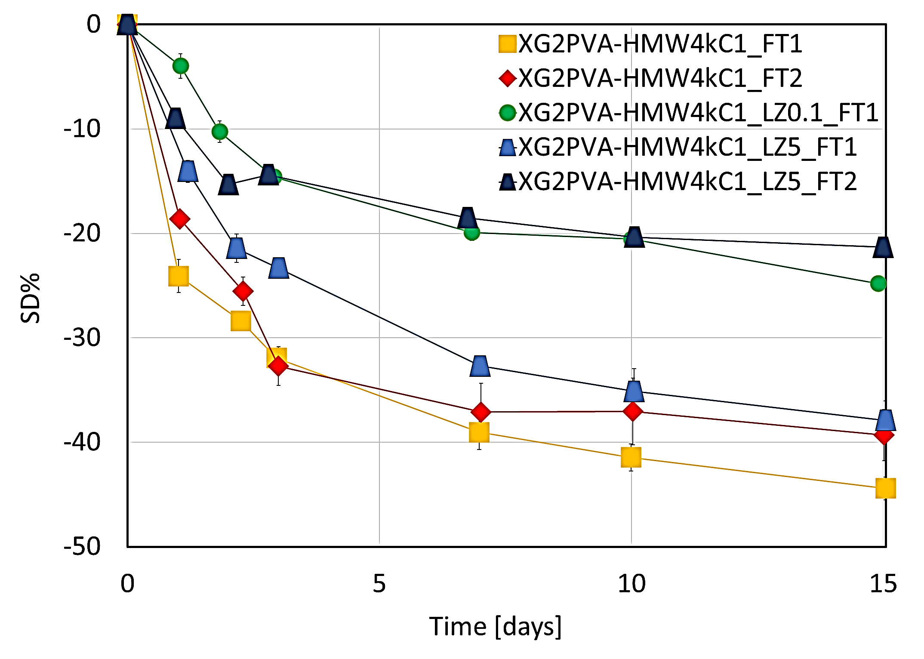

e)

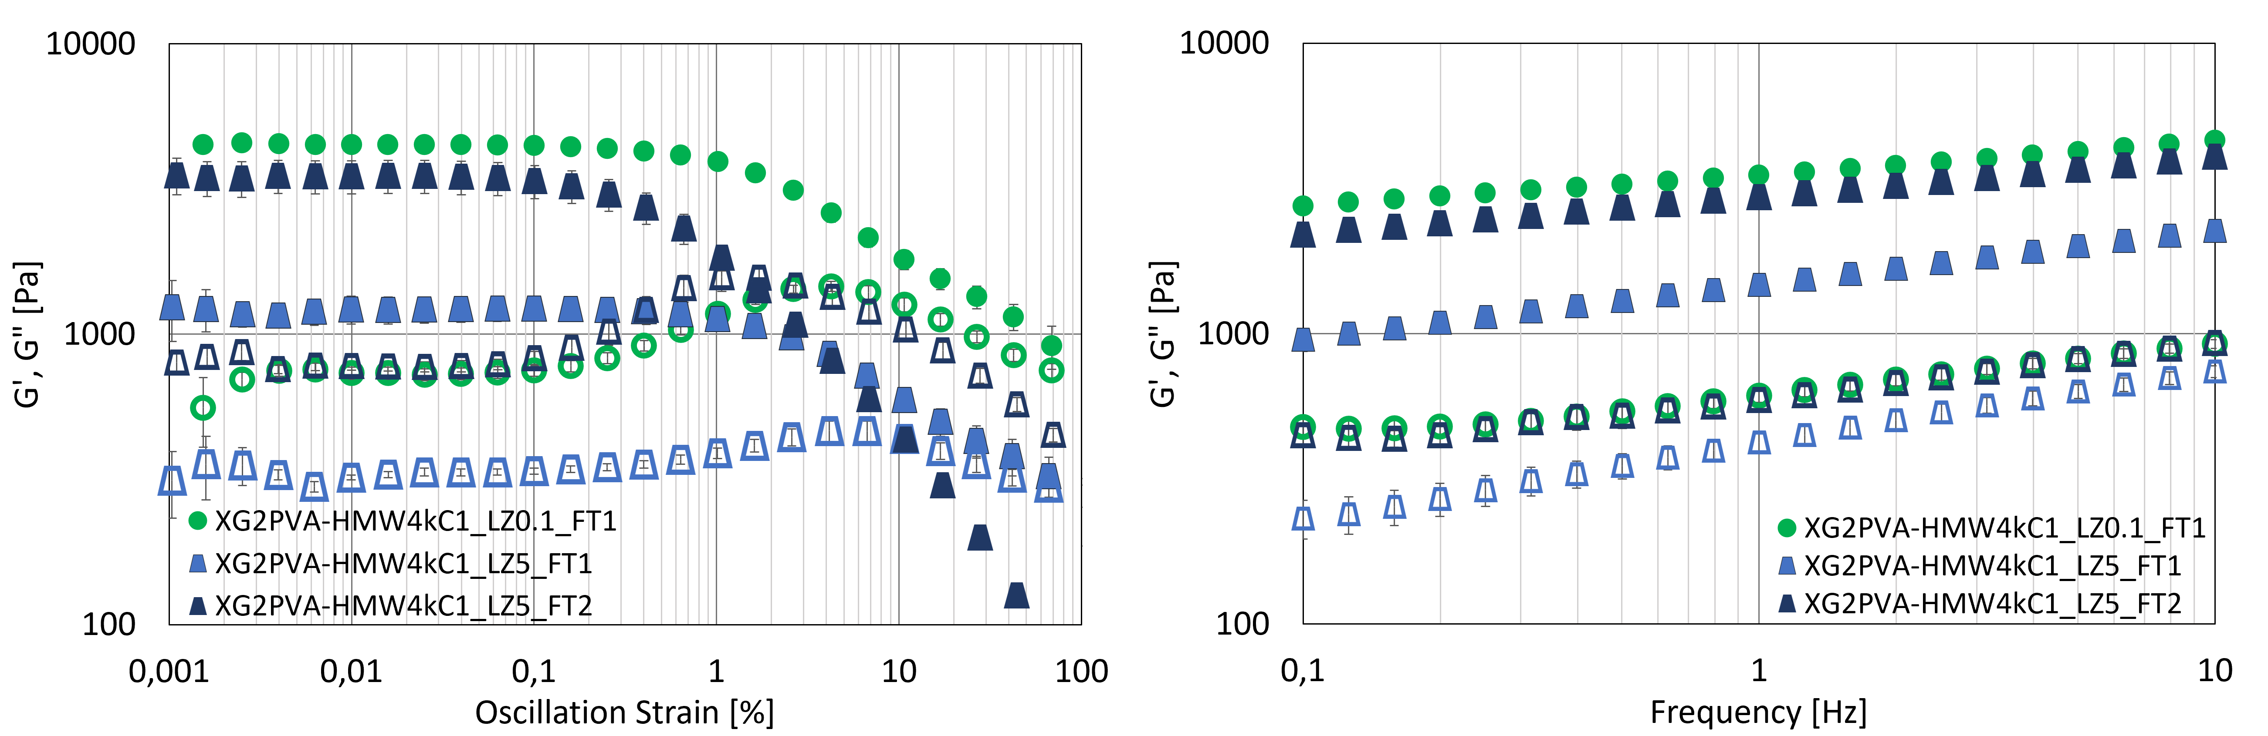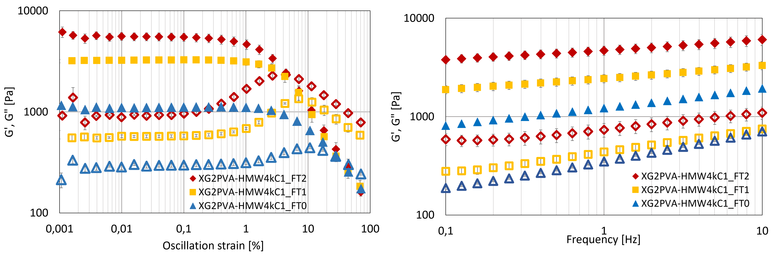

a)

b)

c)

d)

The same characterisations were performed on the FT1 systems loaded with LZ. When the protein is added at a low concentration, it has a slight strengthening effect, causing an increase in G' and G" moduli, whereas when loaded at 5%w it causes a significant decrease in storage modulus and a less pronounced reduction in G", despite the fact that the system is more concentrated. However, G' is higher than G" by an order of magnitude and the hydrogel can be classified a strong gel in rheological terms. Prolonging the FT cycling leads to an increase of G’ and G”. Hence the system has almost recovered the same mechanical performance of the formulation with the lowest content of LZ and only one FT cycle.

Figure 2e shows the swelling/erosion behaviour in excess PBS buffer at 37°C of all investigated systems. A gradual mass reduction over time is observed for all systems, that is significantly slower for the formulations incorporating 0.1 %w LZ after FT1 and 5 %w after FT2. The erosion resistance is enhanced by the presence of LZ, and among these systems is higher for the systems that showed higher storage modulus. When LZ becomes a significant component of the formulation, it interferes with kC and PVA crosslinking and the erosion resistance decreases with respect to XG2PVA-HWM4kC1LZ0.1\_FT1. The increased erosion resistance of XG2PVA-HWM4kC1LZ5\_FT1 with respect to XG2PVA-HWM4kC1\_FT1 can be attributable to the higher solid content.

SEM analysis (Figure 3) allowed to compare the different morphologies of the XG2PVA-HWM4kC1 systems. When no freeze-thaw cycles (FT0) were performed (Figure 3a), the microstructure appears heterogeneous, with large, thick-walled pores that are also internally porous.

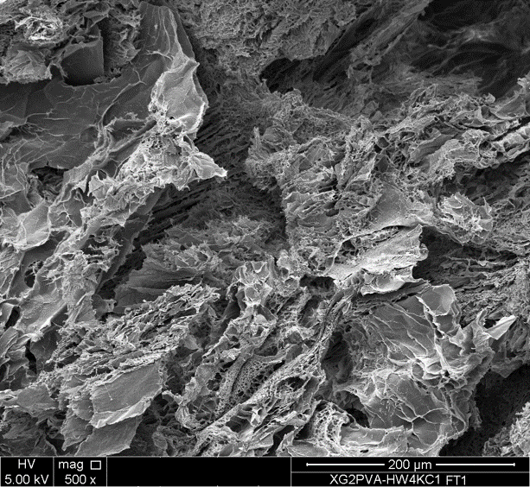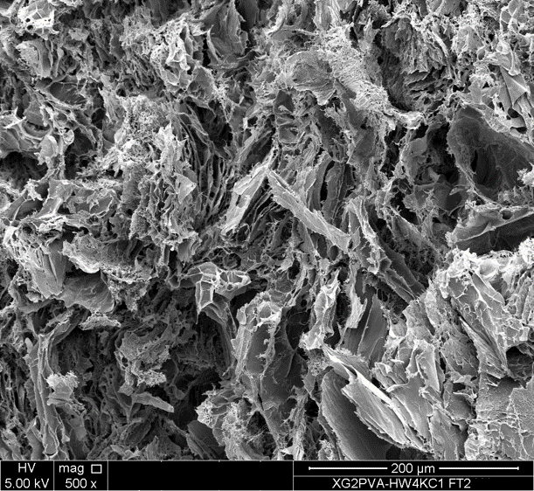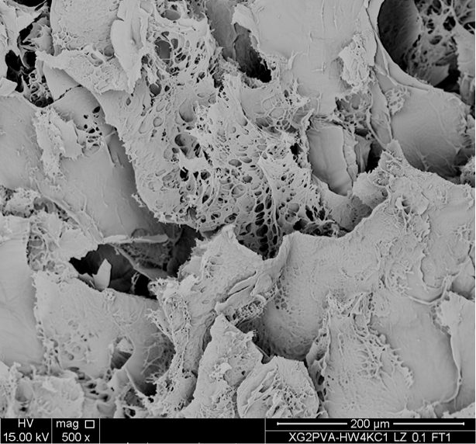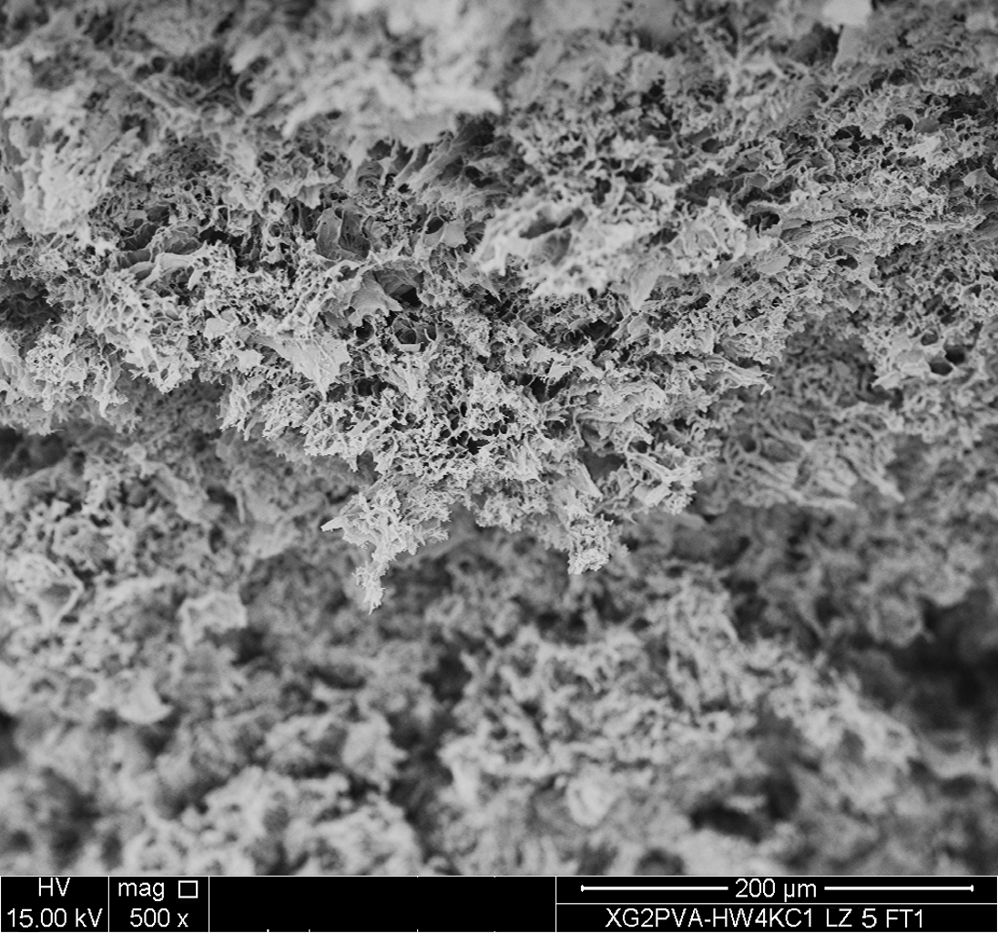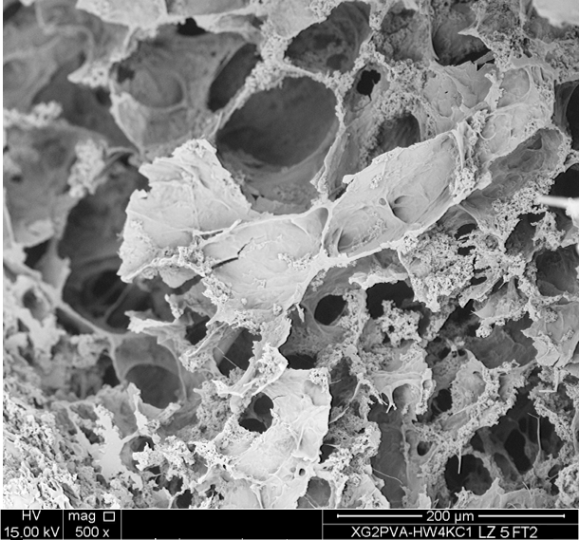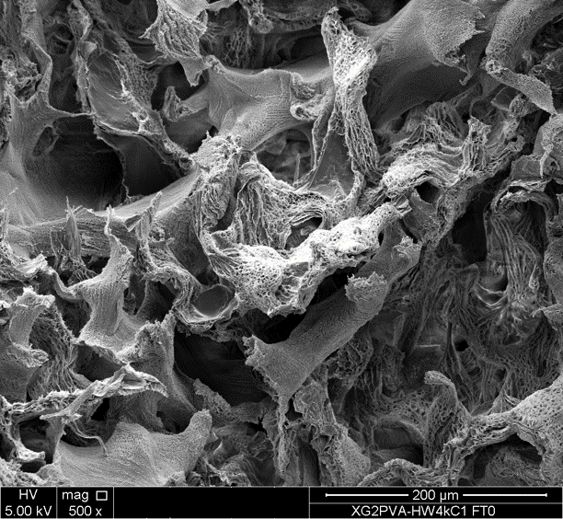

b)

a)

c)

d)

e)

**f)**

*Figure 3. SEM micrographs (cross-sections) of XG/PVA-HMW/kC FT0 (a); FT1 (b), FT2 (c),* LZ0.1 FT1 (d), LZ5 FT1 (e) and LZ5 FT2 (f) *hydrogels (500x magnification, scale bar* 200 μm).

When FT cycles were applied (Figure 3b, 3c), the morphology presents a more uniform porous structure, where the typical kC lamellae are interrupted and replaced by a random network of interconnected pores. The presence of LZ at low concentration has no significant impact on the hydrogel morphology (Figure 3d), whereas when LZ becomes the main component of the system in terms of weight, the morphology changes dramatically. The pores are much smaller, with thinner walls and relatively uniform in size (Figure 3f). The FT2 cycle on this formulation opens up large cavities with thicker walls (Figure 3f), which may explain the increase in storage modulus.

* 1. Conclusions

Novel XG/PVA-HMW/kC hydrogels were prepared, starting from inexpensive polymers with no recourse to initiators and catalysts, showing promising rheological and morphological properties in the prospect of developing wound dressings. Through the application of FT cycles between relatively mild temperatures (-20°C, +20°C), it was possible to produce films, that can also incorporate lysozyme up to 50 mg/ml, elastic, flexible and skin adhesive properties comparable to those commercially required. Further studies will investigate more in depth the specific interactions between lysozyme and the biopolymers constituting the hydrogel and the biological properties of the dressings.

Acknowledgments

Other affiliation for CD and EM: Istituto di BioFisica, Consiglio Nazionale delle Ricerche, Via U. La Malfa 153, 90146 Palermo, Italy. All the authors thank MP GOKYO FOOD & CHEMICAL CO., LTD for providing XG powder. This research is funded by Horizon Europe Project EURATOM-IA titled “RADiation harvesting of bioactive peptides from egg prOteins and their integration in adVanced functional products — RADOV” Project n. 101061694. EM was funded by “HEAL ITALIA - Health Extended Alliance for Innovative Therapies, Advanced Lab-research, and Integrated Approaches of Precision Medicine”, Spoke 6, WP 1, Task 1.1 (PNRR).

References

Ajovalasit A., Sabatino M. A., Todaro S., Alessi S., Giacomazza D., Picone, P., Di Carlo M., Dispenza C., 2018, Xyloglucan-based hydrogel films for wound dressing: Structure-property relationships. Carbohydrate polymers, 179, 262-272.

Dhivya S., Padma V. V., Santhini E., 2015, Wound dressings–a review. BioMedicine, 5(4), 22.

Ferraboschi P., Ciceri S., Grisenti P., 2021, Applications of lysozyme, an innate immune defense factor, as an alternative antibiotic. Antibiotics, 10(12), 1534.

Giori A., Arpini S., Togni S., 2011, inventors; Indena s.p.a., assignee, Tamarind seed polysaccharide for use in the treatment of inflammatory diseases. EU patent WO2011147768 A1. Dec 1.

Jain S., Domb A. J., Kumar N., 2013, Drug delivery to wounds, burns, and diabetes-related ulcers. In Focal Controlled Drug Delivery (pp. 585-605). Boston, MA: Springer US.

Jalili-Firoozinezhad S., Filippi M., Mohabatpour F., Letourneur D., Scherberich A., 2020, Chicken egg white: Hatching of a new old biomaterial. Materials Today, 40, 193-214.

Muscolino E., Sabatino M. A., Jonsson M., and Dispenza C., 2024, The role of water in radiation-induced fragmentation of cellulosic backbone polysaccharides, Cellulose, 31, 2, 841–856.

Nour S., Imani R., Chaudhry G. R., Sharifi A. M., 2021, Skin wound healing assisted by angiogenic targeted tissue engineering: A comprehensive review of bioengineered approaches. Journal of Biomedical Materials Research Part A, 109(4), 453-478.

Peppas N. A., Hoffman A. S., 2020, Hydrogels. In Biomaterials science (pp. 153-166). Academic Press.

Picone P., Sanfilippo T., Vasto S., Baldassano S., Guggino R., Nuzzo D., Bulone D., San Biagio P.L., Muscolino E., Monastero R., et al., 2022, From Small Peptides to Large Proteins against Alzheimer’sDisease, Biomolecules,12,1344.

Rafati Z., Sirousazar M., Hassan Z. M., Kheiri F., 2020, Honey-loaded egg white/poly (vinyl alcohol)/clay bionanocomposite hydrogel wound dressings: in vitro and in vivo evaluations. Journal of Polymers and the Environment, 28, 32-46.

Xu Z., Han S., Gu Z., Wu J., 2020, Advances and impact of antioxidant hydrogel in chronic wound healing. Advanced healthcare materials, 9(5), 1901502.

Yegappan R., Selvaprithiviraj V., Amirthalingam S., Jayakumar R., 2018, Carrageenan based hydrogels for drug delivery, tissue engineering and wound healing. Carbohydrate polymers, 198, 385-400.

Zaman S. B., Hussain M. A., Nye R., Mehta V., Mamun K. T., Hossain N., 2017, A review on antibiotic resistance: alarm bells are ringing. Cureus, 9(6).