|  |  |
| --- | --- |
| cetlogo ***CHEMICAL ENGINEERING TRANSACTIONS***  ***VOL. , 2024*** | A publication of  aidiclogo_grande |
| The Italian Association  of Chemical Engineering  Online at www.cetjournal.it |
| Guest Editors: Marco Bravi, Antonio Marzocchella, Giuseppe Caputo  Copyright © 2024, AIDIC Servizi S.r.l. **ISBN** 979-12-81206-10-6; **ISSN** 2283-9216 | |

Effect of Tetracycline and Ciprofloxacin on Growth and Biochemical Composition of *Chlorella vulgaris*

Shabnam Mirizadeh\*, Luca Callero, Alessandro A. Casazza, Attilio Converti

Department of Civil, Chemical and Environmental Engineering, University of Genoa, via Opera Pia 15, 16145 Genoa, Italy

shabnam.mirizadeh@edu.unige.it

This research aimed to evaluate the impacts of Tetracycline (TC) and Ciprofloxacin (CIP) on the growth and biochemical composition of *Chlorella vulgaris*. In this regard, TC and CIP were added to *C. vulgaris* culture media at concentrations of 5, 10, 30, and 50mg L-1. The effects on growth, antibiotic removal efficiency, and biochemical composition of microalgal cells in terms of chlorophyll, carotenoid, protein, and lipid contents were investigated over a 14-day period. Using both TC and CIP, the highest removal efficiencies (92.0 and 82.2%, respectively) were observed at an antibiotic concentration of 5mg L-1, while the highest final biomass concentrations (0.43 and 0.54g L-1) were obtained at TC and CIP concentrations of 10 and 30mg L-1, respectively. It is noteworthy that, despite the growth limitation at high concentrations of the antibiotics, the microalga exhibited resilience and survival. As the TC and CIP concentration was raised in the medium, a decrease in chlorophyll, carotenoid, and protein contents occurred compared to the control medium. Conversely, at a TC and CIP concentration of 50mg L-1, the lipid content increased up to 28.68 and 27.51%, respectively. This study provides valuable insights into the response of *C. vulgaris* to specific antibiotic-induced stress, shedding light on both growth patterns and biochemical composition of this microalga under such conditions.

* 1. Introduction

Over the past few years, the consumption of pharmaceutical substances, mainly antibiotics, has constantly increased for both human and veterinary applications. Consequently, the levels of these compounds entering aquatic environments, including municipal wastewater treatment systems, river, and groundwater, have also risen (Linghu et al., 2023). The origins of these antibiotics can be traced back to manufacturing facilities, discharge from hospitals and households, livestock farming, as well as runoff from aquaculture and agricultural sites (Kulik et al., 2023). Various concentrations of antibiotics have been identified in diverse wastewater sources, including industrial wastewater (ranging from 26ng L-1 to 31mg L-1), hospital wastewater (from 0.1 to 157μg L-1), and domestic wastewater (from 0.001 to 32μg L-1) (Bhagat et al., 2020; Ebrahimi et al., 2020). The presence of antibiotics in the environment typically induces stress on microorganisms, leading to the emergence of antibiotic-resistant bacteria and genes. This, in turn, constitutes a major risk to human health and other living organisms (Fayaz et al., 2024).

In conventional wastewater treatment systems, the removal of antibiotics is limited, ranging from 20% to 90%, and is primarily ensured by sludge adsorption and natural degradation. To enhance the efficiency of antibiotic removal and prevent detrimental effects on aquatic ecosystems, various techniques are employed. In recent years, microalgae-based technologies have attracted considerable scientific attention for their environmentally friendly, cost-effective, and efficient approach to treating industrial and municipal effluents and removing pollutants (Spennati et al., 2019; Zhang et al., 2023). Microalgae, powered by solar energy, exhibit a short growth cycle, heightened sensitivity to aquatic pollutants, and ability to promptly initiate stress responses, making them highly effective in wastewater treatment (Casazza et al., 2016; Mirizadeh et al., 2023). The primary mechanisms through which microalgae remove antibiotics include bioadsorption, bioaccumulation, biodegradation, photodegradation, hydrolysis, etc. (Zhang et al., 2023). Grimes et al. (2019) studied the removal efficiency of CIP, which was found to be 93% using *Scenedesmus dimorphus*. Similarly, CIP and triclosan were completely removed through biodegradation in F/2 medium during a 15-day treatment by microalgae (Bai et al., 2017).

TC and CIP are commonly used antibiotics for the treatment of infectious diseases due to their effectiveness, easy availability, and low cost. Their presence in high concentrations has been observed in the treated effluent of wastewater treatment plants worldwide. However, information regarding the potential toxicity of these antibiotics on the freshwater microalgae remains scarce. Therefore, in this study, the potential of *C. vulgaris* as a model for the removal of TC and CIP from an aqueous solution was investigated. Furthermore, the effects of these antibiotics on cell growth as well as chlorophyll, lipid, and protein contents were examined. The results were found to be encouraging, although further experimental runs are needed to define the optimal operational conditions for a sound scale-up.

* 1. Materials and Methods

2.1 Microalgal strain and culture conditions

*C. vulgaris* CCAP 211 was obtained from the Culture Collection of Algae and Protozoa (Argyll, UK). The strain was pre-cultured in 250mL flasks containing 100mL of Bold Basal Medium (BBM) on a shaker (Innova 2100, New Brunswick Scientific, Edison, NJ, USA) at 120 rpm under continuous fluorescence illumination of 80μmol photons m-2 s-1 at room temperature for 7 days, with the initial pH adjusted to 6.8. The microalgal suspension, in its exponential phase, was then utilized for subsequent experiments.

2.2 Microalga growth and antibiotic removal experiments

The obtained inoculum was transferred to 500mL flasks containing 300mL of a medium with different concentrations of TC and CIP (5, 10, 30, and 50mg L-1). Samples were taken at regular intervals from the flask cultivated for 14 days on the shaker under the same conditions as the pre-cultivation to assess growth and antibiotic concentration. Additionally, at the end of the cultivation, biomass was centrifuged at 6000 rpm for 5 minutes, lyophilized, and stored at 4°C until biochemical composition analyses. All experiments were conducted in triplicate.

2.3 Analyses

The biomass concentration of *C. vulgaris* was determined using a UV/Vis spectrophotometer (Lambda 25, PerkinElmer, Milan, Italy) at a wavelength of 625nm. This determination relied on the correlation between absorbance (ABS625) and cell dry weight (CDW), as expressed by Eq. (1):

CDW (g L-1) = 0.234× ABS625 R2=0.997 (1)

To determine the microalga dry weight, culture samples were obtained by centrifugation at 5500 rpm for 5 minutes. The resulting pellets were transferred to pre-weighed aluminium cups and then dried in an oven at 100°C until a stable weight was attained. All procedures were conducted in triplicate.

The residual concentrations of TC and CIP were assessed using the same UV/Vis spectrophotometer at wavelengths of 360 and 278nm, respectively. The concentrations of TC and CIP were correlated with the absorbance through Eqs. (2) and (3), respectively:

TC (mg L-1) = 31.45×ABS360-0.309 R2=0.999 (2)

CIP (mg L-1) = 8.835×ABS278+0.1015 R2=0.997 (3)

Lipids were extracted from the microalgal culture using a mixture of methanol/chloroform/water in a ratio of 2.0:2.0:1.8 (v/v/v) following the modified Bligh and Dyer method (Kates et al., 1966). Total lipids were measured gravimetrically, and lipid content and yields were calculated.

Microalgal cellular pigments were quantified using the method described by Lichtenthale (2007). Dried cells were homogenized in 10mL of 80% acetone and left to extract overnight at 4°C. After centrifugation at 5500 rpm for 5 minutes, the supernatant was transferred to a new tube, and its absorbance was measured at 663nm, 646nm, and 470nm. Pigment concentrations were calculated using Eqs. (4) and (5):

Total chlorophyll concentration (mg L-1) = 7.15×ABS663 + 18.71×ABS646 (4)

Total concentration of carotenoids (mg L-1) = 5.05×ABS470+ 2.08×ABS663 – 9.21×ABS646 (5)

The pigment content in the biomass (mg g-1) was calculated by dividing the concentration of each pigment (mg L-1) by the cell dry weight (g L-1).

Proteins were extracted from biomass using water as a solvent by ultrasound-assisted extraction (Spennati et al., 2022). In summary, 50mg of the sample were submitted to extraction with 5mL of milliQ water using an ultrasonic probe (Sonicator Vibra cell 75115, 500 Watt, Bioblock Scientific Co.). After that, the crude extract was separated from residual biomass by centrifugation at 7500 rpm for 10 minutes. Protein concentration was determined by the Bradford assay, with results expressed as mg L-1 based on a standard curve generated with bovine serum albumin:

Protein concentration (mg L-1) = 0.2853 x ABS595^2+1.1903xABS595 -0.0188 R2= 0.997 (6)

* 1. Results and Discussion

3.1 Biomass growth and antibiotic removal

*C. vulgaris* growth was experimentally investigated in the presence of TC and CIP at regular intervals throughout a 2-week period, and the data obtained are illustrated in Figure 1. The findings indicate that concentrations of 5 and 10mg L-1 of TC resulted in a slight increase in algal growth (Figure 1a), with the maximum biomass concentration observed at 10mg L-1 of TC being 0.43g L-1. This can be attributed to the stimulation of repair and maintenance mechanisms by TC at low levels, occurring as early as the 2nd day. These mechanisms involve the production of proteins related to cytoprotection and an increase in antioxidant defense mechanisms (Jiang et al., 2021). Additionally, in the cultivation under non-sterile conditions, the coexistence of bacteria may have led to competition for nutrient consumption with the microalga. At low antibiotic concentrations, reduction of bacterial growth may have created a favorable environment for enhanced microalga growth. Conversely, a concentration of 30mg L-1 of TC resulted in a decline in algal growth after just 6 days compared to the control. It is likely that prolonged exposure to this antibiotic concentration induced excessive oxidative stress, with formation of reactive oxygen species (ROS), which was not efficiently counteracted by an increase in antioxidant defense mechanisms, thus, in turn, leading to toxic effects on the microalga (Hom-Diaz et al., 2022). Moreover, it is evident that the highest TC concentration (50mg L-1) reduced algal growth compared to the control. Regarding the growth of *C. vulgaris* in the presence of CIP, each chosen concentration resulted in an increase in microalga growth. Particularly, at 30mg L-1 of CIP, the biomass concentration doubled within 3 days. Interestingly, the maximum concentration of CIP (50mg L-1) demonstrated a trend similar to that observed at 5mg L-1, likely due to the adverse impact of high concentration, even though it still led to better results compared to the control.

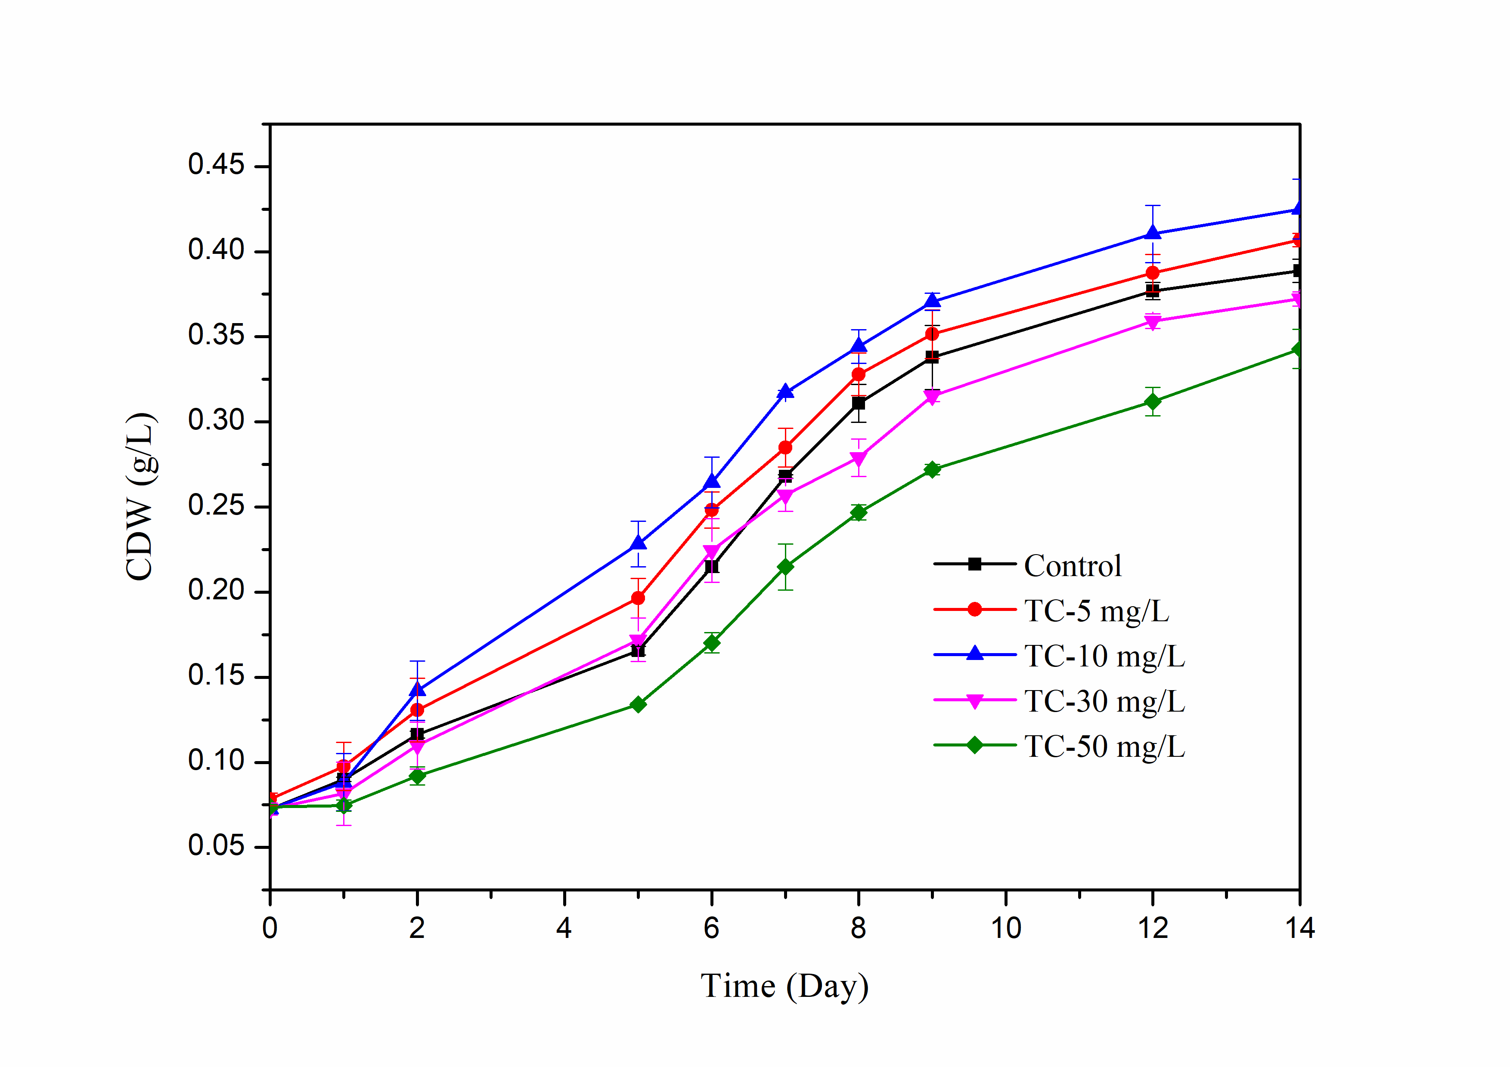

a)

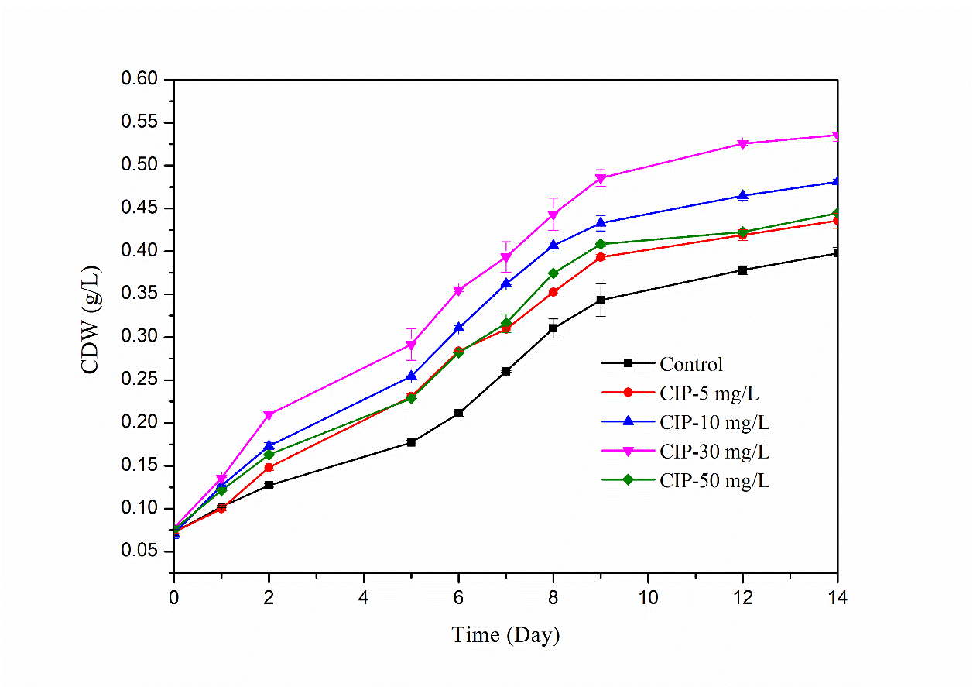

b)

Figure 1. Effect of TC (a) and CIP (b) concentration on growth of C. vulgaris

From the data obtained, it can be concluded that different effects on *C. vulgaris* are induced by TC and CIP. In fact, *C. vulgaris* seemed to have higher sensitivity to TC than to CIP, therefore even high concentrations of CIP led to increased growth compared to the control. This may be attributed to higher effectiveness of TC in inducing stress, leading to an excessive formation of ROS at lower concentrations compared to CIP.

The residual concentrations of TC and CIP in the culture of *C. vulgaris* are shown in Figure 2. The highest removal efficiency at the end of the cultivation period was 92% at the lowest TC concentration (5mg L-1), followed by 82.78%, 86.92%, and 85.63% at concentrations of 10, 30, and 50mg L-1, respectively (Figure 2a). Significantly, TC removal occurred after 10 days of *C. vulgaris* growth. In the case of CIP, the removal efficiency of antibiotics decreased with increasing concentration. The highest removal efficiency was also observed at the end of the cultivation period using 5mg L-1 (82.18%), followed by 79.1%, 68.9%, and 63.57% at 10, 30, and 50mg L-1 of CIP, respectively.

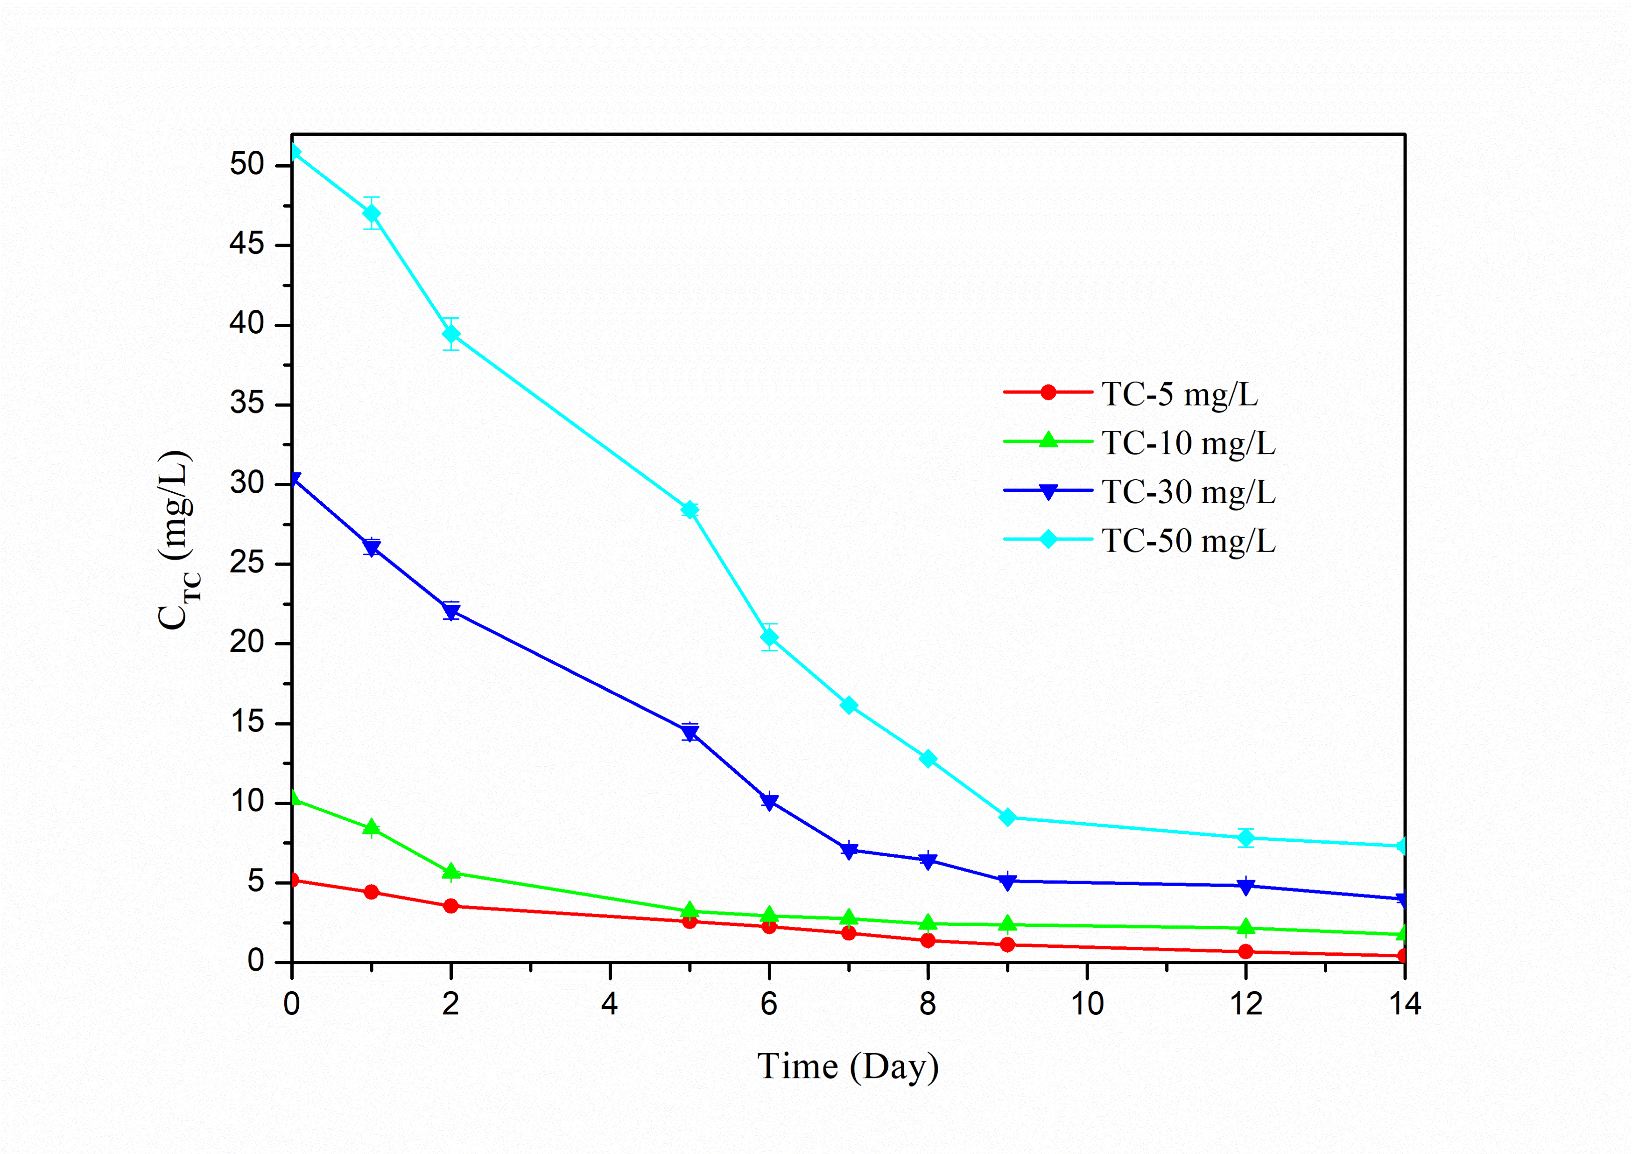

a)

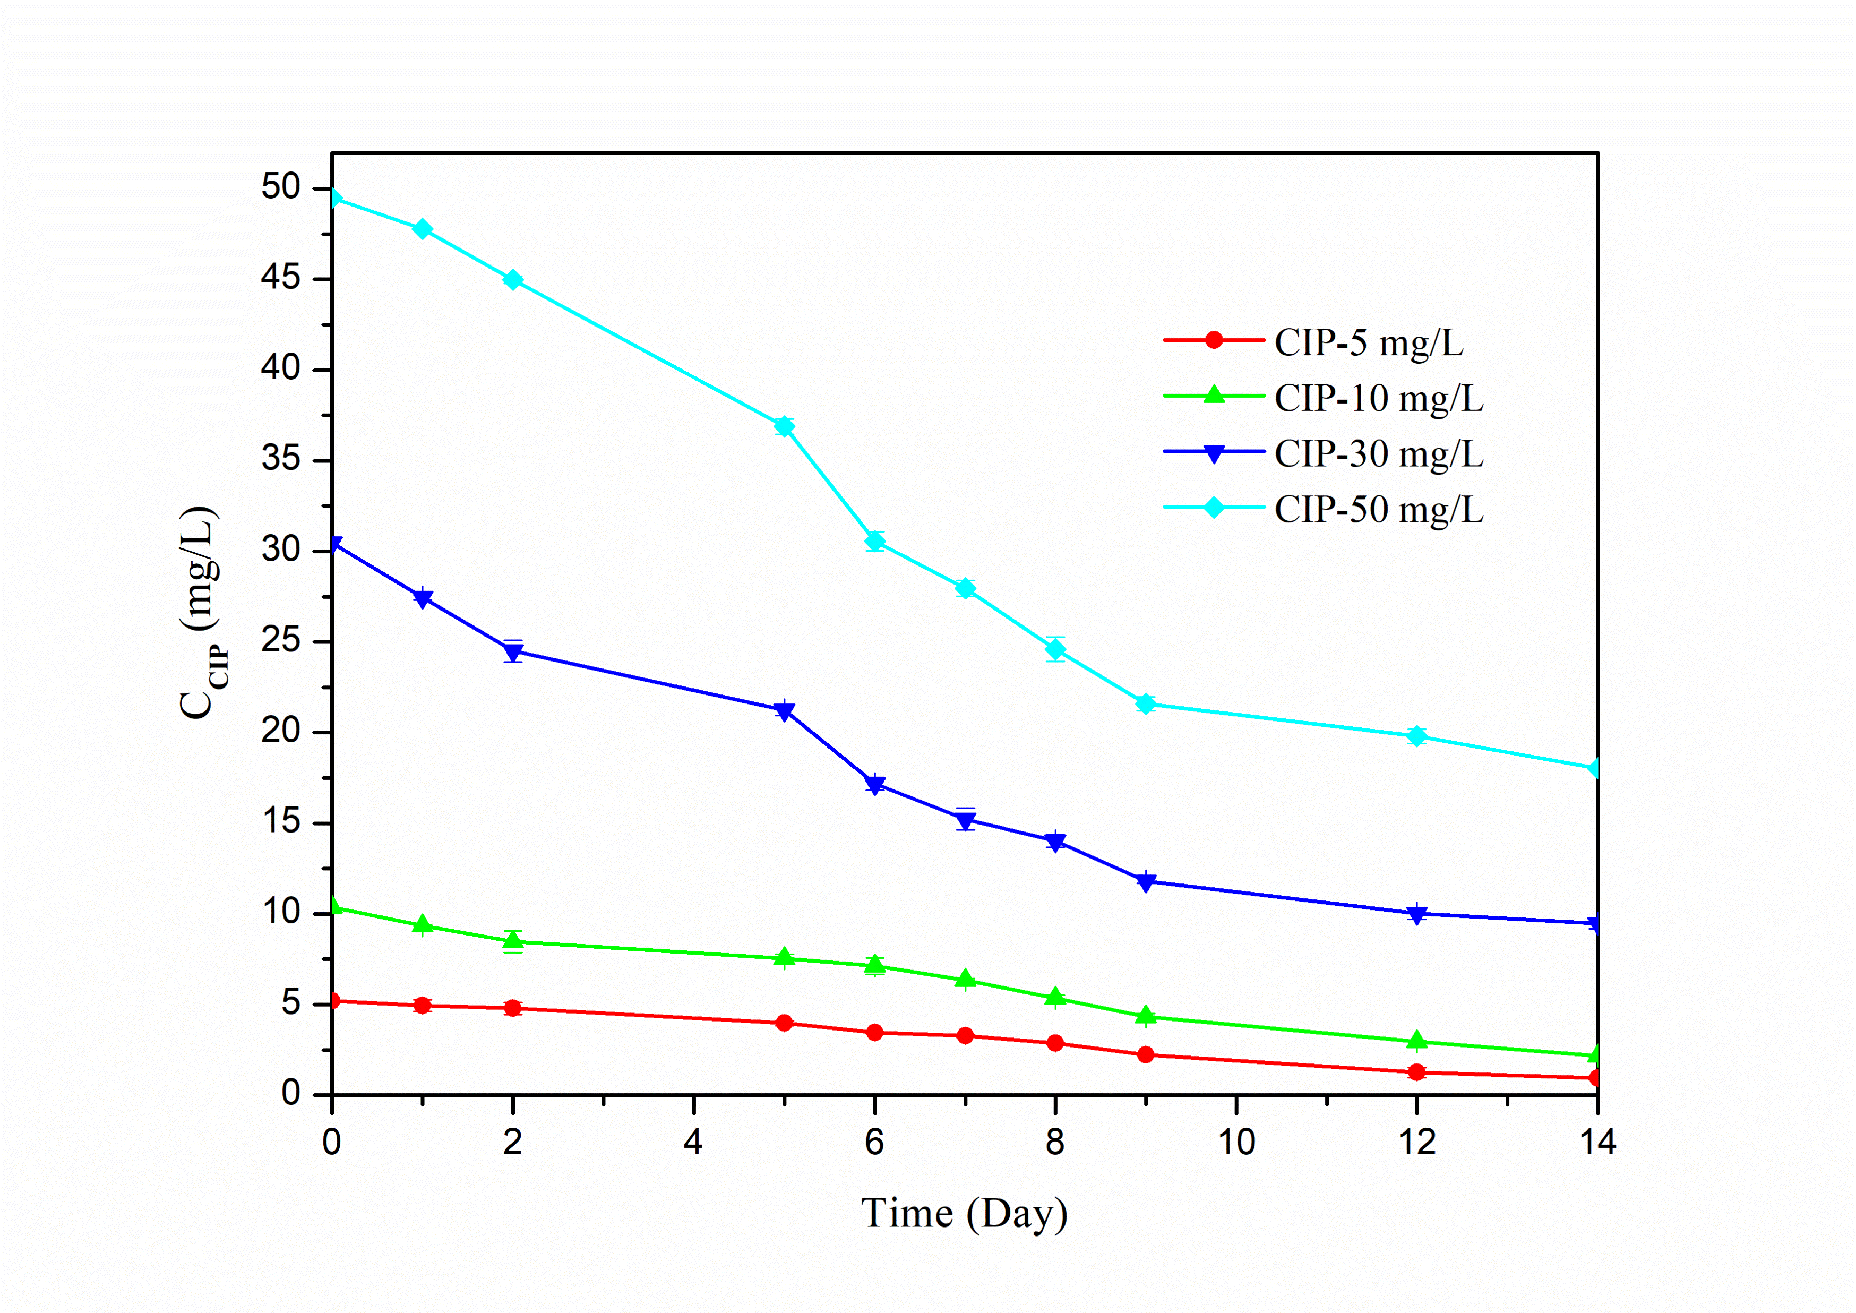

b)

*Figure 2. Residual concentrations of TC (a) and CIP (b) throughout the culture of C. vulgaris*

3.2 Effect of TC and CIP on biochemical composition of the microalga

As shown in Figure 3, both the total chlorophyll and carotenoid contents in the biomass decreased as the concentrations of antibiotics were raised. Specifically, the chlorophyll content in *C. vulgaris* was 24.5mg g-1 in the control without any antibiotics (Figure 3a). This level gradually declined to 15.923mg g-1 and 18.412mg g-1 when exposed to 50mg L-1 of TC and CIP, respectively. These reductions corresponded to approximately 36% and 26%, respectively.

According to the literature, the decline in overall chlorophyll levels observed after exposure to antibiotics may be attributed to the breakdown of the thylakoid membrane, the inhibition of chlorophyll synthesis caused by the accumulation of ROS, and the interference of antibiotics with specific cellular components that impedes the synthesis of the light-harvesting chlorophyll a/b protein complex in microalgae (Chen et al., 2022).

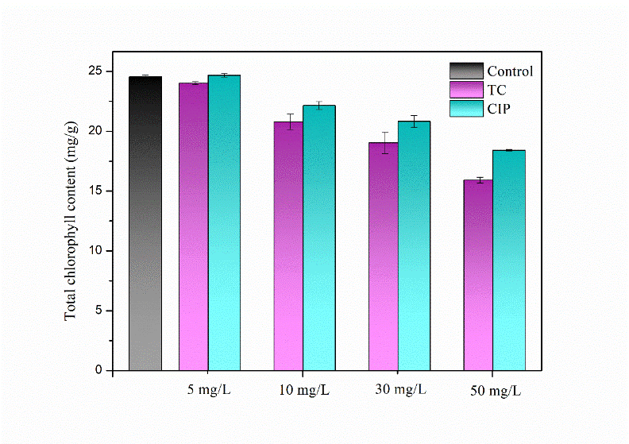

a)

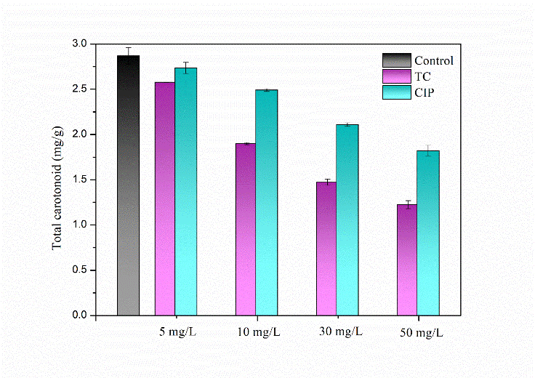

b)

*Figure 3. Effect of TC and CIP concentration on total chlorophyll (a) and carotenoid content (b) in C. vulgaris*

The same pattern was evident in the carotenoid content (Figure 3b), with a reduction of approximately 57% and 37% compared to the control at 50mg L-1 TC and CIP, respectively. Carotenoids play a crucial role in safeguarding the photosynthetic system of microalgae by reacting with lipid peroxidation products and neutralizing excited chlorophyll (Cupellini et al., 2020). After a 14-day exposure, both TC and CIP at higher concentrations significantly reduced the carotenoid content, indicating a weakened protective effect by carotenoids. This reduction may be attributed to the oxidation of carotenoids by superoxide anion radicals produced by triplet chlorophyll (Wan et al., 2021).

The analyses conducted revealed that the lipid content in the biomass depended on the antibiotic concentration, regardless of the type. In fact, as illustrated in Figure 4a, there was a direct proportionality between the lipid content in the biomass and the concentrations of both TC and CIP. For instance, at 50mg L-1 of TC and CIP, the maximum lipid accumulation in *C. vulgaris* reached 28.68% and 27.50%, respectively, marking a 1.4-fold increase compared to the control lipid content (19.54%).

Under stress conditions leading to increased ROS production, it is well established that lipid accumulation occurs during photosynthesis. This is linked to the up-regulation of the enzyme acetyl-CoA carboxylase, converting acetyl-CoA into malonyl-CoA, an essential component in fatty acid synthesis. The resulting fatty acids accumulate as lipids within the chloroplast, serving as energy source during critical periods (Suparmaniam et al., 2023). Furthermore, a potential increase in carbon flux, induced by the nonspecific degradation of carbon chains through excessive ROS formation, into the fatty acid synthesis pathway could explain the dependence of lipid accumulation on the antibiotic concentration (Sidders et al., 2023).

As depicted in Figure 4b, there was a notable decline in protein content with increasing antibiotic concentration. Specifically, it decreased from 39.41% in the control to 25.94% and 29.9% in biomass grown at 50mg L-1 of TC and CIP, respectively. This trend confirms the more pronounced impact of TC on the microalga biochemical composition compared to CIP. Such a decrease in protein level may be attributed to the inhibitory effects of these antibiotics on cellular processes and metabolic pathways responsible for protein synthesis.

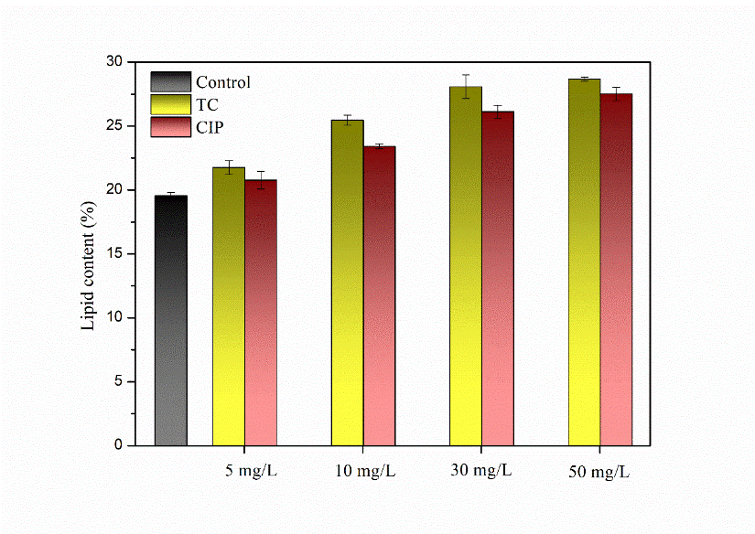

a)

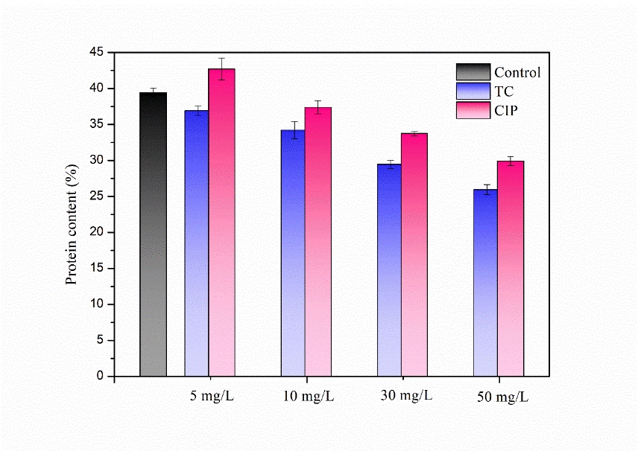

b)

*Figure 4. Effect of TC and CIP concentration on lipid (a) and protein (b) contents in C. vulgaris*

* 1. Conclusions

This study explored the impact of TC and CIP on *C. vulgaris*, focusing on biomass growth, antibiotic removal, and biochemical composition. Findings revealed that low TC concentrations (5 and 10mg L-1) stimulated algal growth, while higher concentrations led to growth decline, indicating excessive oxidative stress. In contrast, all CIP concentrations enhanced growth, with even the maximum concentration (50mg L-1) outperforming the control. The study highlighted different *C. vulgaris* sensitivity to TC- and CIP-induced oxidative stress, with that to the former having been the higher. Biochemical analysis showed a direct relationship between antibiotic concentration and lipid content, which reached maximum values of 28.68% and 27.50% using TC and CIP at concentration of 50mg L-1, respectively. High antibiotic concentrations led to a reduction in total chlorophyll, carotenoid, and protein contents. Overall, the study provides comprehensive insights into the complex interactions between antibiotics and microalgae, suggesting potential applications in wastewater treatment and biofuel production. However, careful consideration of antibiotic concentrations in microalgal cultivation is emphasized.

References

Bai, X., Acharya, K., 2017, Algae-mediated removal of selected pharmaceutical and personal care products (PPCPs) from Lake Mead water, Science of The Total Environment, 581, 734–740.

Bhagat, C., Kumar, M., Tyagi, V. K., Mohapatra, P. K., 2020, Proclivities for prevalence and treatment of antibiotics in the ambient water: a review, Npj Clean Water, 3, 42.

Casazza, A. A., Ferrari, P. F., Aliakbarian, B., Comotto, M., Perego, P., 2016, Microalgae growth using winery wastewater for energetic and environmental purposes, Chemical Engineering Transactions, 49, 565–570.

Chen, Z., Gu, G., Wang, Z., Ou, D., Liang, X., Hu, C., Li, X., 2022, Effects of Tetracycline on *Scenedesmus obliquus* Microalgae Photosynthetic Processes, International Journal of Molecular Sciences, 23, 10544.

Cupellini, L., Calvani, D., Jacquemin, D., Mennucci, B., 2020, Charge transfer from the carotenoid can quench chlorophyll excitation in antenna complexes of plants, Nature Communications, 11, 662.

Ebrahimi, S. M., Dehghanzadeh Reyhani, R., Asghari-JafarAbadi, M., Fathifar, Z., 2020, Diversity of antibiotics in hospital and municipal wastewaters and receiving water bodies and removal efficiency by treatment processes: a systematic review protocol, Environmental Evidence, 9, 1-9.

Fayaz, T., Renuka, N., Ratha, S. K., 2024, Antibiotic occurrence, environmental risks, and their removal from aquatic environments using microalgae: Advances and future perspectives, Chemosphere, 349, 140822.

Grimes, K. L., Dunphy, L. J., Loudermilk, E. M., Melara, A. J., Kolling, G. L., Papin, J. A., Colosi, L. M., 2019, Evaluating the efficacy of an algae-based treatment to mitigate elicitation of antibiotic resistance. Chemosphere, 237, 124421.

Hom-Diaz, A., Jaén-Gil, A., Rodríguez-Mozaz, S., Barceló, D., Vicent, T., Blánquez, P., 2022, Insights into removal of antibiotics by selected microalgae (*Chlamydomonas reinhardtii*, *Chlorella sorokiniana*, *Dunaliella tertiolecta* and *Pseudokirchneriella subcapitata*), Algal Research, 61,102560.

Jiang, Y., Liu, Y., Zhang, J., 2021, Mechanisms for the stimulatory effects of a five-component mixture of antibiotics in *Microcystis aeruginosa* at transcriptomic and proteomic levels, Journal of Hazardous Materials, 406, 124722.

Kates, M., Volcani, B. E., 1966, Lipid components of diatoms. Biochimica et Biophysica Acta (BBA) - Lipids and Lipid Metabolism, 116, 264–278.

Kulik, K., Lenart-Boroń, A., Wyrzykowska, K., 2023, Impact of Antibiotic Pollution on the Bacterial Population within Surface Water with Special Focus on Mountain Rivers, Water, 15, 975.

Lichtenthaler, H. K., 2007, Biosynthesis, accumulation and emission of carotenoids, alpha-tocopherol, plastoquinone, and isoprene in leaves under high photosynthetic irradiance, Photosynthesis Research, 92, 163–179.

Linghu, K., Wu, Q., Zhang, J., Wang, Z., Zeng, J., Gao, S., 2023, Occurrence, distribution and ecological risk assessment of antibiotics in Nanming river: Contribution from wastewater treatment plant and implications of urban river syndrome, Process Safety and Environmental Protection, 169, 428–436.

Mirizadeh, S., Pettinato, M., Fabiano, B., Converti, A., Casazza, A. A., 2023, Innovative Treatment of Digestate and Biogas Upgrade Using *Chlorella vulgaris*, Chemical Engineering Transactions, 105, 337-342.

Sidders, A. E., Kedziora, K. M., Arts, M., Daniel, J.-M., de Benedetti, S., Beam, J. E., Bui, D. T., Parsons, J. B., Schneider, T., Rowe, S. E., Conlon, B. P.,2023, Antibiotic-induced accumulation of lipid II synergizes with antimicrobial fatty acids to eradicate bacterial populations, ELife, 12, e80246.

Spennati, E., Casazza, A. A., Converti, A., Padula, M. P., Dehghani, F., Perego, P., Valtchev, P., 2022, Winery waste valorisation as microalgae culture medium: A step forward for food circular economy, Separation and Purification Technology, 293, 121088.

Spennati, E., Casazza, A., Perego, P., Solisio, C., Busca, G., Converti, A., 2019, Microalgae Growth in Winery Wastewater Under Dark Conditions, Chemical Engineering Transactions, 74, 1471-1476.

Suparmaniam, U., Lam, M. K., Lim, J. W., Yusup, S., Tan, I. S., Lau, S. Y., Kodgire, P., Kachhwaha, S. S., 2023, Influence of environmental stress on microalgae growth and lipid profile: a systematic review, Phytochemistry Reviews, *22*, 879–901.

Wan, L., Wu, Y., Zhang, B., Yang, W., Ding, H., Zhang, W., 2021, Effects of moxifloxacin and gatifloxacin stress on growth, photosynthesis, antioxidant responses, and microcystin release in *Microcystis aeruginosa*, Journal of Hazardous Materials, 409, 124518.

Zhang, M., Ning, R., Zheng, Q., Gao, K., 2023, Microalgae-based biotechnology as a promising strategy for removing antibiotics from wastewater: opportunities, challenges and future directions, Frontiers in Bioengineering and Biotechnology, 11, 1248765.