|  |  |
| --- | --- |
| cetlogo ***CHEMICAL ENGINEERING TRANSACTIONS***  ***VOL. , 2024*** | A publication of  aidiclogo_grande |
| The Italian Association  of Chemical Engineering  Online at www.cetjournal.it |
| Guest Editors: Marco Bravi, Antonio Marzocchella, Giuseppe Caputo  Copyright © 2024, AIDIC Servizi S.r.l. **ISBN** 979-12-81206-10-6; **ISSN** 2283-9216 | |

A two-phase model for ABE fermentation with a modified *Clostridium acetobutylicum* strain

Paula A. Tapias C.a, Karoll M. Rubiano M.a, Juan C. Barreiro P.a, Nicolas Muñoz Castrillóna, Jose M. Bernal M.b, Carlos A. M. Riascosb,\*

aChemical and Environmental Engineering Department, Universidad Nacional de Colombia, Bogotá 111321, Colombia.

bInstitute of Biotechnology, Universidad Nacional de Colombia, Bogotá 111321, Colombia.

camartinezri@unal.edu.co

Acetone-Butanol-Ethanol (ABE) fermentation has regained interest due to the environmental problems generated by fossil fuels and the need to modify production chains including considerations of sustainability and circular economy. This work focuses on the modelling of ABE fermentation, with a *Clostridium acetobutylicum* mutated strain, to support the synthesis and improvement of butanol and acetone production process. To reach this objective, bioreactor fermentations with different glucose concentrations were developed. Results show that a two phases model (with a set of equations for the acidogenesis and another for the solventogenesis) generates satisfactory process predictions. In acidogenesis, the main effect on growth and acid production is due to the inhibition by acids, which can be quantified as a function of the total concentration of acids. While in the solventogenesis, inhibition must be quantified as a function of the total concentration of solvents. This model agrees with metabolic analysis that considers solvents generation being produced, simultaneously, from acids and sugars. For the studied system, acetone and butanol production is based on re-assimilated acids and pyruvate from glycolysis, with a distribution that changes with glucose availability.

* 1. Introduction

Mathematical modelling is a successful strategy for rigorous analysis of processes. This strategy allows an efficient estimation of operational conditions, which impacts the process performance. Bioprocess modelling is a key issue in process development and improvement due to predictive models are essential to support synthesis, optimization, monitoring and control of the processes. The traditional strategy to develop mathematical predictive models for bioprocesses considers the combination of first-principles equations (mass, energy balances) with empirical equations for metabolic rates and growth kinetics, like Monod´s equation; Mears et al. (2017) present an interesting work on the use of mechanistic models for bioprocesses.

Another strategy is to employ only statistical models, such as Response Surface Models (RSM); Al-Shorgani et al. (2016) optimized butanol production in an ABE fermentation employing an RSM strategy, and suggest that it is a valid and successful tool for process analysis. On the other hand, with the recent development in genetics and other omics, there is a tendency to increase the level of complexity of the models by including intracellular metabolism phenomenon, which requires to describe the cell in terms of its internal components, such as ATP, NADH, metabolites, etc. This strategy is supported on a detailed understanding of the metabolism pathways, and the regulation mechanisms, as supported by Rivas-Astroza et al. (2021).

For ABE fermentation, the most commonly used substrate is starch, which is converted into glucose through hydrolysis. Additionally, hydrolysis can also convert other types of substrates from lignocellulosic material such as hemicellulose and cellulose into simple sugars like xylose and glucose (Mayank et al., 2012). In the case of pentoses, such as xylose, the pentose phosphate pathway (PPP) is followed to produce pyruvate, generating 5 moles of adenosine triphosphate (ATP) and 5 moles of nicotinamide adenine dinucleotide (NADH) for every 3 moles of pentose (Jones & Woods, 1986). Meanwhile, for hexoses, the Embden Meyerhof pathway (EMP) is followed; in this pathway, 1 mole of glucose produces 2 moles of pyruvate and has a net production of 2 moles of ATP and 2 moles of NADH, as shown in Figure 1. The pyruvate formed from sugars goes through a series of

****

Figure 1: Major metabolic pathways of ABE fermentation, including some cofactors of the acidogenic phase and the solventogenic phase. Adapted from Moon et al. (2016).

reactions to reach acetyl-CoA, and from this point, other pathways lead to the production of acetic acid, butyric acid and ethanol. During this process, the pH decreases, ATP is produced, and the cell utilises this energy for growth. Subsequently, during the solventogenic phase, there is an energy consumption associated with NADH, and the production of acetone from acetoacetyl-CoA and butanol from butyryl-CoA begins (Moon et al., 2016).

The modelling of ABE fermentation has been reported and reviewed in the literature (Mayank et al., 2012) with different strategies from the simplest to the most complex. Papoutsakis et al. (1984) considered stoichiometric fermentation equations. Mulchandani and Volesky (1986) considered a term for product inhibition. Subsequently, dynamic models that integrate enzymatic behaviour depending on the initial glucose concentration were developed (Li et al., 2011). The shift from acidogenesis to solventogenesis was considered by Buehler and Mesbah (2016) through a transfer function given by pH. Recently, Rivas-Astroza et al. (2021) proposed a model where the process is represented by three different cell types: acidogenic, solventogenic, and spores, this strategy allows to define specific parameters for each stage of the fermentation. Those works reflect that there is currently a deeper understanding of ABE fermentation. Which has led to new strategies, allowing novel and detailed approaches to this process.

This research focuses on the modelling of ABE fermentation with a *C. acetobutylicum* strain obtained by spontaneous mutation at the Institute of Biotechnology of Universidad Nacional de Colombia. Considering the multiple approaches for defining a production fermentation model, the current work limits itself to a black-box model (where only the input and output compounds are considered, without specifying what happens in the middle), this limitation is due to the complexity of including the details of the pathways, their dynamic behaviour and their influence on the bacterial functioning.

* 1. Materials and methods
     1. Flask fermentations

ABE Fermentation studies started with flask fermentation for strain selection. Strains ATCC 824, IBUN IV (butanol hyper-producer mutant from *Clostridium Acetobutylicum* DSM 1732), and IBUN 125C (A Colombian native strain) were studied in two different mediums: Reinforced Clostridium Medium (RCM) and T6 Medium, in order to select the best producing conditions. Compositions for the mediums are as follows: RCM uses Yeast extract 3.0 g/L, Peptone from casein (Tryptone) 10.0 g/L, Meat extract 10.0 g/L, Glucose 5.0 g/L, Starch 10.0 g/L, Sodium chloride 5.0 g/L, Sodium acetate 3.0 g/L, L-Cysteine hydrochloride 0.5 g/L, and Agar 12.5 g/L. For T6 media is used: Potassium dihydrogen phosphate 0.5 g/L, Magnesium sulphate heptahydrate 0.3 g/L, Iron (II) sulphate heptahydrate 0.01 g/L, Ammonium acetate 3.0 g/L, Yeast extract 2.0 g/L, Peptone from casein (Tryptone) 6.0 g/L, L-Cysteine hydrochloride 0.5 g/L, Agar 0.5 g/L and Glucose 40.0 g/L.

The medium pH was adjusted with Sodium hydroxide at 6.5 ± 0.1 and sterilised at 121°C for 15 minutes. Each fermentation occurred in a 50 mL glass flask filled at 80% capacity with medium, inoculated with 2 mL of the corresponding strain, and incubated at 37 °C for 72 and 96 hours.

* + 1. Bioreactor fermentations

After strain selection, batch bioreactor experiments were used to generate data for the modelling analysis. To quantify the inhibitory and limiting effect of the substrate, three initial glucose concentrations were considered (80, 40, and 20 g/L); while the initial concentrations of other nutrients were fixed following the T6 Media composition. Fermentation experiments were performed in a 1 L BIOSTAT A (600 mL working volume) with no pH control, Samples of 2.0 mL of the fermentation broth were taken for analyses.

* + 1. Analytical methods

Concentrations of glucose, butanol, acetone, butyric and acetic acids from fermentation were measured by HPLC, in a Shimadzu chromatograph, using a 300 x 4 mm Eurokat H column, 5 mM H2SO4, at 0.5 mL/min and 85 °C, using a refractive index detector RID 10A; oven module CTO-20A; injection system SIL-20A HT; pumping system LC-20AD and control system CBM-20A.

Biomass was quantified by Dry Cell Weight (DCW) and by Optical Density at 600 nm (OD600). 2.0 mL of fermentation broth was taken out and centrifuged at 5500 rpm for 10 min. The supernatant was discarded, then cells were resuspended in 2.0 mL of distilled water. Optical density was determined at 600 nm with a UV spectrometer (BIO RAD SmartSpec™ plus spectrophotometer). If the OD600 was above 1.00, the sample was diluted and then tested until the OD became less than 1.00. Dry cell weight was determined by taking 5.0 mL of fermentation broth, vacuum filtered through a nitrocellulose filter of 0.2 micrometres, and dried at 40°C until constant weight, approximately for 48 h. The observed relation was: DCW = 0.2695 OD + 1.2195 (R2 = 0.98)

* + 1. Model identification

A three-step strategy was employed for this analysis: the first step considered qualitative analysis of concentration profiles and specific rates to identify dependencies between metabolism and environmental conditions, and to propose the model structure. The second step considered a quantitative analysis based on specific rates to generate initial estimations of model parameters. In the third stage, the predictions of the concentration profiles were used for the final tune of the parameters.

The estimation of the specific rates, for the first and second steps, requires to adjust functions for concentration profiles and to derivate these functions; then, each specific rate was calculated from its definition:

|  |  |
| --- | --- |
| $$µ_{i,exp}= \frac{d i(t)}{dt} \frac{1}{X}$$ | (1) |

where µ*i,exp* is the experimental specific rate of generation or consumption of *i*, *i*(*t*) is the function that adjusts the concentration profile of *i*, and *X* is the biomass concentration. Therefore, for the initial estimation of model parameters, the sum of squared residuals between experimental and estimated specific rates was minimized; whereas, for the final tune of the parameters, the sum of squared residuals between experimental and estimated concentration was minimized. For both minimization procedures, theoretical limits for yields were considered.

* 1. Results and analysis

From flask experiments, IBUN IV, a spontaneous mutant of *Clostridium acetobutylicum* DSM 1732 strain, obtained at the Institute of Biotechnology of Universidad Nacional de Colombia, and T6 medium were selected due to the higher butanol production. In 96-h flask fermentations, the analysed strains produced low levels of butyric acid (1,50 – 2,0 g/L) in both mediums; nevertheless, the strain IBUN IV was the only one able to produce butanol having a higher final concentration in medium T6 (2,5 g/L) in contrast to RCM medium (0,5 g/L). Under these conditions, no ethanol production was observed, this metabolic behaviour requires a careful strain analysis to identify the involved mutation.

Bioreactor fermentations confirmed the main characteristic of ABE fermentation: metabolism is carried out in two phases. The first phase employs sugars to generate acids (butyric and acetic) and biomass (Equations 2 to 5); whereas, in the second one sugars and acids are used to generate solvents (butanol and acetone) without biomass generation (Equations 6 to 10). Therefore, the switch between the metabolic phases generates changes in pH evolution. For acidogenesis, metabolism is characterized by:

* Biomass growing as function of glucose concentration (*S*) and the total concentration of acids (*PA*):

|  |  |
| --- | --- |
|  | (2) |

* Acids (*BA*: butyric acid, *AA*: acetic acid) production associated to growth:

|  |  |
| --- | --- |
| $$µ_{BA}={Y_{BA/X} * µ}_{X}$$ | (3) |
| $$µ_{AA}={Y_{AA/X} * µ}_{X}$$ | (4) |

* Glucose consumption proportional to growth:

|  |  |
| --- | --- |
| $$µ_{S}={-1/Y_{X/S} * µ}_{X}$$ | (5) |

On the other hand, for the solventogenesis phase, the model of the metabolism considers:

* Biomass does not grow (µ*X,S* = 0),
* Glucose consumption depends on glucose availability and it is inhibited by total concentration of solvents (*PS*):

|  |  |
| --- | --- |
|  | (6) |

* Acids remetabolization is inhibited by the total concentration of solvents:

|  |  |
| --- | --- |
| $$µ_{BA,S}=µ_{BA,S,max}{\left[1-\frac{P_{S}}{K_{PS2}}\right]}^{α2}$$ | (7) |
| $$µ_{AA,S}=µ_{AA,S,max}{\left[1-\frac{P_{S}}{K_{PS2}}\right]}^{α2}$$ | (8) |

* Solvents (*B*: butanol, *A*: acetone) production depends on glucose and acids metabolization:

|  |  |
| --- | --- |
| $$µ_{B}={- Y}_{B/S}*µ_{S,S} {- Y}_{B/BA}*µ_{BA,S}$$ | (9) |
| $$µ_{A}={- Y}_{A/S}*µ_{S,S} {- Y}_{A/AA}*µ_{AA,S}$$ | (10) |

Some simplifications considered in the model are: i) there is not consumption for maintenance of the cells, ii) the switch between the metabolic phases is instantaneous, iii) the switch is simultaneous for both products (acetone and butanol). The model Parameters are characterized in Table 1. In the performed experiments, the lag phase, observed before the acidogenesis phase, varied between 3 and 6 hours (Figure 2). This model satisfactorily adjusts the profiles of glucose, biomass and products, for performed experiments, as observed in Figure 2, which confirms the considered mechanistic phenomena:

* Acids accumulation inhibits the metabolism during the acidogenesis phase.
* Solvents accumulation inhibits the metabolic processes in solventogenesis phase.
* Solvents are generated from glucose and the corresponding acid.

Concentration profiles show that, in ABE fermentation without pH control, the metabolic switch happens when pH drops its minimum, and butyric and acetic acid concentrations reach 3.7 ± 0.2 and 6.6 ± 0.5 g/L, respectively.

Table 1. Parameters for ABE fermentation model with IBUN-IV strain.

|  |  |  |  |
| --- | --- | --- | --- |
| Parameter | Meaning | Value | Units |
| µ*max* | Maximum specific growth rate | 0.19 | h-1 |
| *KS* | Half-saturation constant | 1.00 | g/L |
| *Ki* | Constant for Inhibition by substrate on growth | 120 | g/L |
| *KPA* | Critical concentration of acids for growth | 12.0 | g/L |
| *α* | Exponent for inhibition | 0.15 |  |
| *YBA/X* | Yield from biomass to butyric acid | 1.80 | g *BA* / g *X* |
| *YAA/X* | Yield from biomass to acetic acid | 1.10 | g *AA* / g *X* |
| *YX/S* | Yield from substrate to biomass | 0.18 | g *X* / g *S* |
| µ*SS,max* | Maximum specific rate of glucose metabolization in solventogenesis | -0.955 | g *S* / g *X* h |
| *KSS* | Half-saturation constant in solventogenesis | 2.06 | g/L |
| *KPS* | Critical concentration of solvents for glucose metabolization | 36.5 | g/L |
| µ*BA,S,max* | Maximum specific rate of *BA* remetabolization in solventogenesis | -0.22 | g *BA* / g *X* h |
| µ*AA,S,max* | Maximum specific rate of *AA* remetabolization in solventogenesis | -0.22 | g *AA* / g *X* h |
| *KPS*2 | Critical concentration of solvents for acids remetabolization | 24.0 | g/L |
| *α*2 | Exponent for inhibition on acids remetabolization | 1.0 |  |
| *YB/S* | Yield from glucose to butanol | 0.20 | g *B* / g *S* |
| *YA/S* | Yield from glucose to acetone | 0.50 | g *A* / g *S* |
| *YB/BA* | Yield from butyric acid to butanol | 0.841 | g *B* / g *BA* |
| *YA/AA* | Yield from acetic acid to acetone | 0.967 | g *A* / g *AA* |

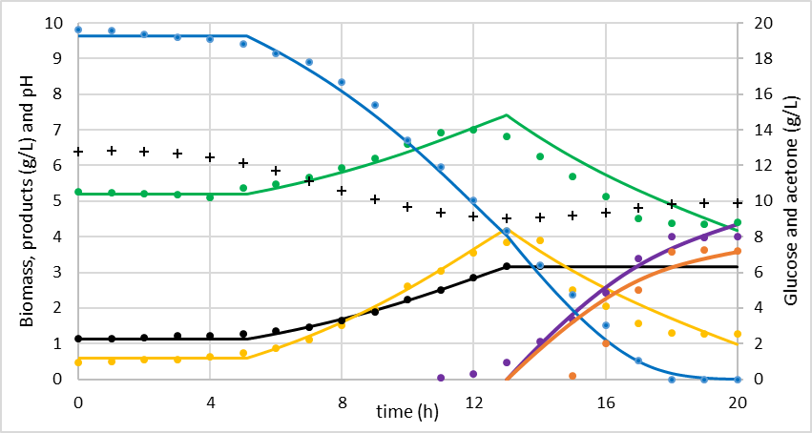

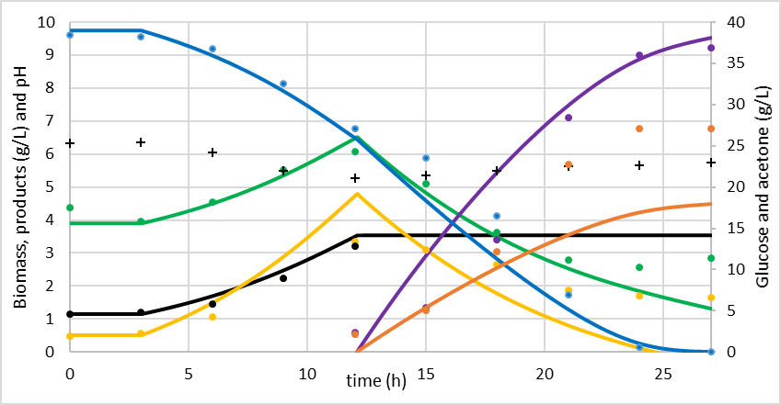

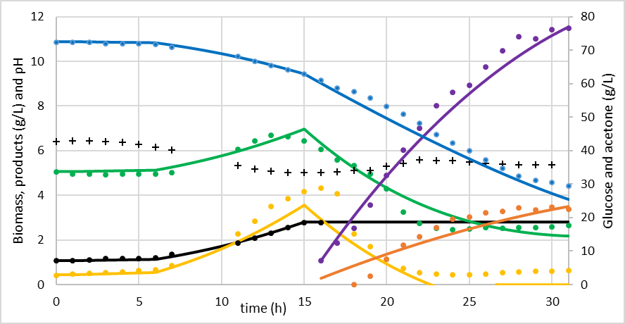

Figure 2: Experimental data (marks) and simulated profiles (continuous lines) for three initial glucose concentrations: top graphic 20 g/L, middle 40 g/L, and bottom 80 g/L. Blue: glucose, green: acetic acid, black: biomass, yellow: butyric acid, purple: butanol, orange: acetone, black crosses: pH.

From a detailed assessment, it is observed that the model generates a very good prediction for the concentration profiles of glucose, biomass and acetic acid during acidogenesis phase; while for other profiles an inferior fit of the prediction is observed. The imbalance in the prediction during the transition between both metabolic phases would be generated by a non-instantaneous switch, the dynamic of the metabolic behaviour, in this transition, would depend on extra- and intra-cellular conditions (concentrations of substrates and products, and concentration of metabolites, enzymes, etc., respectively). Additionally, experimental results suggest that acetic acid consumption begins before butyric acid consumption. Another period with inferior fit is the ending of the solventogenesis phase, which suggest that more complex analysis must be developed. An alternative to improve the model prediction in the metabolic transition periods is to include information about intracellular changes happening due to acids and solvents accumulation, which requires omics analysis. For the future works special attention will be dedicated to the prediction of acetone and butanol production that fit experimental data worse, this model deficiency is attributed to the simplifications above described.

The low values for half saturation constants (*KS* = 1.00 and *KSS* = 2.06 g/L) show that the limiting effect of glucose on metabolic processes is very low; whereas, the values for critical concentration of solvents for glucose metabolization and acids remetabolization (*KPS* = 36.5 and *KPS*2 = 26.0 g/L) show that these processes are not completely associated. Another interesting result is that the fraction of acetone and butanol produced from re-assimilated acids and from glucose changes with glucose availability. For the fermentation with low glucose availability (20 g/L) the fraction of acetone and butanol from acids were 0.35 and 0.54, respectively; whereas, for the experiment with high glucose availability (80 g/L) these fractions were 0.17 and 0.27. These results confirm the metabolism complexity. These results suggest that the metabolic processes depend on intracellular regulation mechanisms, which effects on concentration profiles can only be partially predicted by a mechanistic model, like the here proposed.

For the process development, it is interesting to observe that high glucose concentration (80 g/L) generates higher final solvent concentrations, although not all the glucose is consumed, as such approximately 30 g/L of glucose could be lost in separation operations. On the other hand, for low glucose concentration (20 g/L) final solvent concentration is lower and the totality of glucose is consumed. Therefore, it is a good option to work with an intermediate glucose concentration, as in this case with 40 g/L where the total glucose was consumed in 27 hours, obtaining a butanol concentration of approximately 9.2 g/L. A better initial condition would be obtained from an optimization analysis supported on this or a more complex predictive model. Regarding the specific growth rate, in acidogenesis phase it reached 0.18 h-1 while in solventogenesis no growth was observed.

* 1. Conclusions

The ABE (acetone-butanol-ethanol) fermentation process unfolds in two distinct phases, identified as solventogenesis and acidogenesis determined through the microbial activity as they are submitted to different environmental conditions. This understanding of the specific phases provides a valuable foundation for the design and optimization of ABE fermentation processes.

Glucose concentration is crucial for both developments of the phases the bacteria undergoes, as it favours or limits the production of both acids and solvents with its own inhibitory influence. This is shown through the different product concentrations and the length the fermentation when initial glucose concentration is modified.

Furthermore, the kinetic model developed in the study showed a good capability for a general representation of the ABE fermentation phenomenon, specifically for the *Clostridium Acetobutylicum* IBUN IV strain. The model's ability to predict changes in product concentrations over time, substantiates its utility as a predictive tool for the development and optimization of industrial processes.

The greatest difficulties for modelling this process are in the metabolic transitions, such as the switch between acidogenesis and solventogenesis phases and the end of solventogenesis, so to improve the prediction of the model it is necessary to include aspects such as metabolic control and regulation, through omic information.

References

Al-Shorgani N.K.N., Shukor H., Abdeshahian, P., Kalil M.S., Yusoff W.M.W, Hamidet A.A., 2016, Enhanced butanol production by optimization of medium parameters using *Clostridium acetobutylicum* YM1. Saudi Journal of Biological Sciences, dx.doi.org/10.1016/j.sjbs.2016.02.017

Buehler E.A., Meshab A., 2016, Kinetic study of Acetone-Butanol-Ethanol fermentation in continuous culture. PLOS ONE, 11(8), doi: 10.1371/journal.pone.0158243

Jones D.T., Woods D.R., 1986, Acetone-Butanol Fermentation Revisited, Microbiology Reviews, 50, 484-524.

Li R.D., Li Y.Y., Lu L.Y., Ren C., Li Y.X., Liu L., 2011. An improved kinetic model for the acetone-butanol-ethanol pathway of *Clostridium acetobutylicum* and model-based perturbation analysis, BMC Systems Biology, 5(S1), doi.org/10.1186/1752-0509-5-s1-s12

Mayank R., Ranjan A., Moholkar V.S., 2012, Mathematical models of ABE fermentation: review and analysis, Critical Reviews in Biotechnology, 1-29, doi:10.3109/07388551.2012.726208

Mears L., Stocks S.M., Albaek M.O., Sin G., Gernaey K.V., 2017, Mechanistic Fermentation Models for Process Design, Monitoring, and Control, Trends in Biotech, 35 (10), 914-924, doi.org/10.1016/j.tibtech.2017.07.002

Mulchandani A., Volesky B., 1986, Modeling of the acetone-butanol fermentation with cell retention. The Canadian Journal of Chemical Engineering, 64(4), 625-631. doi.org/10.1002/cjce.5450640413

Papoutsakis E.T., Meyer C.L., 1984, Equations and calculations for fermentations of butyric acid bacteria, Biotechnology and Bioengineering, 25, 174-187, doi: 10.1002/bit.260260210

Rivas‐Astroza M., Paredes I., Guerrero K., Mau S., Quintero J., Gentina J. C., Conejeros R., Aroca, G., 2021, Kinetic model of *Clostridium beijerinckii’s* Acetone-Butanol-Ethanol fermentation considering metabolically diverse cell types, Journal of Biotechnology, 342, 1–12. doi.org/10.1016/j.jbiotec.2021.09.021