|  |  |
| --- | --- |
| cetlogo ***CHEMICAL ENGINEERING TRANSACTIONS***  ***VOL. , 2024*** | A publication of  aidiclogo_grande |
| The Italian Association  of Chemical Engineering  Online at www.cetjournal.it |
| Guest Editors: Marco Bravi, Antonio Marzocchella, Giuseppe Caputo  Copyright © 2024, AIDIC Servizi S.r.l. **ISBN** 979-12-81206-10-6; **ISSN** 2283-9216 | |

Use of Electromagnetic Fields as a Technological Alternative for the production of biomasa in Zea mays L. var Porva and reduction of the carbon footprint of the crop

Deivis Suárez-Rivero\*a, Olga Marín-Mahechaa, Jannet Ortiz-Aguilarb, Maikel Suárez-Riveroc, Eduardo F. Héctor Ardisanad, Tomas J. Guzmán Hernándeze

a Grupo de Investigación e Innovación Agroindustrial – GINNA, Fundación Universitaria Agraria de Colombia – UNIAGRARIA, Colombia.

b Facultad de Ingeniería, Universidad Cooperativa de Colombia - UCC, Avenida Caracas 37-63, Bogotá, Colombia.

c Universidad Nacional Abierta y a Distancia – UNAD.

d Universidad Técnica de Manabí, Ecuador

e Doctorado en Ciencias Naturales para el Desarrollo (DOCINADE). Instituto Tecnológico de Costa Rica, Sede Regional San Carlos, Costa Rica

[\*deivissr2000@hotmail.com](mailto:%2Adeivissr2000@hotmail.com)

In recent years, the use of electromagnetic fields as an enhancer of biological processes in agriculture has emerged as an emerging technology. This is closely related to the carbon footprint, since plants in general and higher plants in particular, through the photosynthesis process, reduce the atmospheric carbon load, converting it into structural carbon of the plant itself. Thus, this research sought to evaluate the effect generated by induced electromagnetic fields (EMF) as a technology for biomass production, with the consequent reduction of the carbon footprint of the crop. Variables related to the germination process were analyzed, including germination percentage, aerial and root fresh mass (g), as well as aerial and root dry mass (g), and photosynthetic pigment contents (Chlorophylls A, B and Total). The aforementioned variables were determined at two points in time, except those related to germination. The above variables, evaluated at two points in time, allowed the calculation of physiological indicators related to CO2 use in the plant (Relative Growth Rate - RGR, Net Assimilation Rate - NAR, Leaf Area Index - FAI, Crop Growth Rate - CGR, Absolute Growth Rate - AGR, Leaf Area Duration - LAD and Specific Leaf Area - SFA). On the other hand, in order to characterize the production, the morphological characteristics of the ear and fruit (weight of the ear with amero, weight of the cassava, weight of the fruit and number of rows) were evaluated. Multiple range tests were carried out to establish the behavior of the variables in comparison with the control, for which SPSS software was used. In the previous experimental context, it was evidenced that the germination process was stimulated by the application of EMF at 70 µT, but at its highest exposure times (300ˈ and Permanent for 15 days. Similar to the above, was presented in pigment synthesis, fresh and dry biomass, with exposure at 70 µT for 180ˈ, with its consequent reflection in the physiological indicators evaluated, differing in all cases from the control. On the other hand, in terms of cob composition, the statistical analyses reflect a better performance of all the variables analyzed for exposure to 118 µT by 300ˈ and Permanent for 15 days, differing significantly in most of the variables evaluated.

* 1. Introduction

Nowadays, it is a reality that farmers find themselves with botanical seeds of reduced germination power, which translates into the use of a greater volume of seeds per unit of surface or a decrease in the number of plants, largely due to the weakening of the earth's magnetic field and the role it plays in the functional dynamics of living beings and systems (Ortiz-Aguilar, et al., 2015). This is why the interest arises in seeking alternative methods to stimulate seed embryos with low viability to increase germination and induce some resistance to exogenous factors that limit their development (factors manifested in climate change) and thus be more efficient in the capture and transformation of atmospheric CO2 (Agüero, Pereyra and Rolando, 2017), thus reducing the carbon footprint associated with agricultural activities. On the other hand, it should be noted that for a long time the negative effects of climate change have been mitigated using genetic crosses, hybridization, cloning, as well as chemical and phytohormonal treatment of plant material (Sánchez-Soto, et al., 2017). However, in the search for other alternatives, magnetic fields on the biological material have been used to improve the productive process and thus the efficiency and metabolic effectiveness, not only in the capture of CO2, but also in its incorporation for the synthesis of biomass (Suárez-Rivero, et al., 2018 a).

* 1. Materials and Methods

The development of the research project took place in the laboratory of Natural Ingredients (Stage I) and experimental plots (Stage II) that simulated the field conditions of the crop at the Fundación Universitaria Agraria de Colombia - UNIAGRARIA. This is located at Calle 170 No 54A -10, Bogotá D.C (Colombia), with coordinates 4°45'70''N and at 74°03'12''W, an elevation 2650 m above sea level (masl), relative humidity of 94% and an average annual temperature of 14 °C (Suárez-Rivero, et al., 2017). Certified commercial corn seed (*Zea mays* L. var Porva) was used, given the importance of this crop in the basic food basket of Colombia and because it is the variety used in the conditions of the Sabana de Bogotá.

**2.1. Induction of low-intensity electromagnetic fields on seeds**

A circuit was formed with coils of 3.5 cm in height and with 1000, 2000 and 3000 turns respectively. The coils used are made of copper wire with a winding filament diameter of 0.364 mm for the coil of 1000 turns, 0.367 mm for the coil of 2000 turns and 0.191 mm for the coil of 3000 turns; likewise, a dual power supply was used in the assembly (guaranteeing direct current) using connections between the sources and the coils with banana - alligator type cables, generating a current (i) of 0.53 A and a voltage of 8.7 V (in the coil of 1000 turns), 0.7 V (in the coil of 1000 turns) and 0.7 V (in the coil of 1000 turns), 0.7 V (in the coil of 3000 turns). 53 A and a voltage of 8.7 V (in coil of 1000 turns), 0.15 A and a voltage of 14.2 V (in coil of 2000 turns) and 0.22 A and a voltage of 28.0 V (in coil of 3000 turns).

**2.2. Effect on the germination process**

The germination percentage (%G), was established as the ratio of seeds sown over the number of germinated seeds, indicating in percentage mode, and thus indicating the efficiency of the application of this type of treatments on botanical seed as propagation material.

$\%G=\left(\frac{N}{Ns}\right)*100$ (1)

Where: **%**G= Germination percentage, N= Number of germinated plants y Ns= Number of seeds sown.

**2.3. Analysis of the impact of electromagnetic fields on pigment synthesis**

It was performed under the procedures proposed by the AOAC (1990) cited and adjusted by Suárez-Rivero, et al. (2016). These are mainly based on the use of spectrophotometry, to determine the content of type A, type B and total chlorophyll (equations 2 to 4) expressed in SPAD units.

$Chlorophyll a \left(ChlA\right)=(12.25 * A_{663nm}) - (2.79 * A_{647nm})$ (2)

$Chlorophyll b \left(ChlB\right)= \left(21.5 * A_{647nm}\right)-(5.1*A_{663nm})$ (3)

$Chlorophyll t \left(ChlT\right) =\left(7.15*A_{663nm}\right)-(18.7*A_{647nm})$ (4)

**2.4. Effects on growth and development variables**

For the evaluation of the effects generated by electromagnetic fields it is necessary to use the establishment of leaf area (cm2), fresh mass (g), dry mass (g), taken as a basis for the calculation of the development indicators Relative Growth Rate - RGR, Net Assimilation Rate - TAN, Leaf Area Index - IAF, Crop Growth Rate - TCC, Absolute Growth Rate - TAC, Leaf Area Duration - DAF and Specific Leaf Area - AFE as cited by Suárez-Rivero, et al. (2016).

**2.5. Effects on productivity variables**

Yield in cob and grain: It is a magnitude of biomass expressed as t ha-1 on a fresh weight basis produced on 20 randomly selected plants per treatment.

Ear morphology: ear weight with amero (PA), ear weight (PT), weight of grains per ear (PGr) and number of rows per ear (NH). These measurements were made directly by weighing on a semi-analytical balance Vibra AJ 2200 g X 0.01 g with external calibration, as well as counting the rows by direct counting.

**2.6. Statistical analysis of data**

A 3 x 4 bifactorial experimental design was used, where 3 are the field intensities and 4 are the exposure times of the seeds to be evaluated. It should be noted that sampling was carried out randomly within each of the plots for each of the variables to be analyzed. Likewise, the experimental units were grouped in two directions (rows and columns) in the field and the treatments were randomly assigned to the units using the Latin square. Multiple range tests were performed to establish the behavior of the variables in comparison with the control, for which SPSS software was used.

3. Results and Discussion

**3.1. Analysis of the effect of electromagnetic fields on the germination process**

When analyzing the capacity of the caryopses to germinate, given by the maximum germination percentage obtained in the time evaluated (15 days), it was evident that the corn grains subjected to treatments T7 and T8 showed the highest values with 96%, contrary to what occurred with C, where the maximum germination only reached 87%. The results for this variable show that the germination process was stimulated by the application of electromagnetic fields at medium intensity (70 µT) within those selected for this research, but at the highest exposure times (300ˈ and permanent for 15 days); coinciding with the treatments proposed by Suárez-Rivero, et al., 2023).

**3.2. Analysis of the impact of electromagnetic fields on pigment synthesis**

Figures 1 to 3 show the behavior of the content of these chlorophylls (A, B and total). Thus, all the treatments show much higher values than the control, differing significantly from it in all cases.

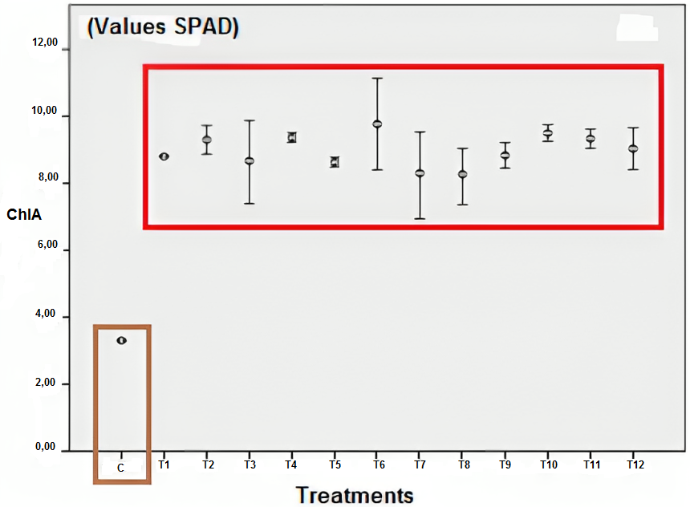

Figure 1: Chlorophyll A content behavior according to electromagnetic induction compared to control plants (The bars represent the error at 95% CI).

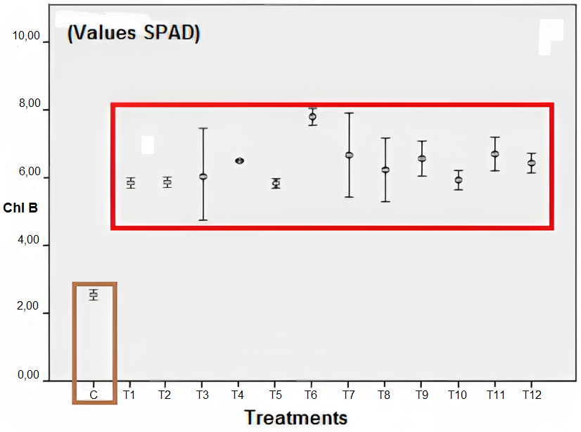

Figure 2: Chlorophyll B content behavior according to electromagnetic induction compared to control plants (The bars represent the error at 95% CI).

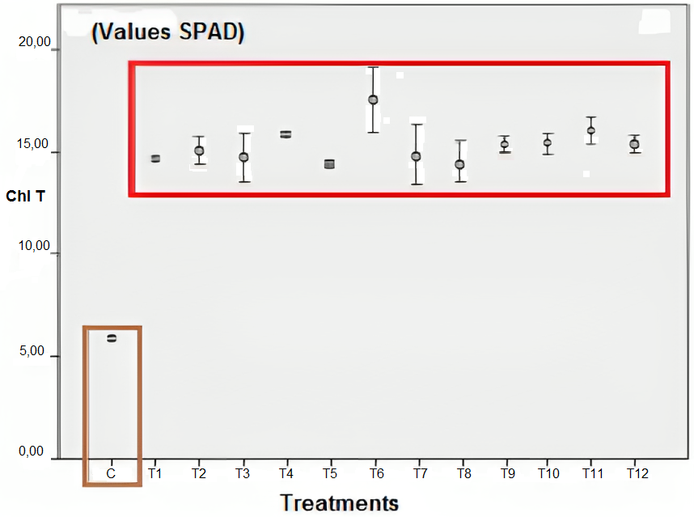

Figure 3: Behavior of total chlorophyll content according to electromagnetic induction compared to control plants (The bars represent the error at 95% CI).

The importance of analyzing photosynthetic pigments lies in the relationship between their content and photosynthetically active radiation (Dow and Bergmann, 2014), for the transformation of light energy into chemical at different wavelengths according to the light receptors in photosystem 1 (P700) and photosystem 2 (P680); which allows a higher rate of CO2 assimilation and synthesis of carbonaceous skeletons.

**3.3. Effects on growth and development variables**

When analyzing the contents of fresh and dry mass of the aerial part and of the root, it was observed that the Control (C) presented the highest values of dry mass accumulation for the root, this could be related to the slower growth of this organ, as well as to the processes of cell division and consequent slower elongation at the apical meristematic level. The Unifactorial ANOVA allowed inferring that there are differences in the Root Dry Mass score, according to the treatments employed (F=2.504; p<0.01). Thus, C accumulated 0.595 g, differing significantly from the rest of the treatments except T1, with T8 (0.363 g) and T12 (0.369 g) having the lowest values and in turn differing significantly from treatments T1, T5, T6, T7, T10 and the Control.

From the analysis of the aerial part in terms of fresh and dry mass, it was evident that the highest cumulative values were presented in T8 (aerial fresh mass: 1.597, aerial dry mass: 0.125), differing significantly from all treatments, except T12 for both variables. In both cases, the Unifactorial ANOVA corroborated that there are differences in the Dry and Fresh Mass score of the aerial part, according to the treatments used and the control (F=1.002; p<0.01). Likewise, the lowest values were presented in both cases by the control (aerial fresh mass: 0.6425, aerial dry mass: 0.0462), differing significantly from all treatments, except T2 in terms of aerial fresh mass. There is research evidence that coincides in that the positive response to magnetic or electromagnetic fields will depend on the time the seeds are exposed to it (Anaya, et al., 2015), its intensity, the growing conditions (environmental conditions), as well as the phytogenetic material (Suárez-Rivero, et al., 2018 b); since the response of different plants to these stimuli can be given to different combinations of magnetic fields and exposure times (Aladjadjiyan, 2010).

When analyzing the development indicators, it can be affirmed that the best behavior in terms of plant development is presented at T12 for TCC, TAC and TAN. This shows that the seeds that were induced with EMF reacted positively to this stimulus, for the indicators evaluated, which is closely related to figures 2 to 4, referring to the synthesis of photosynthetic pigments. On the other hand, dry mass values at the final moment of the experiment for the T12 treatment (118 µT with permanent exposure for 15 days) were 5.53 times higher than control plants, so it should be noted that biomass accumulation depends on growth kinetics and distribution rate, in addition to parameters governed by leaf area, climate and nutrient availability. Thus, both IAF and TAN are components of the crop growth rate (CGR) that measures the dry matter gain in a crop or group of plants in a specific area (Hay and Porter, 2006), which is consistent with the results obtained in terms of growth acceleration, leaf development, and which will later be observed in terms of crop yields with EMF application.

**3.4. Effects on productivity variables**

For the descriptive variables of the ear (see Table 1), except for ear weight (CW), the control (ears from plants not treated with EMF) showed the lowest values, differing significantly from the treatments. For the variable NH, although some treatments showed significant differences, at least 6 did not show significant differences with respect to the control; in this sense, this variable was little influenced by the EMF treatments. In addition, with respect to PT, the lowest values were found in T4 (23 µT permanently exposed for 15 days), differing significantly from the rest of the treatments and the control, although it is worth mentioning that this lower weight in the stem did not significantly affect yield with respect to the control.

On the other hand, when analyzing the significance of the variables under study, it can be seen that, except for NH, the highest values were found in T12 (118 µT permanently exposed for 15 days), which differs from all the treatments and the control. For the variable "yield in weight (t) of ear per hectare (ha) for corn under minimum tillage, as can be seen in the methodology, the yields of the control (2.46 ±0.2 t ha-1) are above the national average for yellow corn under traditional cultivation system (2.11 t ha-1 according to FENALCE, 2022). Likewise, the Federación Nacional de Cultivadores de Cereales, Leguminosas y Soya de Colombia (FENALCE) indicates that for this same type of corn (yellow corn) when cultivated in a technified manner, the national average for the year 2021 was 5.52 t ha-1, placing the yield of the control below this value; however, it is noteworthy that the control maintained a productive behavior in the interval of yellow corn cultivated traditionally and technified, which supports the veracity of the results obtained and allows comparison with the treatments previously established.

*Table 1. Ear characteristics and crop yield as a function of electromagnetic induction compared to control plants.*

| TREATMENT | PA (g) | PT (g) | PGr (g) | NH | Yield in cob  Weight (t ha-1) |
| --- | --- | --- | --- | --- | --- |
| Control | 61,57a ±0,06 | 35,68b ±0,02 | 25,89a ±0,05 | 10,44a ±0,7 | 2,46a ±0,2 |
| T1 | 111,52c ±0,14 | 38,09b ±0,07 | 73,44c ±0,09 | 10,78ab ±0,9 | 4,46c ±0,5 |
| T2 | 114,41c ±0,04 | 41,93c ±0,03 | 72,48bc ±0,01 | 10,75ab ±0,9 | 4,58c ±0,2 |
| T3 | 148,60f ±0,09 | 56,40f ±0,03 | 92,20e ±0,07 | 11,50bcd ±0,5 | 5,94f ±0,4 |
| T4 | 98,40b ±0,05 | 29,17a ±0,06 | 69,23b ±0,03 | 10,78ab ±0,8 | 3,94b ±0,2 |
| T5 | 154,03g ±0,06 | 52,79e ±0,03 | 99,40f ±0,08 | 11,00abc ±0,8 | 6,09f ±0,4 |
| T6 | 132,06e ±0,04 | 46,16d ±0,04 | 85,89d ±0,03 | 11,25abcd ±0,5 | 5,28e ±0,2 |
| T7 | 120,42d ±0,04 | 37,99b ±0,01 | 82,42d ±0,03 | 11,75bcd ±0,5 | 4,82d ±0,2 |
| T8 | 196,15i ±0,05 | 53,92ef ±0,06 | 142,23h ±0,04 | 11,85cde ±0,9 | 7,85h ±0,2 |
| T9 | 172,63h ±0,04 | 47,66e ±0,11 | 124,97g ±0,13 | 12,73e ±0,7 | 6,90g ±0,3 |
| T10 | 225,84j ±0,02 | 82,07g ±0,01 | 143,77h ±0,01 | 12,00de ±0,8 | 9,03i ±0,1 |
| T11 | 297,80k ±0,03 | 127,23h ±0,02 | 170,58i ±0,02 | 12,23de ±0,9 | 11,91j ±0,1 |
| T12 | 440,95l ±0,06 | 242,10i ±0,03 | 198,84j ±0,07 | 12,47bcd ±0,9 | 17,64k ±0,3 |

(Equal letters no significant difference, different letters significant difference. Significance level 0.05)

The yield results are closely related to the development of the photosynthetic apparatus, as shown in Figures 1 to 3. In the case of photosynthetic pigment synthesis, a significant stimulus was found with respect to the control, which could translate into greater efficiency in the development of photosynthesis and be one of the determining factors in crop yield.

Conclusions

Regarding the synthesis of photosynthetic pigments (chlorophylls A, B and total) analyzed in two moments in plants of *Zea mays* L. var Porva subjected to induced electromagnetic fields and comparing these results with control plants, showing a significant stimulation evidenced through the content of these.

The results show a higher growth rate with EMF stimulation, both of the root system and the aerial part of the plants treated with electromagnetic fields, keeping a close relationship with the development of the photosynthetic apparatus, the consequent production of biomass and its destination (accumulation, maintenance or use in the formation of new structures) for T8 (70 µT with permanent exposure for 15 days), as well as contributing positively to the reduction of the carbon footprint generated by agricultural processes.

The scientific relevance of this work lies in the significant stimulation of photosynthetic pigment synthesis in plants treated with electromagnetic fields, which is reflected in higher biomass production per unit area and lower agro-input consumption

Nomenclature

T1 - Field strength 23 µT for 60' for 15 days

T2 - Field strength 23 µT for 180' for 15 days

T3 - Field strength 23 µT for 300' for 15 days

T4 - Permanent 23 µT Field strength for 15 days

T5 - 70 µT Field strength for 60' for 15 days

T6 - Field strength 70 µT for 180' for 15 days

T7 - Field strength 70 µT for 300' for 15 days

T8 - Field strength 70 µT permanent for 15 days

T9 - Field strength 118 µT for 60' for 15 days

T10 - Field strength 118 µT for 180' for 15 days

T11 - Field strength 118 µT for 300' for 15 days

T12 - Field strength 118 µT for 15 days permanent

C - Control

Acknowledgments

To the Fundación Universitaria Agraria de Colombia - UNIAGRARIA, its laboratory section and the rest of the institutions named in the affiliation of the authors of this article, for having financed and supported the development of the project.

References

Agüero, C. G., Pereyra, G. R., Rolando, R. O.,2017, Método alternativo de germinación para determinar la calidad de semillas en Buffel Grass (*Cenchrus ciliaris* L.). Agriscientia, 34, 47-58. Disponible en: <https://pdfs.semanticscholar.org/8461/02b0bbcc50ce2f7e89fe99a5c07055a6696c.pdf>

Aladjadjiyan, A., 2012, Physical factors for plant growth stimulation improve food quality, food production-approaches, challenges and tasks. (Ed. Anna Aladjadjiyan), ISBN: 978-953-307-887-8. In Tech Publisher, 145-68, Rijeka, Croatia. DOI:10.5772/32039

AOAC, 1990, Métodos oficiales de análisis de la AOAC, 15ª ed. Métodos 932.06, 925.09, 985.29, 923.03. Asociación de químicos analíticos oficiales. Arlington, Virginia, Estados Unidos.

Dow, G. J., Bergmann, D. C., 2014, Patterning and processes: how stomatal development defines physiological potential. Current Opinion Plant Biol. 21, 67-74.

FENALCE, 2022, Federación Nacional de Cultivadores de Cereales, Leguminosas y Soya. Obtenido de <https://fenalce.co/estadisticas/>

Hay, R., Porter, J., 2006, The Physiology of Crop Yield. 2nd Edition, Blackwell Publishing, Oxford.

Ortiz-Aguilar, J., Suárez-Rivero, D., Puentes, A. E., Velásquez Perilla, P. E. y Santis Navarro, A. M., 2015, Comparison of the Effects in the Germination and Growth of Corn Seeds (Zea mays L.) by Exposure to Magnetic, Electrical and Electromagnetic Fields. Chemical Engineering Transactions. 43, 169-174. doi:10.3303/CET1543029

Sánchez-Soto, B. H., Pacheco-Aispuro, E., Lugo-García, G. A., Reyes-Olivas, Á., García-Moya, E., 2017, Métodos de escarificación en semillas de *Guaiacum coulteri*, especie amenazada del bosque tropical caducifolio del norte de Sinaloa, México. Gayana Botanical, 74(2), https://scielo.conicyt.cl/pdf/gbot/v74n2/0717-6643-gbot-74-02-00262.pdf

Suárez-Rivero D., Marin-Mahecha O., Ojeda-Barrera L., Ortiz-Aguilar J., Guzman-Hernandez T. de J., MillanMalo B., Alonso-Gómez L.A., Rodriguez-Garcia M.E., 2023, The effect of the electromagnetic field on the physicochemical properties of isolated corn starch obtained of plants from irradiate seeds, International Journal of Biological Macromolecules, 236, 123981, https://doi.org/10.1016/j.ijbiomac.2023.12398.

Suárez-Rivero D., Marín-Mahecha O., Ortiz-Aguilar J., Esperanza Puentes A., Ballesteros L.C., Suárez-Rivero M., 2018 a, Biotechnology as a Tool for the Agroindustrial Exploitation of Residues of the Chain of Musa spp., Chemical Engineering Transactions, 64, 571-576, https://doi.org/10.3303/CET1864096.

Suárez-Rivero, D., Marin-Mahecha, O., González, A. J., Suarez-Rivero, M., Puentes, A. E., Ortiz-Aguilar, J., 2018 b, Composition and behavior of sunflower seeds (Helianthus annuus L.) from plants treated with magnetic fields for energy potential use of biomass. Chemical Engineering Transactions. 65, 679-684. DOI: 10.3303/CET1865114.

Suárez-Rivero, D., Marín-Mahecha, O., Salazar Torres, V., Real, X., Ortiz Aguilar, J., Suárez-Rivero, M., 2017, Biomass Production And Morpho‐Phsysiological Effects On Sunflower Plants (Helianthus annuss L.) Under Induced Magnetic Fiels. Chemical Engineering Transactions. 57, 115-120. doi:10.3303/CET1757020

Suárez-Rivero, D., Ortiz-Aguilar, J., Marín-Mahecha, O., Velásquez, P., Acevedo, P., Santis, A., 2016, The Effect of Magnetic and Electromagnetic Fields on the Morpho-Anatomical Characteristics of Corn (Zea mays L.) during Biomass Production. Chemical Engineering Transactions. 50, 415-420. DOI: 10.3303/CET1650070.