|  |  |
| --- | --- |
| cetlogo ***CHEMICAL ENGINEERING TRANSACTIONS***  ***VOL. , 2024*** | A publication of  aidiclogo_grande |
| The Italian Association  of Chemical Engineering  Online at www.cetjournal.it |
| Guest Editors: Marco Bravi, Antonio Marzocchella, Giuseppe Caputo  Copyright © 2024, AIDIC Servizi S.r.l. **ISBN** 979-12-81206-10-6; **ISSN** 2283-9216 | |

Development of an Electrochemical Sensor for Nitrate Analysis in Municipal Wastewaters Treated by Microalgae

Serena Lima, Alice Spinoso, Bernardo Patella, Alessandro Cosenza, Francesco Giambalvo, Giuseppe Aiello, Rosalinda Inguanta, Giuseppe Caputo, Francesca Scargiali

Department of Engineering, University of Palermo, Viale delle Scienze Ed. 6, 90128, Palermo, Italy.

serena.lima@unipa.it

**Abstract**

Microalgae are photosynthetic microorganisms which may be employed in several fields. Amongst them, an emerging but promising sector of application is their usage for the remediation of wastewaters. They result particularly effective in treating municipal wastewaters, often resulting in nitrate concentrations exceeding the requirements for discharging treated wastewater into the sea. Furthermore, another advantage of using microalgae in civil wastewater treatment is the cooperation with heterotrophic bacteria which may naturally occur in the water or be introduced through sewage sludge in wastewater treatment plants (WTPs). Microalgae, in fact, produce oxygen which may be used by these bacteria reducing the overall operational costs of the WTP.

The assessment of nitrogen compound concentrations in wastewater involves various techniques, with ionic chromatography (IC) and spectrometric methods being commonly used in laboratory settings. However, these methods have drawbacks such as the need for skilled personnel, time-consuming processes, and impracticality for in situ and real-time analysis. To address these issues, electrochemical sensors present a viable alternative. These sensors require portable instruments with low power requirements and can be miniaturized using nanotechnology. Electrochemical sensors operate by reducing/oxidizing the target analyte on the working electrode surface. The choice of electrode material is crucial for sensor sensitivity, and copper is found to exhibit excellent electrocatalytic properties for reducing nitrate ions in acidic media.

In this study, a cost-effective electrochemical sensor made of copper was developed for quantifying nitrate in wastewater. The entire electrochemical cell was constructed from a common substrate used in Printed Circuit Boards (PCB). The whole fabrication procedure was optimized in order to obtain a reproducible fabrication procedure. The reference and counter electrodes were modified with graphite and Ag/AgCl paste, respectively. The results demonstrated that the sensor can effectively quantify nitrate ions in wastewater. Moreover, it can be employed during microalgal treatment to assess the in vivo reduction of nitrate, offering a practical and efficient solution for real-time monitoring of nitrogen compounds in wastewater treatment processes.

* 1. Introduction

Nitrate pollution is an increasing issue all over the world. This is mainly linked to the escalating use of fertilizers, aimed at maximizing crop productivity. It is now evident that less than 50% of the chemical fertilizers applied to the plant are absorbed by them, therefore the residuals may leach down and reach waters bodies and ground waters. The resulting increase of nitrate in surface waters causes uncontrolled algal blooms which in turn are connected to bacteria proliferation and hypoxia (Bijay-Singh & Craswell, 2021). Moreover, nitrates may also cause coronary artery disease, hyperthyroidism and their presence in the gastric system can lead to the formation of compounds with carcinogenic effects (Singh Tomar et al., 2024). To address this issue, nitrate must be removed from wastewater before disposal, and this treatment is typically conducted in wastewater treatment plants (WTPs). Microalgae have recently emerged as an alternative treatment method to the traditional tertiary treatment occurring in WTPs (Lima, Brucato, et al., 2022). Microalgae, being photosynthetic microorganisms with diverse applications, can accumulate valuable compounds useful for cosmetic or pharmaceutical industries (Lima, Lokesh, et al., 2022). Additionally, depending on the species, microalgae can be cultivated for use as food or supplements (Ferreira et al., 2023). Considering their ability to employ as nutrient polluting chemicals such as nitrate and phosphate, their usage in wastewater treatment has been recently considered. In fact, in photosynthetic microalgae, nitrate assimilation begins with a transport step into the cell, followed by a reduction to nitrite catalyzed by cytosolic Nitrate Reductase (NR). Nitrite is then transferred to the chloroplast, where the enzyme Nitrite Reductase (NiR) facilitates its reduction to ammonium. Ammonium is subsequently incorporated into amino acids via the action of synthetase/glutamine oxo-glutarate amino transferase or glutamate synthase (GS/GOGAT). The microalgal treatment for the decreasing of nitrate can be implemented in various ways; for instance, some microalgae may serve as the sole treatment for certain types of municipal wastewater, as they can also decrease carbon oxygen demand (COD) in some cases (Huang et al., 2023). Alternatively, they may be inoculated alongside activated sludge to enhance its action and increase nitrate and phosphate abatement. They can also be applied after activated sludge treatment as a secondary treatment (Baldisserotto et al., 2023). While decreasing the nitrogen content, analytical measurements of the pollutant are necessary to assess the treatment's effectiveness. To assess the concentrations of nitrogen compounds in wastewater, many techniques are available. One commonly used method is ionic chromatography (IC), which can precisely determine the concentration of various nitrogen containing ions present in the wastewater, mainly nitrates and ammonium. Another widely employed method involves spectrometric techniques that analyze total nitrogen (TN) in the sample by adding high toxic compounds such as 2,6 Dimethylphenol. However, both methods are typically carried out in laboratory settings, require skilled personnel, are time-consuming and are not suitable for in situ and real time analysis (Horf et al., 2022). To overcome these issues, electrochemical sensors can be used; indeed, they only need portable instruments with very low power requirements and the sensor can be downed in size by using nanotechnology. Electrochemical sensors work by reducing/oxidizing the target analyte at the surface of the working electrode (Patella et al., 2019). This reaction occurs at the surface of the working electrode and thus the choice of electrode material is crucial to have a high sensor sensitivity (Patella et al., 2022). In the case of nitrate ions, copper exhibits excellent electrocatalytic properties for their reduction in acidic media. For this reason, in this work, a simple and cost-effective electrochemical sensor made of copper was employed for nitrate quantification. Particularly, the whole electrochemical cell was obtained from the common substrate used to manufacture Printed Circuit Boards (PCB).

* 1. Materials and methods
     1. Algal growth

Microalga *Chlorella sp. CW2* was previously isolated from a real activated sludge and molecularly identified (Lima, Brucato, et al., 2022). The microalga was cultivated in a synthetic wastewater medium, the composition of which included the following components: glucose 221.7 mg L-1, NaNO3 160 mg L-1, CaCl2·(2H2O) 165 mg L-1, Na2SO4 63.37 mg L-1, K2HPO4 56.37 mg L-1, NaHCO3 200 mg L-1, EDTA (Na2 salt) 4.14 mg L-1, FeCl3 (6 H2O) 3.15 mg L-1, CuSO4 (5 H2O) 0.01 mg L-1, ZnSO4 (7 H2O) 0.022 mg L-1, CoCl2 (6 H2O) 0.01 mg L-1, MnCl2 (4 H2O) 0.18 mg L-1, Na2MoO4 (2 H2O) 0.006 mg L-1.

A pre-culture was prepared for each sample by inoculating 10 mL of stock culture into 100 mL of synthetic sewage. When the cells reached the late exponential phase, typically after about 8 cultivation days, 10 mL of the cell suspension were used to inoculate the main culture in the sewage medium. Cultures, consisting of 400 mL, were grown in 1000 mL Erlenmeyer flasks placed in an oscillating incubator (Corning Lse) under a photon flux of 200 μmol m-2 s-1 at 27°C. Light intensity was measured using a Delta Ohm-HD 9021 quantometer equipped with a Photosynthetic Active Radiation (PAR) probe (Delta Ohm LP 9021 PAR).

Throughout the 8-day cultivation period, the concentration of the microalgal suspension was regularly monitored by measuring the absorbance of the culture at 750 nm using a spectrophotometer (Cary 60 UV-Vis, Agilent Technologies). An experimental correlation between the dry weight (DW) and the optical absorbance at 750 nm was established as follows:

|  |  |
| --- | --- |
| DW=0.2315\*(Abs)750 nm+ 0.0264 | (1) |

* + 1. Technology for Sensor Fabrication

Once the copper plate of the sensors has been obtained through PCB (Printed Circuit Board) technology, to obtain the final configuration of the sensor it is necessary to modify the reference (RE) and the counter electrodes (CE) in order to make them stable. Therefore, prior modification the chip was polished with abrasive paper to remove the oxidation layer and then a layer of Ag/AgCl and graphite ink were deposited manually on the RE and CE, respectively. After modification, the chip was dried in oven at 60 °C for 30 minutes.

* + 1. Nitrate measurement

Electrochemical quantification of nitrate ions was carried out using Linear Scan Voltammetry (LSV) as detection technique. The reduction of nitrate to nitrite ions occurs at acidic pH thus solution pH was adjusted to 1 before test (adding drops of sulphuric acid 33%). Electrode sensitivity, linear range, and limit of detection (LOD) were obtained by adding nitrate ions (as sodium nitrate) from 0.62 to 620 ppm. In order to quantify nitrate ions content of wastewater after treatment with microalgae the standard addition method was carried out.

To confirm the functioning of the sensor, the nitrate content was analysed also through anionic chromatography (IC, Metrohm 882 Compact IC plus). A Metrosep A Supp 5 was employed using a 0.7 mL min-1 of a Na2CO3 3.2 mM and NaHCO3 1 mM aqueous solution. For each analysis, the sample was adequately diluted and, in some cases, filtered through a CHROMAFIX cartridge packed with C18 silica in order to remove all the organic content.

* 1. Results and discussion
     1. Microalgal growth and nitrate abatement

Figure 1: Growth curve of microalga Chlorella sp. CW2 in the synthetic sewage employed in the experiments.

Figure 1 shows a typical growth curve of the microalga *Chlorella sp. CW2* grown in batch in Erlenmeyer flask. The curve shows the typical exponential phase in the first hours of cultivation, while after the first 120 hours a decreasing of growth rate is observed, meaning that the algae are approaching the stationary phase in which the nutrients are insufficient to optimally support the growth. The microalga is therefore able to optimally grow in this sewage, and Figure 2 shows that the nutrients phosphates and nitrates are adequately decreased after during the growth. Therefore, *Chlorella sp CW2* can grow by using only nitrate as nitrogen source and is able to effectively decrease its concentration. It is worth noting that the analysis of the ions depicted in Figure 2 was performed through ionic chromatography, as described in section 2.3.

*Figure 2: Abatement of nitrate and phosphate during batch cultivation of Chlorella sp. CW2*

* + 1. Functioning of the sensor at varying concentrations of nitrate

Prior to monitor the abatement of nitrate ions by microalgae with the proposed chip, this was characterized in terms of sensitivity, reproducibility, repeatability and selectivity. To do so, tests were carried out using as blank a solution of 0.1M sodium sulphate at pH 1. The proposed chip has a very high sensitivity of -1.006 µA ppm-1 with a reproducibility and a repeatability of 18 and 0.93 %, respectively. The electrode selectivity was analyzed by testing the electrode in the same manner but adding interfering agents that can be present in real wastewaters or that must be added to enable microalgal growth. Results showed that none of the tested interfering agents showed a significant interference, confirming the good selectivity of the proposed method. Finally, the chip has been used to quantify nitrate ions abatement by microalgae grown in simulated wastewater by using the standard dilution method. Particularly, the sample was diluted with blank solution (0.1M sodium sulphate at pH 1) at 5 different ratios, from 5 to 15%. We found out that testing the simulated wastewater itself leads to a low sensitivity, probably due to some fouling effects (Figure 3A). For this reason, the microalgae and the organic content was filtered using a CHROMAFIX cartridge packed with C18 silica and the same test was carried out, finding out a much higher sensitivity (Figure 3B).

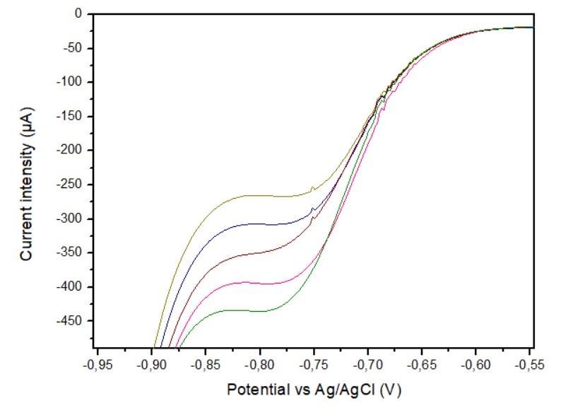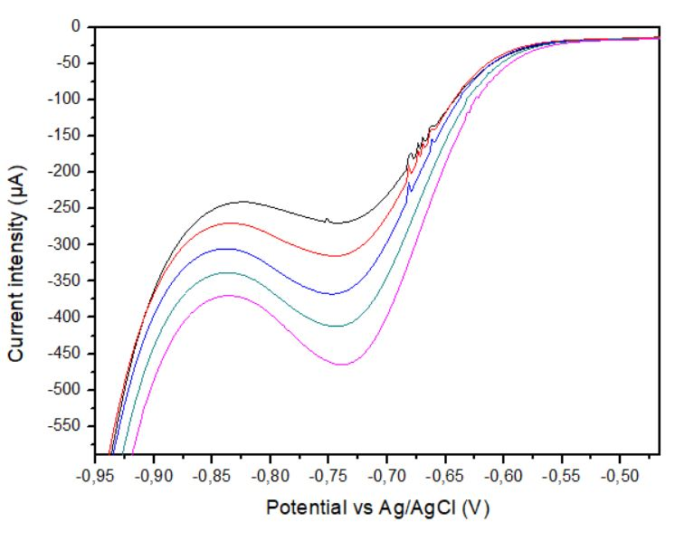

a

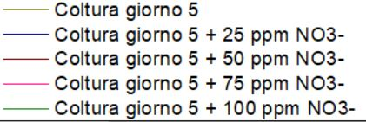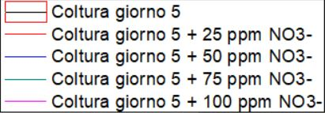

b

Culture day 5

Culture day 5 (+ 25 ppm of nitrate)

Culture day 5 (+ 50 ppm of nitrate)

Culture day 5 (+ 75 ppm of nitrate)

Culture day 5 (+ 100 ppm of nitrate)

Culture day 5

Culture day 5 (+ 25 ppm of nitrate)

Culture day 5 (+ 50 ppm of nitrate)

Culture day 5 (+ 75 ppm of nitrate)

Culture day 5 (+ 100 ppm of nitrate)

Figure 3: Standard addition of nitrate in the simulated wastewater with growing microalgae. a) Sample at day 5 of growth without further treatment b) sample at day 5 of growth in which all the organics were removed before the measurement.

Lastly, a simulated wastewater with an initial concentration of 117 ppm of nitrate ions was inoculated with microalgae and nitrate concentration was monitored day by day, for 1 week, using the proposed sensor and a standard ionic chromatography (IC). Particularly, Figure 4 shows the standard dilution method of the wastewater after 1, 2 and 7 days from the inoculum, Figure 4A, B and C respectively. As it is possible to see, the concentration of nitrate ions decreases with time confirming the ability of the microalgae to raze nitrate ions and of the sensor to quantify it. Furthermore, the same solutions were tested using standard IC and results are in line with that of the proposed method with a correlation factor R2 > 0.999.

a

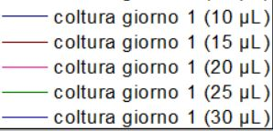

Culture day 1 (dilution ratio of 7 %)

Culture day 1 (dilution ratio of 10 %)

Culture day 1 (dilution ratio of 13 %)

Culture day 1 (dilution ratio of 17 %)

Culture day 1 (dilution ratio of 20 %)

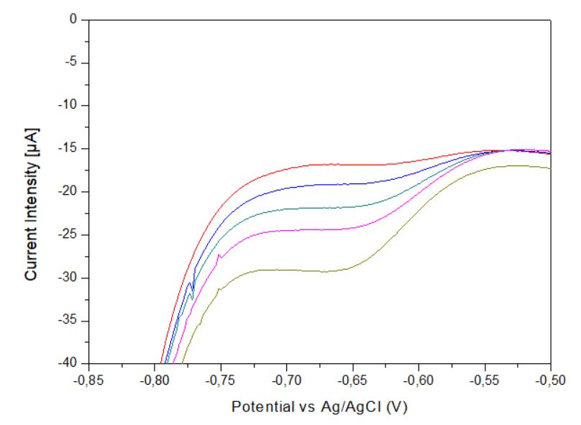

b

Culture day 2 (dilution ratio of 7 %)

Culture day 2 (dilution ratio of 10 %)

Culture day 2 (dilution ratio of 13 %)

Culture day 2 (dilution ratio of 17 %)

Culture day 2 (dilution ratio of 20 %)

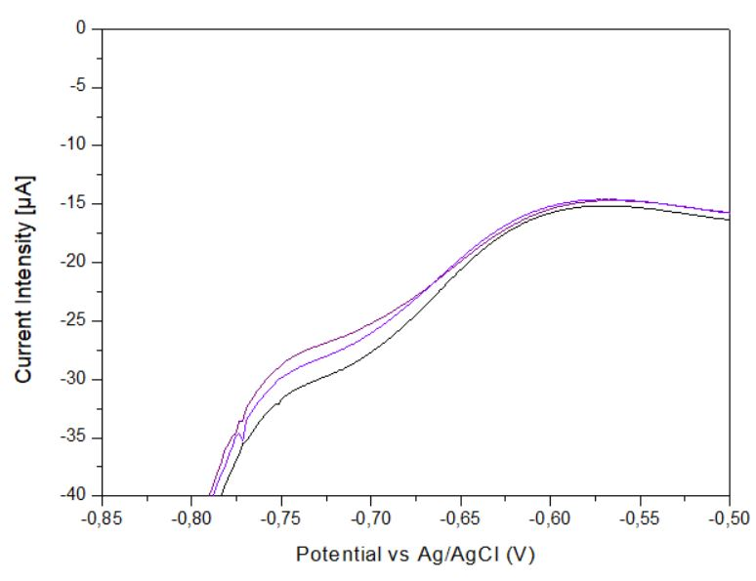

c

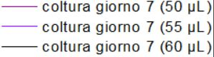

Culture day 7 (dilution ratio of 33 %)

Culture day 7 (dilution ratio of 37 %)

Culture day 7 (dilution ratio of 40 %)

Figure 4: Standard dilution of nitrate of simulated wastewater with growing microalgae. a) Sample at day 1 of growth b) sample at day 2 of growth c) sample at day 7 of growth.

* 1. Conclusions

In this research, a low-cost electrochemical sensor crafted from copper was created to measure nitrate levels in wastewater. The complete electrochemical cell was assembled using a common substrate found in Printed Circuit Boards (PCB). Graphite and Ag/AgCl paste modifications were applied to the reference and counter electrodes, respectively. The chip was applied to assess the abatement of nitrate in a synthetic civil wastewater by the microalgae *Chlorella sp. CW2*. Results showed that the microalgae can grow in synthetic sewage and efficiently reduce nitrate concentrations, indicating its suitability for the tertiary treatment of municipal wastewater. The chip used in the study underwent initial investigations through multiple tests, confirming the sensitivity and reproducibility of the method. Furthermore, the chip was directly applied to the microalgal culture, and the method for the detection was fine-tuned and customized to the microalgal presence. The findings indicated that the sensor is adept at accurately measuring nitrate ions in wastewater. Furthermore, it can be utilized in microalgal treatment to evaluate the real-time reduction of nitrate, providing a practical and effective means for monitoring nitrogen compounds during wastewater treatment processes.

Acknowledgments

This work was carried out with the co-funding of the European Union, European Social Fund – REACT EU, PON Ricerca e Innovazione 2014–2020, Azione IV.4 “Dottorati e contratti di ricerca su tematiche dell’innovazione” and Azione IV.6 “Contratti di ricerca su tematiche Green” (DM 1062/2021), and under the National Recovery and Resilience Plan (NRRP), Mission 4 Component 2 Investment 1.4 - Call for tender No. 3138 of 16 December 2021, rectified by Decree n.3175 of 18 December 2021 of Italian Ministry of University and Research funded by the European Union – NextGenerationEU; Award Number: Project code CN\_00000033, Concession Decree No. 1034 of 17 June 2022 adopted by the Italian Ministry of University and Research, CUP UNIPA B73C22000790001, Project title “National Biodiversity Future Center - NBFC”.

References

Baldisserotto, C., Demaria, S., Arcidiacono, M., Benà, E., Giacò, P., Marchesini, R., Ferroni, L., Benetti, L., Zanella, M., Benini, A., Benini, A., & Pancaldi, S. (2023). Enhancing Urban Wastewater Treatment through Isolated Chlorella Strain-Based Phytoremediation in Centrate Stream: An Analysis of Algae Morpho-Physiology and Nutrients Removal Efficiency. *Plants*, *12*(5). https://doi.org/10.3390/plants12051027

Bijay-Singh, & Craswell, E. (2021). Fertilizers and nitrate pollution of surface and ground water: an increasingly pervasive global problem. *SN Applied Sciences*, *3*(4), 518. https://doi.org/10.1007/s42452-021-04521-8

Ferreira, A., Figueiredo, D., Ferreira, F., Marujo, A., Bastos, C. R. V., Martin-Atanes, G., Ribeiro, B., Štěrbová, K., Marques-dos-Santos, C., Acién, F. G., Acién, F. G., & Gouveia, L. (2023). From piggery wastewater to wheat using microalgae towards zero waste. *Algal Research*, *72*. https://doi.org/10.1016/j.algal.2023.103153

Horf, M., Vogel, S., Drücker, H., Gebbers, R., & Olfs, H. W. (2022). Optical Spectrometry to Determine Nutrient Concentrations and other Physicochemical Parameters in Liquid Organic Manures: A Review. *Agronomy*, *12*(2). https://doi.org/10.3390/agronomy12020514

Huang, L., Xie, T., Wang, Y., Tan, S., Lu, Z., Wang, L., & Mo, C. (2023). Symbiotic treatment of ammonia-nitrogen wastewater by algae and activated sludge: effects of algae and sludge inoculation rates. *Environmental Technology*, *44*(18), 2807–2817. https://doi.org/10.1080/09593330.2022.2044919

Lima, S., Brucato, A., Caputo, G., Grisafi, F., & Scargiali, F. (2022). Inoculum of indigenous microalgae/activated sludge for optimal treatment of municipal wastewaters and biochemical composition of residual biomass for potential applications. *Journal of Water Process Engineering*, *49*(June), 103142. https://doi.org/10.1016/j.jwpe.2022.103142

Lima, S., Lokesh, J., Schulze, P. S. C., Wijffels, R. H., Kiron, V., Scargiali, F., Petters, S., Bernstein, H. C., & Morales-Sánchez, D. (2022). Flashing lights affect the photophysiology and expression of carotenoid and lipid synthesis genes in Nannochloropsis gaditana. *Journal of Biotechnology*, *360*(August), 171–181. https://doi.org/10.1016/j.jbiotec.2022.11.012

Patella, B., Aiello, G., Drago, G., Torino, C., Vilasi, A., O’Riordan, A., & Inguanta, R. (2022). Electrochemical detection of chloride ions using Ag-based electrodes obtained from compact disc. *Analytica Chimica Acta*, *1190*, 339215. https://doi.org/10.1016/j.aca.2021.339215

Patella, B., Sortino, A., Aiello, G., Sunseri, C., & Inguanta, R. (2019). Reduced graphene oxide decorated with metals nanoparticles electrode as electrochemical sensor for dopamine. *2019 IEEE International Conference on Flexible and Printable Sensors and Systems (FLEPS)*, 1–3. https://doi.org/10.1109/FLEPS.2019.8792267

Singh Tomar, S., Anand Omar, R., Bhaduri, B., Verma, N., & Nigam, K. D. P. (2024). Denitrification using a novel Ni-CNF/g-C3N4 catalyst and nitrate-enriched wastewater-resourced Achromobacter denitirificans. *Chemical Engineering Science*, *285*, 119617. https://doi.org/https://doi.org/10.1016/j.ces.2023.119617