|  |  |
| --- | --- |
| cetlogo ***CHEMICAL ENGINEERING TRANSACTIONS***  ***VOL. , 2024*** | A publication of  aidiclogo_grande |
| The Italian Association  of Chemical Engineering  Online at www.cetjournal.it |
| Guest Editors: Marco Bravi, Antonio Marzocchella, Giuseppe Caputo  Copyright © 2024, AIDIC Servizi S.r.l. **ISBN** 979-12-81206-10-6; **ISSN** 2283-9216 | |

Continuous Microbial Pb Removal by an Industrially Obtained Consortium Using an Upflow Anaerobic Sludge Blanket Reactor

Bayandza M. Manzinia, Carla Cilliers, Evans M N Chirwa, Hendrik G Brink\*.

University of Pretoria, Department of Chemical Engineering, University of Pretoria Main Campus, Corner Lynwood & Roper Street, Hatfield, Pretoria, 0002, South Africa

deon.brink@up.ac.za | deonbrink@gmail.com

The objective of the research outlined in this article was to gain a deeper understanding of the microbiome involved in the bioremoval of Pb under continuous flow conditions. A continuous lead removal system, utilizing an upflow anaerobic sludge blanket reactor (UASB) was employed to remove Pb(II) while monitoring factors such as microbial growth along with Pb(II) and nitrate concentrations at two axial heights in the system. The microbiome was assessed to identify any alterations resulting from changing the amounts of Pb(II) in the reactor feed. The UASB was operated under anaerobic conditions, and a nutrient-rich broth comprising exclusively of 5 g/L yeast extract (YE) along with 1g/L of sodium chloride (NaCl) served as the growth medium. The results indicated an effective, robust method of Pb(II) removal. In this study the growth medium was spiked with: 80, 500 and 1000 ppm of Pb(II). The results showed that lower concentrations of Pb(II) were effectively removed with only 5 g/L YE, suggesting a cost-effective option for Pb(II) bioremoval. A maximum Pb-removal rate of 350.6 ppm/d Pb(II) and a maximum specific growth rate of 2.25 per day were observed. Increased concentrations of Pb(II) resulted in reduced metabolic activity (MA) and Pb removal. As is, the system is able to achieve approximately 100% of lower concentrations of Pb and increasing the yeast extract concentration could improve the system. This is the first known study conducted on a continuous flow column Pb(II) removal system. It provides a basis towards developing methods to remove lead (and by extension other heavy metals) which can be carried out at ambient temperatures. This study also provides basis for development of methods to recover and reuse lead from industrial effluents and lead waste sites.

* 1. Introduction

Lead (Pb) is amongst the most toxic and noxious heavy metals and is a major pollutant of soil, plants and water. Therefore, the removal and recovery of heavy metals is of maximum importance (Chatterjee, et al., 2014). Pb is one of four heavy metals known to be most damaging to human health. The other heavy metals in this category are cadmium, mercury, and arsenic. Pb can affect the peripheral and central nervous systems, along with having detrimental effects on the kidneys and blood pressure (Tiwari, et al., 2013). It has also been observed that lead has the propensity to accumulate in human bones. This results in a subsequent gradual release of lead in the body even after a long period of time has elapsed following exposure (Needleman, 2004), too much of which can result in lead poisoning with side effects such as: mental retardation, behavioural disorders as well as low sperm count in men if concentration exceeds 0.4 ppm in the blood (Horstmann & Brink, 2019). As reported by Naik and Dubey (2013), anthropogenic activities have led to an increase in the accumulation of lead in the environment which is over 1000 times greater than it was 300 years ago. This increase of Pb concentration in the environment is correlated to activities such as metal working and the use of Pb-additives in products such as paints and gasoline. These multiple functions of lead also result in the Pb recirculation cycle which has been observed to be a far more potent cause of Pb pollution in the environment than the natural Pb cycle. (Brink, et al., 2019).

Human exposure to Pb(II) occurs through the ingestion of contaminated food and water along with the inhalation of aerosols and dust particles (Chimhundi, et al., 2021). According to the WHO the threshold limits of Pb(II) in drinking water are 0.05ppm, the Environmental Protection Agency also uses this same threshold limit for industrial wastewater discharge (Arbabi, et al., 2015). For these reasons, a suitable and effective treatment method for Pb(II) contaminated water and wastewater is required.

In order to reduce the potential detrimental effects on water sources and the environment there are already several treatment methods in place. These conventional treatment methods which are already in the implementation phase include: sand filtration, Granular Activated Carbon (GAC) adsorption, precipitation sedimentation and ion exchange (Brink, et al., 2019). These methods have shown efficacy in removing a variety of toxic heavy metals such as Cd, Pb, Fe and As from water (Brink, et al., 2019). The major disadvantage of relying on these methods is that they display non-selectivity, low efficiency, costly steps and increased waste production. These process usually also require high activation energy to initiate the reactions required for lead reduction. This indicates a necessity for economically viable and environmentally conscious alternatives (Ngwenya & Chirwa, 2010).

It has been noted by some researchers that not enough alternatives have been developed to offset this reliance on these previously mentioned techniques. Hence it is of great benefit to both human and environmental health that they should be researched and developed (Tiquia-Arashiro, 2018). It would also be of major consequence that these developments also factor in the recovery of lead from waste sites (for example mining tailings) and industrial effluents. This is because the current global depletion rate of lead is estimated to be at 5 Mt/Year while the reserves stand at 85 Mt, the consequence of this is an estimation that the reserves will be depleted within the next 15-17 years (Chimhundi, et al., 2021). Existing recovery processes have proved to be disadvantageous in that they produce toxic waste in high volumes which have hazardous waste disposal processes while being high cost (Chimhundi, et al., 2021).

Taking this into consideration, along with other work done by researchers to study the capability of biological removal and recovery of Pb this current study was conducted. Some researchers have shown that removing Pb from water and wastewater using biological means is possible, these studies have mostly been conducted using microorganisms as biosorbents using dead or reconditioned biomass (Brink, et al., 2019). The possible mechanisms which lead to removal of Pb which have been noted include; reducing soluble Pb(II) to its insoluble elemental Pb form, biosorption of Pb and bioprecipitation of Pb (Brink, et al., 2019).

In this current study, a locally sourced industrial consortia of bacteria was used in a UASB to continuously remove Pb(II) from an aqueous environment. The effects of Pb(II) concentrations along with nutrient concentrations in the feed were also noted to gather more insight into the behaviour of the microbiome during continuous Pb(II) removal.

* 1. Experimental methods and materials
     1. Reactor design and sampling

The UASB reactor was designed based on the work which was presented in the study by Chimhundi, et al. (2021). The design was altered by introducing the flow of feed from the bottom of the column. There are 4 possible points of egress for the effluent along the column height and two of these points along the axial height, named ports 1 and 3 respectively, were employed as the sample points for the study. The fourth port was used as for the overflow to a waste collection point. The column was placed in a warm room which was maintained at temperatures between 30-35⁰C and the reactor feed was placed in a separate room which is kept at 5⁰C. The column and feed were kept in separate rooms as a measure to prevent chances of cross contamination via growth into the feed, the feed was spiked with the relevant Pb(II) concentrations with 5 g/L of Yeast Extract and 1 g/L of NaCl. The fed was pumped at a constant flow of 0.86 mL/min which is equivalent to 1238 mL/day and a Hydraulic Residence Time (HRT) of 8 days. The feed was dripped into the column using a dripper system into the feed line. Figure 1 is a visual representation of the UASB column.

Samples were taken daily by removing 10 mL from the column. In order to ensure that each sample was representative of the column contents the first 10 mL was discarded to empty the sampling tube. Prior to conducting any sampling or any analysis of the column contents the reactor was primed at a constant concentration of 80 ppm Pb(II) for a period of one month, inoculated with the consortium preculture, after which the official experimentation commenced. PbCl tends to precipitate at lower temperatures (like in the cold room), this led to lower Pb(II) concentrations being measured in the feed. This discrepancy is accounted for by reporting both the theoretical (predicted) Pb concentration along with the actual measured value which is in the feed stream. The study was conducted over a 21-day period. During this period the reactor was loaded with three different concentrations of Pb 80, 500 and 1000 ppm respectively. The experimental timeframe is shown in figure 2.

*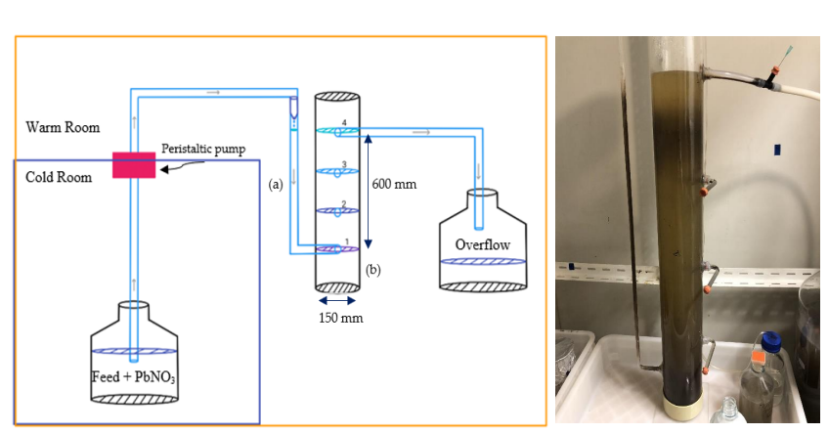Figure 1: Upflow Anaerobic sludge blanket reactor (UASBR) column design alongside real image*

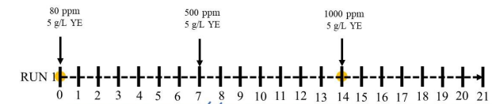

Figure 2: Experimental timeframe (days)

* + 1. Microbial culture preparation

The Pb(II) resistant microbial consortium was obtained from a borehole at an automotive-battery recycling plant in Gauteng, South Africa (Brink, et al., 2017). The initial inoculum was prepared by adding 1 g of Pb(II) contaminated soil to LB broth spiked with 80 ppm Pb(II) in a 100 mL anaerobic serum bottle, which was then incubated for 24 h at 32 °C and 120 rpm. The inoculum was cryogenically stored with glycerol at a final ratio of 20% v/v at -77 °C. Precultures were prepared from the stored inoculum by inoculating 100 mL anaerobic serum bottles spiked with approximately 80, 500, and 1000 ppm Pb(II) respectively. The serum bottles were sealed and incubated at 30°C and 120 rpm until precipitation was visible. The new precultures were again cryogenically stored for direct inoculation of the experiments (Brink, et al., 2019).

* + 1. Materials

The reactor feed was spiked with a lead stock solution prepared with Pb(NO3)2 (Merck, Kennelworth, NJ), the growth medium contained 5 g/L of Yeast extract (YE) and 1 g/L NaCl. Viable cell activity was assessed using 3-(4,5-Dimethylthiazol-2-yl)-2,5-Diphenyltetrazolium Bromide (MTT) and dimethyl sulfoxide (DMSO) (Sigma Aldrich, St Louis, MO) (Chimhundi, et al., 2021).

* + 1. Ion Measurements

Pb(II) and NO3- ions were measured using Ion Chromatography (IC). A 940 Professional IC vario ion chromatography (Metrohm, Herisau, Switzerland) with a Metrosep C 6–250/4.0 (Metrohm, Herisau, Switzerland) separation column and C 6- eluent- 8 mM oxalic acid (Metrohm, Herisau, Switzerland) was used. Pb(II) was measured by UV-Vis (Metrohm, Herisau, Switzerland). The wavelength used was 520 nm with a post-column reagent PAR (pyridylazoresorcinol: Thermo Fisher Scientific, Waltham, Massachusetts, United States) with HNO3 (Glassworld, Robertville, Johannesburg, South Africa) and NH4OH (25%) (Glassworld, Robertville, Johannesburg, South Africa) (Tendendzai, et al., 2022).

* + 1. Growth

MTT was used as a growth analysis to directly measure viable cell activity directly after sampling similar to the work done by Wang, et al (2010). Two measurements were taken of each sample, namely a measurement with biomass and a measurement without; to eliminate background noise and act as a zero for quantification. The measurement without biomass was obtained by filtering each sample with 25 mm nylon syringe filters with 0.45 μm pores (Anatech, Olivedale, Johannesburg, South Africa). The pre-made MTT stock solution was then added to both the filtered and unfiltered samples and incubated for 60 min at 35 °C. The treated samples were then dissolved using DMSO and their absorbance measurements were obtained at 550 nm, indicating a measurement of cell viability.

* 1. Results and discussion
     1. Lead Removal

The initial nitrate and lead concentrations were measured and are presented in the table below. True inlet concentrations are presented along with the theoretical (predicted) concentrations.

Table 1: Initial UASB reactor feed Pb(II) and Nitrate concentrations

|  |  |  |
| --- | --- | --- |
| Anticipated initial Pb(II) concentration (ppm) | True inlet Pb(II) concentration (ppm) | Inlet nitrate concentration (ppm) |
| 80 ppm (A) | 69.6 | 42.7 |
| 500 ppm (C) | 210.8 | 326.4 |
| 1000 ppm (D) | 357.0 | 680.4 |

Figure 3 displays the measured Pb(II) concentrations. The measured concentration from port 1 is shown by the blue line with blue circular markers and port 3 is represented by the grey line with grey square markers. The horizontal lines indicate the feed Pb concentration. The graph has been split into sections (A,C and D) to reflect the inlets described in table 1. The figure is followed by figure 4 which is a visual representation of the progression of the reactor from the 14th day to the 21st day.

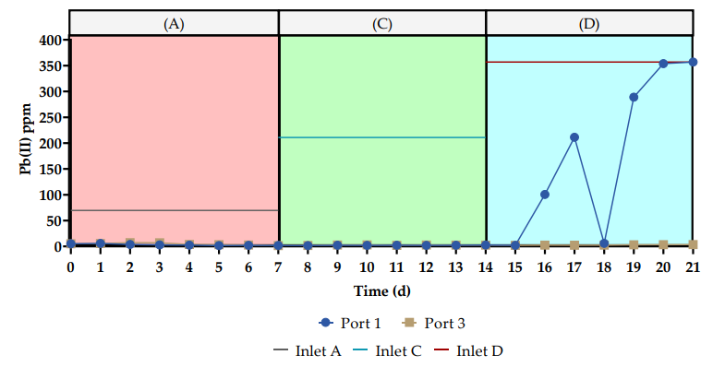

Figure 3: Pb(II) concentrations measured at ports 1 and 3 respectively

Figure 3 shows that biological removal of Pb from aqueous environments is indeed possible with the use of the bacterial consortium. The advantage of this observation is that the process displays success in continuous lead reduction performed at ambient temperatures without high activation energy required. In addition to this, the use of live biomass is a positive shift from the use of dead or reconditioned biomass. In live biosystems enzymes act as catalysts which allow the reactions to continue at ambient temperatures without the need of introducing chemical catalysts (Brink, et al., 2019). Up to day 15 there is near complete removal of Pb from samples taken at both ports, the removal is only hindered at the maximum inlet Pb concentration. After day 14 the Pb concentrations were higher at port 1 than port 3. The primary cause of this observation is the high feed concentration at this point. The system was put under stress and the nutrient availability was not sufficient leading to hindered lead removal. In addition to this, with reference to figure 4, it is observed that there is significant precipitate production. Lead exists in a liquid or solid form at temperatures below 1749°C indicating the detected lead is from the precipitate or is in liquid state (Brown, et al., 2000). Because the samples at port 3 reflect that Pb was removed completely at this height the liquid phase cannot be the major cause of lead being picked up in the samples. The lead was only detected in the lower region of the reactor where the precipitate was most concentrated. The observations in the study by Chimhundi, et al. (2021) showed that the precipitate in the study is likely to contain PbS, PbSO4 and Pb0 which would contribute to higher concentrations of lead at the bottom of the column. The washout of the precipitate also presents a possible avenue in lead recovery. The precipitate containing lead can be recovered and used as feed to a lead sintering process.

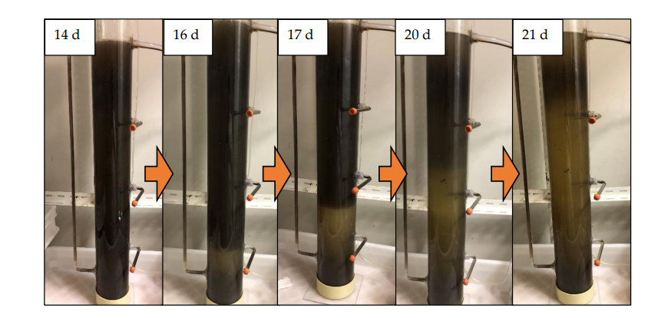

Figure 4: Visual progression of the UASB reactor from day 14 to the end of the run

In figure 5 the metabolic activity of the microbiome is presented. From the figure it is observed that up until day 15 there was significant metabolic activity which gradually decreased. This lends support to the above observations that the system is robust enough to handle Pb concentrations up to 1000ppm, however there is a breakpoint which is reached at this elevated lead concentration. At this concentration nutrient starvation is observed and an increase in nutrient availability would improve lead bioremediation.

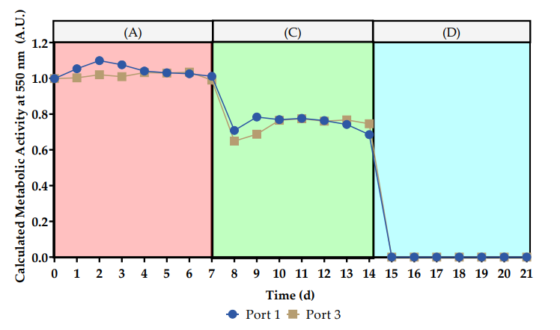

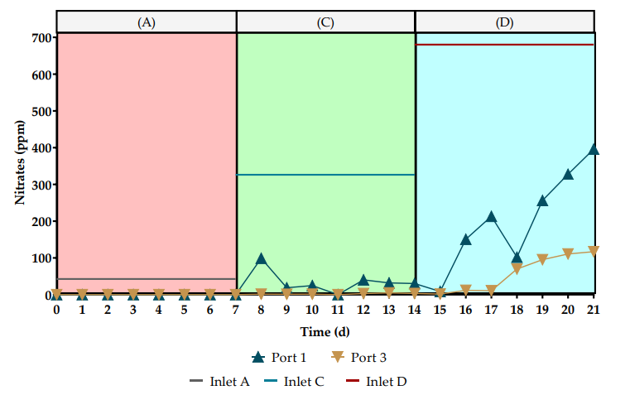Figure 5: Calculated metabolic activity of the microbiome

Figure 6: Change in nitrate concentrations over 21 days

Microbial metabolic and detoxifying mechanisms involving Pb(II) include anaerobic denitrification, and biotransformation (M.M & Dubey, 2013). In figure 6, it is shown that at lower concentration of Pb(II) nitrate concentrations are low showing denitrification as the primary detoxifying mechanism up to the 8th day. Between day 8 and 14 nitrate concentrations increase with an increase in inlet Pb(II) concentration, however Pb(II) removal is maintained. This indicates that secondary detoxifying mechanisms such as biosorption are prevalent. After day 15 high nitrate concentration along with high Pb(II) concentrations show that bioremoval is hindered at this high concentration with denitrifying processes and secondary detoxification mechanisms being inactive in this range. This indicates that the high lead concentration triggered significant loss of biomass which is expected because moderately high concentrations of lead can result in acute or sudden changes to ecosystems (Papp, et al., 2006). However, the loss of biomass could have also occurred during the precipitate washout.

* 1. Conclusions

This paper describes the observations made while operating a UASB reactor under continuous anoxic conditions to remove Pb(II) from an aqueous environment. Nitrate concentrations, metabolic activity and Pb concentrations were measured over a 21-day period to monitor the capabilities of the microbiome when exposed to three different concentrations of Pb(II). The system is robust enough to handle concentrations up to 1000 ppm but it can be noted that 5 g/L of YE as a nutrient concentration leads to a breakpoint in the system after 15 days of extraction which is evident in port 1, but port 3 shows near complete removal even at high concentrations. During operation of the continuous reactor ~99% lead removal was observed during the first 15 days at both ports, this removal percentage continued at port 3 only after the 15th day. These findings are supported by inactive denitrifying processes, high Pb(II) concentrations and decrease in metabolic activity after day 15. The recommendation would be to increase the concentration of nutrients in order to achieve prolonged removal. As is, the system is able to achieve reduction of lower concentrations of Pb and increasing the YE concentration would improve the system overall because the nutrient availability would be significantly improved. The precipitate washout presents a possible avenue in lead recovery, improving this process would lead to new possibilities in remediation and recovery of lead from waste sites and polluted environments and water sources.

# References

Arbabi, M., Hemati, S. & Amiri, M., 2015. Removal of Lead ions from industrial wastewater: A review of removal methods. *International Journnal of Epidemiological Research ,* 2(2), pp. 105-109.

Brink, H. G., Hörstmann, C. & Peens, J., 2019. Microbial Pb(II)-precipitation: the influence of oxygen on Pb(II)-removal from aqueous environment and the resulting precipitate identity. *International Journal of Environmental Science and Technology,* Volume 17, pp. 409-420.

Brink, H. G., Lategan, M., Naude, K. & Chirwa, E. M., 2017. Lead Removal Using Industrially Sourced Consortia: Influence of Lead and Glucose Concentrations. *Chemical Engineering Transactions ,* Volume 57, pp. 409-414.

Brown, T. L., Lemay, E. H. & Bursten, B. E., 2000. *Chemistry: The Central Science.* 8th ed. s.l.:Prentice Hall Inc .

Chatterjee, S., Mukherjee, A., Sarker & Rpy, P., 2014. Bioremediation of lead by lead resistant microorganisms, isolated from industrial sample. *Advanced Biotechnology,* Issue 3, pp. 290-295.

Chimhundi, J., Hörstmann, C., Chirwa, E. & Brink, H., 2021. Microbial Removal of Pb(II) using an Upflow Anaerobic Sludge Blanket (UASB) Reactor. *Catalysts ,* 11(4), p. 512.

Horstmann, C. & Brink, H. G., 2019. Microbial Lead (II) Precipitation: The influence of Zn(II) and Cu(II). *Chemical Engineering Transactions ,* Volume 74, pp. 1447-1452.

M.M, N. & Dubey, S., 2013. Lead Resistant Bacteria: Lead Resistance Mechanisms, Their Applications in Lead Bioremediation and Biomonitoring. *Ecotoxicology and Environmental Safety ,* Volume 98, pp. 1-7.

Needleman, H., 2004. Lead Poisoning. *Annual Review of Medicine ,* 55(1), pp. 209-222.

Ngwenya, N. & Chirwa, E., 2010. Single and binary component sorption of the fission products Sr2+, Cs+ and Co2+ from aqueous solutions onto sulphate reducing bacteria. *Minerals Engineering ,* 23(6), pp. 463-470.

Papp, A., Pecze, L., Szabó, A. & Vezér, T., 2006. Effects on the central and peripheral nervous activity in rats elicited by acute administration of lead, mercury and manganese, and their combinations. *Journal of Applied Toxicology: JAT,* Volume 26, pp. 374-380.

Tendendzai, J. T., Chirwa, E. M. & Brink, H. G., 2022. Enterococcus spp. Cell-Free Extract: An Abiotic Route for Synthesis of Selenium Nanoparticles (SeNPs), Their Characterisation and Inhibition of Escherichia coli. *Nanomaterials ,* Issue 2022, pp. 1-13.

Tiquia-Arashiro, S. M., 2018. Lead absorption mechanisms in bacteria as strategies for lead bioremediation. *Applied Microbiology and Biotechnology,* Volume 102, pp. 5437-5444.

Tiwari, S. et al., 2013. Effects of Lead on Environment.. *International Journal of Emerging Research in Management & Technology,* 2(6), pp. 1-5.

Wang, H. et al., 2010. An improved 3-(4,5-dimethylthiazol-2-yl)-2,5-diphenyl tetrazolium bromide (MTT) reduction assay for evaluating the viability of Escherichia coli cells. *Journal of Microbiological Methods,* 82(3), pp. 330-333.