 CHEMICAL ENGINEERING TRANSACTIONS  VOL. , 2024 | A publication of  
The Italian Association
of Chemical Engineering
Online at www.cetjournal.it

Guest Editors: Marco Bravi, Antonio Marzocchella, Giuseppe Caputo
Copyright © 2024, AIDIC Servizi S.r.l.
ISBN 979-12-81206-10-6; ISSN 2283-9216

Comparative Evaluation Between a Non-Toxic Biodetergent and a Commercial Degreaser for Industrial Use

Rita de C. Freire Soares da Silvaª, Charles B. Barbosa Fariasª, Fabíola C. Gomes de Almeidaª, Ivison A. da Silva^{a,c}, Leonie Asfora Sarubbo^{a,b,c}

ª Advanced Institute of Technology and Innovation - IATI, Rua Potira, n. 31, Prado, 50751310, Recife, Pernambuco, Brazil.
^{b} Catholic University of Pernambuco, Rua do Príncipe, n. 526, Boa Vista, CEP: 50050-900, Recife, Pernambuco, Brazil.
^{c} Northeast Biotechnology Network (RENORBIO), Federal Rural University of Pernambuco, Rua Dom Manuel de Medeiros, s/n, Dois Irmãos, CEP: 52171-900 Recife, PE, Brazill.

To clean surfaces contaminated by petrochemicals, industries use products formulated with substances harmful to the environment and the health of workers. The search for natural and biodegradable tensoactive composts is most necessary. Nesse sense, the development of degreasers and non-toxic detergents formulated from natural sources can be a solution. Based on these needs, many companies offer products claiming to be biodegradable, non-toxic and environmentally compatible. Therefore, this work aimed to carry out comparative tests between a biodegradable and non-toxic biodetergent, produced from vegetable inputs and a commercial degreaser with the same purpose. In this sense, the efficiency of the products was evaluated in of tin removing OCB1 fuel oil from smooth and metallic surfaces, the destabilization capacity of heavy oil in was determined in relation to a time of 5 minutes and its toxicity using cabbage seeds (Brassica oleracea) and microcrustacean larvae (Artemia salina) as indicators. The comparative tests between the two formulations demonstrated very satisfactory results in favor of the biodetergent. Regarding the evaluation of the products for OCB1 removal efficiency, the biodetergent showed satisfactory results, with 100% removal of the oil impregnated on smooth and metallic surfaces and 90% for the commercial product. For the destabilization capacity in relation to time, the biodetergent demonstrated total destabilization of the petroderivative in just 2 minutes, whereas the commercial product required twice as long for partial destabilization of the oil. The ecotoxicological tests demonstrated the absence of toxicity of the detergent formulated with biosurfactant and for the commercial degreaser and a mortality rate of 100% was observed for the indicator organisms. Therefore, the biodetergent demonstrates superior efficiency in relation to commercial degreaser and safer and more reliable chemical and toxicological characteristics for human health and the environment.

  - Introduction

The increasingly automated industrial processes use a large amount of oil to make their activities feasible, as in the case of the thermoelectric plants that they use of fuel oil (OCB1). Thus, the generation of oily waste arising from the operation, maintenance and cleaning of parts, floors and equipment arouses the concern of companies with the environment and the health of workers (Rocha e Silva et al., 2019; Farias et al., 2021). The detergents that have been commonly used by industries powered by fuel oil in the main stages of the washing process of parts, equipment, floors and machines, are synthetic derivatives of petroleum, and therefore have a high degree of toxicity, which can generate secondary hazardous waste such as BTEX and HAP's, which can cause irreversible effects over time in different environments (Rocha e Silva et al., 2019). In addition, most of these commercial detergents / degreasers contain petroleum-based solvents, many of which are not biodegradable and persist in the environment (Selva Filho et al., 2023). In this context, the advancement of sustainable technologies has increasingly driven the search for natural and biodegradable surfactant compounds, which reduce impacts on the environment and guarantee the health of workers (Durval et al., 2019; Sarubbo et al., 2022). Therefore, this work aims to comparatively evaluate the efficiency and toxicity between a biodetergent formulated from natural components and a commercial degreaser for use in the petroleum industry.
  - Material and Methods

2.1 Material
Organic vegetable solvent (fatty acid ester), natural surfactant, stabilizing gum and water. All compounds were purchased from local stores (Recife-PE/Brazil).
The commercial degreaser was provided by a company that operates in the oil sector. Second to the company, the product is ecologically correct, produced based on vegetable oils and surfactant additives.
The OCB1 heavy oil (PETROBRAS, Brazil) was supplied by Centrais Elétricas de Pernambuco S.A. (EPESA). This oil is a complex mixture of hydrocarbons. Its kinematic viscosity at 60°C is 620 Cst, its glow point is 66°C and its density at 20°C is 0.968 g/mL.
2.2 Biodetergent production
The biodetergent was formulated by biodegradable and non-toxic components such as, natural surfactant classified as a fatty alcohol (2.0%), 0,5% de emulsion stabilizing gum and 0,5% de isolated biosurfactant from Pseudomonas aeruginosa ATCC 10145. The liquid components of the formulation, such as the vegetable organic solvent and water, had their concentrations maintained according to previous studies, 20.0% and q.s.p to complete 100%, respectively (Farias et al., 2022).
2.3 Oil removal test from contaminated surface
A glass blade of known mass had part of its area uniformly contaminated with 100 μL of OCB1 oil. The contaminated section of the slide was immersed in the test solution (Biodetergent) for 3 minutes. Then, the slide was immersed in distilled water, removing excess test solution and destabilized residues from the surface. Finally, the slide was dried in an oven at 40 ° C for 30 minutes and its weight noted (Cavalcanti et al., 2020). The removal rate was calculated using the formula:

I = 100 x $\frac{(Mc-Ml)}{(Mc-Mi)}$$\frac{(Mc-Ml)}{(Mc-Mi)}$ (1)

Where Mc represents the weight of the contaminated blade, MI the weight of the post-wash blade and Mi the
initial weight of the blade.

2.4 Metal surface wash
The process was carried out with metallic pieces (nuts) uniformly impregnated by immersion in OBC1 oil. The impregnated parts were subsequently immersed in the test samples (biodetergent) for 10 min, then the parts were immersed in distilled water, removing excess test solution and destabilized residues from the surface. The removal efficiency was visually qualified (Farias et al., 2021b).

2.5 Determination of the destabilization capacity of heavy oil
The products are applied in their concentrated form. Petri dishes, made of glass with 12 cm diameter, previously weighed to confirm their initial weight, then their surface surfaces homogeneously impregnated with heavy oil and left to rest for 24 hours to guarantee greater fixation of the oil. Subsequently, the plates impregnated with oil were weighed again to determine the quantity of oil. A volume of 10 mL two products is added to the layer of oil impregnated on the plates, spread without manual adjustment and ready for the oil adjustment time of 5 minutes. After destabilizing the oil, the plates are washed in distilled water, without manual assistance, removing any excess of the test solution and the destabilized oil derivative. These are then dried in an oven at 50 °C for 30 minutes and then returned to room temperature after their recorded weight. The removal was accompanied by photographic recording after each test carried out and the removal rate was calculated using the formula:

I = 100 x ((Mc-Ml))/((Mc-Mi)) (2)

Where Mc represents the weight of the contaminated plate, Ml the weight of the plate after washing and Mi the initial weight of the plate.

2.6 Ecotoxicological tests
The toxicity test was carried out using microcrustacean larvae (Artemia salina) as an indicator of toxicity, with test solutions of two products diluted in proportions of 1:1, 1:2 and 1:3 (v/v) prepared in distilled water and used in concentrations of 1 and 2%. The larvae were observed for 24 hours to calculate mortality (MEYER et al., 1982). The phytotoxicity of the products was evaluated in a static assay by seed germination and root growth of Solanum lycopersicum (tomato) and seeds of cabbage (Brassica oleracea var. Capitata L.), according to Tiquia et al. (1996). Test solutions were prepared in proportions of 1:1, 1:2 and 1:3 (v/v) in distilled water in concentrations of 1 and 2%. After five days of incubation in the dark, seed germination, root growth (≥ 5 mm) and germination index (GI) were calculated according to the formulas below:
Relative germination of the seed (%) = (number of seeds germinated in the extract / number of seeds
germinated in the control) x 100
  - Results and discussion
During the execution of tests, it was possible to observe and compare the organoleptic characteristics of the two products, such as creamy appearance, light or pearly color, soft or strong odor, fluid and homogeneous consistency. Regarding appearance, we have some similarities between the products, that it refers to homogeneous consistency of the formulations and a subtle differentiation in terms of color, both being clear. Also, both products are emulsified, they contain hydrophobic fractions (solvent and surfactants) and hydrophilic (water thickeners). However, there is a big difference in the type of solvent contained in the tested formulations, or biodetergent is composted by an organic solvent of vegetable origin, and does not present odor, on the other hand, the commercial degreaser, according to its Material Safety Data Sheet (MSDS), contains aliphatic hydrocarbons such as solvent in larger quantities (60% of the formula), which characterizes a very accentuated Naphtha odor.

    - Heavy oil removal test on smooth surface
This comparative study does seek to analysed the removal capacity of the products in the study, where tests were carried out with various concentrations of the products solubilized in water. The aim is to determine the ability to dissolve heavy oil residues, keeping them dispersed in the solution, preventing their redeposition and guaranteeing their complete elimination during the rinse. The products demonstrate promise in removing the OCB1 oil, so some particularities can be observed (Figures 1-3).
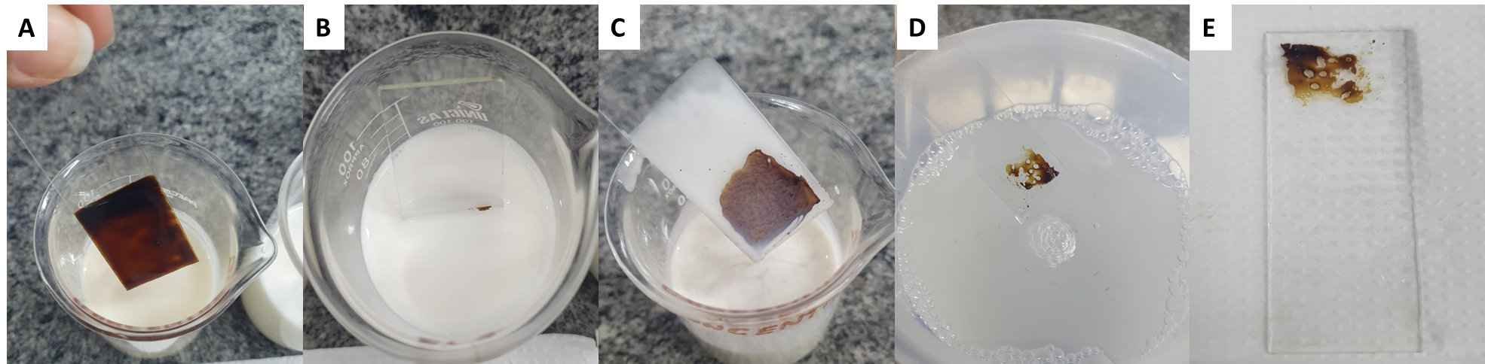
Figure 1: Illustration of removing the OCB1 oil with the addition of the commercial degreaser on a smooth surface. (A) Glass blade impregnated with OCB1 oil. (B) Immersion of the blade impregnated with oil on the product. (C) Removal of the blade after agitation of the product. (D) Total removal of destabilized oil residues after immersion in distilled water. (E) Blade after completion of the cleaning process

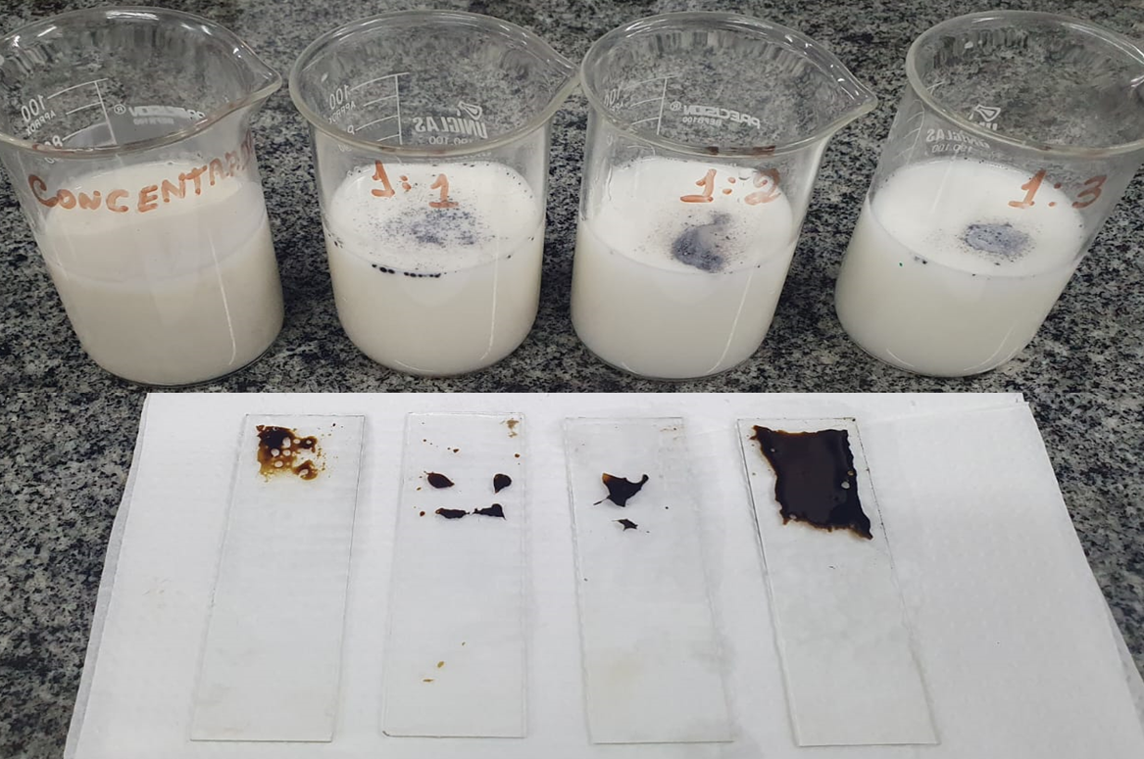
Figure 2: Illustration of the completion of the cleaning process on a smooth surface to remove the OCB1 oil using the commercial degreaser according to its concentration (concentrate, 1:1, 1:2 and 1:3 (v/v), respectively)
The above data confirm the efficiency of the commercial degreaser for use in the removal of heavy oil with high density, such as OCB1 oil (heavy oil used in burning for energy generation in thermoelectric plants), which is an oil with high viscosity, representing an obstacle to the availability of commercial detergents/degreasers and mixtures. Although or the concentrated commercial degreaser has reached a removal percentage equivalent to 80 – 85%, it is necessary to highlight the expressive efficiency of the biodetergent in this study, with a removal of 100% of the oil impregnated on smooth surface, in the concentrated version (Figure 3). Through the evaluation of removal efficiency, the other results for the diluted products were observed and considered promising depending on the level of impregnation of the petroleum derivative to be removed.
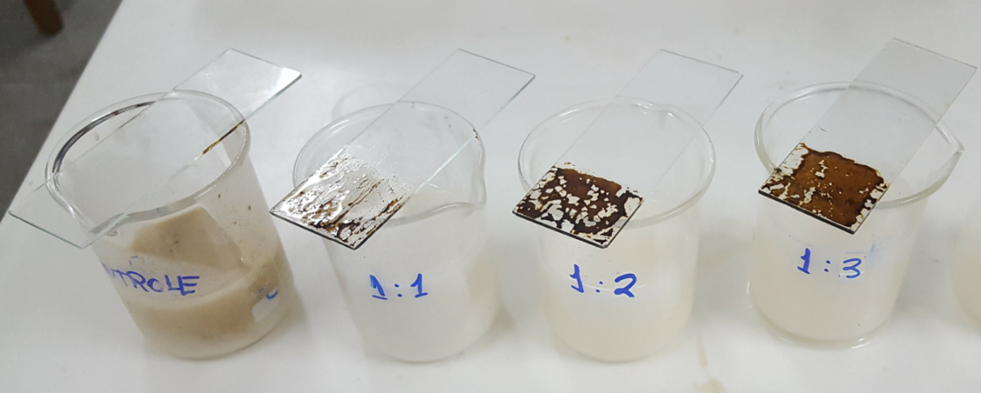
Figure 3: Illustration of the completion of the cleaning process on a smooth surface to remove the OCB1 oil using the biodetergent according to its concentration (pure as controlled, 1:1, 1:2 and 1:3 (v/v), respectively)

3.2 Heavy oil removal test on metal surface
The data obtained demonstrate optimal efficiency results in the removal of OCB1 for both products. The commercial degreaser presents a removal of around 80%, for comparison, the biodetergent presents a removal of 100% of the oil impregnated on a metal surface (Figure 4 and 5).
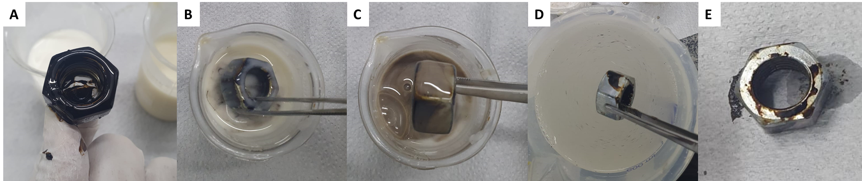
Figure 4: Removal of OCB1 oil on a metal surface with the use of commercial degreaser. (A) Metallic piece impregnated with OCB1 oil. (B) Immerse the piece with degreaser. (C) Withdrawal of the piece after agitation of the product. (D) withdrawal of part to after remove oil and destabilized product. (E) Completion of the metal piece cleaning process

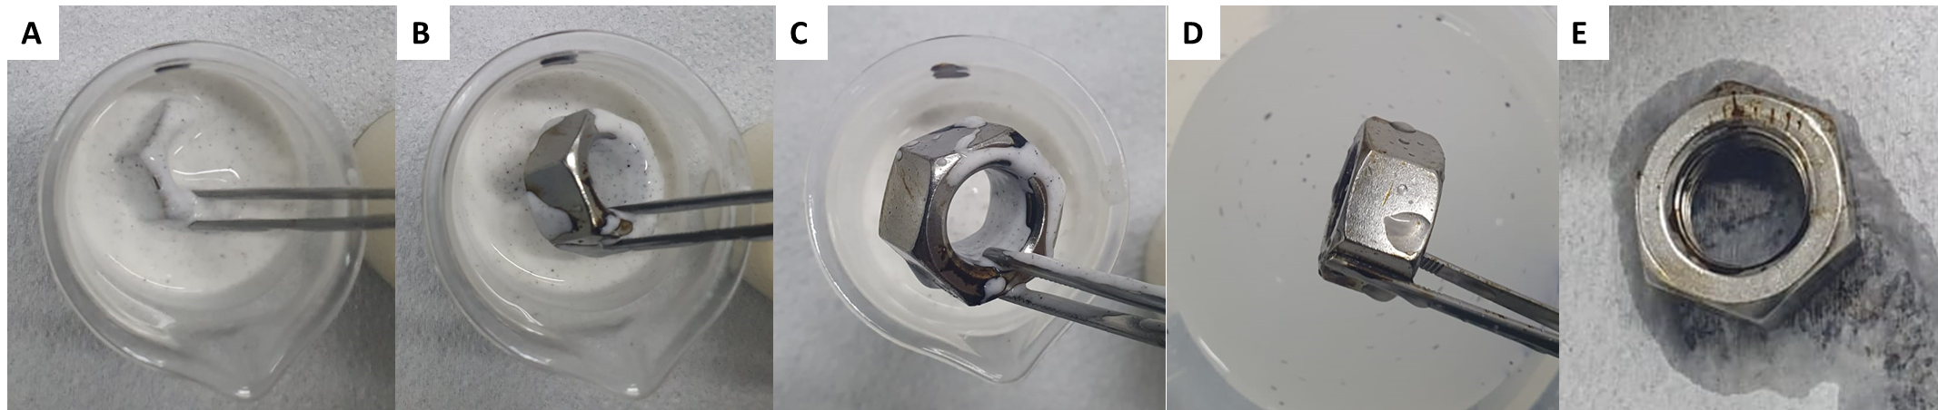
Figure 5: Removal of OCB1 oil on a metal surface with the use of biodetergent. (A) Metallic piece impregnated with OCB1 oil. (B) Immerse the piece with degreaser. (C) Withdrawal of the piece after agitation of the product. (D) withdrawal of part to after remove oil and destabilized product. (E) Completion of the metal piece cleaning process

3.3 Determination of the destabilization capacity of heavy oil
The objective of this test was to evaluate the destabilization capacity of heavy oil in relation to a maximum time of 5 minutes for the of two products. This way it is expected to determine what product will first achieve a satisfactory destabilization of the oil. Also, observe comparatively the quality of the destabilization of heavy oil on the products. Figures 6 and 7 summarize the application and results for the heavy oil destabilization test.
Both products present satisfactory results regarding the destabilization capacity of heavy oil, therefore, the biodetergent demonstrates practically total destabilization (suspension) of the oil derivative in just 2 minutes, but for the commercial degreaser is necessary twice as long (4 minutes) for partial destabilization of the oil.

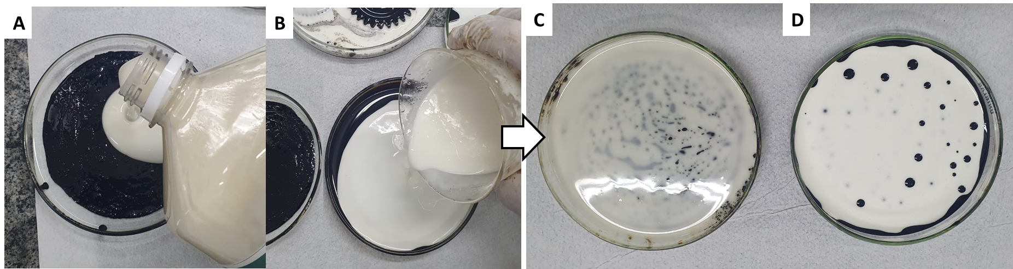
Figure 6: Aspect of the destabilized OCB1 oil on the glass plate surface for the two products in the study. (A and C) Commercial degreaser. (B and D) Biodetergent

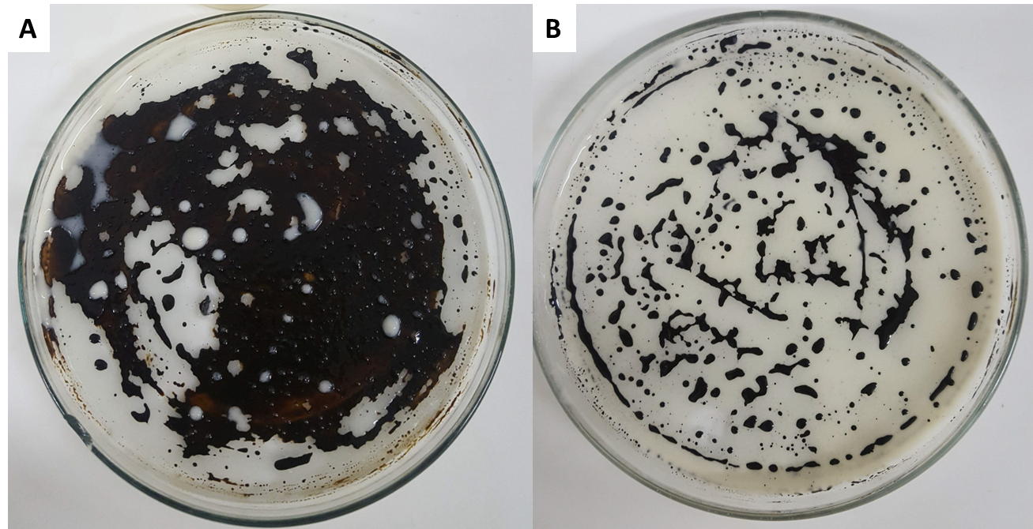
Figure 7: Aspect of the glass plates after rinsing (without physical aid) to remove heavy oil and destabilized products for both of them. (A) Commercial degreaser. (B) Biodetergent

As observed, in Figure 7, after rinsing, part of the oil reintegrates into the surface, which is natural, once no absorbent or abrasive materials (sponges, tow or broom) are used to physically assist in the absolute removal of the oil and products. Therefore, the objective of the test was to validate only the chemical action of the formulations avaluated.

3.4 Ecotoxicological tests
The results obtained show that the biodetergent practically does not present toxicity to the microcrustacean larvae in all the conditions tested, same with the increase in concentration, as it presents a maximum mortality rate of barely 20%. As for the commercial degreaser, the results demonstrate total mortality (100%) for the Artemia salina larvae in all conditions, even for the lowest concentrations of the product (Table 1). Regarding the phytotoxicity, the two products in a comparative study, using cabbage (Brassica oleracea) and tomato (Solanum lycopersicum) seeds, the results were satisfactory for the biodetergent, once the germination index was between 80 to 100% in the seeds of both species for the dilutions used. On the other hand, for the commercial degreaser, there is no germination of the seeds for all the concentrations tested, indicating the toxicity of the product in the study (Table 1).
Table 1: Percentages of bioassay with microcrustacean larvae (Artemia salina) and phytotoxicity with vegetative seeds cabbage (Brassica oleracea) and Cherry tomato (Solanum lycopersicum).
Conditions  Biodetergent/Commercial degreaser (vol/vol) | Germination index (GI) |  | Mortality Artemia salina
 | Cabagge  Brassica oleracea | Tomato  Solanum lycopersicum |  | 1% | 2%
Concentrated biodetergent | 82% ± 0.2 | 80% ± 0.1 | 20% ± 0.1 |  | 20% ± 0.1
Biodetergent/water (1:1) | 87% ± 0.2 | 95% ± 0.4 | 10% ± 0.5 |  | 20% ± 0.5
Biodetergent/water (1:2) | 98% ± 0.1 | 97% ± 0.2 | 0% ± 0.4 |  | 0% ± 0.4
Biodetergent/water (1:3) | 100% ± 0.5 | 98% ± 0.3 | 0% ± 0.1 |  | 0% ± 0.1
Concentrated degreaser | 0% ± 0.2 | 0% ± 0.0 | 100% ± 0.2 |  | 100% ± 0.0
Commercial degreaser (1:1) | 0% ± 0.0 | 0% ± 0.0 | 100% ± 0.0 |  | 100% ± 0.1
Commercial degreaser (1:2) | 0% ± 0.2 | 0% ± 0.1 | 100% ± 0.0 |  | 100% ± 0.0
Commercial degreaser (1:3) | 0% ± 0.0 | 0% ± 0.0 | 100% ± 0.0 |  | 100% ± 0.0

Therefore, unlike the commercial degreaser, the biodetergent proved to be innocuous as expected for a biodegradable detergent, enabling a safer application in the industrial environment without prejudice to human health and ecosystems.
According to the literature, work related to the present study indicates the efficiency of removing heavy oil by adding of a biodetergent, with 100% removal of OCB1 oil impregnated on glass and metal surfaces, in addition to its absence of toxicity (Farias et al., 2021a; Farias et al., 2021b and Soares da Silva et al., 2023). Almeida et al. (2020), evaluated the ability of a surfactant to remove oil in steel parts. The results showed that the surfactant of vegetable origin promoted an efficient oil removal between 82.6 ± 0.5 to 78.4 ± 0.6%, and can be considered with potential for commercialization and replacement of chemical surfactants. A formulation developed in a manner similar to biodetergent, from biodegradable components, also presented excellent results in removing heavy oil and absence of toxicity, demonstrating the potential to be a commercially viable product (Rocha e Silva et al., 2020).
  - Conclusion
The conclusions reached in this comparative study are important, as they directly influence the availability of a biodegradable and non-toxic product in the industrial environment. Both products demonstrate efficient removal of heavy oil. For the market, the commercial degreaser presents an ecological appeal and high efficiency in the removal of heavy oils and greases in industrial plants, although, its proven toxicity tests indicate contradictory results. The biodetergent, truly formulated with natural and non-toxic inputs, showed more reliable, in addition to offering excellent commercial conditions, guaranteeing a safer environment for the use of a product harmless to human health and the environment.

Acknowledgments
This study was funded by the Research and Development Program from National Agency of Electrical Energy (ANEEL) and Thermoelectric EPASA (Centrais Elétricas da Paraíba), EPESA (Centrais Elétricas de Pernambuco S.A.), Energética SUAPE II S.A. and Termocabo S.A. This work was also supported by the National Council for Scientific and Technological Development (CNPq), the Foundation for the Support of Science and Technology of the State of Pernambuco (FACEPE) and the Coordination for the Improvement of Higher-Level Education Personnel (CAPES). The authors are grateful to the Centre of Sciences and Technology of the Catholic University of Pernambuco (UNICAP) and to the Advanced Institute of Technology and Innovation (IATI), Brazil.

References
Almeida F.C.G., Rocha e Silva N.M.P., Souza T.C., Almeida D.G., Luna J.M., Farias C.B.B., Rufino R.D., Sarubbo L.A., 2020, Surfactant Activity of Artocarpus Heterophyllus Fruit Extract and Application in Oil Removal of Solid Surface, Chemical Engineering Transactions, 74, 1135-1140.
Cooper D.G., Goldenberg B.G., 1987, Surface-active Agents from Two Bacillus Species, Applied and Environmental Microbiology, 53, 224-229.
Farias C.B.B., Almeida F.C.G., Silva I.A., Souza T.C., Meira H.M., Soares da Silva R.C.F., Sarubbo, L.A. 2021a, Production of green surfactants: Market prospects, Electronic Journal of Biotechnology, 51, 28–39.
Farias C.B.B, Soares da Silva R.D.C.F., Meira H.M., Souza T.C., Almeida F.C.G., Silva I.A., Luna J.M., Sarubbo L.A., 2021b, Evaluation of the Stability of a Non-toxic Biodetergent for the Removal of Petroderivates in Industries, Chemical, Engineering Transactions, 86, 583-588.
Farias C.B.B., Soares da Silva R.C.F., Almeida F.C.G., Converti A., Santos V.A., Sarubbo L.A., 2022, Physicochemical upgrading of a biodetergent for application in the industrial energy sector, Energies, 15, 463.
Rocha e Silva N.M.P., Meira H.M., Almeida F.C.G., Soares da Silva R.C.F., Almeida D.G., Luna J.M., Rufino R.D., Santos V.A., Sarubbo L.A., 2019, Natural surfactants and their applications for heavy oil removal in industry, Separation & Purification Reviews, 48, 267– 281.
Rocha e Silva N.M.P., Almeida F.C.G., Rocha e Silva F.C., Luna J.M., Sarubbo L.A., 2020, Formulation of a Biodegradable Detergent for Cleaning Oily Residues Generated during Industrial Processes, Journal of Surfactant Detergents, 23, 111-1123.
Sarubbo L.A., Silva M.D.G.C., Durval I.J.B., Bezerra K.G.O., Ribeiro B.G., Silva I.A., Twigg M.S., Banat I.M., 2022, Biosurfactants: Production, properties, applications, trends, and general perspectives, Biochemical Engineering Journal, 181, 108377.
Selva Filho A.A.P., Converti A., Soares da Silva R.C.F., Sarubbo L.A. 2023, Biosurfactants as Multifunctional Remediation Agents of Environmental Pollutants Generated by the Petroleum Industry, Energies, 16, 1209.
Soares da Silva R.C.F., Souza T.C., Farias C.B.B., Almeida F.C.G., Silva I.A., Sarubbo, L.A., 2023, Evaluation of the Stability of a Biodetergent for Industrial Use, Chemical, Engineering Transactions, 99, 481- 486.
Tiquia S.M., Tam N.F.Y., Hodgkiss I. J., 1996, Effects of composting on phytotocicity of spent pig-manure sawdust litter, Environ. Pollution, 93, 249-256.

