 CHEMICAL ENGINEERING TRANSACTIONS  VOL. , 2024 | A publication of  
The Italian Association
of Chemical Engineering
Online at www.cetjournal.it

Guest Editors: Marco Bravi, Antonio Marzocchella, Giuseppe Caputo
Copyright © 2024, AIDIC Servizi S.r.l.
ISBN 979-12-81206-10-6; ISSN 2283-9216
An airlift perfusion bioreactor for Tissue Engineering applications: from computational modeling to experimental validation
Elisa Capuana^{a,*}, Camilla Carboneª, Francesco Carfì Paviaª, Giulio Ghersi^{b}, Vincenzo La Carrubbaª, Valerio Brucatoª
ªDepartment of Engineering, University of Palermo, RU INSTM, Viale delle Scienze, 90128 Palermo, Italy
^{b} Department of Biological, Chemical and Pharmaceutical Sciences and Technologies [STEBICEF] University of Palermo, Viale delle Scienze, Ed. 16, 90128 Palermo, Italy

elisa.capuana@unipa.it

Tissue engineering (TE) offers promising solutions for regenerative medicine through the use of porous scaffolds and cells, providing a favorable environment for the production of functional three-dimensional (3D) tissues. However, TE strategies have faced physiological limitations with static three-dimensional culture alone, and perfusion bioreactors provide a controlled environment that better mimics native tissue. In this study, we present the optimized geometry of an existing custom-made perfusion bioreactor that utilizes an external airlift circulation loop, essentially a specially structured bubble column designed for the simultaneous allocation of multiple seeded scaffolds. By reducing volumes and materials, the optimized system maintains the same level of reliability and functionality. The study employs computational fluid dynamics (CFD) analysis and a mathematical model to gain insights into fluid flow and oxygen transport, respectively. Therefore, in line with the increasingly recognized trend of device miniaturization, scaling down the initial device would enable high-speed analysis of cellular response in perfused cultures, allowing the study of various morphologies, different cell populations, or different drug treatments. Furthermore, the possibility of creating series and parallel connections between multiple devices, while maintaining dimensions suitable for incubator insertion, demonstrates the potential of this system for testing engineered constructs while simultaneously enabling time and cost reduction compared to existing perfusion devices in the field of Tissue Engineering.
  - Introduction
Tissue engineering (TE) stands at the forefront of regenerative medicine, offering innovative approaches to address the limitations of traditional therapeutic methods. Central to TE is the development of three-dimensional (3D) tissues through the strategic integration of porous scaffolds and cells, creating an environment conducive to functional tissue production. Despite the promise of this paradigm, challenges arise from physiological limitations associated with static 3D cultures. Recognizing this, perfusion bioreactors have emerged as a key tool in tissue engineering, providing a controlled environment that closely mimics the native tissue microenvironment (Rezende et al. 2013).
The present study contributes to advancing dynamic cell culture in tissue engineering, exploring the optimization of a custom-made bioreactor's geometry, thus aligning with the trend of device miniaturization for high-throughput analysis and cost-effectiveness. This research builds upon two preceding studies. In the first study, a novel external-loop airlift bioreactor was characterized through mathematical modeling, numerical simulation, and experimental investigations (Capuana et al. 2022). Hydrodynamic parameters and mass transfer of oxygen were assessed, with Computational Fluid Dynamics (CFD) simulations used to optimize the bioreactor's design. Poly-L-Lactic acid (PLLA) scaffolds, produced through Thermally Induced Phase Separation (TIPS), were seeded with fibroblasts for in vitro evaluations. In the second study, computational simulations characterized fluid flow within a perfusion bioreactor supporting multiple scaffolds (Capuana et al. 2023). Micro-CT scanned PLLA scaffolds with complex morphologies were analyzed for fluid dynamics, correlating numerical results with actual cell proliferation within the perfused scaffolds. These studies collectively contribute to the understanding and advancement of dynamic cell culture in tissue engineering.
Notably, other previous works have underscored the importance of dynamic culture systems in enhancing cell viability, tissue maturation, and overall functionality. For instance, Li et al. (Li, Chen, and Fan 2019) demonstrated the impact of scaffold design on perfusion culture outcomes, emphasizing the need for tailored solutions to accommodate diverse tissue types. Additionally, Cioffi et al. (Cioffi et al. 2006) explored the use of computational modeling and micro-CT to optimize the fluid dynamics of scaffolds in perfusion bioreactors, emphasizing the significance of predictive tools in bioreactor design. Computational modeling allows researchers to predict and optimize fluid flow patterns, nutrient distribution, and overall system performance. This approach has been pivotal in advancing our understanding of the complex interactions within bioreactor systems, enabling more informed redesign decisions. The focus on miniaturization and scalability in the presented study resonates with the broader push toward automation and high-throughput methodologies in tissue engineering. This trend is evident in the work of Chang et al. (Chang et al. 2010), where a microfluidic perfusion platform was developed for parallelized culture of multiple cell types. Such advancements facilitate rapid testing of various conditions, including morphologies, cell populations, and drug treatments, aligning with the objectives outlined in the current study.
In this pursuit, the present study aims to scale down and characterize an existing perfusion bioreactor, further featuring a support structure for scaffolds and connected to a peristaltic pump for continuous nutrient perfusion. By using 3D design software, the bioreactor components were meticulously redesigned for optimal performance. The scale-down process achieved a 70% reduction in height and an 80% decrease in the diameter of the perfusion chamber. Fluid dynamics simulations were conducted to ensure a homogeneous flow. To elucidate the oxygen transport dynamics in the optimized bioreactor, a mathematical model provides a framework to assess the transfer of oxygen from the gas to the liquid phase, crucial for sustaining biological processes within the system. This study presents an innovative and efficient miniaturized bioreactor, catering to high-throughput applications in tissue engineering.
  - Materials and Methods
2.1 Bioreactor Scale-down and redesign
Unlike the original glass prototype, the scale-down of the bioreactor was reengineered to be made from printable resin using stereolithographic printing, allowing for flexible and modifiable design using Autodesk's FUSION 360 software, a Computer-Aided Design (CAD) tool. The original bioreactor had a height of 22.1 cm, a perfusion chamber diameter of 3.5 cm, and a riser diameter of 1 cm (Figure 1A). The tested bioreactor, as depicted in Figure 1B, features a reduced height of 6.5 cm, a perfusion chamber diameter of 1.8 cm, and a riser diameter of 0.3 cm, resulting in a marked decrease in size compared to the previous prototype.
During the computational simulations, it was necessary to adjust the initial geometry for the optimization of fluid dynamic results. For this purpose, flow homogenization grids were redesigned in the Fusion 360 software with different squared-hole sizes and distances from the free surface of the liquid phase, i.e. 1 and 3 mm. Two different geometries were used for the grid: one had a height of 0.4 cm and a hole length of 1.5 mm, and the other had a height of 2 mm and squared holes with 0.653 mm side length. The diameter was 16 mm in both geometries.

2.2 Computational Fluid Dynamics (CFD) Simulations

To comprehensively understand flow patterns and velocity fields within the bioreactor, Computational Fluid Dynamics (CFD) simulations were conducted using Comsol Multiphysics software. The 3D model incorporated axial symmetry, significantly reducing simulation costs. A constant air inlet velocity of 0.082 m/s was set, considering the liquid phase as the continuous phase in the two-phase flow model. The bubbly flow model was chosen to simulate the bioreactor regime in a transient analysis of up to 120 s, as it resulted in a steady-state time for the hydrodynamic solution. Boundary conditions included a free surface at atmospheric pressure as the exit surface and a sliding condition on the bioreactor walls for the liquid phase. The simulation aimed to predict the velocity distribution of the liquid phase and the gas hold-up within the system. The same boundary and initial conditions were adopted in simulations where the flow homogenization grid was introduced.

2.3 Oxygen Transfer from Gas Phase to Liquid Phase

In this study, the global oxygen mass balance equation in the liquid phase was employed to assess the oxygen transport from the gas phase to the liquid phase in the system. The optimized bioreactor retains the characteristics of an airlift bioreactor, with the assumption of perfectly mixed fluid. With this consideration, the global mass balance equation for oxygen is (Magrofuoco et al. 2019):

$\frac{dC_{l}}{dt}=k_{l}a_{l}\left(C_{l}^{*}-C_{l}\right)-R_{O_{2}}$ (1)
$R_{O_{2}}=\frac{χq_{0}}{V}$ (2)

In this equation, $k_{l}a_{l}$is the overall mass transfer coefficient (s⁻¹), $C_{l}^{*}$ and $C_{l}$ represent, respectively, the oxygen concentration at the interface and in the bulk (mg/L), $R_{O_{2}}$ is the oxygen consumption due to biological processes. The latter is a function of the cell number (χ), the specific oxygen consumption rate (q0), and the liquid volume (V) inside the bioreactor (Eq. 2). The solution to the steady-state mass balance equation was computed with a number of 360,000 cells. For the transient state, the mathematical description of the oxygen concentration evolution in the liquid phase was determined for this cell count. The initial oxygen concentration in the bulk was considered zero for this estimation. For this analysis, an inlet air velocity of 0.082 and a culture medium volume of 12 ml were assumed, considering $q_{0}$=96 × 10⁻¹⁷ g/(cells x s), typical for mammalian cells (Devarapalli, Lawrence, and Madihally 2009), and conditions of 37 °C, 1 atm as incubator parameters. These values are fundamentals for the calculation of the parameters of Eq. 1 from the two-resistance theory, as previously described (Capuana et al. 2022).
  - Results and Discussion
3.1 Bioreactor Scale-down

Starting from the bioreactor design by Capuana et al. (Capuana et al. 2022), the scaling-down process initially targeted the dimensions, significantly reducing the height and diameter of the perfusion chamber by 70 % and 80 %, respectively. Figure 1 depicts the design of the two customized bioreactors: Figure 1A is taken from Capuana et al. and represents the original prototype, while Figure 1B illustrates the geometric characteristics of the scale-down.

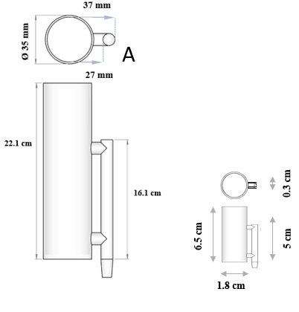
Figure 1: A) Outer shell of the bioreactor of Capuana et al. (Capuana et al. 2022). B) Miniaturized bioreactor: frontal and top views with dimensions.

The dimensions of the redesigned bioreactor were carefully adjusted to maintain a proportional relationship with the original prototype. This deliberate adaptation was made to preserve the specific flow regime characterized by bubble flow, ensuring continuity and consistency between the two versions of the bioreactor. In general, the operating regime of the bioreactor was maintained, involving the creation of a bubble column operating as an external airlift reactor, featuring two interconnected cylindrical tubes: a downcomer and a riser. The riser, serving as the conduit for air bubbles, is the part connected to the peristaltic pump via a silicone tube and a sterile syringe filter. As air bubbles ascend through the riser, they entrain a portion of the culture medium, facilitating circulation within the wider column. This induces liquid-phase movement, promoting gas-liquid mass transfer and oxygenation of the medium (Shaikh and Al-Dahhan 2013).
Regarding the homogenization grids, the two designs are shown in Figure 2. Figure 2C illustrates how the different distance from the free surface was redesigned, considering that the grids need to be handled, so they will have an upper solid part suitable for gripping. This solid part could potentially affect the flow regime along the column.
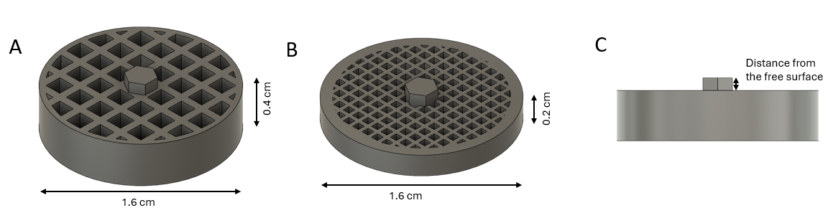
Figure 2: Liquid flow homogenization grid: A) coarse mesh grid (L=1.5mm), B) fine mesh grid (L=0.653 mm), C) frontal view of the grid with the upper solid part defining the distance from the free surface.

3.2 Computational Fluid Dynamics (CFD) Simulations
The fluid dynamics of the bioreactor directly influence bubble size, gas holdup, and mass transfer between the liquid and gas phases, as these parameters depend on the flow regime present in the system (Campolo, Molin, and Soldati 2011). Therefore, in the quest to reengineer an optimized bioreactor, flow analysis serves as the initial step, enabling the implementation of suitable models to optimize the system's hydrodynamics. Gas holdup plays a crucial role in the design and mass transport within the bioreactor.
In this study, gas holdup was determined through CFD simulations of the bioreactor (Figure 3A). As highlighted in the figure, the absence of gas bubbles in the larger perfusion chamber was observed. Air circulates through the upper orifice before exiting the bioreactor.
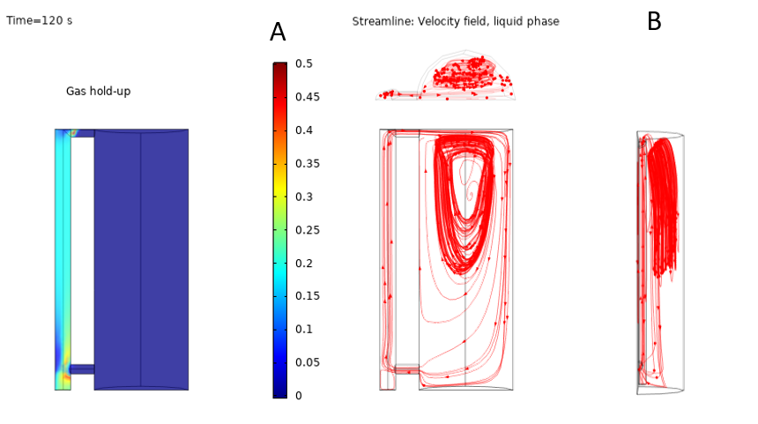
Figure 3: Results of the CFD simulation within the bioreactor: A) gas hold-up, B) streamline of the velocity field for the liquid phase.Time = 120s for the transient solution.

The average gas holdup value in the riser, subsequently used in the mathematical model for oxygen transport and in calculating the specific gas-liquid interfacial area (a_{l}), was found to be 0.18 (Figure 3A). The image clearly shows how bubble formation and entrainment occur only in the riser. Therefore, the calculation of oxygen mass transport between the two phases was focused exclusively on this region. The flow lines within the bioreactor, obtained from CFD analyses and shown in Figure 3B, highlight a pronounced heterogeneity throughout the system's volume. To address this issue, a solution was implemented by introducing a grid at the top to homogenize the flow. Two grids with different dimensions and distances from the free surface of the liquid phase were tested. This approach allows for determining whether a particular hole size or specific grid arrangement is more suitable for achieving a homogeneous distribution of liquid flow within the bioreactor.
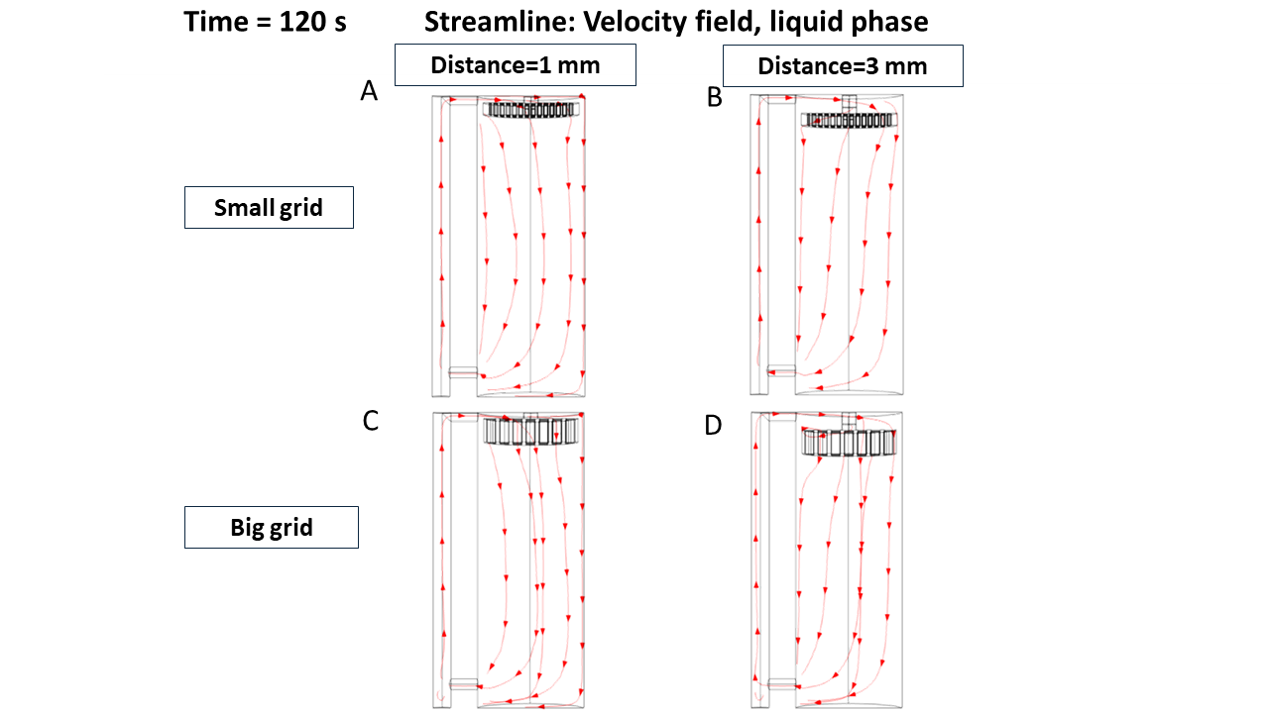
Figure 4: Streamline of the liquid velocity field obtained from the CFD simulation within the bioreactor with an inserted grid in different configurations: A) small grid at 1mm distance from the free surface, B) small grid at 3 mm distance from the free surface, C) big grid at 1mm distance from the free surface, D) big grid at 3 mm distance from the free surface Time = 120 s for the transient solution.

Overall, the streamlines related to uniform flow were found to be better at a shorter distance from the free surface, with the presence of vortices between the grid and the surface. In all cases, the flow proved more suitable for the requirements of homogeneous flow for the culture of scaffolds under the same stimulus compared to the system without a grid. Finally, the configuration in Figure 4A appears to be the best, with a more homogeneous liquid-phase velocity field.

3.3 Oxygen Transfer from Gas Phase to Liquid Phase

Mass transfer in airlift bioreactors is crucial for supplying oxygen to cultured cells. Mass transfer occurs in airlift bioreactors from a dispersed gas phase, i.e. the air bubble, to a continuous liquid phase, i.e., the culture medium. Given the vital role of oxygen in cellular survival, the miniaturization of the bioreactor raised the question of whether the reduced volume of the culture medium was sufficient to maintain an adequate oxygen level for the survival of a high number of cells in the system and proper cellular metabolism. To solve Eq. 1, the mass transfer coefficient k_{l} [m/s] was estimated referring to the two-resistance theory, therefore, by calculating certain constants, such as the Reynolds, Schmidt, and Sherwood numbers. The specific gas-liquid interfacial area (a_{l}) was computed based on the bubble diameter and gas hold-up.
Table 1: Parameter used for solving Eq. 1 from the two-resistance theory: the first column describes the parameters with their unit and the second one the calculated values.
Parameters | Calculated value
Reynolds number | 215.1
Equivalent bubble diameter | [cm] 0.12
Schmidt number | 269.1
Sherwood number | 414.5
k_{l} [m/s] | 0.001
a_{l} | 3.6

The steady-state solution revealed an oxygen concentration of 6.8 mg/l, higher than the minimum cells' oxygen concentration for maintaining cells physiological activity inside the bioreactor (1.7 mg/l) (Grenier et al. 2023) and resulting independent from the oxygen consumption rate and the cell count. This outcome derives from the predominance of oxygen transfer from bubbles to the culture medium over cellular consumption, confirmed by the negligible nature of the reactive term compared to the saturation concentration. The temporal evolution of the oxygen concentration indicated that the profile reaches a steady state in approximately 1200 seconds, underscoring the readiness of the bioreactor to supply oxygen in a shorter timeframe than a standard dynamic culture.
  - Conclusions
The scale-down process affected all parts of the bioreactor. Fluid dynamics simulations highlighted the need to introduce a system into the bioreactor capable of homogenizing the flow. Hence, the introduction of specifically redesigned grids became essential to limit the intrinsic turbulence of an airlift bioreactor, making the flow more uniform. Having a uniform flow is crucial for cellular vitality and ensures that all cells within the scaffolds receive an equal supply of nutrients. Regarding the oxygen transfer from the gas phase to the liquid phase, the results from the mathematical model confirm the effectiveness of the bioreactor's downsizing. They demonstrate that the system is capable of providing an adequate amount of oxygen to cultured cells, a critical aspect for the success of tissue engineering applications.
Acknowledgements
The research was supported by "SiciliAn MicronanOTecH Research And Innovation CEnter "SAMOTHRACE" (MUR, PNRR-M4C2, ECS_00000022).

References
Campolo, Marina, D. Molin, and A. Soldati. 2011. “Predicting and Controlling Bubble Clogging in Bioreactor for Bone Tissue Engineering.” Chemical Engineering Transactions 24: 913–18.
Capuana, Elisa, Simona Campora, Giorgio Catanzaro, Francesco Lopresti, Gioacchino Conoscenti, Giulio Ghersi, Vincenzo La, Valerio Brucato, and Francesco Carfì. 2023. “Computational Modeling and Experimental Characterization of Fluid Dynamics in Micro-CT Scanned Scaffolds within a Multiple-Sample Airlift Perfusion Bioreactor.” Biochemical Engineering Journal 191: 108797. https://doi.org/10.1016/j.bej.2022.108797.
Capuana, Elisa, Francesco Carfì Pavia, Maria Elena Lombardo, Salvatrice Rigogliuso, Giulio Ghersi, Vincenzo La Carrubba, and Valerio Brucato. 2022. “Mathematical and Numerical Modeling of an Airlift Perfusion Bioreactor for Tissue Engineering Applications.” Biochemical Engineering Journal 178 (December): 108298. https://doi.org/10.1016/J.BEJ.2021.108298.
Chang, Robert, Kamal Emami, Honglu Wu, and Wei Sun. 2010. “Biofabrication of a Three-Dimensional Liver Micro-Organ as an in Vitro Drug Metabolism Model.” Biofabrication 2 (4): 045004. https://doi.org/10.1088/1758-5082/2/4/045004.
Cioffi, Margherita, Federica Boschetti, Manuela Teresa Raimondi, and Gabriele Dubini. 2006. “Modeling Evaluation of the Fluid-Dynamic Microenvironment in Tissue-Engineered Constructs: A Micro-CT Based Model.” Biotechnology and Bioengineering 93 (3): 500–510. https://doi.org/10.1002/bit.20740.
Devarapalli, Mamatha, Benjamin J. Lawrence, and Sundararajan V. Madihally. 2009. “Modeling Nutrient Consumptions in Large Flow-through Bioreactors for Tissue Engineering.” Biotechnology and Bioengineering 103 (5): 1003–15. https://doi.org/10.1002/bit.22333.
Grenier, Jérôme, Bertrand David, Clément Journé, Iwona Cicha, Didier Letourneur, and Hervé Duval. 2023. “Perfusion of MC3T3E1 Preosteoblast Spheroids within Polysaccharide-Based Hydrogel Scaffolds: An Experimental and Numerical Study at the Bioreactor Scale.” Bioengineering 10 (7): 849. https://doi.org/10.3390/BIOENGINEERING10070849.
Li, Jian, Diansheng Chen, and Yubo Fan. 2019. “Evaluation and Prediction of Mass Transport Properties for Porous Implant with Different Unit Cells: A Numerical Study.” BioMed Research International 2019. https://doi.org/10.1155/2019/3610785.
Magrofuoco, Enrico, Marina Flaibani, Monica Giomo, and Nicola Elvassore. 2019. “Cell Culture Distribution in a Three-Dimensional Porous Scaffold in Perfusion Bioreactor.” Biochemical Engineering Journal 146 (June): 10–19. https://doi.org/10.1016/j.bej.2019.02.023.
Rezende, Rodrigo A., Júlia A. Nogueira, Viviane F.lara, Vladimir Mironov, Rubens M. Filho, and Jorge V.L. Da Silva. 2013. “Development of a Bioreactor by Computer Fluid Dynamics Simulations for the Maturation of 3D Printed Organs by Rapid Prototyping.” Chemical Engineering Transactions 32: 1153–58. https://doi.org/10.3303/CET1332193.
Shaikh, Ashfaq, and Muthanna Al-Dahhan. 2013. “Scale-up of Bubble Column Reactors: A Review of Current State-of-the-Art.” Industrial and Engineering Chemistry Research 52 (24): 8091–8108. https://doi.org/10.1021/ie302080m.

