CHEMICAL ENGINEERINGTRANSACTIONS  VOL. 76, 2019 | A publication of
The Italian Association
of Chemical Engineering
Online at www.aidic.it/cet
Guest Editors:Sauro Pierucci,Jiří Jaromír Klemeš, Laura Piazza
Copyright © 2019, AIDIC Servizi S.r.l.
ISBN978-88-95608-73-0;ISSN 2283-9216

A Semi-Empirical Model for Estimation of Pressure Drop Coefficient of a Conical Diffuser

Samuel A. Mfonª, Sunday B. Alabi^{a*}, Etim S. Udoetok^{b}, Uchechukwu H. Offorª, Emmanuel U. Nsekª, Zdenek Tomas^{c}, Tomas Miklík^{c}
ªDepartment of Chemical and Petroleum Engineering, University of Uyo, Nigeria
^{b}Department of Mechanical and Aerospace Engineering, University of Uyo, Nigeria
^{c}GE Power, Olomoucká 3419/7 618 00 Brno, Czech Republic
sundayalabi@uniuyo.edu.ng
Diffusers are widely used in technical practice in order to make the transition from a tube/pipe or duct of smaller section to a larger one. Low pressure drop across a diffuser is highly required to save pumping or ventilation work. Diffuser pressure drop is caused by enhanced turbulence of the flow, separation of the boundary layer from the diffuser walls and violent vortex formation. As a result, the precise pressure drop coefficient estimation is of high importance. The pressure drop coefficient (ζ_{d}) of a diffuser depends on diffuser geometry and flow parameters. Traditionally, a number of models must be combined and used with the data obtained from tables (with 2-D interpolation) and charts in a series of steps to obtain ζ_{d}. This approach is not suitable for computer-based simulations. Consequently, in this study, a semi-empirical model, for estimating ζ_{d} of a conical diffuser, as an explicit function of the flow parameters and the diffuser geometry, is developed. The model was validated using literature data. The performance indices which were obtained as high R²=0.9942, low mean absolute relative error (MeARE)=4.04%, low root mean squared error (RMSE)=0.0192 are an indication that the proposed model is accurate enough for computer-based simulations and performance evaluation of a conical diffuser over a wide range of operating conditions.
  - Introduction
Many industrial applications require piping systems to provide energy and deliver efficient products. For example, for the design of ventilation and air-conditioning systems, it is important to know the fan static pressure requirements for a given flow rate. Pipes of different sizes can be connected in order to deliver the required flow. In order to reduce head losses, diffusers are widely used in technical practice to make the transition from a tube/pipe or duct of smaller section to a larger one. Diffusers are extensively used in centrifugal compressors, axial flow compressors, ramjets, combustion chambers, inlet portions of jet engines, etc. (Keerthana and Jamuna Rani, 2012).
A diffuser is a smoothly expanding tubular section used to make the transition from a tube or channel of smaller cross section to a large one thereby converting the kinetic energy of flow into potential energy or of velocity pressure into static pressure with minimum total pressure losses. It is a device that causes a pressure drop at the output region (suction region downstream of the diffuser). The pressure drop caused, accelerates the fluid particles passing through the inner region of the diffuser, and increases the flow velocity near the entrance (Idelchik, 1996; Karunakaran and Ganesa., 2009). The static pressure, also known as the “wall pressure,” is the stationary force applied on the unit area of the walls of the pipe. In a flow system, as the fluid transits from the inlet collector, pressure is reserved and builds up due to continuous flow and this pressure is needed as the velocity decreases downstream of inlet duct to maintain the flow from the exit duct of the diffuser to the straight pipe. The static-pressure rise reflects the ability of the diffuser to accomplish its purpose, which is to convert kinetic energy into pressure energy. The static pressure rise quantity, given in terms of the diffuser effectiveness, is defined as the actual rise in pressure energy divided by the ideal reduction in kinetic energy (Karunakaran and Ganesa, 2009).
Low pressure drop across a diffuser is highly required to save pumping or ventilation work. As a result, the precise estimation of pressure drop coefficient (ζ_{d}) is of high importance. Unfortunately, traditionally, a number of models must be combined and used with the data obtained from tables (with 2D interpolation) and charts in a series of steps to obtain ζ_{d}. This approach is cumbersome and not suitable for computer-based simulations. Therefore, the main contribution of this paper is the development of a single semi-empirical model for estimating ζ_{d} of a conical diffuser as an explicit function of the flow parameters and the diffuser geometry. The model development, its performance evaluation and conclusions are presented in the subsequent sections.
  - Development of the Proposed Semi-Empirical Model
For a diffuser installed in a piping network, and for a fully developed turbulent flow and uniform velocity distribution, ζ_{d}, a function of diffuser angle(α), diffuser areas ratio (n_{ar}) and Reynolds number (Re), is read off from tables (see Idelchik, 1996). This manual approach of obtaining ζ_{d} is not suitable for computer-based simulations. Based on the generalization of experimental data on the losses of diffusers installed in a system, ζ_{d} is given in Eq(1) (Chernyavskiy et al., 1985, 1986), where ζ'_{fr} is the hydraulic friction pressure loss coefficient, ζ_{un} and ζ_{non} are the coefficients which account for expansion losses in the diffuser with a
(1)
uniform velocity profile in its initial section and non-uniform velocity profile in its initial section, respectively. According to Chernyavskiy et al. (1985, 1986), assuming the flow through the diffuser is fully developed and the velocity profile is uniform, ζ_{non} is considered to be negligible. Moreover, for a conical diffuser, ζ_{un} is given in Eq(2), where the shock coefficient ϕ=f(α,Re).
(2)
For a uniform velocity profile and fully developed flow, ζ'_{fr} is given in Eq(3) (Idelchik, 1947, 1954, cited in Idelchik, 1996), where λ is the friction factor and is a function of Re and relative roughness (ε/D) of the diffuser.
(3)
Considering the above assumptions and substituting Eq(2) and Eq(3) into Eq(1), Eq(4) is obtained.
(4)
Reliable explicit models for describing ϕ and λ are required in Eq(4) to obtain a complete explicit pressure drop coefficient model. Till date, ϕ, which is a function of α and Re, can only be obtained from either a table or chart in the open literature. Consequently, 39 datasets containing shock coefficient values for conical diffusers were obtained for Reynolds numbers between 50000 and 600000 and divergence angles between 5⁰ and 180⁰ (see Idelchik, 1996). Three almost overlapping sigmoid curves were obtained by plotting the shock coefficient (ϕ) values against the divergence angle α, at three constant values of Reynolds number (Re=50000, 200000 and 600000) using Microsoft Excel Spreadsheet. The sigmoid curves are as shown in Figure 1. It is observed that each of the curves can easily be described by a logistic function which is defined by the formula given in Eq(5).
(5)
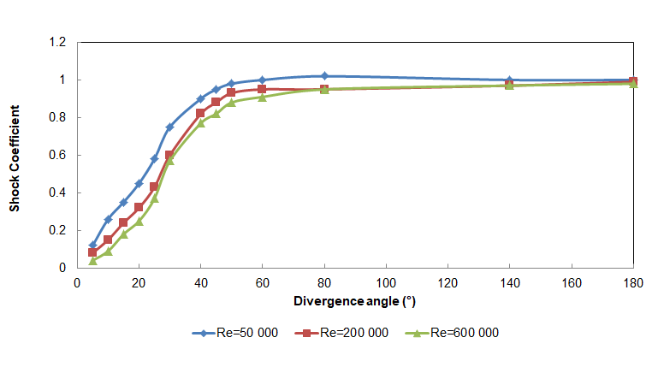
Figure 1: Graphical representation of shock coefficient vs divergence angle at different Reynolds numbers.

At a fixed Reynolds number and varying α, S (x) in Eq(5) was replaced by φ(α) to obtain Eq(6).
(6)
Using MATLAB Curve Fitting tools, for each of the three Reynolds numbers, preliminary values of ‘a’ and ‘b’ were obtained. Using Microsoft Excel Spreadsheet, a linear relationship as given in Eq(7) was obtained between ‘a’ and Re.
(7)
Parameter ‘b’ was observed to be approximately constant (~0.1095) across the three Reynolds numbers.
Therefore, by substituting for ‘a’ and ‘b’ in Eq(6), Eq(8) was obtained.
(8)
Eq(8) was restructured to give Eq(9). The available 39 datasets were divided into two batches which span the
(9)
entire ranges of the variables (21 datasets for modelling/parameters estimation and 18 datasets for model validation). Consequently, based on the 21 modelling/parameters estimation datasets, MATLAB Surface Fitting tools were used to obtain the values of ‘a’, ‘b’, and ‘c’ as 0.1104, 3.361 and 14.75, respectively. By substituting the values of these parameters in Eq(9), the explicit shock coefficient model given in Eq(10) was obtained.
(10)
The performance of the shock coefficient model was evaluated. The predicted shock coefficient was found to be in good agreement with the observed shock coefficient (literature data) as shown in Figure 2. The R-squared statistics are 0.9963 and 0.9930 for the modelling and validation datasets, respectively. It is obvious from Figure 2 and, the modelling and validation R-squared statistics, that the shock coefficient model has good predictive and generalization capacities.

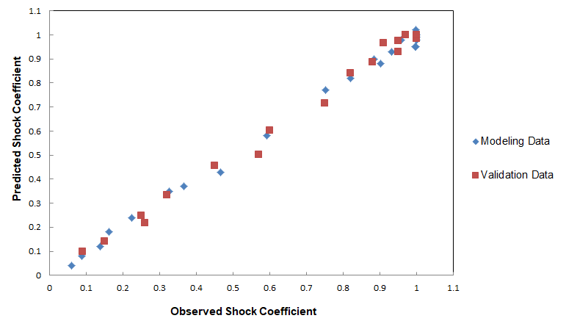
Figure 2: Predicted shock coefficient against observed shock coefficient.

The friction factor λ can be obtained from the Colebrook-White (Colebrook and White, 1937) equation, the popular Moody (1944) diagram or any of the explicit friction factor models. Unfortunately, Colebrook-White equation is implicit in λ and so requires iterative solution. Moody diagram is a graphical tool and so it is not amenable for computer–based simulations. An accurate and computationally efficient explicit friction factor model which is applicable over a wide range of operating conditions will be a good choice. Recently, Pimenta et al (2018) analyzed the performance of several explicit friction factor models and concluded that the explicit friction factor model, developed by Offor and Alabi (2016) and is given in Eq(11), is the most accurate and applicable over the widest range of Reynolds numbers. Therefore, Offor and Alabi (2016) model was chosen in this work.
(11)
Upon substitution of Eq(10) and Eq(11) in Eq(4), the resulting expression forwas obtained as Eq(12).

(12)
Thus, an explicit single semi-empirical model for estimating pressure drop coefficient of a conical diffuser as a function of α, n_{ar}, Re, and ε/D was developed. The model is semi-empirical in nature, as it was obtained from the combination of theoretical concepts and empirical models.
  - Performance evaluation of the semi-empirical pressure drop coefficient model
The developed semi-empirical pressure drop coefficient model (Eq(12)) was validated against the literature data. The popular Moody Chart was used to obtain friction factor and the shock coefficient data were obtained from Idelchik (1996). These were then used to obtain pressure drop coefficient data (from Eq(4)). Thus, 2600 datasets were obtained for the conical diffuser pressure drop coefficient as a function of four (4) input variables in the ranges 5˚ ≤ α ≤ 180˚, 2 ≤ n_{ar} ≤ 10, 0 ≤ Ɛ/D ≤ 0.05, and 50000 ≤ Re ≤ 800000. The predicted pressure drop coefficient obtained from Eq(12) was compared with the observed pressure drop coefficient (the entire 2600 literature datasets). The results are as shown in Figure 3. It is observed from Figure 3 that there is a good agreement between the literature data and the predicted pressure drop coefficient using the new semi-empirical model.

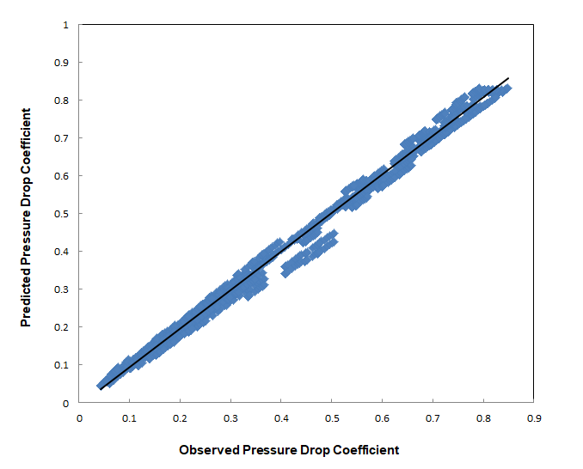
Figure 3: Predicted pressure drop coefficient against observed pressure drop coefficient over wide ranges of operating conditions of a conical diffuser.

Further performance evaluation of the model gives rise to R², mean absolute relative error (MeARE), and root mean square error (RMSE) of 0.9942, 4.04% and 0.0192, respectively. The high R², low MeARE and low RMSE are an indication that the developed semi-empirical model is accurate enough for computer-based simulations and performance evaluation of a conical diffuser over a wide range of operating conditions.
  - Conclusions
The precise estimation of pressure drop coefficient (ζ_{d}) of a diffuser is of high importance. Traditionally, a number of models must be combined and used with the data obtained from tables (with 2D interpolation) and charts in a series of steps to obtain ζ_{d}. To overcome this limitation, this study developed a single semi-empirical model for estimating ζ_{d} of a conical diffuser as an explicit function of the flow parameters and the diffuser geometry. The resulting model has high R² of 0.9942, low MeARE of 4.04% and low RMSE of 0.0192 when compared with the literature data. It is therefore concluded that in lieu of the existing burdensome manual approach, the developed semi-empirical model is accurate enough for computer-based simulation of pressure drop coefficient and performance evaluation of a conical diffuser over a wide range of operating conditions.

References
Chernyavskiy, L.K. and Gordeyev, N.N., 1985, Generalization of Experimental Data on the Losses in Straight Diffusers with a Constant Divergence Angle. Thermal Engineering (6), pp 75-77.
Chernyavskiy, L.K. and Gordeyev, N.N., 1986, Generalization of Experimental Coefficients for the Losses of Diffusers Installed in the System. Thermal Engineering (10), pp 72-74.
Colebrook, C. F.; White, C. M., 1937, Experiments with fluid friction in roughened pipes. Proceedings of the Royal Society A: Mathematical, Physical and Engineering Sciences, v.161, p.367-381. Online: doi.org/10.1098/rspa.1937.0150
Idelchik, I.E., 1996, Resistance to Flow with a Smooth Change in Velocity. Handbook of Hydraulic Resistance, 3rd Edition. Begell House, Inc., pp 239-329.
Karunakaran, E. and Ganesan, V., 2009, Mean Flow Field Measurements in an Axisymmetric Conical Diffuser without Inlet Flow Distortion. Indian Journal of Engineering and Materials Sciences Vol. 16. Indian Institute of Technology, Chennai. pp 211-219.
Keerthana, R. and Jamuna Rani, G., 2012, Flow Analysis of Annular Diffusers. International Journal of Engineering Research and Applications. Vol. 2, ISSN: 2248-9622. pp 2348 – 2351.
Moody, L. F., 1944, Friction factors for pipe flow. Transactions ASME, v.66, p.671-678.
Offor, U.H. and Alabi, S.B., 2016, An Accurate and Computational Efficient Explicit Friction Factor Model. Advances in Chemical Engineering and Science, (6), pp 237-245.
Pimenta, Bruna D., Robaina, Adroaldo D., Peiter, Marcia X., Mezzomo, Wellington, Kirchner, Jardel H., & Ben, Luis H. B., 2018, Performance of explicit approximations of the coefficient of head loss for pressurized conduits. Revista Brasileira de Engenharia Agrícola e Ambiental, 22(5),301-307. Online: dx.doi.org/10.1590/18071929/agriambi.v22n5p301-307

