|  |  |
| --- | --- |
| cetlogo ***CHEMICAL ENGINEERING TRANSACTIONS***  ***VOL.*** | A publication of  aidiclogo_grande |
| The Italian Association  of Chemical Engineering  Online at www.aidic.it/cet |
| Guest Editors:  Copyright © AIDIC Servizi S.r.l. **ISSN** 2283-9216 | |

Uremic toxins removal with   
Mixed Matrix Membranes Adsorbers (MMMAs)

Matilde De Pascale\*, Maria Grazia De Angelis, Cristiana Boi

Department of Civil, Chemical, Environmental and Materials Engineering (DICAM), University of Bologna, via Terracini 28, Bologna, Italy.

matilde.depascale2@unibo.it

Mixed Matrix Membrane Adsorbers (MMMAs) based on Cellulose Acetate (CA) were prepared and tested for the removal of uremic toxins from spent dialysate aqueous streams from hemodialysis treatments. MMMAs were fabricated and modified with a natural zeolite, ZUF, to enhance the affinity towards urea, creatinine and uric acid. Water permeability tests and batch adsorption tests were performed on the prepared MMMAs, obtaining encouraging results. The removal capacity of the pure CA membranes is improved after addition of ZUF by factors as high as 83% for urea and up to 28% for creatinine.

1. Introduction

Hemodialysis is the main therapeutic treatment for people affected by chronic kidney failure, that were approximately 3.2 million at the end of 2017 (Valorization addendum, Maastricht University Research Portal 29/01/2019). For each patient, according to clinical conditions, the hemodialysis cycle needs to be repeated 3-4 times a week with a water consumption of 150 L for every treatment (Association for the Advancement of Medical Instrumentation, 2013).

To reduce hemodialysis wastewater, several studies proposed the reuse of dialysate in landscape and irrigation programs (Agar *et al*., 2008, Tarrass *et al*., 2008 and Haslam *et al*. 2007) or the continuous renewal of the spent dialysate solution during the hemodialysis process through one or more sorbent cartridges, containing different adsorbent materials. This work is focused on the selective removal of uremic toxins, especially urea, creatinine and uric acid, from the spent dialysate side of the dialyzer using solid adsorbents such as Zeolith UF (ZUF) embedded in Mixed Matrix Membranes Adsorbers (MMMAs) based on Cellulose Acetate (CA).

2. Materials and Methods

This work provides a method for the synthesis of porous MMMAs through the phase inversion casting technique (Saljoughi *et* al.,2008). Precise casting conditions need to be respected to obtain a CA matrix with the desired porosity. The adsorption isotherms were obtained for ZUF, ZSM-5, and for Activated Carbon (AC) to evaluate its affinity towards the toxins. The MMMAs prepared were tested for the adsorption of uremic toxins and the hydraulic permeability was calculated in a dead-end ultrafiltration cell.

2.1 Materials

ZUF (HEU) type of zeolite was purchased in powder from ZeoBent Handels GmbH. According to the datasheet the particle diameter was estimated to be lower than 10 µm. Pellets of ZSM-5 were kindly supplied by ZeoChem AG (ZEOcat Z-400) and grinded to obtain a fraction with the particle dimension ≤ 150 µm. For this work, activated carbon was purchased from Sigma-Aldrich (Draco®KB Sigma-Aldrich, USA) in granules and only the fraction of material with a particle diameter < 53 µm was used for the experiments.

Urea was purchased from Sigma Aldrich®, while creatinine and uric acid from Acros Organics®. For MMMAs fabrication, Cellulose Acetate (Mn ≈ 30000 Da, DS =2.4) and poly(ethylene glycol) (PEG) (Mw = 400 Da) were purchased from Sigma Aldrich®. The solvent used is 1-Methyl-2-pyrrolidone (NMP) and it was purchased from Fluorochem.

2.2 Methods

MMMAs synthesis involved the preparation of a solution of NMP and ZUF that was sonicated for 5 min to insure a homogenous dispersion. Subsequently, 1/10 of the total polymer mass is added to the solvent-filler suspension to coat the inorganic particles to promote their dispersion into the organic environment. Afterwards, the remaining polymer and solvent were added to the PEG 400 (used as pore former). The complete solution was stirred for 48 h and then casted. MMMAs were obtained through the phase inversion casting technique using deionized water as non-solvent. MMMAs were prepared at different wt% of ZUF, namely 0, 5, 10, 15, 20, 25 and 30 wt%. After the preparation, MMMAs need to be thermally treated for 1 week at 40°C in a thermostatic water bath.

Adsorption isotherms: 0.125 g of adsorbent material were weighted in a beaker and 4 mL of the pure toxin solution were added. The system was shaken for 24 h at 90 rpm at ambient temperature. To obtain a complete characterization of the adsorption capacity of the solid material, solutions at different toxin concentrations were sampled and analyzed.

Batch characterization of MMMAs: pure polymeric membranes and MMMAs were tested in batch to characterize their adsorption capacity. Two disks of 15 mm of diameter were cut and put in contact with 2 mL of the pure toxin solution. The system was kept under mild agitation for 24 h before the analysis.

To measure the hydraulic permeability, pure polymeric membranes and MMMAs were tested in a dead-end ultrafiltration cell, Amicon® stirred cell. The experiments were performed at different pressures, from 0.5 to 1.5 bar, the water fluxes were then measured, and the hydraulic permeability was calculated.

Scanning Electron Microscopy (SEM): samples were prepared using liquid nitrogen to obtain a fragile fracture and to prevent stretching of the polymer fibers. Subsequently, they were dried overnight at 50 °C. Images were taken after metallization with aluminum by a Philips XL 20 SEM microscope (FEI).

3. Results and Discussion

The morphology was investigated through SEM analysis and a typical structure of a MMMA is shown in Figure 1.

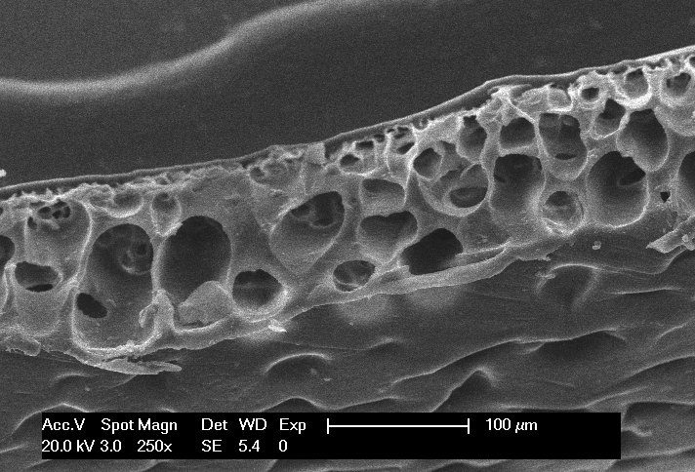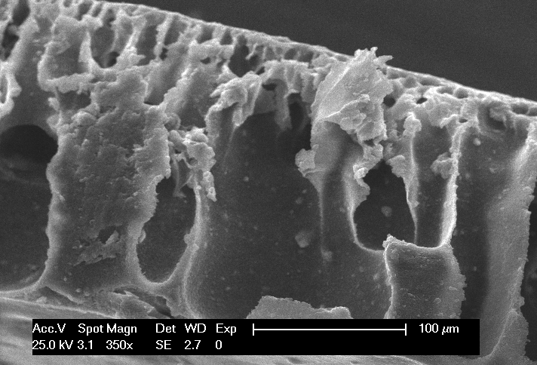

**(a)**

**(b)**

Figure 1. SEM of the MMMAs prepared: (a) MMMA with 5 wt% of ZUF and (b) MMMA with 15 wt% of ZUF

It is important to notice that by increasing the percentage of ZUF from 5 wt% (Figure 1a) to 20 wt% (Figure 1b), the pores seem to lose their configuration; this is caused by the presence of the zeolite, a third component in the casting solution that alters the surface tension of the system. The structure of the membrane changes from a sponge-like structure (Figure 1a) to a finger-like one (Figure 1b) with a consequent increase of the permeability and a decrease of mechanical stability. In Figure 1b we can see the ZUF particles embedded in the polymeric matrix. The hydrophilic degree of the zeolites is associated to the Si/Al ratio. ZUF has a Si/Al ratio of 3.5 and it can be considered hydrophilic. He *et al*. (2015) observed that, for polar solvent/nonsolvent system, such as NMP/H2O, the membrane has a sponge-like structure if the casting solution is hydrophobic. For low percentages of ZUF, the hydrophobicity of CA prevails (Golizadeh *et al*. 2019) and membranes with a sponge-like structure are formed, while for higher filler loadings (15-20 wt%) the membrane structure changes to finger-like structure, due to the large amount of hydrophilic ZUF in the system.

Preliminary results suggest that the different adsorbents have different affinity for the toxins: AC is the most suitable for adsorbing urea, while ZUF has the highest adsorption capacity for creatinine and uric acid.



Figure 2. Adsorption kinetics for the different toxins (Urea, Creatinine and Uric acid) on AC



Figure 3. Uric acid equilibrium isotherms for the 3 different adsorbents (AC, ZSM-5 and ZUF)

The adsorption kinetics of the various toxins onto AC, depicted in Figure 2, is very fast for creatinine and uric acid, indicating that the adsorption sites are saturated by such toxins in the first minutes of adsorption, while for urea the kinetics is slower requiring about 2 hours to reach steady state.

The adsorption capacity of the 3 fillers is different due to the different affinity towards the uremic toxins considered (Figure 3). For the zeolites, the adsorption is specific and it depends primarily on the interaction between the substance and the zeolite lattice, Wernert *et al*. (2005).

MMMAs with different filler concentrations and a pure CA membrane were tested in an ultrafiltration stirred cell to calculate the water permeability in a dead-end filtration mode.

The water permeability of the pure CA membrane is in accordance with the one found by Saljoughi *et al*. (2008). The water permeability coefficient B0 (Table 1) is enhanced by the presence of ZUF, that contributes to increase the void fraction of the system. The decrease of hydraulic permeability with higher filler loadings (25 wt%, 30 wt%) could be linked to a blockage of the pores due to the sizable amount of ZUF present in the casting solution. Another hypothesis could be the collapse of the extreme finger-like structure of these two membranes under the action of pressure. Additional experiments to elucidate this behavior will be performed.

Table 1. Water permeability coefficient B0 of the MMMAs prepared

|  |  |
| --- | --- |
|  | B0 (m2) |
| CA | 4.6E-16 |
| ZUF (5%) | 4.5E-16 |
| A.C. (5%) | 9.8E-16 |
| ZUF (10%) | 7.9E-16 |
| ZUF (15%) | 1.1E-15 |
| ZUF (20%) | 9.6E-16 |
| ZUF (25%) | 9.1E-16 |
| ZUF (30%) | 8.5E-16 |



Figure 4. Percentage of toxins removed as a function of ZUF weight percentage

The MMMAs were also tested to obtain their removal capacity in a batch operation mode. The removal of uric acid is easy, and it is almost independent on the loading of zeolite present in the membrane. From the results shown in Figure 4, it is evident that the membrane itself is actively involved in the adsorption mechanism. The removal of urea and creatinine is much lower with respect to the uric acid one; their dimensions allow penetration also onto the small pores.

4. Conclusions

The preliminary results obtained in this work show the removal capability of pure adsorbents and of MMMAs towards uremic toxins in aqueous solution. Adsorption tests indicate that ZSM-5 has the lowest adsorption capacity, while AC and ZUF are the most promising ones. MMMAs with ZUF were successfully prepared and tested to evaluate their hydraulic permeability and removal capacity. The preliminary results indicate the potentiality of porous materials and MMMAs in toxin removal for the hemodialysis process and justify the future investigation of different combinations of polymers and fillers.

Acknowledgments

The Authors acknowledge the Italian Ministry of University and Research and the University of Bologna for funding. Professor Andrea Saccani is kindly acknowledged for his help with the SEM images.

References

Agar W.M., 2008, Reusing Dialysis Water: The Elephant in the Room, American Journal of Kidney Diseases.,52, 10-12.

Association for the Advancement of Medical Instrumentation, Medical Equipment Management Committee, ANSI/AAMI EQ56: 2013.

Golizadeh M., Karimi A., Gandomi-Ravandi S., Vossoughi M., Khafaji M., Joghataei M., Faghihi F., 2019, Evaluation of cellular attachment and proliferation on different surface charged functional cellulose electrospun nanofibers, Carbohydrate Polymers, 207, 796-805.

He T., Finger-Like Structure, Encyclopedia of Membranes 2015, Springer-Verlag Berlin Heidelberg.

Kameda T., Saya I., Toshiaki Y., Kinetic and Equilibrium Studies of Urea Adsorption onto Activated Carbon: Adsorption Mechanism, Journal of Dispersion Science and Technology, ISNN: 0193-2691(Print) 1532-2351 (Online)

Merchant S.A., Adams K., Fresenius Medical Care Holding, Inc., Cartridge useful in cleaning dialysis solutions, PCT/US20, Massachusetts, North America, 2015.

Saljoughi E., Sadrzadeh M., Mohammadi T., 2009, Effect of preparation variables on morphology and pure water permeation flux through asymmetric cellulose acetate membranes, Journal of Membrane Science, 326(2) 627–634.

Schophuizen C. M. S., De Napoli I. E., Jansen J., Teixeira S., Wilmer M., J., Hoenderop J., G., J., Van den Heuvel L., P., W., Masereeuw R., Stamatialis D., 2015, Development of a living membrane comprising a functional human renal proximal tubule cell monolayer on polyethersulfone polymeric membrane, Acta Biomaterialia., 14, 22-32.

Tarrass F., Benjelloun M., Benjelloun O., 2008, Recycling wastewater after hemodialysis: an environmental analysis for alternative water sources in arid regions,American Journal of Kidney Diseases, 52, 154-158.

Valorization addendum, Maastricht University Research Portal, Netherlands, https://cris.maastrichtuniversity.nl/portal/files/11595947/v5460.pdf, 29/01/2019.

Wernert V., Schäf O., Ghobarkar H., Denoyel R., 2005, Adsorption properties of zeolites for artificial kidney applications, Microporous