CHEMICAL ENGINEERING TRANSACTIONS  VOL. , 2023 | A publication of
The Italian Association
of Chemical Engineering
Online at www.cetjournal.it

Guest Editors: Sauro Pierucci, Jiří Jaromír Klemeš
Copyright © 2023, AIDIC Servizi S.r.l.
ISBN 978-88-95608-98-3; ISSN 2283-9216

Toward Risk-based Inspection of Hydrogen Technologies: A Methodology for the Calculation of the Damage Factor for Hydrogen Embrittlement
Alessandro Campari^{a,}*, Antonio Alvaro^{b}, Federico Ustolinª, Nicola Paltrinieriª
ª Department of Mechanical and Industrial Engineering, NTNU, Trondheim, Norway
^{b} SINTEF Industry, SINTEF, Trondheim, Norway
alessandro.campari@ntnu.no
Hydrogen is considered a promising energy carrier to achieve the ambitious target of a zero-emission society in the forthcoming years. Despite its environmental advantages, hydrogen-induced material damages represent a serious safety concern. Hence, inspection and maintenance activities must be performed to guarantee the equipment's integrity. The risk-based inspection (RBI) is the most beneficial methodology for inspection planning but has never been adopted for components operating in hydrogen environments. The probability of failure of each piece of equipment is quantified through the definition of the damage factor, a parameter that accounts for the damage mechanism likely to occur. Hydrogen embrittlement (HE) is the main active degrading mechanism in equipment exposed to hydrogenated environments; if not appropriately accounted for, it can cause failures at unexpectedly low stress levels. This study aims to bridge a gap in knowledge by proposing a qualitative methodology to assess the degradation of equipment operating in hydrogenated environments and potentially subjected to HE. The environmental severity is estimated based on the operating conditions, while the material’s susceptibility depends on microstructure, strength, and adoption of post-weld heat treatments. This study could set the basis for the application of the RBI methodology to industrial equipment for producing, handling, and storing hydrogen. Hence, it will facilitate the inspection and maintenance of emerging hydrogen technologies.
  - Introduction
The rising demand for clean and affordable energy sources and the necessity for countries to be energetically self-sufficient are stimulating the research of sustainable energy carriers. The European Commission indicated hydrogen as a promising solution to reduce greenhouse gas emissions in power production, transportation, and several industrial sectors (Campari et al., 2022a). Despite the considerable environmental advantages, safety aspects represent one of the bottlenecks for a broad-based rollout of this energy carrier. Hydrogen’s capability of permeating and embrittling most metallic materials makes its transportation and storage challenging. Hydrogen embrittlement is a long-known material degradation phenomenon; nevertheless, it is still responsible for several component failures and subsequent hazardous releases in the environment (Campari et al., 2023). Approximately 99% of equipment breakdowns are preceded by signs that a failure will occur; hence, efficient inspection and maintenance activities could timely detect these failure precursors and prevent undesired hydrogen releases. In the case of hydrogen embrittlement-related failure, such precursors may be strongly reduced or even absent. Therefore, effective inspection planning is, if possible, even more critical to reduce the inspection frequency and complexity, while guaranteeing the utilization of facilities and equipment under safe conditions (Defteraios et al., 2020). Risk-based inspection methodology can be used to identify critical components and prioritize their inspection to mitigate the overall risk of the plant. RBI has been largely adopted in the chemical and petrochemical industries with satisfactory results. Despite this, the current definitions in the existing RBI standards and recommended practices are not suitable for hydrogen technologies, and this is reflected by the absence of specific guidelines for the evaluation of hydrogen embrittlement (Campari et al., 2022b). This study aims to bridge this gap in knowledge by developing a qualitative methodology to assess the degradation of components operating in a pure hydrogen environment, thus potentially subjected to HE. The final purpose is the application of the RBI methodology to industrial equipment for hydrogen production, handling, and storage to facilitate their utilization on an increasingly large scale.
  - Risk-based inspection methodology
Inspection activities are a fundamental part of predictive maintenance. The inspection does not reduce the risk of failure by itself but allows the monitoring of the equipment degradation level and indicates when it will reach a critical point, making possible intervention before the predicted failure date. Risk-based inspection is an inspection planning methodology developed by the American Petroleum Institute (API) which assumes that most of the total risk in a plant is associated with a small number of components (API, 2016). Hence, the risk management effort focuses on these high-risk items, prioritizing their inspection to guarantee the major benefits and reduce the overall risk. The risk combines the probability of failure ($P_{f}$) with its consequences ($C_{f}$):
$$R_{f}\left(t,I_{E}\right)=P_{f}(t,I_{E})∙C_{f}$$ | (1)
The probability of failure is calculated as the product of a generic failure frequency ($gff$), a damage factor ($D_{f}$), and a management system factor ($F_{MS}$):
$$P_{f}\left(t,I_{E}\right)=gff∙D_{f}(t,I_{E})∙F_{MS}$$ | (2)
The generic failure frequency is defined as the number of failures per year of a certain type of equipment and relies on statistical analyses of historical data. The damage factor adjusts the $gff$ and considers the level of susceptibility of the component to a defined damage mechanism, depending on the service time, the material, the operating conditions, and the number and effectiveness of previous inspections. The management system factor accounts for the probability that accumulating damage will be detected before the failure occurrence. The consequence of failure is determined through well-established consequence analysis techniques based on empirical equations and predefined hole sizes. It can be expressed in financial terms or as an impact area in case of flammable or toxic releases (API, 2019). Any error in estimating both the $P_{f}$ and the $C_{f}$ can be propagated to the resulting determination of risk and subsequently affect the inspection planning decisions. The logical progression of the RBI methodology, as presented in API RP 581, is depicted in Figure 1:

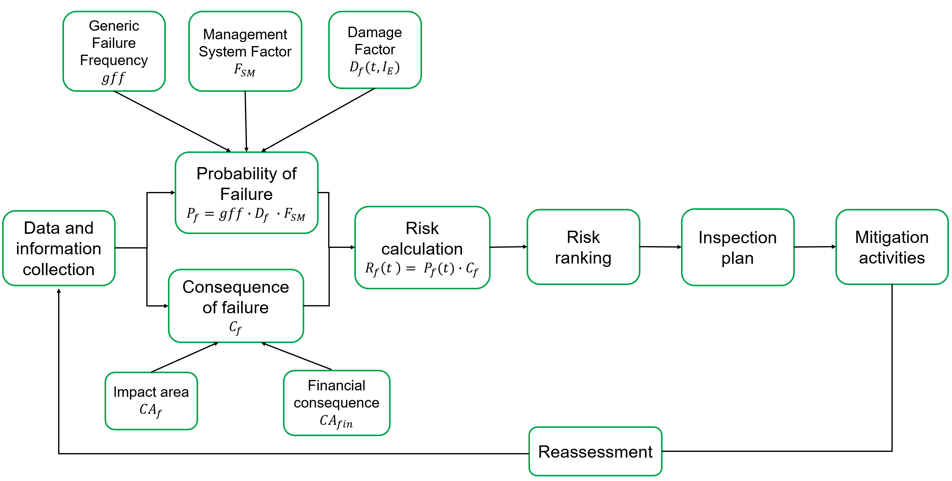
Figure 1: Flow diagram of the API risk-based inspection methodology
The RBI process starts with collecting and validating technical data and historical information on the facility. Secondly, all the damage mechanisms likely to occur must be identified, determining the damage susceptibility of each component, and calculating the $P_{f}$. All the credible failure modes and the related consequence scenarios should be considered. Then, the analysts must calculate the risk associated with each piece of equipment and rank them. The inspection plan should be developed, prioritizing the high-risk components. Then, the entire process is reassessed accordingly to the results of previous inspections.
  - Hydrogen embrittlement
Hydrogen embrittlement is a degradation mechanism that may result in the material loss of ductility, strength, and resistance to crack both under static and cyclic loading and it is connected to the interaction of metallic components when exposed to hydrogenated environments (API, 2020). Absorbed hydrogen tends to diffuse in regions with high triaxial stress and accumulates, affecting the resistance to external loadings and provoking sudden components’ failures (Campari et al., 2022b). HE is responsible for the brittle cracking of otherwise ductile materials and may affect a variety of hydrogen technologies, such as storage tanks, cylinders, pipes, fuel cells, and transport pipelines. In this case, hydrogen embrittlement refers to quasi-static loading conditions resulting from the gas pressure within the containment system or from internal stresses, especially in weldments. From the RBI perspective, hydrogen-enhanced fatigue crack growth (HEFCG) under cyclic loading is considered a different damage type. Hydrogen embrittlement happens as a result of the synergistic interplay of several factors (NASA, 2005):
- Environment – hydrogen partial pressure, temperature, purity (presence of inhibitors), form (atomic or molecular), and source of hydrogen (e.g., cathodic protection, manufacturing processes, etc.);
- Material – chemical composition, grain size, grain boundaries, phase stability, strength, surface conditions, presence of welds and heat-affected zones (HAZ);
- Loading condition – level of applied and residual stresses, type of loading (monotonic or cyclic).
Temperature influences surface reactions that affect hydrogen uptake kinetics, solubility, diffusivity, and trapping into the metal lattice. At low temperatures, the diffusion is slower while, at high temperatures, atoms’ mobility is enhanced, and hydrogen de-trapping is favoured. Hence, the degrading effect of environmental HE reaches a maximum in the temperature range between -70 and 30°C depending on the material system. According to Sievert’s law, the hydrogen concentration in the metal lattice is proportional to the hydrogen partial pressure, following a square root dependence, and the same goes for the HE effects. Nevertheless, above a certain pressure, saturation occurs, and further pressure increases do not affect the HE susceptibility. As a rule of thumb, the susceptibility to HE increases as the material strength increases. Moreover, for a given strength level, certain microstructures (e.g., untampered martensite) are more susceptible than others (e.g., austenite). Low-alloy steels, high-strength steels, 400 series stainless steels, precipitation hardenable stainless steels, duplex stainless steel, and some high-strength nickel-based and titanium-based alloys are potentially susceptible to HE (San Marchi and Somerday, 2012).
  - Calculation of the damage factor
API RP 581 is the most-known reference for putting in action a semi-quantitative RBI. Hence, the methodology proposed in this study to calculate the hydrogen embrittlement damage factor is based on this recommended practice. Table 1 summarizes the information required for the determination of the $D_{f}^{HE}$.
Table 1: Data required for the determination of the damage factor for hydrogen embrittlement
Required data | Specific information | Comments
Environmental severity | Hydrogen partial pressure | Determine the operating pressure and the pressure during start-up, shutdown, and upset conditions
 | Temperature | Determine the operating temperature, and the temperature during start-up, shutdown, and upset conditions
Materials susceptibility | Microstructure, composition, strength | Determine what kind of alloy or steel was used to fabricate the component
 | Welds | Determine if post-weld heat treatments (PWHT) were performed
Component’s history | Time since the last inspection | Use inspection history to determine the time since the last HE inspection
 | Inspection effectiveness category | Determine the effectiveness category for the inspection that has been performed on the component
 | Number of inspections | Determine the number of inspections in each effectiveness category that have been performed on the component
On-line monitoring | Hydrogen probes and/or process variable monitoring | Determine the type of proactive monitoring methods employed

The following procedure may be used to calculate the damage factor for HE:
- STEP 1 – Determine the environmental severity (i.e., the potential level of hydrogen uptake) based on hydrogen partial pressure and temperature, using Table 2 (San Marchi and Somerday, 2012).
Table 2: Environmental severity based on hydrogen partial pressure and temperature
Hydrogen pressure (MPa) | Temperature (°C)
 | $$T<-70$$ | $$-70≤T≤30$$ | $$30<T≤200$$ | $$T>200$$
$$p_{H_{2}}<0.1$$ | Negligible | Moderate | Negligible | Negligible
$$0.1<p_{H_{2}}<5.0$$ | Negligible | High | Moderate | Negligible
$$5.0<p_{H_{2}}<15.0$$ | Moderate | Severe | High | Moderate
$$15.0<p_{H_{2}}<35.0$$ | Moderate | Extreme | Severe | Moderate
$$p_{H_{2}}>35.0$$ | Moderate | Extreme | Severe | Moderate

- STEP 2 – Determine the material susceptibility based on the type of alloy or steel used to fabricate the component, using Table 3. The values tabulated should be increased by one severity level in absence of post-weld heat treatments.
Table 3: Material susceptibility based on the embrittlement indexes tabulated by the NASA (2016)
Material class | HE Susceptibility
 | Negligible | Moderate | High |  | Severe | Extreme
Nickel-based alloys |  |  | Nickel 270 |  |  | Nickel 301, K-Monel
Titanium-based alloys |  | Titanium | Ti-6Al-4V (annealed), Ti-5Al-2.5Sn |  | Ti-6Al-4V (STA) | Ti-11.5Mo-6Zr-4.5Sn, Alpha-2 TiAl, Gamma-TiAl
Copper-based alloys | All | Be-Cu alloy 25
Austenitic steels | A286, 216, 316, Nitronic 50 | 309, 310, 347, 18-3-Mn | Tenelon, A302B, 304, 305, 308, 321, Nitronic 40 |  | Nitronic 32, 18-18 Plus, 18-2-Mn | CG-27
Ferritic steels |  |  | A106, A515, A516, A517, A533, HY-80, HY-100, Iron, X60, X65, X70, 1020, C1025 |  | A212-61T, A372, X42, X52, 430 | X100, 1080, 1042, 4140, 4340
Martensitic steels |  |  |  |  |  | All

- STEP 3 – Determine the Severity Index, according to Table 4.
Table 4: Severity Index for hydrogen embrittlement
 |  | Material susceptibility
 |  | Negligible | Moderate | High | Severe | Extreme
Environmental severity | Extreme | Moderate | High | Severe | Extreme | Extreme
 | Severe | Moderate | High | High | Severe | Extreme
 | High | Moderate | Moderate | High | High | Severe
 | Moderate | Negligible | Moderate | Moderate | High | High
 | Negligible | Negligible | Negligible | Moderate | Moderate | High

- STEP 4 – Determine the age and the time-in-service since the last inspection with no damage detected.
- STEP 5 – Determine the number of past inspection and their inspection effectiveness according to Table 5 (API, 2020). Possible inspection techniques are liquid penetrant testing (PT), magnetic particle testing (MT), wet fluorescent magnetic particle testing (WFMT), shear wave ultrasonic testing (SWUT), and phased array ultrasonic testing (PAUT).
Table 5: Inspection effectiveness of an example technique for hydrogen embrittlement detection
Inspection category | Inspection effectiveness | Intrusive inspection | Non-intrusive inspection
A | Highly Effective  (80 – 100%) | For the total weld area: PT/MT/WFMT with SWUT/PAUT follow-up of indications
B | Usually Effective  (60 – 80%) | For the selected weld area: > 65% PT/MT/WFMT with SWUT/PAUT follow-up of indications | For the total weld area: automated or manual ultrasonic scanning
C | Fairly Effective  (40 – 60%) | For the selected weld area: > 35% PT/MT/WFMT with SWUT/PAUT follow-up of indications | For the selected weld area: > 65% automated or manual ultrasonic scanning
D | Poorly Effective  (20 – 40%) | For the selected weld area: > 10% PT/MT/WFMT with SWUT/PAUT follow-up of indications | For the selected weld area: > 35% automated or manual ultrasonic scanning
E | Ineffective  (< 20%) | Ineffective inspection techniques | Radiographic testing or visual inspections

- STEP 6 – Determine the base $D_{f}$ for HE, using the number of inspections and the highest inspection effectiveness from STEP 5 and the Severity Index from STEP 3, and the table provided in API (2019).
- STEP 7 – Determine the on-line adjustment factor. $F_{OM}$ is equal to 1 if no on-line monitoring methods are employed, 2 if hydrogen probes or process variables monitoring are used, 4 if hydrogen probes are used in combination with process variables monitoring.
- STEP 8 – Calculate the final damage factor using Equation (3), based on the time-in-service since the last inspection from STEP 4 and the on-line adjustment factor from STEP 7.

$$D_{f}^{HE}=min\left[\frac{D_{fB}^{HE}∙{\left(max\left[age,1.0\right]\right)}^{1.1}}{F_{OM}},5000\right]$$ | (3)

The process for the calculation of the HE damage factor is summarized as a flow diagram in Figure 2:

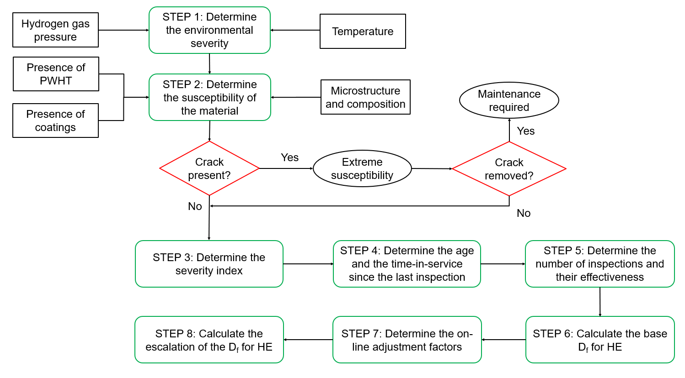
Figure 2: Flow diagram for the determination of the HE damage factor
  - Discussion
The methodology proposed aims at filling a gap in the existing RBI standards and recommended practices: the evaluation of the environmental damage associated with hydrogen embrittlement through a reliable definition of the damage factor. When it comes to planning the inspection of hydrogen-related industrial plants, the major bottleneck is the limited market penetration of these technologies, which makes it difficult to gather the data required to develop accurate reliability models. This is the case of recently developed components (e.g., fuel cells and electrolyzers), for which the generic failure frequency can be determined only with high uncertainty since little to no relevant data are available. On the other hand, several industrial components, such as vessels, cylinders, compressors, pipes, and pipelines, are normally used both in the chemical industry and for transporting and storing pressurized hydrogen gas. Hence, the problem shifts from the determination of the $gff$ to the calculation of the $D_{f}$ for an operating environment that was not considered likely, i.e., pure and compressed gaseous hydrogen. In this perspective, the environmental severity has been determined according to the relevant scientific literature regarding hydrogen embrittlement. The most severe scenario seems to be a high-pressure environment at near-ambient temperature, which is the case for most of the equipment for gaseous hydrogen transport and storage. Moreover, one of the most common parameters used to quantify the material susceptibility to hydrogen embrittlement is the Embrittlement Index (EI), which indicates the relative difference in reduction of the cross-sectional area for a tensile test performed in a relevant hydrogen environment with respect to the same value obtained from the test performed in a reference environment (e.g., in the air). The higher the EI value, the higher will be the susceptibility of the material to HE. As a first step, the modified RBI approach can be applied to a case study and compared with consolidated methodologies for inspection planning. For instance, the time-based approach can be considered a benchmark since it is still largely adopted for its simplicity, despite the over-conservative assumptions and the excessive inspection frequency. After this validation, this study could facilitate the application of the RBI methodology to industrial equipment for hydrogen production, transportation, and storage, thus stimulating their widespread rollout in the future.
  - Conclusions
This study proposes a qualitative methodology for calculating the HE damage factor, based on environmental severity and material susceptibility. While the former depends on the equipment operating conditions, the latter relies on the material microstructure, its strength, and the presence of PWHT. An example of inspection techniques for HE detection is also provided. This methodology is compliant with the existing API RBI and thus can be used for planning inspection activities of hydrogen technologies. Nevertheless, this method could only qualitatively indicate the severity of the H₂-induced material damage, without providing numerical values for a quantitative or semi-quantitative RBI. Further studies are required, and work is ongoing to numerically quantify the $D_{f}$ for hydrogen embrittlement through experimental tests coupled with advanced AI approaches.
Acknowledgments
This work was undertaken as a part of the research projects H₂CoopStorage and SH₂IFT-2, and the authors would like to acknowledge the financial support of the Nordic Energy Research within the program ERA-Net Smart Energy System (Grant No. 106291) and of the Research Council of Norway (Grant No. 327009).
References
API, 2016, API Recommended Practice 580 – Risk-Based Inspection, Washington, USA.
API, 2019, API Recommended Practice 581 – Risk-Based Inspection Methodology, Washington, USA.
API, 2020, API Recommended Practice 571 – Damage Mechanisms Affecting Fixed Equipment in the Refining Industry, Washington, USA.
Campari A., Pio G., Ustolin F., Paltrinieri N., Salzano E., 2022a, Design and Optimization of an Emergency Auto-thermal Burner for Liquid Hydrogen, Chem. Eng. Trans., 91, 325-330, DOI: 10.3303/CET2291055.
Campari A., Darabi M.A., Ustolin F., Alvaro A., Paltrinieri N., 2022b, Applicability of Risk-based Inspection Methodology to Hydrogen Technologies: A Preliminary Review of the Existing Standards, Proceedings of the 32nd ESREL, Dublin, Ireland, 574-581, DOI: 10.3850/978-981-18-5183-4_R13-01-095-cd.
Campari A., Nakhal A.J., Ustolin F., Alvaro A., Ledda A., Agnello P., Moretto P., Patriarca R., Paltrinieri N., 2023, Lessons Learned from HIAD 2.0: Inspection and Maintenance to Avoid Hydrogen-Induced Material Failures, Comput. Chem. Eng., 173, DOI: 10.1016/j.compchemeng.2023.108199.
Defteraios N., Kyranoudis C., Nivolianitou Z., Aneziris O., 2020, Hydrogen explosion incident mitigation in steam reforming units through enhanced inspection and forecasting corrosion tools implementation, J. Loss Prev. Process, 63, DOI: 10.1016/j.jlp.2019.104016.
NASA, 2005, NSS 1740.16 – Safety Standard for Hydrogen and Hydrogen Systems, Washington, USA.
NASA, 2016, NASA/TM-2016–218602 – Hydrogen Embrittlement, Huntsville, USA.
San Marchi C., Somerday B.P., 2012, Technical Reference for Hydrogen Compatibility of Materials, USA.

