CHEMICAL ENGINEERING TRANSACTIONS  VOL. 92, 2023 | A publication of
The Italian Association
of Chemical Engineering
Online at www.cetjournal.it

Guest Editor: Sauro Pierucci
Copyright © 2023, AIDIC Servizi S.r.l.
ISBN 978-88-95608-98-3; ISSN 2283-9216

Toxicological evaluation of the sediments of the Juan Angola channel (Cartagena) using C. elegans as biological model
María Sierra, Lesly Tejeda, Karina Ojeda*
Process Design and Biomass Utilization Research Group (IDAB), Chemical Engineering Department, University of Cartagena, Cartagena, Bolívar, Colombia.
* Corresponding author: kojedad@unicartagena.edu.co
Recently, the pollution in bodies of water near urban settlements has drawn the attention of government agencies. The city of Cartagena, being a coastal city, has multiple bodies of water that make up its ecosystems, both maritime and freshwater. One of these bodies of water is the Juan Angola channel, the focus of our research, which fulfills its function of flowing nutrients to the Ciénaga de la Virgen. However, due to the accumulation of pollutants and the neglect of the environmental authorities, the “Juan Angola” channel has become a dumping ground for the pollution and a garbage dump for its surrounding neighborhoods, significantly affecting the living beings that reside in it, including the mangrove swamp. The “Juan Angola” channel is a water corridor that runs from the Ciénaga de la Virgen to the Cabrero lagoon, Cartagena - Colombia. This work aimed to evaluate the toxicological effects using the nematode Caenorhabditis elegans in extracts of sediments of the channel. This work had quantitative experimental methodology by using the samples taken in the field trips, which were conditioned and analyzed by using the nematode nematodes through endpoints such as Lethality. The results showed a high case fatality rate of nematodes after exposing them to the extract of sediments.
Keywords: Nematode, Caenorhabditis elegans, Channel Juan Angola, sediments, toxicological evaluation.

INTRODUCTION

A high level of contamination, foul odors and turbid water is qualitatively evident in the Juan Angola stream, which is why we seek to determine the level of toxicity of this body of water using Caenorhabditis elegans as a biological indicator.

Water is a scarce natural resource, necessary for human life and for the maintenance of the environment, but due to accelerated human and economic growth and development and its excessive use, it has been used as a means of waste disposal and has suffered an alarming decline. During the last few years, tons of biologically active substances, synthesized for use in agriculture, industry, medicine, have been discharged into the environment without taking into account the possible consequences on the ecosystem (Lina et al., 2010). Pollution in bodies of water near urban settlements has become a focus of attention for governmental agencies, especially in sectors where communities are more vulnerable.

The city of Cartagena de Indias, being a coastal city, has multiple water bodies that make up its ecosystems, both marine and freshwater. One of these bodies of water is the Juan Angola channel, the focus of our research, which fulfills its function of breathing the Ciénaga de la Virgen; however, the accumulation of pollutants and neglect by environmental authorities, the Juan Angola channel has become a dumping ground for the city and a garbage dump for its surrounding neighborhoods, significantly affecting the living beings that reside in it, including the mangrove.

The Juan Angola channel is a water corridor that runs from the Ciénaga de la Virgen to the El Cabrero lagoon, its waters surround the Rafael Núñez international airport and different neighborhoods of the city such as San Francisco, La María, Canapote, Marbella, Crespito, Crespo, among others; neighborhoods that, due to social aspects, contribute to the high rate of contamination that the channel contains. Informal human settlements, sewage dumping and sedimentation have caused the environmental deterioration of the Juan Angola channel, the channel through which nutrients and oxygen flow from the city's two largest bodies of water (Pereira, 2020). In addition to this situation, there is evidence of mangrove overpopulation in some points of the Juan Angola channel, specifically in the area parallel to the Cartagena airport, since at certain points of the channel the mangrove is growing excessively on both banks and is preventing sunlight from entering the water, thus increasing the turbidity of the water in those areas.

In the city of Cartagena, the entity responsible for the conservation of water bodies is the Environmental Public Establishment (EPA), which has presented projects for the recovery of the Juan Angola channel, being the most recent proposal presented by the entity in May 2021 for the recovery of the channel, which proposes a complete change in the infrastructure of the banks of the channel, improvement of the channel, control of human settlements and the recovery of the mangrove and fauna of the area.

The specific objective of this project is to evaluate the environmental quality of the Juan Angola channel through the determination of physicochemical and biological parameters, heavy metals, organic pollutants, and toxicological quality using the nematode Caenorhabditis elegans in sediments, which is linked to the research project entitled Toxicological and environmental evaluation of the effect of heavy metals in the ecosystems associated with the Juan Angola channel (Cartagena-Bolivar), in surface water and sediments. In order to fulfill the objective, methodologically, the geo-referencing of the sampling points, water and sediment sampling, followed by physicochemical, microbiological and toxicological tests are carried out.

The nematode Caenorhabditis elegans is a microorganism of easy maintenance, short life cycle and low cost, which is repeatedly used as a biological model in toxicology assays. The use of stress-related gene expression responses, functional genomics, and transgenic biosensor has considerable potential for sensitive diagnosis of environmental contamination (Choi, 2008).

METHODOLOGY
POPULATION-SAMPLE
The object of study of the present investigation was the Juan Angola stream, from which sediment samples were taken at different points, which were E-1, E1, E3 and E5 during the dry and rainy seasons, The points are represented geographically in the following figure.

Fig 1. sample points.
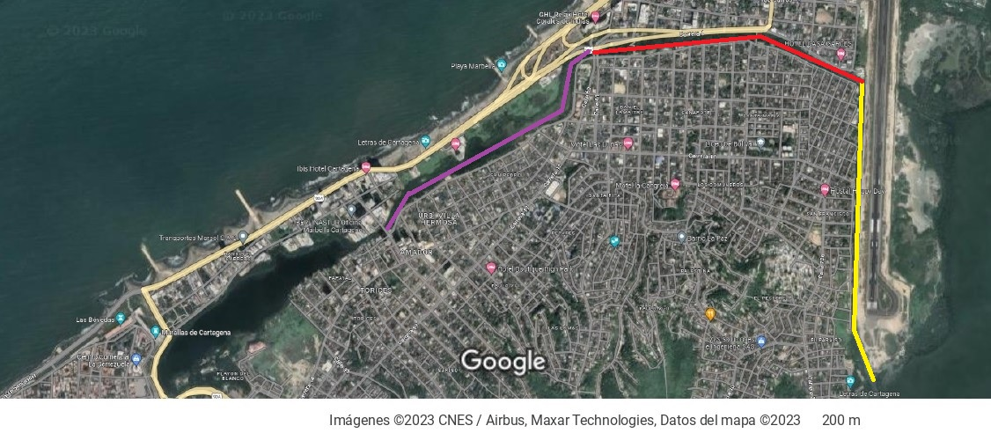
E 5
E 3
E-1
E 1

MATERIALS, EQUIPMENT AND REAGENTS
Instruments and equipment
The equipment and instruments used for the optimal experimental development of the research internship are shown in Table 1.
Table 1 Equipment required for the experimental procedure.
Name of the equipment | Brand | Function/use
Analytical scale | Vibra HT | Determine the weight of the samples before submitting them to the lyophilization process.
Lyophilizer | -- | Decrease moisture content in sediment samples.
Sifter | Edibon orto alresa Mod. Vibro | Select particle size of sediment samples after passing them through the freeze-drying process.
Soxleth | –
Incubator | – | Incubation and growth of Caenorhabditis elegans.

EXPERIMENTAL PROCEDURE
Prior to the experimental procedure, two field trips were made to collect samples in the Juan Angola channel; one trip took place during the rainy season and the other during the dry season. The purpose of the field trips was to collect sediment samples from the Juan Angola channel for toxicological analysis. A general scheme of the process is shown in Fig 2.
Fig 2 Experimental procedure.
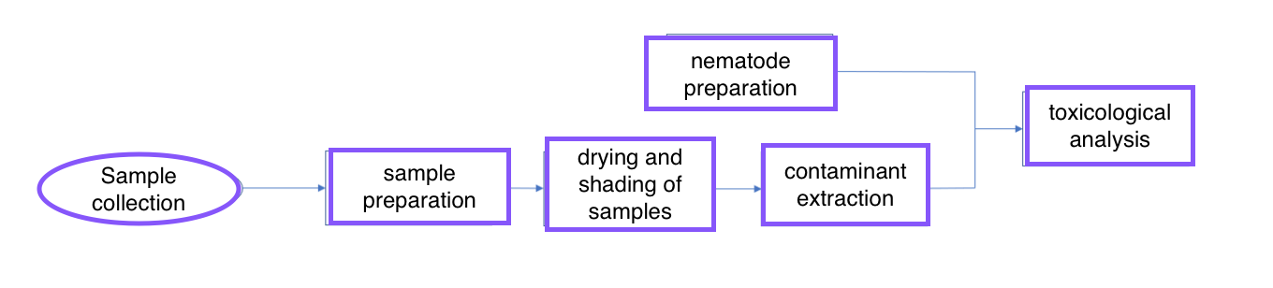

Preparation of sediment samples
The samples taken were stored with temperature conditions of (-20 °C) in a refrigerator located in the facilities of the University of Cartagena, in order to preserve the samples (González et al., 2021). The samples were distributed in glass material, using four bottles per sampling point, having 24 bottles in total with 20g of content each (Tejeda et al., 2016).
Sample drying and sieving process
The samples were subjected to a drying process using the freeze dryer (Canedo et al., 2014) located at the University of Cartagena facilities, the equipment operated at -40°c and 0.01 mbar vacuum for 48 hours, after drying the samples were crushed and sieved to select the particle size smaller than 63 µm with which the sediments were used for toxicological analysis (González et al., 2021).
Extraction of contaminants
Contaminants were extracted from the sediment samples by Soxhlet extraction (Santos, 2011) using distilled water as solvent and using 20 g of the previously sieved sediments as solute, in a 1:1 solution.
Nematode preparation
The nematodes used were supplied by the microbiology laboratory of the University of Cartagena, the nematodes remained in Petri dishes in an incubator at 20°C (Torres, De los rios, 2022), located in the heat transfer laboratory of Chemical Engineering, Piedra de Bolivar campus, which ensured the optimal state of the worms prior to analysis. To perform the toxicological analysis with the nematode, 10 cell culture plates of 96 wells each were used and approximately 10 nematodes were introduced in each well, each worm in larval stage L4 (Quijano, 2021).
Toxicological analysis
To perform the toxicological analysis of the Juan Angola channel, the Caenorhabditis elegans were exposed to the sediments for 24 h at 20 °C, with four replicates for each treatment (González et al., 2021). After 24 hours, using a stereoscope, the number of live individuals was counted and a comparison was made between each of the points analyzed, and the locomotion of the live organisms after the test was analyzed (Hidalgo, 2022). Table 2 shows the variables to be taken into account for the toxicological analysis.
Table 2 Experimental design Toxicological analysis.
Types of variables | Variables | Dimensions | Levels
 | Larval Stage | L4 | 4
 | Extract concentration | % P/V | -
 | Nematode ambient temperature | °C | -
Dependents | Number of living organisms per point | - | 6
 | Hatching time | Hours | -
 | Age | Days | -
Interveners | Light | Hours | -

RESULTS

The following graph shows the obtained results by following the methodology described previously.

Fig 3 nematode lethality percentage E-1 Fig 4 nematode lethality percentage E1

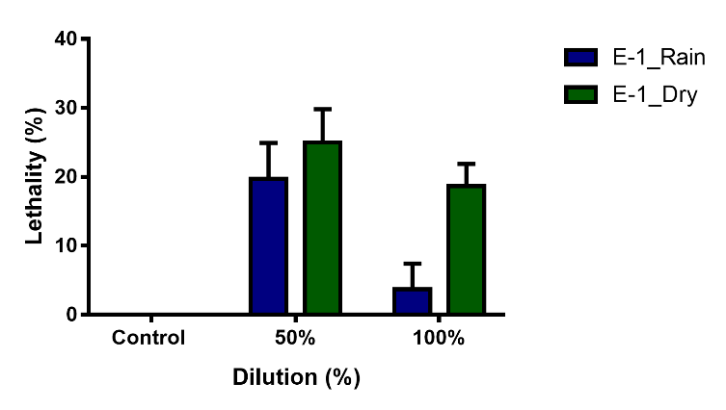
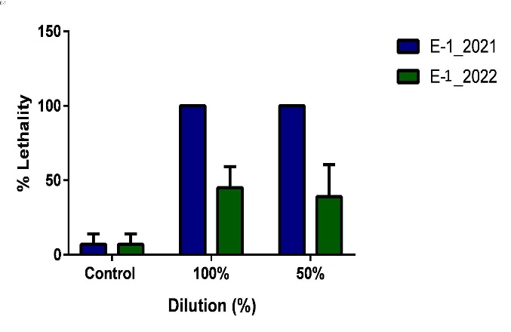

In order to determine the feasibility of the toxicological analyses, ANOVA was performed and the significance levels were examined by comparing them with the P value. In the case of the data shown in Fig. 3, there is an interaction with the control of p=0.0009, a p<0.0001 for the data compared between the control and E-1 2021 and a p<0.0001 for the data compared between the control and each E-1 2022. Consequently, the null hypothesis is rejected.

for the case of Figure 4, we will not take into account the 100% dilution in rainy season since there is no significant difference, therefore we will take into account the data that have enough significant difference: in the 50% dilution in rainy season p=0.0095, in the 50% dilution in dry season p=0.0015 and in the 100% dilution of dry season p=0.0139.

Fig. 3 shows the lethality percentage of nematodes 24 hours after exposure to contaminant extracts taken from sediment samples. Analyzing the graph, it is evident that point E -1 2021 had a lethality of 100%, that is, none of the nematodes survived the exposure to the extract in any of the dilutions. We also observed that point E - 1 2022 had a lethality lower than 50% in both dilutions, however, it had a higher lethality in the pure extracts than in the 50% dilution.

The absolute lethality of nematodes at point E-1 2021 may be due to the fact that this sample was taken during the rainy season, a time when sediments are stirred up and all the runoff and streams from the city reaches the Juan Angola channel loaded with garbage, emerging pollutants, heavy metals, among others.

Fig. 4 shows the percentage of nematode lethality 24 hours after exposure to the contaminant extracts taken from the sediment samples. Analyzing the graph, it is evident that point E 1 in rainy season is more contaminated than point E 1 in dry season and this is denoted in both dilutions.

Establishing a comparison between both points, we realize that point E 1 has a lower degree of contamination than E 1, both in the dry season and in the rainy season, since the lethality of point E 1 does not exceed 30%, while the lethality recorded at point E 1 does not decrease by 40%, therefore it would be precise to assume that point E 1 is the one that needs a greater intervention to correct the Juan Angola channel.
As previously mentioned, C. elegans is a biological model that is easy to handle for toxicological studies such as the one carried out in this document. It is easy to observe thanks to its transparent body; however, this can become a difficulty when carrying out tests with sediments since these have a dark tone. Therefore, it will generate problems while observing the behavior of the nematode when exposed to contaminants.

The tests carried out in this research provide the necessary and divulgable knowledge to share with the communities surrounding the Juan Angola channel and the authorities in charge, such as the EPA, and thus contribute to a future restructuring and sanitation of the channel.

CONCLUSION

C. elegans was used to generate the toxicity profile of sediments taken from four sampling points along the Juan Angola channel in two field trips distributed according to climatic conditions. The aqueous extracts of the sediments to which the nematodes were exposed caused lethal effects on them, showing complete lethality at point E - 1 2021 and at point E - 1 2022 showed a better response to the stress caused by exposure, with a lethality of approximately 50%. The response of the nematode to exposure to aqueous extracts of pollutants shows us how important it is to take action on the toxicological and environmental quality of the Juan Angola river, in addition to paying attention to regulate the waste and streams that reach the river due to the infrastructure of the city and the social conditions of the communities surrounding the channel.

BIBLIOGRAPHY
1. Lima V.C., Prata T.S., Landa G., Yannuzzi L.A., Rosen R.B. (2010). Intravitreal triamcinolone and bevacizumab therapy for combined papillophlebitis and central retinal artery occlusion. Retin Cases Br Reports, 4(2), 125–8.
2. Pereira M. J. (2 de noviembre de 2020). Caño Juan Angola: el reto de recuperar el corazón hídrico de Cartagena. El Espectador. https://www.elespectador.com/colombia/cartagena/el-reto-de-recuperar-el-corazon-hidrico-de-cartagena-article/
3. Choi J. (2008). Caenorhabditis elegans as a biological model for multilevel biomarker analysis in environmental toxicology and risk assessment. Toxicol Res, 24(4), 235–43.
4. Martínez A. (2020). Estrategias de resistencia, gobernanza ambiental y climática en ecosistemas urbanos: La defensa del Caño Juan Angola, en Cartagena de Indias–Colombia.
5. González Carrasco V.H., Tejeda Benítez L.P., Pilaloa Tamayo J.C. (2021). Evaluación toxicológica de los sedimentos marinos del estero Huaylá, usando como bioindicador al nematodo C. elegans. Cienc y Tecnol., 14(1), 61–9.
6. Canedo-López, Y., Ruiz-Marín, A., & Chi-Ayil, J. C. (2014). Diagnóstico de la contaminación por metales pesados en sedimento superficial de la laguna de términos, Campeche: una aproximación Estadística. Revista AIDIS de Ingeniería y Ciencias Ambientales. Investigación, desarrollo y práctica, 7(2).
7. Santos, A. S. O. D. (2011). Estudo comparativo entre extração Soxhlet e ultrasom para determinação de hidrocarbonetos policíclicos aromáticos em sedimentos do estuário do rio Sergipe por cromatografia a gás acoplada a espectrometria de massas.
8. Torres Barrera, E. M., & De Los Ríos Pedraza, A. C. (2022). Evaluación de elementos potencialmente tóxicos (pb y hg) presentes en PM2. 5 del aire de la ciudad de Barranquilla empleando el modelo biológico C. Elegans.we
9. Quijano Guerrero, D. P. (2021). Evaluación del efecto de la capacidad inhibitoria de la agregación de las mutantes A30W, K28A y M35C del péptido β-amiloide en un modelo in vivo de C. elegans (Doctoral dissertation, Universidad Autónoma de Nuevo León).
10. Hidalgo Pulido, K. L. (2022). Evaluación del efecto del fitocannabinoide cannabidiol (CBD) en la cepa NL5901 de Caenorhabditis elegans.

