CHEMICAL ENGINEERING TRANSACTIONS  VOL. , 2023 | A publication of
The Italian Association
of Chemical Engineering
Online at www.cetjournal.it

Guest Editors: Sauro Pierucci, Jiří Jaromír Klemeš
Copyright © 2023, AIDIC Servizi S.r.l.
ISBN 978-88-95608-98-3; ISSN 2283-9216
The effects of deposition parameters on the properties of NiCr coatings obtained by electroless plating.
Marco Conti,*, Laura Paglia, Virgilio Genova, Giulia Pedrizzetti, Lidia Baiamonte, Francesco Marra.
Dept. of Chemical Engineering, Materials, Environment, Sapienza University of Rome, INSTM Reference Laboratory for Engineering of Surface Treatments, Via Eudossiana, 18 - 00184 Rome – Italy
*m.conti@uniroma1.it
The use of Nickel-Chromium (NiCr) alloys as surface coatings have gained widespread popularity in the power generation and aerospace industries due to their optimal resistance to oxidation and corrosion at high temperatures. This study explores the synthesis of NiCr coatings via electroless autocatalytic deposition, a promising method that enables the formation of non-directional, Cr (VI)-free coatings. Coatings were deposited onto low-carbon steel (LF2) substrates and chromium nanoparticles were incorporated into an electroless nickel bath based on hydrazine monohydrate as the reducing agent. The stability of the bath was improved using Cetyltrimethylammonium Bromide (CTAB) as a dispersing agent. Optimization of the deposition parameters allowed the deposition of a 60 µm thick NiCr coating with 11 atomic % chromium content, obtained through a uniform distribution of well-dispersed chromium particles across the sample. This study highlights the potential of electroless autocatalytic deposition as a promising method for the synthesis of NiCr coatings.
  - Introduction
The properties and characteristics of NiCr coatings have been attracting significant attention due to their remarkable corrosion resistance and hardness. The addition of nickel (Ni) and chromium (Cr) in steel leads to an improvement in the material's resistance against corrosion and oxidation at high temperatures, as confirmed by studies by Meier (1989) and Nicholls and Hancock (1985). These coatings are widely used for protection against corrosion, heat, and high-temperature oxidation in power plants, boilers, chemical industries, and aviation. Various thermal spraying techniques, such as flame, plasma, High-Velocity Oxy Fuel (HVOF), and high-frequency pulse detonation (HFPD), have been employed to deposit NiCr coatings (Picas et al. 2006)(Saaedi et al. 2010). However, thermal spraying techniques can result in nonuniform coating thickness due to the intrinsic directionality of the process (Hardwicke and Lau 2013). The electrodeposition method has also been extensively used to obtain NiCr coatings, with baths based on Cr (VI) ions as chromium sources. Despite its widespread use, Cr (VI) is banned because of health and safety issues, being a carcinogenic substance. Although alternative electrodeposition baths from Cr (III) can serve as a safe alternative, they have limited covering power, (Protsenko and Danilov 2014). Therefore, electroless autocatalytic plating can be considered an attractive alternative method, as it allows non-line-of-sight deposition of NiCr coatings without the use of Cr (VI). Another interesting advantage of the electroless process for the deposition of metal films consists in the selective reduction of metal ions onto the substrate. Unlike electrodeposition, this method does not require the application of external electrical power, as the electrons involved in the reduction of metal ions for coating formation come from a reducing agent incorporated in the bath [7]. No electric field is applied, so the resulting metal deposits are uniform and can cover all surfaces and internal cavities, regardless of their shape. Bath components for electroless plating typically include a source of metal ions, a reducing agent, complexing agents, accelerators, and stabilizers, to prevent bath decomposition while maintaining acceptable plating rates. pH is also known to strongly influence deposition, so a buffer system for pH control is also included. In this study, a pure Ni coating was obtained by using hydrazine as the reducing agent, with a procedure described in detail by V. Genova et al. (2019). In this work, the concept behind the design of NiCr coatings is to incorporate a secondary phase of nanoscale Cr particles into electroless Ni coating to enhance their high-temperature corrosion and oxidation resistance. This process is similar to traditional electroless techniques, but the introduction of suspended Cr nanoparticles in the plating solution allows their incorporation in the growing Ni film. The successful co-deposit of ion Cr particles strongly depends on bath chemistry and deposition parameters (Sudagar et al. 2013). The introduction of fine metal particles into the electroless bath significantly increases its reactivity, as the catalytic surface area increases by approximately 700 times. To address this increased reactivity and prevent the possible decomposition of the electroless bath due to uncontrolled deposition onto the particles, stabilizing agents (such as wetting agents that improve surface wettability) and surfactants (to avoid agglomeration of the suspended fine powder particles) are utilized. Therefore, analysis of deposition parameters is required to determine the best set-up for an efficient and controlled co-deposition process to produce NiCr coating. The effect of particle concentration, agitation, and surfactants was investigated to define the best parameters to deposit coatings with sufficient Cr content to increase corrosion and high-temperature oxidation resistance.
    - Material and Methods
Squared specimens of 15 mm x 15 mm x 3 mm of LF2 steel are used as substrates. All chemicals required for the formulation of the plating solution are of analytical grade and, if not otherwise specified, and purchased by Alfa Aesar (Thermo Fisher Scientific). Cr nanoparticles with an average size of 50 nm were purchased from Io-Li-Tec (Ionic Liquid Technologies GmbH) and used without any further purification. The co-deposition of chromium particles is a complex process that is influenced by various factors such as bath chemistry, particle concentration, and operating conditions. The addition of fine nanometer-sized second-phase particles can result in the uncontrolled reactivity of the bath, due to the increased surface area caused by nanoparticle incorporation. To mitigate this issue, a strategy is to use appropriate stabilizing agents, whose effective action is only possible after the proper design of the deposition system, to optimize the co-deposition process and ensure consistent results.
    - Experimental set-up
The experiments were conducted using an opportunely designed deposition system, which ensures effective co-deposition of nanometric Cr particles, as illustrated in Figure 1.
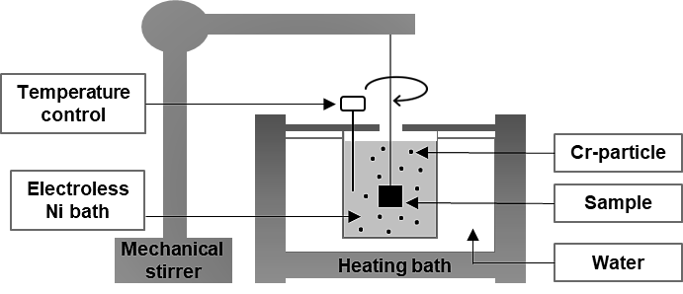
Figure 1: Experimental set-up adopted for electroless deposition.
The constant control over the deposition temperature of the electroless Ni plating solution is accomplished by immersing the deposition beaker in Elmasonic S 30 (H) ultrasonic cleaning bath with integrated temperature control. A second temperature sensor is placed in direct contact with the solution, to constantly monitor deposition temperature. Upon reaching the desired temperature, Cr nanoparticles are added to the plating bath, and their dispersion is facilitated through the combination of the integrated sonication unit and the introduction of a surfactant, Cetyltrimethylammonium Bromide (CTAB). Bath for nickel deposition is prepared according to the recipe proposed by [8], using Nickel chloride (NiCl₂⋅6H₂O) as a source of nickel ions and hydrazine monohydrate (N₂H₄⋅H₂O) as the reducing agent at a pH greater than 11. For this study, Cr particles and CTAB are added to the bath chemistry, in the concentrations indicated in Table 1.
Table 1: Plating solution compositions.
Compound | Chemical formula | Role | Concentration [mol/L]
Nickel chloride  Hydrazine  Sodium hydroxide  Potassium hydrogen phosphate  Chromium particles (APS=50 nm)  Cetyltrimethylammonium Bromide (CTAB) | NiCl2⋅ 6H₂O  N₂H₄⋅ H₂O  NaOH  K₂HPO₄  Cr  C₁₆H₃₃N(CH₃)₃Br | Source of Ni²⁺  Reducing agent  pH adjusting  pH buffer  Source of Cr  Dispersing agent | 0.2  0.8  0.25  0.50  0.048 ÷ 0.384  0.2·10⁻³ ÷ 2.0·10⁻³
Plating parameters are reported in Table 2. Temperature, pH, and time are kept fixed while varying the stirring conditions.
Table 2: Plating parameters.
Parameter | Range
Temperature (°C)  pH  Plating time (min)  Sample rotation speed (rpm) | 70 ± 5  11  120  20 ÷ 160

    - Characterizations
Surface morphology analyses were performed with a FEG-SEM Tescan Mira3 (Tescan, Brno, Czech Republic) equipped with an Edax Octane Elect EDX system (Edax/Ametek Inc.) for elemental analysis and quantification.
  - Results and discussion
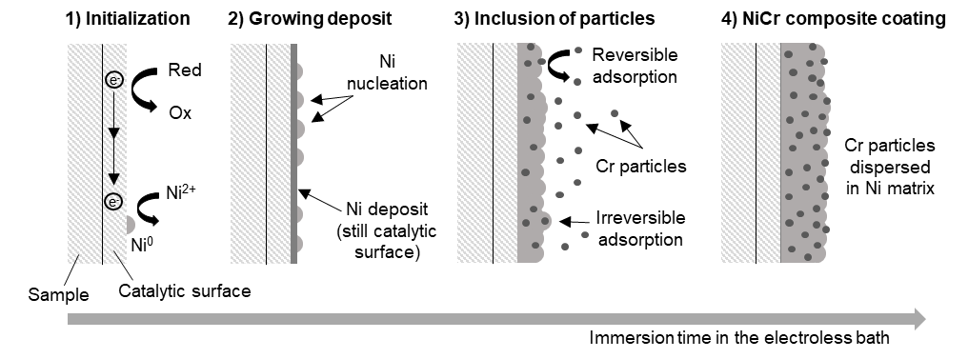
    - Growth mechanism
Figure 2: Growing mechanism of the NiCr composite coating obtained by electroless plating.
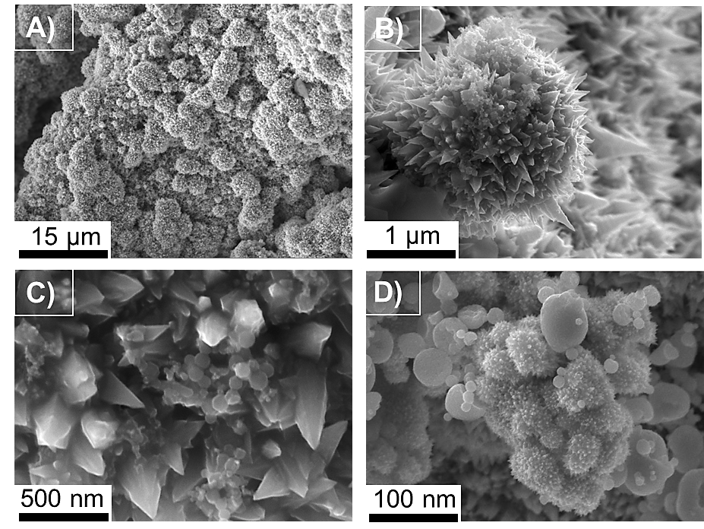
The inclusion mechanism of secondary particles, proposed by several authors (Celis et al. 1987; Guglielmi 1972; Valdes 1987), suggests that the Cr particles are incorporated in the Ni matrix through an impingement and setting mechanism that involves their reversible adsorption onto the substrate. This process implies a physical interaction between the particles and the surface to be coated and does not involve any chemical bonding. As the Ni deposit grows on the surface, there is a probability that the reversibly adsorbed particles will be embedded into the growing Ni matrix, Figure 2. This phenomenon is typically observed with inert particles onto which deposition does not occur. Conversely, Cr particles are metallic in nature and they act as a catalytic surface for the Ni deposition reaction. The catalytic activity of conductive secondary phases that are finely dispersed in solution was already reported by Genova et al. (2017). Consequently, a Ni deposit with the same spiky nanostructure as the deposit on the substrate grows on the particle surface, as shown in Figure 3.
Figure 3: SEM micrographs of NiCr coating surface: A) coating surface; B) spikes structure typical of Ni obtained by hydrazine reduction; C) Cr particles adsorbed on typical Ni nano-spikes; D) Ni growing on the surface of Cr particles.
The NiCr deposit surface displays a hierarchical structure consisting of coalesced nucleation points (Figure 3, picture A). These points are Ni accretions formed using hydrazine as a reducing agent (Figure 3, picture B), with adsorbed Cr nanoparticles observed on the nano-spikes of the structures (Figure 3, picture C). The catalytic activity of the Cr particles against Ni growth is supported by the growth of similar nano-spikes on the particle surface (Figure 3, picture D).
    - Deposition parameters
The growth of Ni on the particles can be regulated by controlling deposition parameters such as particle concentration, sample rotation speed, and concentration of CTAB in the bath. Tuning of such parameters allows the incorporation of a high quantity of well-dispersed Cr nanoparticles, with uniform distribution in the coating.
Particle concentration. It is generally observed that a higher concentration of particles in the bath results in a higher particle inclusion in the metal coating, as depicted in Figure 4, picture A. However, this correlation holds only up to a certain threshold of Cr particle concentration. Beyond 15 g/L, further increases in nanoparticle concentration result in a steep decline in the percentage of Cr incorporated in the coating. This is due to the metallic nature of Cr particles, which results in increased reactivity within the solution. The increase in particle concentration leads to an increased active surface area within the solution, causing a dramatic increase in the number of nucleation sites, uncontrolled Ni consumption, and progressive degradation of the deposition bath. Moreover, higher particle concentration is also associated with smaller interparticle distance and lower dispersion capacity, with agglomeration that occurs even at constant stirring speed.
Sample rotation speed. The agitation speed of the solution is a critical factor in determining the outcome of composite coatings obtained through electroless plating since it affects both dispersion and rate of incorporation. Overly high agitation speed results in turbulence in the solution [14], reducing the incorporation of particles, (Figure 4, picture B). The Cr particles require sufficient time to form a reversible adsorption bond with the sample surface, which then transforms into irreversible adsorption as the Ni deposit grows and embeds the particles. On the other hand, low agitation speed hinders the homogeneous dispersion of Cr particles, leading to their sedimentation and eventual coalescence due to gravity. Therefore, the optimal agitation speed is selected equal to 80 rpm, to achieve a great compromise between these opposing factors.
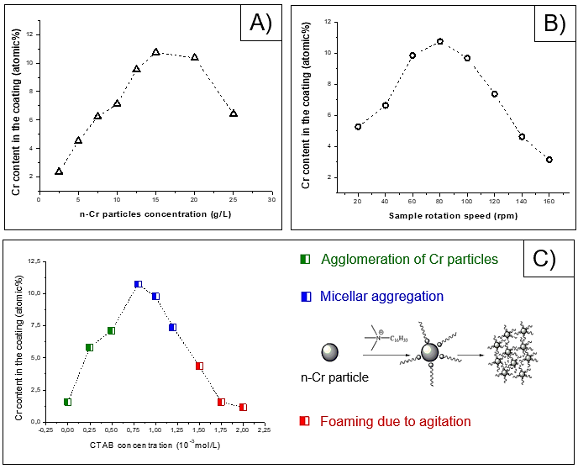
Addition of surfactant. The amount of Cr content in the coating as a function of CTAB concentration is reported in Figure 4, picture A. Without surfactant, Cr particles tend to agglomerate and settle, reducing the incorporation of Cr into the Ni matrix. The initial addition of CTAB to the deposition bath enhances bath stability and increases the amount of Cr in the coating. The highest percentage of Cr in the deposit is observed near a CTAB concentration of approximately 0.8 * 10^-3 mol/L, which is consistent with the critical micellar concentration (CMC) of CTAB in an aqueous solution at 25°C [15]. The formation of micelles around Cr particles allows to obtain a better dispersion and to reduce the reactivity of the deposition bath, leading to improved stability and a more uniform dispersion across the coating. Further increases in the CTAB concentration cause foaming due to the evolution of gases generated during the electroless Ni deposition reaction. Further, increase in CTAB concentration beyond 2 * 10^-3 mol/L leads to extremely poor particle incorporation, because of the massive foam evolution.
Figure 4: Deposition parameters investigated: A) influence of Cr particles concentration in solution; B) sample rotation speed effect; C) effects of CTAB concentration in the deposition bath.
    - Microstructural characterization
With increasing coating thickness during deposition, the Cr particles became irreversibly incorporated into the metal matrix (Figure 5, picture A), resulting in a homogeneous distribution of Cr throughout the entire coating thickness, as confirmed by cross-sectional energy-dispersive X-ray spectroscopy (EDX) map in Figure 5 B, which showed the distribution and relative concentration of Cr within the coating. The quantitative composition analysis revealed the presence of 11 at. % of chromium.
  - Conclusions
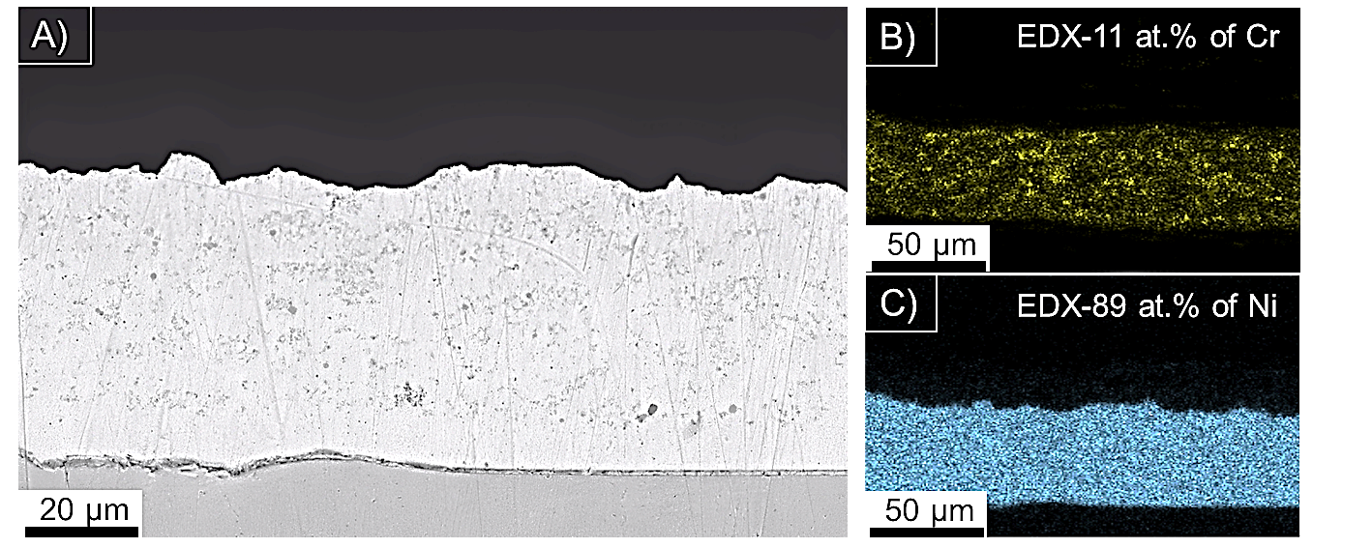
To achieve a uniformly distributed 60 µm-thick NiCr coating containing 11 atomic% of Cr, the deposition parameters were carefully optimized. Increasing the stirring speed up to 80 rpm improved particle incorporation; however, higher speeds resulted in reduced Cr content. To prevent particle aggregation, the particle concentration in the deposition bath should be precisely maintained between 15 and 20 g/L. Additionally, it is crucial to maintain a CTAB concentration of up to 0.8 * 10^-3 mol/L to stabilize Cr particles within micellar structures and prevent foam formation, which may otherwise lead to a decrease in the Cr content within the coating. The use of an innovative electroless composite approach with metal particles in the preparation of NiCr coatings provides a promising technique for achieving homogeneous coatings on even the most complex components, which have previously been difficult to coat using other methods.

Figure 5: Cross-section SEM micrographs: A) as deposited NiCr coating; B) Cr into the coating, 11 atomic %; C) Ni into the coating, 89 atomic %.
References
[1] Meier, G. H., 1989, A review of advances in high-temperature corrosion. Materials Science and Engineering A, 120–121, 1–11.
[2] Nicholls, J. R., Hancock, P.,1985, Advanced High Temperature Coatings for Gas Turbines. Indust. Corros. 5 5–24.
[3] Picas, J. A., Forn, A., Matthäus, G., 2006, HVOF coatings as an alternative to hard chrome for pistons and valves. Wear, 261, 477–484.
[4] Samedi, J., Coyle, T. W., Arabi, H., Mirdamadi, S., Mostaghimi, J., 2010, Effects of HVOF process parameters on the properties of Ni-Cr coatings, Journal of Thermal Spray Technology,19, 521-530.
[5] Hardwicke, C. U., Lau, Y. C., 2013, Advances in thermal spray coatings for gas turbines and energy generation: A review. Journal of Thermal Spray Technology, 22, 564–576.
[6] Protsenko, V. S., Danilov, F. I., 2014, Chromium electroplating from trivalent chromium baths as an environmentally friendly alternative to hazardous hexavalent chromium baths: Comparative study on advantages and disadvantages. Clean Technologies and Environmental Policy, 16, 1201–1206.
[7] Brenner, A., Riddell, G. E., 1998, Nickel Plating on Steel by Chemical Reduction. Plating and Surface Finishing, 85, 54–56.
[8] Genova, V., Paglia, L., Marra, F., Bartuli, C., Pulci, G., 2019, Pure thick nickel coating obtained by electroless plating: Surface characterization and wetting properties. Surface and Coatings Technology, 357, 595–603.
[9] Sudagar, J., Lian, J., Sha, W., 2013, Electroless nickel, alloy, composite and nano coatings - A critical review. Journal of Alloys and Compounds, 571, 183–204.
[10] Guglielmi, N., 1972, Kinetics of the Deposition of Inert Particles from Electrolytic Baths. Journal of The Electrochemical Society, 119, 1009.
[11] Valdes, J. L., 1987, Electrodeposition of Colloidal Particles. Journal of The Electrochemical Society, 134, 223C-225C.
[12] Celis, J. P., Roos, J. R., Buelens, C.,1987, A Mathematical Model for the Electrolytic Codeposition of Particles with a Metallic Matrix. Journal of The Electrochemical Society, 134, 1402–1408.
[13] Genova, V., Marini, D., Valente, M., Marra, F., Pulci, G., 2017, Nanostructured nickel film deposition on carbon fibers for improving reinforcement-matrix interface in metal matrix composites. Chemical Engineering Transactions, 60, 73–78.
[14] E.C. Kedward, 1981, Processes for the electrodeposition of composite coatings. United States Patent 4,305,792
[15] Karimi, M. A., Mozaheb, M. A., Hatefi-Mehrjardi, A., Tavallali, H., Attaran, A. M., Shamsi, R., 2015, A new simple method for determining the critical micelle concentration of surfactants using surface plasmon resonance of silver nanoparticles. Journal of Analytical Science and Technology, 6.

