|  |  |
| --- | --- |
| cetlogo ***CHEMICAL ENGINEERING TRANSACTIONS***  ***VOL. , 2023*** | A publication of  aidiclogo_grande |
| The Italian Association  of Chemical Engineering  Online at www.cetjournal.it |
| Guest Editor: Sauro Pierucci  Copyright © 2023, AIDIC Servizi S.r.l. **ISBN** 978-88-95608-98-3; **ISSN** 2283-9216 | |

Effect of Type of Biomass used in the Hydrothermal Liquefaction of Microalgae on the Bio Crude Yields and Quality

Paula A. Costaa\*, Ricardo M. Mataa, Filomena Pintoa, Filipe Paradelaa, Rafela Duarteb, Cristina Matosc

aLNEG - National Laboratory on Energy and Geology, Estrada do Paço do Lumiar, Lisboa, 1649-038, Portugal

bIST – Instituto Superior Técnico, Av. Rovisco Pais 1, 1049-001 Lisboa, Portugal

cA4F - Algae for future, Estrada do Paço do Lumiar, Ed. E – R/C, 1649-038, Lisboa, Portugal

paula.costa@lneg.pt

Hydrothermal liquefaction (HTL) is an energy-efficient technology that converts biomass with high moisture content, such as lignocellulosic material and aquatic biomass, into bio-oil which can be used as a precursor in the production of renewable biofuels. The current state of technology is mostly at a laboratory scale with relatively low Technology Readiness Levels (TRL). Most HTL research takes place in batch reaction systems, but there is growing interest in scaling up the technology through the use of continuous units. The process is influenced by several factors and operational parameters, which affect the performance of the process in terms of production and bio-oil quality. HTL is highly dependent on the type of biomass used. The main advantages in relation to other thermochemical processes is the possibility of using wet biomass, avoiding the high cost of the drying process. In this work several types of biomasses were studied, different types of micro algae (i. e. Spirulina, Chlorella Vulgaris, algae grown in industrial effluents), and grass. Growing microalgae has a significant cost in the production process of liquid biofuels. So, it was also tested algae cultivated in industrial effluents which has advantages from an economic and environmental point of view. Also, the grass wastes, have high moisture content and so its adequate to be process in HTL. In all the tests, four different products were obtained: gases, aqueous and organic (biocrude) products and solids. All these fractions were characterized to suggest their most favourable application. The gases were mainly composed of Hydrogen, Oxygen, Carbon Monoxide, Carbon Dioxide and Hydrocarbons until C4. Bio oil composition was the parameter most affected by biomass type. So, when microalgae were used, it was observed higher content of nitrogenous compounds, like pyrroles, indoles, pyrazines and other nitrogen-containing compounds, probably formed from the protein fraction of the algae. In all the bio-oils it was also detected the presence of oxygenated compounds, such as ketones, esters, phenols, fatty acids, alcohols, that maybe were produced from the lipids and carbohydrates. Hydrocarbons, including alkanes, alkenes, alkynes and aromatics compounds were also present. The composition of the biomass used has a higher effect on the bio-oil composition, so it is important an extensive characterization of the feedstock in order to select the best raw material to be used in HTL process depending on the intended application. This paper analyses the effect of biomass composition in the HTL to assess its viability to be used to produce biofuels or valuable chemicals.

**1. Introduction**

Biomass is a renewable energy resource composed by organic material such as trees, plants, algae, and agricultural and urban waste that has gained a lot of interest over the years, especially in the field of environmental pollution. The interest of decreasing greenhouse gas emissions and toxic metals to the environmental has reached global levels and the use of fossil fuels has gradually decreased by the utilization of renewable resources to produce fuels and energy. Furthermore, air and water pollution have been widely discussed with the aim of studying it and of developing methods to prevent such phenomena. There are three generations of biofuels obtained by biomass. The first generation includes biomass that is highly dependent on the use of cultivatable land such as sugarcane and corn. The second generation of biofuels are derived from biomass such as wood and straw. The third generation consists of biofuel derived from algae, bacteria, and other microorganisms (Ravichandran et al., 2022). Algae biomass is considered a good renewable energy resource, due to the no competition with food resources and are easily cultivated on various conditions even using wastewater (Mahima et al., 2021). However, these types of algae biomasses can have high quantities of ash content (Carpio et al., 2021). As the biomass is rich in carbon, the C-C and C-O bonds requires a depolymerization technique to produce bio-oil, a viscous liquid composed mainly by hydrocarbons (Mukundan et al., 2022). Biomass can be converted into biofuels by mechanical, thermochemical, or biochemical methods. Thermochemical processes are a viable technology and have some advantages over other methods that have dependency to other types of microorganisms and the necessity of a carefully cultivated environments. During the thermochemical process, the biomass is fragmented by thermal energy under pressure and a chosen atmosphere during a short period of time (Mishra et al., 2022). Hydrothermal liquefaction is a thermochemical process which converts wet biomass at relatively low temperatures (200 to 400 °C) (Prestigiacomo et al., 2022) and high pressures, into four main compounds: gas phase, bio-oil also known as bio-crude, aqueous phase, and a solid residue. Besides bio-oil, these products can also be valorised. As the aqueous phase is rich in nutrients derived from the environmental of algae biomass, it can be used to irrigate soils and, therefore, to increase soil fertility. Solid residue is a carbon-rich charcoal that can be used for soil amendment, due to the high capacity of water retention. Furthermore, the inorganic elements present in the composition are distributed between the solid residue and aqueous phase. Finally, the gas fraction can be used to generate electricity. Usually, the gas fraction is composed by small amounts of hydrogen, hydrocarbons, and high quantities of carbon dioxide. In general, the most common reactions during HTL process are reactions of depolymerization, bond breaking, decarboxylation and instantaneous re-polymerization (Ni et al., 2022). The capability to convert wet biomass and the requirement of a lower reaction energy are some of the advantages of HTL over the other thermochemical methods such as pyrolysis and gasification (Fan et al., 2023). It has been reported that several reactions like hydrolysis, dehydration, decarboxylation, repolymerization, deamination and Maillard reactions take place when the macromolecules (lipid, proteins and carbohydrates) of the biomass are subjected to subcritical HTL conditions (180–370 °C and 5–21 MPa). These reactions convert the macromolecules into different products (water-insoluble and soluble fractions, non-condensable gases, and solid char) (Mathur et al., 2022). Algae biomass with high lipids, carbohydrates and proteins content can favour the bio-oil production (Mathur et al., 2022). However, bio-oil quality is dependent on the biomass properties. Indeed, the chemical composition of algae biomass has shown to be a key factor in the production of the bio-crude (Ratha et al., 2022). It was studied that different types of biomasses can lead to a different bio-oil yields and properties (Mishra et al., 2022). It is fundamental to study composition of the biomass before the process and to study what kind of biomass can generate a significant quantity of bio-oil with high quality. Among all the studied biomass, including algae, lignocellulosic and food waste, reports shown that microalgae produced more quantities of bio-oil, than macroalgae (Lu et al., 2022). The main objective of this work is to study the quantity and quality of the bio-crude production by hydrothermal liquefaction using different types of microalgae biomass and grass as feedstock. The valorisation of grass is also essential as the grass can be grown at large quantities at various types of environments. The comparison between this type of biomass with microalgae will increase the review information and the assessment of the hydrothermal liquefaction study.

**2. Materials and methods**

The HTL tests were performed in 0.16 L batch reactors, built in Hastelloy C276 by Parr Instruments, with a controller device connected to both the pressure gauge and the thermocouple. Firstly, the feedstock was placed inside the reactor and closed, afterwards it was cleaned with nitrogen (N2) to maintain an inert atmosphere inside the reactor. The reactor was heated by an oven that has an oscillation system to provide agitation. The operation conditions were based in a previous study performed by the authors (Costa et al. 2022) and were 325 ºC and biomass/water ratio of 1/10 (w/w) were used. The reactor always operated with 77 g of material (biomass+water). Before the beginning of each test, the autoclave was purged and then pressurized with N2, to guarantee that the operating pressure was within the desired range. At the end of each test, the reactor was cooled in an ice bath until it reached room temperature for the collection of the products. After cooling, the gas products were measured and collected for the GC-FID-TCD (Gas chromatography – Flame Ionization Detector - Thermal Conductivity Detector) analysis. Then the reactor was opened, and the products were separated using the procedure presented in Figure. 1. The bio-oil was characterized by GC/MS (Gas chromatography – Mass Spectrometry). The tests were carried out in a completely randomized design (CRD), with two repetitions for each treatment. The feedstock used was four different microalgae (mixture of microalgae grown in a fertilizer industry effluent, Spirulina, Chlorella, Nannochloropsis). The characterization of the feedstock is presented in Table 1. Different HTL tests were performed to assess the influence of the type of biomass in the product yields and quality. The reaction time was always settled to 30 minutes, the temperature at 325 °C and the biomass/water ratio of 1/10 (w/w) and initial nitrogen pressure of 3.9 MPa.



*Figure 1: Process scheme.*

Table 1: Characterization of the biomasses used.

|  |  |  |  |  |  |  |
| --- | --- | --- | --- | --- | --- | --- |
| % w/w (dry basis) | Mix | Chlorella vulgaris | Spirulina | Nannochloropsis |  | Grass |
| Lipids | 15 | 12 | 6 | 20 |  | 4 |
| Proteins | 41 | 47 | 70 | 14 |  | 16 |
| Ashes | 24.5 | 9 | 12.1 | 11.6 |  | 12.4 |

**3. Results and discussion**

The composition of the bio-oil is primarily influenced by the characteristics of the raw material once HTL products derive directly from the conversion of the biomolecules that compose the microalgal biomass. The choose of the composition of the microalgae used is, therefore, an essential resource which allows the optimization of the biofuel production process using the HTL technology. However, this type of synergy is only achievable through a thorough understanding of the existing interactions between the biochemical composition of the microalgae and the characteristics of the products of the HTL (Leow et al. 2015). As observed in Figure 2, The conversion of microalgae with different biochemical compositions generally results in significant differences in bio-oil yield. The different biochemical compositions can create a compromise between the optimization of the quantity (yield) and quality of the bio-oil. For example, the lipids present in the microalgae, are easily hydrolyze in subcritical water, while peptide bonds need higher temperatures to break down. The presence of proteins contributes significantly for the yield of bio-oil, but it is, at the same time, one important source of nitrogenated compounds that affect the final product quality. Also, microalgae with a higher lipid fraction generally led to higher quality bio-oils. Cheng et al. (2018) compared bio-oil produced through the HTL of two species of microalgae with different lipid contents (G. sulphuraria, low and N. salina, high) and concluded that N. salina resulted in a higher quality of bio-oil, especially in more moderate operating conditions. On the other hand, good bio-oil yields can, also, be observed in microalgae whose lipid content is lower, as Spirulina. Shakya et al. (2017), for example, observed good bio-oil yields, between 36 – 46% w/w, in the HTL of several species of lipid-poor microalgae. As shown in Figure 2, the highest amount of bio-oil (55,6 %w/w) was produced by the microalgae mixture. This result was expected for Nannochloropsis HTL conversion once this microalga has more lipid content. However, the protein-rich microalgal biomass has also been associated with favourable yields, especially when compared to microalgae rich in carbohydrates (He et al. (2020)). So, it seems that the bio-oil yields do not depend only on the lipid content, but also on the protein content. Regarding the wet biomass (grass), the mainly product was the aqueous phase. The low amount of bio-oil produced can be, probably explained by the low lipid and protein content of this biomass. In a general, the production of bio-oil considering the biochemistry of microalgal biomass tends to follow the order of lipids > proteins > carbohydrates. However, HTL operational conditions play an important role too, especially the temperature and biomass/water ratio.

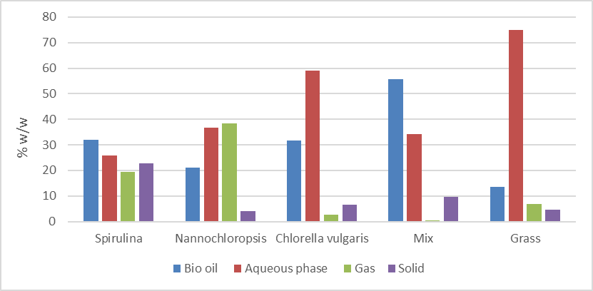

Figure 2: *Effect of type of biomass on product yields (reaction temperature=325ºC; reaction time=30 min; biomass/water ration=1/10.*

*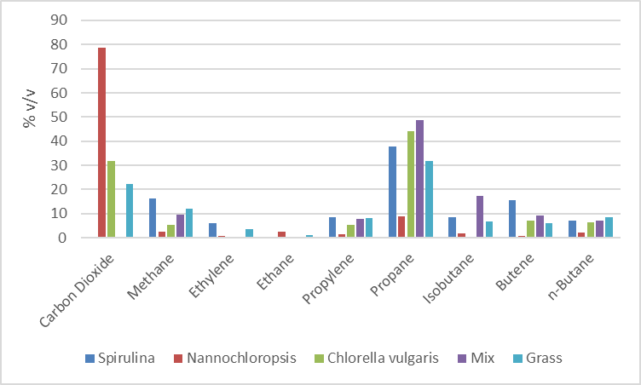*

Figure 3: *Effect of type of biomass on gas composition (reaction temperature=325ºC; reaction time=30 min; biomass/water ration=1/10*

Regarding the gas phase, in Nannochloropsis HTL was formed, mainly, CO2, achieving almost 80% v/v. In the case of the grass, the main compounds were hydrocarbons (total of 78% v/v), being mainly methane and propane (Figure 3). The main hydrocarbon formed was propane.

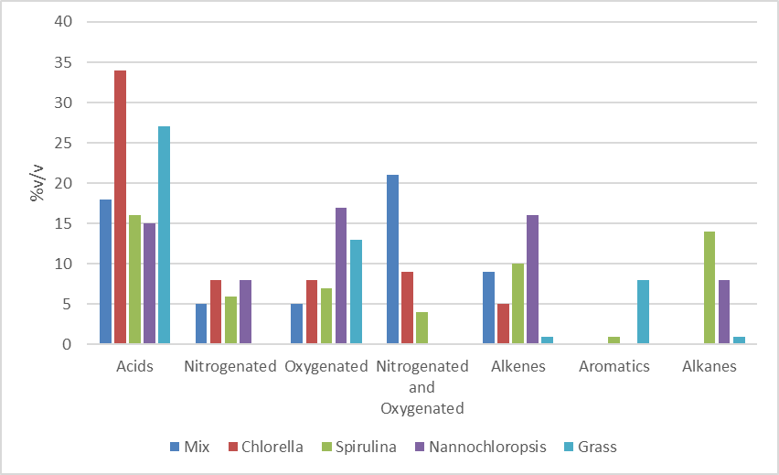

Figure 4: *Effect of type of biomass on bio-oil composition (reaction temperature=325ºC; reaction time=30 min; biomass/water ration=1/10)*

As it can be seen in Figure 4, the main type of compounds present in bio-oil composition were acids, mainly oleic and hexadecanoic acid. The results depend on the type of biomass used. In the HTL of the mix of algae, the nitrogenated and oxygenated compounds were produced in the highest amount, while for Nannochloropsis the percentage of acids, oxygenated compounds and alkenes were similar. The lower amount of nitrogenated compounds maybe due the less content of proteins of this microalga. The acid compounds can be produced by reactions such as condensation and cyclization of the amino acids that form the cell proteins. Due to the CHN composition of the biomasses used in this study, it could be expected that acids and nitrogenated compounds will be produced in higher amounts when spirulina was used, but probably, in the experimental conditions used, the nitrogen is present in compounds more soluble in the aqueous phase, than in the bio-oil. In these conditions, the HTL of spirulina formed higher amounts of hydrocarbons and oxygenated compounds in the bio-oil. The higher amounts of acids (mainly hexadecanoic acid) were produced in the Chorella HTL, while the use of the microalgae mix lead to a higher formation of oxygenated and nitrogenated compounds. The aromatic compounds were mainly detected when the grass was used. In HTL of the microalgae these compounds were only detected when spirulina was used and in very low percentage (1% v/v).

1. Conclusions

HTL is an emerging technology for the liquefaction of microalgae and wet biomass. The product yield and quality depend highly on the type of biomass used in the process. However, it is not clear how the lipids and protein content influence the bio-oil yield and composition, as some contradictory results were obtained. The lowest bio-oil yield (13 % w/w) and the highest aqueous phase yield (75% w/w) were obtained with grass. The highest bio-oil yield obtained was about 55% (w/w) when the mixture of different microalgae grown in a effluent of an fertilizer industry was used, which may indicated that the use of microalgae from industrial effluents in the HTL process can be a good option. Regarding the gas composition, CO2 and propane were the compounds present with the highest contents. The bio-oil was a complex mixture of acids, nitrogenated and/or oxygenated compounds and hydrocarbons. The compound present in the highest concentration was the hexadecanoic acid. Unfortunately, the hydrocarbons concentration was low, with all the biomasses tested, which indicates, as expected, that further upgrade is needed.

Acknowledgments

This research was supported by Move2LowC project (POCI-01-0247-FEDER-046117), cofinanced by Programa Operacional Competitividade e Internacionalização (POCI), Programa Operacional Regional de Lisboa, Portugal 2020 and the European Union, through the European Regional Development Fund (ERDF).

References

Carpio R. B., Zhang Y., Kuo C., Chen W., Schideman L. C., Leon R., 2021, Effects of reaction temperature and reaction time on the hydrothermal liquefaction of demineralized wastewater algal biomass, Bioresource Technology Reports, 14, 100679.

Cheng F., Cui Z., Mallick K., Nirmalakhandan N. & Brewer C. E. 2018, Hydrothermal liquefaction of high and low-lipid algae: Mass and energy balances. Bioresour. Technol. 258, 158–167

Costa P., Mata R. Pinto F., Paradela F., Dutra F., 2022, Hydrothermal Liquefaction of Microalgae for the Production of Biocrude and Value-added Chemicals. Chemical Engineering Transactions, 94.

Fan Q., Fu P., Song C., Fan Y., 2023, Valorization of waste biomass through hydrothermal liquefaction: a review with focus on linking hydrothermal factors to products characteristics, Industrial Crops & Products, 191, 116017.

He Z. et al., 2020, Synergistic effect of hydrothermal Co-liquefaction of Spirulina platensis and Lignin: Optimization of operating parameters by response surface methodology. Energy 201, 117550.

Leow S. et al. 2015, Prediction of microalgae hydrothermal liquefaction products from feedstock biochemical composition. Green Chem. 17, 3584–3599

Lu J., Watson J., Liu Z., Wu Y., 2022, Elemental migration and transformation during hydrothermal liquefaction of biomass, Journal of Hazardous Materials, 423, 126961.

Mahima J., Sundaresh R. K., Gopinath K. P., Rajan P. S. S., Arun J., Kim S., Pugazhendhi A., 2021, Effect of algae (Scenedesmus obliquus) biomass pre-treatment on bio-oil production in hydrothermal liquefaction (HTL): Biochar and aqueous phase utilization studies, Science of the Total Environment, 778, 146262.

Mathur M., Hans N., Naaz F., Naik S. N., Pant K. K., Malik A., 2022, Valorization of microalgal biomass to value-added products using integrated supercritical CO2 extraction and sub-critical hydrothermal liquefaction, Journal of Cleaner Production, 373, 133925.

Mishra R. K., Kumar V., Kumar P., Mohanty K., 2022, Hydrothermal liquefaction of biomass for bio-crude production: a review on feedstocks, chemical compositions, operating parameters, reaction kinetics, techno-economic study, and life cycle assessment, Fuel, 316, 123377.

Mukundan S., Wagner J. L., Annamalai P. K., Ravindran D. S., Krishnapillai G. K., Beltramini J., 2022, Hydrothermal co-liquefaction of biomass and plastic wastes into biofuel: study on catalyst property, product distribution and synergistic effects, Fuel Processing Technology, 238, 107523.

Ni J., Qian L., Wang Y., Zhang B., Gu H., Hu Y., Wang Q., 2022, A review on fast hydrothermal liquefaction of biomass, Fuel, 327, 125135.

Prestigiacomo C., Scialdone O., Galia A., 2022, Hydrothermal liquefaction of wet biomass in batch reactors: critical assessment of the role of operating parameters as a function of the nature of the feedstock, The Journal of Supercritical Fluids, 189, 105689.

Ravichandran S. R., Venkatachalam C. D., Sengottian M., Sekar S., Kandasamy S., Subramanian K. P. R., Purushothaman K., Chandrasekaran A. L., Narayanan M., 2022, A review on hydrothermal liquefaction of algal biomass on process parameters, purification and applications, Fuel, 313, 122679.

Ratha S. K., Renuka N., Abunama T., Rawat I., Bux F., 2022, Hydrothermal liquefaction of algal feedstocks: the effect of biomass characteristics and extraction solvents, Renewable and Sustainable Energy Reviews, 156, 111973.

Shakya R. et al., 2017, Influence of biochemical composition during hydrothermal liquefaction of algae on product yields and fuel properties. Bioresour. Technol. 243, 1112–1120.