CHEMICAL ENGINEERING TRANSACTIONS  VOL. , 2023 | A publication of
The Italian Association
of Chemical Engineering
Online at www.cetjournal.it

Guest Editor: Sauro Pierucci
Copyright © 2023, AIDIC Servizi S.r.l.
ISBN 978-88-95608-98-3; ISSN 2283-9216

Changes in Chemical and Physical Properties of Bio-Based Thermoplastics during Fused Deposition Modelling (FDM) Process
Antonella Patti^{a,}*, Stefano Acierno^{b}, Gianluca Cicalaª, Domenico Acierno^{c}
ªDepartment of Civil Engineering and Architecture (DICAr), University of Catania, Viale Andrea Doria 6,95125 Catania, Italy
^{b}Department of Engineering, University of Sannio, Piazza Roma 21, 82100 Benevento, Italy.
^{c}CRdC Nuove Tecnologie per le Attività Produttive Scarl,Via Nuova Agnano 11, 80125, Naples, Italy
antonella.patti@unict.it
The purpose of this research was to better understand the potential degradation effects of bioderived thermoplastic polymers during fused deposition modeling (FDM). Commercially available filaments made from virgin and recycled polylactic acid (PLA) (named PLA-1 and PLA-2, respectively), as well as a wood flour/PLA composite (PLA-3), were considered. Pre-optimized conditions, satisfying the printing quality of 3D final products, at an extruder temperature of 210 °C, were used to realize samples. The main characterization techniques, were dynamic rotational rheology (in time sweep mode) and infrared spectroscopy (in attenuated total reflectance mode). These methods allowed to verify molecular modifications, occurring in the polymer structure during the 3D printing process. The storage and loss modulus, and complex viscosity over time were presented for both neat and printed specimens. A comparison between the properties of printed and unprocessed materials revealed a decrease in rheological parameters over time as well as a loss in absorbance intensity for typical absorption bands. The viscosity values of PLA-1 and PLA-2 were found to be strongly unstable, with a significant decreasing trend over time. The experimental data were modeled using an exponential decay law, and the original decline was attributed primarily to the interaction of high temperatures and shear stress. Despite the fact that degradation effects were visible in wood/PLA composite materials, such systems remained thermally more stable than pure polymers.
  - Introduction
The wide range of Additive Manufacturing (AM) technologies includes many different techniques to develop parts with complex geometries and shapes: material extrusion, powder bed fusion, material jetting, binder jetting, and vat photopolymerization (Negi et al., 2013).
The fused deposition modelling (FDM) is often chosen as manufacturing (AM) technology in different industrial contexts such as automotive and aerospace to fashion and textiles world, given its low cost, smooth operation, ease of support material removal, better raw material handling and ability to process different thermoplastics (Sathies et al., 2020). The FDM method involves melting a polymer-based filament, extruding it through a nozzle, and then layering it on a heated support by drawing a 3D object from computer-aided design (CAD) models with precise, meticulous, and detailed geometry (Patti et al., 2022a).
Synthetic thermoplastics derived from crude oil, such as acrylonitrile butadiene styrene (ABS) and polyether ether ketone (PEEK), or bio-based polymers, such as polylactic acid (PLA) and polycaprolactone (PCL), or composite systems composed of carbon, glass, and natural fibers, ceramic and metallic particles are among the most commonly used materials in FDM technique (Sztorch et al., 2022).
Research efforts are shifting toward more sustainable, low-impact alternatives to common petroleum-derived polymers, such as those derived from renewable resources and recycling operations, to reduce environmental concerns such as greenhouse gas emissions and trash accumulation in the environment and landfills. (Patti et al., 2022b).
Depending on the environmental conditions (heat, air, water, light etc), polymers can easily degrade resulting into an embrittlement, reduced mechanical properties and molecular weight (Patti et al., 2019). In most cases, polymer processing is followed by a series of chemical events that significantly alter the physical and chemical properties of produced goods, and shorten their useful lives. The thermal, mechanical, and autocatalytic events that occur during extrusion can involve free radicals, ions, and low molecular weight entities. At the typical polymer processing conditions, i.e., in presence of oxygen, at temperatures ranging from 180 to 250 °C, and shear rates ranging from 10 to 10³ s⁻¹ the mechanical stress or oxidative reactions can change the properties of a material. Processing degradation involves the formation of alkyl (R°) radicals, which react with oxygen to form peroxy radical (RO2°). When these radicals are produced, macromolecular bonds are inevitably broken, resulting in a decrease in molecular weight. The chemical changes that occur during extrusion can be described using the traditional thermal oxidation scheme. This scheme begins with mechanical destruction and oxidation as the primary causes of polymer chain breakage (El’darov et al., 1996).
Carrasco et al. (2010) used dynamic thermogravimetry to investigate the kinetics of thermal degradation of PLA during the two main industrial processes of injection and extrusion followed by injection, with or without additional annealing. All of the processed materials had degradation temperatures that were very similar but lower than the unprocessed systems. The order of reaction was shown to be first-order throughout the conversion range.
In this context, the goal of our research was to investigate how material properties changed after FDM processing technology. Infrared spectroscopy and rotational rheology were used to investigate three different PLA-based filaments. Each filament was then extruded under pre-optimized conditions in a 3D printing machine. The printed specimens were then characterized using the same methods as the raw materials. Differences in absorbance in correspondence of characteristic groups at typical wavenumbers for PLA polymer, as well as variations in complex viscosity as a function of time, were regarded as useful aspects for determining structural alterations of the polymer macromolecules during the printing process.
  - Materials and methods
2.1 Materials
Three commercially available filaments provided by Eumakers (Barletta, Italy) were used in this investigation. The first (PLA-1) is made of virgin polylactide acid pellets (codified as IngeoTM Biopolymer 4032D by Natureworks, USA). The second (PLA-2) is made from waste of PLA-1 filament manufacturing process. The third (PLA-3) is a combination of Fir wood fibers and PLA polymer.
2.2 Sample Preparation
The conditions for the filaments’ extrusion were carefully considered to ensure the highest printing quality of 3D printed parts (pre-optimized according to our previous works). A printing device made by Zortax (Olsztyn, Poland) was utilized for all the materials. The extruder temperature was set at 210°C, the platform temperature was set at 70 °C, and the number of top surface layers was set at 6. Then, the printing speed was left to the default value while the retraction speed was established of 27 and 20 mm/s for neat PLA polymers and wood composite, respectively. The layer thickness was fixed equal to 0.09 mm for the unfilled polymers, and equal to 0.19 mm for the wood filled resin. Before the processing and testing, all materials were dried in an oven at 70 °C for 7 hours. For the rheological investigations, disc-shaped specimens measuring 25 mm in diameter and 2 mm in thickness were produced.
    - Characterization techniques
Fourier transform infrared (FTIR) spectroscopy was used to characterize the molecular structure of polymers and identify conformational differences that could be attributed to the degradation process. This analysis was carried out in attenuated total reflectance (ATR) mode with a Perkin Elmer spectrometer (model Spectrum 65 FT IR) (USA). Samples were put in contact with a diamond crystal (high refractive index and excellent IR transmitting properties). Measurements were performed in a wavelength number range between 650-4000 cm⁻¹ at 16 scan per measurements. The camera resolution was 4 cm⁻¹. The peak at 1455 cm⁻¹ connected to the asymmetric bending of the methyl group, was frequently considered as an internal standard for PLA polymers. This peak was used to normalize each curve.
The time-sweep rheometric test was employed to assess the physical changes that occurred in the polymer over time. This analysis was carried out for 900 seconds at 210°C in a rotational rheometer (TA Instruments, USA) in a plate-plate configuration (D = 25 mm, gap = 1 mm) at a frequency of 1 rad/s. During testing, a nitrogen atmosphere was imposed to prevent oxidative effects in the thermally induced decomposition of samples.
  - Experimental Results
3.1 Rheological measurements
The storage (G') and loss moduli (G") in Pa, as well as the complex viscosity (η*) in Pa*s, were measured at 210 °C over 900 s during time sweep experiments of neat and extruded materials. Figure 1 depicts a data summary.
Figure 1. Storage modulus (G’), loss modulus (G’’), and complex viscosity (η*) at 210°C as function of time (s) for neat and printed materials.

The loss modulus was always greater than the storage modulus in all cases, and the flow behavior was dominated by the viscous component ("liquid-like structure"). The moduli and complex viscosity for the unprocessed PLA-1 and PLA-2 remained nearly constant up to 900 sec by confirming a good thermal stability of the pristine materials. When these systems were printed, however, the initial values (at zero time) of all the rheological signals were significantly reduced, and after about 100 seconds, entered a decreasing phase. This trend was ascribed to degradation mechanisms that took place at high temperature of 210 °C.
In the case of wood-based composite, the values of G' and G" for PLA-3 and printed PLA-3 showed very small differences, with qualitatively very similar trends as a function of time. Although the complex viscosity of extruded specimens was always lower than that of the basic material, no variation in this parameter was observed over time, remaining around a constant value of 1.2x10³ Pa*s. This attitude was regarded as a sign of good thermal stability of wood/PLA composites at 210 °C and was attributed to the formation of tortuous pathways within the polymer of dispersed fillers. The wood particles slowed the mass diffusion of degradation products from the polymer's bulk to the gas phase and protected against thermal decomposition (Patti et al., 2021).
The decrease in viscosity of a polymeric material is usually attributed to a decrease in molecular weight caused by various mechanisms of polymer chain degradation. Intermolecular vibrations and macromolecule conformational changes increase as temperature rises. When the chemical bonds are sufficiently stressed, homolytic dissociation occurs, resulting in fragments with radical end-groups (thermal degradation). When water is absorbed into the polymer, both species (polymer and water) can react, resulting in ester cleavage and the diffusion of low molecular-weight products out of the polymer, as well as the formation of new chain ends (hydrolytic degradation). When polymers are melted at high temperatures in an oxygen-depleted environment, the combined effects of temperature and mechanical stress can cause polymer macromolecules to degrade, resulting in chemical alterations of the polymer structure (thermo-mechanical degradation). When exposed to air, a branched radical chain reaction can occur via hydrogen attack or homolytic scission of a carbon-carbon bond (oxidative degradation) (Vohlidal, 2021).
In this case, oxidative and hydrolytic degradation were ruled out. The amount of water in the filaments was deemed insignificant because each material had been thoroughly dried prior to the operation. Furthermore, the polymer was completely contained during the extrusion process, and the only point of contact with air occurred during feeding at the air-polymer interface (Colin et al., 2006). For these reasons, thermal-mechanical degradation was considered the main reason of the viscosity drop. A kinetic model for the PLA degradation, induced by hydrolysis and heat, was proposed in (Speranza et al., 2014) and used to describe experimental data. The viscosity of dried and non-dried samples, under different testing temperatures, was measured using dynamic time sweep rheological tests. The zero-shear viscosity (η) was correlated to the polymer molecular weight (Mw) through the Eq.1:
$η∝{M_{n}}^{3.4}$ (1)
The ester concentration (C_{E}) has been correlated to the molecular mass (M) according to the Eq. 2:
$C_{E}=\frac{ρ}{M_{n}}\left(DP-1\right)$ (2)
where ρ is polymer density and DP $\left(=\frac{M_{n}}{M}\right)$ is the average degree of polymerization.
In this case, by considering only the occurrence of thermal degradation (assumed as first-order reaction), the time evolution of ester concentration can be determined from Eq.3:
$\frac{d}{dt}C_{E}={-R}_{t}C_{E}$ (3)
It was possible to deduce that the ester concentration decreased over time in an exponential decay relation. Since the ester concentration was indirectly related to the viscosity via the molecular weight, the same model was considered useful to fit the experimental data of viscosity in time:
$η=η_{0}e^{-\frac{t}{τ}}$ (4)
where $η_{0}$ was the value of viscosity at zero-time (initially) and τ was the exponential decay constant (characteristic time). The longer the characteristic time (τ), the slower the decrease in viscosity.
Figure 2 shows the experimental results for PLA-1 and PLA-2 models using exponential decay and Table 1 shows a summary of the model's parameters.
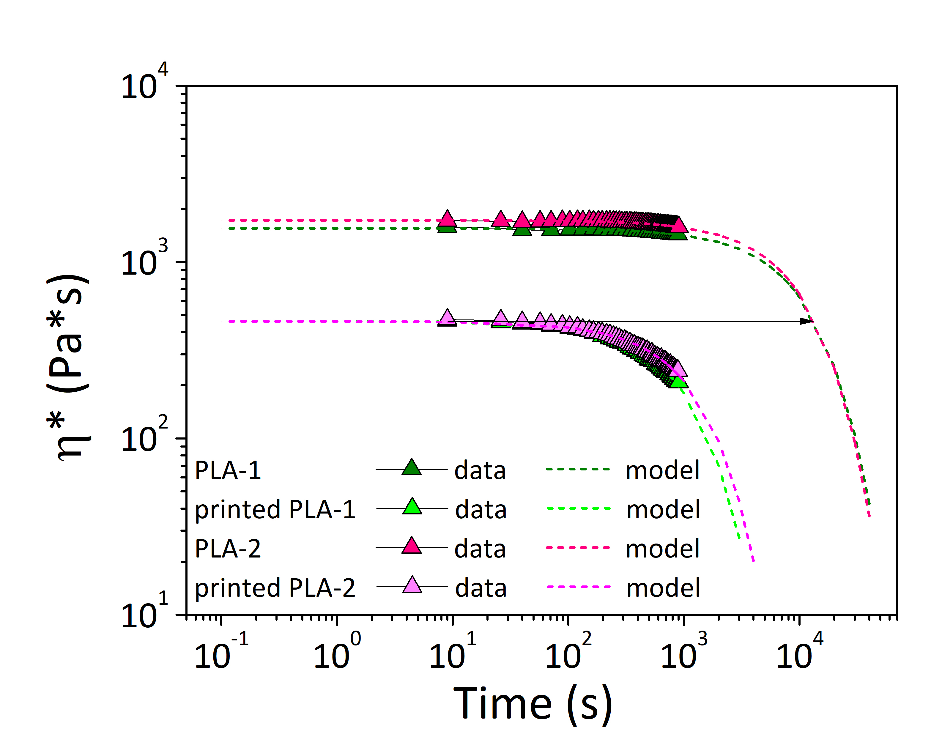
Figure 2. Exponential decay model to fit viscosity data and corresponding model parameters for PLA-1 and PLA-2.
Table 1. Fitting parameters in terms of initial viscosity and characteristics decay time for PLA-1 and PLA-2.
 |  | PLA-1 | PLA-1 printed | PLA-2 neat | PLA-2 printed
 | η₀ (Pa*s) | 1552 | 462 | 1725 | 461
 | τ (s) | 1.11x10⁴ | 1.06 x10³ | 1.03 x10⁴ | 1.28 x10³
 | R² | 0.98 | 0.99 | 0.97 | 0.99

The decay kinetics of the two polymers were extremely comparable both as basic and extruded materials. It was discovered that the characteristic degradation time of virgin materials was one order of magnitude longer than printed materials. The initial viscosity of the printed materials (4x10² Pa*s) was achieved for virgin filaments after about 2x10⁴ s (about 5 hours) at 210 °C. Taking these factors into account, the combined effect of temperature and mechanical stress during printer extrusion (residence time of polymer in the barrel approximately of 10 sec) could be compared to the effect of the 210 °C alone for 5 hours.
3.2 Infrared spectroscopy
Figure 3 depicts a comparison of the FTIR-ATR spectra of basic filaments and printed materials. For each investigated system, several well-documented absorption features and overall aspects characteristics of semicrystalline PLA polymer were displayed.
Figure 3: ATR spectra of basic filament (dashed curve) and 3D printed material (solid curve) for virgin (a), recycled PLA (b), and composite (c) materials.
Similar to the work by Pop et al.( 2019) the main changes in intensity between the basic and printed samples were found in correspondence of: i) the characteristic peaks of C-H alkane stretching in the range of 2800-3000 cm⁻¹; ii) the characteristic peak attributed carboxyl group (C=O) stretching at 1750 cm⁻¹; iii) peaks at 1183 cm⁻¹ and at 1085 cm⁻¹, the first attributed to the C-O vibration of ester group (symmetric stretching), the second attributed to the C-O-C vibration of ester group (asymmetric stretching). All of the tested materials showed very similar variations in absorbance intensity of characteristic groups (Table 2). The reduction in intensity in correspondence of 1085 cm⁻¹ and 1183 cm⁻¹ was slightly higher than 20% for the PLA-1 and PLA-2 filaments, and around 13% for the PLA-3 filament; the reduction in carboxyl group absorbance in correspondence at 1750 cm⁻¹ was around 20-30%. The latter signal grew in proportion to the presence of syndiotactic polylactide acid and was thought to be indicative of morphological changes. As a result, changes in the intensity of this band have been linked to the restructuring of PLA macromolecules during 3D printing (Pop et al., 2019). The slight increase in the hydroxyl band at 3400 cm⁻¹ after PLA processing was regarded as insignificant, indicating that degradation occurred primarily via chain scission (Oliveira et al., 2016).

Table 2: Absorbance ratio between basic and printed materials at given wavelength.
Wavelength | $$\frac{A_{Printed PLA-1}}{A_{PLA-1}}$$ |  | $$\frac{A_{Printed PLA-2}}{A_{ PLA-2}}$$ |  | $$\frac{A_{Printed PLA-3}}{A_{PLA-3}}$$
2920 cm⁻¹ | 1.92 |  | 4.43 |  | 1.28
1750 cm⁻¹ | 0.76 |  | 0.74 |  | 0.81
1650 cm⁻¹ | 2.00 |  | 2.00 |  | 2.04
1183 cm⁻¹ | 0.76 |  | 0.77 |  | 0.86
1085 cm⁻¹ | 0.73 |  | 0.76 |  | 0.86
  - Conclusion
This study was a preliminary investigation into the effect of 3D printing on the final properties of thermoplastic biopolymers, two of which were unfilled (PLA-1 and PLA-2) and one of which was filled with wood powder (PLA-3). A comparison of the rheological parameters and FTIR-ATR spectra of printed and pristine materials provided qualitative information on the structural changes of polymer chains and, as a result, on the degradation phenomenon that occurs during the process.
Measurements over 900 sec of storage and loss modulus, as well as viscosity, revealed a strong instability of rheological signals in time, particularly in the case of unfilled polymers. The initial viscosity of pristine filaments was reduced by more than 70% when the polymer was printed. Then it continued to fall over the testing period as the material was kept at higher temperatures. The decay characteristic time of printed materials (10⁴ s) was found to be one order of magnitude higher than that of basic filaments (10³ s). For the wood-based composite, despite slightly lower values, the trend of rheological parameters in printed materials was nearly identical to that of raw materials, confirming a good stability. All of the printed systems showed a reduction in absorbance intensity for typical absorption bands when compared to basic filaments.
In conclusion, the printing process caused a polymer decomposition reaction, which led to reduce the rheological properties and absorption bands intensity. If the material was kept at high temperatures, this detrimental action could be sustained over time further damaging the macromolecules in pure systems, whereas it remained confined to the duration of the printing process in wood composites.
Acknowledgments
A. Patti wishes to thank the Italian Ministry of Education, Universities and Research (MIUR) in the framework of Action 1.2 “Researcher Mobility” of The Axis I of PON R&I2014-142 2020 under the call “AIM—Attrazione e Mobilità Internazionale”. S. Acierno and G. Cicala acknowledge the support of the Italian Ministry of University, project PRIN 2017, 20179SWLKA“Multiple Advanced Materials Manufactured by Additive technologies (MAMMA)
References
Carrasco, F., Pagès, P., Gámez-Pérez, J., Santana, O. O. and Maspoch, M. L. (2010), Processing of Poly(Lactic Acid): Characterization of Chemical Structure, Thermal Stability and Mechanical Properties. Polymer Degradation and Stability, 95(2): 116–125.
Colin, X. and Verdu, J. (2006), Polymer Degradation during Processing. Comptes Rendus Chimie, 9(11–12): 1380–1395.
El’darov, E. G., Mamedov, F. V., Gol’dberg, V. M. and Zaikov, G. E. (1996), A Kinetic Model of Polymer Degradation during Extrusion. Polymer Degradation and Stability, 51(3): 271–279.
Negi, Sushant, Kumar Sharma, Rajesh and Dhiman, Suresh (2013), Basics, Applications and Future of Additive Manufacturing Technologies: A Review . Journal of Manufacturing Technology Research , 5(1): 75–96.
Oliveira, M., Santos, E., Araújo, A., Fechine, G. J.M., Machado, A. V. and Botelho, G. (2016), The Role of Shear and Stabilizer on PLA Degradation. Polymer Testing, 51: 109–116.
Patti, Antonella and Acierno, Domenico (2019), The Puncture and Water Resistance of Polyurethane- Impregnated Fabrics after UV Weathering. Polymers, 12(1): 15.
Patti, A., Acierno, S., Cicala, G. and Acierno, D. (2022a), Recycling Waste from Film Packaging to 3D Printing Applications: A Prospective Study to Identify the Processing Temperature. Chemical Engineering Transactions, 96: 55–60.
Patti, A., Acierno, S., Cicala, G., Tuccitto, N. and Acierno, D. (2022b), Refining the 3D Printer Set-up to Reduce the Environmental Impact of the Fused Deposition Modelling (Fdm) Technology. Chemical Engineering Transactions, 91: 415–420.
Patti, A., Cicala, G. and Acierno, S. (2021), Rotational Rheology of Wood Flour Composites Based on Recycled Polyethylene. Polymers, 13(14): 2226.
Pop, M. A., Croitoru, C., Bedő, T., Geaman, V., Radomir, I., Coșnița, M., Zaharia, S. M., Chicoș, L. A. and Miloșan, I. (2019), Structural Changes during 3D Printing of Bioderived and Synthetic Thermoplastic Materials. Journal of Applied Polymer Science, 136(17): 47382.
Sathies, T., Senthil, P. and Anoop, M. S. (2020), A Review on Advancements in Applications of Fused Deposition Modelling Process. Rapid Prototyping Journal, 26(4): 669–687.
Speranza, V., De Meo, A. and Pantani, R. (2014), Thermal and Hydrolytic Degradation Kinetics of PLA in the Molten State. Polymer Degradation and Stability, 100(1): 37–41.
Sztorch, B., Brząkalski D., Pakuła, D., Frydrych, M., Špitalský, Z. and Przekop, R.E (2022), Natural and Synthetic Polymer Fillers for Applications in 3D Printing—FDM Technology Area. Solids, 3(3): 508–548.
Vohlidal, J. (2021), Polymer Degradation: A Short Review. Chemistry Teacher International, 3(2): 213–220.

