|  |  |
| --- | --- |
| cetlogo ***CHEMICAL ENGINEERING TRANSACTIONS***  ***VOL. , 2023*** | A publication of  aidiclogo_grande |
| The Italian Association  of Chemical Engineering  Online at www.cetjournal.it |
| Guest Editors: Sauro Pierucci, Jiří Jaromír Klemeš  Copyright © 2023, AIDIC Servizi S.r.l. **ISBN** 978-88-95608-98-3; **ISSN** 2283-9216 | |

Development of Hybrid Organophilic Pervaporation and Distillation Method for Separation of Mixture Containing Heterogeneous Azeotropic

Andras Jozsef Toth\*, Huyen Trang Do Thi, Eniko Haaz

Environmental and Process Engineering Research Group, Department of Chemical and Environmental Process Engineering, Budapest University of Technology and Economics, H-1111, Budapest, Budafoki Street 8., Hungary

andrasjozseftoth@edu.bme.hu

The study is motivated by the industrial separation problem in the fine chemical and pharmaceutical industry, that is isobutanol removal from process wastewater. There are several options for separating the isobutanol-water system. When separating on an industrial scale, it is essential that the most suitable alternative is implemented. The classical method of isobutanol-water separation is distillation. However, since the mixture forms a heteroazeotrope, only an azeotrope composition can be achieved with traditional distillation. Azeotropic distillation is a solution, the alternative is membrane separation, including pervaporation. The aim of this study is to investigate and optimize hybrid organophilic pervaporation and distillation processes for the separation of the isobutanol-water mixture. The examination is carried out in professional flowsheet simulator environment with user-added organophilic pervaporation membrane modules, phase separator and distillation column. Applying this new process, it is possible to obtain 99.9 weight% alcohol and water product from the initial 7 weight% isobutanol - 93 weight% water mixture.

* 1. Introduction

Pervaporation is a relatively new technology (Crespo and Brazinha, 2015), where the mixture to be treated is vaporised at low pressure on the permeate side of the membranes, and the separation of the mixtures progresses by preferential sorption and diffusion phenomenon of the desired component through the dense membranes. Vacuum pump on the permeate side can maintain the low vapour pressure. Pervaporation is capable of the separation of many organic aqueous systems (Jaimes et al., 2014). The unit operation is mainly used to dehydrate organic compounds from their aqueous mixtures, remove low-concentration organics from water and remove organic-organic separation (Van der Bruggen and Luis, 2014). This unit operation has the specialities such as no-pollution and energy-saving, simply actualisation and high separation, which are difficult to obtain by other conventional technologies (Babalou et al., 2015; Crespo and Brazinha, 2015; Luis and Van der Bruggen, 2015).

Among the pervaporation models found in the literature (Luis and Van der Bruggen, 2015), Rautenbach's solution-diffusion model is one of the most common. The model defines the pervaporation process in the following steps (Rautenbach et al., 1990):

* adsorption of the target component in the selective layer of the membrane;
* diffusion of the component through the material of the membrane;
* desorption of the target component on the vapor side.

According to the model, the driving force of the process is the chemical potential difference between the two sides of the membrane, which can be simplified to a concentration difference by assuming a constant pressure value within the membrane. The model can be applied to two-layer composite membranes, in which case the pressure difference in the porous support layer is negligible.

The flux can be expressed as follows according to the model:

i=(1,...k) *(1)*



where *pi1* and *pi3* are the pressures of component *i* on the feed and permeate side (bar), *pi0* is the tension of pure component *i*, *Q0* is the permeability factor for the porous support layer (kmol/m2hbar), medium activity coefficient (-), and the transport coefficient (kmol/m2h), whose concentration dependence was assumed by Rautenbach to be negligible.



Applying this model to the dehydration of different alcohols, it can be observed that although the calculated fluxes at low feed organic matter concentrations show good agreement with the experimental results, in the case of higher initial target component contents, the measured and calculated values differed significantly (Cséfalvay et al., 2008). Considering that higher initial concentrations may occur in the industry, it became necessary to develop the existing model.

Valentínyi et al. (2013) added an exponential factor to Rautenbach's model, which includes the feed concentration of component *i*. The following formula introduces the improved pervaporation model:

i=(1,...,k) *(2)*



Since both models are semi-empirical, reliable experimental results for the given mixture and the given membrane material are necessary to determine the various parameters. The parameters *Q0*, , *Ei* and *B* can be obtained by fitting the parameters with the Statistica program. Many studies investigated the combination of pervaporation and distillation processes. Cséfalvay et al. (2008) investigated the isopropanol dehydration with the combination of hydrophilic pervaporation and distillation. The separation alternatives of pervaporation and distillation systems were examined for ethanol dehydration in a flowsheet environment (Do Thi et al., 2021). Liu et al. (2022) summarized in their study the academic and industrial aspects of the combination of distillation and pervaporation processes. Koczka et al. (2007) investigated the separation of ethanol-water binary mixture with extractive distillation and different hybrid methods.



It must be mentioned that the application of distillation and hydrophilic pervaporation processes are the most common hybrid type when combining these processes. Furthermore, Toth et al. (2015) investigated the method for separating binary isobutanol-water mixture, which was the combination of organophilic and hydrophilic pervaporation processes. In this work, the estimation parameters of the pervaporation model were used based on Eq. (2) from the previous work to investigate organophilic pervaporation.

* 1. Materials and methods

Pervaporation is considered a competitive separation alternative to distillation. Our goal is to investigate the separation of the binary isobutanol-water mixture by hybrid organophilic pervaporation and distillation processes using rigorous modelling in a professional flowsheet simulation environment and to conclude whether the separation can be completed.

Figure 1 shows the modelling and simulation algorithm of isobutanol-water organophilic pervaporation. This flowchart also describes the background of the model development as usual. Basically, the problem and objectives must be defined, i.e. a 7 m/m% isobutanol-water mixture must be separated at the feed rate of 1000 kg/h. This composition (7 m/m%) is the heterogeneous azeotropic water-rich phase of the isobutanol-water mixture (Gmehling et al., 1994; Marsden, 1954). Product purity of 99.9 m/m% must also be achieved in the case of water and isobutanol. Modelling of pervaporation consists of three main steps as follows:

* System identification,
* Estimation of model parameters and
* Control (Verification and Validation).

The model of Valentínyi et al. (2013) was selected and applied to model the pervaporation. The model’s parameters were determined based on experiments using the parameter estimation technique. The pervaporation model with defined parameters is verified by comparing measured and modelled data. If the model is verified, i.e. the parameters of the model are accurate, it can be used for rigorous modelling in the professional process representation environment (ChemCAD). In this step, the accuracy of the calibrated model is checked with a defined objective function (OF), which shows the sum of the deviations of the modelled and measured data.

Validation of the pervaporation model also takes place in a flowchart environment. First, the simulator program must be run with experimental data, and if the results are satisfactory, then optimization can be performed. The membrane transfer area (A) and heat requirements (Q) were minimized in this case.

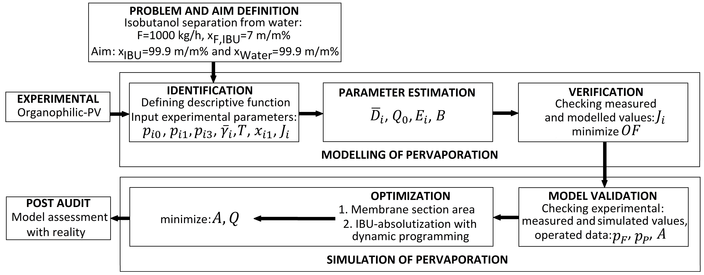

*Figure 1: Modelling and simulation steps in the case of pervaporation investigation (amended from* (Toth et al., 2015))

Our previous work confirmed the model verification and validation in the case of isobutanol-water organophilic separation (Toth et al., 2015). Consequently, the present work focuses on the optimization of isobutanol removal from water in ChemCAD flowsheet program. This simulator was applied for the investigation of hybrid separation. The combination of organophilic pervaporation and distillation processes can be seen in Figure 2.



*Figure 2: Flowsheet of the hybrid organophilic pervaporation and distillation processes*

NRTL thermodynamic model was used in SCDS distillation column and the exponential Rautenbach model (Valentínyi et al., 2013) for organophilic pervaporation. Table 1 shows the estimated parameters of this pervaporation model (Toth et al., 2015).

*Table 1: Estimated parameters for isobutanol–water mixture with Sulzer PERVAP™ 4060 membrane* (Toth et al., 2015)

|  |  |  |
| --- | --- | --- |
|  | Water | Isobutanol |
| Transport coefficient [kmol/m2h]  Activation energy [kJ/kmol]  Exponential parameter [-]  Permeability coefficient [kmol/m2hbar] | 5.05 x 109  42359  -27.02  108 | 1.49 x 101  -18279  -1.83  108 |

The binary isobutanol-water mixture was entered into the organophilic pervaporation units in the first step. In this main step, the permeate of the feed was enriched in the organic compound. Permeate streams leaving the pervaporation units were collected, mixed, and condensed with cooler and their pressure was increased again from vacuum with a pump. In our case, the permeate of the organophilic pervaporation should enter the limited solubility region (8.6–84.5 m/m% permeate isobutanol concentration (Gmehling et al., 1994). The retentate stream was rich in water so we can get it as a “Water product”.

Additional devices were also necessary for pervaporation units. The pressure and the temperature must be increased for the operational level before the first membrane unit, because the initial binary mixture had atmospheric conditions. The applied feed temperature in membrane modules was 70°C. Feed and permeate pressures were the following, 3 bar and 0.008 bar. Retentate flow was reheated after each membrane module by further heat exchangers (Tusel and Brüschke, 1985), except for the last unit (Toth et al., 2015).

The permeate product of the organophilic pervaporation was separated into two phases in a liquid-liquid phase separator: organic-rich and water-rich phases. The aqueous phase was recycled to the feed of the first step. Before the phase separator, a heat exchanger increased the temperature again to 20℃.

In the further step, the upper part of the phase separator was pumped into the middle of the distillation column. The “Isobutanol product” can be received as the bottom product (W) of distillation. The distillate product (D), which was the azeotropic composition of binary isobutanol-water mixture was recycled before the distillation column. The objective function of optimization in the case of distillation was the number of theoretical stages and minimal reflux ratio.

At last, post coolers and valves decreased the pressure and temperature of the “Water product” and the “Isobutanol product” to atmospheric values.

* 1. Results and discussion

In the case of different “Water product” and “Isobutanol product” compositions, the main configurations and characteristics introduce the following in Table 2 and Table 3. The abbreviations in the tables are: OPV: Organophilic pervaporation, D: Distillation column, A: Effective membrane surface (m2), N: Number of theoretical stages (-), R: Reflux ratio (-).

*Table 2: The main material flows of the hybrid method in the case of 99.9 % product purities*

*A: 35 m2, N: 10, R: 1*

|  |  |  |  |  |
| --- | --- | --- | --- | --- |
|  | Feed  into OPV | Feed  into D | Water  product | Isubutanol product |
| Flow rate [kg/h] | 1000 | 132 | 931 | 69 |
| Isubutanol [m/m%] | 7 | 84.4 | 0.1 | 99.9 |
| Water [m/m%] | 93 | 15.6 | 99.9 | 0.1 |

*Table 3: The main material flows of the hybrid method in the case of 99.5 % product purities*

*A: 10 m2, N: 8, R: 1*

|  |  |  |  |  |
| --- | --- | --- | --- | --- |
|  | Feed  into OPV | Feed  into D | Water  product | Isubutanol product |
| Flow rate [kg/h] | 1000 | 124 | 934 | 66 |
| Isubutanol [m/m%] | 7 | 84.4 | 0.05 | 99.5 |
| Water [m/m%] | 93 | 15.6 | 99.5 | 0.05 |

It can be seen, the material loss is significantly higher in the case of lower product purity. Furthermore, the sufficient membrane surface is remarkably lower in Table 3. Given that the investment cost of the membrane is high in many cases (Toth et al., 2018), it is worth considering a lower product purity. Figure 3 shows the tendency of water concentration in each retentate module (see also Figure 2).

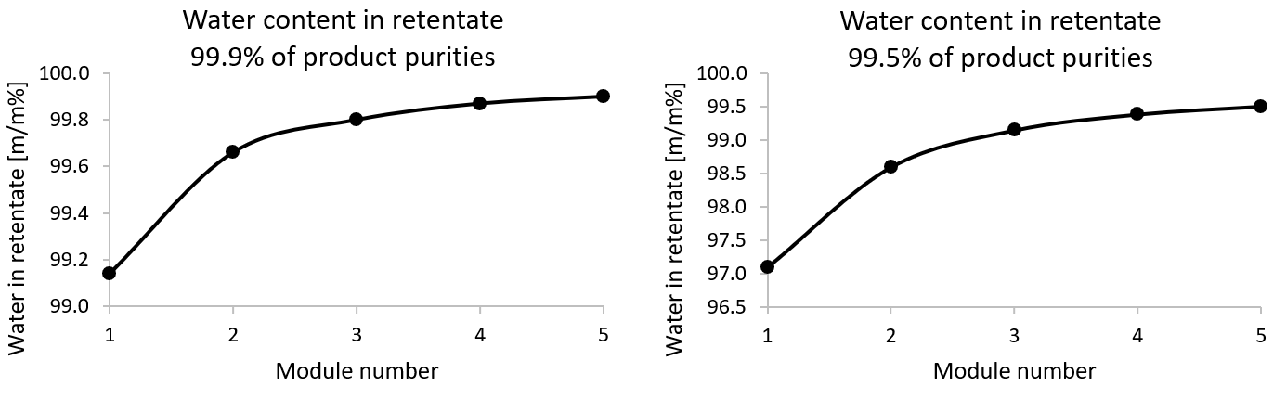

*Figure 3: Water weight percent in retentate streams*

The trend follows the literature (Baker, 2004; Toth et al., 2018), according to which the curves are flattening. Table 4 and Table 5 show the calculated heat duties of the hybrid method in the case of different product purity.

*Table 4: Calculated heat duties of hybrid organophilic and distillation processes in the case of 99.9 % product purities*

|  |  |  |  |
| --- | --- | --- | --- |
| Calculated heat duties |  | QHeating [MJ/h] | QCooling [MJ/h] |
| Pervaporation | Feed preheating | 256 |  |
|  | Retentate heating | 242 |  |
|  | Permeate cooler |  | -338 |
|  | Post cooler |  | -160 |
| Feed preheating |  | 30 |  |
| Phase separator |  |  | -14 |
| Distillation | Reboiler | 176 |  |
|  | Condenser |  | -144 |
|  | Post cooler |  | -17 |
| Total |  | 674 | -674 |

*Table 5: Calculated heat duties of hybrid organophilic and distillation processes in the case of 99.5 % product purities*

|  |  |  |  |
| --- | --- | --- | --- |
| Calculated heat duties |  | QHeating [MJ/h] | QCooling [MJ/h] |
| Pervaporation | Feed preheating | 209 |  |
|  | Retentate heating | 84 |  |
|  | Permeate cooler |  | -121 |
|  | Post cooler |  | -183 |
| Feed preheating |  | 12 |  |
| Phase separator |  |  | -13 |
| Distillation | Reboiler | 163 |  |
|  | Condenser |  | -134 |
|  | Post cooler |  | -16 |
| Total |  | 468 | -468 |

It can be determined that the whole process's heat consumption decreased by more than 30 % in the case of lower purity. The reduction is also significant here, but not as much as in the case of the membrane size.

It can be observed that, there is no remarkable reduction, in the size and heat duties of the distillation process. It can be explained by the fact that there is no change in the feed composition (see Table 2 and Table 3). Vapor-liquid equilibria determine this in the phase separator.

4. Conclusions

The hybrid separation process was investigated and optimized in the flowsheet program. It can be concluded that, the combination of organophilic pervaporation and distillation processes can solve the separation of the binary isobutanol-water mixture. Semi-empirical pervaporation model was used for membrane modules in ChemCAD software integrated with liquid-liquid-vapor flash and distillation modules. Recirculation could also be solved, so two pure product streams can only be received. 99.5 % and 99.9 % product purities were also calculated. It was established, in the case of a product with a cleaner composition, significantly larger membrane was required and, in connection with this, higher heat demand.

Acknowledgments

This publication was supported by NTP-NFTÖ-21-B-0014 National Talent Program of the Cabinet Office of the Prime Minister, MEC 140699, OTKA 128543 and OTKA 131586. The research reported in this paper and carried out at the Budapest University of Technology and Economics has been supported by the National Research Development and Innovation Fund (TKP2020 National Challenges Subprogram, Grant No. BME-NC).

References

Babalou A.A., Rafia N., Ghasemzadeh K., 2015. 3 - Integrated systems involving pervaporation and applications, in: Basile, A., Figoli, A., Khayet, M. (Eds.), Pervaporation, Vapour Permeation and Membrane Distillation, Woodhead Publishing Series in Energy. Woodhead Publishing, Oxford, pp. 65–86. https://doi.org/10.1016/B978-1-78242-246-4.00003-9

Baker R.W., 2004. Membrane Technology and Applications, 2nd ed. John Wiley & Sons, Ltd, Chichester.

Crespo J.G., Brazinha C., 2015. 1 - Fundamentals of pervaporation, in: Basile, A., Figoli, A., Khayet, M. (Eds.), Pervaporation, Vapour Permeation and Membrane Distillation, Woodhead Publishing Series in Energy. Woodhead Publishing, Oxford, pp. 3–17. https://doi.org/10.1016/B978-1-78242-246-4.00001-5

Cséfalvay E., Szitkai Z., Mizsey P., Fonyó Z., 2008. Experimental data based modelling and simulation of isopropanol dehydration by pervaporation. Desalination 229, 94–108. https://doi.org/10.1016/j.desal.2007.07.029

Do Thi H.T., Szilagyi B., Haaz E., Fozer D., Toth A.J., 2021. Optimization of Hybrid Distillation-hydrophilic and Organophilic Pervaporation Systems. Chemical Engineering Transactions 86, 1027–1032. https://doi.org/10.3303/CET2186172

Gmehling J., Menke J., Krafczyk J., Fischer K., 1994. Azeotropic Data. Wiley-VCH Verlag GmbH & Co. KGaA, Weinheim, New York, Basel, Cambridge, Tokyo.

Jaimes J.H.B., Alvarez M.E.T., Rojas J.V., Filho R.M., 2014. Pervaporation: Promissory Method for the Bioethanol Separation of Fermentation. Chemical Engineering Transactions 38, 139–144. https://doi.org/10.3303/CET1438024

Koczka K., Mizsey P., Fonyo Z., 2007. Rigorous modelling and optimization of hybrid separation processes based on pervaporation. Central European Journal of Chemistry 5, 1124–1147. https://doi.org/10.2478/s11532-007-0050-8

Liu S., Li H., Kruber B., Skiborowski M., Gao X., 2022. Process intensification by integration of distillation and vapor permeation or pervaporation - An academic and industrial perspective. Results in Engineering 15, 100527. https://doi.org/10.1016/j.rineng.2022.100527

Luis P., Van der Bruggení B., 2015. 4 - Pervaporation modeling: state of the art and future trends, in: Basile, A., Figoli, A., Khayet, M. (Eds.), Pervaporation, Vapour Permeation and Membrane Distillation, Woodhead Publishing Series in Energy. Woodhead Publishing, Oxford, pp. 87–106. https://doi.org/10.1016/B978-1-78242-246-4.00004-0

Marsden C., 1954. Solvents And Allied Substances Manual With Solubility Chart, 1st ed., Cleaver-Hume and Elsevier.

Rautenbach R., Herion C., Meyer-Blumentoth U., 1990. Pervaporation membrane separation processes. Membrane science and technology series 1, 181–191.

Toth A.J., Andre A., Haaz E., Mizsey P., 2015. New horizon for the membrane separation: Combination of organophilic and hydrophilic pervaporations. Separation and Purification Technology 156, 432–443. https://doi.org/10.1016/j.seppur.2015.10.032

Toth A.J., Haaz E., Nagy T., Tarjani A.J., Fozer D., Andre A., Valentinyi N., Solti S., Mizsey P., 2018. Treatment of Pharmaceutical Process Wastewater with Hybrid Separation Method: Distillation and Hydrophilic Pervaporation. Waste Treatment and Recovery 3, 8–13. https://doi.org/10.1515/wtr-2018-0002

Tusel G.F., Brüschke H.E.A., 1985. Use of pervaporation systems in the chemical industry. Desalination, Proceedings of the Symposium on Membrane Technology 53, 327–338. https://doi.org/10.1016/0011-9164(85)85070-0

Valentínyi N., Cséfalvay E., Mizsey P., 2013. Modelling of pervaporation: Parameter estimation and model development. Chemical Engineering Research and Design 91, 174–183. https://doi.org/10.1016/j.cherd.2012.07.001

Van der Bruggen B., Luis P., 2014. Pervaporation as a tool in chemical engineering: a new era? Current Opinion in Chemical Engineering, Nanotechnology / Separation engineering 4, 47–53. https://doi.org/10.1016/j.coche.2014.01.005