CHEMICAL ENGINEERING TRANSACTIONS  VOL. , 2023 | A publication of
The Italian Association
of Chemical Engineering
Online at www.cetjournal.it

Guest Editors: Sauro Pierucci, Jiří Jaromír Klemeš
Copyright © 2023, AIDIC Servizi S.r.l.
ISBN 978-88-95608-98-3; ISSN 2283-9216

Copper oxide onto gas diffusion electrodes to enhance selectivity towards >C1 chemicals in gas-phase CO₂ electrocatalytic reduction
Daniele Giusi*, Francesco Tavella, Matteo Miceli, Angela Mercedes Ronsisvalle, Veronica Costantino, Claudio Ampelli
Department of Chemical, Biological, Pharmaceutical and Environmental Sciences (ChiBioFarAm) – University of Messina, ERIC aisbl and CASPE/INSTM, v.le F. Stagno d'Alcontres, 31 – 98166 Messina, Italy
dgiusi@unime.it
We report here the electrocatalytic behaviour of an unconventional gas-phase reactor for the process of CO₂ conversion. Conventional systems for the CO₂ electrocatalytic reduction refer to electrodes immersed in a liquid electrolyte, presenting many issues mainly related to the low solubility of CO₂ in water. In gas-phase (or electrolyte-less conditions) the working electrode is engineered to be in direct contact with an ion-exchange membrane (forming a zero-gap system) and the CO₂ flows directly through the catalyst with no electrolyte. The influence of the reactor design (gas- or liquid-phase) is discussed by processing the same kind of electrode based on copper oxide (CuO) deposited on a gas diffusion layer to form a gas-diffusion electrode (GDE). Results, in terms of >C₁ productivity and supported by electrochemical characterizations (such as Electrochemical Impedance Spectroscopy -EIS), showed remarkable difference between the two systems and clarified the role of the proton-diffusion process at the catalyst interface. The reasons can be summarized as follows: i) increase of the local CO₂ concentration on the electrode surface, overcoming CO₂ solubility limitations in water-based solvents; ii) control/limitation of the proton concentration on the catalyst surface due to the absence of aqueous electrolyte. The process selectivity is strongly influenced by charge transport properties on the catalytic surface beyond the properties of the electrocatalyst itself. As a result, engineering of the reactor assumes a role no less important than the role of the electrocatalyst.
  - Introduction
The electrochemical conversion of CO₂ into value-added chemicals and fuels represents an important challenge in the field of renewable energies (Nitopi et al., 2019). Liquid-phase systems are conventionally used, in which an ion-exchange membrane separates two compartments (anode and cathode) for the reactions of water oxidation and CO₂ reduction, respectively (Gawel et al., 2020). The reduction catalyst, usually supported over a conductive substrate, is immersed in an aqueous electrolyte. However, the high concentration of protons in water leads to parasitic reactions, such as the hydrogen formation, which consumes electrons disadvantaging the formation of carbon-based compounds (Goyal et al., 2020).
Recently, great attention has been given to gas-phase operating systems, which allowed to obtain different performances compared to conventional liquid-phase systems (Giusi et al., 2022). Among the most attractive electrocatalysts for CO₂ reduction, copper oxides, both pure and in composite form, have been the most used in the literature for their activity (Mais et al., 2019) and because allow the formation of long carbon chains, going beyond the formation of CO and HCOOH (Duarah et al. 2021). The latter are the simplest products to obtain because they need only two electrons for their formation, but less interesting from an industrial point of view, in the field of renewable fuels. C>1 compounds, instead, offer interesting opportunities for long-term and large-scale renewable energy storage and green-chemical production, especially if their production is obtained with renewable energy, such as solar energy through photovoltaic systems (Giusi et al., 2021a). Numerous studies have highlighted the importance of the operating conditions, for example showing how the distribution of the products is dependent on the applied current density (Giusi et al., 2021b). High importance is often given to tailoring the electrocatalyst properties, underestimating the influence of the electrode and reactor design in determining the process selectivity (Gao et al., 2020). The control of the proton ionic mobility in the cathodic compartment is therefore decisive in mitigating the diffusion on the catalytic surface and limiting the formation of hydrogen (Ampelli, 2020).
The unconventional gas-phase conditions (also called electrolyte-less or zero-gap conditions) can be achieved by developing a membrane electrode assembly (MEA), similar to that used in fuel cell technology, coupling the catalyst with an ion-exchange membrane to create a solid electrolyte, thus replacing the liquid cathodic compartment (Park et al., 2023). Factors such as i) higher concentration of CO₂ on the electrode surface and ii) controlled proton mobility in the catalyst/membrane interface, allow to address the catalytic surface reactions towards the formation of long carbonaceous chains, limiting the production of hydrogen (H₂), carbon monoxide (CO) and formic acid/formate (HCOOH/HCOO⁻) (Giusi et al., 2022).
The engineering of the system is therefore able to drastically modify the selectivity of the process, making a catalyst selective towards the formation of >C1 species without any modifications, i.e. the addition of expensive doping elements or the use of alloys and bimetallic system (Marepally et al., 2017). This does not mean that the electrocatalyst itself is unimportant, but that the catalytic behaviour is dominated by the reactor characteristics, determined mainly by transport phenomena and surface population by adspecies at the electrode surface (Pan and Mauzeroll, 2020).
In this work, the comparison of the electrochemical performances of an unconventional gas-phase system with a common liquid-phase reactor using the same electrocatalyst (i.e. CuO) was studied, and the reasons of the different electrochemical behaviours were unveiled by electrochemical impedance spectroscopy (EIS) analysis. The obtained productivity, supported by EIS characterization, has highlighted how the process is controlled by the diffusion of CO₂ species at the catalyst/membrane interface rather than by kinetic factors, which in turn is conditioned by the applied potential. We have also demonstrated how the high concentration of CO₂ species in the catalyst surface drastically modified the selectivity of the process. In gas-phase operations, the membrane acts as a sort of solid electrolyte, favouring the ion migration through the catalyst, closing the ionic circuit between the electrodes. This configuration, in addition to allowing a continuous supply of CO₂ species onto the electrocatalytic surface, has the advantage of i) allowing to design compact and scalable systems to an industrial level; ii) limiting the diffusion processes present in the liquid phase and iii) easy recovering of the liquid products.
  - Experimental
    - CuO nanocubes
CuO nanocubes were synthesized through a facile hydrothermal synthesis (Liu et al., 2016) by dissolving 0.85 g of CuCl₂∙2H₂O in 500 mL of ultrapure water. Subsequently, 50 mL of 2 M NaOH solution were added and the resulting solution was stirred for 30 min at room temperature. Then, 50 mL of a 0.6 M solution of ascorbic acid were slowly added, until formation of a red precipitate; the mixture was left at 60 °C under stirring for 30 min. The obtained precipitate was separated by centrifugation and washed three times with water to remove the impurity. Finally, it was dried under vacuum at 60 °C for 24 h and then calcinated at 450 °C for 1 h (ramp of 10 °C min⁻¹) to transform Cu₂O into CuO. This material was proved active for multi-electron transfer in the CO₂ reduction in gas-phase operations, due to the presence of Cu⁺/Cu⁰ sites (Giusi et al., 2022).
    - Electrode preparation
The working electrode was prepared by depositing the CuO powder on a carbon gas-diffusion layer (GDL, Sigracet® 29 BCE, supplied by Ion Power) by spray-coating technique. The support was heated during the operation in order to allow the evaporation of the organic solvent. The ink was made by sonicating a mixture of a proper amount of catalyst, 10 mL of isopropanol and 50 µL of 5 wt. % Nafion perfluorinated solution for about 15 min until a stable and homogeneous suspension was formed. The catalysts were deposited on the GDL to obtain a final loading of about 1 mg cm⁻².
The electrode used in the gas-phase system was prepared in the form of a MEA, a technology widely used for fuel cells, by hot pressing (130 °C) the catalyst deposited on GDL with a Nafion® N-115 membrane (provided by Ion Power). The proton-exchange membrane, in direct contact with the catalytic layer, allows efficient transport of charges (protons) and has the function of separating the cathodic and anodic compartments.
    - Electrochemical device
The gas-phase device consists of i) a cathode compartment, i.e. a gas-chamber in which the CO₂ flows through the GDL, ii) the catalyst and iii) the proton-exchange membrane (Nafion®115), assembled to form the MEA (see Figure 1). The CO₂ adsorbs on the catalyst surface and reacts with the protons diffusing from the proton-exchange membrane. The membrane guarantees separation with the anodic compartment, the latter filled with a CO₂-saturated KHCO₃ solution in which the anode, a commercial Pt electrode and an Ag/AgCl reference electrode (3 M KCl) are immersed. The gas products diffuse back into the gas chamber and are absorbed in a dilute solution of sulfuric acid (0.001 M). At the end of the test, this solution was analyzed by Gas Chromatography-Mass Spectrometry (GC–MS, equipped with Stabilwax column, with He as the carrier gas) to check the formation of ethanol, methanol and other alcohols, and by Ion Chromatography (IC, column organic acids) to detect organic acids. Gaseous products were periodically taken from the gas chamber and analyzed by Gas Chromatograph (MicroGC GCX Pollution Analytic Equipment).
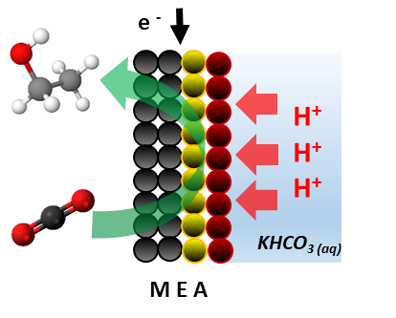
Figure 1: Gas-phase assembly. Black, yellow and red circles refer to GDL, catalyst and membrane, respectively (the formation of ethanol was reported as model).
The liquid-phase system is a conventional three-electrode cell consisting of two liquid compartments, anode and cathode, separated by a proton-exchange membrane (Nafion®324). This has the function of separating the two chambers, preventing the mixing of the reaction products and allowing the protons, produced from the water oxidation, to diffuse to the cathode through the liquid solution. Aqueous solutions of 0.1 M KHCO₃ and 1 M KOH are continuously recirculated by a peristaltic pump in the cathodic and anodic compartments, respectively. The bicarbonate solution is pre-saturated with CO₂ before the test until pH 6.8 is reached, while the CO₂ is flushed throughout the test in the cathodic electrolyte with a flow of 20 mL min⁻¹.
The electrodes used in liquid- and gas-phase have a surface geometrical area of 1 and 2 cm² respectively, and they both have a CuO loading of 5 mg cm⁻².
  - Results and Discussion
    - X-Ray diffraction (XRD) analysis
X-Ray Diffraction (XRD) crystallography was carried out to determine the purity of the obtained material and its degree of crystallinity (see Figure 2).
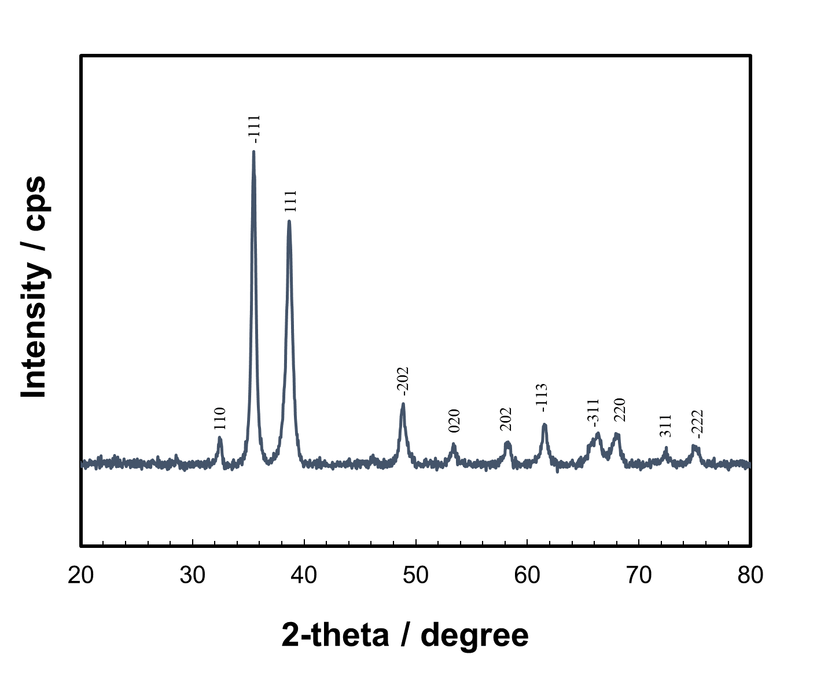
Figure 2: XRD pattern for CuO.
The following peaks were found: 32.6, 35.6, 38.8, 48.8, 53.5, 58.2, 61.6, 66.3, 68.3, 72.5, 75.4 ° referring to the crystalline CuO planes (110), (-111), (111), (-202), (020), (202), (-113), (-311), (220), (311), (-222), respectively. No impurities were found in the material.
3.2 Reduction tests
The CuO/GDL electrode was tested in the gas-phase system and its performance was compared with that in a conventional liquid-phase system. In both reactors, the tests were performed following a rigid electrochemical protocol consisting of i) a series of cyclic voltammetry (CV_{s}) to stabilize the catalyst up to the potential of the reaction test, and ii) a chrono-amperometry (CA) at the desired set potential (Giusi et al., 2022). The potentials investigated were –0.4 and –0.6 V vs. RHE for the liquid-phase system, and –0.4 and –1 V vs. RHE in the gas-phase system. This potential window, selected after the preliminary CV_{s} carried out in the two systems, allowed not to have too low or too high currents, with liquid quantification problems or excessive hydrogen formation. These potentials were also chosen in order to obtain the same current density in the two systems, due to the different cell geometries that lead to growing overpotential by increasing the current. The purpose of this work was not to investigate the performance at various potentials, but rather to compare the two systems under the most similar conditions. Figure 3 compares the two reaction configurations showing the Faradaic efficiencies (FE) to cumulative C₁ and >C₁ products plotted versus the current density.
All the tests reported here were repeated three times, with an analytical error within 5%.

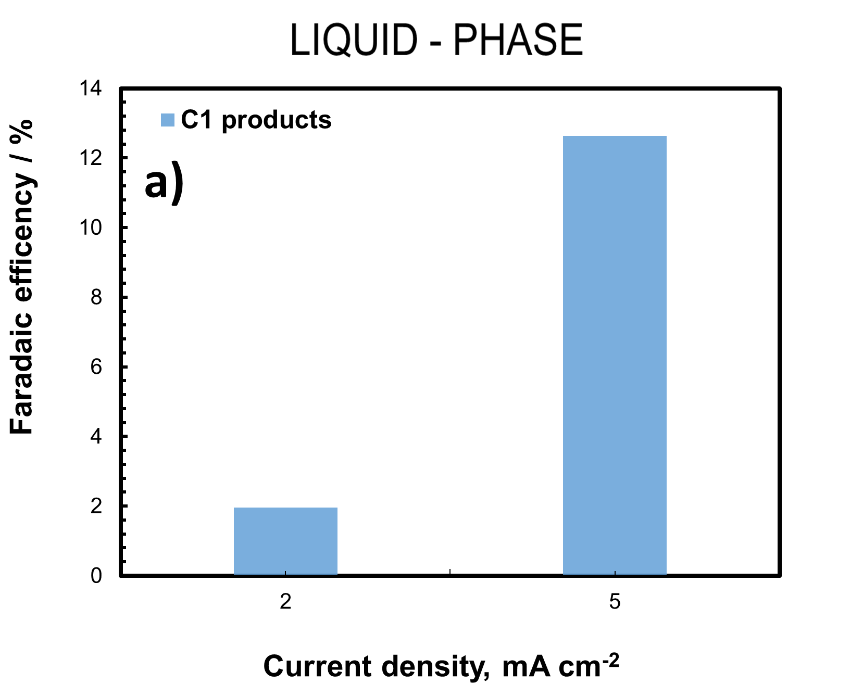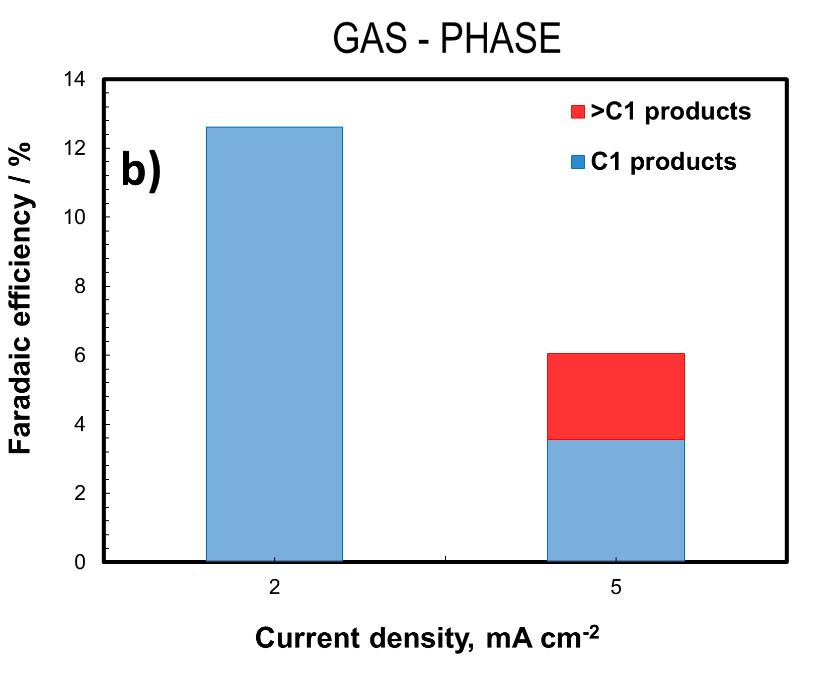
Figure 3: Faradaic efficiency to C₁ and >C₁ products at different current density of a) liquid-phase and b) gas-phase systems.
The results showed that, while in the liquid phase the main products obtained were formic acid and carbon monoxide (C1 products), in the gas phase the distribution of the products was strongly modified, leading to the formation of >C₁ carbon compounds. More in detail, in gas phase, carbon monoxide, acetaldehyde, ethanol and traces of propionaldehyde, butanone and acetic acid, were detected. No >C1 products were found in the liquid-phase tests. The values of carbon selectivity for both systems at the two applied current densities (2 and 5 mA cm⁻²) are reported in Table 1.
Table 1: Carbon selectivity (C.sel., %) obtained from gas-phase and liquid-phase tests at 2 and 5 mA cm⁻² current density using the same CuO/GDL electrocatalyst.
 |  | Gas-phase |  | Liquid-phase
 | Products | C.sel., %  2 mA cm⁻² | C.sel., %  5 mA cm⁻² | Products | C.sel., %  2 mA cm⁻² | C.sel., %  5 mA cm⁻²
 | Carbon monoxide | ≈100 | 58.7 | Carbon monoxide | 34.5 | 74.5
 | Formic acid | traces | - | Formic acid | 65.5 | 25.5
 | Acetaldehyde | - | 6.6
 | Ethanol | - | 34.2
 | Propionaldehyde, butanone, acetic acid | - | traces

While at low currents, due to the analytical detection limits, it was not possible to measure the amount of hydrogen, at 5 mA cm⁻² the faradaic efficiency was 83% and 96% for the liquid- and gas-phase, respectively.
At lower current density, in the gas-phase system the productivity towards the C1 species (mainly CO) was higher than that produced in the liquid-phase (CO and formic acid), while this proportion was reversed at higher current densities, leading to the formation of >C₁ species only in the gas-phase reactor. Considering that in the gas-phase system the electrolyte was absent, the mobility of the proton species and their surface concentration in the GDL/catalyst/membrane interface was lower than in the liquid-phase system. The CO-CO coupling reaction, which leads to the formation of the C₂₊ species, occurred more likely compared to the protonation of CO that leads to formic acid (more present in liquid phase), especially at higher current density.
To support the catalytic productivity data and provide an explanation in qualitative terms of the phenomena occurring in the two systems and to understand which factor determines this huge difference in the product distribution, the Electrochemical Impedance Spectroscopy (EIS) was used. This is very useful tool because, by describing the system through a theoretical model, information such as the series-resistance (R_{s}), the charge-transfer resistance (R_{ct}) and the capacitance (C) can be obtained. The R_{s} is mainly determined by the electrolyte composition, while R_{ct} is determined by the difficulty that a charge has to transfer to an electrically charged surface. The EIS analyses were performed in the two systems at –0.4, –0.6, –0.8 and –1.0 V vs. RHE under the same operating conditions of the CO₂ reduction tests. In the gas-phase system, the R_{ct} values were lower than in the liquid phase for each applied potential (especially at low potentials), as shown in Figure 4a reporting the ratio of the liquid- and gas-phase R_{ct} values in the two conditions.
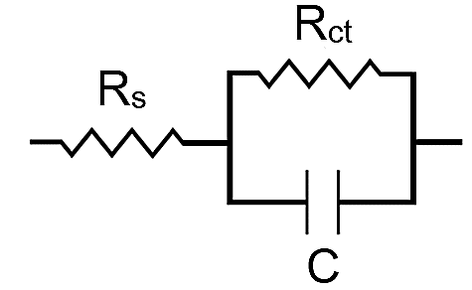
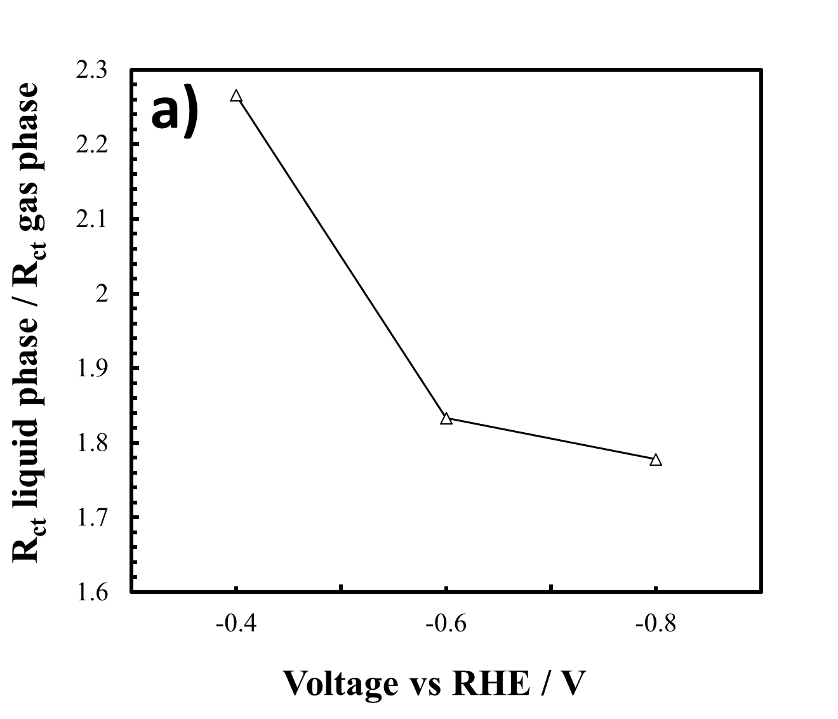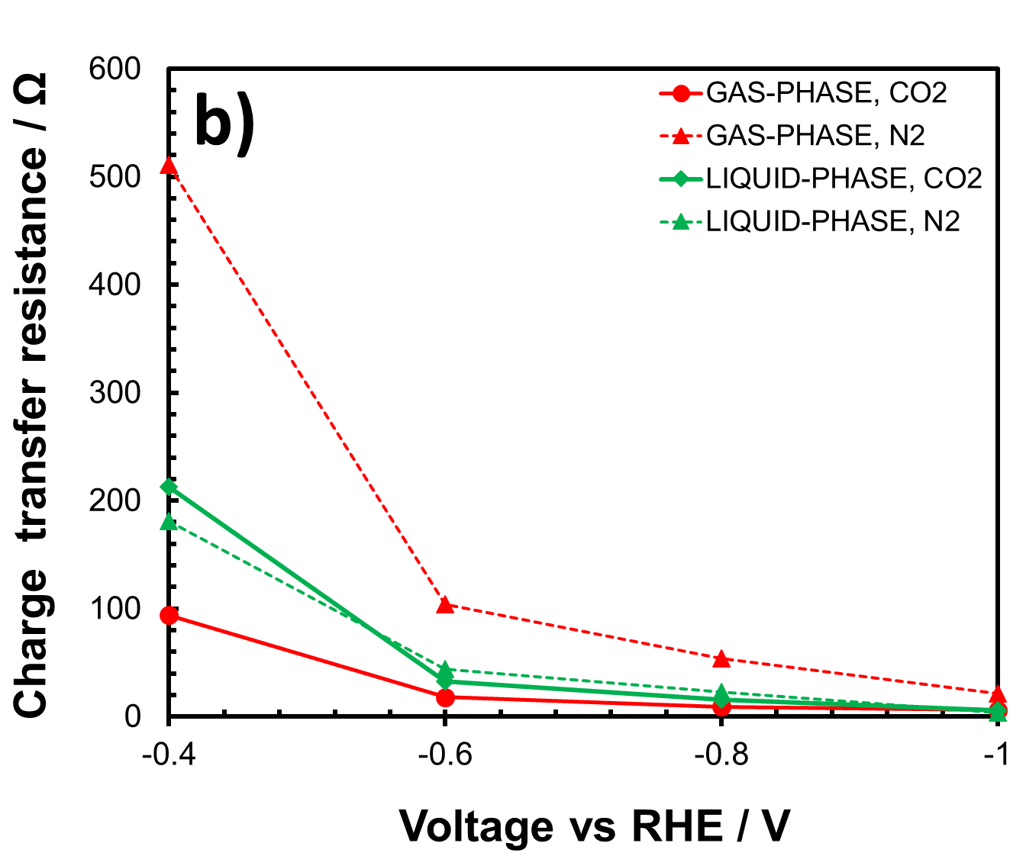
Basic EIS model
Figure 4: a) Liquid- and gas-phase charge-transfer resistance ratio (R_{ct}) and b) charge-transfer resistance in liquid and gas-phase devices, in presence of CO₂ or N₂ at different voltages.
Increasing the potential, the R_{ct} values decrease in both cases, and this is to ascribe to the fact that the charge-transfer process to the electrode interface is favoured due to the faster charge mobility between the electrodes, thus decreasing the overall resistance. In gas-phase, the concentration of CO₂ at the electrolyte/electrode interface is much higher than in the liquid-phase system (where instead its availability is limited by the solubility), and this strongly influences the charge-transfer mechanism, thus reducing the R_{ct} in presence of CO₂ (Ampelli et al., 2014). The high CO₂ concentration in gas phase limits the proton availability at the catalytic interface, slowing down the desorption of the -CO species, which through CO-CO coupling reactions lead to the formation of long carbon chains (Giusi et al., 2022). To understand the phenomena that address the different diffusive behaviour of protons in the catalytic layer, EIS analyses were performed in the two systems in presence of CO₂ or N₂ and the R_{ct} values were compared (see Figure 4b). The results show that in liquid-phase the R_{ct} values were very similar in the presence or absence of CO₂ (CO₂ vs. N₂). On the contrary, a great difference was obtained when operating in gas-phase. The gas-phase R_{ct} values under N₂ flow were, in fact, much higher than under CO₂ flow, especially at lower potentials. This is a clear indication that in liquid-phase, due to higher diffusional resistances than in the gas-phase, the R_{ct} of the system is less affected by the presence of CO₂ or N₂, as the high concentration of protons at the interface is dominant. The consequent competition in surface adsorption with respect to the intermediate species of CO₂ leads mainly to the formation of carbon monoxide and formic acid (which requires only 2 electrons), thus favouring their rapid desorption.
  - Conclusions
In this work, the influence of engineering of an electrochemical device on CO₂ reduction selectivity has been studied. Most of the works in the literature investigate the intrinsic properties of electrocatalysts, without focusing on the diffusion phenomena and the availability of CO₂ species at the catalyst/electrolyte interface. We compared the performances obtained in a gas-phase system with a conventional liquid-system, using a CuO/GDL electrode in both cases. At higher currents, a lower production of C₁ species was detected in the gas-phase system, together with the formation of >C₁ compounds, such as acetaldehyde, ethanol, propionaldehyde, butanone, and acetic acid. These products were not produced in liquid-phase operations. Under similar current density conditions, the CO carbon selectivity shifted from 74% (the remaining was formic acid) in liquid phase to 58.7% in gas-phase, while ethanol and acetaldehyde contributed for 34.3% and 6.6%, respectively. The catalytic production data were supported by EIS measurements, which highlighted high differences in terms of charge transfer resistance (R_{ct}) in the two systems varying the applied potential. This value, in fact, was generally lower in a gas-phase system, in which the absence of electrolyte caused a lower proton concentration at the catalyst/membrane interface, together with a high concentration of CO₂, which is no longer limited by solubility as occurs in water-based electrolytes. These aspects, compared to a liquid-phase system, determine great differences in terms of reaction intermediates and thus of catalytic selectivity. These results highlight the importance of the engineering of an electrochemical reactor in addressing the process selectivity beyond the properties of the electrocatalyst itself. To further increase the performance of CO₂ electrocatalytic reduction in gas-phase, higher currents and pressures could be applied, but a more sophisticated control system would be required due to increased system complexity. Furthermore, the integration of the electrocatalytic reactor with photo-anodes (Ferreira de Brito et al., 2019) or external photovoltaic modules will allow a direct conversion of solar energy into sustainable carbon fuels.
Acknowledgements
This work is funded by the European Union through the DECADE H2020 project (ID: 862030), which is gratefully acknowledged.
References
Ampelli C., 2020, Electrode design for ammonia synthesis, Nature Catalysis, 3, 420–421.
Ampelli C., Genovese C., Passalacqua R., Perathoner S., Centi G., 2014, A gas-phase reactor powered by solar energy and ethanol for H₂ production, Applied Thermal Engineering, 70, 1270–1275.
Duarah P., Haldar D., Yadav VSK, Purkait MK., 2021, Progress in the electrochemical reduction of CO₂ to formic acid: A review on current trends and future prospects, Journal of Environmental Chemical Engineering, 9, 6, 106394.
Ferreira de Brito J., Genovese C., Tavella F., Ampelli C., Boldrin Zanoni M.V., Centi G., Perathoner S., 2019, CO₂ Reduction of Hybrid Cu₂O–Cu/Gas Diffusion Layer Electrodes and their Integration in a Cu-based Photoelectrocatalytic Cell, ChemSusChem, 12, 4274-4284.
Gao F., Bao R.C., Gao M.R., Yu S.H., 2020, Electrochemical CO₂-to-CO conversion: electrocatalysts, electrolytes, and electrolyzers, J. Mater. Chem. A 8, 15458–15478.
Gawel A., Jaster T., Siegmund D., Holzmann J., Lohmann H., Klemm E., Apfel U.P., Electrochemical CO₂ reduction - The macroscopic world of electrode design, reactor concepts & economic aspects, iScience, 25, 4, 2022, 104011.
Giusi D., Ampelli C., Genovese C., Perathoner S., Centi G., 2021a, A novel gas flow-through photocatalytic reactor based on copper-functionalized nanomembranes for the photoreduction of CO₂ to C1-C2 carboxylic acids and C1-C3 alcohols, Chemical Engineering Journal, 408, 127250.
Giusi D., Miceli M., Genovese C., Centi G., Perathoner S., Ampelli C., 2022, In situ electrochemical characterization of Cu_{x}O-based gas-diffusion electrodes (GDEs) for CO₂ electrocatalytic reduction in presence and absence of liquid electrolyte and relationship with C2+ products formation, Applied Catalysis B: Environmental, 318, 121845.
Giusi D., Tavella F., Miceli M., Ampelli C., Centi G., Cosio D., Genovese C., Perathoner S., 2021b, Synergetic Electrocatalytic Effects of Cu₂O-TiO₂ Heterostructures in a Solar Driven PEC Device for CO₂ Reduction to >C1 Chemicals, Chemical Engineering Transactions, 86, 1405–1410
Goyal A., Marcandalli G., Mints V.A., and. Koper M.T.M., 2020, Competition between CO₂ Reduction and Hydrogen Evolution on a Gold Electrode under Well-Defined Mass Transport Conditions, Journal of the American Chemical Society, 142 (9), 4154–4161.
Liu H., Hu Z., Hu R., Liu B., Ruan H., Zhang L., Xiao W., 2016, Large-scale synthesis of Cu₂O nanocubes and their electrochemical properties, International Journal of Electrochemical Science, 11, 2756–2761.
Mais L., Palmas S., Vacca A., Mascia M., Ferrara F., Pettinau, A., 2019, Catalytic activity of Cu and Cu/Sn electrodes during CO₂ reduction from aqueous media, Chemical Engineering Transactions, 73, 97–102.
Marepally B.C., Ampelli C., Genovese C., Saboo T., Perathoner S., Wisser F.M., Veyre L., Canivet J., Quadrelli E.A., Centi G., 2017, Enhanced formation of >C1 Products in the Electroreduction of CO₂ by Adding a CO₂ Adsorption Component to a Gas-Diffusion Layer-Type Catalytic Electrode, ChemSusChem, 10, 4442–4446.
Nitopi S., Bertheussen E., Scott S.B., Liu X., Engstfeld A.K., Horch S., Seger B., Stephens I.E.L., Chan K., Hahn C., Nørskov J.K., Jaramillo T.F., Chorkendorff I., 2019, Progress and Perspectives of Electrochemical CO₂ Reduction on Copper in Aqueous Electrolyte, Chemical Reviews, 119, 7610–7672.
Pan Y., Mauzeroll J., 2020, Boosting CO₂ Reduction: Creating an Efficient Path for Gas Transport, Joule, 4, 4, 712-714.
Park J., Ko Y., Lim C., Kim H., Min B.K., Lee K.W., Koh J.H., Oh H.S., Lee W.H., 2023, Strategies for CO₂ electroreduction in cation exchange membrane electrode assembly, Chemical Engineering Journal, 453.

