CHEMICAL ENGINEERING TRANSACTIONS  VOL. , 2023 | A publication of
The Italian Association
of Chemical Engineering
Online at www.cetjournal.it

Guest Editors: Sauro Pierucci, Jiří Jaromír Klemeš
Copyright © 2023, AIDIC Servizi S.r.l.
ISBN 978-88-95608-98-3; ISSN 2283-9216

Optimized renewable energy mixes: facing energy scarcity in remote islands
M. Cipolletta^{a,b,}*, E. Dialyna^{b}, L. Bozzoliª, V. Casson Morenoª, T. Tsoutsos^{b}, V. Cozzaniª
ª Laboratory of Industrial Safety and Environmental Sustainability – DICAM, University of Bologna, Bologna, Italy
^{b} Renewable and Sustainable Energy Systems Lab - School of Chemical and Environmental Engineering, Technical University of Crete, Chania, Greece
* mariasole.cipolletta@unibo.it

The actual energy transition calls for the highest ever engagement of institutions and private sectors in the adoption of renewable energy systems in order to decarbonize all production chains. The high potential of renewable energy sources (RESs) in several locations worldwide is looked at as an important opportunity to both limit the energy supply issues and shift towards a greener society. On the other hand, it is also accompanied by the issues of resource variability, forecasting need and difficult management of the energy surpluses.
The contemporary exploitation of multiple RESs in a hybrid renewable energy system (HRES) is a strategic initiative aimed at reducing the energy supply risk in a specific location, while decarbonizing the power generation facilities that satisfy specific energy requests. By means of systems optimally designed that valorize the RESs site-specific features and time trends, it is possible to comply with the identified energy demands while obtaining increased reliability. This contribution introduces an approach for the preliminary design of HRESs which is capable of accounting for the specific geographical constraints and the energy requests to be fulfilled. The approach is simulation-based, thus analyses the performance of all the possible combinations of renewable energy conversion technologies in terms of supply reliability and assesses their sustainability profile through key indicators. The application of the method is exemplified through a case study located on the island of Crete, Greece, for the valorization of the combined exploitation of offshore wind and wave energy. The most sustainable designs of the HRES in the site foresee the installation of 12 offshore wind turbines and maximum 10 wave energy converters for an overall system potentiality higher than 110 MW.
  - Introduction
To ensure a sustainable future despite the impacts of climate change, the European Commission adopted a European Climate Law with the goal of achieving net zero GreenHouse Gas (GHG) emissions in the EU by 2050 and a reduction of at least 55 % by 2030 in comparison with 1990 levels (European Commission, 2022). For the accomplishment of these targets, the energy transition to renewable energies is essential. Indeed, the valorization of all the available RESs in a region can ensure energy security while minimizing the uptake of fossil fuels, especially in isolated systems. Nevertheless, the decarbonization of islands is a more complex issue than that of mainland systems because of the vulnerable stability of islands’ electricity grids, which makes its coupling with the intermittent nature of RESs very difficult (Dallavalle et al., 2021). HRESs are a viable alternative for islands and the exploitation of multiple RESs can improve supply reliability (Liu et al., 2018).
Greece, being made up of a plethora of islands, represents a special case for decarbonization applications. The islands suffer from the high cost of energy generation and pollution from the import and combustion of fossil fuels. On the other hand, the availability of seas and oceans pushes towards the exploitation of marine energies. Specifically, wave energy has been often investigated in the last years in combination with other RESs, due to its technological immaturity (Dialyna and Tsoutsos, 2021). Several authors searched for the most energetic areas in Greece for harvesting wave and offshore wind energy, Emmanouil et al. (2016) among others.
In this study, a sustainability-based approach is applied to identify the optimal energy mix of technologies exploiting multiple RESs. The method accounts for the features of the location where an integrated energy system might be implemented, in order to propose realistic alternative HRESs. Furthermore, the method was conceptualized to tune the optimal energy mixes on the basis of: the RESs energy potentials in the sites, their capability of dynamic integration with respect to an assigned power load, and the technological, economic and environmental criteria. The application of the approach is exemplified through a case study localized on the island of Crete, Greece.
  - Methodology
The opportunity to valorize multiple RESs is expressed by identifying the most sustainable energy mixes that might be designed in locations where there is a claimed potential for the exploitation of multiple RESs. The main steps are explained in the following.
First (step 1), locations where the potential of multiple RESs is acknowledged are selected. A set of information that can represent constraints for the application of the methodology are verified, such as surface limitations, location features (orography, bathymetry, seabed, offshore distance), regulations in force and the eventual presence of protected areas or wildlife species.
In the selected location, meteo-climatic data describing the energy potential of the RESs of interest are collected on a reference period (step 2), with a preference towards real-time trends of site parameters, as measurement data. In the considered region, socio-economic and energy-use characteristics of the inhabitant population are gathered, in order to select the target duty to be supplied by the integrated energy system (step 3). The load can be either steady, as when related to the operation of a facility, or variable, related to the local energy demand. The time pace of meteo-climatic and load data should be the same and in the range of one or three hours as to observe the coupling capability of the resources with loads of different types, even those that vary in the daily frame. If not possible, either load data or meteo-climatic data need to be reworked to enable a proper comparison in each time step. On the basis of both the analysis of RESs potentials at the site and the location features from steps 1 and 2, a set of proper conversion technologies is selected and concurs in the determination of the optimal energy mix (step 4). For each technology, the relative specifications related to the operating principle, operation constraints (cut-in/cut-off), performance, expected lifetime and primary costs (CAPEX and OPEX) are gathered. Additionally, Global Warming Potential (GWP) data related to the lifecycle of each considered technology are retrieved in order to estimate the environmental impact referred to GHG emissions associable with any considered integrated energy system. Step 5 sees the identification of the possible energy mixes. On the basis of the areas considered available after step 1, the maximum number of devices with respect to each technology considered is found through the application of specific spacing rules. All the possible combinations of devices, either in type, number and exploited resource, are defined and tagged with unique numbers. In step 6, the power generation of each energy mix is simulated through computations on the reference period according to the performance information available from step 4. The power generated by each energy mix is compared with the load tenor $P_{LOAD}$ to be supplied in each time step.
Through step 7, three sustainability indicators are derived. The “energy mix coverage ratio”, ${COV}_{MIX}$, quantifies the performance of each energy mix in satisfying the energy demand according to Eq(1), where $T$ is the number of time points in the reference period (Cipolletta et al., 2021).
$${COV}_{MIX}= \frac{\sum_{t=1}^{T}{ t:{ P}_{MIX }\left(t\right)>P_{LOAD}(t)}}{T}$$ | (1)
The economic performance of each mix is assessed through its “levelized cost of energy” ${LCOE}_{MIX}$ as in Eq(2) where ${CAPEX}_{MIX}$ and ${OPEX}_{MIX}$ are the overall capital and operative costs of each energy mix, respectively, and $L$ is the number of time steps in the lifetime of the integrated system.
$${LCOE}_{MIX}= \left({CAPEX}_{MIX}+ \sum_{t=1}^{L}{\left({{OPEX}_{MIX}}/{{\left(1+\frac{r}{T}\right)}^{T}}\right)}\right)/\left(\sum_{t=1}^{L}{\left(\frac{P_{MIX}\left(t\right)}{{\left(1+\frac{r}{T}\right)}^{T}}\right)}\right)$$ | (2)
$${GWP}_{MIX}= \left(\sum_{s=1}^{n}{{GWP}_{s}}\right)/\left(\sum_{t=1}^{L}{P_{MIX}\left(t\right)}\right)$$ | (3)
The environmental indicator employed per each energy mix is the “levelized global warming potential” ${GWP}_{MIX}$ in Eq(3). It reports the environmental impacts with respect to the cradle-to-grave GHG emissions associated with the generation of 1 MWh of electricity, where $n$ indicates the number of renewable systems within the energy mix. Step 8 foresees the identification of the optimal energy mix. The three sustainability indicators, derived from the simulation of each energy mix, can be used separately to produce three different rankings of all the energy mixes defined. In order to address the three aspects of sustainability (technological, economic and environmental) simultaneously, the three indicators are linearly normalized in their internal existence ranges in order to become comparable and have the same directionality (1 – desired result, 0 – undesired result). The three normalization ranges are defined by the minimum and maximum figures obtained for ${COV}_{MIX}$, ${LCOE}_{MIX}$ and ${GWP}_{MIX}$ from the simulations of all energy mixes. The normalization converts ${COV}_{MIX}$ in $I_{TEC,MIX}$, ${LCOE}_{MIX}$ in $I_{ECO,MIX}$, ${GWP}_{MIX}$ in $I_{ENV,MIX}$. Finally, the normalized indicators related to each mix are aggregated by means of arithmetical average, resulting in the final metric $I_{AGG,MIX}$.
  - Results from the case study application
Crete is Greece's largest island and the fifth-largest island in the Mediterranean Sea. The impact of tourism creates intense seasonal fluctuations in population and in the island's energy needs.
Electricity consumption reaches its highest peaks during summer due to both tourism and the need for cooling, while a modest electricity demand is observed during winter. In 2019, the share of RESs in Crete’s electricity production was 21 %, made up of onshore wind energy (16.6 %) and solar photovoltaic energy (residual 4.4 %) (Katsaprakakis et al., 2022). Most of the electricity remains generated by thermal power plants using fuel oil and diesel (Vourdoubas, 2021). In recent years, there have been two considerable efforts to connect Crete to Greece's mainland grid (IPTO, 2021). However, the energy transition and the unsecured reliability of the sole interconnections lead to the need of increasing RESs penetration both in the island energy mix and in off-grid systems and facilities. Several areas with significant offshore wind and wave potential were identified in Crete (Lavidas and Venugopal, 2018). Gkeka-Serpetsidaki and Tsoutsos (2022) found the most sustainable locations in Crete for the development of fixed-bottom offshore wind farms through a multi-criteria analysis, among whom an area northwest of Heraklion is present. In this research, this area was selected for the possible installation of a wind-wave farm. The application of step 1 of the proposed methodology led to the exact identification of a sea area comprised between Dia island and Crete.

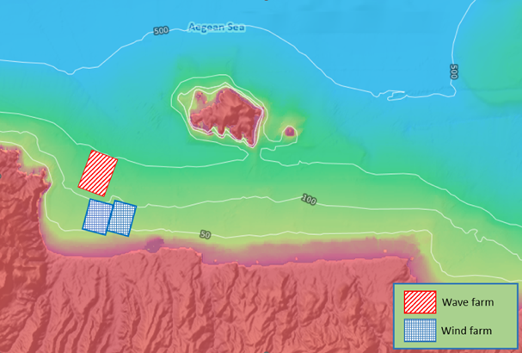
Figure 1. Considered area for the possible installation of wind-wave farm.
In Figure 1, the wind-wave farm site is displayed. The two blue parallelograms are the areas for the possible installation of Offshore Wind Turbines (OWTs), with a total surface of 9 km² and water depths between 50 and 100 m. The red parallelogram is the suitable location for a farm of Wave Energy Converters (WECs), occupying a surface of 6 km² in water depths between 100 and 150 m. By applying step 2, real wind and wave data were retrieved from the Poseidon moored buoy that is anchored north of the investigated wind-wave farm areas. The floating buoy records the needed meteo-climatic parameters (wind speed, wind direction, significant wave height, maximum wave height, wave direction and peak wave period). The reference year selected for the analysis is 2018 due to its data completeness (90 %). According to step 3, the load to be used in the integrated system optimization procedure is a share (1 %) of the island’s electricity demand in 2019, a representative year before COVID-19. The load hourly data series were provided by the Hellenic Electricity Distribution Network Operator SA (HEDNO). In line with step 4 of the methodology, three OWTs models and three WECs models are examined for the definition of the energy mixes, having considered the RESs energy potentials, the technologies’ installation feasibility in the site and their specifications availability. The technologies’ features are summarized in Table 1 and Table 2. To define the possible energy systems (step 5), the maximum number of devices installable in the areas per conversion technology needs to be identified. Thus, spacing factors are applied. For all models of OWTs, the crosswind and downwind distances are 5 and 7 times the OWT rotor diameter, respectively, as in previous studies (Gkeka-Serpetsidaki and Tsoutsos, 2022). In the case of WECs, the reference minimum spacing distance for non-point absorber technologies was set as 150 m as in the study of the Pelamis wave farm (Previsic et al., 2004). The maximum number of devices installable in the given areas is reported in the ending lines of Table 1 and Table 2. The combinations of devices representing all the possible designs of the wind-wave farm are 2,812 (combination of 37 OWTs and 76 WECs deployment choices).
Table 1: Features of the OWTs included in the assessment.
Model name (tag) | V164 - 9.5 MW (1) | SG 8.0-167 DD (2) | SWT-6.0-154 (3)
Data and power curves ref. | (The Wind Power, 2022)
Nominal power – P_{nom} (kW) | 9500 | 8000 | 6000
Rotor diameter (m) | 164 | 167 | 154
Rotor height (m) | 105 | 92 | 100
CAPEX (Eur) | following an adaptation of the cost model from Ioannou et al. (2018)
OPEX (Eur/y) | following an adaptation of the cost model from Ioannou et al. (2018)
GWP/ P_{nom} (kgCO₂/kWp) | 1.5E3 (adapted from Raadal et al. (2014))
Maximum number of devices | 12 | 12 | 12
Table 2: Features of the WECs included in the assessment.
Model name (tag) | Wave Dragon 7 MW (1) | Wave Dragon 1 MW (2) | Pelamis (3)
Data ref. | (Silva et al., 2013) | (Sørensen and Friis-Madsen, 2015) | (Silva et al., 2013)
Nominal power - P_{nom} (kW) | 7000 | 1000 | 750
Characteristic length (m) | 300 | 170 | 150
Minimum dimension (m) | 170 | 96 | 5
Power matrices ref. | (Silva et al., 2013) | downscaled as per Fernández-Chozas et al. (2014) | (Silva et al. 2013)
Costs ref. | (Sørensen and Friis-Madsen, 2015) | (Sørensen and Friis-Madsen, 2015) | (Bosserelle et al., 2015)
CAPEX (M Eur) | 23.6 | 9.1 | 2.8
OPEX (M Eur/y) | 1.7 | 0.6 | 0.1
GWP ref. | adapted from Banerjee et al. (2013)
GWP/P_{nom} (kgCO₂/kWp) | 4.0E4 | 4.7E4 | 1.3E7
Maximum number of devices | 18 | 27 | 30
Their energy performances are simulated in the reference period (step 6), while the three sustainability indicators are calculated (step 7). The separate application of the three criteria expressed by Eqs(1-3) orders the energy mixes into three separate rankings, while their simultaneous application produces the final ranking based on $I_{AGG,MIX}$ (step 8).
The top ten energy mixes of the four rankings are reported on the x-axis of the bar plots in Figure 2 and Figure 3, along with the value of their absolute indicators, their nominal power installed, the number and type of converters. As per the tags on the x-axis, it can be observed that the four sets of results are not aligned.
The maximum reached figures of ${COV}_{MIX}$ (reported in Figure 2-panel A) are around 80 % and prioritize those energy mixes mainly consisting of OWTs (over 100 MW installed vs less than 50 MW of WECs). According to this technological indicator, the optimal type and number of OWTs are the V164 - 9.5 MW OWT by Vestas (tag2) and 12, while for the WF the optimal device is the “2” (Wave Dragon 1 MW) in a variable number.
When considering economics (Figure 2-panel B), the still high LCOE for wave energy make this option discarded, and the ranking is dominated by the mixes minimizing the installed WECs in favor of OWTs.
From Figure 3-panel A, it can be noticed that the minimization of ${GWP}_{MIX}$ prioritizes energy mixes constituted solely by OWTs, given the still high impacts associated with the lifecycle of WECs, especially due to the significant employment of construction materials and the important energy expenses related to the installation phase (Banerjee et al., 2013). Differently from the rankings produced by ${COV}_{MIX}$ and ${LCOE}_{MIX}$, the top ten less impacting energy mixes are characterized by lower installed capacities (50 MW in average) and the choice of another OWT model (tag3: SWT-6.0-154). Finally, $I_{AGG,MIX}$ provides the sustainability-based ranking, which considers all three criteria simultaneously (Figure 3 – panel B). The overall top ten energy mixes are characterized by very high scores of $I_{ECO,MIX}$ and $I_{ENV,MIX}$, even presenting some tags in common with the $I_{ECO,MIX}$ ranking. Moreover, the wave farms’ sizes are limited to a maximum of 10 WECs, while the wind farm is maximized up to the number of OWTs feasible of installation in the identified areas.

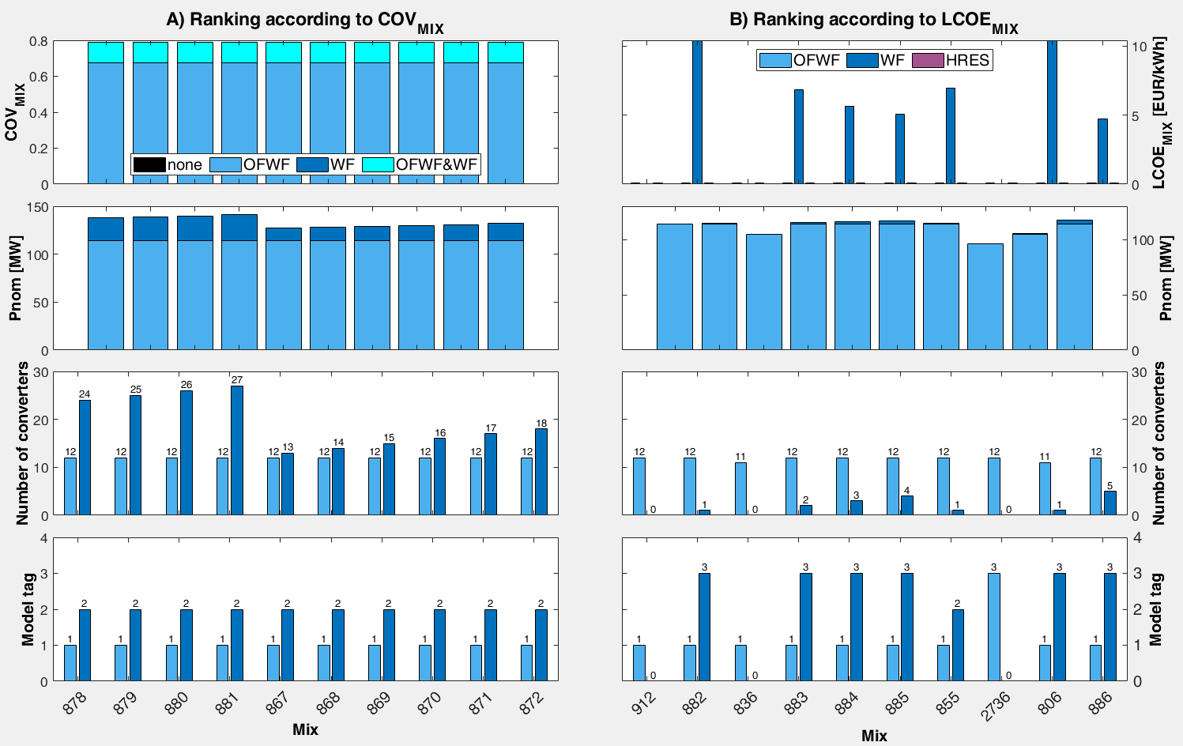
Figure 2. Top ten energy mixes of the rankings obtained separately by ${COV}_{MIX}$ (A) and ${LCOE}_{MIX}$ (B).
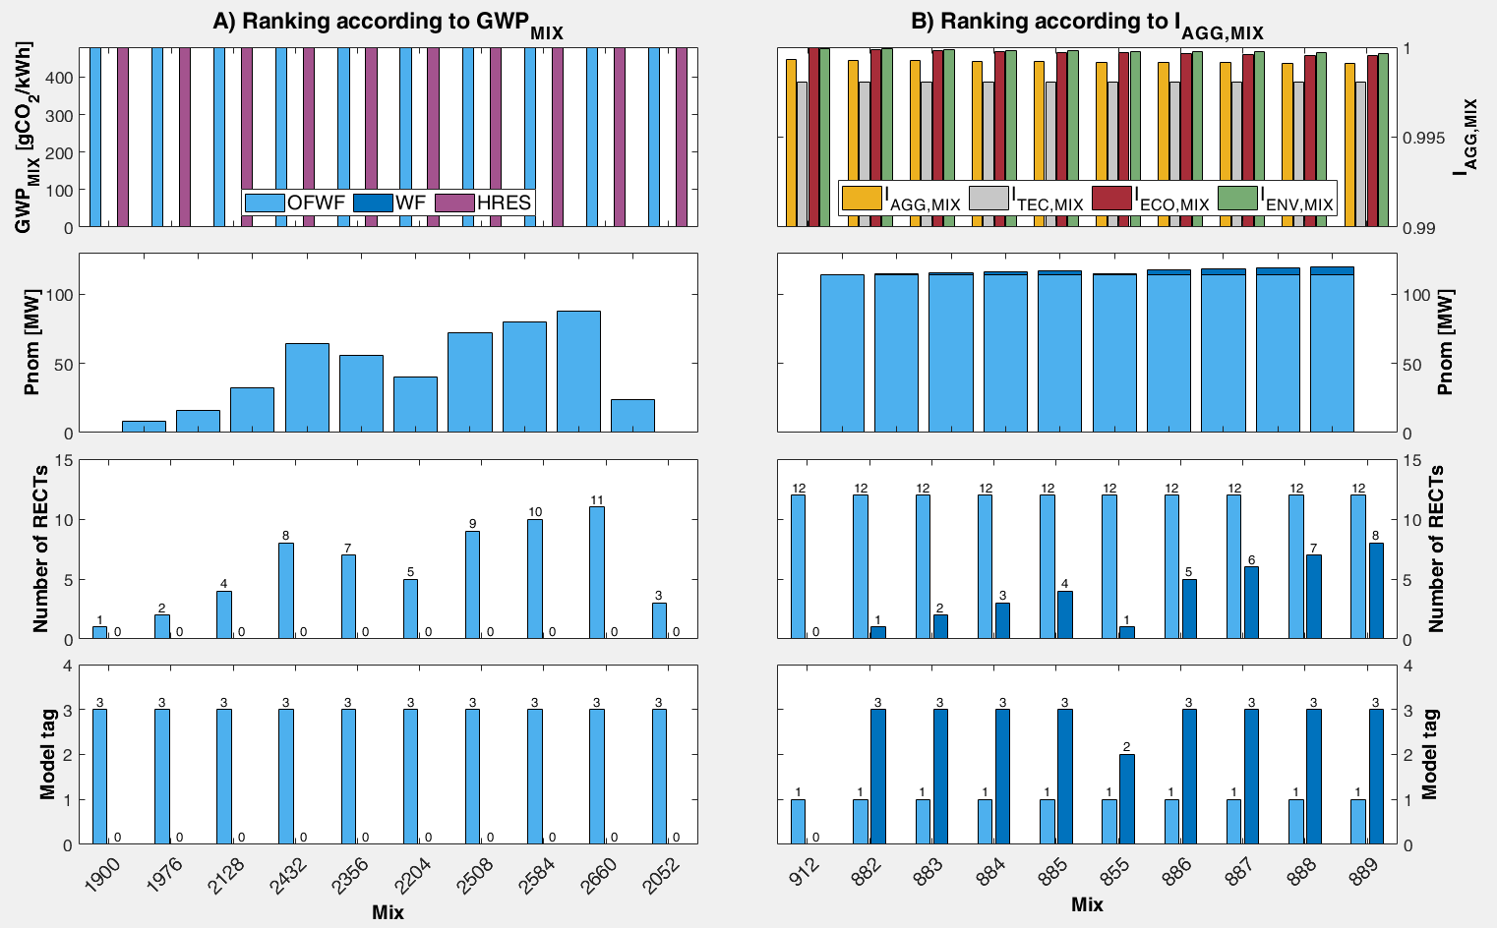
Figure 3. Top ten energy mixes of the rankings obtained according to ${GWP}_{MIX}$ (A) and $I_{AGG,MIX}$ (B).
  - Conclusions
The study demonstrated the potential of a straightforward approach for the optimized design of HRESs capturing the site’s features. The simultaneous consideration of sustainability metrics, such as costs and environmental impacts, together with the crucial need to meet the defined load demand, boosts the exploitation of consolidated technologies but also encourages, even if to a lower extent, the deployment of more immature conversion devices, as WECs, in hybrid systems. The sustainability-based conceptual design in the region of Heraklion, Crete, mainly drives towards the installation of a 110 MW wind farm and maximum 10 Pelamis WECs to sustain 1 % of the island electricity consumption. Aspects deserving deeper investigation are the possibility of storage in the case of off-grid applications of the integrated energy system as well as the possibility to integrate in the presented approach a detailed impact evaluation of the considered energy mixes at the site of interest.
Acknowledgments
The authors thank HCMR POSEIDON system for providing the wind and wave data and the Hellenic Electricity Distribution Network Operator SA (HEDNO) for providing the energy demand data.
References
Banerjee S., Duckers L., Blanchard R.E., 2013, An overview on greenhouse gas emission characteristics and energy evaluation of ocean energy systems from life cycle assessment and energy accounting studies, Journal of Applied and Natural Science, 5, 535–540.
Bosserelle C., Reddy S.K., Kruger J., 2015, Waves and Coasts in the Pacific, Report, Pacific Community, Suva, Fiji Islands.
Cipolletta M., Casson Moreno V., Dallavalle E., Zanuttigh B., Cozzani V., 2021, Aiding water production in isolated islands using integrated renewable energies sources, Chemical Engineering Transactions, 86, 205–210.
Dallavalle E., Cipolletta M., Casson Moreno V., Cozzani V., Zanuttigh B., 2021, Towards green transition of touristic islands through hybrid renewable energy systems. A case study in Tenerife, Canary Islands, Renewable Energy, 174, 426–443.
Dialyna E., Tsoutsos T., 2021, Wave energy in the mediterranean sea: Resource assessment, deployed wecs and prospects, Energies 14, 1-18.
Emmanouil G., Galanis G., Kalogeri C., Zodiatis G., Kallos G., 2016, 10-year high resolution study of wind, sea waves and wave energy assessment in the Greek offshore areas, Renewable Energy, 90, 399–419.
European Commission, 2022, European Climate Law, EC, <ec.europa.eu/clima/eu-action/european-green-deal/european-climate-law_en> accessed 5.22.22.
Fernández-Chozas J., Kofoed J.P., Jensen N.E.H., 2014, User guide – COE Calculation tool for Wave Energy Converters ver. 1.6, Report, Aalborg University, Aalborg, Denmark.
Gkeka-Serpetsidaki P., Tsoutsos T., 2022, A methodological framework for optimal siting of offshore wind farms: A case study on the island of Crete, Energy, 239, 1-19.
Ioannou A., Angus A., Brennan F., 2018, Parametric CAPEX, OPEX, and LCOE expressions for offshore wind farms based on global deployment parameters. Energy Sources, Part B: Economics, Planning and Policy, 13, 281–290.
IPTO, 2021, Interconnection of Crete with Peloponnese, Independent Power Transmission Operator, <admie.gr/en/erga/erga-diasyndeseis/diasyndesi-tis-kritis-me-tin-peloponniso> accessed 4.30.22.
Katsaprakakis D. A., Michopoulos A., Skoulou V., Dakanali E., Maragkaki A., Pappa S., Antonakakis I., Christakis D., Condaxakis C., 2022, A Multidisciplinary Approach for an Effective and Rational Energy Transition in Crete Island, Greece, Energies, 15, 1-49.
Lavidas G., Venugopal V., 2018, Energy Production Benefits by Wind and Wave Energies for the Autonomous System of Crete, Energies, 11, 1–14.
Liu Y., Yu S., Zhu Y., Wang D., Liu J., 2018, Modeling, planning, application and management of energy systems for isolated areas: A review, Renewable and Sustainable Energy Reviews, 82, 460–470.
Previsic M., Siddiqui O., Bedard R., Hagerman G., 2004, System level design, performance and costs for San Francisco California Pelamis offshore wave power plant, Report, Electricity Innovation Institute, Palo Alto, US.
Raadal H.L., Vold B.I., Myhr A., Nygaard T.A., 2014, GHG emissions and energy performance of offshore wind power, Renewable Energy, 66, 314–324.
Silva D., Rusu E., Soares C.G., 2013, Evaluation of various technologies for wave energy conversion in the portuguese nearshore, Energies, 6, 1344–1364.
Sørensen H.C., Friis-Madsen E., 2015, Wave Dragon 1.5 MW North Sea Demonstrator - Phase 1, Report, Aalborg University, Copenaghen, Denmark.
The Wind Power, 2022, Manufacturers and turbines, <thewindpower.net/store_manufacturers_turbines_view_all_en.php> accessed 21.07.2022.
Vourdoubas J., 2021, Islands with Zero Net Carbon Footprint due to Electricity Use. The Case of Crete, Greece, European Journal of Environment and Earth Sciences, 2, 37–43.

