S CHEMICAL ENGINEERING TRANSACTIONS  VOL. , 2023 | A publication of
The Italian Association
of Chemical Engineering
Online at www.cetjournal.it

Guest Editor: Sauro Pierucci
Copyright © 2023, AIDIC Servizi S.r.l.
ISBN 978-88-95608-98-3; ISSN 2283-9216

Nanostructured Ni-Fe-P Alloy for Alkaline Electrolyzer
Sonia Carbone^{a,*}, Alessandro G. M. Carusoª, Bernardo Patellaª, Rosario Miceliª, Filippo Pellitteriª, Massimo Carusoª, Philippe Mandin^{b}, Giuseppe Aielloª, Rosalinda Inguantaª.
ªDepartment of Engineering, Università degli Studi di Palermo
^{b} IRDL UMR CNRS 6027, Université de Bretagne Sud, 56100 Lorient, France
* sonia.carbone@unipa.it

In recent years, the interest towards green hydrogen has drastically increased due to the global decarbonization process. Electrochemical water splitting is considered an attractive solution to convert and store the surplus energy from renewable energy sources. However, hydrogen production by water electrolysis is not economically sustainable. To reduce the cost of produced hydrogen, it is necessary to switch from noble-metal catalyst (Pt, Pd…) to cheap alternatives with a lower per unit energy cost but at the same time able to guarantee a high electrocatalytic activity for both oxygen and hydrogen evolution reactions. Among transition metals, nickel was selected as active material for its low cost and high chemical stability in alkaline media. Currently, the most investigated transition metal catalyst includes alloy of nickel with sulfide, phosphide, and nitride. In this work, a ternary alloy of Nickel-Iron-Phosphorus with nanowires morphology was investigated and compared to the binary alloy of Nickel-Iron. Ni-Fe-P NWs electrodes were obtained by potential-controlled pulse electrochemical deposition using polycarbonate membrane as template. Electrodes morphology and structure were studied by scanning electrode microscopy (SEM), energy diffraction spectroscopy (EDS) and X-ray diffraction (XRD). Electrodes were tested both as cathodes as anodes by Quasi Steady State Polarization (QSSP) and Galvanostatic Test. All the tests were performed in 30% w/w KOH aqueous solution at room temperature. Preliminary results showed better performance of the ternary alloy compared to the binary one.
  - Introduction
Due to the global energy crisis and environmental pollution, more and more researchers are trying to develop clean energy systems with zero greenhouse gas emissions. With this in mind, hydrogen is seen as a key energy carrier that can replace fossil fuels, such as oil and coal (Tian et al., 2019). There are many methods by which hydrogen can be produced, which can be classified according to the process used (gasification, pyrolysis, and electrolysis, etc.) and the energy source used (coal, nuclear electricity, renewable electricity, etc.). Nowadays, almost all hydrogen is produced from fossil sources (Lee et al., 2022). Electrolysis of water represents a clean way to generate hydrogen and oxygen, especially if the electricity comes from the surplus of energy from renewable sources (Kuang et al., 2019). At the basis of the electrolysis process of water are two half-reactions: first, the water reduction reaction (hydrogen evolution reaction, HER) which takes place at the cathode, and on the other hand, the water oxidation reaction (oxygen evolution reaction, OER) which takes place at the anode. Theoretically, these reactions take place by applying a potential of 1.23 V, which is equivalent to an energy demand of ΔG = 237.1 kJ mol⁻¹. However, the amount of energy required is higher due to different losses, such as activation, ohmic and mass transport losses. The hurdle to be overcome is the realization of highly efficient but inexpensive electrode materials as an alternative to traditional noble metal-based materials such as Pt, Pd for HER, and IrO₂ and RuO₂ for OER (Guo et al., 2019). However, so far, most of the electrocatalysts developed do not met good catalytic activity and stability in alkaline environments. For this reason, it is essential to develop electrodes able of comprehensively catalyzing water splitting with high efficiencies and low costs (Li et al., 2019). The most promising materials are those of the iron group. Nickel and its alloys are considered the best due to their stability in an alkaline environment, high electrocatalytic activity and low cost (Ganci et al., 2021). Transition metal electrodes (Ni, Co and Fe ) are considered excellent candidates due to their high catalytic activity (Dionigi et al., 2016). The binary alloy of Nickel-iron has been extensively studied and is currently considered one of the best options for alkaline electrolysers due its low price, favorable electrocatalytic activity and abundance. In addition, Transition metal phosphides (TMPs) have attracted attention due to their catalytic action for HER and OER in alkaline electrolytes. TMPs have distinct charge structures: positive charges in metal and negative charges in phosphorus. The negatively charged P acts as a proton acceptor and weakens the metal (positively charged, hydride acceptor as M−H) bond strength to avoid the kinetically sluggish desorption of hydrogen (Kwong et al., 2017; Zhao et al., 2022). Most electrodes containing phosphorus are made through a doping process. For example, Ledendecker et al. made Ni₅P₄ films by doping of nickel foil with red phosphorous for 1 h at 550 °C using an inert atmosphere (Ledendecker et al., 2015). Compared to binary alloys, the use of a ternary is an excellent strategy to increase electrode performance by combining the properties of several metals. However, the role of ternary components in the electrolysis process is still unclear and the improvement of bifunctional catalytic performance is still urgent (Xuan et al., 2017). In addition to the material used, the performance of a catalyst can be affected by the size, structure, and morphology of the working electrode. In particular, by focusing on structure, electrodes with high surface areas and thus a significant number of catalytic active sites can be used to increase electrode features (Wang et al., 2022). The construction of nanostructured materials such as nanorods, nanowires, nanosheets, and so on, leads to high electrochemical active surface, which increases catalytic activity. Particularly, well-ordered nanowires or nanorods arrays are perfect candidates for HER and OER because they can reduce the ionic diffusion path, facilitate ionic motion facilitating the rising of gas bubbles (Yan et al., 2015). Accordingly, in this work, a ternary alloy of nickel-iron-phosphorous nanowires electrode was fabricated by electrodeposition and its performance was compared with the binary nickel-iron alloy obtained in an our previous work (Buccheri et al., 2021). These electrodes were obtained by template electrosynthesis a simple and cheap method. Compared to traditional methods mentioned earlier to obtain phosphorus-doped electrodes, which require very long times and very high temperatures, electrodeposition can reduce energy consumption and expand the scope of application.
  - Experimental
    - Electrode Fabrication
Nickel-Iron and Nickel-Iron-Phosphorus nanostructured electrodes were fabricated through template electrosynthesis, using a polycarbonate membrane as a template. The entire manufacturing process takes place at ambient temperature and atmospheric pressure. This method consists of four essentially equal steps for the manufacture of the two electrodes. At the beginning, the membrane was made conductive through a sputtering process. A thin film of gold was deposited on one side of the template. The sputter is a Scancoat Six Sputter Coater from Edwards Ltd. Deposition takes place by applying a continuous current of 30 mA for 3 minutes. Subsequently, on the gold side, Nickel was electrodeposited using a Watt’s bath (300 g/L Nickel sulphate hexahydrate, 45 g/L nickel chloride, 45 g/L boric acid), by potentiostatic electrodeposition at -1.5 V vs. Saturated Calomel Electrode (SCE) for 1.5 h. The Nickel-Iron and Nickel-Iron-Phosphorus NWs manufacturing processes differs in the deposition in terms of solution composition and operating parameters. For the Ni-Fe deposition, a Watt’s bath with 0.44 M FeSO₄∙7H₂O was used. This bath (containing about 67% of Ni and 33% of Fe) was selected because led to the deposition of NiFe alloy nanowires with the best performance (Buccheri et al., 2021) with a Fe content of nanowires of about 79%. Nanowires were obtained by pulse electrodeposition switching the potential between -1.35 (for 6 s) and -0.65 (for 4 s) V vs. SCE for 100 cycles. To obtain better-performing electrodes, the possibility of adding a source of phosphorus to the NWs deposition bath was evaluated. Ni-Fe-P NWs were manufactured by adding 20 g/L of sodium hypophosphite monohydrate to the previous solution (Watt’s bath with FeSO₄). Starting from the data in the literature, optimum values were sought for the deposition. The deposition technique is again a pulsed square wave deposition where the potential switches from -1.2 (for 6 s) to -0.75 V (for 4 s) vs. SCE for 70 cycles, for a total duration of approximately 20 minutes. This deposition technique allows to control the composition and the morphology of the nanostructures. The desirable strategy of electrodeposition has also been adopted in the synthetic of phosphide catalysts and submitted satisfactory answers in terms of HER and OER performance. The deposition process of metal phosphide with sodium hypophosphite as phosphorus source (Li et al., 2021) is shown in the following reactions:
H₂PO₂ ⁻ + 2H⁺ + e⁻ P + 2H₂O (1)
M^{z+} + P + ze⁻ MP (2)
The electrodeposition was carried out in a standard three electrodes cell at room temperature. A Pt mesh was used as a counter electrode and a saturated SCE as a reference. After electrodeposition, the samples were etched in pure CHCl₃ to remove the polycarbonate template in four consecutive baths of five minutes each. A multichannel Cell Test System (Solartron, Mod. 1470 E) was used to fabricate electrodes and the data were recorded by MultiStat Software. All the chemicals were dissolved in ultrapure water (Type 1, with resistivity greater than 18 MΩ*cm). The obtained NWs electrodes were characterized by scanning electron microscopy (SEM) using a FEG-ESEM microscope (QUANTA 200 by FEI), and energy dispersive spectroscopy (EDS) to evaluate the morphology and the composition of the nanowires. In addition, nanowires electrodes were characterized by X-ray diffraction (XRD) using a RIGAKU X-ray diffractometer (D-MAX 25600 HK) in the 2θ range from 20° to 100°.

    - Electrochemical Characterizations
Ni-Fe and Ni-Fe-P NWs electrodes were tested both as anodes as cathodes to study their performances as bifunctional catalysts in alkaline electrolysers. Electrochemical tests were carried out in a 30% w/w KOH aqueous solution. The electrochemical measurements were performed in a standard three-electrode system: NWs electrode is the working electrode (A ≈ 0.6 cm²), a Ni strip was used as counter-electrode and Hg/HgO 0.1 M NaOH as reference. In the following, all the potentials will be referred to the value of the Reversible Hydrogen electrode (RHE) at pH 14. All the tests were performed at room temperature and without stirring. Quasi Steady State Polarization (QSSP) is a potentiodynamic electrochemical characterization performed in a potential range of 0.7 V around the thermodynamic potential of HER and OER, which corresponds to 0 and 1.23 V vs. RHE, at a scan rate of 0.1667 mV s^{–1}. To get insight into the catalytic reaction, Tafel plots were utilized to evaluate the catalytic kinetics for both reactions. Tafel plots were obtained from the QSSP curves based on the Tafel equation ƞ=a + blogj where j is the current density and b is the Tafel slope. To evaluate the mid-term behaviour of the electrodes, the stability test was performed at a current density of -50 mA cm⁻² for HER and 50 mA cm⁻² for OER, for 3 hours. Each point in the graphs is the mean value of the potential over 1800 s.
A multichannel Cell Test System was used to perform the electrochemical characterization and the data were recorded by MultiStat Software. Each experiment was repeated at last three times.
  - Results and discussions
To observe the structure morphology of two different electrodes, SEM has been employed. Figures 1a and 1b showed the SEM images, at increasing magnifications, of NiFe NWs and NiFeP NWs, respectively. As one might expect, due to the shape of the nanopores in the membrane, both electrodes consist of nanowires with a cylindrical structure, a smooth and regular surface and are evenly distributed over the entire surface of the nickel collector. To detect the atomic percentage of each element, EDS analysis were carried out. To obtain the EDS spectrum measurement with a more exact estimate of the composition, the NWs were ripped from the nickel collector. The figure 2a, shows the EDS spectrum of the as obtained ripped NWs. As we can see, the presence of phosphorus has been confirmed. Both types of alloys were obtained from a solution richer in nickel than in iron. However, in agreement with the data in the literature (Matlosz, 1993; Yin and Lin, 1996), the NWs appear richer in iron, confirming the anomalous deposition of iron. For NiFe alloy, NWs consisting of about 79% Fe and 21% Ni. Instead, for NiFeP alloy, the NWs composition is: 70.57% Fe, 25.60% Ni and 3.83% P.

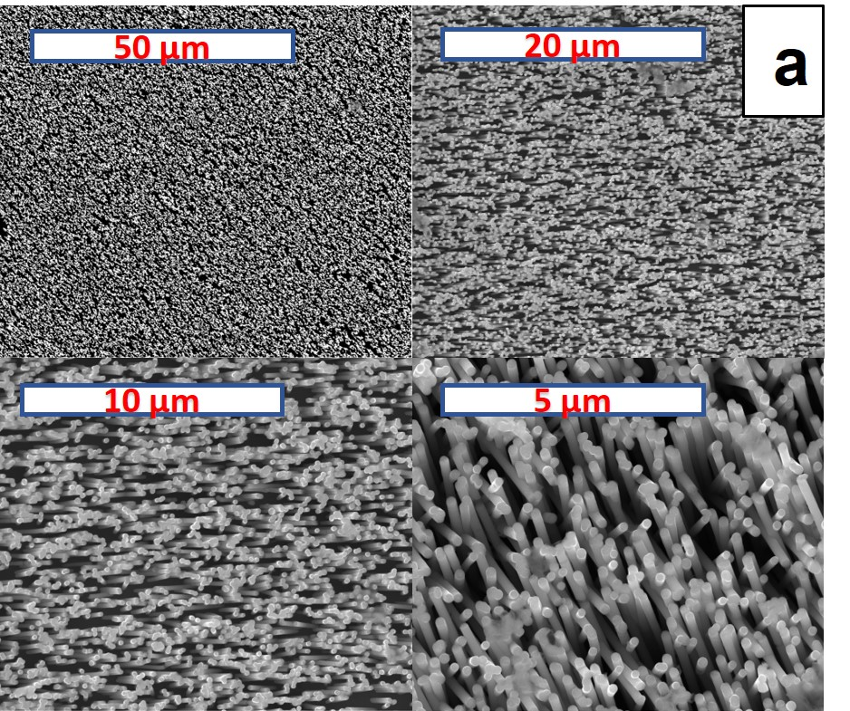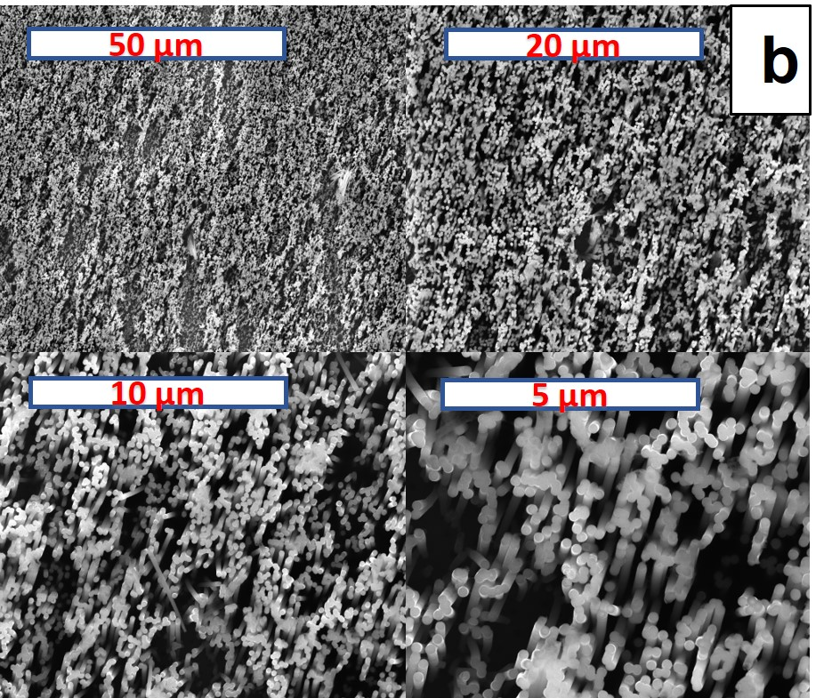
Figure 1: SEM images of (a) NiFe NWs and (b) NiFeP NWs
Nanostructured electrodes were also characterized by XRD, Figure 2b. In the as prepared electrodes, the peaks at about 43.23°, 50.38°, 74.18° and 90.16° can be indexed to (111), (200), (220) and (420) planes of the fcc Fe-Ni Alloy (card no. 47-105) (Dragos et al., 2016). In addition, Ni peaks were also observed at 44.53°, 51,86°(card no. 04-850). From preliminary studies, the two analyses differ in some peaks, 76.20°, 83.01° and 93.02° which can be attributed to the presence of phosphorus.

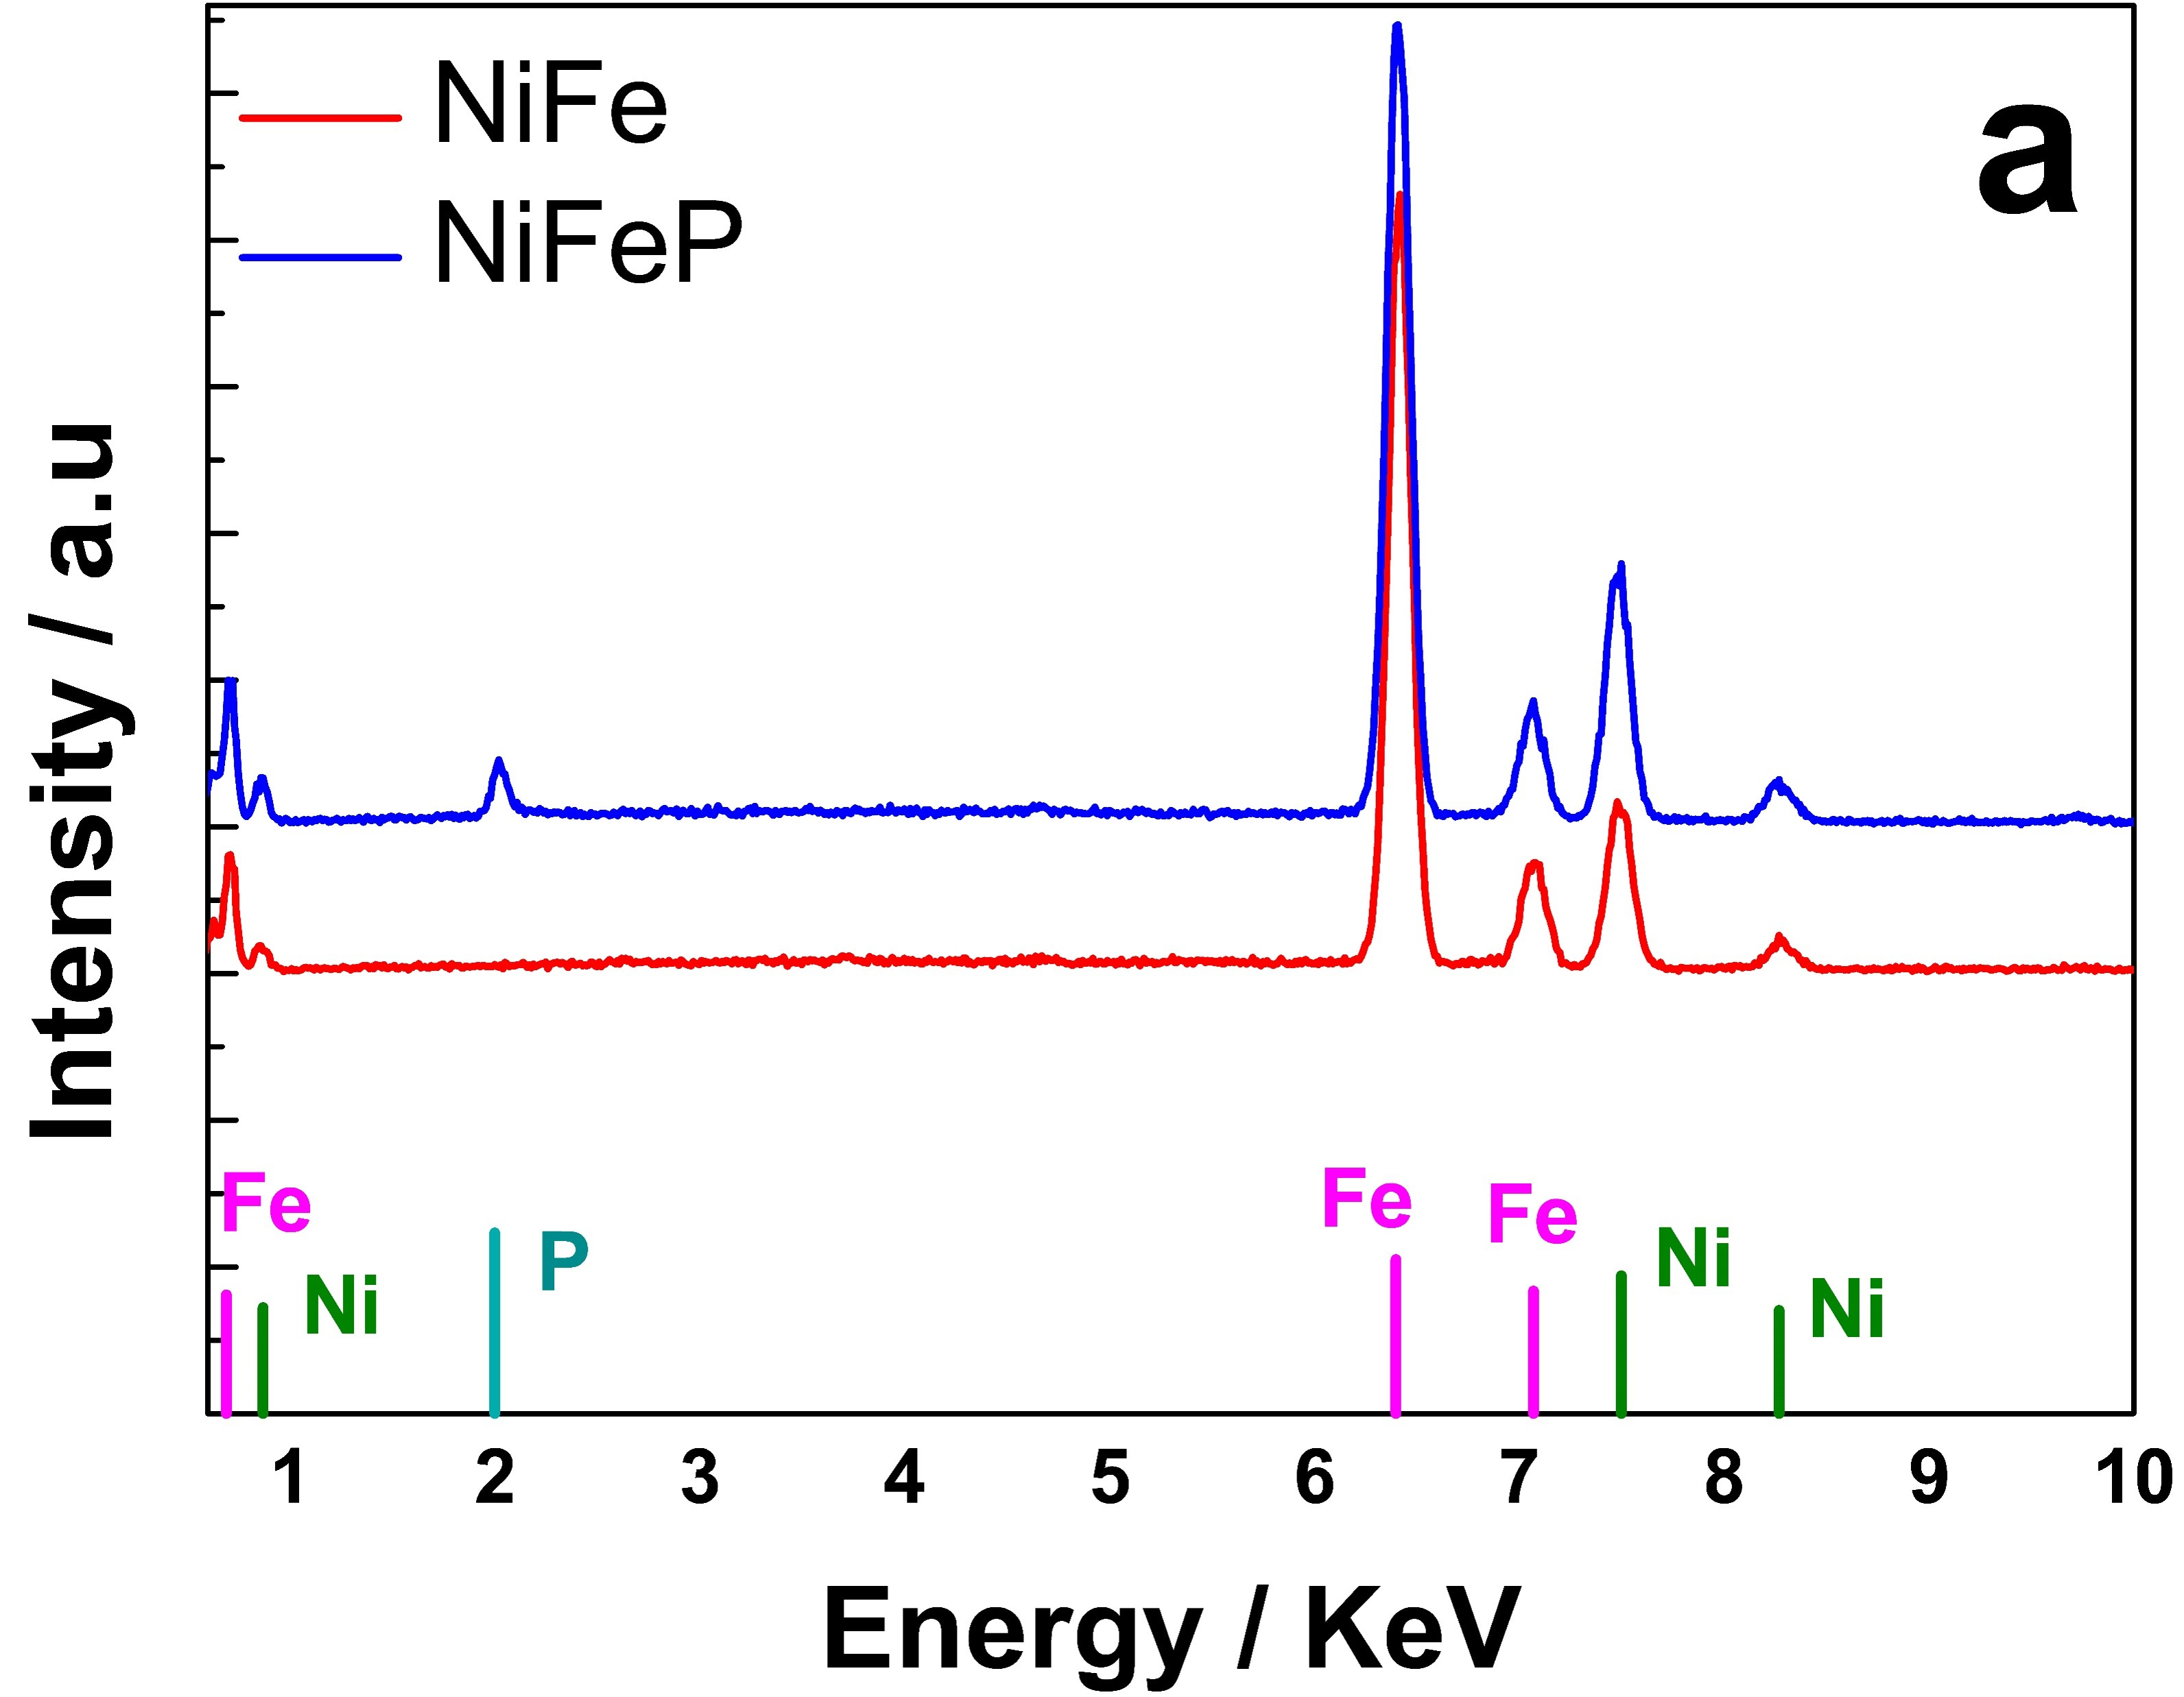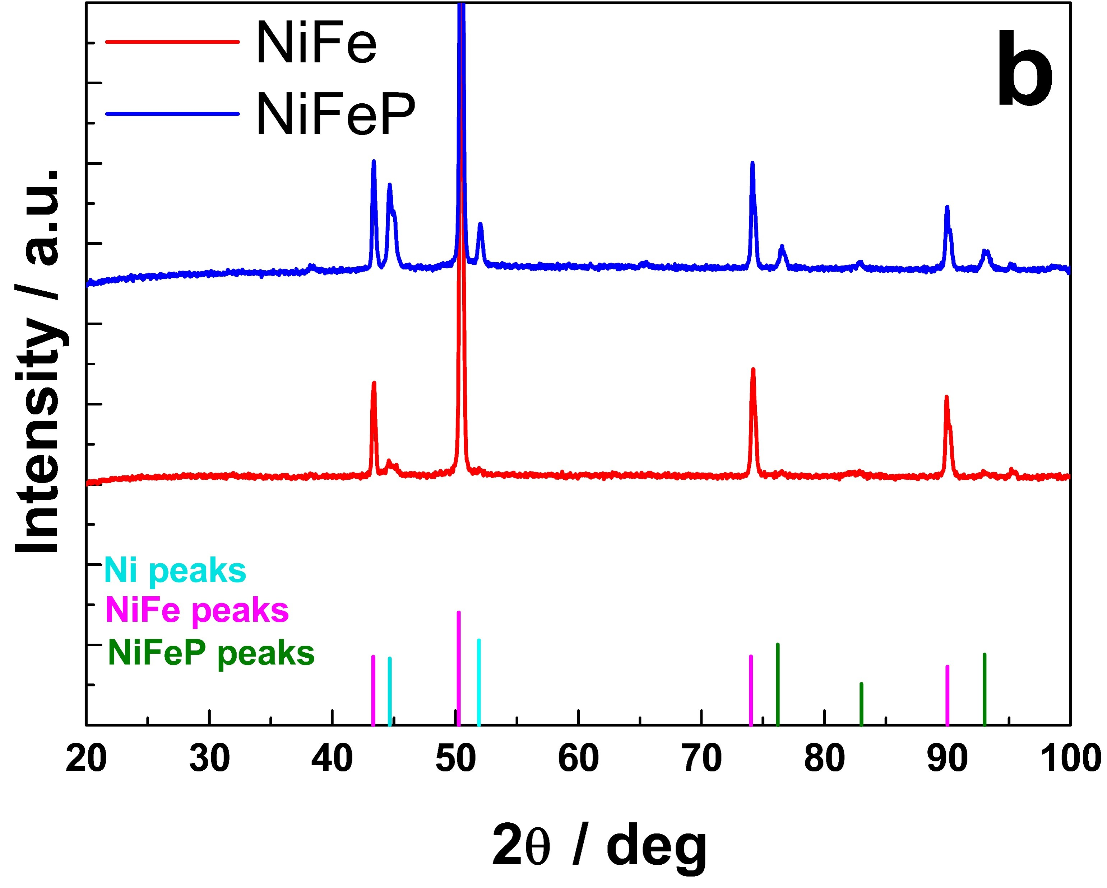
Figure 2: (a) EDS of NWs electrodes; (b) XRD Pattern of NWs electrodes
Figures 3a and 3b showed the linear range of QSSP curves fitted by Tafel’s equation, for HER and OER, respectively. Tafel parameters are listed in Table 1. The good results obtained with the binary were exceeded with the ternary alloy. In this paper, the Tafel slope values of NiFeP alloy are much lower than NiFe alloy values, implying a faster HER and OER kinetics of NiFeP alloy. These results are similar or better compared to others alloy containing phosphorus (Battiato et al., 2022; Li et al., 2019). Tafel slope values can be used to understand which step is kinetically decisive. For OER, the Tafel slope of the ternary alloy close to 45 mV dec⁻¹ indicates that the rate determining step is linked to the reaction: MO⁻ = MO + e⁻ (Li et al., 2018). Instead, the slope value for HER is in the range of 38-116 mV dec⁻¹ indicating that the rate determining step of the HER mechanism electrode includes Volmer-Heyrovsky and that the Volmer stage is rate determining step (Barati Darband et al., 2020).

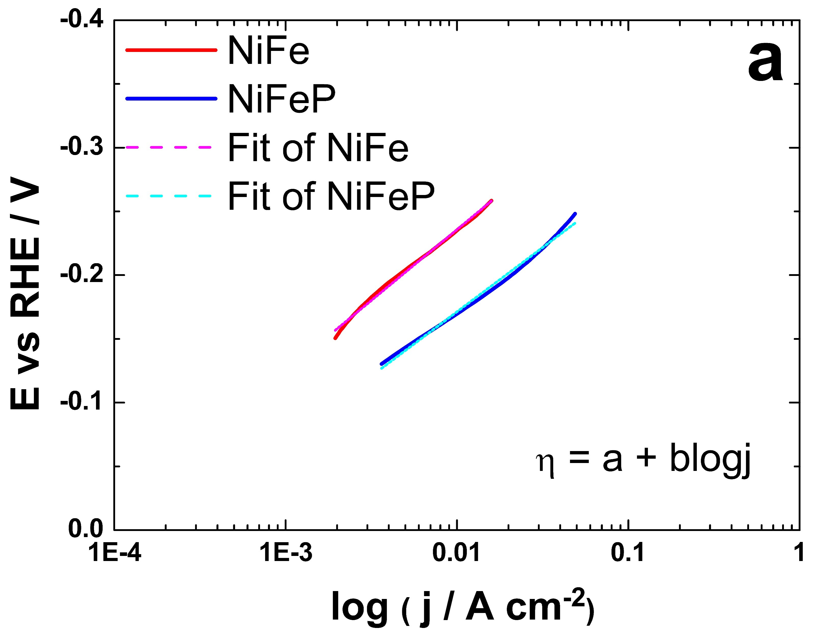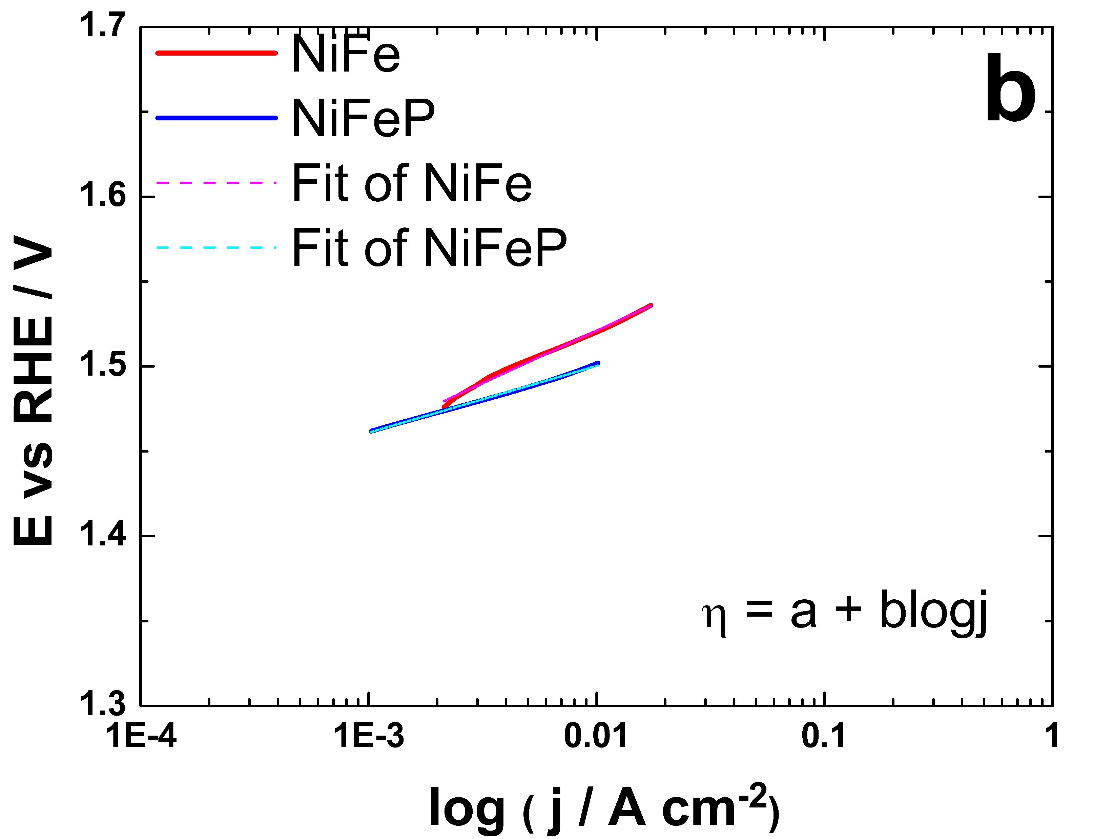
Figure 3: Linearity range of QSSP curves for (a) HER and (b) OER

Table 1: Fitted Tafel’s parameters for both reactions and both electrodes.
Electrode | HER |  |  | OER
 | a | b | R²(%) | a | b | R²(%)
NiFe NWs | -0.471 | -0.116 | 99.57 | 1.612 | 0.045 | 99.46
NiFeP NWs | -0.372 | -0.101 | 99.28 | 1.581 | 0.039 | 99.77

Moreover, the stability of electrocatalyst is an important index that represents the ability to catalyse water splitting for a long time. In the figures 4a and 4b, stability test results are shown.
Both electrodes showed very good stability. The potential values remained almost constant between the start and end of the test. Throughout the test, the ternary alloy potential is lower than the binary one. By switching from binary to ternary alloy, an energy gain of 100 mV was obtained for HER and 40 mV for OER. These results confirm those obtained through the QSSPs. The presence of phosphorus improves the kinetics of both reactions in an alkaline environment. Within the literature, in a catalyst consisting of two or more metals, a synergistic effect is created between the constituents such that the properties and thus, the intrinsic catalytic activity of each element are enhanced (Wu, 2022).

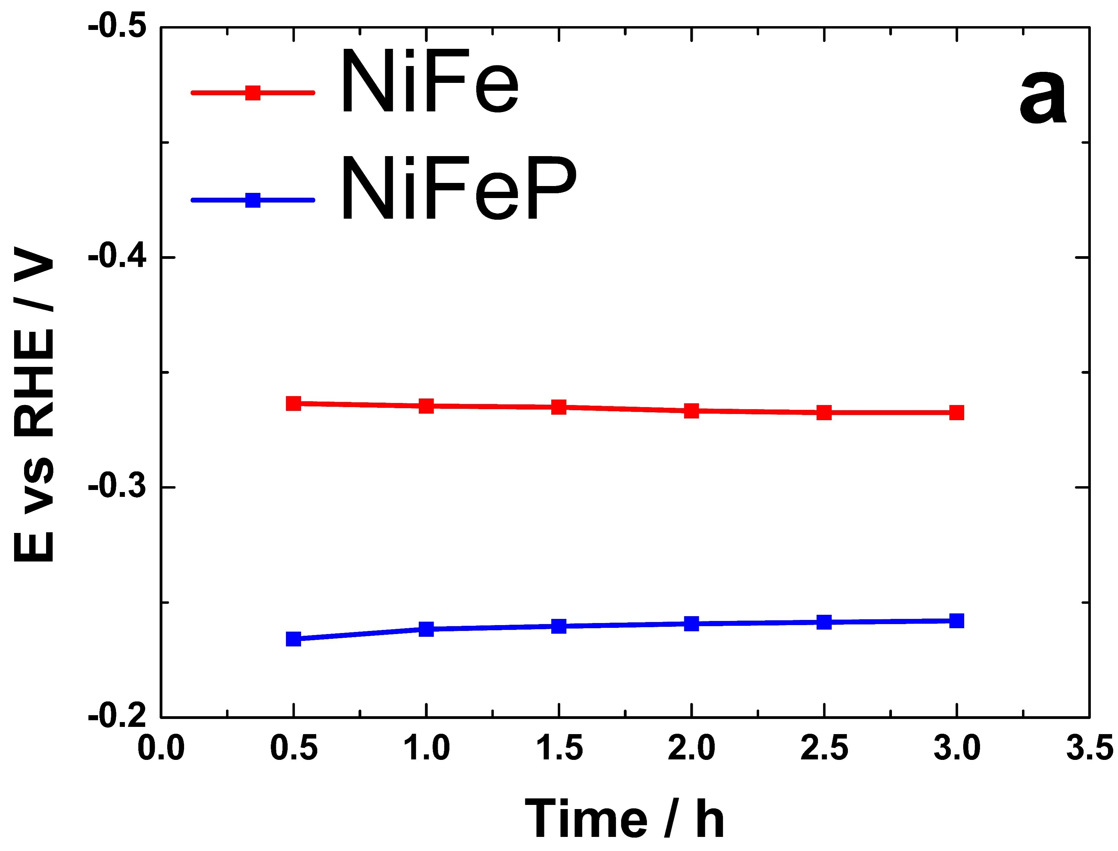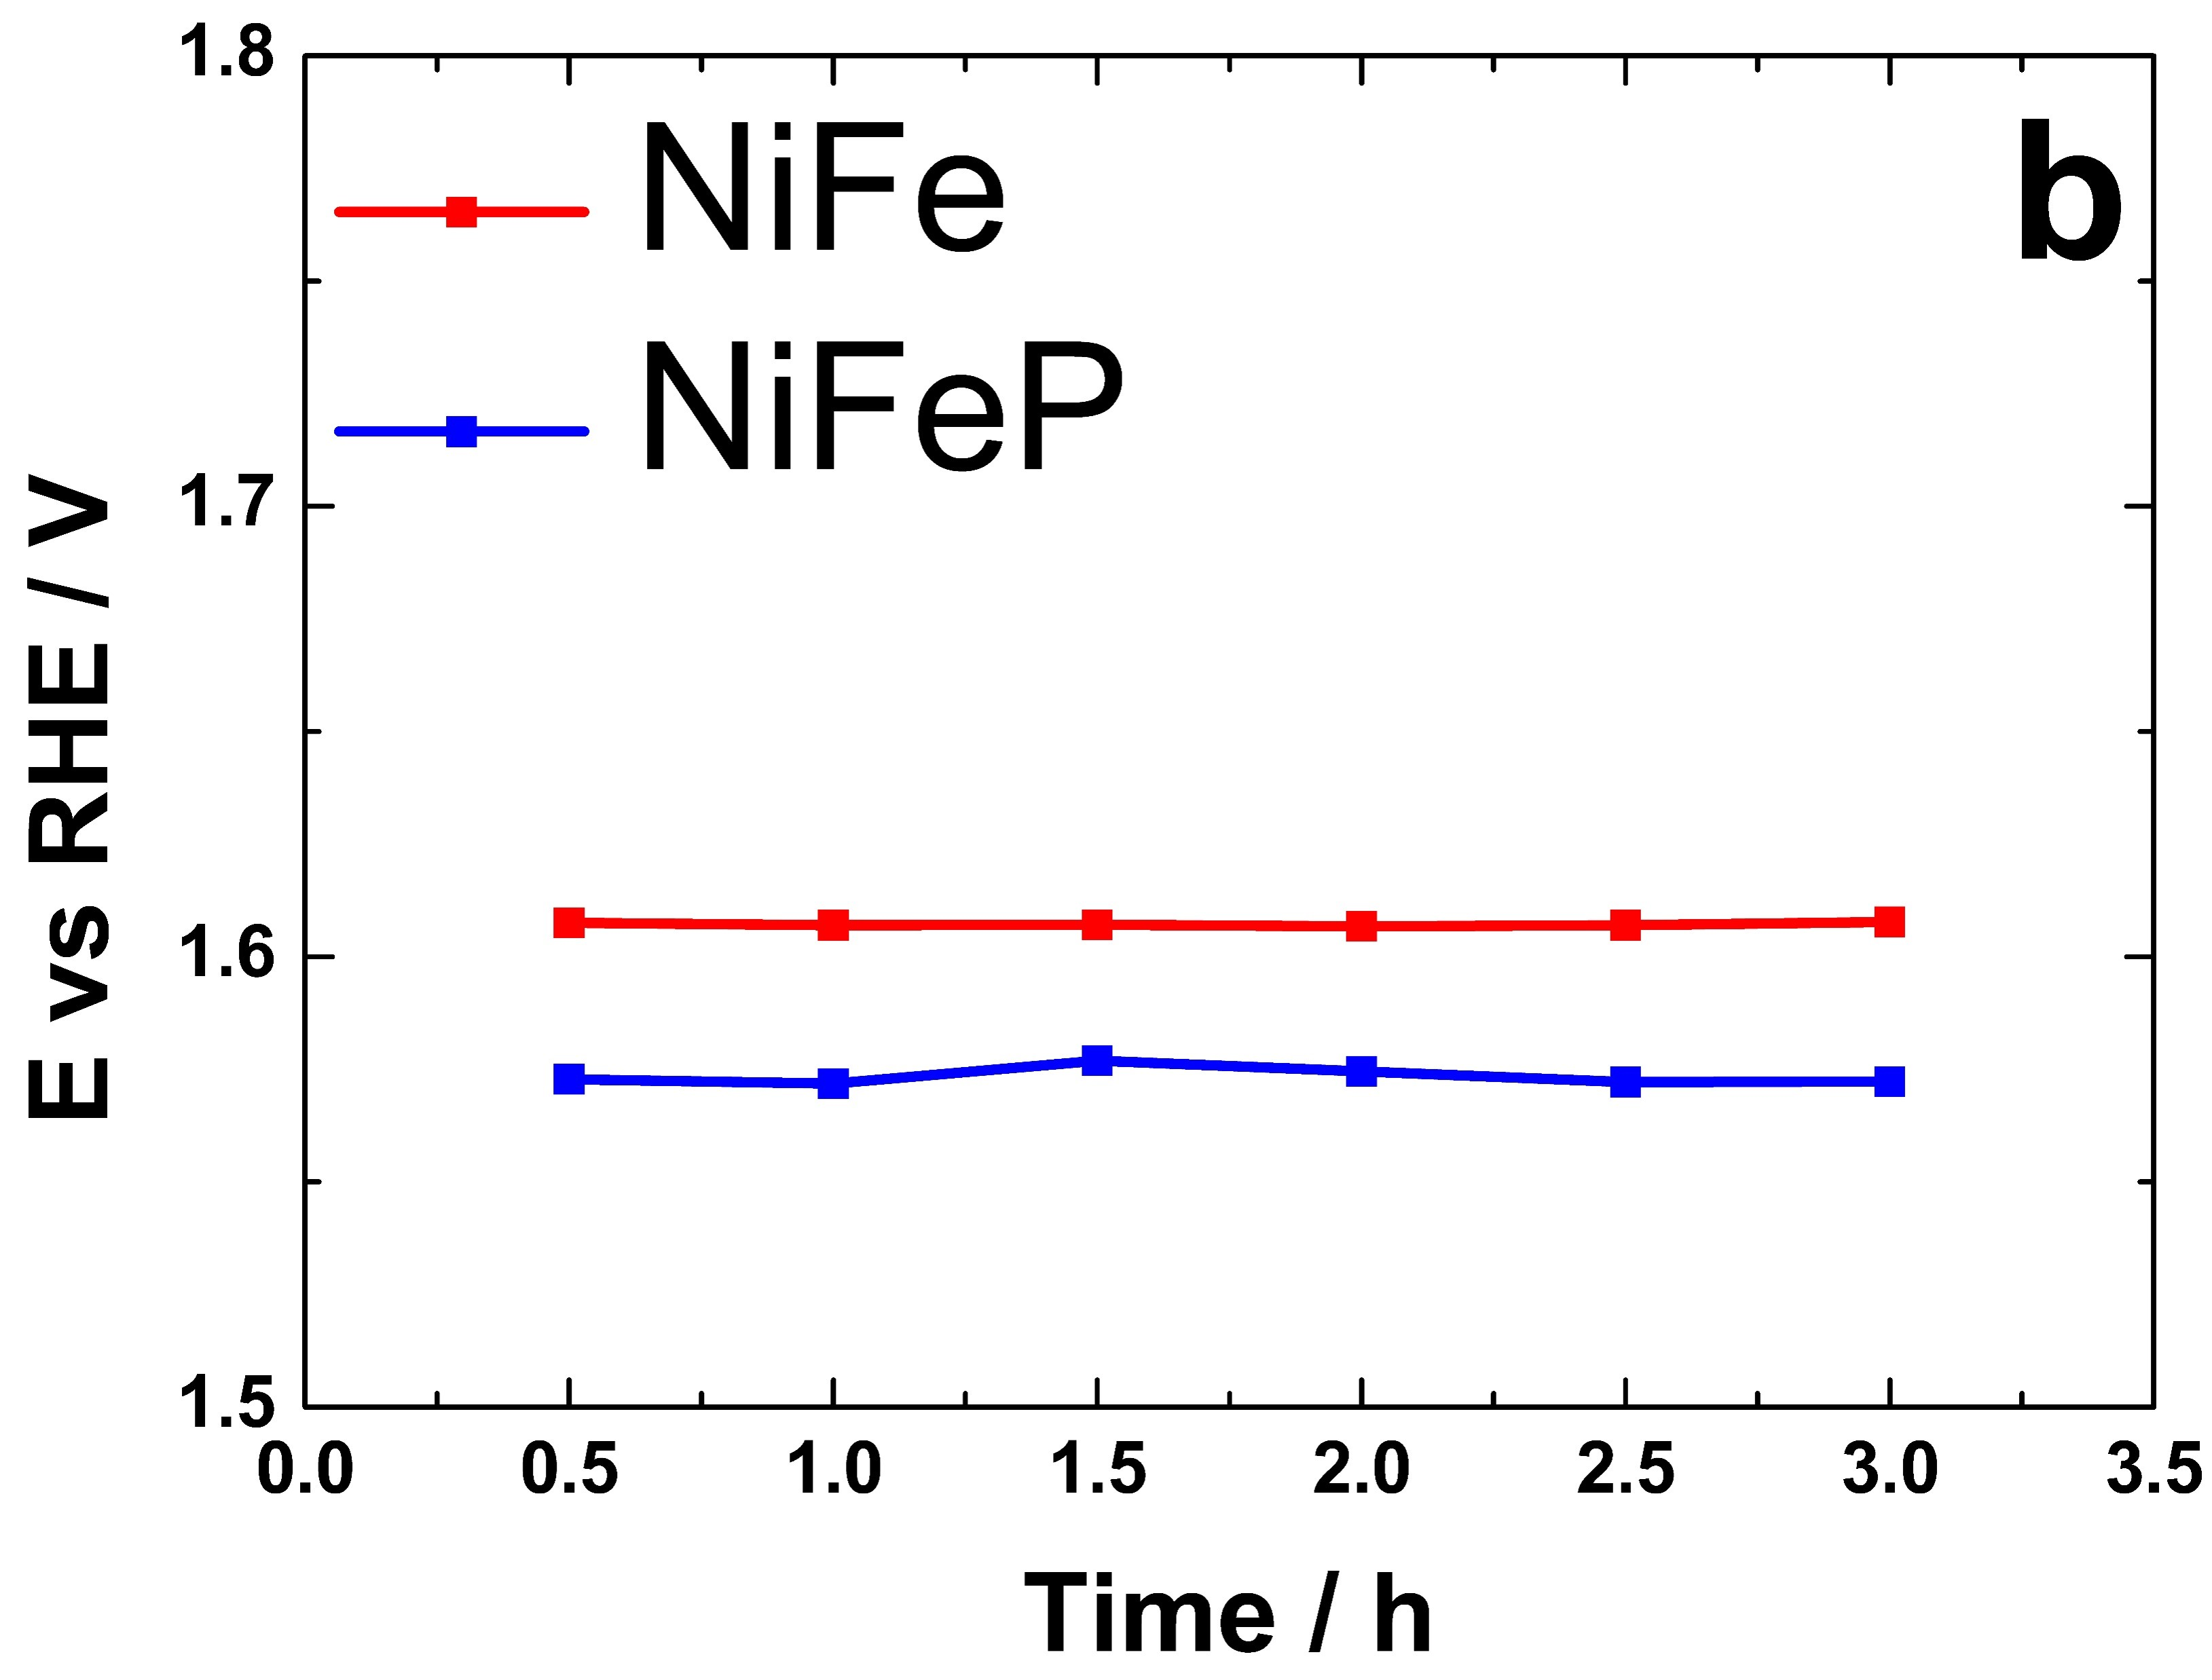
Figure 4: Mid-term stability test for 3 hours for (a) HER at -50 mA cm⁻² and b) OER at 50 mA cm⁻²

  - Conclusions

NiFeP NWs have been successfully manufactured in order to improve the already known performance of NiFe NWs. The deposition method used is simple and inexpensive. SEM images showed nanostructured morphology. The presence of the 3 elements was confirmed by EDS and XRD analysis. After assessing morphology and composition, the electrodes were tested both as anodes and as cathodes in a 30% by weight aqueous KOH solution. Preliminary results have shown a significant increase in performance using the ternary alloy. Therefore, it can be considered an excellent bi-catalyst for water splitting reactions in an alkaline media. Further work is in progress aimed to fabricate and test electrodes with different phosphorus content to assess the effect of composition on electrochemical and electrocatalytic performance.
Acknowledgments
This research was funded by MUR, CNMS Centro Nazionale per la Mobilità sostenibile grant number CN00000023
References
Barati Darband, G., Aliofkhazraei, M., Hyun, S., Shanmugam, S., 2020. Pulse Electrodeposition of a Superhydrophilic and Binder-Free Ni–Fe–P Nanostructure as Highly Active and Durable Electrocatalyst for Both Hydrogen and Oxygen Evolution Reactions. ACS Appl. Mater. Interfaces 12, 53719–53730.
Battiato, S., Bruno, L., Pellegrino, A.L., Terrasi, A., Mirabella, S., 2022. ×Optimized electroless deposition of NiCoP electrocalysts for enhanced water splitting. Catalysis Today S0920586122003856.
Buccheri, B., Ganci, F., Patella, B., Aiello, G., Mandin, P., Inguanta, R., 2021. Ni-Fe alloy nanostructured electrodes for water splitting in alkaline electrolyser. Electrochimica Acta 388, 138588.
Dionigi, F., Reier, T., Pawolek, Z., Gliech, M., Strasser, P., 2016. Design Criteria, Operating Conditions, and Nickel-Iron Hydroxide Catalyst Materials for Selective Seawater Electrolysis. ChemSusChem 9, 962–972.
Dragos, O., Chiriac, H., Lupu, N., Grigoras, M., Tabakovic, I., 2016. Anomalous Codeposition of fcc NiFe Nanowires with 5–55% Fe and Their Morphology, Crystal Structure and Magnetic Properties. J. Electrochem. Soc. 163, D83–D94.
Ganci, F., Patella, B., Cannata, E., Cusumano, V., Aiello, G., Sunseri, C., Mandin, P., Inguanta, R., 2021. Ni alloy nanowires as high efficiency electrode materials for alkaline electrolysers. International Journal of Hydrogen Energy 46, 35777–35789.
Gao, Y., Zhao, Z., Jia, H., Yang, X., Lei, X., Kong, X., Zhang, F., 2019. Partially reduced Ni2+, Fe3+-layered double hydroxide for ethanol electrocatalysis. J Mater Sci 54, 14515–14523.
Guo, Y., Park, T., Yi, J.W., Henzie, J., Kim, J., Wang, Z., Jiang, B., Bando, Y., Sugahara, Y., Tang, J., Yamauchi, Y., 2019. Nanoarchitectonics for Transition‐Metal‐Sulfide‐Based Electrocatalysts for Water Splitting. Adv. Mater. 31, 1807134.
Jing, P., Liu, M., Pu, Y., Cui, Y., Wang, Z., Wang, J., Liu, Q., 2016. Dependence of phase configurations, microstructures and magnetic properties of iron-nickel (Fe-Ni) alloy nanoribbons on deoxidization temperature in hydrogen. Sci Rep 6, 37701.
Kuang, Y., Kenney, M.J., Meng, Y., Hung, W.-H., Liu, Y., Huang, J.E., Prasanna, R., Li, P., Li, Y., Wang, L., Lin, M.-C., McGehee, M.D., Sun, X., Dai, H., 2019. Solar-driven, highly sustained splitting of seawater into hydrogen and oxygen fuels. Proc. Natl. Acad. Sci. U.S.A. 116, 6624–6629.
Kwong, W.L., Lee, C.C., Messinger, J., 2017. Scalable Two-Step Synthesis of Nickel–Iron Phosphide Electrodes for Stable and Efficient Electrocatalytic Hydrogen Evolution. J. Phys. Chem. C 121, 284–292.
Ledendecker, M., Krick Calderón, S., Papp, C., Steinrück, H.-P., Antonietti, M., Shalom, M., 2015. The Synthesis of Nanostructured Ni ₅ P ₄ Films and their Use as a Non-Noble Bifunctional Electrocatalyst for Full Water Splitting. Angew. Chem. Int. Ed. 54, 12361–12365.
Lee, J.E., Jeon, K.-J., Show, P.L., Lee, I.H., Jung, S.-C., Choi, Y.J., Rhee, G.H., Lin, K.-Y.A., Park, Y.-K., 2022. Mini review on H2 production from electrochemical water splitting according to special nanostructured morphology of electrocatalysts. Fuel 308, 122048.
Li, G., Anderson, L., Chen, Y., Pan, M., Abel Chuang, P.-Y., 2018. New insights into evaluating catalyst activity and stability for oxygen evolution reactions in alkaline media. Sustainable Energy Fuels 2, 237–251.
Li, R., Li, Y., Yang, P., Wang, D., Xu, H., Wang, B., Meng, F., Zhang, J., An, M., 2021. Electrodeposition: Synthesis of advanced transition metal-based catalyst for hydrogen production via electrolysis of water. Journal of Energy Chemistry 57, 547–566. https://doi.org/10.1016/j.jechem.2020.08.040
Li, S., Wang, X., Li, M., Liu, J., Li, C., Wu, H., Guo, D., Ye, F., Wang, S., Cheng, L., Liu, A., 2019. Self-supported ternary (NixFey)2P nanoplates arrays as an efficient bifunctional electrocatalyst for overall water splitting. Electrochimica Acta 319, 561–568.
Matlosz, M., 1993. Competitive Adsorption Effects in the Electrodeposition of Iron‐Nickel Alloys. J. Electrochem. Soc. 140, 2272–2279.
Tian, L., Wo, H., Wang, K., Wang, X., Zhuang, W., Li, T., Du, X., 2019. Ultrathin wrinkled NiFeP nanosheets enable efficient oxygen evolution electrocatalysis. Journal of the Taiwan Institute of Chemical Engineers 97, 200–206.
Wang, F., Tian, R., Guo, X., Hou, Y., Zou, C., Yang, H., 2022. Construction of Petal-Like Ag NWs@NiCoP with Three-Dimensional Core-Shell Structure for Overall Water Splitting. Nanomaterials 12, 1205.
Wu, Y., 2022. Ni2P nanoparticles-inserted NiFeP nanosheets with rich interfaces as efficient catalysts for the oxygen evolution reaction. Journal of Alloys and Compounds 10.
Xuan, C., Wang, J., Xia, W., Peng, Z., Wu, Z., Lei, W., Xia, K., Xin, H.L., Wang, D., 2017. Porous Structured Ni–Fe–P Nanocubes Derived from a Prussian Blue Analogue as an Electrocatalyst for Efficient Overall Water Splitting. ACS Appl. Mater. Interfaces 9, 26134–26142.
Yan, Y., Thia, L., Xia, B.Y., Ge, X., Liu, Z., Fisher, A., Wang, X., 2015. Construction of Efficient 3D Gas Evolution Electrocatalyst for Hydrogen Evolution: Porous FeP Nanowire Arrays on Graphene Sheets. Adv. Sci. 2, 1500120.
Yin, K.-M., Lin, B.-T., 1996. Effects of boric acid on the electrodeposition of iron, nickel and iron-nickel. Surface and Coatings Technology 78, 205–210.
Zhao, Y., Dongfang, N., Triana, C.A., Huang, C., Erni, R., Wan, W., Li, J., Stoian, D., Pan, L., Zhang, P., Lan, J., Iannuzzi, M., Patzke, G.R., 2022. Dynamics and control of active sites in hierarchically nanostructured cobalt phosphide/chalcogenide-based electrocatalysts for water splitting. Energy Environ. Sci. 15, 727–739.

