CHEMICAL ENGINEERING TRANSACTIONS  VOL. , 2023 | A publication of
The Italian Association
of Chemical Engineering
Online at www.cetjournal.it

Guest Editor: Sauro Pierucci
Copyright © 2023, AIDIC Servizi S.r.l.
ISBN 978-88-95608-98-3; ISSN 2283-9216

Wearable Sensor for Real-Time Monitoring of Hydrogen Peroxide in Simulated Exhaled Air
Maria G. Bruno^{a,}*, Bernardo Patellaª, Giuseppe Aielloª, Claudia Torino^{b}, Antonio Vilasi^{b}, Chiara Cipollina^{c}, Serena Di Vincenzo^{d}, Elisabetta Pace^{d}, Alan O’Riordan^{e}, Rosalinda Inguantaª
ª Engineering Department, Università degli Studi di Palermo, Viale delle Scienze, 90128 Palermo, Italy
^{b} Institute of Clinical Physiology, National Research Council, 89124 Reggio Calabria, Italy
^{c} Fondazione Ri.MED, Palermo, Italy
^{d} Institute of Translational Pharmacology, National Research Council, 90146 Palermo, Italy
^{e} Nanotechnology Group, Tyndall National Institute, University College Cork, Cork, T12 R5CP, Ireland
mariagiuseppina.bruno@unipa.it
In this work, an innovative and cheap electrochemical sensor for hydrogen peroxide quantification in exhaled breath was developed. H₂O₂ is the most used biomarker among the Reactive Oxygen Species (ROS) for monitoring the level of oxidative stress in the respiratory system. This is due to its stability and ability to cross biological membranes and also because it is detectable in extracellular space. The electrochemical sensor was obtained using the silver layer of wasted compact discs (CDs). All three electrodes, working (WE), counter (CE), and pseudo-reference electrode (RE), were fabricated using a laser cutter. The working electrode was used directly, while an Ag/AgCl paste and a graphite paste were applied respectively on the RE and the CE. In addition, a chitosan layer was deposited by Electro-Phoretic Deposition (EPD) on the surface of the sensor. This biopolymer improves the wettability of the sensor in presence of a humid atmosphere such as that given by exhaled air. The sensor was tested in both liquid and nebulized solutions containing different concentrations of hydrogen peroxide. The detection of H₂O₂ was evaluated using Linear Sweep Voltammetry (LSV) as electrochemical technique. The results show that the peak current increases linearly with hydrogen peroxide concentration from 100 to 500 μM with a sensitivity of 0.068 µA µM⁻¹ cm⁻² and 0.108 µA µM⁻¹ cm⁻², a Limit Of Detection (LOD) of 60 μM and 30 μM respectively for liquid and nebulized solutions. Therefore, the use of the electrochemical sensor can allow the monitoring of hydrogen peroxide in real time with good results.
  - Introduction
Hydrogen peroxide is a simple bioactive small molecule that is involved in many physiological processes including oxidative damage and disease progression. Thus, the quantification of H₂O₂ in biological fluids appears a convenient way to monitor the oxidative status of the cells (Patella et al., 2022a). High levels of H₂O₂ cause a pathological condition, known as oxidative stress, which can lead to cardiovascular, neurodegenerative and respiratory diseases. For these reasons, it is very important to monitor its concentration (Patella et al., 2022b). Traditional hydrogen peroxide detection technologies, such as fluorescence, chemiluminescence and spectrophotometry are complex, expensive and time-consuming. However, since H₂O₂ is an electroactive molecule, that can be oxidized or reduced on the electrode surface, electrochemical sensors can provide a simple, rapid, sensitive and economic method for its detection (Yu et al., 2022).
Exhaled breath consists of a gaseous phase, which contains volatile compounds such as nitric oxide (NO) and carbon monoxide and a water vapour saturated phase that contains aerosol particles of non-volatile compounds, such as H₂O₂ (Montuschi and Barnes, 2002). In healthy people, the concentration of H₂O₂ in the exhaled air is quite low, but it will significantly increase in patients who suffer from some diseases or when the human lung becomes in contact with oxidative gases like tobacco smoke. For this reason, the monitoring of the hydrogen peroxide level in the exhaled air can provide reliable information for the diagnostics of some diseases (Anh et al., 2005). To date, exhaled breath can be condensed through a cooling system into Exhaled Breath Condensate (EBC) which is collected for time-consuming spectroscopic analyses that require a relatively large volume of the sample. In addition, devices for EBC collection and analyses cannot be easily performed due to their size and cost and sampling conditions such as condensing temperature, flow rate and collection time can affect the intrinsic properties of hydrogen peroxide such as solubility, volatility and decomposition rate. So a decrease in H₂O₂ concentration may be due to these sampling conditions instead of the patient’s health status (Chen and Danao, 2013).
In recent years, to overcome all these problems, progresses have been made in the research for the development of smart wearable systems that may provide an alternative for rapid and cost-effective diagnosis of respiratory diseases (Maier et al., 2019). This is related to the recent technological advances in micro- and nanotechnologies and that will change the concept of healthcare through real-time monitoring of a patient's health status. Consisting of various components including sensors, these wearable systems could support complex healthcare applications for continuous monitoring of health (Chan et al., 2012). In particular, the development of a wearable sensor for hydrogen peroxide detection in exhaled breath would avoid its collection by condensation and all the problems associated with it.
In this work, a sensor based on a three electrodes system was fabricated using the metallic layer of wasted CDs that consists of uniform silver tracks with a mean dimension of 820 nm (Patella et al., 2022a). The low cost of this sensor is related to the fact that it is obtained from compact discs at the end of life. For more than two decades, electronic waste has been a problem due to the toxicity risks to human health and environmental quality. For this reason, this fabrication method fits with the approach of circular economy and sustainability (Patella et al., 2022a). Electrodes realized from noble metals can be quite expensive, but CDs and DVDs have a thin layer of Au or Ag that can be used as a cheap alternative source to obtain electrodes (Chen and Ogunseitan, 2021). Shafei and Honeychurch (Shafei and Honeychurch, 2013) have utilized an unmodified Ag electrode manufactured from a DVD-R that was used as part of a three-electrode system for the determination of hydrogen peroxide in water. The sensor was tested by Cyclic Voltammetry (CV) and a LOD of 78.35 μM was recorded with a linear range from 0.087 mM to 3.41 mM of hydrogen peroxide.
In this case, the working electrode wasn’t modified, while the pseudo-reference and counter electrodes were made of Ag/AgCl paste and graphite paste, respectively. In particular, this conductive carbon paste was applied on the counter electrode to avoid its modification during electrochemical tests. Finally, in order to absorb the humidity of exhaled breath, improving the wettability of the sensor, a thin layer of chitosan was electrodeposited on the surface of the three electrodes. This natural polymer is produced by the deacetylation of chitin, a structural element in the exoskeleton of crustaceans and insects, which is the second most abundant natural biopolymer after cellulose (Bhattarai et al., 2010). Chitosan is one of the most promising polymers for biomedical applications due to its many properties such as biodegradability, biocompatibility and non-toxicity (Simchi et al., 2009). Moreover, this hydrogel can be electrodeposited on electrodes surface as a thin coating in a potential controlled way and this property is important in miniaturized devices such as micro and nano-bio sensors (Annu and Raja, 2020).
The final sensor was characterized using scanning electron microscopy (SEM) and energy dispersive spectroscopy (EDS) and then it was used to quantify hydrogen peroxide, firstly in a liquid phase and then in an aerosol phase by using a common nebulizer. The results showed that the sensor can quantify the analyte both in liquid and aerosol phases with a good selectivity towards the hydrogen peroxide.
  - Experimental
    - Electrode fabrication
The sensor was realized according to our previous publication (Patella et al., 2022a) with some modifications. Firstly, the silver layer was peeled off the CD using a double tape and the three electrodes configuration shown in Figure 1 was given using a laser cutter (Maitech MT-5030W50). The distance between the three electrodes has been reduced progressively to 0.25 mm to allow electrolytic contact when the sensor is in contact with a humid atmosphere such as that given by exhaled breath.
The sensor was fixed on a flexible acetate sheet and the external contacts were realized with copper tape. An Ag/AgCl paste was applied to the reference electrode and a graphite paste was applied to the counter electrode, while the Ag working electrode was used directly without any modifications.
A chitosan layer was electrodeposited on the surface of the three electrodes as absorber material to facilitate the trapping of the aerosol phase during the tests. This biopolymer was deposited on the sensor by EPD, a simple and low-cost process of deposition that offers the possibility of accurate control of the coating thickness (Raddaha et al., 2014).

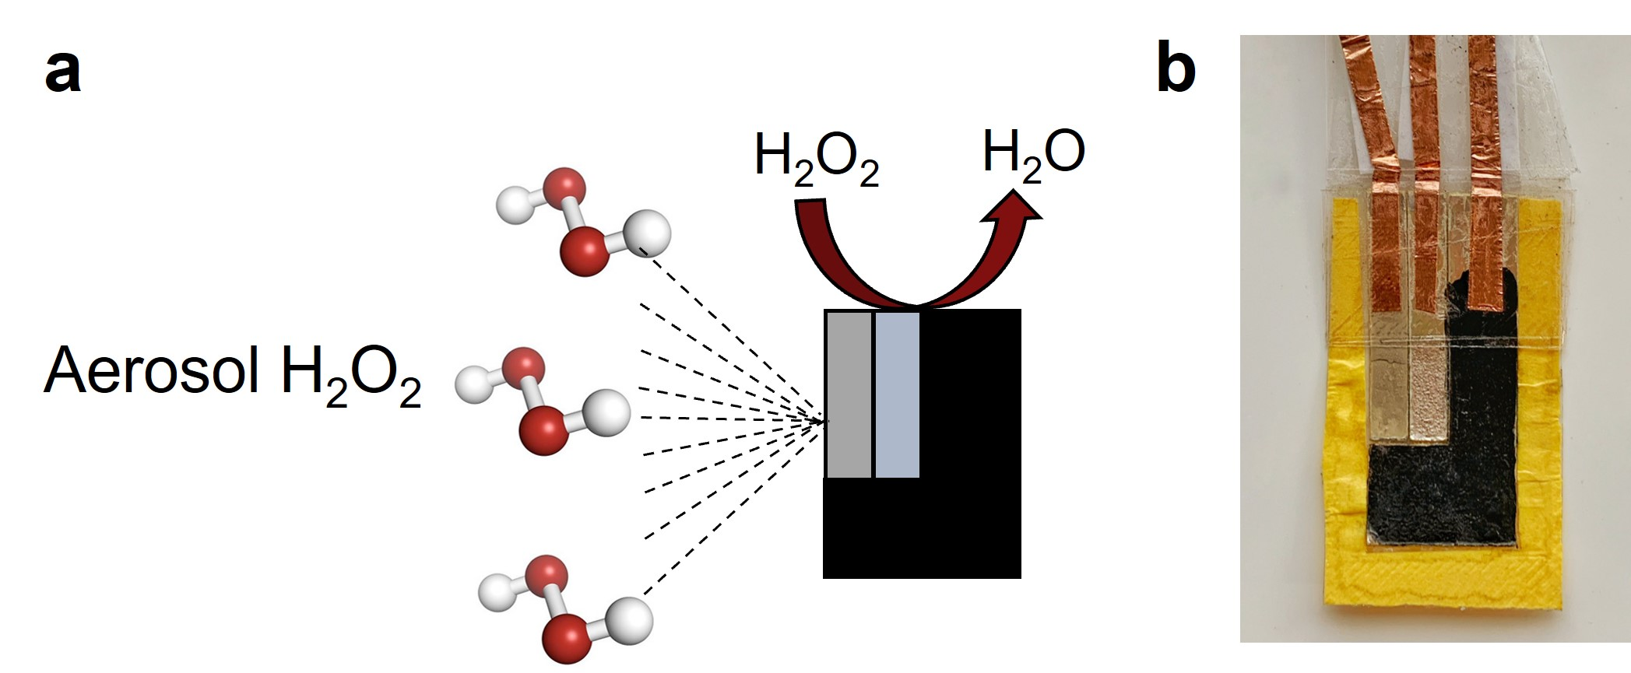
Figure 1: a) Schematic representation of the sensor with the three electrodes: RE, WE and CE from left to right. b) The final sensor with the electrodeposited chitosan coating.
Chitosan is soluble at low pH (pH < 6.5) (Pavoni et al., 2019), so it was dissolved in a 0.3 M solution of lactic acid at a temperature of 50 °C. The deposition conditions are reported in Table 1. Finally, the electrodes were characterized by Field Emission Scanning Electron Microscopy (FESEM, FEG-ESEM, FEI QUANTA 200) and Energy Dispersive Spectroscopy (EDS). All chemicals used in this work were dissolved in ultrapure water (Type 1, with a resistivity greater than 18 MΩ cm).
Table 1: Parameters used for EPD of chitosan.
Parameter | Value
Chitosan concentration  Deposition time | 5 g L⁻¹  1800 s
Deposition potential | 10 V

    - Electrochemical detection
Cell Test System (Solartron, Mod. 1470 E) and a cell realized with a Zortrax 3D printer were used to perform the electrochemical tests and the data were recorded by MultiStat Software. H₂O₂ detection was performed by LSV with a scan rate of 10 mV s⁻¹ in the potential range from -0.2V to -1V vs Ag/AgCl. H₂O₂ solutions were prepared by dilution of H₂O₂ 9.8 M in 0.1 M PBS (Phosphate Buffer Solution) at pH=7.4.
A commercially available nebulizer (Mod. P0111EM F400) was used in order to simulate the humid atmosphere of exhaled breath. In particular, the sensor was exposed to nebulized solutions for about 10 s to wet it homogeneously, allowing electrolytic contact between the electrodes.
The calibration curve was obtained by employing the subtract baseline method. As blanch, PBS was used. In order to test the selectivity of the sensor, LSV tests were carried out in presence of different interfering species such as NaCl, glucose, 4-(2-HydroxyEthyl)-1-PiperazineEthaneSulfonic acid (HEPES), NaNO₃ and lactic acid that can be found in real biological samples.
All measurements were performed in triplicate to obtain the Relative Standard Deviation (RSD). The main value of these has been plotted to calculate the main properties of the sensor.
  - Results and Discussion
    - Electrode characterization
Figure 2 shows the current density vs time curve reordered during the EPD of chitosan on the three electrodes at a potential of 10 V. As shown, after an initial transient, the curve reaches a plateau. For each deposition, the obtained curves are similar, suggesting a good reproducibility of the deposition method.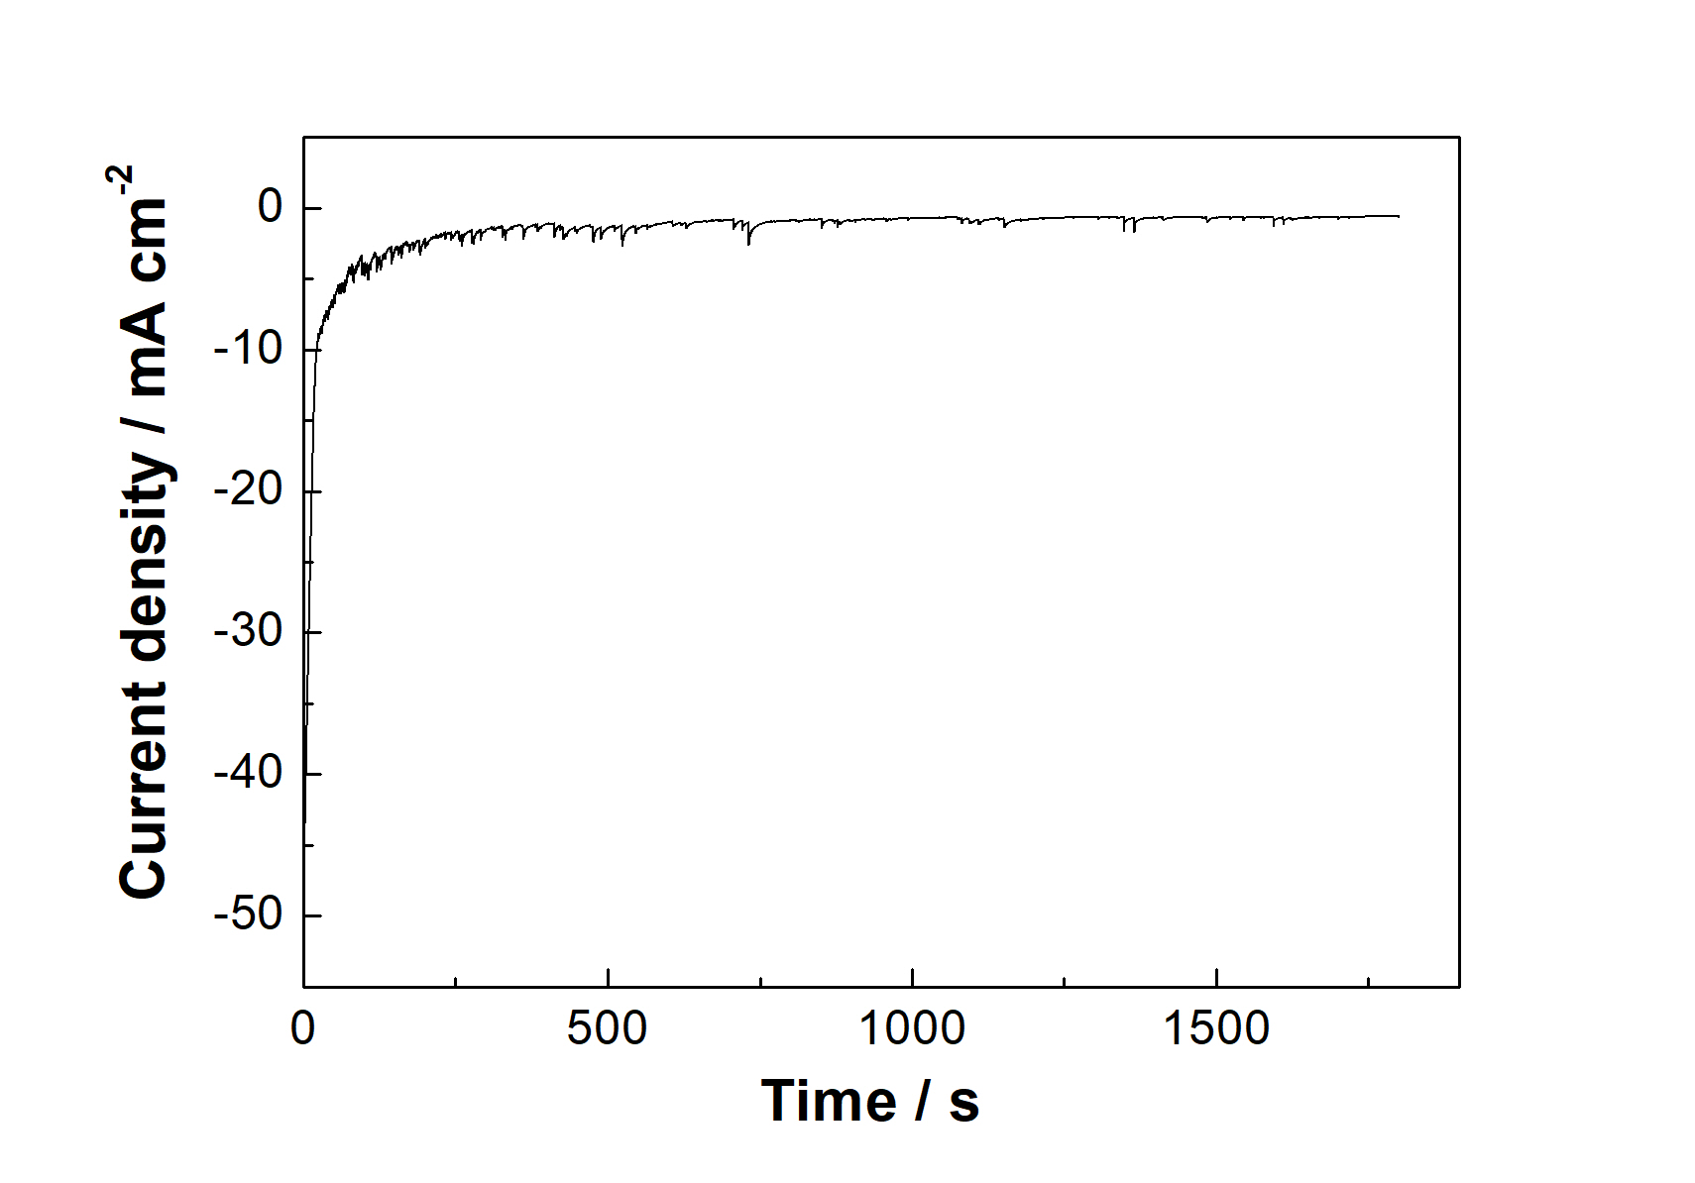
Figure 2: Current-time for the EPD of chitosan at 10 V.
Figure 3a shows the typical morphology of chitosan film (Gebhardt et al., 2012) obtained using the optimal deposition parameters (composition of the solution, deposition time and applied potential) shown in Table 1. These parameters result in a homogeneous and compact film of chitosan present on the entire surface of the sensor. The corresponding EDS spectrum of Figure 3b shows the presence of C and O confirming the deposition of chitosan, while the other elements, Ag, Ca, Ti, Si and S, come from the pealed CD layer (Patella et al., 2022a).

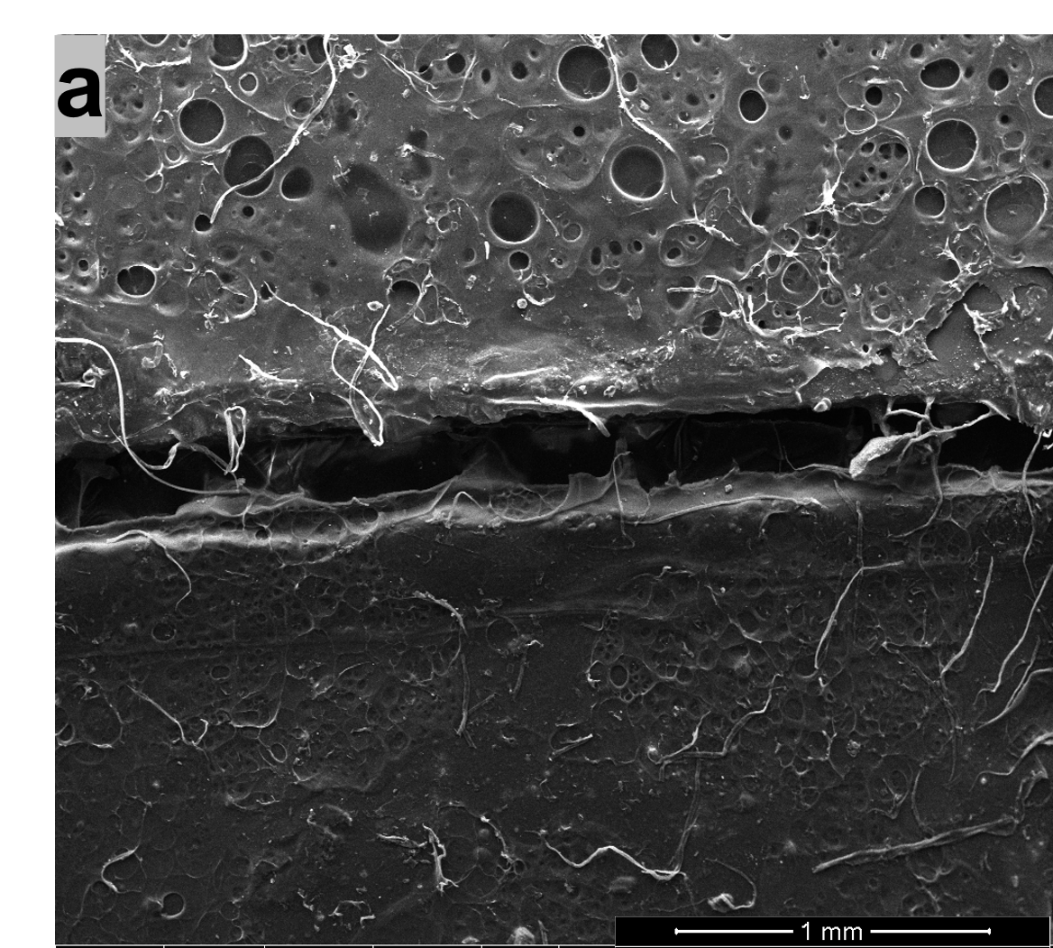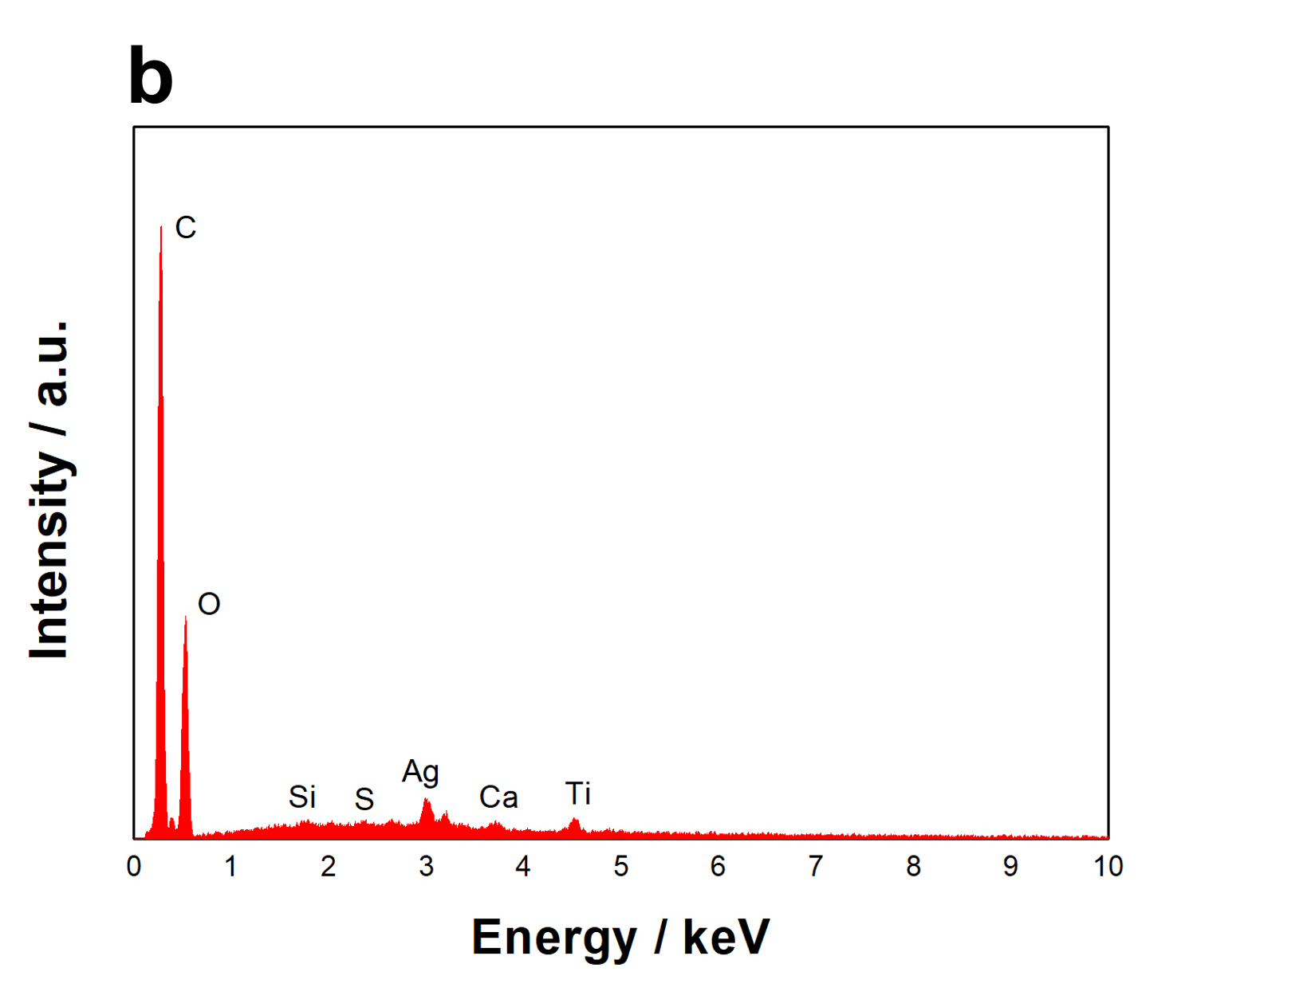
Figure 3: a) SEM image and b) EDS spectrum of chitosan layer present on WE and CE.
    - Electrochemical characterization
In order to study the performance of the sensor, LSV tests in the potential range from -0.2 to -1 V vs Ag/AgCl were carried out in liquid and aerosol solutions at different concentrations of hydrogen peroxide. Figure 4 shows that the intensity of the reduction peak of H₂O₂ increased linearly with H₂O₂ concentration from 100 µM to 500 µM with a sensitivity of 0.068 µA µM⁻¹ cm⁻² and 0.108 µA µM⁻¹ for liquid and aerosol solutions respectively. LOD was calculated by using the following equation:
LOD = 3.3 SD S⁻¹ (1)
in which SD is the standard deviation of the blank and S is the sensitivity of the electrode. Using this equation, a LOD of 60 and 30 µM for liquid and aerosol phases respectively was measured. The mean RSD is about 4% in both liquid and aerosol phases. This RSD value suggests that the fabrication method used to realize the sensor involves good reproducibility. The obtained results suggest that the sensor shows a higher sensitivity when it is used to detect hydrogen peroxide in the aerosol phase as confirmed by Fiore et al (Fiore et al., 2021).

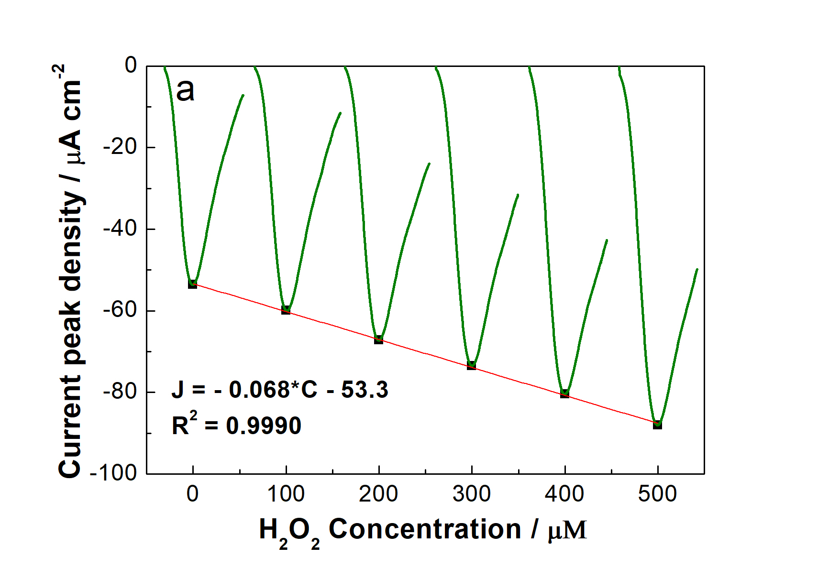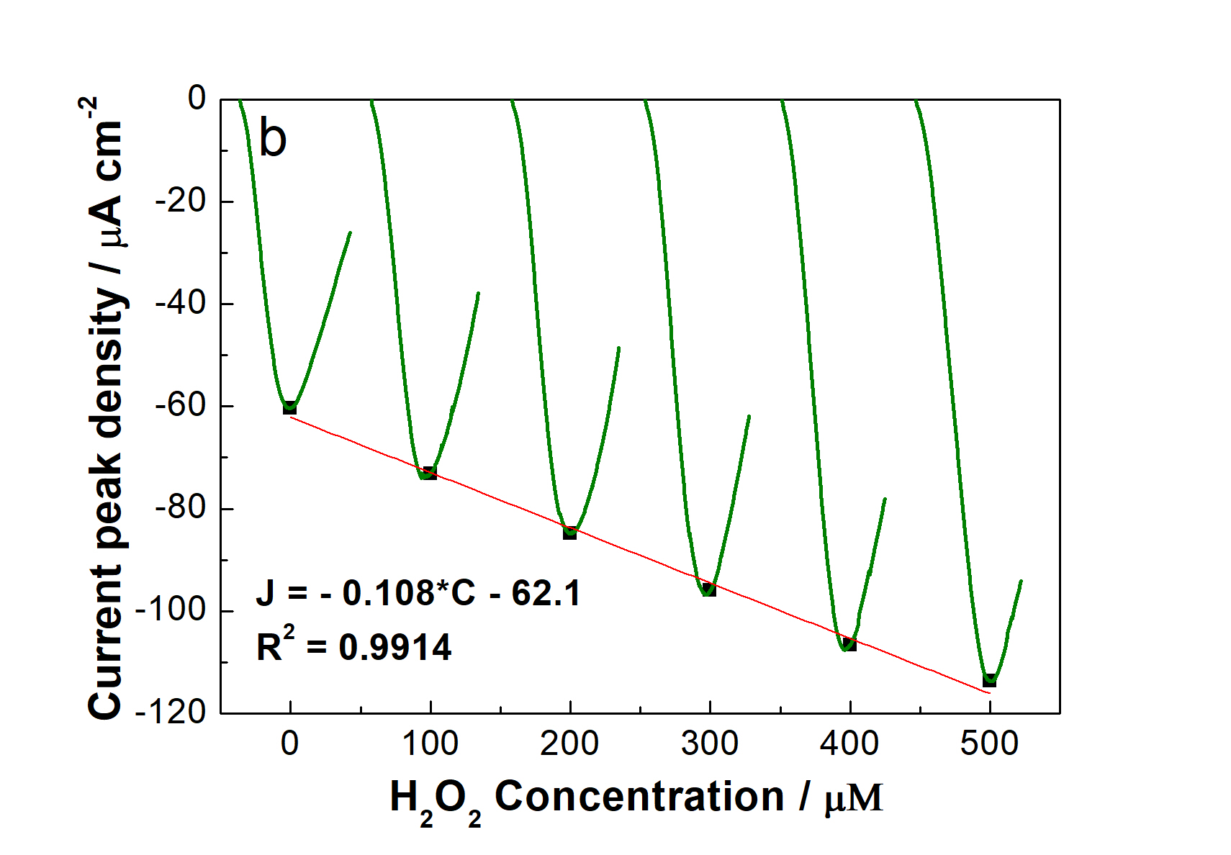
Figure 4: Peak current density vs H₂0₂ concentration and relative calibration line for a) liquid and b) aerosol solutions.
Interference tests were performed towards different species (glucose, HEPES, lactic acid, NaCl, NaNO₃) that could be found in biological samples (Arodin Selenius et al., 2019; Baker et al., 2009) to understand the applicability of the sensor. In particular, 1 mM of interfering species was added to the nebulized solution containing 0.1 mM of hydrogen peroxide. Table 2 shows the ratio between the peak current recorded in the presence and the absence of each interferent. As shown, a negligible effect on the detection of H₂O₂ was observed although interferent concentration was ten times higher than H₂O₂ concentration.

Table 2: Effect of interfering species on the detection of H₂O₂.
 | Current peak µA cm⁻² |  | % Ratio
H₂O₂  Glucose  HEPES | 72.9  73.2  72.5 |  | 100  100.4  99.5
Lactic acid  NaCl  NaNO₃ | 73.9  74  73.3 |  | 101  101.5  100.6

  - Conclusions
In this work, an electrochemical sensor for H₂O₂ detection was obtained from the silver layer of CDs. The method employed for the fabrication of electrodes is simple, rapid and cheap. Moreover, it allows obtaining sensors with the same properties due to the high reproducibility. In particular, the best performance was obtained with electrodes electrodeposited at 10 V for 30 min with a solution of 5 gL⁻¹ chitosan. After the fabrication, the electrodes were characterized by SEM and EDS analyses. Using LSV as detection technique, a sensitivity of 0.068 µA µM⁻¹ cm⁻² and 0.108 µA µM⁻¹ cm⁻² with a LOD of 60 μM and 30 μM were obtained respectively for liquid and nebulized solutions in a linear range from 100 to 500 μM. Thus, the experimental results showed that the sensor is also efficient when it is tested with aerosol solutions and not only with liquid ones. The interference tests showed an excellent selectivity of the sensor even at 1:10 ratio of H₂O₂/interferent.
In the future, this sensor will require further miniaturization and optimization of performance to allow the development of a wearable device for real-time monitoring of oxidative stress, avoiding all the problems connected to the condensation of the sample.

Acknowledgments
This work was partially financed by the project SENSOMAR- SEnsore Nanostrutturato per Stress Ossidativo integrato in MAscherina per valutazioni in Remoto, MUR-FISR2020IP_03106.
References
Anh, D.T.V., Olthuis, W., Bergveld, P., 2005. A hydrogen peroxide sensor for exhaled breath measurement. Sensors and Actuators B: Chemical 111–112, 494–499.
Annu, Raja, A.N., 2020. Recent development in chitosan-based electrochemical sensors and its sensing application. International Journal of Biological Macromolecules 164, 4231–4244.
Arodin Selenius, L., Wallenberg Lundgren, M., Jawad, R., Danielsson, O., Björnstedt, M., 2019. The Cell Culture Medium Affects Growth, Phenotype Expression and the Response to Selenium Cytotoxicity in A549 and HepG2 Cells. Antioxidants 8, 130.
Baker, M., Assis, S., Higa, O., Costa, I., 2009. Nanocomposite hydroxyapatite formation on a Ti–13Nb–13Zr alloy exposed in a MEM cell culture medium and the effect of H2O2 addition. Acta Biomaterialia 5, 63–75.
Bhattarai, N., Gunn, J., Zhang, M., 2010. Chitosan-based hydrogels for controlled, localized drug delivery. Advanced Drug Delivery Reviews 62, 83–99.
Chan, M., Estève, D., Fourniols, J.-Y., Escriba, C., Campo, E., 2012. Smart wearable systems: Current status and future challenges. Artificial Intelligence in Medicine 56, 137–156.
Chen, M., Ogunseitan, O.A., 2021. Zero E-waste: Regulatory impediments and blockchain imperatives. Front. Environ. Sci. Eng. 15, 114.
Chen, S.-F., Danao, M.-G.C., 2013. Decomposition and solubility of H ₂ O ₂ : implications in exhaled breath condensate. J. Breath Res. 7, 046001.
Fiore, L., Mazzaracchio, V., Galloni, P., Sabuzi, F., Pezzola, S., Matteucci, G., Moscone, D., Arduini, F., 2021. A paper-based electrochemical sensor for H2O2 detection in aerosol phase: Measure of H2O2 nebulized by a reconverted ultrasonic aroma diffuser as a case of study. Microchemical Journal 166, 106249.
Gebhardt, F., Seuss, S., Turhan, M.C., Hornberger, H., Virtanen, S., Boccaccini, A.R., 2012. Characterization of electrophoretic chitosan coatings on stainless steel. Materials Letters 66, 302–304.
Maier, D., Laubender, E., Basavanna, A., Schumann, S., Güder, F., Urban, G.A., Dincer, C., 2019. Toward Continuous Monitoring of Breath Biochemistry: A Paper-Based Wearable Sensor for Real-Time Hydrogen Peroxide Measurement in Simulated Breath. ACS Sens. 4, 2945–2951.
Montuschi, P., Barnes, P.J., 2002. Analysis of exhaled breath condensate for monitoring airway inflammation. Trends in Pharmacological Sciences 23, 232–237.
Patella, B., Aiello, G., Drago, G., Torino, C., Vilasi, A., O’Riordan, A., Inguanta, R., 2022a. Electrochemical detection of chloride ions using Ag-based electrodes obtained from compact disc. Analytica Chimica Acta 1190, 339215.
Patella, B., Vincenzo, S.D., Zanca, C., Bollaci, L., Ferraro, M., Giuffrè, M.R., Cipollina, C., Bruno, M.G., Aiello, G., Russo, M., Inguanta, R., Pace, E., 2022b. Electrochemical Quantification of H2O2 Released by Airway Cells Growing in Different Culture Media. Micromachines 13, 1762.
Pavoni, J.M.F., Luchese, C.L., Tessaro, I.C., 2019. Impact of acid type for chitosan dissolution on the characteristics and biodegradability of cornstarch/chitosan based films. International Journal of Biological Macromolecules 138, 693–703.
Raddaha, N., Cordero-Arias, L., Cabanas-Polo, S., Virtanen, S., Roether, J., Boccaccini, A., 2014. Electrophoretic Deposition of Chitosan/h-BN and Chitosan/h-BN/TiO2 Composite Coatings on Stainless Steel (316L) Substrates. Materials 7, 1814–1829.
Shafei, M., Honeychurch, K.C., 2013. Voltammetric behaviour of hydrogen peroxide at a silver electrode fabricated from a rewritable digital versatile disc (DVD) and its determination in water samples. Anal. Methods 5, 6631.
Simchi, A., Pishbin, F., Boccaccini, A.R., 2009. Electrophoretic deposition of chitosan. Materials Letters 63, 2253–2256.
Yu, Y., Pan, M., Peng, J., Hu, D., Hao, Y., Qian, Z., 2022. A review on recent advances in hydrogen peroxide electrochemical sensors for applications in cell detection. Chinese Chemical Letters 33, 4133–4145.

