CHEMICAL ENGINEERING TRANSACTIONS  VOL. , 2023 | A publication of
The Italian Association
of Chemical Engineering
Online at www.cetjournal.it

Guest Editors: Sauro Pierucci, Jiří Jaromír Klemeš
Copyright © 2023, AIDIC Servizi S.r.l.
ISBN 978-88-95608-98-3; ISSN 2283-9216

In₂O₃-ZrO₂ as Alternative to Cu-based Catalysts for Methanol Production Step in the CO₂ to Hydrocarbon Process
Onintze Parra*, Ander Portillo, Javier Ereña, Ainara Ateka, Javier Bilbao
Department of Chemical Engineering, University of the Basque Country, UPV/EHU, P.O. Box 644, 48080 Bilbao, Spain
onintze.parra@ehu.eus
As a consequence of the increasing greenhouse gas emissions, CO₂ valorization processes are gaining importance in the last decades. Amongst the most attractive processes for CO₂ utilization, its conversion into hydrocarbons stands out, in particular by means of catalytic processes with syngas co-feeding. With this purpose, an In₂O₃-ZrO₂ (InZr) catalyst alternative to the traditional Cu-ZnO-ZrO₂ (CuZnZr) for methanol synthesis (as the first stage of the direct synthesis of hydrocarbons from CO₂/CO hydrogenation) was assessed. Afterwards, both catalysts were tested in tandem with HZM-5 zeolite for the production of fuel-range hydrocarbons. The catalysts were characterized by several techniques and ascertained by means of reaction runs at different operating conditions, aiming to assess the effect of temperature on the performance. Even if CuZnZr resulted in higher methanol production, InZr catalyst proved to be the most adequate catalyst for the integrated process, since CuZnZr sintered at temperatures above 300 ºC (needed for the conversion of methanol to hydrocarbons). With InZr/HZSM-5 catalyst, C₅₊ hydrocarbon yield near 20% was obtained at 420 ºC and 50 bar, with a CO_{x} conversion of 23%, by feeding a CO₂/CO equimolar mixture, and with a H₂/CO_{x} ratio of 3.
  - Introduction
Climate change, rising CO₂ emissions and global warming have put carbon capture and utilization (CCU) technologies in the spotlight. Among the most attractive CO₂ utilization processes, its conversion into hydrocarbons stands out (Saeidi et al., 2021), especially through catalytic processes, which can also be performed co-feeding sustainably obtained syngas (from biomass or waste). Currently, addressing the need for using sustainably sourced fuels as consequence of the fossil fuels scarcity, research is focused on the production of hydrocarbons by CO₂/CO hydrogenation. These processes may be conducted following: (i) the Modified Fischer Tropsch Route (Kim et al., 2022), in which CO₂ is firstly converted to CO (through the rWGS reaction), and later converted into hydrocarbons by the traditional Fischer Tropsch synthesis; and (ii) the route with oxygenates (methanol/DME) as intermediates (Ateka et al., 2022). Meanwhile, the latter can be performed through indirect or direct routes. The indirect synthesis consists of two reaction stages: (i) the synthesis of methanol by CO₂/CO hydrogenation (Eqs (1) and (2)) in a first stage and (ii) its subsequent conversion to higher hydrocarbons.

$$CO_{2}+3H_{2}↔CH_{3}OH+H_{2}O$$ | (1)
$$CO+2H_{2}↔CH_{3}OH$$ | (2)

Methanol synthesis is attributed to the reaction mechanism with formate ions (HCOO*) as intermediate species, and to the further hydrogenation of CO₂ (Grabow and Mavrikakis, 2011). These reactions are exothermic, and thus, they are favored at low temperature and high pressure, demanding highly active catalysts working in these reaction conditions (Zhang et al., 2021). In this field, metallic oxides are the most suitable alternatives, although temperature above 250 ºC is needed in order to favor the reaction rate of methanol formation (Samiee and Gandzha, 2019). Nonetheless, it will also boost the side formation of CO by the reverse Water Gas Shift (rWGS) reaction (Eq (3)) and the methanation reactions (Eqs (4) and (5)).
$${CO}_{2}+H_{2} ↔CO+H_{2}O$$ | (3)
$${CO}_{2}+4H_{2} ↔{CH}_{4}+2H_{2}O$$ | (4)
$$CO+3H_{2} ↔{CH}_{4}+H_{2}O$$ | (5)
The synthesized methanol is converted into hydrocarbons by means of an acid catalyst, typically zeolites. This reaction stage (Eq (6)) is favored at high temperature (>300 ºC) and takes places by way of the dual cycle mechanism with olefins and arenes as intermediates.
$$2CH_{3}OH\overset{-H_{2}O}{\overset{⇋}{+H_{2}O}}CH_{3}OCH_{3}\underset{→}{-H_{2}O}Light Olefins⟶ \begin{matrix}n/isoparaffins \\ Higher Olefins \\ Aromatics/napthenes \end{matrix}$$ | (6)

As pointed out above, the hydrogenation of CO₂/CO can be also carried out by the direct route, integrating both reaction stages in the same reactor. For this purpose, tandem catalysts, consisting of a metallic oxide and a zeotype, are used. In order to achieve high conversion, optimizing the operating conditions is fundamental for ensuring both high methanol synthesis and consequently, high formation of hydrocarbons. Therefore, the thermal limitation of Cu-based catalysts due to the sintering of Cu in the conditions required for the integrated process makes the screening of an active and stable catalyst a key target for enhancing the direct synthesis of hydrocarbons from CO₂/CO hydrogenation.

In this regard, this work aims to deepen in the study of an alternative In₂O₃-ZrO₂ metallic catalyst for methanol synthesis, and in the optimization of the operating conditions, pursuing the avoidance of sintering and the feasibility in the integrated CO and CO₂ hydrogenation into hydrocarbons. For that, In₂O₃-ZrO₂ (InZr) and CuO-ZnO-ZrO₂ (CuZnZr) catalysts were tested initially under several operating conditions, in order to compare their effectiveness in methanol synthesis step. Afterwards, the catalysts were assessed in tandem with HZSM-5 zeolite (InZr/H5 and CuZnZr/H5) as to observe the effect of operating in the integrated process.
  - Experimental Section
    - Preparation and Characterization of the Catalysts
The metallic catalysts (CuZnZr and InZr) used for the methanol synthesis step were synthesized by co-precipitation, following the methods proposed by Sanchez-Contador et al. (2018) and Portillo et al. (2022). For preparing CuZnZr catalyst, with a Cu:Zn:Zr ratio of 2/1/1, an aqueous solution of Cu(NO₃)₂, Zn(NO₃)₂ and ZrO(NO₃)₂ (1 M) and an aqueous solution of Na₂CO₃ (1 M) as precipitant agent were prepared, and added dropwise over distilled water at a constant temperature of 70 ºC and a pH of 7. After the co-precipitation, the catalyst was aged at the aforementioned conditions for 1 h, filtered and washed to eliminate Na⁺ ions. Afterwards, the obtained solution was dried at room temperature for 12 h, and another 12 h at 110 ºC. Finally, the obtained catalyst was calcined at 300 ºC for 10 h. As for the InZr catalyst, with an atomic In:Zr ratio of 2/1, the procedure was similar as outlined above. In this case, In(NO₃)₃ and Zr(NO₃)₄ nitrates were employed, and (NH₄)₂CO₃ was used as precipitating agent. After aging, filtering and washing, the obtained solution was dried and calcined at 500 ºC for 1 h. The acid catalyst was a commercial HZSM-5 (obtained by Zeolyst International) with a Si/Al ratio of 140. The zeolite was obtained in ammonium form and calcined at 575 ºC for 2 hours for obtaining the acidic form. The tandem catalysts (InZr/H5 and CuZnZr/H5) were prepared by physical mixture of the metallic and acid catalyst, with a metalilc/acid mass ratio of 1/1. This configuration was selected to shift the equilibrium of the first reaction-stage (methanol synthesis) by favoring the synergy between the metallic and the acid catalyst when physically mixing them.
    - Reaction and Analysis Equipment
The catalytic reactions were carried out in an automated reaction equipment (PID Eng & Tech Microactivity Reference) provided with an isothermal fixed bed reactor made of stainless steel and with an internal ceramic coating. The catalytic bed consisted of a mixture of the catalyst and an inert SiC solid, with the aim of avoiding preferential flow paths and ensuring isothermal conditions in the bed. The feed and products streams were analyzed on-line by means of a Varian CP-4900 (Agilent) micro chromatograph, equipped with three analytical modules with TCD detectors: molecular sieve (MS-5), Porapak Q (PPQ) and 5 CB column (CPSiL). A more detailed configuration of the experimental setup is described elsewhere (Ateka, 2016).

The reaction runs with the metallic catalysts were performed under the succeeding conditions: 310-430 ºC; 50 bar; CO₂/(CO+CO₂) ratio, 0.5; H₂/(CO+CO₂) ratio, 3; space time, 6 g_{cat} h mol_{C}⁻¹ (only metallic catalyst). Regarding the reactions with the tandem catalysts, the reactions were carried out under the following conditions: 340 ºC, 380 ºC and 420 ºC; 50 bar; CO₂/(CO+CO₂) ratio, 0.5; H₂/(CO+CO₂) ratio, 3; space time, 12 g_{cat} h mol_{C}⁻¹ (metallic and acid catalysts). The results of the reactions are the average value of three tested reactions, in which carbon balance was closed above 95%.
    - Reaction Indices
The conversion of CO₂ and CO_{x} (CO₂+CO) were calculated in accordance with the following expressions:
$$X_{{CO}_{2}}=\frac{F_{CO_{2}}^{0}-F_{CO_{2}}}{F_{CO_{2}}^{0}}$$ | (6)
$$X_{{CO}_{x}}=\frac{F_{CO_{x}}^{0}-F_{CO_{x}}}{F_{CO_{x}}^{0}}$$ | (7)

where F⁰_{CO2} and F⁰_{COx} are the inlet molar flow rates in content of C atoms of CO₂ and CO_{x}, respectively, and F_{CO2} and F_{COx} are the outlet molar flow rates in content of C atoms of CO₂ and CO_{x} respectively.

The yield of each i product (Y_{i}, except for CO and CO₂) was measured as follows:

$$Y_{i}=\frac{n_{i}·F_{i}}{F_{CO_{x}}^{0}}·100$$ | (8)
where n_{i} is the number of carbon atoms for the i product and F_{i} the molar flow rate of the i in the products stream.
  - Results
    - Alternative Catalysts for Methanol Synthesis
In this section, a comparison of the traditional CuZnZr and the alternative InZr metallic catalysts was performed. As stated above, the integrated process requires higher temperature to yield hydrocarbons. Accordingly, reaction runs were performed between 310 ºC and 430 ºC. Figures 1a and 1b show the effect of the temperature on methanol and on undesired methane yield, respectively.

As seen in Figure 1a, the traditional CuZnZr catalyst exhibited higher methanol yield than the alternative InZr catalyst at lower temperature (14.5 % vs. 3.6 % at 310 ºC). At this temperature, InZr catalyst is not as active as CuZnZr, and thus it required higher reaction temperature to increase methanol yield, leading to the maximum yield at 340 ºC. However, even at this temperature, CuZnZr showed better results than InZr. Nonetheless, with CuZnZr catalyst, methanol yield decreased at higher temperature (due to the thermodynamic limitation), driving the methanol yield to less than 1 % at 430 ºC. Cu-based catalysts are known to sinter at temperatures above 300 ºC (Sanchez-Contador, 2018), which makes them unsuitable for process requiring high temperatures. Therefore, CuZnZr better activity might not be so significant at the temperatures required for the integrated process, in which a stable catalyst is required.

As for the methane yield, Figure 1b, with both catalysts methane increased with rising temperature. This occurred as a result of the cracking of olefins and the decomposition of methanol (Portillo et al., 2022), and the methane production accounted for almost 1.5 % at 430 ºC, almost doubling methanol yield (0.8 %). The rising trend of methane production is nearly the same for both catalysts, allowing concluding that the tendency is related to the operating conditions, regardless the catalyst used.

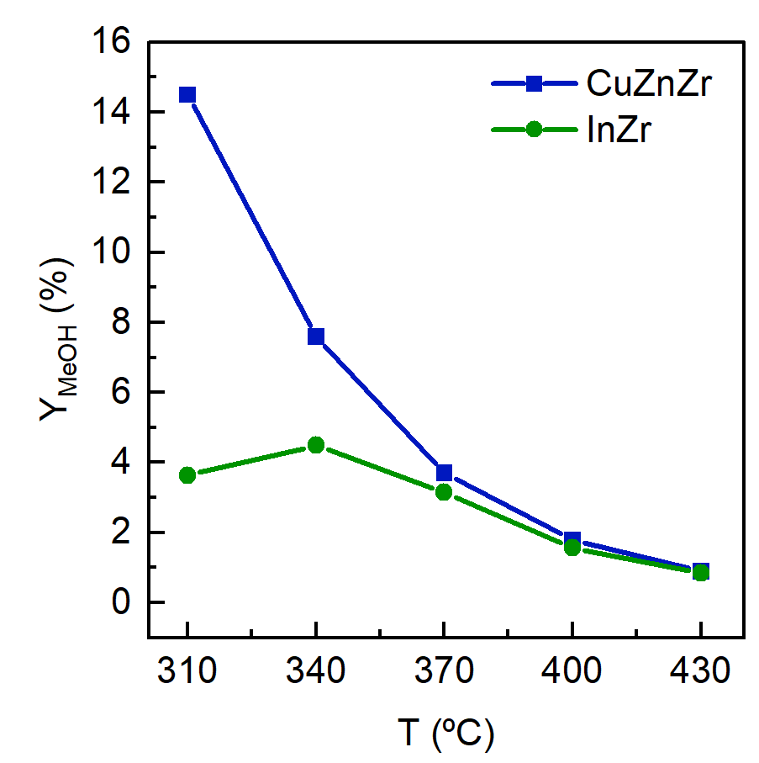  a) | 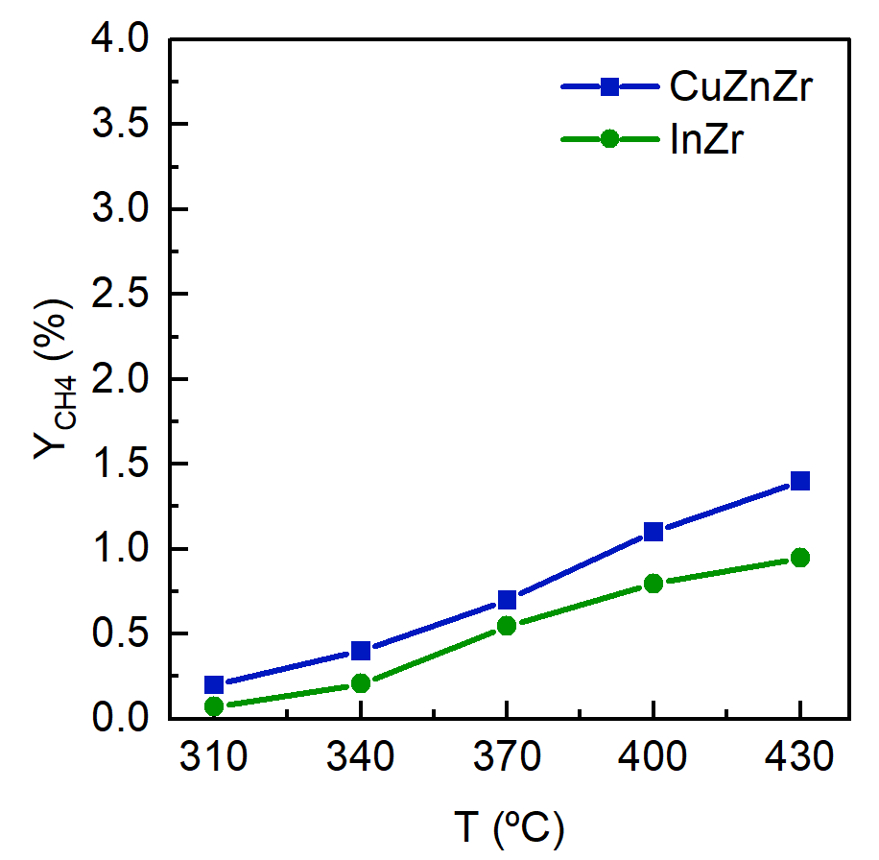  b)
Figure 1: Effect of the temperature on (a) methanol yield and (b) methane yield with CuZnZr and InZr metallic oxide catalysts. Reaction conditions: 50 bar; space time, 6 g_{cat} h mol_{C}⁻¹; H₂/CO_{x}, 3.

    - Alternative Tandem Catalysts For Hydrocarbons Synthesis
As mentioned above, working in a single stage has several benefits, such as a lower economic investment due to the use of a single reactor. Nonetheless, the main advantage of working in a single stage is the shifting of the equilibrium, as methanol immediately converts into higher hydrocarbons when operating in the same reactor. This way, the role of the synergy between the metallic and the acid catalyst becomes an essential aspect. Therefore, CuZnZr and InZr were tested in tandem with HZSM-5 zeolite (CuZnZr/H5 and InZr/H5), as to prove whether these metallic oxide catalysts were feasible for operating in the integrated CO_{x} to hydrocarbons process. Since methanol synthesis step is favored at low temperature (and high pressure) and methanol to hydrocarbons (MTH) reactions are favored at high temperature, optimizing the operating conditions for boosting the whole process in a single stage is a key feature.

Figures 3 and 4 display the yield of the desired products, i.e., methanol when the reactions were carried out with the metallic CuZnZr and InZr catalysts and fuel-range hydrocarbons (C₅₊ hydrocarbons) when tandem catalysts were tested. It can be observed that, as concluded before, obtaining a higher methanol production with the CuZnZr than with InZr did not result in a better performance with tandem configuration, evidencing that achieving a successful synergy among catalysts is more significant than combining the best catalysts in the same conditions. In fact, as observed in Figure 3, even if at low temperature, high methanol production was obtained, virtually no hydrocarbons were yielded at 340 ºC (~0.1 %). At this temperature, the methanol was selectively dehydrated to dimethyl ether over the HZSM-5 zeolite and the hydrocarbon pool mechanism did require higher temperature to activate. As temperature increased, hydrocarbons started to form over the zeolite (mainly C₂-C₄ paraffins). However, as a consequence of the decline of the CuZnZr catalyst due to the thermal sintering, the C₅₊ hydrocarbons yield did not exceed 3 % in any case. It can be thus concluded that CuZnZr/H5 tandem catalyst is a feasible catalyst for dimethyl ether production, but it is not a good choice for fuel-range hydrocarbons production as targeted.

On the other hand, the results completely differed with InZr/H5 tandem catalyst. As exhibited in Figure 4, considerably lower methanol yield was obtained with InZr metallic catalyst as compared with CuZnZr. Nevertheless, InZr did not suffer any thermal sintering, leading to highly enhanced results. Even at low temperature, the C₅₊ hydrocarbon yield was higher than the maximum obtained with CuZnZr/H5 (4.9% vs. 2.9 %). As temperature was risen, owing to the favored MTH reactions, hydrocarbon production sharply increased. In fact, at 420 ºC, the C₅₊ yield reached 17 %. Even if almost no methanol was produced only with the metallic catalyst at these conditions, the high hydrocarbons production was obtained by dint of the displaced equilibrium of the first step in the integrated process. The great thermodynamic advantage of operating in a single stage is therefore evidenced. Moreover, with the InZr/H5 tandem catalyst, the conversion of CO₂/CO hydrogenation rocketed from 1.8 % when operating just with the metallic catalyst to 23 % in the integrated process.

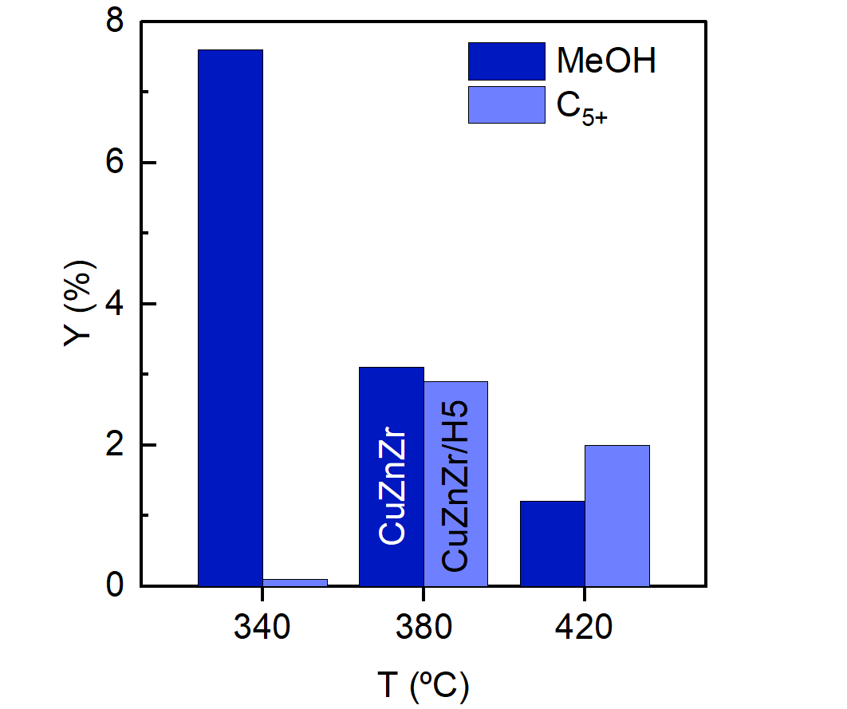
Figure 3. Effect of the temperature on the yield of the desired product fraction: (i) methanol (with CuZnZr metallic catalyst) and (ii) C₅₊ hydrocarbons (with CuZnZr/H5 tandem catalyst). Reaction conditions: 50 bar; space time, 6 and 12 g_{cat} h mol_{C}⁻¹; H₂/CO_{x}, 3.

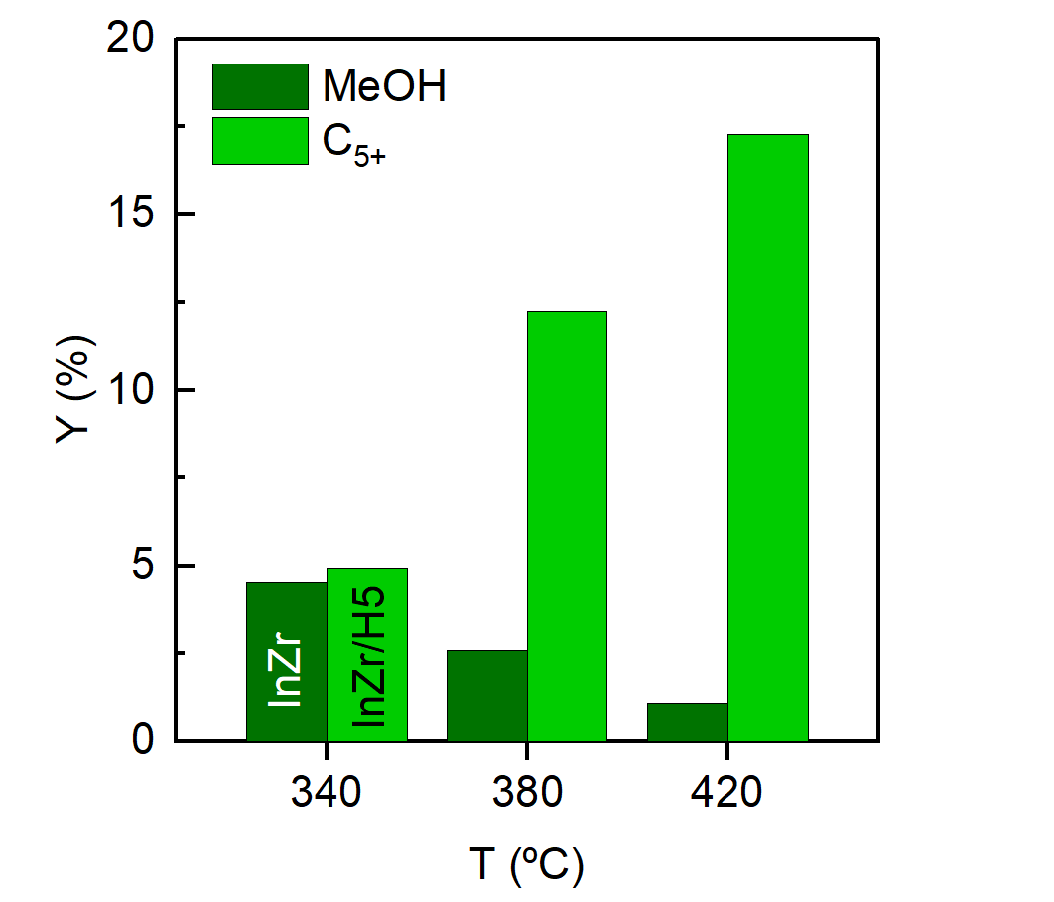
Figure 4. Effect of the temperature on the yield of the desired product fraction: (i) methanol (with InZr metallic catalyst) and (ii) C₅₊ hydrocarbons (with InZr/H5 tandem catalyst). Reaction conditions: 50 bar; space time, 6 and 12 g_{cat} h mol_{C}⁻¹; H₂/CO_{x}, 3.
Table 1 shows the distribution of the obtained hydrocarbons at 420 ºC. Isoparaffins in the C₄-C₆ range turned out to be the most numerous produced hydrocarbons, accounting for more than half of the obtained hydrocarbon products. Almost no aromatics were produced, and olefins did not reach 15%. This composition is very suitable for its incorporation into the gasoline-pool. Because, when mixed with streams with high aromatic (such as those from the FCC) or olefin content, it would help meet environmental requirements. In addition, it is remarkable that the produced hydrocarbons do not contain S or N, pollutants present in refinery streams. On the other hand, its commercial application is interesting for the CO₂ valorization policies aimed at synthesizing products of commercial interest that partially compensate the costs of CO₂ capture technologies and the higher cost of indium-based catalysts. It is noteworthy that the hydrocarbons obtained with CuZnZr/H5 were mainly 5 carbon number paraffins, with almost no presence of naphthenic or aromatic compounds.

Table 1: Distribution of hydrocarbons by product fraction and carbon number (mol %) obtained with InZr/H5 catalyst. Reaction conditions: 420 ºC; 50 bar; space time, 12 g_{cat} h mol_{C}⁻¹; H₂/CO_{x}, 3. The remainder to reach 100% corresponds to oxygenate fraction.
Carbon number | n-paraffin | Isoparaffin | Olefin | Naphthene | Aromatic
C₁ | 8.8 | - | - | - | -
C₂ | 3.0 | - | 3.4 | - | -
C₃ | 5.4 | - | 3.4 | - | -
C₄ | - | 11.2 | 5.4 | - | -
C₅ | 3.2 | 21.3 | - | 0.8 | -
C₆ | 2.2 | 20.1 | - | 2.4 | -
C₇₊ | - | 1.4 | - | 4.7 | 2.2
Conclusions
The production of C₅₊ fuel-range hydrocarbons from CO₂/CO hydrogenation is an interesting process for CO₂ valorization and synthesis of sustainably sourced fuels. Two metallic catalysts (CuO-ZnO-ZrO₂ and In₂O₃-ZrO₂) were tested under different operating conditions on CO₂/CO hydrogenation to methanol. Even CuO-ZnO-ZrO₂ seemed a good alternative attending the high methanol yield obtained at low temperature, the catalyst suffered Cu sintered at temperature above 300 ºC, leading to high methane production and lower methanol yield in the conditions required for the integrated process. On the other hand, besides the limited methanol yield (5%) obtained with In₂O₃-ZrO₂ at low temperature, at which hydrogenation reactions are favored, operating in tandem with a zeolite favorably displaced the thermodynamic equilibrium of methanol formation and In₂O₃-ZrO₂/HZSM-5 proved to be an excellent catalyst for fuel-range hydrocarbons production. The C₅₊ yield at high temperature (420 ºC) reached almost 20%, and the conversion was boosted from 1.8% (with just In₂O₃-ZrO₂ metallic catalyst) to 23% in the integrated process (with In₂O₃-ZrO₂/HZSM-5 tandem catalyst). In addition, the obtained hydrocarbon stream was rich in isoparaffinic compounds, and contained low aromatic and olefin content, resulting in an adequate product for its incorporation into the refinery gasoline-pool.
Acknowledgments
This work has been carried out with the financial support of the MICINN of Spanish Government (PID2019-108448RB-100); the Basque Government (IT1645-22), the European Regional Development Funds (ERDF). O. Parra is grateful for the financial support of the grant of the Basque Government (PRE_2021_1_0014).
References
Ateka A., Sierra I., Ereña J., Bilbao J., Aguayo A.T., 2016, Performance of CuO–ZnO–ZrO₂ and CuO–ZnO–MnO as metallic functions and SAPO-18 as acid function of the catalyst for the synthesis of DME co-feeding CO₂. Fuel Processing Technology, 152, 34-45.
Ateka A., Rodriguez-Vega P., Ereña J., Aguayo A.T., Bilbao J., 2022, A review on the valorization of CO₂. Focusing on the thermodynamics and catalyst design studies of the direct synthesis of dimethyl ether, Fuel Processing Technology, 233, 107310.
Grabow L.C., Mavrikakis M., 2011, Mechanism of methanol synthesis on Cu through CO₂ and CO hydrogenation, ACS Catalysis, 1, 365-384.
Kim H.D., Song H., Fazeli A., Eslami A.A., Noh Y.S., Saeidabad N.G., Lee K., Moon D. J., 2022, CO/CO₂ hydrogenation for the production of lighter hydrocarbons over SAPO-34 modified hybrid FTS catalysts, Catalysis Today, 388-389, 410-416.
Portillo A., Ateka A., Ereña J., Aguayo A.T., Bilbao J., 2022, Conditions for the joint conversion of CO₂ and syngas in the direct synthesis of light olefins using In₂O₃-ZrO₂/SAPO-34 catalyst, Industrial & Engineering Chemistry Research, 61, 10365-10376.
Saeidi S., Najari S., Hessel V., Wilson K., Keil F.J., Concepción P., Suib S.L., Rodrigues A.E., 2021, Recent advances in CO₂ hydrogenation to value-added products — Current challenges and future directions, Progress in Energy and Combustion Science, 85, 100905.
Samiee L., Ganszha S., 2019, Power to methanol technologies via CO₂ recovery: CO₂ hydrogenation and electrocatalytic routes. Reviews in Chemical Engineering, 37, 619-641.
Sánchez-Contador M., Ateka A., Rodriguez-Vega P., Bilbao J., Aguayo A.T., 2018, Optimization of the Zr content in the CuO-ZnO-ZrO₂/SAPO-11 catalyst for the selective hydrogenation of CO+CO₂ mixtures in the direct synthesis of dimethyl ether, Industrial & Engineering Chemistry Research, 57, 1169-1178.
Zhang S., Wu Z., Liu X., Hua K., Shao Z., Wei B., Huang C., Wang H., Sun Y., 2021, A short review of recent advances in direct CO₂ hydrogenation to alcohols, Topics in Catalysis, 64, 371-394.

