CHEMICAL ENGINEERING TRANSACTIONS  VOL. , 2023 | A publication of
The Italian Association
of Chemical Engineering
Online at www.cetjournal.it

Guest Editor: Sauro Pierucci
Copyright © 2023, AIDIC Servizi S.r.l.
ISBN 978-88-95608-98-3; ISSN 2283-9216

A Simulation Approach For Investigating The Effect Of Valeric Acid Concentration On Poly(3-hydroxybutyrate-co-3-hydroxyvalerate) Generation In Presence Of Methane.

Claudia Amabile¹, Teresa Abate¹, Carmen De Crescenzo^{1,*}, Antimo Migliaccio¹, Giuseppe Capece², Renato Ciampa³, Raul Muñoz⁴, Simeone Chianese¹, Dino Musmarra¹
¹Department of Engineering, University of Campania “Luigi Vanvitelli”, Via Roma 29, 81031, Aversa, Italy
²Progest S.r.l., Zona ASI Aversa-Nord, Via della Stazione s.n.c., CE, Gricignano d'Aversa, 81030, Italy
³Centro Diagnostico Baronia S.r.l., Località Taverna Annibale SNC, Area PIP, Lotto n°7, AV, Frigento, 83040, Italy
⁴Institute of Sustainable Processes, University of Valladolid, Dr. Mergelina, s/n, 47011, Valladolid, Spain
*Corresponding author: carmen.decrescenzo@unicampania.it
Polyhydroxyalkanoates (PHAs) are biobased and biodegradable polymers that may be considered to replace fossil-based materials. However, their widespread deployment is slowed down because of the high production cost and their low quality. Using methane during the generation of poly(3-hydroxybutyrate-co-3-hydroxyvalerate) (PHB-co-HV) could reduce the production costs, which are usually owed to the carbon source used, and enhance the performance of the material. In fact, the properties of PHB-co-HV make it more suitable than the most common homopolymer, named poly(3-hydroxybutyrate) (PHB), for many applications since it is more flexible, has a wider thermal processing range, a lower crystallinity and permeability to water. In this work, the production of Poly(3-hydroxybutyrate-co-3-hydroxyvalerate) was simulated using an innovative process scheme consisting of two bioreactors working in series equipped with a gas recycling unit, which was designed to increase the methane mass transfer from the gas to the liquid. During the first step, a Methylocystis dominated culture was grown on ammonia and methane to reach a high cell concentration; then, the cells were moved to the second bioreactor and subjected to nutrients starvation to favour the metabolic pathway addressed to the accumulation of PHB-co-HV. The effect of the variation of valeric acid concentration (100-400 ppm), which was used as co-substrate, on the fraction of PHB-co-HV stored in the cells and the percentage of 3-hydroxyvalerate (3-HV) was investigated: results showed that the highest the valeric acid concentration, the lower the total polymer content and the higher the HV fraction accumulated.
  - Introduction
Bio-based and biodegradable plastics such as polyhydroxyalkanoates (PHAs) show several advantages over conventional petroleum-based materials, but their industrial diffusion is limited by their high production costs due to the carbonaceous substrate, fermentation procedures, yields on the selected substrate and extraction/purification process (Abate et al., 2022). It was reported that in 2004 the price of commercial polyhydroxyalkanoates was 15-17 times higher than that of conventional plastics, thus resulting in no-marketable. Many efforts have been made to meet the economic feasibility, and several studies today address the achievement of high levels of PHAs as a percentage of dry cell weight, improved fermentation conditions, low-cost recovery methods, low-cost substrates, high productivity in terms of grams of product per unit volume and the scalability of the process (Sipkema et al., 1998).
One valid approach to reduce the costs is the production of PHAs by mixed microbial cultures (MMC) since MMC require a lower sterility degree and basic equipment in comparison with monoseptic cultures (Policastro et al., 2021). Anyway, PHAs production by MMC has never been implemented at an industrial scale, where only pure cultures (wild or genetically modified strains) are used (Madison and Huisman, 1999). Moreover, it has been demonstrated that mixed methanotrophic consortiums can use renewable and cheap substrates such as methane as the sole carbon source to grow and accumulate PHAs (Liu et al., 2020). Still, the addition of other substrates, such as volatile fatty acids, could also allow the incorporation of 3-hydroxyvalerate units, thus improving the performance of the polymeric structure (Fergala et al., 2018). Poly(3-hydroxybutyrate-co-hydroxyvalerate) was reported to have better characteristics compared to poly(3-hydroxybutyrate) (PHB) (Table 1): PHB-co-HV has a lower melting point, allowing a wider thermal processing window, is more flexible, less permeable to water and less crystalline than PHB (Myung et al., 2016). Note that most of these characteristics were reported within wide ranges since the values depend on the fraction of 3-HV accumulated into the copolymer, which in turn is related to the initial concentration of co-substrate (Weng et al., 2011). Also, the biodegradability is affected by the amount of 3-HV accumulated since this amorphous fraction increases the degradation rates of the polymer (Rossetti et al., 2021). In this work, the production of the enhanced PHB-co-HV was simulated using valeric acid as substrate, which could be derived from the anaerobic digestion of the organic waste, thus giving a chance for an integrated biorefinery.
Table 1: Comparison of PHB, PHB-co-HV and PP properties (adapted from Koller et al., 2010)
Property | PHB | Poly(3HB-co-HV) | PP
M [10⁵ g/mol] | 1-8 | 3 | 2.2-7
ρ [kg/dm³] | 1.25 | 1.2 | 0.905
Melting point [°C] | 171-182 | 75-172 | 176
Crystallinity [%] | 80 | 55-70 | 70
Glass transition temperature [°C] | 5-10 | -13-8 | -10
O₂-permeability [cm/m²kPa day] | 0.4 | n.d. | 17
UV-resistance | Good | Good | Bad
Resistance to solvents | Bad | Bad | Good
Tensile strength [MPa] | 40 | 25-30 | 38
Elongation to break [%] | 6 | 8-1200 | 400
Young’s modulus | 3.5 | 2.9 (3%HV);  0.7 (25%3HV) | 1.7
Biodegradability | Yes | Yes | No

  - Simulation strategy
The process to produce PHB-co-HV was simulated in AspenPlus using two reactors with a working volume of 1 m³, in which the liquid represented the batch charge and a gas stream containing methane was diffused continuously in the form of small bubbles (d_{b}≈10mm) at a superficial gas velocity (U_{g}) of 0.02 ms⁻¹. A gas recirculation unit operating at a recycling ratio (RR) of 5, i.e. the ratio between the recycled flow rate and the initial fresh gas fed, was also implemented (Figure 1).

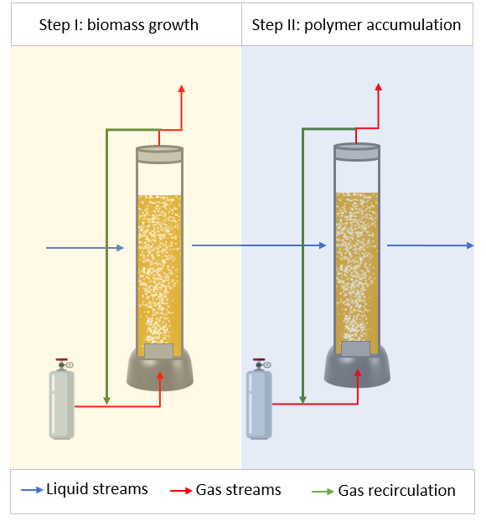
Figure 1: Main simulation flowsheet
The strategy implemented in this work consisted of the growth of a mixed Type II-dominated methanotrophic culture (Step I), followed by the accumulation of the polymeric granules into the cells under nutrient starvation (Step II). Since the yield of the process depends on biomass metabolism and the transfer rate of oxygen and methane to the liquid phase, both the kinetic constant and the gas-liquid mass transfer coefficients were estimated.

    - Biomass growth
During the growth of the mixed methanotrophic culture, an ammonia-based mineral salt medium was used, and a gas stream containing methane and oxygen (1:2 v/v%) was fed to the reactor (Table 1). The temperature was set at 27 °C and pressure at 1 bar; the duration of the process was assumed to be 96 h.
Table 2: Description of the growth unit streams.
Growth reactor |  | G_{BIOMASS}-in | L_{BIOMASS}-in | G_{BIOMASS}-out | L_{BIOMASS}-out
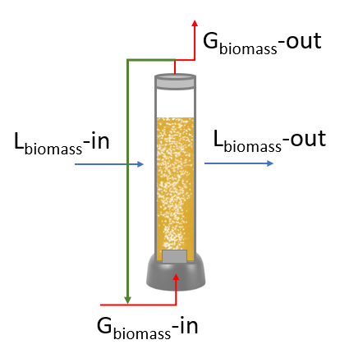 |  | CH₄, O₂ | Mineral salt medium containing an initial concentration of the mixed methanotrophic consortium | CH₄, O_{2,} CO₂ | Mineral salt medium containing the grown biomass

In these conditions, ammonia, methane and oxygen are converted to CO₂ and biomass (C₅H₇NO₂), according to the reaction proposed by Rostkowski et al. (2013) (Eq.1).

$\frac{\text{1}}{\text{4}}\text{C}{\text{H}}_{\text{4}}\text{+}\left(\frac{\text{1}}{\text{4}}\text{+}\frac{{\text{f}}_{\text{e}}}{\text{4}}\right){\text{O}}_{\text{2}}\text{+}\frac{{\text{f}}_{\text{s}}}{\text{23}}\text{HC}{\text{O}}_{\text{3}}^{\text{-}}\text{+}\frac{{\text{f}}_{\text{s}}}{\text{23}}\text{N}{\text{H}}_{\text{4}}^{\text{+}}\left(\frac{\text{24}}{\text{23}}{\text{f}}_{\text{s}}\text{+}{\text{f}}_{\text{e}}\text{-1}\right){\text{H}}^{\text{+}}\text{→}\left(\frac{\text{1}}{\text{4}}\text{-}\frac{\text{4}{\text{f}}_{\text{s}}}{\text{23}}\right)\text{C}{\text{O}}_{\text{2}}\text{+}\left(\frac{{\text{f}}_{\text{e}}}{\text{2}}\text{+}\frac{\text{9}{\text{f}}_{\text{s}}}{\text{23}}\right){\text{H}}_{\text{2}}\text{O+}\left(\frac{{\text{f}}_{\text{s}}}{\text{23}}\right){\text{C}}_{\text{5}}{\text{H}}_{\text{7}}{\text{O}}_{\text{2}}\text{N }$ (1)

In Eq.1, the degree of conversion depends on the partition coefficients f_{e} and f_{s}, which represent the fractions of electrons employed for reducing oxygen to water and cell synthesis, respectively. The values used in this work are those reported for a Methylocystis-dominated culture and account for 0.27 and 0.73, respectively. Moreover, since the growth of this strain was reported to be linear in time, the reaction kinetics was assumed a zero-order type, and the kinetic constant calculated was 0.000106 kmol m⁻³h⁻¹.

    - PHB-co-HV accumulation from methane
During the production of PHB-co-HV, a nitrogen-deprived mineral salt medium was considered, and a gas stream containing methane and oxygen (1:2 v/v) was fed to the reactor (Table 2), which was operated at 27 °C and 1 bar for 96 h. Valeric acid at 100 and 400 ppm was supplemented as a co-substrate to promote the formation of 3-HV monomers.
Table 3: Description of the accumulation unit streams.
Accumulation reactor |  | G_{PHB-co-HV}-in | L_{PHB-co-HV}-in | G_{PHB-co-HV}-out | L_{PHB-co-HV}-out
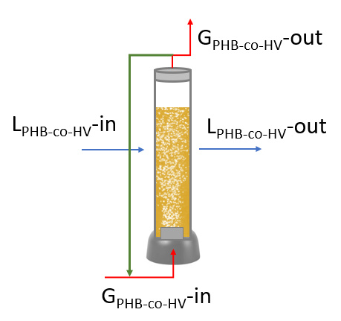 |  | CH₄, O₂ | Nutrient-deprived medium containing  the grown biomass, valeric acid  (100, 400 ppm) | CH₄, O₂, CO₂ | Nutrient deprived  medium containing biomass rich in PHB-co-HV
In the reaction considered, methane and oxygen are consumed by the biomass to produce CO₂ and the polymer (C₄H₆O₂).

$\frac{\text{1}}{\text{4}}\text{C}{\text{H}}_{\text{4}}\text{+}\left(\frac{\text{1}}{\text{4}}\text{+}\frac{{\text{f}}_{\text{e}}}{\text{4}}\right){\text{O}}_{\text{2}}\text{→}\left(\frac{\text{1}}{\text{4}}\text{-}\frac{\text{4}{\text{f}}_{\text{s}}}{\text{18}}\right)\text{C}{\text{O}}_{\text{2}}\text{+}\left(\frac{{\text{f}}_{\text{e}}}{\text{2}}\text{+}\frac{{\text{f}}_{\text{s}}}{\text{3}}\right){\text{H}}_{\text{2}}\text{O+}\left(\frac{{\text{f}}_{\text{s}}}{\text{18}}\right){\text{C}}_{\text{4}}{\text{H}}_{\text{6}}{\text{O}}_{\text{2 }}$ (2)

The partition coefficients used were measured experimentally for a Methylocystis-dominated culture in the same conditions simulated (low and high valeric acid, methane as substrate). As for the growth phase, the kinetic constant was extrapolated from the literature, considering a zero-order reaction. Table 4 reports the kinetic and transfer data used for these simulations, which were calculated according to Amabile et al. (2022a).
Table 4: kinetic and transfer parameters used to simulate PHB-co-HV accumulation.
Parameter | Valeric acid [ppm]
 | 100 | 400
k_{kin} [kmol m⁻³h⁻¹] | 1.10x10⁻⁴ | 6x10⁻⁵
f_{e} | 0.35 | 0.45
f_{s} | 0.65 | 0.55
kLa [s⁻¹] | 1x10⁻² | 1x10⁻²

  - Results
The results of the simulations, expressed in terms of production as a function of the time of biomass and PHB-co-HV, are shown in Figure 2. The initial biomass content was 1 kg and reached 2.76 kg after 96 h of fermentation, while the amounts of biopolymer produced at the end of the cycle were 1.38 (33.3% of the total suspended solids) and 0.764 kg (18.7% of the total suspended solids) for the lower and higher valeric acid concentration, respectively. Despite the lower amounts of PHB-co-HV produced at 400ppm, the fraction of the 3-HV monomers was higher (40%mol). Similar results were previously reported in the literature (Myung et al., 2015), thus confirming the validity of the model implemented (Amabile et al., 2022c). Furthermore, other experimental works demonstrated the reduction of the polymer production obtained with high valeric acid concentrations, probably because of the lower pH values encountered in these cases (López et al., 2018).

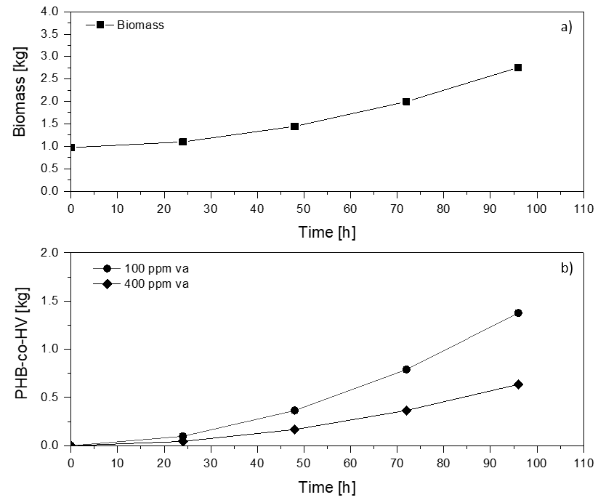
Figure 2: Time course of the production of biomass and PHB-co-HV at low and high valerate concentrations
Other parameters used as performance indicators, such as the productivity of PHB-co-HV (pPHB-co-HV), the production of polymer for the unit of biomass (PHB-co-HV/biomass) and methane fed (PHB-co-HV/CH₄), are shown in Table 5.
Table 5: Results of the simulations for the two conditions studied: 100 and 400 ppm of valerate.
Parameter | Valeric acid [ppm]
 | 100 | 400
pPHB-co-HV [g m⁻³ d⁻¹] | 6.9 | 5.83
PHB-co-HV/biomass [g g⁻¹] | 0.499 | 0.23
PHB-co-HV/CH₄ [g g⁻¹] | 0.155 | 0.13
The results show that when adding 100 ppm of valeric acid, the production of PHB-co-HV with respect to the initial biomass and the productivity of the polymer is higher than when supplying 400 ppm. These findings agree with the literature, where in the range 100-400ppm of valerate, the lower limit led to the highest production and 400ppm to the maximum HV content. Moreover, the productions here obtained for 1 m³ of working volume were higher than those reported in prior studies, where lower reactor capacities were considered (García-Pérez et al., 2018). As regards the production for the unit of methane, there is no significant difference between the two cases examined, thus indicating that the parameter depends on the mass transfer conditions, which in turn are related to the process and reactor design. In this context, it was previously demonstrated through simulations analysis that increasing the reactor volume enhances productivity but lowers the production related to methane consumption (Amabile et al., 2022b). These results suggest that alternative strategies to boost the mass transfer of methane and oxygen to the liquid phase should be evaluated when using larger volumes to improve the biopolymer production in bioreactors at larger scales. In this context, also other scale-up aspects, such as the study of the reactor geometry, the reduction of sterility conditions and the possibility of using low-cost substrates, should be evaluated.
  - Conclusions
The process to produce PHB-co-HV from methane was simulated in AspenPlus. A mixed microbial methanotrophic strain was used since it requires low sterility and could be a valuable option to reduce production costs. Two bubble column bioreactors with 1 m³ of working volume were implemented to perform the growth phase and the accumulation step. This latter was conducted with the addition of valeric acid as a co-substrate, which was fed at low (100 ppm) and high (400 ppm) concentrations in order to understand if the mass loss of PHB-co-HV at 400ppm could be compensated by the highest HV fraction. The results show that all the concentrations in the range 100-400ppm of valerate could be taken into account for PHB-co-HV production. The addition of low amounts of valeric acid does not modify the microbial activity, thus allowing the incorporation of 3-HV monomers without threatening the total production yields. On the other hand, a higher amount of valerate can inhibit microbial activity, thus inducing the formation of 3-HV granules but reducing the amount of polymer produced at the end of the cycle.

Nomenclature
d_{b} – bubbles diameter [mm]
kla – gas-liquid volumetric mass tranfer coefficient [s⁻¹]
PHB – Poly(3-hydroxybutyrate)
PHB-co-HV – Poly(3-hydroxybutyrate-co-3-hydroxyvalerate)
M – molecular mass [g mol⁻¹]
ρ – density [kg m⁻³]
3-HV – 3-hydroxyvalerate
p-PHB-co-HV – volumetric productivity per day
U_{g} – superficial gas velocity [m s⁻¹]

Acknowledgments
This work was supported by the Ministry of Economic Development through the “Fondo per lo Sportello Sostenibile – Sportello “Agrifood” PON I&C 2014-2020”, di cui al D.M. 5 marzo 2018 Capo III. Prof. n. F/200125/01-03/X45. The authors would like to thank VALERE “VAnviteLli pEr la RicErca”” PROGRAMME by the University of Campania “Luigi Vanvitelli”. The Regional Government of Castilla y Leon and the EU-FEDER (CLU 2017-09, CL-EI-2021-07, and UIC 315) are also gratefully acknowledged.
References
Abate, T., Amabile, C., De Crescenzo, C., Sabbarese, S., Capece, G., Ciampa, R., Chianese, S., Musmarra, D., 2022. Alternative Polyhydroxybutyrate Solvent Extraction: a Process Simulation Study. Chem. Eng. Trans. 92, 265–270. https://doi.org/10.3303/CET2292045
Amabile, C., Abate, T., Crescenzo, C. De, Sabbarese, S., Migliaccio, A., Chianese, S., Musmarra, D., De Crescenzo, C., Sabbarese, S., Migliaccio, A., Chianese, S., Musmarra, D., 2022a. Poly(3-hydroxybutyrate) production from methane in bubble column bioreactors: Process simulation and design optimization. N. Biotechnol. 70, 39–48. https://doi.org/10.1016/j.nbt.2022.04.004
Amabile, C., Abate, T., De Crescenzo, C., Sabbarese, S., Capece, G., Ciampa, R., Chianese, S., Musmarra, D., 2022b. Enhancing Poly(3-hydroxybutyrate) Production through the Optimization of Reactor Geometry. Chem. Eng. Trans. 93, 277–282. https://doi.org/10.3303/CET2293047
Amabile, C., Abate, T., De Crescenzo, C., Sabbarese, S., Muñoz, R., Chianese, S., Musmarra, D., 2022c. Sustainable Process for the Production of Poly(3-hydroxybutyrate- co-3-hydroxyvalerate) from Renewable Resources: A Simulation Study. ACS Sustain. Chem. Eng. 10, 14230–14239. https://doi.org/10.1021/acssuschemeng.2c04111
Fergala, A., Alsayed, A., Khattab, S., Ramirez, M., Eldyasti, A., 2018. Development of Methane-Utilizing Mixed Cultures for the Production of Polyhydroxyalkanoates (PHAs) from Anaerobic Digester Sludge. Environ. Sci. Technol. 52, 12376–12387. https://doi.org/10.1021/acs.est.8b04142
García-Pérez, T., López, J.C., Passos, F., Lebrero, R., Revah, S., Muñoz, R., García-Pérez Teresa, C.López Juan, Passos Fabiana, Lebrero Raquel, Revah Sergio, M.R., 2018. Simultaneous methane abatement and PHB production by Methylocystis hirsuta in a novel gas-recycling bubble column bioreactor. Chem. Eng. J. 334, 691–697. https://doi.org/10.1016/j.cej.2017.10.106
Koller, M., Salerno, A., Dias, M., Reiterer, A., Braunegg, G., 2010. Modern biotechnological polymer synthesis: A review. Food Technol. Biotechnol. 48, 255–269.
Liu, L.Y., Xie, G.J., Xing, D.F., Liu, B.F., Ding, J., Ren, N.Q., 2020. Biological conversion of methane to polyhydroxyalkanoates: Current advances, challenges, and perspectives. Environ. Sci. Ecotechnology 2. https://doi.org/10.1016/j.ese.2020.100029
López, J.C., Arnáiz, E., Merchán, L., Lebrero, R., Muñoz, R., 2018. Biogas-based polyhydroxyalkanoates production by Methylocystis hirsuta: A step further in anaerobic digestion biorefineries. Chem. Eng. J. 333, 529–536. https://doi.org/10.1016/j.cej.2017.09.185
Madison, L.L., Huisman, G.W., 1999. Metabolic Engineering of Poly(3-Hydroxyalkanoates): From DNA to Plastic. Microbiol. Mol. Biol. Rev. 63, 21–53. https://doi.org/10.1128/mmbr.63.1.21-53.1999
Myung, J., Flanagan, J.C.A., Waymouth, R.M., Criddle, C.S., 2016. Methane or methanol-oxidation dependent synthesis of poly(3-hydroxybutyrate-co-3-hydroxyvalerate) by obligate type II methanotrophs. Process Biochem. 51, 561–567. https://doi.org/10.1016/j.procbio.2016.02.005
Myung, J., Galega, W.M., Van Nostrand, J.D., Yuan, T., Zhou, J., Criddle, C.S., 2015. Long-term cultivation of a stable Methylocystis-dominated methanotrophic enrichment enabling tailored production of poly(3-hydroxybutyrate-co-3-hydroxyvalerate). Bioresour. Technol. 198, 811–818. https://doi.org/10.1016/j.biortech.2015.09.094
Policastro, G., Panico, A., Fabbricino, M., 2021. Improving biological production of poly ( 3-hydroxybutyrate- co -3-hydroxyvalerate ) ( PHBV ) co-polymer : a critical review, Reviews in Environmental Science and Bio/Technology. Springer Netherlands. https://doi.org/10.1007/s11157-021-09575-z
Rossetti, I., Conte, F., Ramis, G., 2021. Kinetic Modelling of Biodegradability Data of Commercial Polymers Obtained under Aerobic Composting Conditions. Eng 2, 54–68. https://doi.org/10.3390/eng2010005
Rostkowski, K.H., Pfluger, A.R., Criddle, C.S., 2013. Stoichiometry and kinetics of the PHB-producing Type II methanotrophs Methylosinus trichosporium OB3b and Methylocystis parvus OBBP. Bioresour. Technol. 132, 71–77. https://doi.org/10.1016/j.biortech.2012.12.129
Sipkema, E.M., De Koning, W., Ganzeveld, K.J., Janssen, D.B., Beenackers, A.A.C.M., 1998. Experimental pulse technique for the study of microbial kinetics in continuous culture. J. Biotechnol. 64, 159–176. https://doi.org/10.1016/S0168-1656(98)00076-5
Weng, Y.X., Wang, X.L., Wang, Y.Z., 2011. Biodegradation behavior of PHAs with different chemical structures under controlled composting conditions. Polym. Test. 30, 372–380. https://doi.org/10.1016/j.polymertesting.2011.02.001

