CHEMICAL ENGINEERING TRANSACTIONS  VOL. , 2023 | A publication of
The Italian Association
of Chemical Engineering
Online at www.cetjournal.it

Guest Editor: Sauro Pierucci
Copyright © 2023, AIDIC Servizi S.r.l.
ISBN 978-88-95608-98-3; ISSN 2283-9216

Inherent hazards and limited regulatory oversight in the waste plastic recycling sector – repeat explosion at pyrolysis plant
Frank Huess Hedlund^{a,b}
ª COWI, Parallelvej 2, DK-2800 Kongens Lyngby, Denmark
^{b} DTU/Compute. Technical University of Denmark DK-2800 Kongens Lyngby, Denmark
fhhe@cowi.com
Denmark has set ambitious targets for the recycling of plastic and local authorities have rolled out mandatory programs for collection of the waste plastic fraction at households. The waste streams are often dirty and contain many different types of plastic. In comparison to mechanical recycling, the pyrolysis process can tolerate considerably higher levels of contaminants in the feed. Municipalities pay a fee to have recyclers accept the waste and cover transportation costs. This represents a business opportunity for entrepreneurs who devise proprietary pyrolysis processes. Pyrolysis is an inherently hazardous process but barriers to entry appear rather low and regulatory oversight limited. A proprietary pyrolysis prototype plant experienced a serious explosion in 2020. An explosion in 2021 at the same plant led to its complete destruction. The paper examines the limited evidence available and presents a plausible set of lessons not learned. In Denmark, it is a policy objective to encourage circular economy and recycling of waste streams to reduce dependence on fossil fuels. However, utmost care should be taken to avoid media shifting – that the resolution of a problem within one domain, the environmental domain, comes at the expense of problems in another, the workplace safety domain.
  - Introduction
Several authors have argued that emerging waste-to-energy plants have complex risk profiles, that they have hazards more akin to the chemical process industries than to an incinerator (Elsdon and Pal, 2011). It is important not to underestimate emerging new risk from plastic waste recycling plants. To ensure plant safety, rigorous hazard assessment is required (Jankuj et al., 2022).
Denmark has set ambitious targets for recycling of plastic and municipalities have mandatory programs for collection of the household waste plastic fraction. Recycling is technically difficult however, and it is often exported for recycling. Municipalities pay a fee to have recyclers accept the waste plastic. This represents a business opportunity for entrepreneurs who devise proprietary pyrolysis process units aiming to upcycle the waste to fuels and new chemical feedstocks.
In mechanical recycling of waste plastic, the chemical identity of the polymer is unchanged. Disadvantages include stability and loss of properties as the polymers degrade with repeated reprocessing. Chemical recycling uses processes such as pyrolysis to break down the polymer into gases, liquids, and waxes that are feedstocks for production of new polymers, chemicals, or fuels (Thiounn and Smith, 2020). Pyrolysis has several advantages over other recycling methods. Plastic collected from different waste streams are often heterogeneous and dirty, making mechanical recycling unattractive as it requires cleaning and separation steps. Compared to mechanical recycling, pyrolysis can tolerate considerably higher levels of contaminants which makes pyrolysis economically attractive due to fewer pre-treatment steps. Pyrolysis is also attractive for safe circular economy as it can handle harmful substances and legacy additives (Qureshi et al., 2020).
A serious explosion occurred at a domestic pyrolysis prototype plant in 2020. A repeat explosion in 2021 led to complete destruction of plant, both cases fortuitously without loss of life. There is limited information about what went wrong. This paper examines available evidence and presents a plausible set of lessons not learned.
  - Inherent hazards of pyrolysis
Pyrolysis is a thermal degradation process in which organic materials are broken down into smaller molecules in the absence of oxygen. The process involves heating the organic material to high temperatures, typically in the range of 400°C to 800°C.
Pyrolysis processes generate toxic and flammable gases. Pyrolysis takes place at high temperatures that exceed the autoignition temperature (AIT) of the substances involved. Accidents are frequent – the UK waste sector had a fatality rate around 15 times greater than the rate across all industries over the five-year period up to 2016, and over three times greater than the rate in the construction sector (Rollinson, 2018).
Inherent pyrolysis hazards include fire and explosion risk and accidental release of toxic gases such as carbon monoxide. The greatest risk of fire, explosion, and toxic release comes when the system is starting up and shutting down or operating intermittently (Rollinson, 2018). Inert gas purging is essential to manage explosion risks.
  - Material and methods
Information on the explosions in 2020 and 2021 was requested from the Danish Working Environment Authority (DWEA) and the Danish Safety Technology Authority (DSTA) under the Danish equivalent of a Freedom of Information Act. The environmental permit was retrieved using the same procedure. The dockets so obtained comprise the main documentary basis for this paper. Articles in reputable media are used sparingly.
  - The plant
Egebjerg, Nykøbing Sjælland, is a Danish rural community with about 400 inhabitants. Despite its modest size, the village has a local school, a community hall, a sports club, and a supermarket. A Waste Plastic Pyrolysis Company (henceforth: The Company) rented space in the easternmost part of a cluster of factory buildings (figure 1) for testing of three pyrolysis plant prototype units, type P4O. The Company's application for an environmental permit dated September 18, 2019, stated that pyrolysis is a proven process and the system had passed an independent third-party "SGS certification". The permit was granted on March 17, 2020, and allowed for processing of two types of waste plastic, types EWC 15.01.02 "plastic packaging" and EWC 20.01.39 "plastics" (EWC - European Waste Codes). The waste types are not classified as hazardous waste.
The P4O (Plastic-4-Oil) design is proprietary, and details are not available. The pyrolysis reactor is a rotary kiln, 10 m in length and a diameter of about 2.5 m. Rotary kilns are robust and affordable (Qureshi et al., 2020). A combustion chamber with oil and gas burners below the reactor provides heating. A jacket around the reactor takes flue gases to a stack. The reactor's endcap is hinged allowing a forklift truck to load the reactor with batches of baled waste plastic. The endcap is closed with heavy-duty bolts. A pressure safety valve set at less than 50 kPa exempts the reactor from the EU Pressure Equipment Directive.
When temperatures are high enough for pyrolysis gases to form, a valve is opened to a condenser unit in another room, which produces light and heavy oil. The light oil is feedstock for production of new plastic, and the heavy oil is automotive fuel blendstock. Non-condensable pyrolysis gases not used for heating are led to a flare.

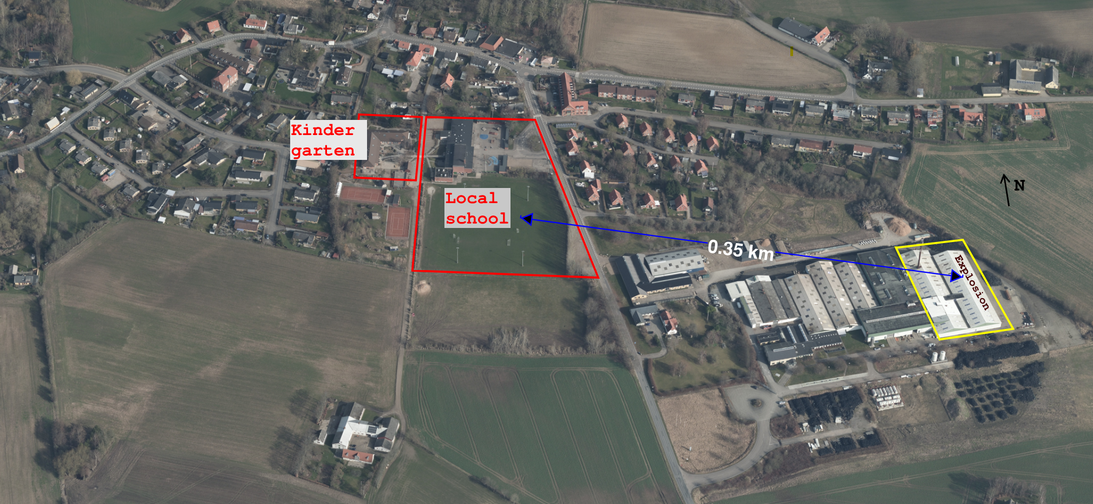
Figure 1 – Pyrolysis plant located at the outskirts of the Egebjerg rural community.
Source: Skraafoto, 31 March 2021
  - Explosion 2020
On August 17, 2020, an internal explosion occurred in a P4O reactor. The endcap was blown open with great force tearing all the heavy-duty bolts. There was significant material damage. A masonry wall was partly blown out, as was the roof above the reactor. Another wall presented with large cracks. There were no casualties.
Details of the circumstances leading to the explosion remain unclear. Initial DWEA documents state that to remove moisture from the waste plastic, valves towards the downstream condenser unit and stack were opened and burners lit. The oil pump for the burners had been replaced and an operator worked on oil and burner air adjustments. The reactor was not rotating. Most likely, burners heated the underside, pyrolysis gases were formed and ignited when the wall temperature exceeded the autoignition temperature of the gases.
In the initial DWEA reports, there is no information on efforts to flush out (purge) oxygen in the reactor with nitrogen, before igniting the burners. There is no mention that the presence of oxygen (air) inside the reactor constitutes a potential explosion hazard. The Company CEO later stated that the explosion took place during a brief oil burner adjustment, which ignited residue from a previous pyrolysis operation, and that nitrogen flushing was part of the normal start-up procedure. He attributed the cause of the accident to human error.
The accident took place during manual oil burner adjustment but there is no information on the whereabouts of workers. Based on the damage, the fact that a large flame must have shot out when the endcap was blown open, and falling debris from the collapsed roof section, it is unlikely that anyone in the room could have escaped unharmed. Only by pure chance did this incident not result in severe injury.
An inspector from the DWEA visited the site on the day of the accident. Because the accident took place during burner adjustment, the inspector immediately issued an enforcement order (#1) to ensure that burner adjustment can be carried out safely. The inspector also logged several violations:
- There was no written manual (a written manual in Danish is required).
- The worker had only received oral instructions from Spanish consultants and the Company manager.
- The worker was unaware of any explosion risks.
At a meeting on September 14, 2020, with representatives from both DWEA and the DSTA, additional violations were identified and logged:
- No risk assessment had been carried out.
- No ATEX assessment had been carried out.
- The pyrolysis plant was not CE marked.
A new enforcement order (#2) was issued, to investigate the causes of the explosion. The Company engaged a consultant to assist in producing the required documentation. A grainy photo of one page of the ATEX assessment is available, the methodology used was SCRAM (Scalable Risk Analysis and Evaluation Method). SCRAM is mainly relevant for machines covered by the EU Machinery Directive (Görnemann, 2007). The ATEX study concluded that the risk for personnel was low, and no further measures were required. The Company issued a CE statement of conformity with the following EU Directives and international standards:
- Machinery Directive 2006/42/EC.  - EMC Directive 2014/30/EU.  - ATEX Directive 2014/34/EU.  - ISO 12100:2010 Safety of Machinery.  - ISO 14121-2:2012 Safety of Machinery, Risk assessment, Part 2: Practical guidance.  - ISO 14121-1,2,3,4:2016 Safety of Machinery, Permanent means of access to machinery.  - ISO 13849-1:2015 Safety-related Parts of Control Systems. | - IEC 61511-1:2017 Functional Safety, Safety instrumented systems for the process industry.  - BS EN 746-2:2010 Industrial Thermoprocessing Equipment, Safety requirements for combustion and fuel handling systems.  - ISO 80079-36:2016 Explosive Atmospheres, Part 36: Non-electrical equipment.  - ISO 80079-37:2016 Explosive Atmospheres, Part 37: Non-electrical equipment, Control of ignition sources.
This satisfied the inspectors from the DWEA and the DSTA. On March 30, 2021, enforcement orders #1 and #2 were lifted, which permitted The Company to resume prototype test operations.
  - Explosion 2021
On October 8, 2021, a P4O pyrolysis reactor experienced a repeat internal explosion. Again, the explosion tore open the hinged endcap and the blast wave and ensuring fire caused extensive structural damage, the roof was gone and walls blown out (figures 2-5). There were no casualties as nobody was present.
The explosion took place during af full pyrolysis test run. The reactor was loaded with seven tonnes of baled waste plastic. The endcap was closed, bolts tightened, and nitrogen let into the reactor. At 07:15 oil burners were lit, and the pyrolysis process initiated. At 07:40 endcap bolts were re-tightened. At 07:45, when everybody was in the control room for a morning briefing, the reactor exploded. Burning liquid plastic flowed out of the open reactor and ignited baled waste plastic stored near the reactor. The company CEO briefly attempted to fight the fire using a fire hose reel but quickly had to accept defeat. The fire services were called at 07:47. At about 07:55 a sharp bang was heard followed by a hissing sound which was later determined to be a compressed gas cylinder that overheated and ruptured due to fire exposure.
The ensuing fire produced large amounts of black smoke. Children at the neighboring local school were instructed to stay indoors although a light wind blew the smoke away from the school.
On October 12, 2021, when the police had lifted area entry restriction, inspectors from DWEA and DSTA visited the site. The DWEA inspector noted that the reactor had experienced an internal pressure much higher than 50 kPa and issued an enforcement order (#3) for overpressure protection. Several violations were identified:
- The Company's CE statement did not include the Pressure Equipment Directive 2014/68/EU.
- The written start-up procedure called for pressurization of the reactor with nitrogen to 40 kPa but this pressure had not been verified by measurement. A worker had indeed purged with nitrogen, but the purge was terminated after two minutes, when gas was seen bubbling at a downstream water seal.
On October 16, 2021, notice was given of an enforcement order (#4) to investigate the causes of the explosion. On October 25, the Company informed that waste plastic pyrolysis activities at the site would be permanently shut down. This closed all open enforcement orders including the investigation of the causes of the explosion.
Readers unfamiliar with workplace accident investigation practices in Denmark may be surprised that all enforcement orders were lifted. The reason is that the DWEA authority is narrowly tasked with enforcement of the Occupational Health and Safety Act. If the company terminates operations, there are no longer any ongoing violations and hence nothing to enforce. Nor can the DWEA collect information for legal prosecution of violations. Companies have a legal obligation of disclosure to inspectors of whatever information is required for the DWEA to carry out its enforcement work. But according to the Due Process of Law Act, companies have no legal obligation to disclose potentially self-incriminatory information to inspectors (Hedlund & Aldrich, 2020). Only the police are authorized to carry out such investigations. The police terminated the investigation two days after the explosion however, as they could not identify wrongdoing or malicious intent – it was merely an accident.
  - Reactions of the local community
Initially, the local community in Egebjerg welcomed the pyrolysis activities, not the least because of the prospect of much-wanted employment opportunities. Complaints about nuisance odor and noise gradually cooled the enthusiasm. After the first explosion in 2020, concerns were raised about the soundness of having pyrolysis activities in the middle of a small community and close to the local school, but the political support for Greentech companies was unwavering. A chief executive of the local authority stated that the pyrolysis company was an up-and-coming enterprise with major development plans for the local community.
After the second explosion in 2021, the community reaction turned hostile. The mayor said that an accident that cannot and must not happen had now happened twice. Political support disappeared and various legal options to halt operations were considered. Not much could be done, however, because The Company had all the environmental permits, which according to law cannot be renegotiated for a grace period of eight years.
Large piles of about 1,000 tonnes of used car tires stacked on the premises added to the local discontent (figure 6). Two related but different legal companies did pyrolysis activities at the premises: The plastic P4O company and a tire T2O (Tire-2-Oil) company that was not damaged in the P4O explosions. A third related company owned the tires and had accepted them for a fee of more than 2 million DKK (0.3 million EUR), media said.
The ownership structure of the three companies is complicated and appears convoluted. The T2O company declared bankruptcy and was taken over in January 2022 by an, apparently unrelated, owner consortium comprising an auto mechanic and financial investors.
The local authority attempted legal action to have the tires removed, stating lack of permit to establish a private waste dump. Legal counsel advised against this however, as the legal status of the tires was in doubt: The tires could constitute illegal waste and the same time legal raw material for the tire pyrolysis company. A detailed exposition of ownership issues and legal quagmires is beyond the scope of this paper.
  - Discussion
The immediate cause of the two explosions is autoignition of flammable pyrolysis vapors. Because the pyrolysis process temperature is higher than the autoignition temperature of the pyrolysis gases, a source of ignition is always present inside the pyrolysis reactor. Inert gas purging is therefore essential to control explosion risk.
Inert gas purging makes the atmosphere oxygen deficient so that when pyrolysis gases are generated, an ignitable mixture cannot form. In combustion engineering terms, the inert gas dilutes the oxygen to below the Limiting Oxygen Concentration (LOC). It is no simple task to estimate the LOC for a pyrolysis gas mixture for which the gas composition is not known. A study carried out for pyrolysis of contaminated wood assumed that the LOC at 520 °C could be as low as 3 percent volume (Cuypers, 2011).

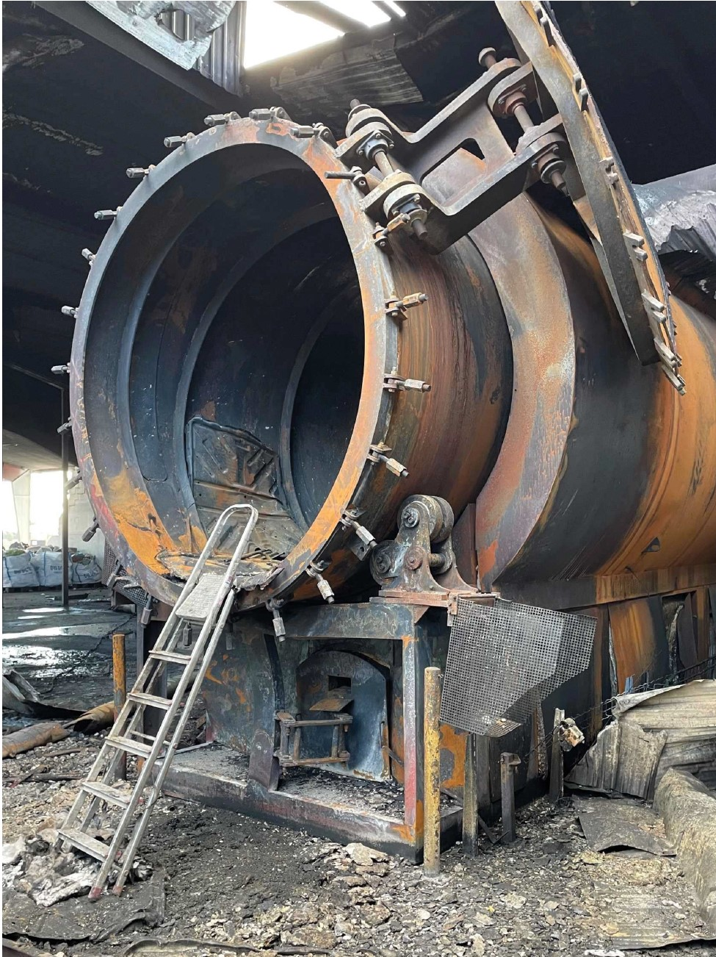  Figure 2 – Reactor endcap torn open, deformed, 2021 | 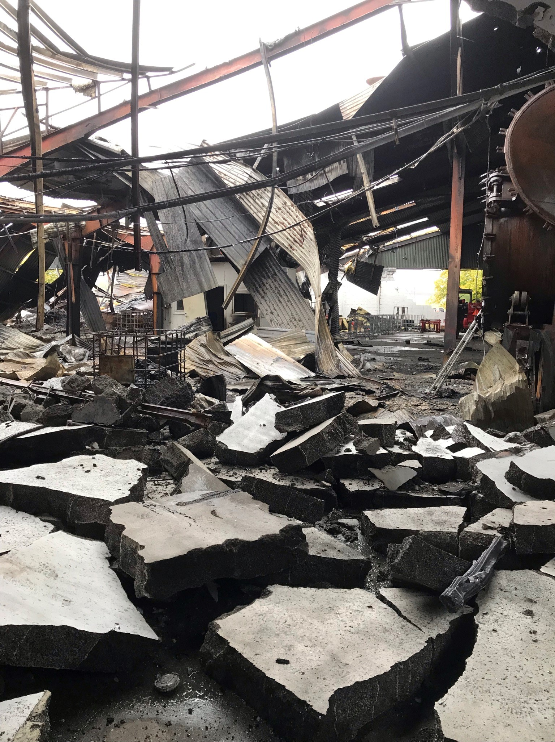  Figure 3 – Walls toppled due to explosion, roof gone, 2021 | 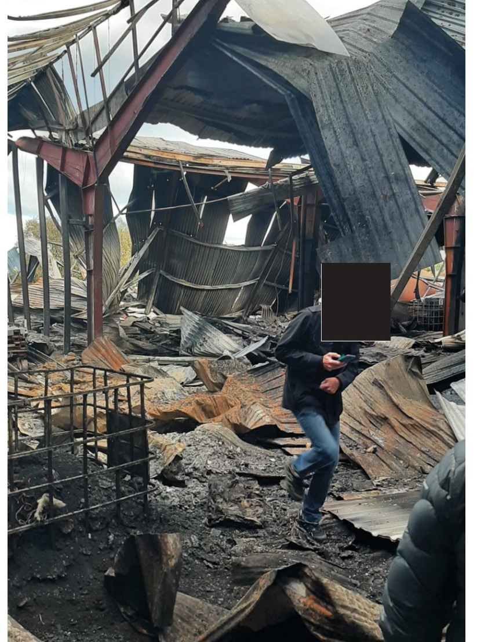  Figure 4 – Extensive fire damage, 2021
Source: Dockets retrieved through the Freedom of Information Act

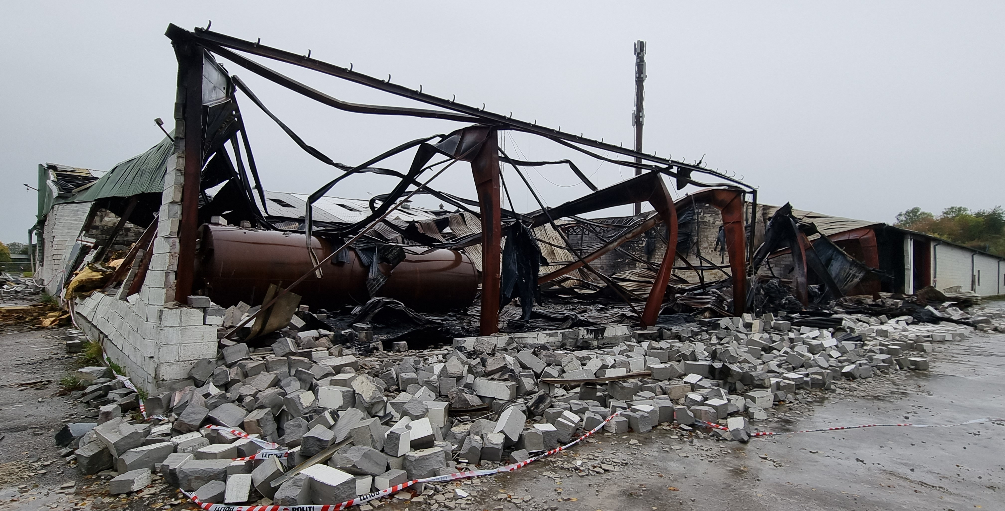  Figure 5 – Walls blown out, 2021 |  | 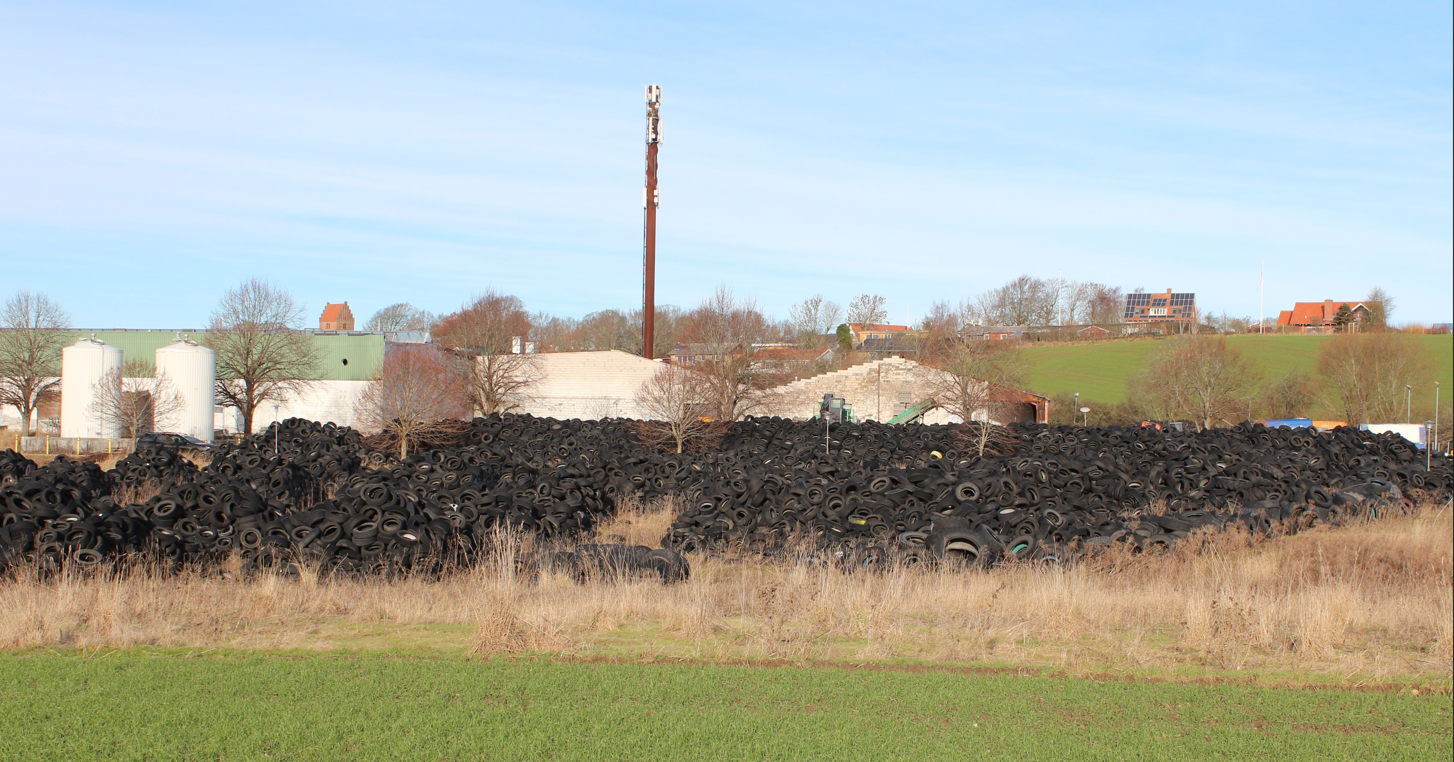  Figure 6 – Piles of unprocessed tires, Jan 2023
Source: Private collection | Source: Own work

The Company has vehemently stated that both explosions were caused solely by human error. While there is some truth to this, it is not the full story. Two conclusions can be drawn from the 2021 explosion. First, that premature termination of the nitrogen purge testifies to unqualified operators and a severe lack of basic process safety understanding. Second, that the Company's written start-up procedure, which called for pressurization of the reactor with nitrogen to 40 kPa, is equally problematic. Simple calculation yields that this reduces the oxygen concentration to 15 percent volume only, far above the safe LOC.
The idea that simple pressurization with nitrogen could be an effective inerting procedure is indeed unconventional. Repeated alternating pressurizations could indeed be effective (NFPA, 2014), in German standards known as "Druckwechselverfahren" (TRBS, 2012), which involves drawing a partial vacuum on the vessel and breaking it with an inert gas. The Company's startup inerting procedure is clearly unsafe, and it is an open question why earlier pyrolysis test runs did not result in an internal explosion.
A comparative review of the environmental permit and the DWEA/DSTA documents reveals a stark difference in timing, level of detail, and subject matter insight. The environmental permit contains no less than 49 detailed conditions, including emissions of odor, noise, dust, high-level alarms on tanks, etc. Regarding Best Available Techniques (BAT), the permit states that pyrolysis precisely contributes to the purpose of BAT by helping to find new ways to deal with waste plastic. The permit activity takes place before the plant is constructed.
In contrast, the DWEA and DSTA inspectors only arrive after a severe explosion has taken place, their level of insight is limited, and most of their actions are futile. The identified violations: lack of instructions, no ATEX assessment, and no CE statement, were all rectified but did not prevent a repeat explosion. The underlying root causes, a limited grasp of explosion protection engineering and inert gas purging procedures were not identified after the first explosion and remained unidentified even after the second explosion. The accidents were not investigated, and any lessons learned not identified. The importance of learning from past mishaps should not be underestimated. An explosion of a pyrolysis plant in Finland, was also attributed to nitrogen purge difficulties (Talvitie et al., 2014). Other authors (Rollinson and Oladejo, 2019) have expressed frustrations with the safety performance of the Greentech industry that promotes regenerative circular systems, often touting climate action, responsibility, and sustainability. Quoting Rollinson (2018):
"If the [pyrolysis] waste industry is to avoid further process losses, it must learn from the lessons of gasification history and the lessons of risk assessment developed through major chemical process accidents of the past. At present however, risk is being aggravated by a reluctance to disclose or address these failures, preferences for novelty, a lack of stakeholder understanding, and a desire to operate beyond technological capabilities" (Rollinson, 2018).
This paper does not decry the value of pyrolysis for recycling of heterogeneous and dirty waste plastic. It merely draws attention to an important fact, that many processes related to the green transition, alternative fuels, and zero-carbon initiatives have similar, but sometimes unrecognized, hazard profiles as the traditional fossil chemical process industry (Hedlund and Madsen, 2018). Utmost care should be taken to avoid so-called media shifting (Ashford, 1997) – that the resolution of a problem within one domain, the climate or environmental domain, comes at the expense of new problems in another, the workplace safety domain.
  - Conclusion
Many countries set ambitious targets for recycling of plastic. Pyrolysis may have an important role to play as it can transform dirty household waste plastic into feedstocks for production of new virgin plastic – essential for recycled plastic intended to come into contact with foods. But pyrolysis is an inherently hazardous process and rigorous hazard assessment and safety engineering are required to ensure plant safety. The case presented in this paper raises important questions about barriers to entry, levels of regulatory oversight, accident investigation practices, and the need for a serious mechanism to share lessons learned.
Acknowledgments
This paper has been produced as a voluntary effort and did not receive any funding support. Opinions expressed are strictly those of the author, not of his employers or organizations. Mr. R.S. Selig kindly commented on an early version of the manuscript.
References
Ashford, N. A. (1997) ‘Industrial safety: the neglected issue in industrial ecology’, Journal of Cleaner Production, 5(1), pp. 115–121. doi: 10.1016/S0959-6526(97)00024-3.
Cuypers, F. (2011) Low temperature pyrolysis of CCA treated wood (PhD thesis). KU Leuven, Belgium.
Elsdon, R. and Pal, D. (2011) ‘Waste-To-Energy plant process safety challenges’, in Hazards XXII: Process Safety and Environmental Protection. Inst Chem Engineers, pp. 356–360.
Görnemann, O. (2007) ‘SCRAM - Scalable Risk Analysis and Evaluation Method’, in ESREL 2007 Safety & Reliability Conference, Stavanger / Norway.
Hedlund, F. H. and Aldrich, P. T. (2020) Forbedret opklaring og læring efter alvorlige og komplicerede ulykker [Improved investigation and learning after serious and complicated accidents]. COWI.
Hedlund, F. H. and Madsen, M. (2018) ‘Incomplete understanding of biogas chemical hazards’, Journal of Chemical Health and Safety, 25(6), pp. 13–21. doi: 10.1016/j.jchas.2018.05.004.
Jankuj, V. et al. (2022) ‘Safety of Alternative Energy Sources: a review’, Chemical Engineering Transactions, 90, pp. 115–120. doi: 10.3303/CET2290020.
NFPA (2014) NFPA 69. Standard on Explosion Prevention Systems. Quincy, Massachusetts, USA: National Fire Protection Association.
Qureshi, M. S. et al. (2020) ‘Pyrolysis of plastic waste: Opportunities and challenges’, Journal of Analytical and Applied Pyrolysis, 152. doi: 10.1016/j.jaap.2020.104804.
Rollinson, A. N. (2018) ‘Fire, explosion and chemical toxicity hazards of gasification energy from waste’, Journal of Loss Prevention in the Process Industries, 54, pp. 273–280. doi: 10.1016/j.jlp.2018.04.010.
Rollinson, A. N. and Oladejo, J. M. (2019) ‘“Patented blunderings”, efficiency awareness, and self-sustainability claims in the pyrolysis energy from waste sector’, Resources, Conservation and Recycling, 141, pp. 233–242. doi: 10.1016/j.resconrec.2018.10.038.
Talvitie, M., Nissilä, M. and Pietikäinen, S. (2014) ‘Explosion at a pyrolysis plant in Joensuu: Abstract’.
Thiounn, T. and Smith, R. C. (2020) ‘Advances and approaches for chemical recycling of plastic waste’, Journal of Polymer Science, 58(10), pp. 1347–1364. doi: 10.1002/pol.20190261.
TRBS (2012) ‘TRBS 2152 Teil 2: Vermeidung oder Einschränkung gefährlicher explosionsfähiger Atmosphäre. [Part 2: Prevention or reduction of explosive atmospheres]’, GMBl, 22, pp. 398–410.

