CHEMICAL ENGINEERING TRANSACTIONS  VOL. , 2023 | A publication of
The Italian Association
of Chemical Engineering
Online at www.cetjournal.it

Guest Editors: Sauro Pierucci, Jiří Jaromír Klemeš
Copyright © 2023, AIDIC Servizi S.r.l.
ISBN 978-88-95608-98-3; ISSN 2283-9216

APPLICATION OF HYDROGEL IN FIXED BED FOR WATER REMOVAL FROM FUELS: EFFECT OF OPERATING CONDITIONS
Henrique L. Gonçalvesª, Patrícia B. L. Fregolente^{b}, Maria Regina W. Macielª, Leonardo V. Fregolente^{a*}
ªUniversity of Campinas, Chemical Engineering School, 13081-970 Campinas, São Paulo, Brazil
^{b}Salesian University Center of São Paulo, 13075-490 Campinas, São Paulo, Brazil
*leonardo@feq.unicamp.br
The concentration of water above the specification defined by regulatory agencies can impact performance and reliability of the use of fuels (e.g., corrosion and filter clogging), thus separation processes are necessary to reduce or control the water content of fuels. This necessity may lead to high investments or operational costs, so alternative technologies to remove water from fuels have been considered. They include the use of polymeric hydrogels. As demonstrated in recent studies, hydrogels can remove free, emulsified and soluble water, and based on that, in his work poly(sodium acrylate-co-acrylamide) hydrogel packing, similar to Raschig Rings, here named Ring Packed Hydrogel Bed, was designed and applied as a hydrophilic bed for water removal from diesel and biodiesel. The effects of temperature, flow rate and the hydrogel initial water content on the efficiency of water removal were analyzed. The results for diesel demonstrated that under the operating conditions explored, the use of hydrogels can reduce the water content to meet the commercial standards. Also, it was shown that the efficiency of the process to dry a high hygroscopic biodiesel, where water content reductions of up to 36.9 wt% (from 2146 ± 8 ppm) were achieved. The results can be used for the design of industrial equipments that use the hydrogel technology.
  - Introduction
The presence of water in high concentrations in fuels is a common concern that can result in corrosion of fuel systems, impact the expected fuel properties, lead to microorganism growth and reduce the safety of vehicles (Chen et al., 2022). Thus, maximum water content in fuels is specified by regulatory agencies, being 200 ppm for diesel (EN 590, 2009) and 500 ppm for biodiesel (EN 14214, 2012) in the European Union. Considering that water can be incorporated into fuels during their processing (e.g., during product stripping or washing), transport or storage (Gonçalves et al., 2020), the removal of the incorporated water is usually necessary for the product commercialization.
Currently, the technologies used for water removal from fuels, such as separation by gravity, centrifuges, coalescing filters, distillation, or use of salts (Troyer, 2019) can have a series of drawbacks, namely high costs (initial or operational), not removing solubilized water (the most difficult type of water to remove), generation of effluents or corrosion of equipments. In this context, the use of hydrogels as an alternative for water content reduction has been studied recently (Gonçalves et al., 2020), achieving reduction of fuel turbidity (Fregolente et al., 2023) and studying the kinetics of water removal (Santos et al., 2022). Polymer hydrogels are highly hydrophilic network materials, capable of associating themselves with big quantities of water without dissolving (Oyen, 2013).
In this work, it was studied the potential application of poly(acrylamide-co-sodium acrylate) hydrogels (PAAm-co-SA) as desiccant materials to remove water from fuels continuously. Fuels with different water contents (only solubilized water or emulsified and solubilized water) were used to feed the hydrogel bed. Also, the influence of feed flow rate and temperature were studied following an experimental design.
Raschig Rings-like PAAm-co-SA were used as random packing for water removal from diesel and biodiesel. This geometry was chosen to allow a large surface area of contact between the fuel and the hydrogel, and at the same time, due to the simplicity of production. It was evaluated the regeneration capacity of the hydrogel and how the regeneration impacts the particle geometry.
  - Materials and methods
Based on previous studies of the research group for hydrogel synthesis and use for water removal from fuels (Gonçalves et al., 2020), experiments were carried out.
    - Materials
For the synthesis of the hydrogel, acrylamide (AAm) ultrapure (Amresco), sodium acrylate (SA) 97 % (Aldrich), N,N’-methylenebisacrylamide (mBAAm) ultrapure (USB), potassium persulfate 99 % (Fisher Scientific) and N,N,N,N’-tetramethylethylenediamine (TEMED) 99 % (Sigma-Aldrich) were used.
Diesel was used in studies of the influence of flow rate and temperature on the water removal capacities of the hydrogel bed, and biodiesel was used on the experiments of hydrogel regeneration and fuel turbidity. The diesel was purchased at a local gas station. In the case of biodiesel, two types were used: one was synthetized by the research group using soybean oil, and another was highly hygroscopic biodiesel donated by a local distributor. Some of their properties are shown on Table 1. The Boiling Point (BP) distribution of the diesel – obtained following the ASTM D7169 standard (2020) – is presented on Table 2.
Table 1: Fuel properties
 | Method | Diesel | Biodiesel | Highly Hygroscopic Biodiesel
Density (g/cm³) at 20 °C | ASTM 4052 (2018) | 0.84230 ± 0.00003 | 0.88108 ± 0.00001 | 0.88457 ± 0.00001
Viscosity (mm²/s) at 40 °C | ASTM D445 (2018) | 2.894 ± 0.003 | 4.151 ± 0.0022 | -
Peroxide Value (mmeq/kg) | Kong and Singh (2011) | - | 7.07 ± 1.01 | 250.02 ± 27.59
Flash Point (°C) | ASTM D56 (2022) | 61.4 ± 1.3 | - | -
Table 2: Boiling Point (BP) distribution for diesel
Recovered mass | 5% | 10% | 30% | 50% | 70% | 90%
Temperature (°C) | 209.2 | 223.9 | 267.9 | 304.0 | 357.5 | 424.6
    - Hydrogel Packing Production
For each 50 ml of solution, 1 g of AAm, 1.5 g of SA, 0.069 g of mBBAm and 1 ml of TEMED (0.57 mol/l) was solubilized in distilled water, at room temperature. N₂ gas was bubbled into the solution for 10 minutes, inside of plastic tubes (1.5 cm diameter), and 0.02 g of sodium persulfate was added to the mixture. The bubbling was kept until the formation of the hydrogel. Then, a glass rod of 1.0 cm of diameter was inserted in the center of the plastic tube and the hydrogel was left to rest for at least 24 hours. Afterwards, the glass rod was removed, and the hydrogel was cut in the geometry of Raschig rings and oven dried at 60 °C.
    - Water removal from highly hygroscopic biodiesel
The hydrogel Raschig Rings were applied as random packing inside a 4.5 cm of diameter column. The bed height used was 6.0 cm, with the porosity of 0.65. This configuration was used for all the experiments that included the hydrogel bed.
The highly hygroscopic biodiesel was saturated with water (2146 ± 8 ppm) and fed into the hydrogel bed, at a flow rate of 7.5 ml/min (upstream) and a temperature of 25 °C. Afterwards, biodiesel containing other water contents (1426 ± 13 ppm and 1479 ± 8 ppm) were fed into the bed under the same condition. The water content of the outlet biodiesel stream was measured every 30 minutes. Figure 1 shows the hydrogel bed operating on water removal from biodiesel, as well as the hydrogel Raschig Rings.
After this water removal experiment, the hydrogel cylinders were removed from the bed and regenerated - washed with ethanol and oven dried at 60 °C - before being reused. This experiment was then repeated using the regenerated hydrogel, to evaluate if any performance change could be perceived. This repetition was carried out with inlet streams containing 1864 ± 35 ppm, 1661 ± 6 ppm and 1561 ± 20 ppm of water. All the water content measurements, here and in the next sections, were made through Karl Fischer titration, following the ASTM D6304 standard (2020) on a Metrohm 852 Titrando equipment.
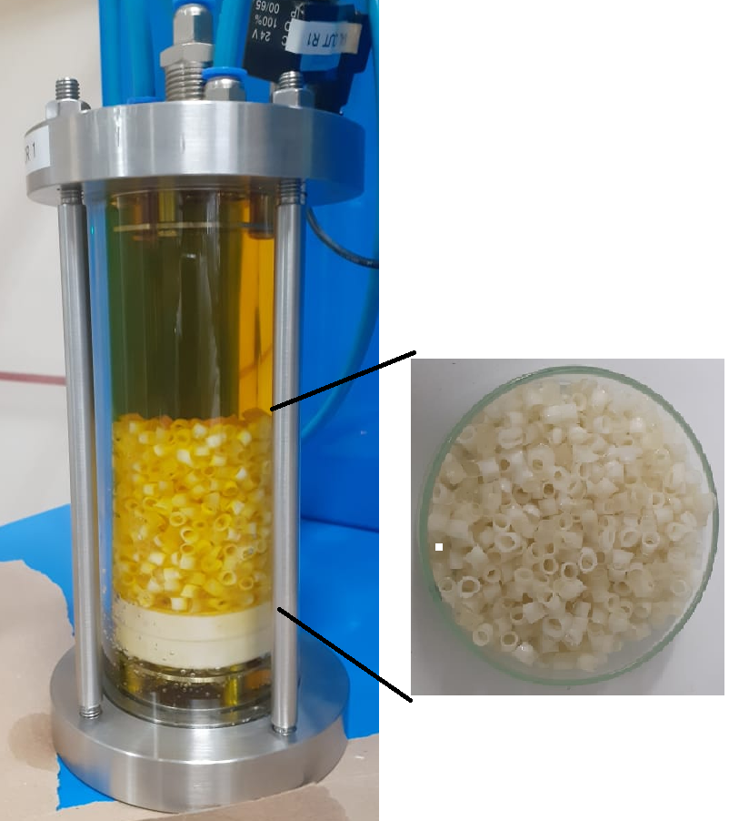
Figure 1: Hydrogel bed for removal of water from fuels
    - Hydrogel dimensional evaluation
30 pieces of hydrogel Raschig Rings used in the experiment described on section 2.3 were randomly picked and had their height, inner diameter and outer diameter measured with a paquimeter, both before the experiment and after being regenerated. It was important to verify if the regeneration process affects the material dimensions (i.e. column parameters) and if it should be considered on a future column design for industrial applications.
    - Biodiesel Turbidity reduction using the hydrogel bed
The biodiesel synthetized by the research group was used on an experiment to evaluate the hidrogel bed capacity of reducing the fuel turbidity. Turbidity is a way to measure the presence of free water (Pangetsu and Stanfel, 2009) and an important quality parameter for fuel commercialization. For producing turbid biodiesel, 3 wt% of distilled water was added to the biofuel and mixed using an Ultra Turrax disperser (IKA, model T65 digital) for 30 min, at 4000 rpm. The Haze scale (ASTM D4176, 2022) was used to determine the turbidity. This emulsion was fed into the hydrogel column, and the outlet stream had its water content and turbidity determined. Then, after regenerating the hydrogel and slightly swelling it using 0.12 g H₂O/g hydrogel, the same experiment was repeated in duplicate, to evaluate how the hydrogel swelling due to water adsorption (expected at continuous processes, after a sufficient operational period) affects the water removal capacity. Biodiesel was chosen instead of diesel for this experiment for being more hydrophilic, what makes water removal more challenging and results in a higher water content at the outlet stream. This higher water content is expected to make the differences in results between the experiments easier to perceive.
    - Effects of flow rate and temperature on water removal from diesel
To better understand the impact of some operational conditions of the bed on the water removal from fuels containing low water content, as well as the hydrogel performance on a less hydrophilic fuel (diesel), an experimental design (2² factorial design) was carried out, with diesel flow rate and temperature being the factors and the percentage of water content reduction the response. Diesel saturated with water (214 ± 34 ppm) was used, there were three experiments at the center points, and the experimental ranges were 7.5-22.5 ml/min and 28.6-46.4 °C.
  - Results and discussions
The results from the continuous water removal from diesel and biodiesel, as well as a dimensional evaluation of the Raschig Ring hydrogels, are presented on this section.
    - Water removal from highly hygroscopic biodiesel
For this experiment, a highly hygroscopic biodiesel was used. This hygroscopicity can be associated with its high peroxide value, as shown on Table 1, indicating severe oxidation. The water content of the outlet biodiesel stream during the experiment is shown on Figures 2a (new hydrogel) and 2b (regenerated hydrogel), as well as the water content at the feed (for comparison purposes). On these Figures, Experiments 1 to 3 were done sequentially, with recently synthetized hydrogel and different water contents at the feed, and Experiments 4 to 6 were done sequentially after regenerating the hydrogel.
It is worth highlighting that the biodiesel at the feed was attested to have only soluble water, the water form of most challenging removal. Water content reductions of up to 36.9 wt% was obtained for the recently synthetized hydrogel, and up to 32.9 wt% for the regenerated hydrogel. Although these values are similar, the biodiesel on the experiments with regenerated hydrogel resulted in a lower water content on the outlet stream. Also, comparing experiment 3 (1479 ± 8 ppm at the feed, 1347 ± 9 ppm at the outlet after 3 hours) with experiment 6 (1561 ± 20 ppm at the feed, 1160 ± 6 ppm at the outlet after 3 hours), even with a higher water content being fed into the bed, a smaller water content was obtained at the outlet stream.
After 3 hours of experiment steady state was reached, and the hydrogel did not lose its water removal ability, what would happen when saturated.
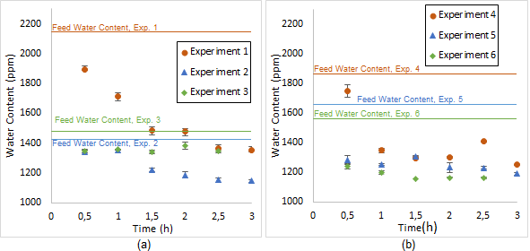
Figure 2: Water removal from biodiesel using (a) new hydrogel bed and (b) regenerated hydrogel bed
    - Hydrogel Dimensional Evaluation
After the hydrogel synthesis (new hydrogel) and the set of Experiments 4-6 (regenerated hydrogel), the hydrogel Raschig Rings had their dimensions measured, and the obtained values are presented on Table 3.
The regeneration capacity of the hydrogel is an important parameter for its commercial viability, enabling reuse. Here, the possibility of the regeneration procedure affecting the dimensions of the hydrogel Raschig Rings was studied, From the values on Table 3, statistically there is no difference on the particle dimensions, thus, the regeneration process does not affect, on any noticeable way, the cylinders geometry.
Table 3: Hydrogel cylinders dimensions
 | New Hydrogel | Regenerated Hydrogel
Height (mm) | 5.4 ± 0.9 | 5.3 ± 0.6
Inner Diameter | 3.5 ± 0.3 | 3.2 ± 0.2
Outer Diameter | 5.2 ± 0.3 | 5.1 ± 0.2
    - Turbidity reduction using the hydrogel bed
The outlet water content using a dry hydrogel was 1890 ± 43, while at the two experiments using a slightly swollen hydrogel were 1733 ± 2 ppm and 1658 ± 6 ppm, indicating that a swollen hydrogel improved the water removal capacity. This improvement is better perceived on Figure 3, which shows the Haze of the biodiesel.
From Figure 3 it can be noticed that for the dry hydrogel, while the biodiesel became less cloudy, the Haze value kept at 6 (the maximum value at the scale), while using the slightly swollen hydrogel the Haze value went from 6 down to 2, a noticeable turbidity reduction. One potential reason for this behavior is that a hydrogel, when swollen, has bigger and more noticeable pores than a dry hydrogel (Gonçalves et al., 2020). Thus, it facilitates the entrance of water into the hydrogel, improving the removal of water and reducing turbidity more efficiently. The experiments from section 3.1, that used dry hydrogel at the start of the sets of experiments, had an outlet water content reduction over time. Considering that the hydrogel swells when retaining water, it again shows that a slightly swollen hydrogel has improved water removal capacity.
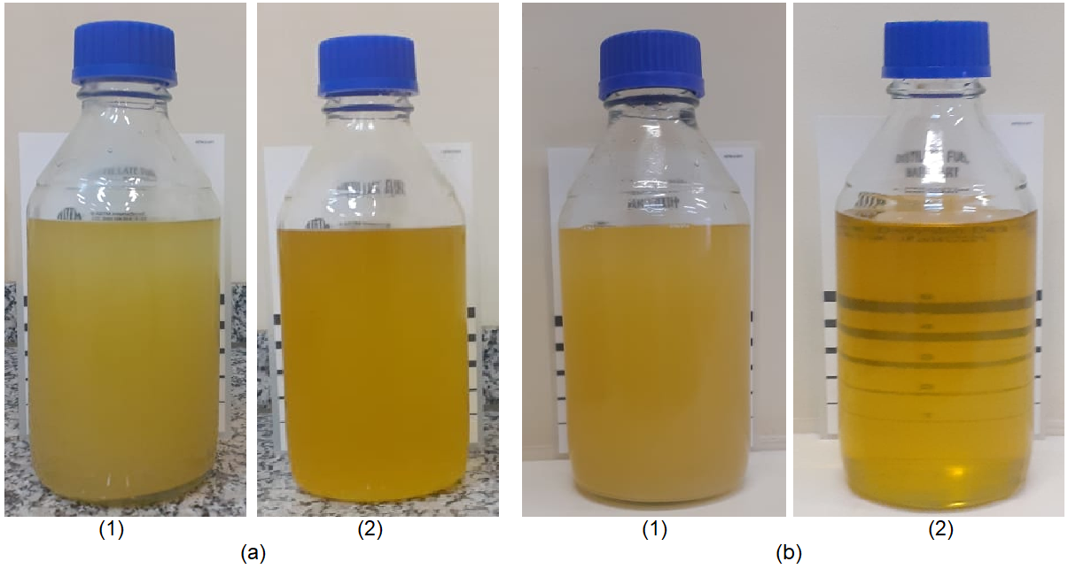
Figure 3: Haze of biodiesel fuel (1) before and (2) after treatment by the bed containing (a) dry and (b) slightly swollen hydrogel
Although a slightly swollen hydrogel ends up being more efficient on turbidity reduction and water removal than a dry one, further swelling of the hydrogel would result on bed clogging, loss of mechanical strength of the material and of its geometric conformation, and reduction of the efficiency of water removal. Hence, keeping the material under an ideal swollen range and regenerating it is important for the bed operation.
    - Effects of flow rate and temperature on water removal from diesel
The water content reductions, using diesel saturated with water (214 ± 34 ppm), are shown in Table 4, following an experimental design at different temperature and flow rate levels. The coded levels are presented in parentheses, and the parameters effects and confidence limits (95% of confidence) are shown in Table 5.
Table 4: Experimental design for water removal from diesel
Temperature (°C) | Flow Rate (ml/min) | Removal (%)
28.6 (-1) | 7.5 (-1) | 26.4
46.4 (+1) | 7.5 (-1) | 26.3
28.6 (-1) | 22.5 (+1) | 12.7
46.4 (+1) | 22.5 (+1) | 5.8
37.5 (0) | 15 (0) | 16.9
37.5 (0) | 15 (0) | 23.5
37.5 (0) | 15 (0) | 23.3
Table 5: Effects of parameters and confidence limits
 | Effect | -95 % Confidence Limit | +95% Confidence Limit
Mean | 19.3 | 14.4 | 24.1
Temperature | -3.5 | -16.4 | 9.3
Flow Rate | -17.1 | -30.0 | -4.3
Temperature by Flow Rate | -3.4 | -16.3 | 9.4
Considering the information in Table 3, for the studied experimental range, only the flow rate was significant. The importance of diesel flow rate was expected to be of importance, because it is related to the fuel residence time, and higher flow rates (i.e. lower residence time) reduces the interval in which the hydrogel and the water in the fuel can interact, and it is known that the hydrogel-fuel contact time impacts the water removal results, due to the adsorption kinetics (Santos et al. 2022). On the other hand, while there are reports on the literature of temperature increases affecting positively the water removal from fuels by a hydrogel (Santos et al., 2022), due to adsorption being an exothermic process, there is also an increase of water solubility in the fuel as temperature rises, which could affect negatively the water removal. Thus, how a temperature change impacts (if there is an impact) the water removal from fuels depends on the experimental range, hydrogel composition and fuel being studied. On the present study, no influence ended up being perceived.
  - Conclusions
This work further developed the studies of water removal using hydrogels, focusing on the use of a bed filled with Raschig Ring-shaped pAAm-co-SA hydrogels. It demonstrated that the hydrogel is capable of removing soluble water (the type of water of most complicated removal) from a highly hygroscopic biodiesel, with reductions of up to 32.9 wt%. It was demonstrated that regenerating and reusing the hydrogel does not hinder the water removal capacity. An experimental design to evaluate how temperature and flow rate impacts the hydrogel bed performance showed that, under the experimental range, the flow rate has a bigger influence on the bed operation than the temperature (which was not significant). Also, it is expected that the bed swells a little during its operation, due to retaining water, and it was perceived that this little swelling seems to improve the turbidity reduction by the hydrogel. Therefore, important contributions for the future development of industrial equipments using hydrogels were shown on the present work.
Acknowledgments
The authors are grateful to FAPESP (grant n° 2015/20630-4, 2017/12120-1 and 2021/03472-7), CNPq (grant n° 140005/2022-6 and 313952/2020-5) and CAPES (finance code 001).
References
ASTM International, 2018, ASTM D4052: Standard Test Method for Density, Relative Density, and API Gravity of Liquids by Digital Density Meter, West Conshohocken, PA.
ASTM International, ASTM D445: Standard Test Method for Kinematic Viscosity of Transparent and Opaque Liquids (And Calculation of Dynamic Viscosity), West Conshohocken, PA.
ASTM International, 2022, ASTM D4176-22: Standard Test Method for Free Water and Particulate Contamination in Distillate Fuels (Visual Inspection Procedures), West Conshohocken, PA.
ASTM International, 2022, ASTM D56-22: Standard Test Method for Flash Point by Tag Closed Cup Tester, West Conshohocken, PA.
ASTM International, 2020, ASTM D6304-20: Standard Test Method for Determination of Water in Petroleum Products, Lubricating Oils, and Additives by Coulometric Karl Fischer Titration, West Conshohocken, PA.
ASTM International, 2020, ASTM D7169-20E1: Standard Test Method for Boiling Point Distribution of Samples with Residues Such as Crude Oils and Atmospheric and Vacuum Residues by High Temperature Gas Chromatography, West Conshohocken, PA.
Chen T., Xu X., Hu J., Guo L., Yang S., Zhao T., Ma J., 2022, Water behavior of current jet fuel versus operating conditions: Storage time, temperature, relative humidity and anti-icing agent, Fuel, 309.
CEN (European Committee for Standardization), 2009, EN 590, Automotive Fuels – Diesel – Requirements and Test Methods.
CEN (European Committee for Standardization), 2012, EN 14214, Liquid petroleum products. Fatty acid methyl esters (FAME) for use in diesel engines and heating applications. Requirements and test methods.
Fregolente L. V., GONCALVES H. L., Fregolente P. B. L., Wolf Maciel M. R., 2023, Sodium Polyacrylate Hydrogel Fixed Bed to Treat Water-Contaminated Cloudy Diesel, Fuel, vol. 332 (1).
Gonçalves H. L., Fregolente P. B. L., Wolf Maciel M. R., Fregolente L. V., 2020, Formulations of hydrogels for water removal from diesel and biodiesel, Separation Science and Technology, vol. 55.
Kong F., Singh R. P., 2011, 12 - Advances in instrumental methods to determine food quality deterioration, Chapter In: Food and Beverage Stability and Shelf Life, Woodhead Publishing Series in Food Science, Technology and Nutrition.
Oyen M. L., 2013, Mechanical characterisation of hydrogel materials, International Materials Reviews, vol. 59.
Pangetsu F. D, Stanfel C. M., 2009, Media for Water Separation from Biodiesel-Ultra Low Sulfur Diesel Blends, SAE International Journal of Fuels and Lubricants, 2 (1), 305-316.
Santos F. B., Perez I. D., Fregolente L.V., Wolf Maciel M. R., 2022, Application of Poly(acrylamide-co-acrylonitrile) Hydrogel to Remove Soluble Water from Biodiesel and Evaluation in the Control Mechanism of the Mass Transfer Process in an Adsorption Process, Chemical Engineering Transactions, 92, 487-492.
Troyer, D., 2019, Removing Water Contamination from Oil, Machinery Lubrication, 1– 6.

