CHEMICAL ENGINEERING TRANSACTIONS  VOL. , 2023 | A publication of
The Italian Association
of Chemical Engineering
Online at www.cetjournal.it

Guest Editor: Sauro Pierucci
Copyright © 2023, AIDIC Servizi S.r.l.
ISBN 978-88-95608-98-3; ISSN 2283-9216

Identification of Consequences of Failure for Hydrogen Equipment
Federico Ustolin*, Alessandro Campari, Leonardo Giannini, Elena Baboi, Nicola Paltrinieri
Department of Mechanical and Industrial Engineering, Norwegian University of Science and Technology NTNU, Richard Birkelands vei 2B, 7034 Trondheim, Norway
federico.ustolin@ntnu.no
Hydrogen has not only the potential of tackling climate-related issues by replacing fossil fuels, but it also plays a main role in the energy transition which will have several geopolitical implications. According to the International Renewable Energy Agency (IRENA), relations between countries and communities will be transformed by “a new energy age” changing the concept of power, security, energy independence and prosperity. For these reasons, the interest in hydrogen recently skyrocketed as shown by the hydrogen strategies developed by many countries in the world. This will result in a considerable increase of hydrogen produced, stored, and consumed worldwide in the near future. Safety aspects must always be considered during the whole hydrogen lifecycle. The aim of this study is to pinpoint the consequences of failure for hydrogen technologies and the most common types of techniques developed and validated to assess them. Different types of models including theoretical and numerical ones were adopted to assess these consequences in the past. The advantages and drawbacks of these types of techniques are highlighted in this work. The intent is to provide critical insights to analysts carrying out the risk assessment in order to improve the overall safety of hydrogen technologies.
  - Introduction
The International Renewable Energy Agency (IRENA, 2022) stated that a new energy age will drastically modify the relationships between nations and communities and will bring out novel concepts of power, security, energy independence and prosperity. In this perspective, hydrogen has been largely indicated as a clean and sustainable energy carrier, capable of mitigating greenhouse gas emissions, tackling global warming, and making countries energetically self-sufficient. For this reason, 29 countries, all over the world, have already released national hydrogen strategies, and other 13 are including hydrogen in their decarbonization policies, even without an official and binding guideline. It is worth mentioning that most of the countries with consolidated and already implemented hydrogen strategies are in Europe, while only few Asian nations have developed a defined plan (HyResource, 2023). Hydrogen demand is expected to grow exponentially in the forthcoming years, reaching 10% of the global final energy consumption by 2050 (IEA, 2021). Despite the potential environmental advantages of this energy carrier, its broad-based utilization is sometime held back by safety concerns associated with the peculiar physiochemical properties of this substance. Its low minimum ignition energy (0.017 mJ (Ono et al., 2007)), wide flammability range (4 %vol – 75 %vol in air (McCarty et al., 1981)) make hydrogen extremely flammable and explosive. On the other hand, hydrogen has a few characteristics such as its buoyancy and high burning velocity compared to other conventional fuels (e.g. gasoline, natural gas) that may reduce the overall risk in case of releases.
Safety aspects associated with hydrogen handling and storage have been thoroughly investigated to reduce the probability of component failures and mitigate the consequences of potential undesired releases. Unignited dispersions, fires, and explosions are the most likely scenarios resulting from a loss of integrity (LOI). In past years, several consequence analysis techniques have been developed and validated to quantitatively estimate the severity of hydrogen fires and explosions through a variety of parameters, depending on the specific accident scenario. Theoretical, analytical, and numerical models have been developed and used to assess the yield of the hydrogen releases consequences. This study aims to summarize these consequences and discuss the main types of models developed for the consequence analysis by highlighting their advantages and drawbacks. The outcomes of this study can be exploited by safety analysts to identify the consequences of failure as part of quantitative risk assessments for hydrogen technologies. In addition, they can be used for a risk-informed design of industrial equipment and safety devices, thus stimulating an increasingly widespread rollout of hydrogen technologies in the future.
  - Identification of consequences of failure
The first step to collect and analyze the different consequence analysis techniques is to identify the consequences that may occur from the LOI and loss of containment (LOC) of hydrogen equipment. Different methodologies were proposed to generate event trees which are implemented together with fault trees in the bow-tie diagrams during a risk analysis. Event trees gather the potential consequence of failure for each selected critical event (e.g. leak from pipe, catastrophic rupture), while the fault trees provide information on the causes that might lead to the critical events. One of the most used techniques to building event trees is the Methodology for the Identification of Major Accident Hazards (MIMAH). Therefore, this methodology can be exploited to identify the consequences of failure for hydrogen technologies.
    - MIMAH methodology
MIMAH methodology used for the building of generic event trees was developed during the project ARAMIS (Accidental Risk Assessment Methodology for Industries) (Delvosalle et al., 2006). The main steps of the MIMAH methodology to create a generic event tree are as follow: Step 1: collect needed information; Step 2: identify potentially hazardous equipment in the plant; Step 3: select relevant hazardous equipment; Step 4: for each selected equipment, associate critical events; Step 5: for each critical event, build a fault tree; Step 6: for each critical event, build an event tree; Step 7: for each selected equipment, build the complete bow-ties
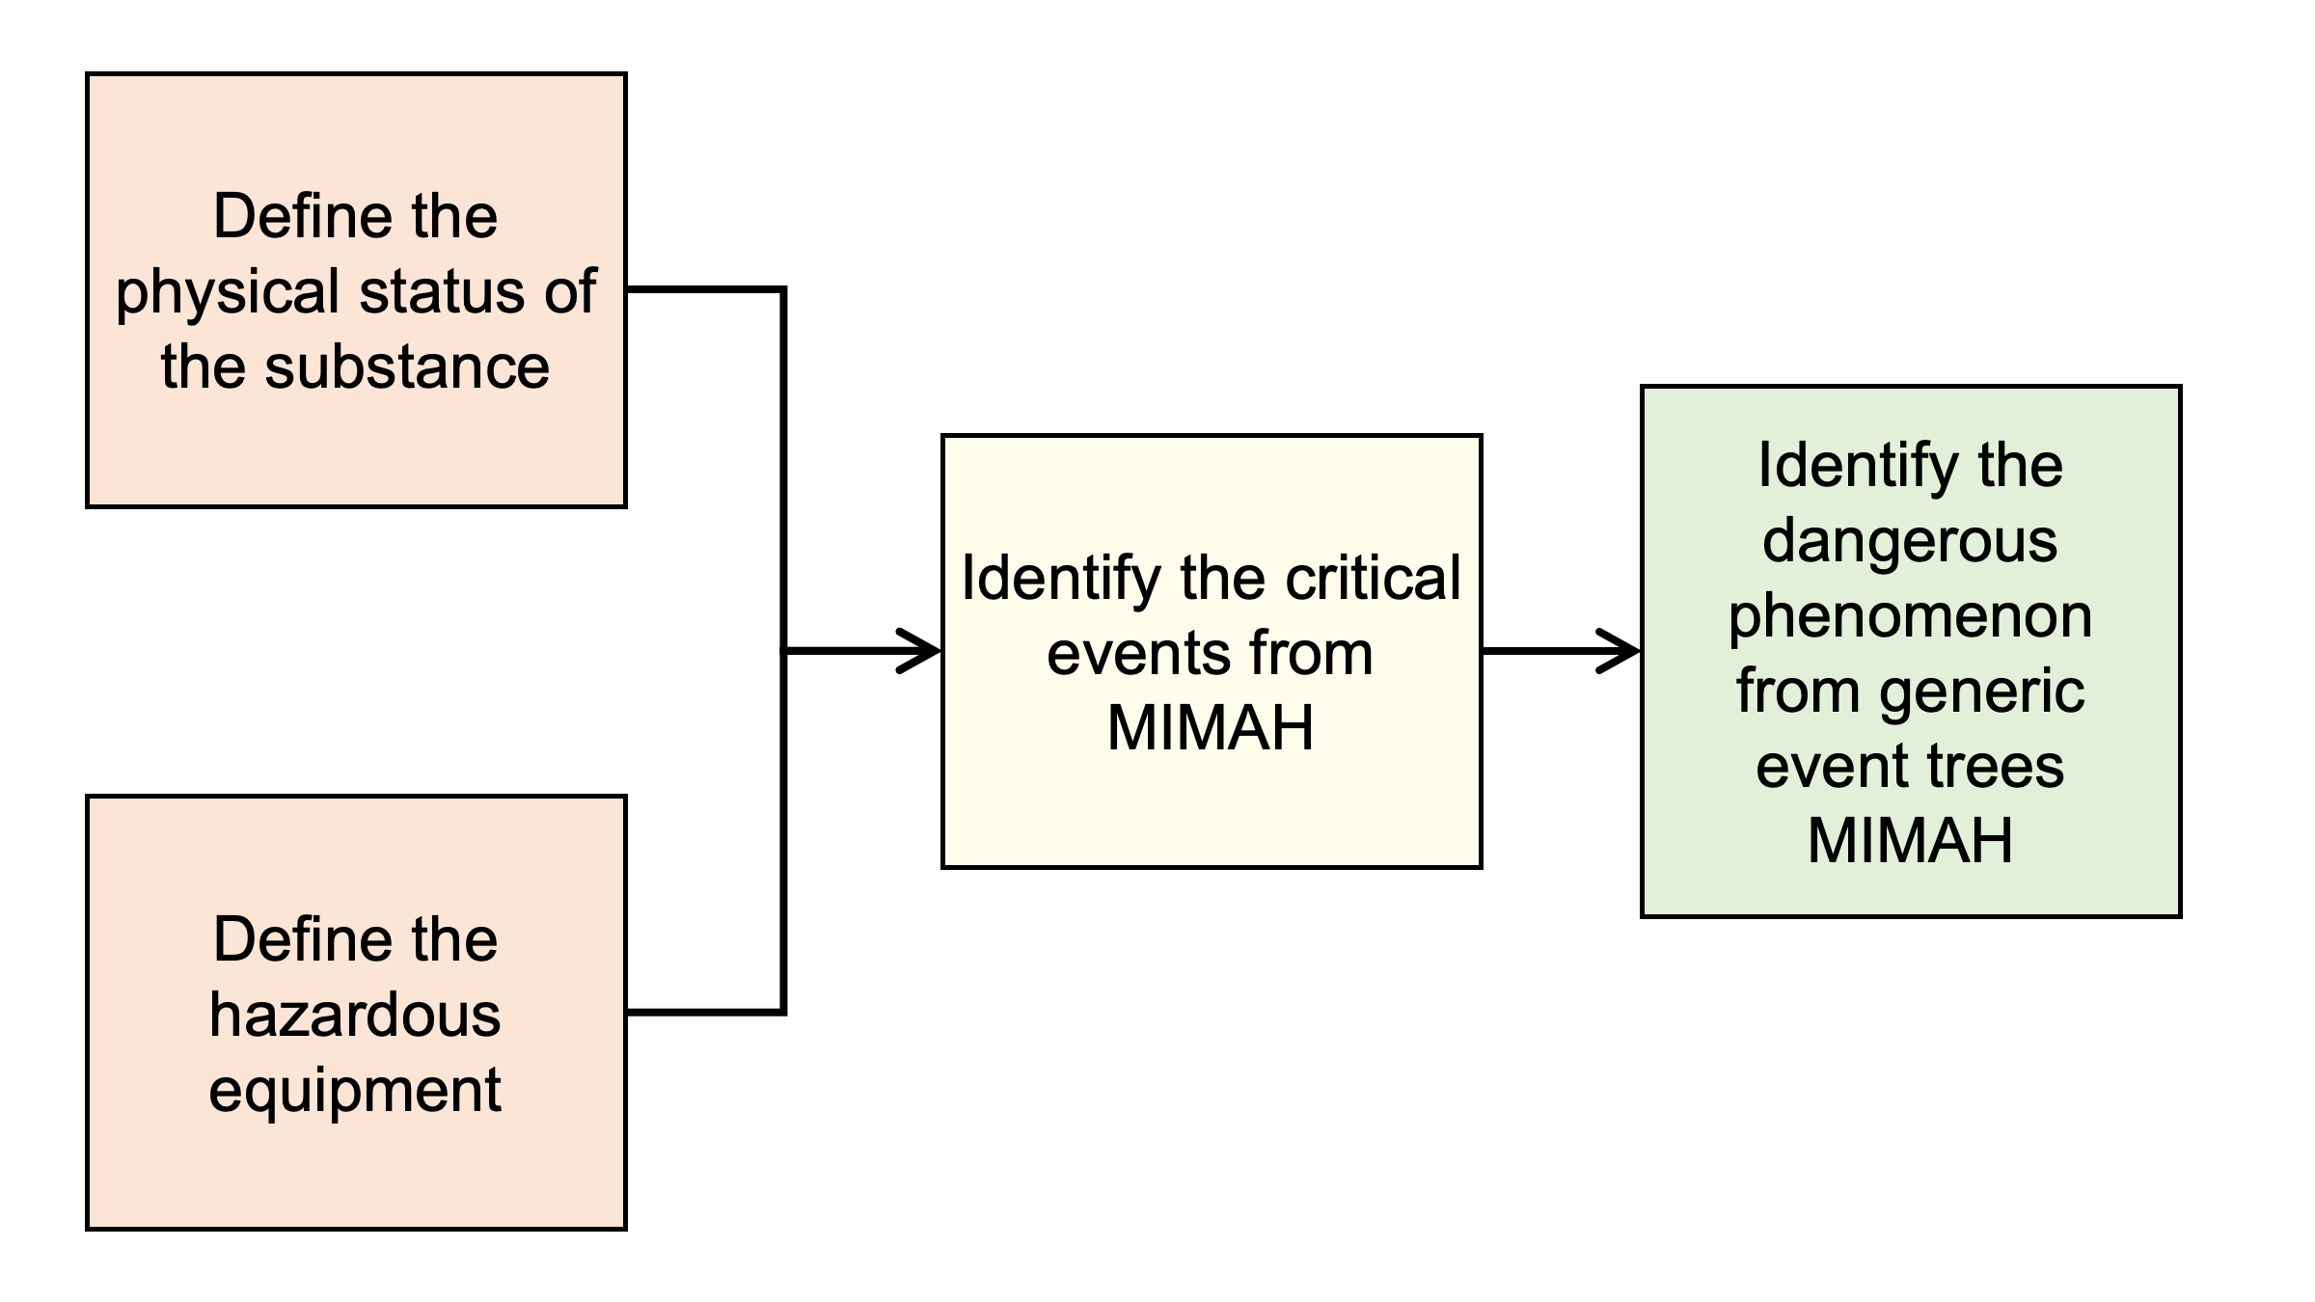
Figure 1: procedure to identify the consequences of failure for hydrogen technologies by exploiting the MIMAH methodology
In this study, steps 5 and 7 are disregarded since the focus is placed on the consequences of failure. During step 1, different information regarding the components and operating conditions and substance handled in the plant must be specified. In this study, only the physical status of hydrogen will be specified. Then, the equipment considered in the study are defined (step 2 & 3). The critical events can be identified once the physical status of the substance and the equipment are known (step 4). Finally, the event trees can be built for each critical event. The dangerous phenomena which are the consequences of the critical events can be retrieved from the even trees. Figure 1 shows the schematic of the procedure to identify the consequences of failure for hydrogen technologies by exploiting the MIMAH methodology as suggested in this work.
    - Consequences from the loss of containment of hydrogen equipment
The MIMAH methodology was applied to the LOC of hydrogen technologies without applying steps 5 and 7 since they are not relevant for this study. The main consequences were identified as follow:

Step 1 - Collect needed information
Obviously, MIMAH was developed to be used in different chemical and process industries and be applied by risk analysts who are working directly in the industrial facilities. For the purpose of this paper, the most critical information is the hazardous properties of hydrogen which is extremely flammable (R12). Moreover, hydrogen can be stored in gaseous or liquid phase, hence a high-pressure or cryogenic hazard is present, respectively. In case of release from a liquid hydrogen (LH2) equipment, a two-phase jet can be developed due to the rapid evaporation (flashing) of hydrogen when in contact with the atmosphere. Therefore, the physical states of the substance are:
- Liquid
- Two-phase
- Gas

Step 2 & 3 - Identify potentially hazardous equipment in the plant & select relevant hazardous equipment
Step 2 and 3 are merged in this study because a specific plant was not considered. Hydrogen is usually stored under high pressure (100 - 700 bar (Andersson and Grönkvist, 2019)) in metallic or composite tanks depending on the type of application. It can also be transported via pipelines as a compressed gas or liquefied and kept in double-walled vacuum insulated tanks. For this reasons, the following equipment were selected from the table of equipment provided by Delvosalle et al. (2006) who developed the MIMAH methodology:
- Pressure storage
- Cryogenic storage
- Pressure transport equipment
- Pipe network

Step 4 - for each selected equipment, associate critical events
Different critical events may arise from the LOI of hydrogen equipment. The ones selected in this work are based on the type of equipment and the physical state of hydrogen (gas or liquid) as follow:
- start of fire
- breach on the shell in vapour phase
- breach on the shell in liquid phase
- leak from liquid pipe
- leak from gas pipe
- catastrophic rupture
- vessel collapse

Step 6 - for each critical event, build an event tree
MIMAH methodology provides generic event trees were the evolution of secondary and tertiary critical events are shown before the occurrence of the dangerous phenomenon. DPs are called consequences in this paper and were selected based on the critical events listed as result of step 4. Here, the chosen consequences were categorized as dispersion (unignited release), fire, and explosion, and collected in Table 1.
The consequences related to the toxicity of a substance (e.g. toxic cloud) that can be found in the generic event trees were neglected since hydrogen is not toxic. It must be noted that few phenomena that may occur for hydrogen are not considered by the MIMAH methodology. For instance, the pressure peaking phenomenon (PPP) is an event that can manifest when hydrogen or other gases with a density lower than air (e.g. helium) are released indoor (e.g. garage) and there is presence of one or more vents (Brennan and Molkov, 2018). It is difficult to categorize the PPP because it is generated without any combustion or other chemical reactions. Moreover, the time scale of this phenomenon is much longer than the explosion one. In addition, the peak of pressure is quite larger than a gas release and dispersion.
Table 1: selected consequences from the loss of containment of hydrogen equipment
Consequence category | Consequence | Physical status of hydrogen
Dispersion | Pool formation | Liquid
 | Pool dispersion | Liquid
 | Jet | Two phase, gas
 | Dispersion | Gas
Fire | Fire | Liquid, two phase, gas
 | Pool fire | Liquid
 | Boilover | Liquid
 | Jet fire | Two phase, gas
 | Fireball | Gas
 | Flash fire | Gas
Explosion | Vapour cloud explosion (VCE) | Gas
 | Overpressure generation | Liquid, two-phase, gas
 | Missiles ejection | Liquid, two-phase, gas

The only type of explosion defined in MIMAH is the vapor cloud explosion (VCE), while hydrogen can deflagrate, detonate, or transition from deflagration to detonation (DDT). The main difference among these types of explosions is the flame front speed. More precisely, a deflagration is an explosion with a subsonic flame front, while a detonation generates supersonic pressure waves with a speed up to almost 2,000 m/s and 1.56 MPa (Molkov, 2012). Different boundary conditions are necessary for these events to manifest. Furthermore, the severity of these explosions and the effects they have on structures and humans is widely different. Another type of explosion that is considered only as a domino effect in MIMAH is the boiling liquid expanding vapor explosion (BLEVE) (Ustolin et al., 2019). BLEVE is a physical explosion that might manifest in case of catastrophic rupture of a liquid hydrogen tank. Despite it is an atypical accident scenario with low probability of occurrence, it must not be neglected during the risk assessment of LH2 technologies due to its severe consequences. Recently, many studies focused on LH2 BLEVE demonstrating that it is possible, and it depends on different factors such as type of thermal insulation and presence of the safety devices (e.g. pressure relief valve) (van Wingerden et al., 2022). Lastly, condensed phase explosions are detonations that may by generated by the ignition of a mixture of LH2 and liquid or solid oxygen (Ustolin et al., 2022).
Table 2: additional consequences not included in MIMAH and typical for hydrogen
Consequence category | Consequence | Physical status of hydrogen
 | Pressure peaking phenomenon (PPP) | Gas
Explosion | Deflagration | Liquid, two phase, gas
 | Detonation | Two phase, gas
 | Deflagration to detonation transition (DDT) | Two phase, gas
 | Boiling liquid expanding vapor explosion (BLEVE) | Liquid, two phase
 | Condensed phase explosion | Liquid

  - Consequence analysis techniques
The results from the Section 2 can be used to investigate the most relevant techniques to analyze the consequences of hydrogen LOC. A literature review can be carried out to seek for critical studies where a consequence analysis was carried out with the focus on the phenomena described in Section 2.2. In this paper, a preliminary literature review was conducted. The growing trend in number of publications demonstrates that the interest in this type of research is increasing exponentially (see Figure 2). Most of the papers found during the review focused on fires and explosions, probably due to the flammability hazard intrinsic in hydrogen. Nevertheless, many studies also investigated dispersions, mainly considering hydrogen in gaseous phase. Few authors dedicated their research on PPP, pool dispersion and fire, flash fire, fireball, BLEVE, and missiles. No publications were found on tank fire and boilover for hydrogen.

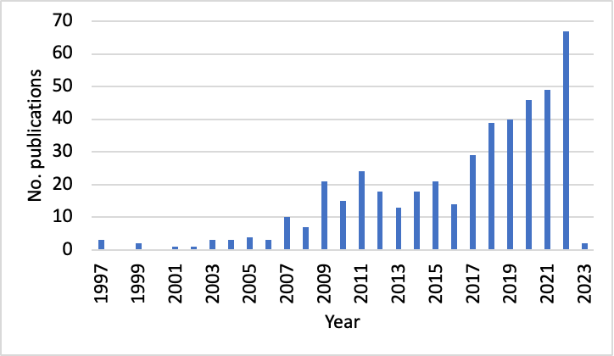
Figure 2: Publication trend of journal papers related to consequence analysis of hydrogen technologies in the last 26 years
In these publications, three types of models were developed or adopted to execute consequence analyses for hydrogen technologies:
- Theoretical
- Empirical
- Numerical
The main advantage of using theoretical models (also called integral models by risk analysts) is that they can be applied by engineers without any specific specialization. Moreover, these models are fast to implement and once validated for a phenomenon, a good accuracy can be achieved when applied to different case studies on different scales because they are based on physical laws. The main drawback of theoretical models is that they are not accurate when it is needed to consider also other phenomena or complex domains (e.g. industrial plant).
Empirical models may be even simpler to apply since these are usually correlations that were proposed by observing at experimental data and depends on few parameters. The main drawback of empirical model is that they require a large data set to be accurate. Otherwise, large errors can be generated by developing empirical correlations based on a few data points. Also empirical models focus on a specific phenomenon and most of the times on a specific scale.
Numerical models are known to be the most accurate and are capable of simulating complex geometries and take into account many different phenomena. Computational fluid dynamics (CFD) is an example of numerical model widely employed for the consequence analysis of hydrogen technologies. CFD technique is time and computational demanding and requires highly qualify personnel to be used. For these reasons, CFD is employed when new phenomena must be studied in detail as it was recently done for the LH2 BLEVE (Ustolin et al., 2022). Once the phenomenon is understood, the results of the CFD analysis can be exploited to develop other type of models or correlations.
  - Discussion
MIMAH methodology is very useful to develop generic event trees for conventional fuels such as hydrocarbons. This technique is fast and easy to implement if the level of knowledge of the industrial plant is satisfactory. However, the results attained from the application of MIMAH are not complete wen considering specific and peculiar substances such as hydrogen. It is suggested to update or develop a new methodology ad-hoc for hydrogen. The severity of the consequences not considered in MIMAH is not negligible and these phenomena (PPP, DDT, BLEVE) must be taken into account during a risk assessment.
Consequence analysis of hydrogen technologies was carried out in hundreds of publications in the last two decades. The interest in these technologies is high as never before, thus there is a need to reduce the risk of accidents especially for new applications. Knowledge gaps still exist for the most peculiar event such as PPP and LH2 BLEVE. Theoretical, empirical, and numerical models were developed and validate for different phenomena that may occur for hydrogen. CFD is the most used numerical model to assess the yield of hydrogen consequences. Further validation with experimental data is paramount to improve the accuracy of the developed models. For the risk assessment of new infrastructures in the transportation sector, there is need to create or strengthen the capabilities of integral model in order to reduce the computational time. The results of the consequence analyses can aid the selection of effective risk reduction measures as part of the risk management. The deployment of hydrogen technologies in new applications can be enhanced only by decreasing the overall risk. Obviously, the evaluation of the probabilities of failure is another critical task part of the risk assessment. The root cause of critical events must be comprehended to prevent them by applying operational safety barriers such as inspection and maintenance (Campari et al., 2022).
  - Conclusions
The main consequences of failure for hydrogen technologies were identified through the MIMAH methodology. Specific phenomena that might occur during the LOC of hydrogen equipment were integrated to the results of the application of the MIMAH technique. A preliminary literature review was carried out to understand the number of publications, type of phenomena investigated and consequence analysis for hydrogen technologies. The results of this study can be used as a starting point to deepen into this topic a develop a complete portfolio of consequence analysis techniques. This would be a fundamental tool needed to conduct effective and rapid risk assessment for new hydrogen infrastructures and suggest appropriate fashions to implement appropriate safety barriers to lower the overall risk.
Acknowledgments
This work was undertaken as a part of the research project H2CoopStorage, and the authors would like to acknowledge the financial support of the Nordic Energy Research within the program ERA-Net Smart Energy System (Grant No. 106291). Co-funded by the European Union (EU, HyInHeat ,101091456). Views and opinions expressed are however those of the authors only and do not necessarily reflect those of the European Union or the European Health and Digital Executive Agency. Neither the European Union nor the granting authority can be held responsible for them.
References
Andersson J., Grönkvist S., 2019, Large-scale storage of hydrogen, International Journal of Hydrogen Energy, 44, 11901–11919.
﻿Brennan S., Molkov V., 2018, Pressure peaking phenomenon for indoor hydrogen releases, International Journal of Hydrogen Energy, 43, 18530–18541.
Campari A., Darabi M.A., Ustolin F., Alvaro A., Paltrinieri N., 2022, Applicability of Risk-based Inspection Methodology to Hydrogen Technologies: A Preliminary Review of the Existing Standards, European Safety and Reliability Conference (ESREL 2022).
Delvosalle C., Fievez C., Pipart A., Debray B., 2006, ARAMIS project: A comprehensive methodology for the identification of reference accident scenarios in process industries, Journal of Hazardous Materials, 130, 200–219.
HyResource, 2023, International Politics, <https://research.csiro.au/hyresource/policy/international/> accessed 09.02.2023.
IEA, 2021, Net Zero by 2050 – A Roadmap for the Global Energy Sector, International Energy Agency, Paris.
IRENA, 2022, Geopolitics of the Energy Transformation: The Hydrogen Factor, International Renewable Energy Agency, Abu Dhabi.
McCarty R., Hord J., Roder H., 1981, Selected Properties of Hydrogen (Engineering Design Data), National Bureau of Standards (NBS) Monograph, Boulder, Colorado.
﻿Molkov V., 2012, Hydrogen Safety Engineering: The State-of-the-Art and Future Progress, Comprehensive Renewable Energy, 4, 97–129.
Ono R., Nifuku M., Fujiwara S., Horiguchi S., Oda T., 2007, Minimum ignition energy of hydrogen–air mixture: effects of humidity and spark duration, Journal of Electrostatics, 65, 87–93.
Ustolin F., Song G., Paltrinieri N., 2019, The Influence of H2 Safety Research on Relevant Risk Assessment, Chemical Engineering Transactions, 74, 1393–1398.
﻿Ustolin F., Ferrari F., Paltrinieri N., 2022, Prediction of Condensed Phase Formation during an Accidental Release of Liquid Hydrogen, Chemical Engineering Transactions, 91, 439–444.
﻿Ustolin F., Tolias I.C., Giannissi S.G., Venetsanos A.G., Paltrinieri N., 2022, A CFD analysis of liquefied gas vessel explosions, Process Safety and Environmental Protection, 159, 61–75.
van Wingerden K., Kluge M., Habib A.K., Ustolin F., Paltrinieri N., 2022. Medium-scale Tests to Investigate the Possibility and Effects of BLEVEs of Storage Vessels Containing Liquified Hydrogen, Chemical Engineering Transaction, 90, 547–552.

