CHEMICAL ENGINEERING TRANSACTIONS  VOL., 2023 | A publication of
The Italian Association
of Chemical Engineering
Online at www.cetjournal.it
Guest Editors:
Copyright © 2023, AIDIC Servizi S.r.l.
ISBN ; ISSN 2283-9216

Fragments generated during liquid hydrogen tank explosions
Giulia Collina^{a,b,}*, Federico Ustolinª, Gabriele Tincani^{a,b}, Leonardo Gianniniª, Ernesto Salzano^{b}, Valerio Cozzani^{b}
ªDepartment of Mechanical and Industrial Engineering, Norwegian University of Science and Technology NTNU, Richard Birkelands vei 2B, 7034 Trondheim, Norway
^{b}Dipartimento di Ingegneria Civile, Chimica, Ambientale e dei Materiali, Università degli studi di Bologna, Via Terracini 28, 40131 Bologna, Italy
giulia.collina@ntnu.no
Liquid hydrogen (LH2) may be employed to transport large quantities of pure hydrogen or be stored onboard of ships, airplanes and trains fuelled by hydrogen, thanks to its high density compared to gaseous compressed hydrogen. LH2 is a cryogenic fluid with an extremely low boiling point (-253°C at atmospheric pressure) that must be stored in double-walled vacuum insulated tanks to limit the boil-off formation. There is limited knowledge on the consequences of LH2 tanks catastrophic rupture. In fact, the yield of the consequences of an LH2 tank explosion (pressure wave, fragments and fireball) depend on many parameters such as tank dimension, filling degree, and tank internal conditions (temperature and pressure) prior the rupture. Only two accidents provoked by the rupture of an LH2 tank occurred in the past and a couple of experimental campaigns focussed on this type of accident scenario were carried out for LH2.
The aim of this study is to analyse one of the LH2 tank explosion consequences namely the fragments. The longest horizontal and vertical ranges of the fragments thrown away from the blast wave are estimated together with the spatial distribution around the tank. Theoretical models are adopted in this work and validated with the experimental results. The proposed models can aid the risk analysis of LH2 storage technologies and provide critical insights to plan a prevention and mitigation strategy and improve the safety of hydrogen applications.
  - Introduction
Incorporating hydrogen as a key player in the shift towards a decarbonized energy landscape requires storing significant amounts of hydrogen. This can be challenging due to its low density at ambient conditions. Liquid hydrogen at cryogenic temperature (-253 °C) is a promising solution for efficiently storing hydrogen, but it requires double-walled vacuum-insulated tanks to ensure proper thermal insulation and prevent boil-off gas formation. Aside from requiring specific storage conditions, hydrogen also has properties that require caution, including the wide flammability range in air of 4 – 75 %vol (Nicoletti et al., 2015) and the low minimum ignition energy of 0.017 mJ (Nicoletti et al., 2015). Therefore, the willingness to expand the range of hydrogen applications requires a thorough investigation of safety aspects.
Accident scenarios that may occur include the catastrophic rupture of the LH₂ vessel, which could result in a Boiling Liquid Expanding Vapor Explosion (BLEVE), a physical explosion considered as an atypical accident scenario, which is a scenario that falls outside of the typical range of unwanted or worst-case events, and is therefore not considered credible by standard risk assessment processes (Paltrinieri et al., 2012). BLEVE can be defined as “the explosion of a vessel containing a liquid (or liquid plus vapor) at a temperature significantly above its boiling point at atmospheric pressure” (Hemmatian et al., 2016). This phenomenon has been extensively studied and described by Ustolin et al. (2020, 2022) including attempts to simulate its potential consequences, which are shock wave, fireball and fragments. The projection of the latter can lead to both human injury and property damage and can mostly cause an escalation of the accident (domino effect), as shown by Tugnoli et al. (2022). For this reason, predicting the trajectory and maximum range of fragments is critical, as it would allow safety measures to be taken to prevent or mitigate the effects of this phenomenon. Several models have been proposed to predict how many debris might be generated after the catastrophic rupture of the tank, how far they may travel, and how they might be distributed in space. However, according to the authors’ knowledge, the only fragment analysis for liquid hydrogen tank explosions was carried out by Ustolin et al. (2020). In that study, a preliminary fragment analysis was carried out by simulating the BMW LH2 tank bursting scenario tests (Pehr, 1996), while in this study the LH2 tank fire tests carried out during the Norwegian project Safe Hydrogen Fuel Handling and Use for Efficient Implementation (SH2IFT) (van Wingerden et al., 2022) are analysed for the first time by focussing on the generated fragments. The peculiar properties of hydrogen and the double-walled tanks structure differ from conventional hydrocarbon technologies and must be taken into account when carrying out this type of analysis.
This paper should be considered as a starting point for addressing this lack of information. The State of the art (Section 2) describes models for predicting horizontal distance. However, the focus of this paper is the analysis of experimental data from the SH₂IFT project, which is described in Section 3. As depicted in Methodology (Section 4), the purpose is to study the distribution of fragments in the area around the vessel. Finally, the Results (Section 5) and Discussion (Section 6) are provided together with some suggestions for further studies (Section 7).
  - State of the art
The failure of a tank is associated with both the release of its contents and the release of its internal energy. This latter is converted into mechanical energy, and a significant fraction of it is responsible for damaging shock waves and high-velocity fragments. The extent of the blast and fragmentation effects is directly tied to the amount of internal energy available, which is determined by the type of fuel, its mass stored in the tank, and its thermodynamic properties. To conduct an effective risk assessment, evaluating the severity of the potential outcomes is essential. In the case of pressure waves, it is necessary to measure the impulse and overpressure, which is crucial in determining the extent of damage that could occur. In addition to impulse and overpressure, fragments are another important factor to consider in a risk analysis of an explosion event. Fragments refer to pieces of debris or shrapnel that can be produced from tank destruction and thrown away by the following explosion and can cause significant damage and injury to people and property. The size and trajectory of the fragments are important factors to consider when assessing the potential consequences of a blast wave. Fragment-related consequences are typically gauged in terms of hazardous distance. For this reason, the horizontal range travelled by fragments is a crucial parameter to evaluate, and different approaches are available in the literature. The procedure for assessing this parameter begins with estimating the energy released by the explosion (step 1); several methods presented by Ustolin et al. (2020) can be used to achieve this aim. The following step (step 2) is to assess the fraction of mechanical energy that contributes to the generation and projection of the fragments. Two different values were indicated by Kumar (1996) (40 %) and Van de Bosch et al. (1997) (4 %). At this point, it is possible to evaluate the initial velocity in m s⁻¹ of the fragment (step 3) with Eq (1) as in Ustolin et al. (2020):
$v_{i}= \sqrt{\frac{2∙λ∙E_{av}}{M_{v}}}$ | (1)
where $λ$ is the energy fraction responsible for fragment projection, $E_{av}$ is the released energy from the explosion in J kg⁻¹ and $M_{v}$ is the mass of the empty vessel in kg. Once the initial velocity has been established, there are two methods for estimating the flying distance of fragments in an explosion event (step 4). The first method assumes that air resistance is negligible and only calculates the flying distance considering the gravitational force. The fragments characteristics are challenging to set a priori, this method focuses on the assumption of the initial angle, which is typically 5÷10 ° for cylindrical vessels horizontally placed and 45 ° if vertically oriented (Kumar, 1996). Solving the equations of motion leads to determining the flying path of fragments, especially the horizontal range by means of Eq(2) as shown by Lees (2012):
$R= \frac{v_{i}^{2}∙sin\left(2α\right)}{g}$ | (2)
where $α$ is the initial angle of the fragments and $g$ is the acceleration of gravity (9.81 m s⁻²). Clearly, this method is useful to describe the overall distance a fragment can reach without giving any specific information.
On the other hand, the second method provides a more accurate prediction of the flying distance, but requires a more detailed analysis of the fragment and the surrounding environment. Fluid dynamic forces are subdivided into drag and lift components. The effect of drag and lift will depend both on the shape of the fragment and its direction of motion with respect to the relative wind. The fluid dynamic force components of drag and lift at any instant can be expressed with Eq(3) as presented by Lees (2012):
$\left\{\begin{aligned}F_{L}= C_{L}A_{L}\frac{ρ_{a}∙v_{i}^{2}}{2} \\ F_{D}= C_{D}A_{D}\frac{ρ_{a}∙v_{i}^{2}}{2}\end{aligned}\right.$ | (3)
where $A_{D}$ is the drag area in m², $A_{L}$ is the lift area in m², $C_{D}$ is the drag coefficient, $C_{L}$ is the lift coefficient, $F_{D}$ is the drag force in N, $F_{L}$ is the lift force in N, $v_{i}$ is the velocity of the fragment in m s⁻¹ and $ρ_{a}$ is the density of air in kg m⁻³. In this case, solving the equations of motion is not trivial, and a graphical method is possible according to Baker et al. (1983). It requires the evaluation of the initial scaled velocity as Eq(4) as illustrated by Lees (2012):
$\overline{v_{i}}= \frac{C_{D}A_{D}∙ρ_{a}∙v_{i}^{2}}{M_{f}∙g}$ | (4)
where $M_{f}$ is the mass of the fragment. The corresponding dimensionless range $\overline{R}$ is read off from the graph provided by Kumar (1996), and the horizontal range is finally estimated with Eq(5) as shown by Lees (2012):
$R= \frac{ \overline{R}∙M_{f}}{C_{D}A_{D}∙ρ_{a}}$ | (5)
To use this latter method, it is necessary to assume the mass, shape and dimension of the fragment, as the parameters relating to the fluid dynamic forces are involved in the calculation. For this reason, it is suggested to couple this method with the prediction of fragment patterns as in Gubinelli and Cozzani (2009). The steps of the procedure outlined above are briefly presented in Figure 1.
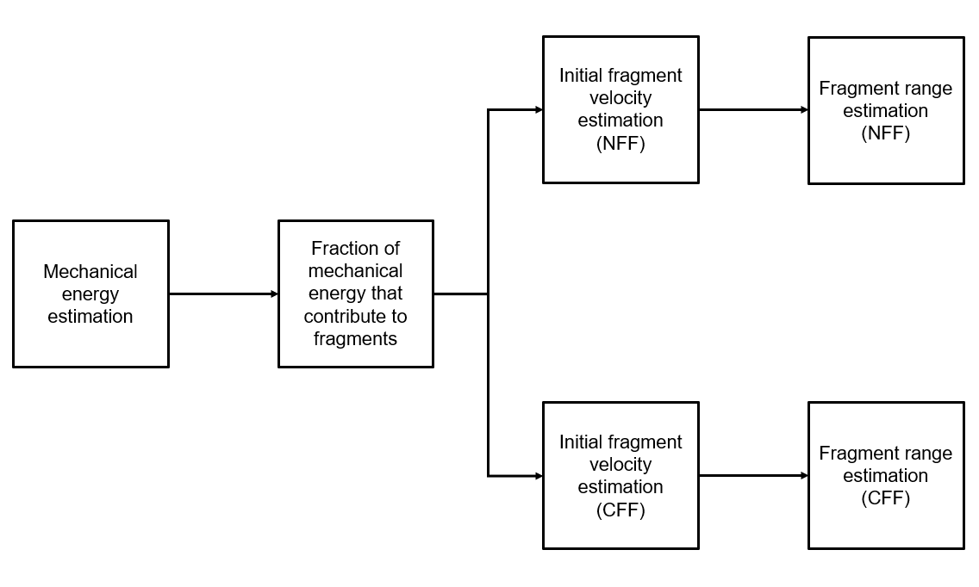
Figure 1 – Block diagram showing the procedure to apply models for predicting the horizontal range of fragments.
  - Case study – SH2IFT LH2 BLEVE test
The experiment performed at the Test Site Technical Safety (TTS) of the Bundesanstalt für Materialforschung und –prüfung (BAM) institute in Germany as part of the Norwegian project Safe Hydrogen Fuel Handling and Use for Efficient Implementation (SH₂IFT) was selected as a case study (van Wingerden K et al., 2022). This test campaign aimed to investigate the behaviour of a double-walled storage tank containing liquefied hydrogen (LH2) engulfed by a propane fire and the consequences of a BLEVE explosion in case of rupture of the LH2 vessel. A total of three LH2 tanks were tested with different types of insulation and orientation (horizontal or vertical). Only one out of three vessels catastrophically failed to provoke an explosion.
More specifically, an LH2 double-walled vacuum insulated vessel of 1 m³ volume oriented horizontal was exposed to flames generated by the combustion of propane fuelled by burners placed under the tank. In this way, the LH2 contained in the tank began to evaporate due to the enhanced heat transfer, causing the internal pressure of the tank to rise to a value of 50 bar. After 1 hour the vessel failed to generate a fireball, blast waves, and fragments. The magnitudes of these consequences were measured with dedicated instruments, such as a blast pencil for the pressure wave, and bolometers for the fireball radiation, and data were collected for the fragment analysis. Specifically, each fragment's spatial coordinates, weight, and pictures were recorded and catalogued. These data were exploited for the analysis proposed in this study.
  - Methodology
This section describes the methodology adopted to analyze the fragments generated after the catastrophic rupture of a double-walled tank containing a cryogenic liquefied gas and thrown away by the consequent explosion. The first step for a proper fragment investigation is analyzing experimental data collected during the experiments to examine the shape and number of fragments, then to showcase the scattering of fragments in the area surrounding the tank. The weight of each piece is also considered. As mentioned in Section 3, the data collected by the experiment for each fragment are:
- Spatial coordinates (x,y)
- Mass
- Pictures.
From these, a distribution graph is generated to allow for immediate visualization of the scale of fragments produced by the explosion, both in terms of quantity and weight. It also reveals any possible preferential directions or areas for fragment projection. Overall, it is essential to note that a light fragment should not be compared to a fragment with a much greater mass, as the impact consequences for people or equipment would be vastly different. Therefore, in this stage of the analysis only the main fragments, which weigh more than 60 kg, are counted.
  - Results
The LH2 vessel broke into 53 fragments with different masses, however the number of main and heaviest fragments (m > 60 kg) was six.
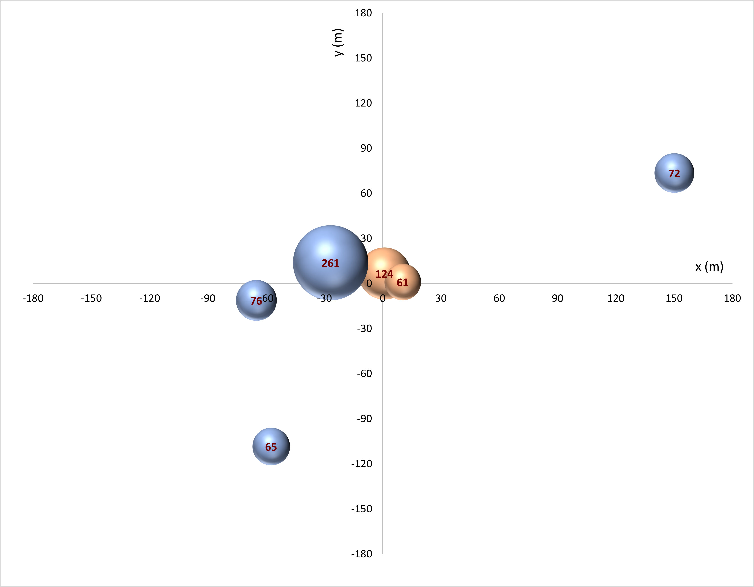
Figure 2 – Distribution of main fragments (m > 60 kg).The size of the bubbles is related to the mass (red label) of each fragment of the tank (blue bubbles for the outer vessel and red bubbles for the inner vessel).
The outer vessel failed to generate four pieces: two end caps (72 kg and 76 kg) and two parts of the shell; one part remained attached to the tank support, resulting in a very heavy fragment (261 kg). The inner vessel broke into two pieces: one end cap (61 kg) and the shell opened like a plate and attached to the other end cap (124 kg). The fragment that flew furthest was one of the two end caps of the outer vessel that reached 167 m. The others spread out in the space around the vessel covering varying distances. Figure 2 shows the distribution of the main fragments in the blast area. The size of the bubbles is related to the mass of each fragment, which is labeled in red. Two different colors were used to distinguish between the two vessels: red bubbles indicate the pieces of the inner tank, while blue bubbles indicate the ones of the outer tank. The origin of the graph corresponds to the center of the initial location of the tank. The x-axis is oriented as the longitudinal axis of the tank, while the y-axis is the transversal one. The explosion videos clearly show that the end cap of the inner tank (61 kg) collided with the protective wall of the propane tank, and then rebounded toward the original position of the LH2 tank. It is uncertain how far the fragment would have traveled without this barrier, but it would likely have gone further.
  - Discussion
As expected, the outer and inner shells of the double-walled LH2 tanks showed a very different behavior to the explosion. Firstly, the shells were ruptured into a different number of fragments, four pieces for the outer vessel and two parts for the internal tank. Secondly, the outer shell pieces traveled larger distances than the inner ones. The furthest fragments found were the end cap of the external tank (72 kg) and the lightest piece of its shell (65 kg). On the other hand, the two parts of the inner tank were found very close to the point of the explosion. This might suggest that the force of the explosion was not uniform, and some parts were affected more than others. Further investigation would be required to determine the reasons for the differential distribution of fragments. Moreover, the tendency of end caps to spread along the direction parallel to the longitudinal axis of the vessel is higher than that of shell fragments as shown in Figure 2. This result is consistent with what was expected according to Tugnoli et al. (2014).
Experimental data analysis regarding fragments was conducted for the first time for the selected case study. The next step should be to apply the models described in Section 2 for predicting horizontal distance and validate them with the experimental outcome. Clearly, to suggest potential modifications or adjustments, new data and experiments will be necessary to validate the models, as there is not enough data on double-walled tanks in the literature. Small-scale tests are recommended due to the cost-critical nature of these experiments.
  - Conclusion
An analysis of experimental data on the fragments generated by a BLEVE caused by the complete rupture of a double-walled LH2 vessel was carried out in this study. The experimental data provided by the Norwegian project Safe Hydrogen Fuel Handling and Use for Efficient Implementation (SH₂IFT) were processed to analyze the distribution of the fragments in the space surrounding the original position of the vessel. During that experiment a double-walled vacuum insulated vessel engulfed by a propane fire failed leading to a fireball, a pressure wave and fragments projection. Six heavier fragments were detected, four from the outer tank and two from the inner tank. The fragments of the outer sell were found further away than the inner one, which, on the other hand, remained much closer to the original vessel position. The maximum measured distance was 167 m from the initial tank position. Additional studies such as modelling fragment distribution with conventional models and their validation with experimental data were suggested. The ability to predict the behavior of tank fragments after a failure is valuable for the domino effect handling part of the risk analysis.
Nomenclature

v_{i} – initial velocity, m∙s⁻¹
λ – energy fraction to fragments projection, -
E_{av} – energy available after the explosion, J
M_{v} – mass of the empty tank, kg
R – horizontal range of fragment, m
α – initial angle of fragment, °
g – acceleration of gravity, m∙s⁻²
C_{L} – lift coefficient, -
C_{D} – drag coefficient, -
A_{L} – lift area, m²
A_{D} – drag area, m²
F_{L} – lift force, N
F_{D} – drag force, N
ρ_{a} – density of air, kg∙m⁻³
$\overline{R}$ – dimensionless range, -
$\overline{v_{i}}$ – dimensionless initial velocity, -
M_{f} – mass of fragment, kg

Acknowledgments
This work was undertaken as part of the research project Safe Hydrogen Fuel Handling and Use for Efficient Implementation (SH2IFT), and the authors would like to acknowledge the financial support of the Research Council of Norway under the ENERGIX programme (Grant No. 280964). Furthermore, this work was undertaken as part of the ELVHYS project No. 101101381 supported by the Clean Hydrogen Partnership and its members. UK participants in Horizon Europe Project ELVHYS are supported by UKRI grant numbers 10063519 (University of Ulster) and 10070592 (Health and Safety Executive). Funded by the European Union. Views and opinions expressed are however those of the author(s) only and do not necessarily reflect those of the European Union or the Clean Hydrogen Partnership. Neither the European Union nor the Clean Hydrogen Partnership can be held responsible for them.
References
Baker W.E., Cox P.A., Kulesz J.J., Strehlow R.A., Westine P.S., 1983, Explosion Hazards and Evaluation. Elsevier Science, New York.
Gubinelli, G., Cozzani, V., 2009. Assessment of missile hazards: identification of reference fragmentation patterns. Journal of Hazardous Materials, 163(2-3), 1008-1018.
Hemmatian, B., Planas, E., & Casal, J., 2016. On BLEVE definition, the significance of superheat limit temperature (T-sl) and LNG BLEVE’s. Journal of Loss Prevention in the Process Industries, 40, 81-81.
Kumar, A., 1996. Guidelines for evaluating the characteristics of vapor cloud explosions, flash fires, and bleves. Center for Chemical Process Safety (CCPS) of the AIChE, Published by the American Institute of Chemical Engineers, New York, NY (1994), 387 pages.
Lees, F., 2012. Lees' Loss prevention in the process industries: Hazard identification, assessment and control. Butterworth-Heinemann.
Mébarki, A., Mercier, F., Nguyen, Q. B., & Saada, R. A., 2009. Structural fragments and explosions in industrial facilities. Part I: Probabilistic description of the source terms. Journal of Loss Prevention in the Process Industries, 22(4), 408-416.
Nicoletti, G., Arcuri, N., Nicoletti, G., & Bruno, R., 2015. A technical and environmental comparison between hydrogen and some fossil fuels. Energy Conversion and Management, 89, 205-213.
NIST, 2019. NIST Chemistry WebBook 69. https://webbook.nist.gov/chemistry/ (accessed March 19, 2019).
Paltrinieri, N., Øien, K., & Cozzani, V., 2012. Assessment and comparison of two early warning indicator methods in the perspective of prevention of atypical accident scenarios. Reliability Engineering & System Safety, 108, 21-31.
Pehr K., 1996, Aspects of safety and acceptance of LH2 tank systems in passenger cars, International Journal of Hydrogen Energy, 21, 387–395.
Tugnoli, A., Gubinelli, G., Landucci, G., & Cozzani, V., 2014. Assessment of fragment projection hazard: Probability distributions for the initial direction of fragments. Journal of hazardous materials, 279, 418-427.
Tugnoli, A., Scarponi, G. E., Antonioni, G., & Cozzani, V., 2022. Quantitative assessment of domino effect and escalation scenarios caused by fragment projection. Reliability Engineering and System Safety, 217. https://doi.org/10.1016/j.ress.2021.108059.
Ustolin F, Song G, Paltrinieri N, 2019, The influence of H2 safety research on relevant risk assessment. Chemical Engineering Transaction, 74, 1393–1398.
Ustolin F., Paltrinieri N., Landucci G., 2020a, An innovative and comprehensive approach for the consequence analysis of liquid hydrogen vessel explosions, Journal of Loss Prevention in the Process Industries, 68, 104323.
﻿Ustolin, F., Tolias, I. C., Giannissi, S. G., Venetsanos, A. G., & Paltrinieri, N., 2022. A CFD analysis of liquefied gas vessel explosions. Process Safety and Environmental Protection, 159, 61–75.
Van den Bosch, C. J. H., and R. A. P.M. Weterings, eds. Methods for the Calculation of Physical Effects: Due to Releases of Hazardous Materials (liquids and Gases),'yellow Book'. CPR 14E [in Two Parts]. Sdu Uitgevers, 1997.
van Wingerden K, Kluge M, Habib AK, Ustolin F, Paltrinieri N, 2022. Medium-scale Tests to Investigate the Possibility and Effects of BLEVEs of Storage Vessels Containing Liquified Hydrogen. Chemical Engineering Transaction, 90, 547–552.

