CHEMICAL ENGINEERING TRANSACTIONS  VOL. , 2023 | A publication of
The Italian Association
of Chemical Engineering
Online at www.cetjournal.it

Guest Editors: Sauro Pierucci, Jiří Jaromír Klemeš
Copyright © 2023, AIDIC Servizi S.r.l.
ISBN 978-88-95608-98-3; ISSN 2283-9216

Microplastics in Fluvial Sediments: Identification and localization in the Lower Basin and Mouths of the Lurín and Chillón rivers, Perú
Jhordanna L. Martínez Rodasª, Mijael J. Quispe Valenzuelaª, Víctor Pretell^{b}, John Jáuregui-Nongrados^{c}, Carlos Castañeda Oliveraª, Elmer Benites-Alfaro^{a,*}
ªUniversidad César Vallejo, Av. Alfredo Mendiola 6332, Lima 15314, Perú.
^{b}Universidad Nacional de Ingeniería, Av. Túpac Amaru 210, Lima 15333, Perú
^{c}Universidad San Ignacio de Loyola, Campus La Molina, Lima, Pewrú.
ebenitesa@ucv.edu.pe
The presence of microplastics in rivers remains an unanswered question in many parts of the world. The research aimed to determine the presence of microplastics (MP) in river sediments of the lower basins and mouths of the Lurín and Chillón rivers. For monitoring, 4 stations were established for each river (E.CL1, E.CL2, E.CL3, E.DL4 and E.CCH1, E.CCH2, E.CCH3, E.DCH4), located from the lower basin to the estuary where they flow into. The microplastic separation method consisted of taking soil samples from the indicated points and sieving them with 850 µm, 1000 µm, 2000 µm and ˃2000 µm meshes. The separation was then refined with the density method using sodium chloride (NaCl) solution. The MPs were sorted by color, shape, weight and size. Most of the MPs were observed to be irregular, square, rectangular, spherical, elongated, rigid, pink, white, blue, black, green, yellow, red and light blue. FTIR infrared spectroscopy was used to identify the type of polymer constituent of the MPS. In the Lurín river, polypropylene (PP), high density polystyrene (HDP) and polystyrene (PS) were identified; in the Chillón river, polypropylene (PP), high density polystyrene (HDP) and polyethylene terephthalate (PET) were found. The main sources of PM were anthropogenic activities, such as industries and waste dumped by the neighboring urban population. Therefore, the information found will allow managers to implement environmental improvement measures for microplastic pollution in watersheds.
  - Introduction
The presence of microplastics in water sources is increasingly worrying, due to the danger it represents for human and animal health, mainly due to the ease with that it can be incorporated into organisms due to the trophic chain, food being the most important (Rubio, 2021), especially in seafood (De la Torre, 2019); a study indicates that each year Americans consume between 39,000 and 52,000 particles of plastics (Cox, 2019).
These types of plastics with dimensions smaller than 5 mm called microplastics are used in certain industrial products and are then discarded or released as a consequence of their physical degradation from larger sizes, reach natural ecosystems, and can deposited in various places due to environmental factors and their characteristics (Parda, 2020); The first place where microplastics have been found is the sea, which has become a great danger as a deposit of plastics; in the second abiotic compartment where these contaminants are found, are marine sediments from the depths of the seas to the beaches (Rojo and Montoto, 2017), and within the beaches the mouths of the rivers where the pollutants brought from the upstream basins arrive, in such a way that it is estimated that between 5.95 and 15.11 million tons of plastics arrive each year at the oceans directly by rivers and that there would be approximately 236,000 tons of plastic particles suspended in the planet's seas (Aquae, 2021). A study reveals that each liter of surface sea water on average has 11.8 microplastics per liter (Barrow et al., 2018) or 10.4 particles per liter in bottled water of the size of 100 microns as indicated by a study by the organization Orb Media in the State University of New York (Tyree C. and Morrison, 2020).
There are still not many investigations on microplastics in rivers, due to inconveniences and difficulties that monitoring represents due to temporal factors; however, the presence of microplastics has been found using the trawl method to collect samples of microparticles up to the size of 300 µm as carried out by Schrank et al., (2021). In this sense, the objective of the research was to establish the quantity, type and form of microplastics in the lower basin and mouth of the Lurín and Chillón rivers. The information found may be important for managers and managers in waste management in order to preserve the environment together with the objectives of sustainable development.
  - Methodology
The research design consisted of taking soil sediment samples from 4 points on the near bank of the river and from the mouth of the Lurín and Chillón rivers located in the Lima region.. Then was identify the microplastics found in the samples and characterized them. The investigation was carried out between the months of April and May 2021, the transition period from light rains to dryness in the basins of these rivers.
2.1 Sampling points
The soil sampling locations were coded and located in the UTM coordinates indicated in Table 1.
Table 1: Sampling points
Sampling Points or Station | UTM coordinates, zone 17 S of WGS84 |  |  | System you are in | District, province
 | East | North
E.CL1 | 297648 |  | 8652032 | River | Pachacamac, Lima
E.CL2 | 296488 |  | 8649318 | River | Pachacamac, Lima
E.CL3 | 294017 |  | 8644953 | River | Lurín, Lima
E.DL4 | 293014 |  | 8642558 | estuary | Lurín, Lima
E.CCH1 | 273292 |  | 8679992 | River | Los Olivos, Lima
E.CCH2 | 272206 |  | 8678682 | River | San Martin de Porres, Lima
E.CCH3 | 271947 |  | 8678333 | River | San Martin de Porres, Lima
E.DCH4 | 267162 |  | 8679248 | estuary | Márquez, Callao
2.2 Soil sampling
3 kg was collected for each soil sample. For the lower river basin, the sample was obtained in the following way: A parallel transect was traced to the river bank looking for an accessible area with the presence of sediments, two random samples were taken for each point and homogenized; For the samples from the mouth of the river, as the area is larger, they were taken from four 5-cm test pits and homogenized. The samples were labeled with the codes of the sampling points and taken to the laboratory for analysis of microplastics.
2.3 Separation of microplastic
In the identification of microplastics, the following steps were carried out:
Drying of soil samples: According to the methodology proposed by Manrique (2019), the samples were dried at room temperature and then in an oven at 70 °C for 24 h.
Sieve: The sediment sample was sieved using meshes of 850 μm, 2000 μm and greater than 2000 μm. Then the 850 μm through holes were separated to continue with the process, taking into account the size of the microplastics that were sought to be identified.
Separation of microplastics by density: It was done using a sodium chloride solution (40 g of NaCl in 1 L of water), and by density, the microplastics remain on the surface. Was filtered and dry the supernatant. The remaining fragments were taken for characterization. This method is based on the buoyancy principle that microplastics have because they are less dense than salt water and has been used in other investigations such as those carried out by Pretell et al. (2020) on three beaches in Lima and Vásquez-Mollano et al. (2021) in the Buenaventura basin – Colombia
2.4 Identification of microplastics
It was selected taking into account the color, weight, size and texture. Infrared spectroscopy with a Shimadzu FTIR IR-Affinity spectrophotometer adapted to a Pike Technologies MIRacle ATR was used to identify the type of plastic.
  - Results and discussion
Weight of microplastics in the lower basin and river mouths
The microplastics found at each sampling point of the Lurín and Chillón rivers are shown in Table 2, which corresponds to the weight found per 3 kg of sediment analyzed; the ECL1 point stands out and especially the mouths where the greatest quantity by weight was found. Similarly, it was at the mouth of the Lurín River where more microplastics were found in comparison to the Chillon River, which suggests that it is in this river where there is more contamination by these wastes, mainly due to the geography of the mouth and the lower flow in the Lurín River (2. 72 m³/s) than in the Chillón River (3.17 m³/s) in May 2021 (SENAMHI, 2021), which probably allowed for greater deposition of microplastics in the benthic soils of the river banks and estuaries.
Table 2: Weight of microplastics in the Lurin River and Chillón River
Sampling Points or Station  (River Lurín) | Microplastics weight  (g) | Sampling Points or Station  (River Chillón) | Microplastics weight  (g)
E.CL1 | 0.123 | E.CCH1 | 0.1404
E.CL2 | 0.6 | E.CCH2 | 0.2034
E.CL3 | 0.8 | E.CCH3 | 0.3207
E.DL4 | 1.5 | E.DCH4 | 0.5590
Total | 3.023 | Total | 1.2235

Type of microplastics
Using FTIR, the type of polymers found at the monitoring points were identified. Table 3 details the polymers found in the Lurín river; polypropylene, high density polyethylene, polystyrene and polyethylene terephthalate were identified in smaller quantities because terephthalate is more resistant due to the high proportion of aromatic terephthalate in its structure (Ahmaditabatabaei et al., 2022), or sometimes it is reinforced to increase impact resistance (Mohd et al., 2021). Similarly, the colors of microplastics are presented in the same table.
Table 3: Types and colors of the polymer at each sampling point in the Lurín River
Sampling Points | Sample | Types of polymers | Color of polymers
E.CL1 | M1 | Polypropylene | White
E.CL2 | M1 | High Density Polyethylene | Light blue
 | M2 | Polypropylene | Blue
 | M3 | High Density Polyethylene | Light Blue
E.CL3 | M1 | High Density Polyethylene | White
 | M2 | Polystyrene | White
 | M3 | Polypropylene | Light Blue
 | M4 | Polyethylene Terephthalate | Blue
E.CL4 | M1 | Polyethylene Terephthalate | Lead
 | M2 | Polypropylene | Blue
 | M3 | Polypropylene | Yellow
 | M4 | Polypropylene | Light Blue
 | M5 | Polystyrene | White

The type of polymers found in the control points of the Chillon River was also identified using the FTIR method. Table 4 shows the polymers found in the river and their colors. Polypropylene was found in most of the samples, followed by high density polyethylene and polyethylene terephthalate. The greatest amount of polyethylene is due to the fact that it is the simplest polymer obtained by polymerization of ethylene, and among the types of polyethylene, there is high density polyethylene and low-density polyethylene, with a density between 0.91 and 0.94 g/cm³ and generally those that reach the sea come from plastic bags and bottles. Polystyrene generally comes from plastic utensils and containers (Ortega, 2020).
Table 4: Types and color of polymer in each sampling point of the Chillón River
Sampling Points | Sample | Types of polymers | Color of polymers
ECCH1 | M1 | Polypropylene | Black
 | M2 | Polypropylene | Pink
 | M3 | Polypropylene | White
 | M4 | Polypropylene | Light Blue
 | M5 | Polypropylene | Green
E.CCH2 | M1 | High Density Polyethylene | Black
 | M2 | Polypropylene | Red
 | M3 | High Density Polyethylene | Yellow
 | M4 | Polypropylene | Black
 | M5 | Polypropylene | White
 | M6 | Polypropylene | black
 | M7 | Polypropylene | Light blue
 | M8 | Polypropylene | Red
E.CCH3 | M1 | Polypropylene | White
 | M2 | Polypropylene | Yellow
 | M3 | Polypropylene | Green
 | M4 | Polypropylene | White
 | M5 | Polypropylene | Red
 | M6 | High Density Polyethylene | Blue
E.CCH4 | M1 | Polypropylene | Black
 | M2 | High Density Polyethylene | Yellow
 | M3 | Polypropylene | Light blue
 | M4 | High Density Polyethylene | Red
 | M5 | Polypropylene | White
 | M6 | Polypropylene | Red
 | M7 | Polypropylene | Lead
 | M8 | High Density Polyethylene | Light Blue
 | M9 | High Density Polyethylene | Red
 | M10 | High Density Polyethylene | Blue
 | M11 | Polyethylene Terephthalate | White
 | M12 | Polyethylene Terephthalate | Yellow

Figures 1, 2, 3, 4 and 5 show some of the identification spectra of the polymers found using FTIR, by comparison with a pattern of each polymer (red or green line). This was done for all samples.

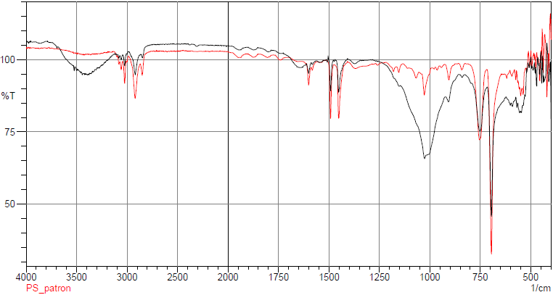  Figure 1: Polystyrene identification spectrum using FTIR (point M2_ E.CL3). | 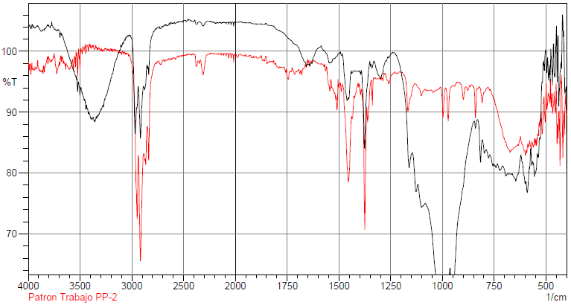  Figure 2: Polypropylene identification spectrum using FTIR (Point M2_E.DL4).
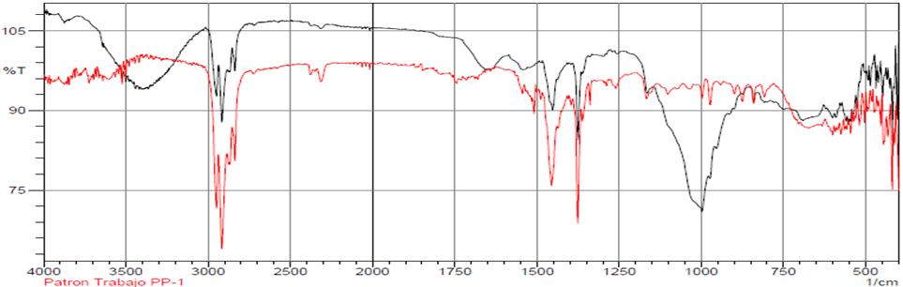  Figure 3: Polypropylene identification spectrum using FTIR (point M1_E.CCH1) | 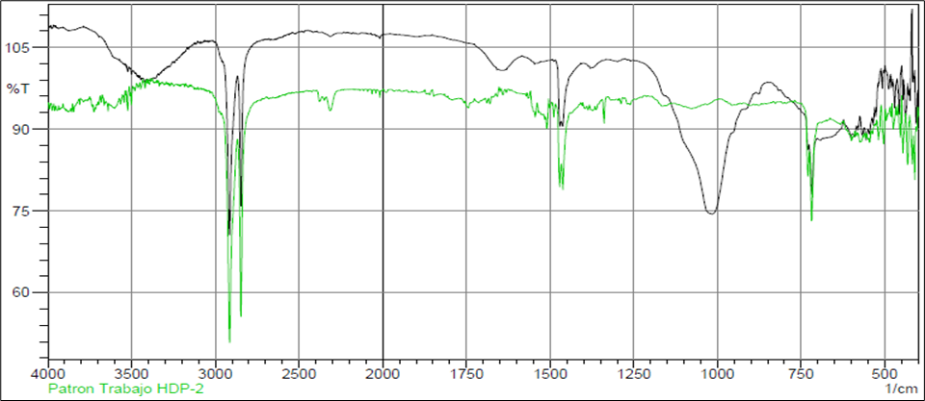  Figure 4: Identification spectrum of high-density polyethylene, using FTIR (Point M1 E.CL3)
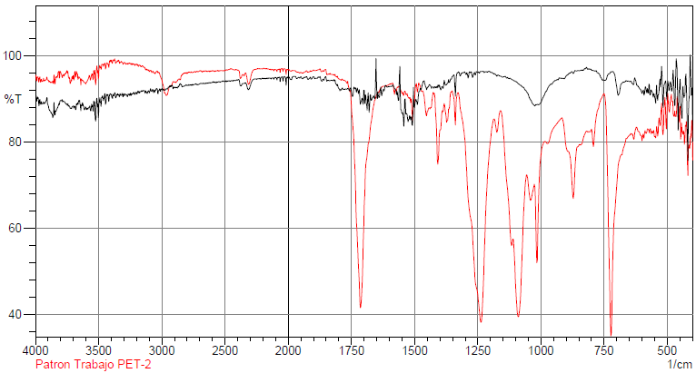
Figure 5: Identification spectrum Polyethylene terephthalate, using FTIR (Point M11 E.DCH4)

The use of FTIR (Fourier transform infrared) spectroscopy, is a methodology that allows the identification of microplastics (Käppler, 2015), but that can be reinforced by Raman spectroscopy ideal for sizes smaller than 20 µm, both technologies have the advantage of being non-destructive, a small amount of sample is used, with high detection performance and above all respect for the environment (Araujo C., 2018).
Microplastics, particles smaller than 5 mm, are considered emerging pollutants whose presence in different natural resources is not new, but their identification and knowledge of the different forms of risk and impact on the environment is still new. One place that requires more attention is the waters, banks and estuaries of rivers, since they are a direct transport route of plastics and microplastics to the sea, compromising the ecosystem services of rivers. For example, in a study on the La Plata River, microplastics were found in the southern coastal strip of the estuary of this river, in sediments and biota of the site (Pazos, 2021). Therefore, this type of study requires an in-depth study of all aspects, both anthropic and natural, of the presence of microplastics and their impacts on the environment.
  - Conclusion
In the lower basins and at the mouths of the Lurín and Chillón rivers, microplastics of various colors, irregular shapes and of type polyethylene, polypropylene, high-density polyethylene, polystyrene and polyethylene terephthalate were identified by FTIR microscopy; Likewise, in the case of the Lurín river was where a greater quantity was found compared to the Chillón river. Thus, it is necessary to continue research on microplastic contamination in rivers, in order to establish ways of managing microplastic precursor waste to avoid this type of contamination with detrimental impacts on ecosystems, human health and the environment.
Acknowledgments

The authors would like to thank the Vice-Rectorate of Research of César Vallejo University, in its "Research UCV” program, for the support for the dissemination of this research.

References

Ahmaditabatabaei S., Iqbal HM, Moinipoor Z., Kyazze G., Keshavarz T., 2022, Pretreatment with cationic and nonionic surfactant to improve bacterial biodegradation of pets, chemical engineering transactions, 93, 235-240, (in Spanish)
AQUAE, 2021, Microplastics on land, in freshwater and in the sea, Foundation, (In spanish) <fundacionaquae.org/wiki/dia-mundial-del-medio-ambiente-microplasticos-en-la-tierra-en-el-agua-dulce-y-en-el-mar/ accessed 15.02.2023.
Araujo C., Nolasco M., Ribeiro A., Ribeiro-Claro P., 2018, Identification of microplastics using Raman spectroscopy: Latest developments and future prospects, Water Research, 142, 426-440.
Barrow A., Cathey S., Petersen C., 2018, Marine environment microfiber contamination: Global patterns and the diversity of microparticle origin, Environmental pollution, 237, 275-284.
Cox K., Covernton G., Davies H., Dower J. F., Juanes F., and Dudas S., Human Consumption of Microplastics, Environmental Science & Technology, 53 (12), 7068-7074.
De la Torre, 2019, Microplastics in the marine environment: a problem to be addressed, Revista Ciencia y Tecnología, 15(4), 27-37.
Käppler A, Windrich F, Löder MG, Malanin M, Fischer D, Labrenz M, Eichhorn KJ, Voit B., 2015, Identification of microplastics by FTIR and Raman microscopy: a novel silicon filter substrate opens the important spectral range below 1300 cm(-1) for FTIR transmission measurements. Anal Bioanal Chem., 407(22), 6791-801. doi: 10.1007/s00216-015-8850-8, Epub 2015 Jun 28. PMID: 26123441.
Mohd Rosmmi NH, Khan ZI, Mohamad Z., Abd Majid R., Othman N., Che Man SH, Abd Karim KJ, 2021, Impact resistance and morphology of recycled polyethylene terephthalate blends of sustainable origin, Chemical Engineering Transactions., 83, 265- 270.
Ortega P., 2020, Microplastics detection in sea water using Raman spectroscopy, Thesis de grado, Cantabria University, Science Faculty, (in Spanish).
Parda J., 2020, The problem of microplastics in the Canary Islands, Thesis de grado, Universidad de La Laguna, España, (in Spanish)
Pazos R., 2021, Study of microplastics in the water column, intertidal sediment and resident biota on the coast of the estuary of the Río de la Plata (South Coastal Strip), Thesis of Doctored, Universidad Nacional de la Plata, (In spanish).
Pretell v., Pinedo L., Ramos W., Benites E., 2020, Evaluation and Characterization of Microplastics on Three Sandy Beaches of Lima, Peru, Engineering, Integration, and Alliances for a Sustainable Development. Hemispheric Cooperation for Competitiveness and Prosperity on a Knowledge-Based Economy: Proceedings of the 18th LACCEI International Multi-Conference for Engineering, Education and Technology, 71.
Rojo-Nieto E. and Montoto T., 2017, Marine litter, plastics and microplastics: origins, impacts and consequences of a global threat, Report, Ecologists in action,(in Spanish) <accedacris.ulpgc.es/bitstream/10553/56275/2/informe-basuras-marinas.pdf>, accessed 15.02.2023. (in Spanish)
Rubio M., 2021, Dietary exposure to microplastics in Spain, Thesis, Máster Universitario en Seguridad y Calidad de los Alimentos, universidad de La Laguna, España, (in Spanish).
Schrank I., Löder MGJ., Imhof HK., Moses SR., Heß M., Schwaiger J. and Laforsch C., 2022, Riverine microplastic contamination in southwest Germany: A large-scale survey. Front. Earth Sci. 10:794250.
SENAMHI, 2021, Boletin hidrológico mensua a nivel nacional: Mayo, <repositorio.senamhi.gob.pe/bitstream/handle/20.500.12542/987/Bolet%C3%ADn-hidrol%C3%B3gico-mensual-a-nivel-nacional-may_2021.pdf?sequence=1&isAllowed=y>, accessed 15.02.2023.
Tyree C. and Morrison D., 2020, Plus Plastic: Microplastics Found in Global Bottled Water, Orb Media, An Investigative Report, <orbmedia.org/plus-plastic?locale=es>, accessed 15.02.2023.
Vásquez-Molano D., Molina A. and Duque G., 2021. Spatial distribution and increase of microplastics over time in sediments of Buenaventura Bay, Colombian Pacific, Marine and Oceans Research Newsletter, 50(22), 27–42. https://doi.org/10.25268/bimc.invemar.2021.50.1

