CHEMICAL ENGINEERING TRANSACTIONS  VOL. , 2023 | A publication of
The Italian Association
of Chemical Engineering
Online at www.cetjournal.it

Guest Editor: Sauro Pierucci
Copyright © 2023, AIDIC Servizi S.r.l.
ISBN 978-88-95608-98-3; ISSN 2283-9216

Study of Pigments of Peruvian Colonial Mural Painting Through Chemical Analysis and Under Simulated Conditions for Aiming Cultural Heritage Care
Anibal Alviz-Meza^{a,b*}, Lucila Iglesias^{c,d}, Diana Castillo^{d}, Andrés De Leo^{d}, Edwin Torres-Salazar^{b}, Juan Orozco-Agamez^{e}
ªGrupo de investigación en Deterioro de Materiales, Transición energética y Ciencia de Datos DANT3, Universidad Señor
de Sipán, Faculty of enginering, arquitecture and urbanism, Chiclayo, Pimentel 14001, Peru
^{b}Semillero de Investigación en Corrosión de Metales, Energías Sostenibles y Análisis de Datos - COMD3S, Faculty of enginering, arquitecture and urbanism, Universidad Señor de Sipán, Chiclayo, Pimentel, 14001, Peru
^{c}Centro de Investigación en Arte, Materia y Cultura, Universidad Nacional de Tres de Febrero - UNTREF, Buenos Aires, Argentina
^{d}Research Center for Heritage Conservation, Universidad de Ingeniería y Tecnología - UTEC, Lima, Peru
^{e}Universidad Industrial Santander, Escuela de Ingeniería Metalúrgica y Ciencia de los Materiales, Grupo de Investigaciones en Corrosión – GIC, cra 27 calle 9, Bucaramanga –Santander, Colombia
alvizanibal@crece.uss.edu.pe
Color is an important heritage asset property, giving value and life to historical objects. Colonial paintings require management and control since their constitutive pigments are susceptible to physical and chemical changes due to weather and pollutant conditions. In this regard, simulation and experimental techniques such as X-ray diffraction and scanning electron microscopy were used to determine the aging and composition of a selected mural painting from the colonial period of Cusco, Peru. As a result, hematite is suggested as the pigment used in the mural painting. Meanwhile, Cusco's low humidity environmental conditions in certain seasons favor the transformation of hematite to goethite, modifying the original color of paintings. This research aims to understand the material deterioration of pigments from heritage objects as input for future studies pursuing conservation strategies.
  - Introduction
This section is divided into two subsections to describe properly the heritage object under study and the painting methods used in the colonial period in Cusco, Peru.
    - Legend of Our Lord of Seven Stabs in Cusco
The catholic image known as Señor de las 7 puñaladas (translated to English as Our Lord of Seven Stabs) is a peculiar case of a colonial mural painting that has been fragmented to become a strong cult in Cusco in the early 19th century. This painting became part of one of the altarpieces in the Lesser Basilica of la Merced in Cusco in 1835. The painting depicts the iconography of Ecce Homo and shows four visible stabs. It was painted in adobe (sun-dried brick) but after its desecration was added to a wooden crate.
The legend of the Christ image was described in 1835 by the friar Jose M. Blanco, He wrote in his Diary: “This year 1835, Mercedarian friars moved to this church (the Lesser Basilica of la Merced in Cusco) the image of Jesus Christ painted in clay, which was located in the second courtyard of the Company, next to the Jesuit church, which a soldier named Corrales stabbed it many years ago, reason for which It is known by the name of Lord of the Stabs" (Blanco J. M., 1974). The attack against this image became an origin story for this cult that nowadays has a crowd of believers that venerate it.
    - Pigments in colonial mural painting
Mural painting practiced in the Andes region during colonial times was typically based on the tempera technique on a dry surface, contrary to the usual fresco used in Europe. The technique used for these pictorial images is still poorly studied, as well as the characterization of their materials, the interaction between them, and how this is related to their state of conservation.
In the case of the mural painting “Our Lord of the seven stabs”, the surface on which it was produced was an adobe wall. These kinds of walls are built from blocks made with kneaded clay mixed with vegetable fibers. Once it has dried in the sun, those blocks acquire the desired physical properties to be used as a structural element of the enclosure. A mud coating, with a more fluid consistency, was placed on the adobe wall bound with vegetable fibers and juice of a local cactus (hahuacollay) that kept the mixture moist for a prolonged period, guaranteeing its cohesion. Once it is dried, this surface is prepared with a mixture of plaster (calcium sulfate) whose thickness varies according to the time, artist, and required needs. Finally, the agglutinated pigments are applied, generally in protein media. The advantage of this technique, dry tempera, is that it allows the use of a varied palette of colors, which is not possible with the fresco technique, due to the chemical reaction that is generated. This advantage is related to the varied color that characterizes Andean mural painting, which, at the same time, is connected with its fragile stability and state of conservation. This last aspect represents a concern that has received limited scientific attention.
Our Lord of the seven stabs represents the Andean mural painting technique from the 18th century. This artwork has been fragmented from the original wall and manipulated as a painting on canvas. In this research work, we focused on the red pigment used in the curtain and mantle of the representation.
  - Materials and methods
This section is divided into fieldwork, which leads to the extraction of pigments, and lab work, which includes material characterization combined with aging simulations of the selected samples.
    - Examination of the mural painting with lighting techniques
The fieldwork at the Basilica of la Merced required lifting equipment to elevate cameras to the altitude of the mural painting Our Lord of Seven Stabs. Once the photography set was installed, the painting was examined with different lighting techniques such as visible and UV-A (399 nm wavelength) in order to reveal non-visible details on the surface. For the UV-A images, we used a NIKON D5300 18mm f/3.5 3s ISO400 camera.
The resulting photographs allowed us to identify the successive modifications made to the painting and to find areas free of interventions for the extraction of pigment samples. Two samples were extracted, one taken for SEM-EDS and the other for XRD analysis
    - Characterization of samples and aging simulation
We used Scanning Electron Microscopy with Energy Dispersive Spectroscopy (SEM-EDS) and X-Ray Diffraction (XRD) for characterizing the extracted samples of pigments. SEM-EDS supplied chemical data and morphological information of the extracted sample while XRD indicated the crystalline phases present in the samples. Table 1 shows the measuring parameters.
Table 1: Characterization equipment and its operational parameters
Technique | Equipment | Parameter
SEM-EDS | Quanta FEG 250, BSED-SSD, EDAX APOLO X | Voltage 25 kV, high vacuum, and detector resolution of 126.1 eV, Mn-$Kα$
XRD | Bruker D8 Advance  DaVinci geometry | Voltage 40 kV, current 40 mA, scan range between 5 and 70 $°2θ$, step size of 0.06 $°2θ$, and a counting time of 1 s per step

Table 2 summarizes the input data implemented in the HSC Chemistry 9 software (Metso: Outotec, 2020) for two studied scenarios: Cusco environmental conditions at low and high humidity, considering CO and NO₂ pollutants (Lanier Pear, 2007; Weather-Atlas, 2023).
Regarding the found limitations, it is important to highlight that information regarding the concentration of contaminants in multiple measuring stations from Cusco is scarce and it cannot be assumed as the real conditions where heritage objects are exhibited or stored typically. Besides, an estimation of a 1000:1 molar ratio (John, 2010) to correlate the air composition and hematite was implemented to evaluate the thermodynamic equilibrium of the pigment (Mendez et al., 2022). The obtained results are limited to the interfacial region between the environment and the substrate, deeper zones within the substrates respond to different equilibrium conditions.

Table 2: simulation conditions implemented in the software HSC Chemistry 9
Sample | Composition  (%wt.) | Environmental conditions^{b}
 |  | High humidity | Low humidity
 |  | Air at 21 ºC and relative humidity of 66 %  77.1 %mol $N_{2}$  21 %mol $O_{2}$  1.7 %mol $H_{2}O$  0.2 %mol $CO$  0.0013 %mol ${NO}_{2}$ | Air at 0 ºC and relative humidity of 46 %  78.5 %mol $N_{2}$  21 %mol $O_{2}$  0.3 %mol $H_{2}O$  0.2 %mol $CO$  0.0013 %mol ${NO}_{2}$
Pigmentª | 100 Fe₂O₃
ª Obtained by SEM-EDS analysis.
^{b} Taken from the psychrometric chart and references (Lanier Pear, 2007; Weather-Atlas, 2023).
  - Results and discussion
This section is presented in the same order as the methodological section: fieldwork and lab work.
    - Fieldwork
The taken visible light photographs revealed irregularities at the painting surface, as usual on wall paintings (see Figure 1a). This figure, also makes evident the bigger holes produced by the stabs. The use of UV-A light in Figure 1b, revealed several fluorescence areas as evidence of repaints interventions and blueish fluorescence related to oil-resin varnish (Diaz Martos, 1987). This examination was necessary for deciding the sampling area, as we were looking for less repainted surfaces. Moreover, the UV-A light in Figure 1c made visible the origin of a texture on the right side of Christ's head and neck. Those repainted tiny holes indicate an old votive custom, usual in cult images, related to the inclusion of metallic accessories. In this case, perhaps due to the implementation of a metallic aureole.
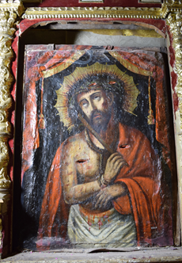
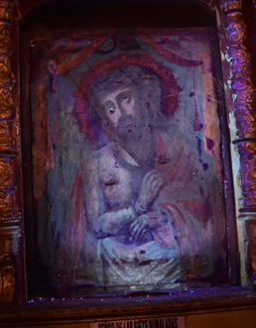
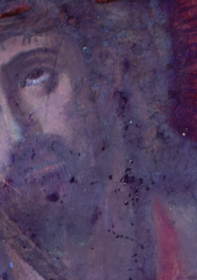
a) b) c)

Figure 1: Photographs of a) visible light, b) UV-A light complete view, and c) UV-A light face focused

    - Characterization and simulation findings
The SEM-EDS analysis shown in Figure 2 and Table 3, provided multiple elemental information about the sample extracted from the mural painting. This sample seems to be a mixture of diverse mineral layers, as part of the elaboration process. Usually, the mural structure of paintings from the colonial times of Peru was made according to the following steps. First, the support was prepared with plaster of fine mud with vegetable fibers, a layer of pre-screened mud with clay 1:1 mixed with hydrated lime, and a layer of hydrated lime spread on the surface (used as a primer). In the second step, the pictorial layer was applied, which was composed of pigments of mineral and organic origin. Cochineal and colorants similar to sepia and carmine were used. These colors were alternated with pigments such as ochres, oxides, and carbonates. The egg white was sometimes used as a medium, as well as animal glue and cactus juice (Argumedo, 1986).
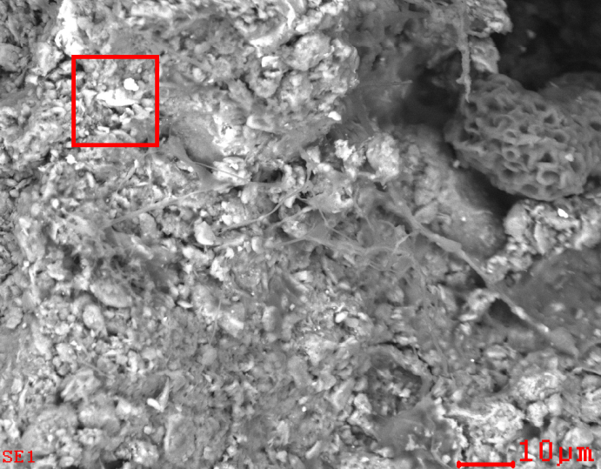
Figure 2: SEM micrograph of the sample extracted from the mural painting. The red zone indicates a zone where the backscattered electrons analysis was performed
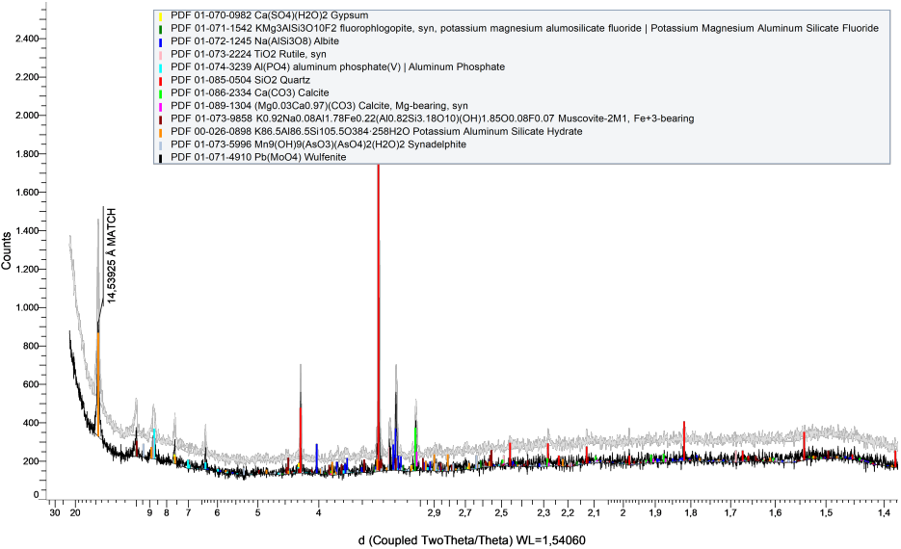
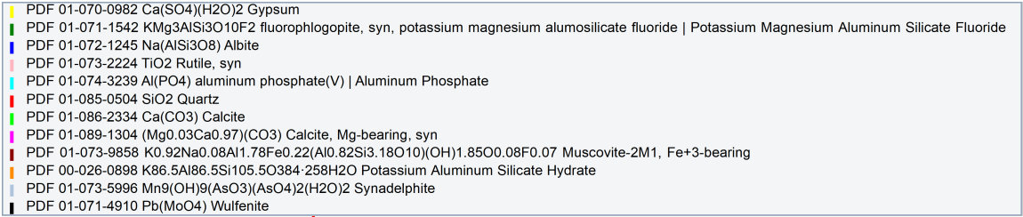
Table 3: SEM-EDS results associated with Figure 1
 | C | O | Na | Mg | Al | Si | S | K | Ca | Fe
%wt. | Balance | 21.24 | 01.01 | 01.66 | 6.12 | 12.99 | 02.09 | 03.09 | 08.35 | 21.96

Figure 3: XRD pattern obtained for an extracted sample of the studied mural painting

The presence of iron in Figure 2 may be linked to the presence of hematite as a pigment, which gives a darker red tone to the painting (Tomasini et al., 2016). However, iron may act together with silicon, aluminum, magnesium, potassium, calcium, and so forth to conform to other compounds found in red north Peruvian mural paintings such as illite and smectite (Wright, Meneses, et al., 2015). Likewise, a red mural painting from the south coast of Peru has been described as a combination of iron oxide (hematite), gypsum, and illite, which is added to a noticeable concentration of mineral salt (halite, NaCl) (Wright, Pacheco, et al., 2015). These arguments are consistent with our findings in SEM-EDS and XRD, where gypsum, illite, and smectites were identified in the sample’s bulk (see Figure 3).
The results of chemical predominance for hematite (Fe₂O₃) in Figure 4, proved that it is stable at low humidity conditions. As humidity increases the presence of goethite (FeO*OH) increases, changing the original pigment color to a more brownish-red. Similar results have been published by other authors, pointing out that high percentages of humidity in the environment tend to degrade hematite (Alviz-Meza et al., 2021; Maguregui et al., 2010). Moreover, goethite has been found in mural paintings together with hematite, which may be a consequence of its aging (Wright et al., 2015). Therefore, as a general premise, it can be claimed that hematite requires a low-humidity environment for its conservation in heritage paintings.

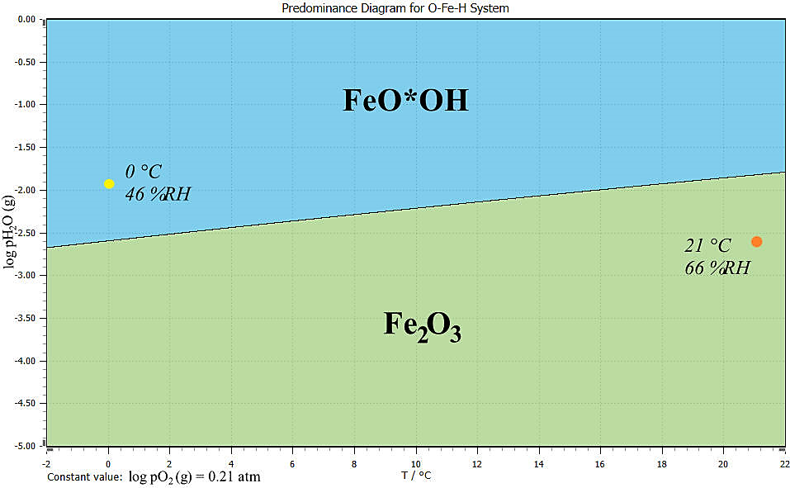
Figure 4: Stability phase diagram for the studied pigments at the environmental conditions of Cusco, Peru
  - Conclusions
This research work assesses the deterioration of a heritage mural painting from the colonial period of Peru through chemical characterization of extracted samples and by simulating aging in the Cusco’s environmental conditions. The characterization results obtained through SEM-EDS and XRD indicated the presence of hematite, gypsum, illite, and smectites in the analyzed sample. The HCS Chemistry 9 software led us to conclude that when displacing the equilibrium stability from 66 %RH and 21 °C to 46 %RH and 0 °C the transformation of hematite to goethite is promoted. As a consequence, the red pigment changes its hue or intensity. As a general recommendation, according to the results obtained, we propose to use low humidity in the exhibition or storage environments of heritage paintings to contribute to the conservation of these historical pieces. These results highlight the importance of the correct management of heritage collections.
Acknowledgments
The authors express their gratitude to the Universidad Señor de Sipan for funding the research project under the code 082-2022/PD-USS and to the Thomas Foundation, for the provided Research & Travel Award that made possible part of the fieldwork in Cusco.
References
Alviz-Meza A., Rodriguez J. C., Chacaliza A., 2021, Thermodynamic stability of gilded copper and pigments at high relative humidity and at environmental conditions of Lima , Perú Thermodynamic stability of gilded copper and pigments at high relative humidity and at environmental conditions of Lima , Perú. Journal of Physics Conference Series, 1938. https://doi.org/10.1088/1742-6596/1938/1/012003
Argumedo R. S., 1986, Mural painting on adobe walls during Peruvian colonial times — its restoration and conservation. Studies in Conservation, 31(July), 75–79. https://doi.org/10.1179/sic.1986.31.Supplement-1.75
John R., 2010, Sulfidation and mixed gas corrosion of alloys. In Shreir´s Corrosion (pp. 240–270). Shell Global Solutions. https://doi.org/10.1016/B978-044452787-5.00014-7
Lanier Pear J., 2007, USE OF GIS IN THE ASSESSMENT OF AIR POLLUTION IN CUSCO, PERU [The University of Georgia]. https://getd.libs.uga.edu/pdfs/pearce_john_l_200705_ms.pdf
Maguregui M., Knuutinen U., Castro K., Madariaga J. M., 2010, Raman spectroscopy as a tool to diagnose the impact and conservation state of Pompeian second and fourth style wall paintings exposed to diverse environments (House of Marcus Lucretius). Journal of Raman Spectroscopy, 41(11), 1400–1409. https://doi.org/10.1002/jrs.2671
Mendez D. A., Uribe B. E., Orozco-Agamez J., Pena-Ballesteros D., Alviz-Meza A., 2022, Evaluation of the Diffusive Capacity of Hydrogen Through 9Cr-1Mo Ferritic Steel in the Dual Environment of a Furnace: a Simulation Study in Comsol Multiphysics® CHEMICAL ENGINEERING TRANSACTIONS Evaluation of the Diffusive Capacity of Hydrogen through 9Cr-1Mo Ferritic Steel in the Dual Environment of a Furnace: a Simulation Study in COMSOL Multiphysics®. https://doi.org/10.3303/CET2296044
Metso:Outotec, 2020, HSC Chemistry 9 (9.0). Metso: Outotec. https://www.hsc-chemistry.com/
Tomasini E., Rodríguez D. C., Gómez B. A., De Faria D. L. A., Landa C. R., Siracusano G., Maier M. S., 2016, A multi-analytical investigation of the materials and painting technique of a wall painting from the church of Copacabana de Andamarca (Bolivia). Microchemical Journal, 128, 172–180. https://doi.org/10.1016/J.MICROC.2016.04.020
Weather-Atlas, 2023, Previsión meteorológica y clima mensual Cusco, Peru. https://www.weather-atlas.com/es/peru/cusco-clima#humidity_relative
Wright V., Meneses I. A., Laval É., 2015, The origins of mural painting in Ancient Peru: archaeometric preliminary study of the Ventarrón mural paintings, Valle de Lambayeque. Heritage Science 2015 3:1, 3(1), 1–10. https://doi.org/10.1186/S40494-015-0059-9

