CHEMICAL ENGINEERING TRANSACTIONS  VOL. , 2023 | A publication of
The Italian Association
of Chemical Engineering
Online at www.cetjournal.it

Guest Editor: Sauro Pierucci
Copyright © 2023, AIDIC Servizi S.r.l.
ISBN 978-88-95608-98-3; ISSN 2283-9216

Study of Silver Used in Peruvian Viceroyalty Objects Through Chemical Analysis
Anibal Alviz-Meza^{a,b,*}, Andrés De Leo^{c}, José Barandiaran-Gamarraª, Edwin Torres-Salazar^{b}, Juan Orozco-Agamez^{d}
ªGrupo de investigación en Deterioro de Materiales, Transición energética y Ciencia de Datos - DANT3, Faculty of enginering, arquitecture and urbanism, Universidad Señor de Sipán, Chiclayo, Pimentel 14001, Peru
^{b}Semillero de Investigación en Corrosión de Metales, Energías Sostenibles y Análisis de Datos - COMD3S, Faculty of enginering, arquitecture and urbanism, Universidad Señor de Sipán, Chiclayo, Pimentel, 14001, Peru
^{c}Research Center for Heritage Conservation, Universidad de Ingeniería y Tecnología - UTEC, Lima, Peru
^{d} Universidad Industrial Santander, Escuela de Ingeniería Metalúrgica y Ciencia de los Materiales, Grupo de Investigaciones en Corrosión – GIC, cra 27 calle 9, Bucaramanga –Santander, Colombia
alvizanibal@crece.uss.edu.pe
The exploitation of metals such as silver and copper has been the basis of the economic and socio-cultural development of multiple Andean societies such as Peru. Vestiges of the main centers of colonial metallurgy are known for their exhibition at various points of the Andean baroque route. However, exist doubts about the constituent minerals that these objects may drag. A record of trace metals emitted during smelting operations are useful to estimate their quality and provenance. In this approach, we found viceroyalty silver objects with only copper as a tracer metal, in Ag/Cu ratios from 9 to 34.85. The crystalline system of both metals was found to be cubic in one object while other objects indicated amorphous phases for both elements. This type of research has the potential to be extended with other characterization techniques such as lead isotopic analysis, leading to the determination of the provenance of pieces today ubicated at Cusco.
  - Introduction
In the 16th and 18th centuries, the quality of the material used in silver objects was an extremely important issue for the crown of Spain and its religiosity. The precious metals had symbolic characteristics in the catholic ritual leading to high-quality controls in such pieces in terms of their value for the payment of taxes associated with the extraction and trade of silver-made artefacts from the American territory.
A couple of studies have been dealing with chemical characterization to obtain the quality of heritage silver objects, focused on the viceroyalty period. One of these works was carried out in Mexico, with a chalice of a popular tradition called the "chalice of the twelve" because it has been referred to as the first chalice that came with the inaugural evangelizes that visited the new Spain territory. The SEM-EDS technique was applied to this chalice to ubicate its period of fabrication around the first years of the 16th century since its composition was rich in lead, with a lack of precious metals such as silver or gold. It was a key feature since during the first half of the 16th century, the use of precious metals in this type of object was not as strict as it was at the end of the same century (De Leo, 2021). Another example of the importance of material characterization is found in the work of Luisa Vetter, the only one of its kind within the Peruvian sphere, specifically, around the characterization of materials in colonial pieces and with biases of interest in pre-Hispanic works (Vetter, 2008). The researcher intended to present the possibilities that the characterization of the materials can offer by SEM-EDS, delivering a proposal on the percentages of the metals found; which helped to establish the legal standards that were of the Crown for the quality of silver pieces worked during the viceroyalty period. These findings represent the only research aiming to study viceroyalty objects from Peru through chemical characterization.
In the historical history telling about silver pieces from the viceroyalty period, the silver objects made in the different American viceroyalty cities responded to the law of the time and to the control given to the "Caja Real", an institution administered by the crown that was in charge of collecting taxes. Each city with a Caja Real had an "ensayador" (tester) at its service, a silversmith with outstanding reputation and skills, who verified the quality of the silver in objects. In general terms, before a religious or civil silver object was made, the silversmith had to present the silver with which the piece would be made to the tester. The metal was weighed and its quality was verified. After this, the silversmith returned to his workshop to make the pieces. When he finished, he returned to the tester with the pieces to be weighed again and quality verified. From this weight, the owner had to pay a fifth of the value as a tax of 20%. The tester verified that the silversmith's work did not exceed the alloy of other less noble metals, such as copper, and that the silver declared at the beginning was not traded illegally, evading taxes. In this way, each verified piece was marked with the signs of the Caja Real, the tester, the silversmith, and in some cases the owner. Besides, a zigzag incision that demonstrated the random extraction of metal for its inspection remained marked in the piece (Ruiz Medrano, 2002). Although this was the ideal of control to make the pieces in the territory of the American viceroyalties, the vast majority of silver objects that exist do not have these marks, so questions arise for the history of the art of silverware such as: Even though the production of silver pieces was not controlled, what alloy guidelines did silversmiths follow in the Cuzco region, Peru? Regarding its quality and religious use, is there a relationship between quality and use?
  - Method and materials
This section is divided into fieldwork, which leads to the extraction of samples, and lab work, which includes chemical characterization.
    - Selection of objects to be studied
Three silver pieces located in the temple San Pedro Apóstol de Andahuaylillas were selected to approach possible answers to the research question presented in the introduction section. This is a provincial temple located 35 km from the city of Cuzco, Peru. It is characterized by having a bunch of art pieces accumulated from the late 16th to the 19th century. Among the various silver objects in the said collection, a lectern, a chalice, and a ciborium were taken to be studied. Each silver object was chosen based on its era, relationship with the tester brands, and its use.
We also collected chronological data from the three viceroyalty objects: three characteristics for their dating based on style and markings, and information about the use of these pieces in the catholic rituals. From this, the sacredness that the ciborium and the chalice must have, unlike the lectern, stands out, since according to the Catholic ritual, the containers of wine and wafer are sacred. It was necessary to select a surface that did not compromise the aesthetics of the pieces for the extraction of samples. It was determined that the best place for extraction was the internal parts of the objects. After selecting the areas, they were cleaned with cotton and isopropyl alcohol. Subsequently, a superficial section of the piece was extracted to be discarded with a surgical steel scalpel due to its likely contamination. Finally, with another new scalpel blade, a new extraction was performed in the before exposed area (previous scratch) obtaining shavings to be chemically analyzed.
    - Characterization of samples
We used Scanning Electron Microscopy with Energy Dispersive Spectroscopy (SEM-EDS) and X-Ray Diffraction (XRD) for characterizing the extracted samples of silver. SEM-EDS supplied chemical data of the extracted sample while XRD indicated the crystalline phases present in the silver slivers. Table 1 shows the measuring parameters.
Table 1: Characterization equipment and its operational parameters
Technique | Equipment | Parameter
SEM-EDS | Quanta FEG 250, BSED-SSD, EDAX APOLO X | Voltage 25 kV, high vacuum, and detector resolution of 126.1 eV, Mn-$Kα$
XRD | Bruker D8 Advance  DaVinci geometry | Voltage 45 kV, current 40 mA, scan range between 10 and 80 $°2θ$, step size of 0.05 $°2θ$, and a counting time of 5 s per step
  - Results and discussion
This section is alienated from the methodological section, the first subsection is about the selected silver objects and the second is destined for the chemical analysis performed.
    - Descriptions of the selected silver objects
The chalice observed in Figure 1 is a cup used as a fundamental object for the ritual of the mass. Its function is to contain the wine that is transubstantiated as the blood of Christ during the ritual of the mass, according to Catholic belief. The Andahuaylillas’ chalice can be dated to the mid-17th century due to its shape and aesthetic characteristics. The absence of decoration and its smooth surfaces are characteristic of the models established at that time throughout the Hispanic territory, which denoted the importance of the form in the ritual of the mass (De Leo, 2022). One aspect to be highlighted of this chalice is that on the inner part of its base, it has a series of five incision lines, as a mark that it was quality verified by a tester.

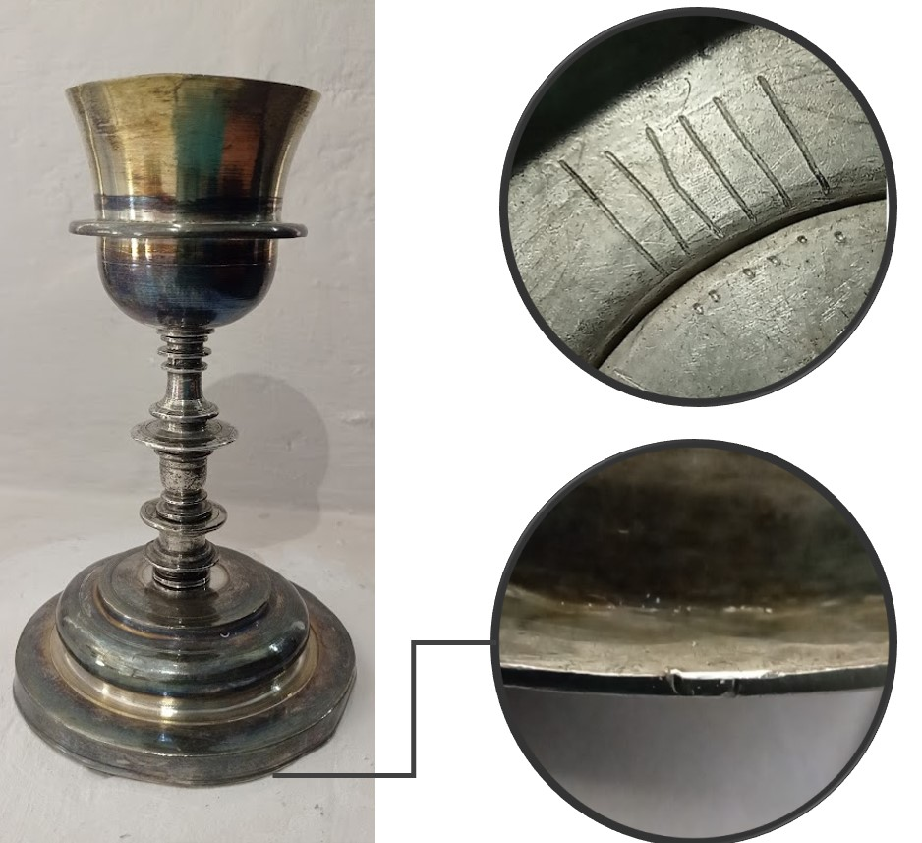
a)
b)
Figure 1: Anonymous chalice, carved silver, mid-17th century. a) tester marks. b) sample extraction point

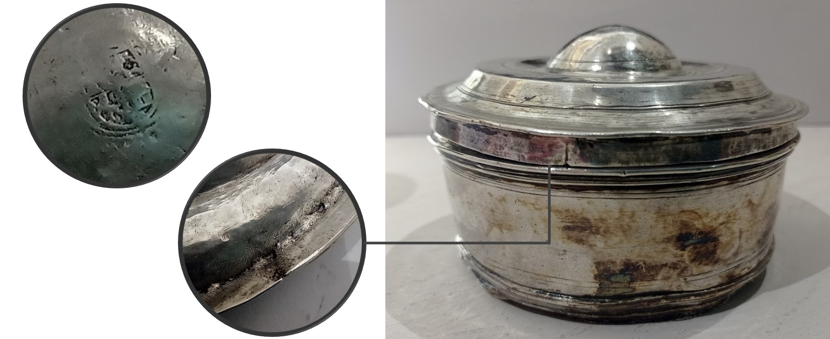
a)
b)
Figure 2: Anonymous ciborium, Carved Silver, 1575-1598. a) Caja Real, Lima. b) sample extraction point

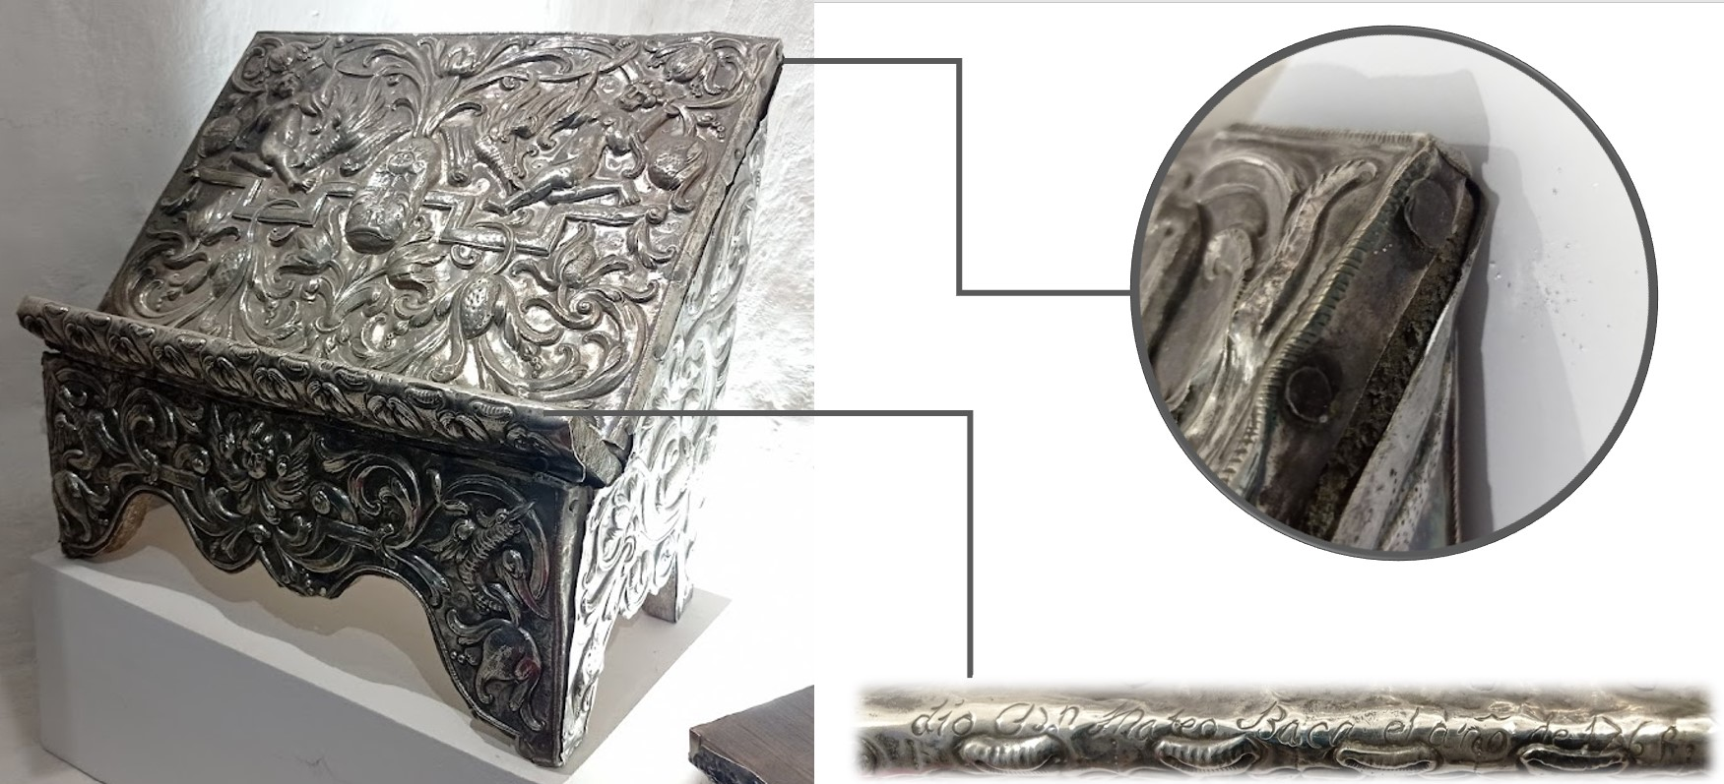
a)
b)
Figure 3: Anonymous table lectern, carved silver, 1765. a) sample extraction point. b) registration of donor and date

The ciborium is a container that is used to store consecrated wafers (see Figure 2). The Catholic dogma indicates that these wafers also transubstantiate the body of Christ during the mass. This object is comparable to the chalice due to the simplicity of its aesthetic characteristics; however, it has a centered mark in its inner part that can be associated with the mark of the Caja Real of Lima, used between 1575 and 1598 (Esteras, 2000). The third piece is a table lectern (see Figure 3). This object was used in the mass ritual to place the book of the gospels on the altar table. In this case, the piece was made of wood lined with embossed silver plates. A feature to highlight of this piece is that on its frontal part, it has an inscription that says “gave Dn. Mateo Baca in the year 1765”, with the name of the donor and the date on which the piece was made.
    - Chemical characterization of samples
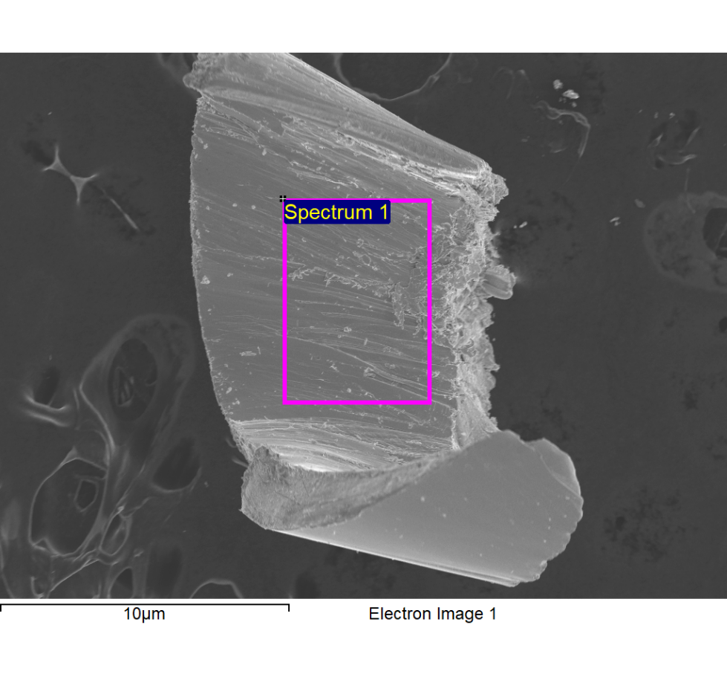
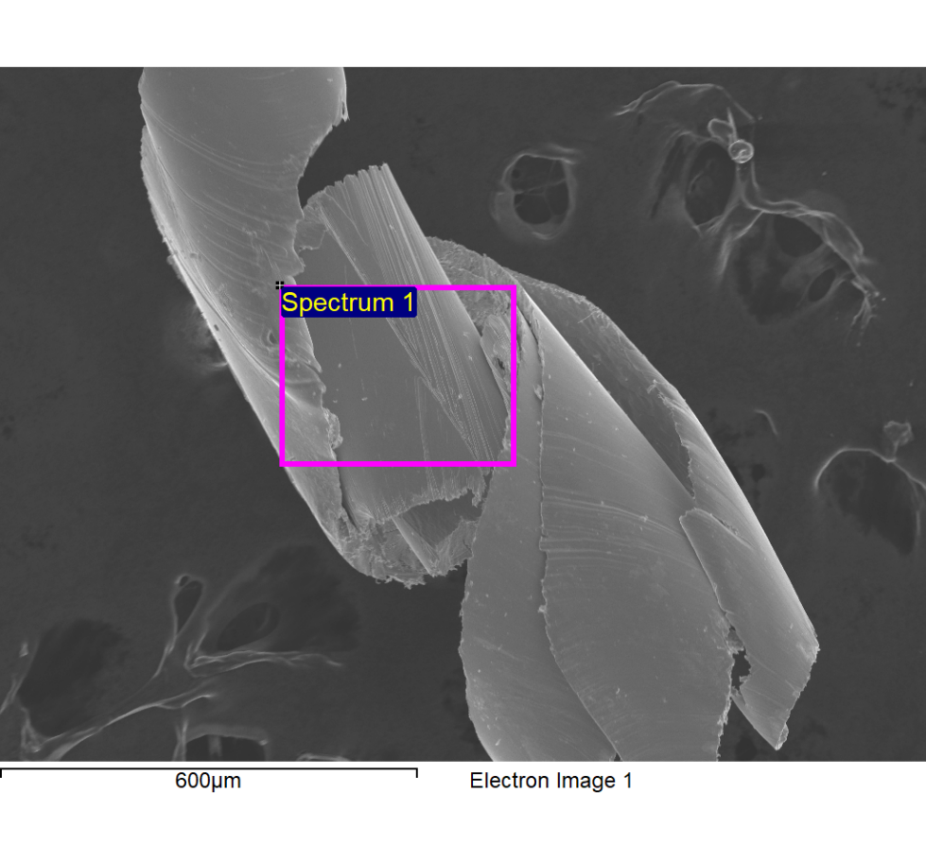
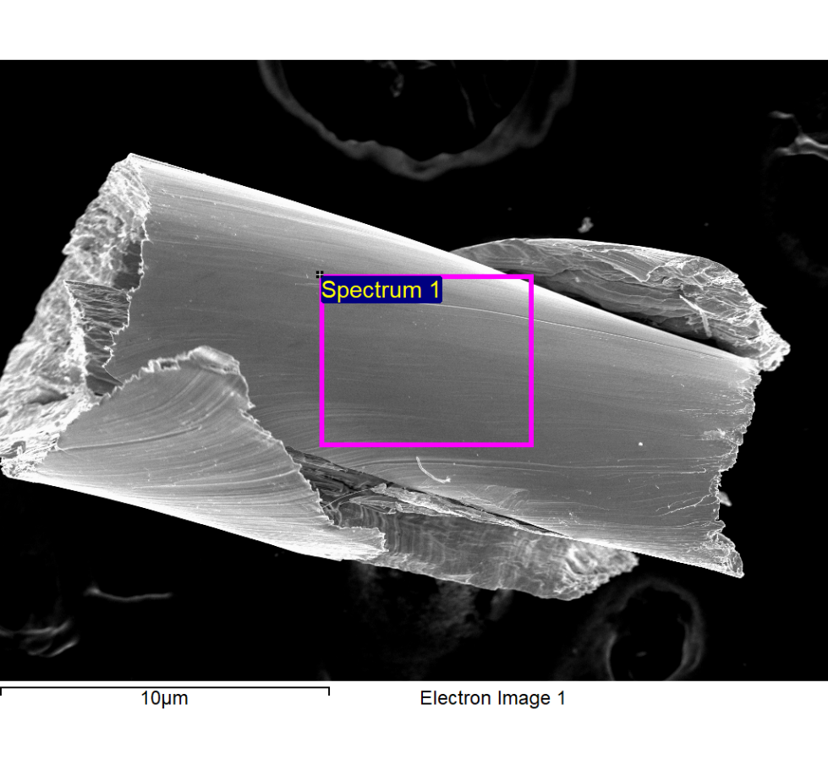
The characterization of metals in artistic pieces with heritage value and the geographical tracking of the origin of their raw material is a topic that has had an impact on the European sphere, especially in prehistoric and medieval works (Hernández-Casas, 2021). In American cases, it has only been applied to pre-Hispanic works (Guédron et al., 2021; Macfarlane, Andrew W. Petersen, 1990), and to date, it has not been explored in silverware from the viceroyalty period, covering the entire Spanish-American territory.
a) b)
c)
Figure 4: Backscattered electrons images obtained of the internal part of a) lectern, b) chalice, and c) ciborium silver objects
The use of chemical analysis to explore the composition of metal artefacts has been triggered by the appearance of cutting-edge technologies such as X-ray fluorescence, atomic emission spectrometry, and isotopic analysis. This technological revolution of the 20th century has shed light on the origin of heritage objects made from copper, silver, or their alloys (Pernicka, 2013). The methods employed to reveal the provenance of metals suggest the combination of two techniques: one based on the elemental composition analysis of the objects and another based on their isotopic analysis of minerals, including those of mercury (Cooke et al., 2013). In Peru, some studies have limited the use of XRF and pXRF (portable) to determine the origin of minerals (Craig et al., 2007). Meanwhile, in Lake Titicaca (Guédron et al., 2021), Hualgáyoc (Macfarlane, Andrew W. Petersen, 1990), and in Castillo de Huarmey (Kałaska et al., 2022) isotopic analysis has been used, since elemental analysis may be insufficient for the precise determination of the silvers’ mine origin (Gale and Stos-Gale, 2000). The study of trace elements present in artefacts made of silver is useful in cases described previously for copper alloys (Pernicka 2013) when the trace metals of the objects can be associated with particular quarries. In those cases, XRF and SEM-EDX measurements are focused on the ratios of silver to the rest of the elements present, to aim to explore the provenance, based on comparisons with various heritage objects (classification) and mine soils with exclusive trace elements (Isa-adaniya et al., 2022). For example, trace traces of silver, antimony, and nickel have worked to study the provenance of copper (Merkel, 1990). Our results of SEM-EDS showed that copper is the only metal presented in the studied silver objects (see Figure 4), covering a range between 9 and 34.85 in the Ag/Cu ratio, as observed in Table 2. Probably, the chalice was intentionally made highly rich in silver due to its spiritual meaning in the catholic context. Besides, it should be noted that we found a mark or certification of high-quality silver in the chalice at the moment of extracting the samples. Although the precision of the measurements is relevant, it has been reported that the minerals present in the quarries cover representative ranges of an order of magnitude, so the elemental patterns -fingerprint- have turned out to be more decisive (Radivojević et al., 2010). Then, as determined in the well-known Stuttgart project -copper provenance-, chemical analyses by themselves fail to determine the provenance of metals due to: chemical heterogeneities in mineral deposits, variable fractionation of chemical elements between ores, slag, and primitive smelting processes (Stos-Gale and Gale, 2009).
On the other hand, XDR results (see Figure 5 and Table 3) aimed to add information about the crystalline phases that may be present in viceroyalty silver objects. This statement does not represent all the characterized objects since the lectern and the chalice did not provide data about crystalline systems. Finally, all the collected chemical evidence is released to be used as a complement to isotopic analysis in a future study.
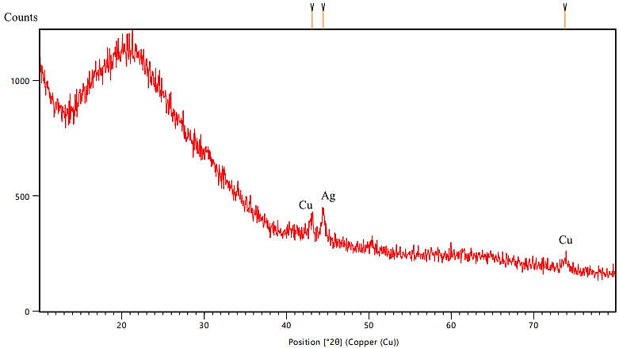
Table 2: %wt. results of the SEM-EDS analysis taken to the samples shown in Figure 1
 | C | O | Cu | Ag | Ag/Cu ratio
Lectern | Balance | 5.65 | 8.28 | 79.93 | 9.65
Chalice | Balance | 5.17 | 2.44 | 85.03 | 34.85
Ciborium | Balance | 7.10 | 9.29 | 83.61 | 9.00
Figure 5: XRD pattern obtained from the Ciborium sample
Table 3: Peak details of the XRD pattern of Figure 2
Reference  code | Crystal system | Pos. [°2θ] | Height [cts] | FWHM  Left [°2θ] | d-spacing [Å] | Rel. Int. [%]
00-004-0783 | Ag - Cubic | 44.4518 | 120.69 | 0.3936 | 2.03812 |  | 100.00
00-004-0836 | Cu - Cubic | 43.0814 | 85.57 | 0.4920 | 2.09972 |  | 70.90
00-004-0836 | Cu - Cubic | 73.7952 | 43.45 | 0.7872 | 1.28407 |  | 36.01
  - Conclusions
This research aims to provide chemical data through SEM-EDS and XRD techniques of selected silver viceroyalty objects from Cusco, Peru. As a result, copper was found as the only trace metal in the heritage objects, covering an Ag/Cu ratio range from 9 to 34.85. Moreover, both copper and silver presented a cubic crystalline system in one sample while both were amorphous in another sample. These results may be used as income data for a study focused on determining the provenance of these objects using isotopic analysis.
Acknowledgments
The authors express their gratitude to the Universidad Señor de Sipán for funding the research project under code 133-2022/PD-USS. Equally, the authors are grateful to the Universidad Complutense de Madrid for providing access to their characterization laboratories, especially to professor Francisco Javier Pérez Trujillo.
References
Cooke, C. A., Hintelmann, H., Ague, J. J., Burger, R., Biester, H., Sachs, J. P., & Engstrom, D. R., 2013, Use and legacy of mercury in the Andes. Environmental Science and Technology, 47(9), 4181–4188. https://doi.org/10.1021/es3048027
Craig, N., Speakman, R. J., Popelka-Filcoff, R. S., Glascock, M. D., Robertson, J. D., Shackley, M. S., & Aldenderfer, M. S., 2007, Comparison of XRF and PXRF for analysis of archaeological obsidian from southern Perú. Journal of Archaeological Science, 34(12), 2012–2024. https://doi.org/10.1016/j.jas.2007.01.015
De Leo Martínez, J., 2021, La platería de Puebla de los Ángeles: desde sus referentes hasta su distinción. Tesis de doctorado:. Ciudad de México: Universidad Nacional Autónoma de México.
De Leo, A., 2022, La distinción del cáliz de Puebla de los Ángeles en el s. XVIII, entre dos Mundos. Journal 18, 14, 1-12. https://www.journal18.org/6567.
Esteras, C., 2000, Más interrogantes sobre el marcaje de la platería americana. "Los cuños monetarios". Anales del Museo de América, 8, 29-43.
Gale, N. H., & Stos-Gale, Z., 2000, Lead isotope analyses applied to provenance studies. CHEMICAL ANALYSIS NEW YORK INTERSCIENCE THEN JOHN WILEY, 1(155), 503–584.
Guédron, S., Tolu, J., Delaere, C., Sabatier, P., Barre, J., Heredia, C., Brisset, E., Campillo, S., Bindler, R., Fritz, S. C., Baker, P. A., & Amouroux, D., 2021, Reconstructing two millennia of copper and silver metallurgy in the Lake Titicaca region (Bolivia/Peru) using trace metals and lead isotopic composition. Anthropocene, 34. https://doi.org/10.1016/j.ancene.2021.100288
Hernández-Casas, Y., 2021, Investigación del metal y Arqueología Medieval en la península ibérica: estado de la cuestión y nuevas perspectivas | Arqueología y Territorio Medieval. Arqueología y Territorio Medieval. https://doi.org/10.17561/aytm.v28.6898
Isa-adaniya, A., Alviz-Meza, A., & Rodriguez-Reyes, J. C. F., 2022, Chain Model for Research in Heritage Conservation : The Research Center for Heritage Conservation in Lima , Peru. Studies in Conservation, 137.
Kałaska, M., Mathur, R., Kamenov, G., Chyla, J., Prządka-Giersz, P., & Giersz, M., 2022, Deciphering the origin of small metal artefacts from Castillo de Huarmey (Peru) with Pb, Cu, and Ag isotopes. Archaeometry. https://doi.org/10.1111/ARCM.12775
Macfarlane, Andrew W. Petersen, U., 1990, Pb Isotopes of the Hualgayoc Area, Northern Peru: Implications for Metal Provenance and Genesis of a Cordilleran Polymetallic Mining District. Economic Geology, 85, 1303–1327
Medrano, C. R. R., 2002, Plata labrada en la real hacienda: estudio fiscal novohispano, 1739-1800 (Vol. 445). Instituto Nacional de Antropología de Historia.
Merkel, J., 1990, Experimental reconstruction of Bronze Age copper smelting based on archaeological evidence from Timna. In The ancient metallurgy of copper: archaeology-experiment-theory (pp. 78–120). Institute for Archaeo-Metallurgical Studies
Pernicka, E., 2013, Provenance determination of archaeological metal objects. Archaeometallurgy in Global Perspective: Methods and Syntheses, 239–268. https://doi.org/10.1007/978-1-4614-9017-3_11
Radivojević, M., Rehren, T., Pernicka, E., Šljivar, D., Brauns, M., & Borić, D., 2010, On the origins of extractive metallurgy: New evidence from Europe. Journal of Archaeological Science, 37(11), 2775–2787. https://doi.org/10.1016/j.jas.2010.06.012
Stos-Gale, Z. A., & Gale, N. H., 2009, Metal provenancing using isotopes and the Oxford archaeological lead isotope database (OXALID). Archaeological and Anthropological Sciences, 1(3), 195–213. https://doi.org/10.1007/S12520-009-0011-6/TABLES/7
Vetter, L., 2008, Plateros indígenas en el Virreinato del Perú: Siglos XVI y XVII. Fondo Editorial UNMSM. Lima.

