CHEMICAL ENGINEERING TRANSACTIONS  VOL. 98, 2023 | A publication of
The Italian Association
of Chemical Engineering
Online at www.cetjournal.it

Guest Editors:
Copyright © 2023, AIDIC Servizi S.r.l.
ISBN 979-12-81206-XX-X; ISSN 2283-9216

A numerical model for the prediction of vulcanization degree of a Fiber Reinforced Elastomeric Isolator (FREI) taking into account the induction time
Gaetano Pianese^{a,*}, Gabriele Milaniª, Federico Milani^{b}
ªPolitecnico di Milano, Piazza Leonardo da Vinci 32, 20133 Milano, Italy
^{b}Chem. Co Consultant, Occhiobello, Italy
gaetano.pianese@polimi.it
The rubber material is widely used either for household or industrial needs. Since the prehistoric era, rubber has been involved in human life by exploiting the latex from specific trees. For elastomeric isolators, rubber pads have a central role. Damping performance is a prerequisite for isolation-bearing materials. Besides, the materials must have an excellent overall performance, such as high strength to resist damage. From a chemical point of view, it is paramount that the rubber used for assembling the devices is vulcanized correctly. It is crucial to determine the optimal vulcanization times and temperatures to properly create the polymer network and make the rubber capable of exhibiting good mechanical properties at large strains applied. All rubber mechanical properties are strongly affected by vulcanization. This study proposes a numerical model to predict the degree of vulcanization of a Fiber-Reinforced Elastomeric Isolator (FREI) made of a Natural Rubber (NR) – Ethylene Propylene Diene Monomer (EPDM) blend. The aim is to determine the optimal vulcanization time and temperature, taking the induction time into account, to obtain a homogeneous curing level distribution within the isolator.

Nomenclature
A | Rubber after the induction time (activated)
a_{pr} | Particular solution
C_{i} | Integration constant
E_{a} | Activation energy
I | Rubber before induction
I₀ | Initial concentration of I(t)
K_{a} | Activation kinetic constant
K_{P} | Polymerization kinetic constant
K_{P,max} | Kinetic constant at an infinite temperature
MH | Highest torque recorded on the curve
ML | Lowest torque recorded on the curve
P | Cured polymer
R² | Coefficient of determination
R_{g} | Universal gas constant
T | Temperature
T₁₀ | Time from the start of the rheometer test to the point where 10% of the MH value is reached
T₅₀ | Time from the start of the rheometer test to the point where 50% of the MH value is reached
T₉₀ | Time from the start of the rheometer test to the point where 90% of the MH value is reached
TS₂ | Time from the beginning of the rhemoter test to the time the torque has increased two units above the ML value
α_{R} | Crosslinking degree
  - Introduction
Fiber Reinforced Elastomeric Isolator (FREI) represents a new class of elastomeric isolators that utilizes thin fiber layers for vertical reinforcement in place of steel laminations. Compared to traditional Steel Reinforced Elastomeric Isolators (SREIs), FREIs exhibit a considerable reduction in weight and can be manufactured through a cold vulcanization process. These isolators can be applied to structures through various methods, including bonded (Moon et al. 2002), unbonded (Habieb et al. 2019)(Toopchi-Nezhad et al. 2008), and partially bonded (Toopchi-Nezhad et al. 2019)(Van Engelen et al. 2015). The absence of steel supports in unbonded applications (UFREIs) allows for easy installation of FREIs between the upper structure and foundation without the need for bonding or fastening, with shear load transferred through friction generated between the isolator and structure surfaces. All rubber mechanical properties are strongly affected by vulcanization. It is the most critical step of device fabrication. For instance, if a sample is over-cured and rubber exhibits reversion, the device strength exhibits a macroscopic decrease as a result of transverse cross-link failure. Instead, an under-cured sample will not possess optimal mechanical properties and will exhibit poor performance. Under-vulcanization is a prevalent production error caused by the inability to reach higher temperatures in the standard rubber forming presses utilized in large-scale production, particularly when the product dimensions are substantial. It is not uncommon to encounter large inventories of isolators in which the rubber pads have been processed at suboptimal temperatures. [12]. In this study, a reasoned advanced numerical modeling is proposed to predict the vulcanization degree of UFREIs cured into a steel mold. Numerical analysis has been carried out discretizing the isolator into Finite Elements (FEs) and deriving the final cross-linking degree, simulating the heating process in a rubber-forming press through 3D elements obeying Fourier's heat transmission equation. By assuming a kinetic law for rubber (Milani and Milani 2014)(Milani 2013), it has been possible to easily derive the cross-linking degree, also considering the induction period (Milani and Milani 2021).
  - Rubber vulcanization numerical models
The UFREIs considered in this study have been assembled with an NR-EPDM rubber blend. Sulfur curing kinetic is particularly simple for EPDM. Contrary to NR, EPDM does not exhibit perceivable reversion. In the absence of reversion, a first-order kinetic law can be adopted. The present study also confirms such a feature, where a blend made of NR-EPDM is studied. Experimental rheometer curves obtained at four different temperatures (from 140°C to 170°C) show that reversion is absent (Figure 1a), and therefore the following kinetic scheme holds:
$$A\underset{→}{K_{P}(T)}P$$ | (1)
Where A and P are, respectively, the uncured and the cured polymer, whereas K_{P}(T) is the kinetic constant, a function of the temperature T ruling the reaction.

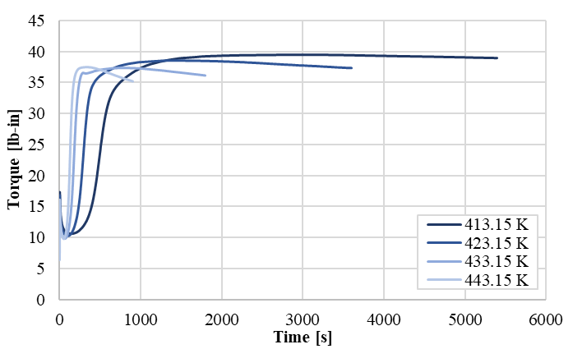 | 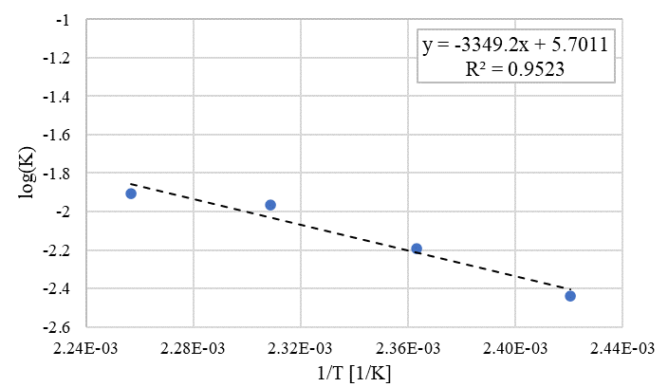
a) | b)
Figure 1: NR-EPDM rheometer curves (a) and experimental determination by the linear best fitting of the reaction kinetic constant for the rubber blend (b)

Table 1 – Rheometer experimental results
Test temp | Test temp | Test time | ML | TS₂ | T₁₀ | T₅₀ | T₉₀ | MH
[K] | [°C] | [min] | [lb-in] | [min.ss] | [min.ss] | [min.ss] | [min.ss] | [lb-in]
413.15 | 140 | 90 | 10.56 | 5.29 | 5.59 | 8.31 | 15.01 | 39.48
423.15 | 150 | 60 | 10.22 | 3.14 | 3.29 | 4.59 | 7.5 | 38.49
433.15 | 160 | 30 | 9.76 | 1.58 | 2.07 | 3.01 | 3.59 | 37.38
443.15 | 170 | 12 | 9.56 | 1.19 | 1.25 | 2.01 | 2.4 | 37.36

The cross-linking degree α_{R}, ranging from 0 (non-vulcanized rubber) to 1 (maximum vulcanization), is therefore expressed by the following formula:
$$α_{R}=1-e^{-K_{P}t}$$ | (2)
K_{P}(T) is traditionally assumed to obey an Arrhenius law, i.e. its logarithm is linked to the inverse of the absolute temperature by a linear relationship, as follows:
$$\log{K_{P}\left(T\right)=\log{K_{P,max}}- \frac{E_{a}}{R_{g}}\frac{1}{T}}$$ | (3)
where K_{P,max} is the kinetic constant at an infinite temperature T, E_{a} is the activation energy, and R_{g} is the universal gas constant. After normalization of the rheometer curve, obtained experimentally, the parameters log K_{P,max} and $\frac{E_{a}}{R_{g}}$ can be evaluated by linear interpolating the data. In this study, a good fitting quality has been obtained with a coefficient of determination (R²) equal to 0.95 (Figure 1b). The procedure allows predicting the degree of vulcanization α_{R} in each point of the isolator once the temperature profile during curing is known, for instance, solving a heat transmission problem resorting to numerical methods (Finite Elements)(Pianese, Milani, et al. 2021). Indeed, combining Equations (2) and (3), it is possible to deduce the evolution of α_{R} over time as follows:
$$α_{R}=1- e^{-{10}^{\log{K_{max}}- \frac{E_{a}}{R_{g}}\frac{1}{T\left(t\right)}}t}$$ | (4)
However, this model doesn't consider the induction time. The induction is known as waiting time, the time needed for a reaction to proceed. Therefore, the following scheme with two reactions occurring in series can be considered:
$$I\underset{→}{ k_{a} }A\underset{→}{ k_{P }}P$$ | (5)
where I is the rubber before induction, A is the rubber after the induction time (activated), P is the cured polymer, k_{a} is the activation kinetic constant, and k_{P} is the polymerization kinetic constant. The two reactions occur with a kinetic velocity depending on the temperature reaction associated with the two kinetic constants. Differential equations associated with chemical reactions (I-A-P) are the following:
$$\left\{\begin{aligned}\frac{dI}{dt}= -k_{a}I \\ \frac{dA}{dt}=k_{a}I-k_{p}A \\ \frac{dP}{dt}=k_{p}A \end{aligned}\right.$$ | a)  b)  c) | (6)
When K_{a} and K_{p} are independent of T, or T is constant (rheometer test), from Equation (6)(a), we can directly derive the analytical function for I by separation of variables as:
$$\frac{dI}{I}=-k_{a}dt⇒ln\frac{I}{I_{0}}=-k_{a}t⇒\ln{i}=-k_{a}t⇒i=e^{-k_{a}t}$$ | (7)
where I₀ is the initial concentration of I(t), assumed unitary to fit normalized experimental data. Substituting Equation (7) into Equation (6)(b), we obtain a first-order nonhomogeneous linear differential equation (1ODE) as follows:
$$\frac{da}{dt}= k_{a}i-k_{p}a⇒\frac{da}{dt}+k_{p}a-e^{-k_{a}t}$$ | (8)
The solution is
$$a= C_{1}i-e^{-k_{p}a}+ a_{pr}$$ | (9)
Where a_{pr} is a particular solution for (8):
$$a_{pr}= C_{2}e^{-k_{a}t}+ a_{pr}⇒\frac{{da}_{pr}}{dt}= {-C}_{2}{k_{a}e}^{-k_{a}t}$$ | (10)
Substituting in the differential equation:
$${-C}_{2}{k_{a}e}^{-k_{a}t}+C_{2}{k_{p}e}^{-k_{a}t}-{k_{a}e}^{-k_{a}t}⇒C_{2}=\frac{k_{a}}{k_{p}-k_{a}}$$ | (11)
so
$$a= C_{1}e^{-k_{p}t}+\frac{k_{a}}{k_{p}-k_{a}} e^{-k_{a}t}$$ | (12)
If we assume the reasonable initial condition $\left(t=0\right) a=0$, then:
$$C_{1}=-\frac{k_{a}}{k_{p}-k_{a}}$$ | (13)
So
$$a= -\frac{k_{a}}{k_{p}-k_{a}}e^{-k_{p}t}+\frac{k_{a}}{k_{p}-k_{a}} e^{-k_{a}t}$$ | (14)
Substituting (7) into Eq. (2)(c), we obtain:
$$\frac{dp}{dt}=k_{p}a= -\frac{k_{p}k_{a}}{k_{p}-k_{a}}e^{-k_{p}t}+\frac{k_{p}k_{a}}{k_{p}-k_{a}} e^{-k_{a}t}⇒$$  $$⇒p\left(t\right)= \frac{k_{a}}{k_{p}-k_{a}}e^{-k_{p}t}+\frac{k_{p}}{k_{p}-k_{a}} e^{-k_{a}t}+C$$ | (15)
Assuming $p(t)=0$, it is possible to determine constant C as follows:
$$0=-1+C⇒C=1$$  $$⇒p\left(t\right)= \frac{k_{a}}{k_{p}-k_{a}}e^{-k_{p}t}+\frac{k_{p}}{k_{p}-k_{a}} e^{-k_{a}t}+1$$ | (16)
Note that $p\left(0\right)=0$ and $p\left(∞\right)=+1$.
When k_{a} and k_{p} are dependent on T and T depends on t (real device vulcanization):
$$\left\{\begin{aligned}\frac{dI}{dt}= -k_{a}(T(t))I \\ \frac{dA}{dt}=k_{a}(T(t))I-k_{p}(T(t))A \\ \frac{dP}{dt}=k_{p}(T(t))A \end{aligned}\right.$$ | a)  b)  c) | (17)
To solve these differential equations is possible to use a numerical solver like ODE45 (Runge-Kutta), available in MATLAB (MathWorks 2020). In this study, two numerical cross-linking models will be considered for the prediction of optimum vulcanization: the first model without induction (Pianese, Torrini, et al. 2021), and the second one with it, assuming K_{a} and K_{p} dependent on T.
  - Cross-linking prediction of UFREIs
The curing level of the UFREIs has been evaluated numerically, modeling the actual manufacturing process, where the overall device (i.e. rubber pads and GFRP laminas) is cured inside a steel mold (Figure 2) under a forming press at 145°C (418,15 K). 3D geometric models of the isolator and the mold have been meshed into Abaqus.
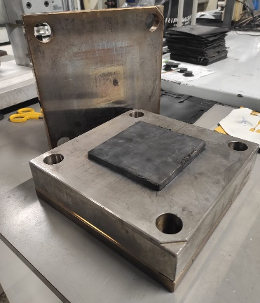
Figure 2: Steel mold for the UFREI fabrication
The analysis performed, heat conduction problem, has considered a steel mold surrounding the UFREI. In Figure 3, the FE discretization used in the analysis is shown. The thermal properties assumed for GFRP laminas and rubber pads are summarized in Table 2 (Sandberg and Bäckström 1979)(Erfanian et al. 2016). The faces of the isolator have been assumed to be perfectly bonded to the steel mold using surface-to-surface tie constraints. Linear hexahedral elements of type DC3D8 have been used. In the initial step, the top and bottom surfaces of the steel mold have been set at the temperature of 145°C. Instead, all the other parts have been assumed at the room temperature of 23°C (296,15 K). Subsequently, the analysis started, and the evolution of the temperature of two control points of the rubber device, one in the core (RP1) and one in the corner (RP2) (Figure 3c), have been monitored for 10800 seconds. The results obtained are shown in Figure 4.
Having at disposal the temperature profile T(t) of the two points of the isolator, the evolution of the degree of vulcanization point by point has been estimated with the cross-linking models.

Table 2: Thermal properties of materials
Property/Material | NR-EPDM | Steel | GFRP
Specific heat Capacity[J/(kgK)] | 1240 | 434 | 1000
Heat Conductivity [W/mK] | 0.50 | 50 | 0.30

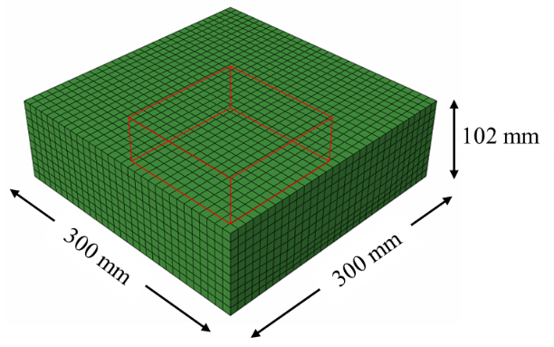 | 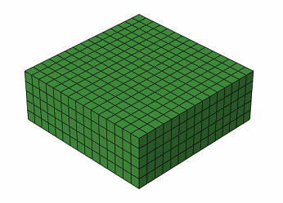 | 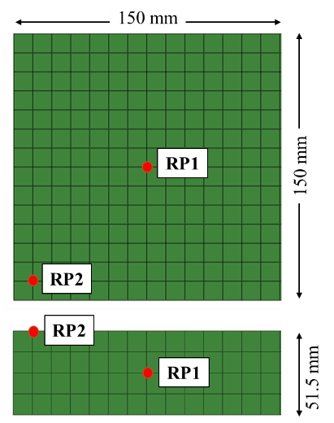
a) | b) | c)
Figure 3: FE model of the steel mold for the vulcanization of UFREI (a) and rubber device with the two reference points for the evaluation of the temperature profile (b-c)
In Figure 5, is shown the curing level for the two points with the two models. Results obtained with the model with induction have shown an optimum vulcanization time of 5400 seconds. Instead, results obtained with the one without induction have shown an optimum vulcanization time of 3600 seconds.
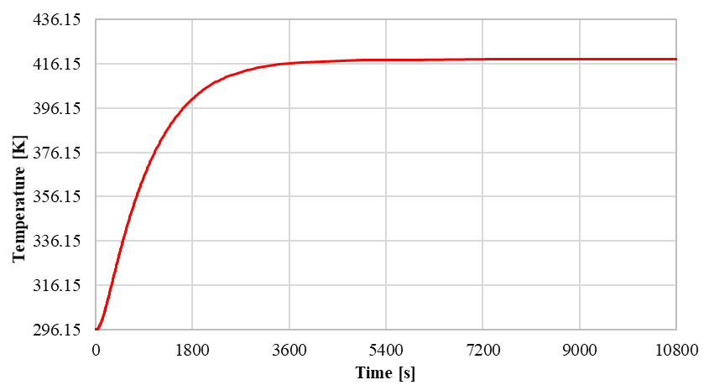 | 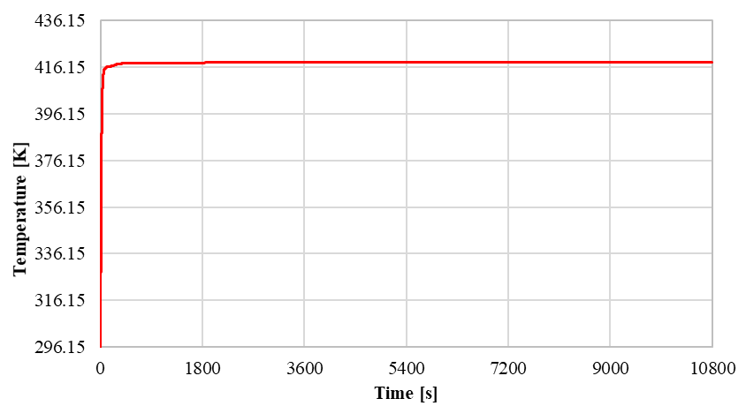
a) | b)
Figure 4: Temperature profile during vulcanization for RP1 (a) and RP2 (b)
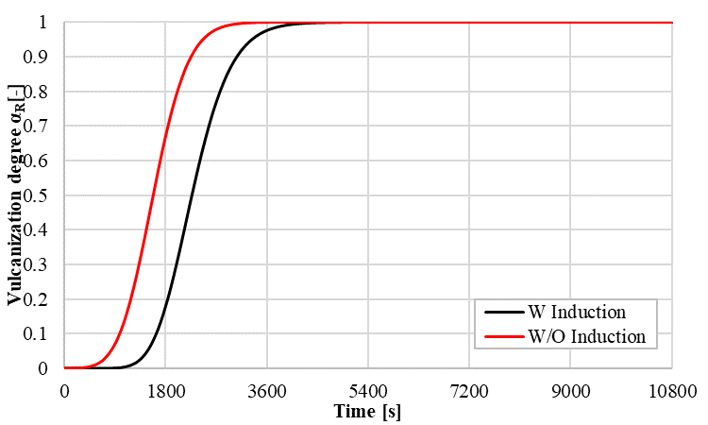 | 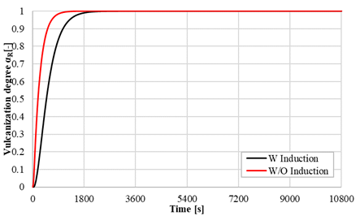
a) | b)
Figure 5: Evolution of vulcanization degree for RP1 (a) and RP2 (b)

  - Conclusions
The paper presents a numerical approach for accurately evaluating the cross-linking degree of Fiber Reinforced Elastomeric Isolators (FREIs) made of NR-EPDM rubber blend. Two models have been considered: the first one, already developed by the authors in a previous study, for the prediction of the cross-linking degree, without considering the induction time and reversion, and the second one, taking into account the induction time. In both models, the reversion can be not considered because of the absence of this feature in the proposed NR-EPDM rubber compound. The cross-linking degree was numerically evaluated by solving a 3D heat exchange problem using the Finite Element method. It was found that a curing time of 3600 seconds at 145°C resulted in suboptimal cross-linking density, optimal for the model without induction, whereas a curing time of 5400 seconds at 145°C yielded full and homogeneous curing. As expected, the results revealed that the induction period strongly affects the vulcanization time, especially when the rubber compounds rheometric curves are “slow”, and when the thickness of the items increases. The induction time is significant for these cases, and the proposed new model is recommended. Considering the first model can lead to an underestimation of the vulcanization time and so to suboptimal curing, with non-homogeneous mechanical properties distribution within the item. On the contrary, when the rheometric curves are “fast,” and the thickness of the item is small, the induction period is negligible, and so the first numerical model can be considered.
References
Van Engelen, N.C., Osgooei, P.M., Tait, M.J., and Konstantinidis, D., 2015. Partially bonded fiber-reinforced elastomeric isolators (PB-FREIs). Structural Control and Health Monitoring, 22 (3).
Erfanian, M.R., Anbarsooz, M., and Moghiman, M., 2016. A three dimensional simulation of a rubber curing process considering variable order of reaction. Applied Mathematical Modelling, 40 (19–20).
Habieb, A.B., Valente, M., and Milani, G., 2019. Base seismic isolation of a historical masonry church using fiber reinforced elastomeric isolators. Soil Dynamics and Earthquake Engineering, 120.
MathWorks, T., 2020. MATLAB (R2020b). The MathWorks Inc., (x).
Milani, G., 2013. Closed form analytical approach for a second order non-linear ODE interpreting EPDM vulcanization with peroxides. Journal of Mathematical Chemistry, 51 (8).
Milani, G. and Milani, F., 2014. Effective closed form starting point determination for kinetic model interpreting NR vulcanized with sulphur. Journal of Mathematical Chemistry, 52 (2).
Milani, G. and Milani, F., 2021. Relation between activation energy and induction in rubber sulfur vulcanization: An experimental study. Journal of Applied Polymer Science, 138 (12).
Moon, B.Y., Kang, G.J., Kang, B.S., and Kelly, J.M., 2002. Design and manufacturing of fiber reinforced elastomeric isolator for seismic isolation. In: Journal of Materials Processing Technology.
Pianese, G., Milani, G., Cerchiaro, R., and Milani, F., 2021. Optimal vulcanization of unbonded fiber reinforced elastomeric isolator devices. Chemical Engineering Transactions, 86.
Pianese, G., Torrini, D., Milani, G., and Formisano, A., 2021. Influence of crosslinking on the seismic performance of unbonded fiber reinforced elastomeric isolators (UFREI) made of regenerated rubber. In: COMPDYN Proceedings.
Sandberg, O. and Bäckström, G., 1979. Thermal properties of natural rubber versus temperature and pressure. Journal of Applied Physics, 50 (7).
Toopchi-Nezhad, H., Ghotb, M.R., Al-Anany, Y.M., and Tait, M.J., 2019. Partially bonded fiber reinforced elastomeric bearings: Feasibility, effectiveness, aging effects, and low temperature response. Engineering Structures, 179.
Toopchi-Nezhad, H., Tait, M.J., and Drysdale, R.G., 2008. Lateral Response Evaluation of Fiber-Reinforced Neoprene Seismic Isolators Utilized in an Unbonded Application. Journal of Structural Engineering, 134 (10).

