CHEMICAL ENGINEERING TRANSACTIONS  VOL. , 2023 | A publication of
The Italian Association
of Chemical Engineering
Online at www.cetjournal.it

Guest Editors: Sauro Pierucci , Jiří Jaromír Klemeš
Copyright © 2023, AIDIC Servizi srl .
isbn 978-88-95608-98-3 ; ISSN 2283-9216

Control of food diet in the minimization of greenhouse gases generated by cattle bovine
Elmer Benites-Alfaro* Milagros Y. Cajaleon Martel, Tovar S. Salvador, Verónica Tello Mendivil, Danny A. Lizarzaburu-Aguinaga, Cecilia I. Terán Mejía, Carlos A. Castañeda-Olivera
Universidad César Vallejo, Av. Alfredo Mendiola 6332, Lima 15314, Perú
ebenitesa@ucv.edu.pe

The objective of this work was studying the diet of extensively reared bovines that decreases the emission of greenhouse gases. The study took place in a farm called Campo Dorado located in the district of Huallanca, in the province of Bolognesi, department from Ancash, in Peru. In this study, the sample selected was 4 Brown Swiss cattle between 4 to 5 years of age and weighing between 470 to 570 kg, they were chosen for a population of 70 cattle from the livestock, which were conditioned in chambers separated, specially prepared for monitoring, as the sample. The closed chamber technique was performed on 4 groups (differentiated according to the type of diet followed in the study) with 2 monitoring teams and lasted 5 days. The control group's diet was green grass from the research area, while group 1 had a diet of oat silage, group 2 of oat hay, and group 3 of a mixture of silage and hay. The reductions achieved for methane emissions were: in group 1 the reduction was 16%, for group 2 the reduction turned out to be 29% and for group 3 it was 9%. Regarding the reductions achieved with carbon dioxide for groups 1 and 2, they were 33% and 61% respectively, while for group 3 there was an increase of this last gas by 4%. Therefore, it was concluded that oat hay is the most appropriate diet for reducing greenhouse gas emissions in extensively reared cattle.
  - Introduction
One of the serious environmental problems linked to the raising of animals such as cattle, goats, sheep, etc., is the emission of gases that generate the greenhouse effect (Shi R. et al., 2022), gaseous emissions from livestock activity are among 14% and 18% of all greenhouse gas emissions on the planet, generating polluting gases such as methane, whose warming potential is up to 25 times greater than carbon dioxide or Nitrous oxide (N₂O) whose heating Power is It has been estimated to be 298 more intense than CO₂ (Tirado et al., 2018). This problem places the planet in a context of environmental crisis and there is a need to mitigate emissions of human origin, to prevent the earth's temperature from continuing to increase (Hoegh-Gulberg et al., 2018).
The Food and Agriculture Organization (FAO) is aware that livestock production is one of the most important industries related to greenhouse gas emissions compared to other sources of food. In other words, these emissions originate from food production, enteric fermentation, animal waste (Widjaja et al., 2017) and the variations suffered by the fields due to their use is so much so that the livestock supply chains mean 7.1 Gt CO₂, which represents 14.5% of the greenhouse gas emissions generated by man's global activity, while only cattle raising (beef, milk) represents about two thirds of that, it’s due to methane gas emissions generated from rumen fermentation (FAO, 2018). The amounts of enteric methane generated by livestock activity are 30% of methane emissions worldwide, it is considered a short-lived climate pollutant, so minimizing enteric methane emissions makes it possible to reduce climate change in the current lifetime (FAO, 2018). Low-carbon livestock production is a possibility, however, political will and actions by organizations around the world must be more decisive. The consumption of meat, milk, skins and leather in low- and middle-income countries is increasing, due to the increase in the world population and its higher income, year after year (FAO, 2018).
In order to proposing solutions to this problem, the generation of methane in cattle that fed on pastures with the addition of oat silage, tannins and concentrates (Moscoso et al., 2017) and supplements with natural pastures (Lipa, 2017) have been investigated, as well as adding legumes (Valencia and Rojas, 2017). All the investigations seek to minimize the environmental contamination produced by the digestion of ruminants through controlled modification of the type of feeding, in such a way that the microbial change occurs naturally; that is, when these supplements are added to the diet, they serve as modulators of rumen microorganisms, helping digestion by reducing methane production without altering milk production (Martinez, 2020).
Livestock in Peru is linked to feeding a society that consumes meat and milk, so livestock grows year after year to meet demand (MINAGRI, 2019). According to the INEI (National Institute of Statistics and Informatics) the largest population of cattle is in the Andes, according to the 4th national agricultural census of the year 2012 in Peru, it indicates that the department of Ancash had 275,292 head of cattle belonging to Holstein, Brown Swiss, Criollo and Other breeds. One of the provinces of Ancash is Bolognesi, which has Huallanca as a district, where 80% of the inhabitants are dedicated to livestock, this activity plays a fundamental role for the economy of the town and for its own consumption, counting this province with 105,085.45 hectares for livestock activity (INEI, 2012). It is with this reality and context that an investigation was carried out with the objective of identifying the best nutritional diet for cattle, among several alternatives that were tested, to reduce the generation of greenhouse gases (methane, CO₂) by this type of cattle; In this way, provide a less harmful alternative, and that in the long term allows the reduction in the emission of gases that by their nature are highly harmful to the environment.
  - Experimental method
    - Construction of chambers for test cattle
The investigation consisted of placing a bovine in four closed chambers and feeding it with different diets to each one, measuring the generation of gases that it produces. These chambers were built in a shed that had dimensions of 19 m long, 6 m wide and 2.5 m high and inside it the chambers were conditioned in an area provided by the Campo Dorado cattle ranch in the district of Huallanca, province of Bolognesi in the department of Ancash, the place is at an altitude of 4200 meters above sea level, at UTM coordinates 8907224, 285075.
The chambers had dimensions of 3.15 m long, 2.15 m wide and 2.20 m high. Figure 1 shows the design of the chamber and Figure 2 shows how the chambers for bovines were established in the shed.
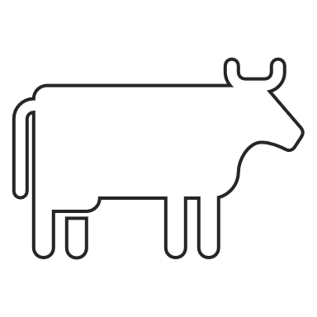
trough and
drinker
Chamber closed with polyethylene
gas emission
CH4/CO2
Access to bovine
Figure 1: Bovine chamber design

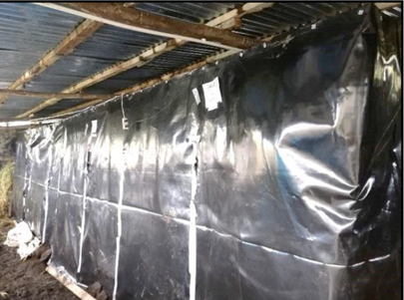
Figure 2: Cameras in the cattle shed.
    - Bovine sample selection
For the selection of cattle for research, the sample was extracted from a population of 70 individuals of cattle in the town of Huallanca. In a selection for convenience, four breeding female bovines of the Brown Swiss type were chosen, producing milk with a live weight range between 470 kg to 570 kg by means of the weighing tape measure method (considering the circumference of the thorax with respect to its equivalence in kilos), see Figure 3.
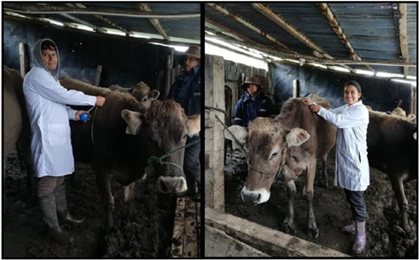
Figure 3: Measurement of bovine weight.
    - Adaptation of bovines to the chamber
The adaptation of the study bovines to the closed chambers was carried out for a period of 12 days, seeking that the bovines become familiar with their new condition of certain isolation. Prior to the application of the diet, each of the test bovines were dewormed. Figure 4 shows the bovine in the test chamber. The experimental part lasted 5 days, and the gases generated did not constitute a danger to the animals due to their low level of concentration according to environmental air quality standards; In addition, the oxygen concentration was monitored, remaining around 19%, which is the minimum value that must exist in confined spaces (Moore, 2020). The gases were measured with the TESTO X-350 and ALTAIR 4X (Multigas detector) equipment, duly calibrated (See Figure 5).
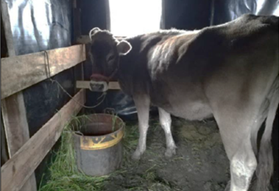  Figure 4: Adaptation of bovines in the chambers. | 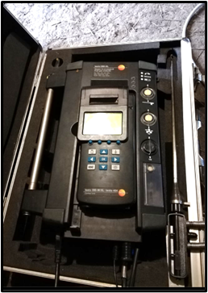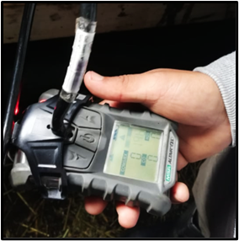  Figure 5: Gas measurement equipment TESTO X-350 y ALTAIR 4X
    - Exemplary and type of food
Regarding the intake stage, the bovines were provided with green grass and two kinds of feed, hay and silage in morning and afternoon shifts. One bovine was provided with a diet based on natural grass from the study site, it was considered a control bovine, and bovines 1, 2, and 3 were provided with a diet of silage and hay in the manner as it is detailed in Table 1. Figure 6 shows the types of diets for each specimen.

Table 1: Type of intake per bovine
Bovine and weight (kg) | Type of diets (feeding) | Amount of diet (kg))
control bovine (570) | Green grasslands | 50
Bovine 1 (470) | silage | 40
Bovine 2 (490) | Hay | 25
Bovine 3 (510) | Ensilage and Hay (Mix: 50% of each) | 34

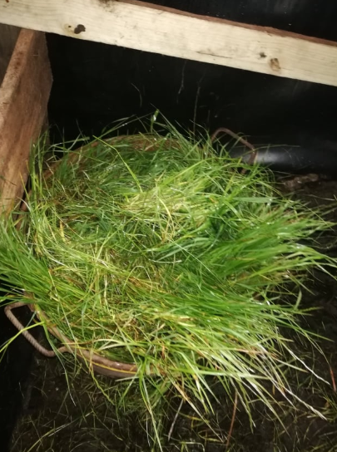  Green grasslands | 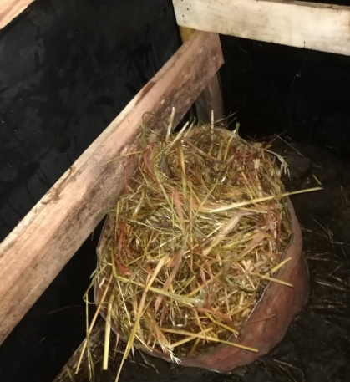  Ensilage | 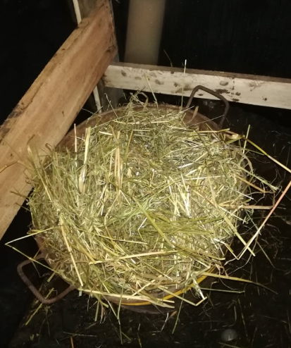  Hay - Ensilage | 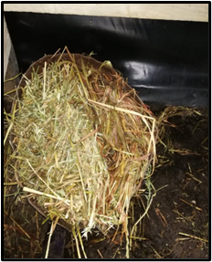  Hay
Figure 6: Types of diets
  - Results
    - Methane emission
With the bovines in the closed chambers, each bovine was fed with the assigned diet. At the same time, the methane emission was monitored for 5 days. The result is presented in Table 2, where it stands out that in the chamber with bovine 2, where the diet used was hay, the generation of methane (CH₄) was lower than the other bovines, resulting in 28.66 % less than that generated by the control bovine; likewise, bovine 1 and 3 generated 16.46 % and 9.14 % less than the control bovine, after the test time. Likewise, Table 3 shows the percentage of daily average oxygen was around 19 % to guarantee the oxygenation conditions of the animals.

Table 2: Methane emission (L/day)  Day control bovine Bovine 1 Bovine 2 Bovine 3  1 1403.29 1140.18 1052.47 1315.59  2 1359.44 1184.03 964.76 1271.74  3 1491.00 1184.03 1052.47 1315.59  4 1447.15 1271.74 1096.32 1359.44  5 1491.00 1227.88 964.76 1271.74  Average 1438.38 1201.57 1026.16 1306.82  Reduction 0 % 16.46% 28.66% 9.14% | Table 3: oxygen in the chamber  Day control bovine (%) Bovine 1 (%) Bovine 2 (%) Bovine 3 (%)  1 1403.29 1140.18 1052.47 1315.59  2 1359.44 1184.03 964.76 1271.74  3 1491.00 1184.03 1052.47 1315.59  4 1447.15 1271.74 1096.32 1359.44  5 1491.00 1227.88 964.76 1271.74  Average 1438.38 1201.57 1026.16 1306.82  Reduction 0 % 16.46% 28.66% 9.14%

    - Emission of carbon dioxide (CO₂)
Regarding the emission of carbon dioxide in 5 days of monitoring generated by the bovines, the results are presented in Table 3; With the hay diet in cattle 2 less CO₂ was generated evidencing a reduction of up to 61% in CO₂ generation compared to the control bovine that was fed with natural grass. On the other hand, bovine 1 also had a significant decrease (31 %), while bovine 3 generated more CO₂ than the control bovine (4%).
Table 3: Emission of carbon dioxide L/day
Day | control bovine | Bovine 1 | Bovine 2 | Bovine 3
1 | 2.76 | 1.38 | 1.10 | 2.76
2 | 2.62 | 1.24 | 0.96 | 2.76
3 | 2.34 | 1.52 | 1.10 | 2.76
4 | 2.89 | 1.93 | 0.96 | 2.76
5 | 2.62 | 2.76 | 0.96 | 2.76
Final average | 2.65 | 1.76 | 1.02 | 2.76
Reduction |  | 33 % | 61 % | -4 %
  - Discussion
The results obtained in the present study present similarities with respect to the study carried out by Moscoso et al. (2017) in which one of the dietary treatments with tannin had a methane gas emission reduction of 21.6 %, that is, a percentage difference of only 7.4 %, this is probably due to a similar method if studies such as for example, the geographical altitude, breed of bovines, (although they differ in terms of the ages of the study specimens), similar environments in which the experiments were carried out, as well as in the emission determination technique; On the other hand, the differences may be due to the fact that in the dry season the temperatures are higher than in the wet seasons, in such a way that the higher the temperature there will be a higher concentration of methane.
Regarding food supplements, Chino (2016) states that tannin-based supplements reduce the degradability of nutrients in the diet, even inhibiting enzymatic action, greatly reducing the number of cellulite bacteria, causing a reduction in the emission of enteric methane by 28%, similar to what was achieved in the present research, with a hay-only diet (with a higher amount of carbohydrates), which was reduced by 28.66%; In addition, the diets that are chopped, ground facilitate the digestion of bovines, which at the end of the digestive process also prevents the generation of methane.
The methane reduction in the research presented reached 28.66 %, very close to what was achieved in the study carried out by Lipa (2017) which managed to reduce 30 %, coincidentally both studies have in common the altitude of the places where it was carried out. the experimental stage that was 4300 and 4200 meters above sea level, respectively; however, the differences in the ages of the bovines used for the study (between 3 to 4 years of difference) must be taken into account, which surely intervenes in the digestion process of the diet.
It also corroborates what was said by Alayón et al. (2018) in which they affirm that the diet based on legumes such as hay, and the use of concentrates rich in carbohydrates, inhibit the production of methane by bovines, mitigating its emission into the environment; In the same way, Valencia and Rojas (2017) through the use of a tannin diet managed to reduce 15 % of methane in cattle. On the other hand, the results regarding carbon dioxide show what Alayón et al. (2018) had established that a legume such as hay also has a decisive influence on the reduction of said greenhouse gas with reductions close to 61 %. In the investigation, no advantageous results were obtained with respect to mixed diets of hay and silage, so other types of diets will continue to be tested to corroborate the effectiveness in reducing methane and carbon dioxide to the environment.
This type of research should be complemented with the determination of greenhouse gases (methane and carbon dioxide) that are produced in the feces of cattle (Hanafiah et al., 2021).
Conclusions
It is established that the diet in cattle is an important factor in the generation of methane and carbon dioxide through belching and bloating of these animals. That one way to effectively reduce this type of gases, which are precursors of the greenhouse effect and ultimately generate climate change, is through the modification of the bovine diet. In the investigation that was carried out, it was found that the feeding of bovines based on oat hay meant a reduction of 28.66 % in the generation of methane and 61 % in carbon dioxide by bovines compared to a natural diet with grass. green of the place; however, a reduction was also found when silage-based diets were used with less efficiency and without positive results when tested with a mixed mixture of hay and silage. The findings of this research allow us to search for ways to improve diet management practices in cattle, in order to avoid the generation of greenhouse gases that are harmful to the environment.

Acknowledgments
The authors would like to thank "Investiga UCV" of the Universidad César Vallejo for financial support for the publication of this research.
References
Alayón J., Jiménez G., Piñeiro-Vázquez Á., Canul-Solís J., Albores-Moreno, S., Villanueva-López G., Nahed-Toral, J., Ku-Vera J., 2018, Greenhouse gas mitigation strategies in livestock, Revista Agroproductividad, 211 (2), (In Spanish).
FAO – Organización de las Naciones Unidas para la Alimentación y la Agricultura, 2018, Livestock solutions for climate change, <www.fao.org>, acceseed 06.03.2023
Hoegh-Guldberg, O., Jacob, D., Taylor, M., Bindi, M., Brown, S., Camilloni, I Diedhiou A., Djalante R., Ebi K.L., Engelbrecht F., Guiot J., Hijioka Y., Mehrotra S., Payne A., Seneviratne S., Thomas A., Warren R., Zhou G., Tschakert P., 2018, Impacts of 1.5ºC global warming on natural and human systems. In Global Warming of 1.5°C: An IPCC Special Report on the impacts of global warming of 1.5°C above pre-industrial levels and related global greenhouse gas emission pathways, in the context of strengthening the global response to the threat of climate change, sustainable development, and efforts to eradicate poverty IPCC, School of Agriculture and Environment, The University of Western Australia.
INEI - Instituto Nacional de Estadística e Informática, 2013, Final Results, IV National Agricultural Census 2012. Lima, Perú; 2013, <sinia.minam.gob.pe/documentos/resultados-definitivos-iv-censo-nacional-agropecuario-2012> accessed 28.12.2022, (In Spanish).
Lipa V., 2017, Evaluation of the amount of methane produced in cattle under grazing conditions and supplementation in the dry season at La Raya Experimental Center, bachelor's thesis, Universidad Nacional de San Antonio Abad del Cusco]. Repositorio Institucional <hdl.handle.net/20.500.12918/1817>. 12.02.2023, (In Spanish).
MINAGRI - Ministerio de Agricultura y Riego, 2022, Traceability guarantees the safety of meat and promotes its consumption, MSD-Animal-Health, www.msd-animal-health.com.pe/2022/08/26/trazabilidad-garantiza-la-inocuidad-de-la-carne-e-impulsa-su-consumo/#:~:text=Lima%2C%20Per%C3%BA%2C%20abril%20de%202021,mil%20toneladas%20producidas%20en%202018, accessed 06.03.2023, (In Spanish).
Moscoso J., Franco F., San Martín F., Olazábal J., Chino L., Pinares C., 2017, Methane Production in Grazing Cattle Supplemented with Silage, Concentrate and Tannins in the Peruvian Highlands in the Dry Season, Revista Inv Vet Perú. 28(4), 822-833. http://dx.doi.org/10.15381/rivep.v28i4.13887.
Moore D., 2020, Acceptable and dangerous gas levels in confined spaces, Industrial scientific, <www.indsci.com/es/blog/niveles-de-gas-aceptables-y-peligrosos-en-espacios-confinados> 06.03.2023
Moscoso J., Franco F., San Martín F., Olazábal J., Chino L., Pinares C. (2017). Methane Production in Grazing Cattle Supplemented with Silage, Concentrate and Tannins in the Peruvian Highlands in the Dry Season. Inv Magazine Vet Peru. 28(4): 822-833, (In spanis)
Martinez J., 2020, Changes in the bovine diet would reduce methane emissions, National University of Colombia, <agenciadenoticias.unal.edu.co/detalle/cambios-en-la-dieta-bovina-reducaria-emisiones-de-metano>, accessed 13.02.2023, (In Spanish)
Shi R., Irfan M., Liu G., Yang X., Su X., 2022, Analysis of the Impact of Livestock Structure on Carbon Emissions of Animal Husbandry: A Sustainable Way to Improving Public Health and Green Environment. Front Public Health, 10, 835210.
Tirado R., Thompso K..F, Miller K.A., and Johnston P., 2018, Less is more: Reducing meat and dairy for a healthier life and planet - Scientific background on the Greenpeace vision of the meat and dairy system towards 2050. Amsterdam, www.greenpeace.org/livestock_vision, accessed 06.03.2023.
Valencia F. and Rojas T., 2017, Animal Nutrition Mechanisms to Reduce the Greenhouse Effect, ECAPMA Working papers, Universidad Nacional Abierta y a Distancia, 2 (2019), <doi.org/10.22490/ECAPMA.3459>, accessed 06.03.2023.
Widjaja T., Iswanto T., Altway A., Shovitri M., and Juliastuti S. R., 2017, Methane production from coffee pulp by microorganism of rumen fluid and cow dung in co-digestion, Chemical Engineering Transactions , 56 , 1465–1470. https://doi.org/10.3303/CET1756245

