CHEMICAL ENGINEERING TRANSACTIONS  VOL. , 2023 | A publication of
The Italian Association
of Chemical Engineering
Online at www.cetjournal.it

Guest Editors: Sauro Pierucci , Jiří Jaromír Klemeš
Copyright © 2023, AIDIC Servizi srl .
isbn 978-88-95608-98-3 ; ISSN 2283-9216

Removal of Oils and Fats in Domestic Water Through a Biofilter
Maria F. Ramirez Escobar, Danny A. Lizarzaburu-Aguinaga*, Pierina M. Urbina Valderrama
Universidad César Vallejo, Av. Alfredo Mendiola 6232, Los Olivos. Lima, Perú
dlizarzaburu@ducv.edu.pe
In Latin America, a deficit in wastewater treatment translates into the degradation of the environmental quality of other ecological spaces. Due to this problem, the effect of the use of a biofilter on the treatment of domestic wastewater was investigated. In this research was evaluated the parameters of turbidity, dissolved oxygen, COD, BOD₅, total solids, dissolved solids, and total suspended solids and mainly the parameter of oils and fats (determined by the Soxhlet method). The water sample was obtained from the peri-urban area of San Benito at the Carabayllo district. The treatment unit used two residual inputs: biochar that was made from shell residues of Carya illinoinensis and hydrogel that was made with Caesalpinia spinosa gum; previously were determined the physical-chemical parameters of these inputs. The following configuration was used in the treatment unit: an 80 L tank to deposit domestic wastewater, the biofilter made up of 3 beds of biochar (+/- 12 mesh) of 700 g, 800 g, and 700 g respectively, a flocculation tank of 20 L to which was added the Caesalpinia spinosa gel, another biofilter with 2 beds of 600 g and 700 g respectively and, finally, a tank to receive the treated water. The process carried out during the implementation of the test was characterized by being continuous: On every 30 minutes was adding 500 ml of hydrogel for 5 times and at the same process, the treated water samples were collected in an amount of 2 L every 25 minutes. On a removal process of 3 hours and 20 minutes, the final results showed a reduction of oils and fats from an initial value of 906 mg/l to 277 mg/l (69.43% reduction); Additionally, other physicochemical parameters were also reduced, obtained a final value of 80.70 NTU of turbidity, 2.53 mg/l of dissolved oxygen, 548.3 mg/l of COD, 4.17 BOD₅, 1,211 mg/l of total solids, 948 mg/l of dissolved solids and 233 mg /l of total suspended solids. This research proves the positive effect of this biofilter for the removal of oils and fats, so it can be considered an alternative solution in wastewater sanitation problems.
  - Introduction
The population growth in the world produces greater wastewater. According to the World Bank 36% of the population lives in regions with lack of water, this generates problems such as the degradation of water quality, the inadequate supply of this resource, and a gap for a proper infrastructure for treatment. In Latin America, only 30 to 40% of the water withdrawn is treated, which is far to accomplish the challenge of the SDG 6 (Rodriguez et al., 2020). In Peru, around 14% of the wastewater treatment plants (PTAR) accomplish with the current national regulations for their correct operation (Larios et al., 2015) and one of the problems that generates this infrastructure gap is the high value of the oils and greases parameters in the effluents that according to national regulations should not exceed 20 mg/L (MINAM, 2010); Furthermore, in the last diagnosis of the wastewater treatment plants in the country made by Loose (2016), not only did he identify the problem of the treatment of oils and fats, but also the dumping of unauthorized wastewater. He indicates that only 27.59% of the WWTPs accomplish with the maximum permissible limits in their effluents in 2013 (p. 81), it also suggests researching improvements and application of appropriate technologies for wastewater treatment (p.140).
In this context, one of the water treatment methods to reduce oils and greases has been through biofilters as developed as Esquivel and Castañeda-Olivera (2022) who treated industrial water in order to improve its quality with activated carbon biofilters. Instead, compost biofilters have also been built to remove H₂S and NH₃ ( Vela-Aparicio et al., 2022). Considering these experiences, it was proposed to carry out an investigation whose objective was to investigate the effects produced by a carbon biofilter of Carya illinoinensis shell-based and hydrogel obtained from Caesalpinia spinosa on the removal of oils and greases of the domestic wastewater.
  - Materials and methods
In the investigation, 5 stages were developed, in which the entire water treatment process and subsequent analysis of results were described, as shown in figure 1.
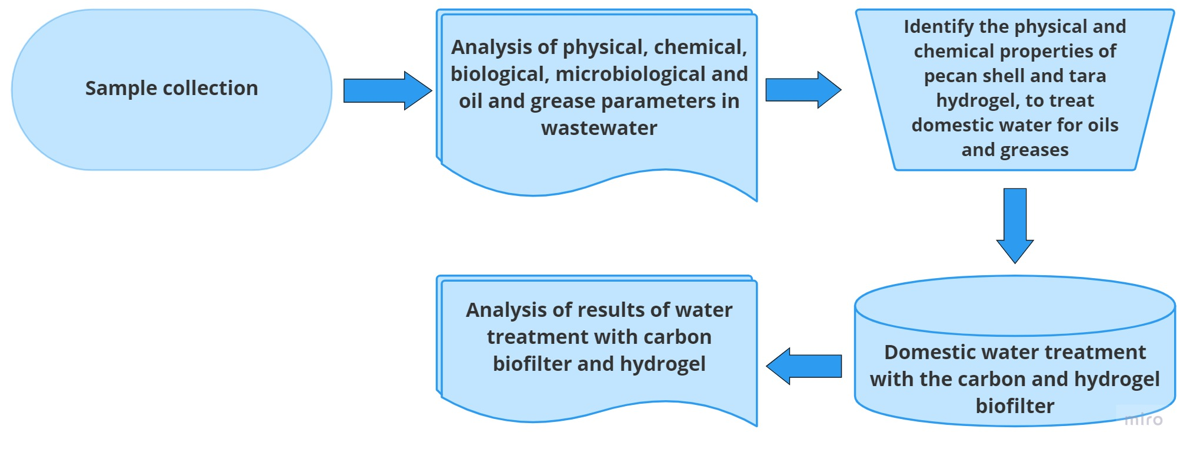
Figure 1: Oil and grease removal process in domestic wastewater
    - Collection of samples
The sample was collected taking into consideration the monitoring protocol of the sanitary quality of surface water resources issued by the Directorate General of Health Services of Perú (2007) at a fixed point (effluent discharge from a house) located in the informal settlement of San Benito-Carabayllo, at UTM coordinates 11°49'52.8˝ W. The amount of sample collected was 80 L of domestic wastewater. Carya illinoinensis shell sample (20 kg) was obtained from Retail Market No. 1, located at Aviation Avenue 325 La Victoria - Lima, which was later converted to biochar by pyrolysis. 1 kg of Caesalpinia spinosa pods were also collected in Lomas de Primavera - Carabayllo - Lima, for the elaboration of the hydrogel.
    - Methods of Analysis of physicochemical, biological, and organic parameters.
The physicochemical parameters evaluated were pH, turbidity, Dissolved Oxygen (DO) performed through the Winkler method, and Chemical Oxygen Demand (COD) that was found through reflux method with potassium dichromate as the oxidant. Total Solids (ST), Dissolved Solids (SD) and Total Suspended Solids (TSS), all these physical parameters, were determined by the gravimetric method and filtered with Whatman No. 40 paper. The biological parameter analyzed was the total coliforms where was used a multiple tube method and planted in a Petri dish to perform a colony count (CFU/ml). The organic parameters are Biochemical Oxygen Demand (BOD₅) and the oils and fats parameter that were determined by the distillation method after having processed the sample with the Soxhlet equipment (Environment Federation, 2012), see figure 2a.
    - Determination of the physicochemical properties of Carya illinoinensis shell, Caesalpinia spinosa hydrogel, and the biochar.
The humidity of Carya illinoinensis shell and Caesalpinia spinosa were found applying the ASTM D-2216 standard. The biochar was made with the Carya illinoinensis shell by an anaerobic process (see figure 2b). The biochar humidity was determined through the ASTM D3173 method, to find the volatile matter was used the ASTM D3175 method, the ash content in it was calculated using the ASTM D5142 method, the fixed carbon was identified in the residue that remained in the volatile matter crucible following the ASTM D3172 standard. To determine the diameter of the biochar particles was used a micrometer. The granulometric analysis of the sample was made by sieving with a 1/2” mesh according to the ASTM D422 standard and the color by direct observation.
The Caesalpinia spinosa mother hydrogel is prepared with 300 ml of distilled water and with 700 ml of a base solution gel of the legumes. For obtaining this solution was the legumes of Caesalpinia spinosa prepared by introducing the pods in the oven to loosen the shells and eliminate the germs and then dry seeds were ground.
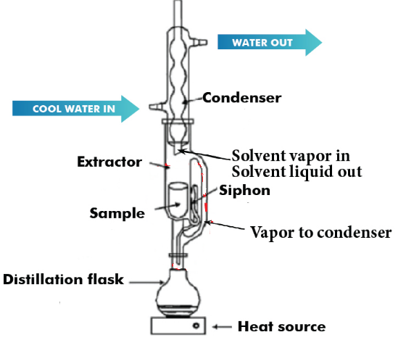 | 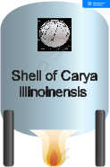
Figure 2a. Determination of oils and fats by the Soxhlet method | Figure 2b. Artisanal pyrolysis reactor
    - Domestic water treatment system with biofilters
The System made was up of three units following the design of the scientific literature (Burciaga-Montemayor et al., 2020) as shown in Figure 3: The first one was built with a biochar filter divided by two ASTM No. 10 and No. 12 meshes (2 mm and 1.68 mm) , where each separation retain a biochar mattress with 700 g, 800 g, and 700 g each one respectively to capture the total solids of the water sample (80 L); It follow a tank with Caesalpinia spinosa gel (20 L) where the flocculation of the dissolved solids is carried out; Next, in other tank was incorporated other biochar filter divided by an ASTM No. 12 mesh, in this unit, the two mattresses formed contained 600 g and 700 g respectively, this filter also has the function of trapping the dissolved solids from the flocculation process.

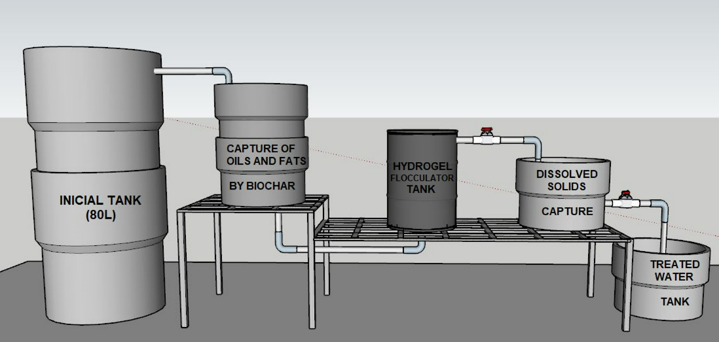
Figure 3: Biofilter design for domestic water treatment
    - Biofilter System Operation
The operation process of the biofilter system for the treatment of domestic wastewater was developed to work continuously. The domestic wastewater was flowed from the initial tank to the first biofilter (see figure 4a) where was separated the oils and fats from water, then it was passed to the flocculation tank where 500 ml of hydrogel solution was added every 30 minutes. The next step was passed the water to the second filter (see figure 4b) seeking to separate the dissolved solids, then the residual water was stored in a collection tank where a 2 L sample was taken every 25 minutes, the entire process lasted 3 hours and 20 minutes and was used a total of 3.5 kg of biochar and 2.5 L of the hydrogel.
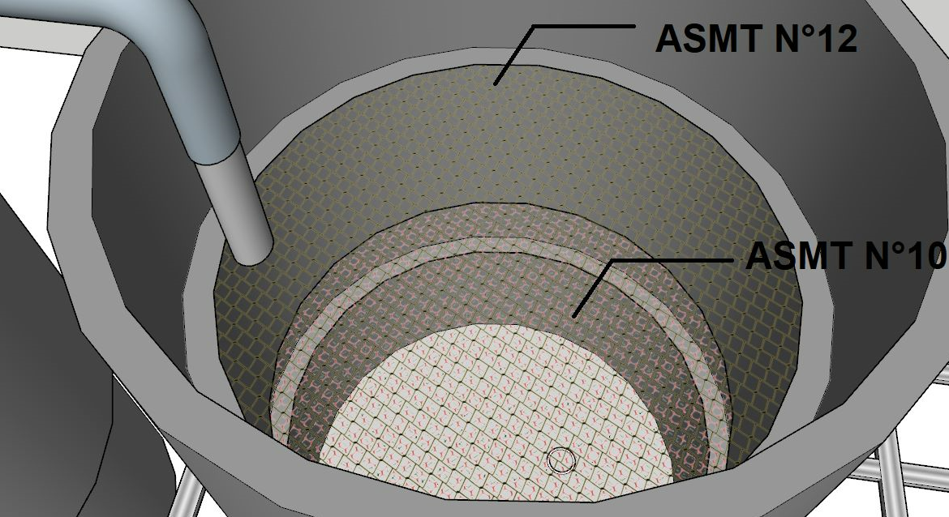  ASTM10  ASTM 12  Figure 4. Biofilter | 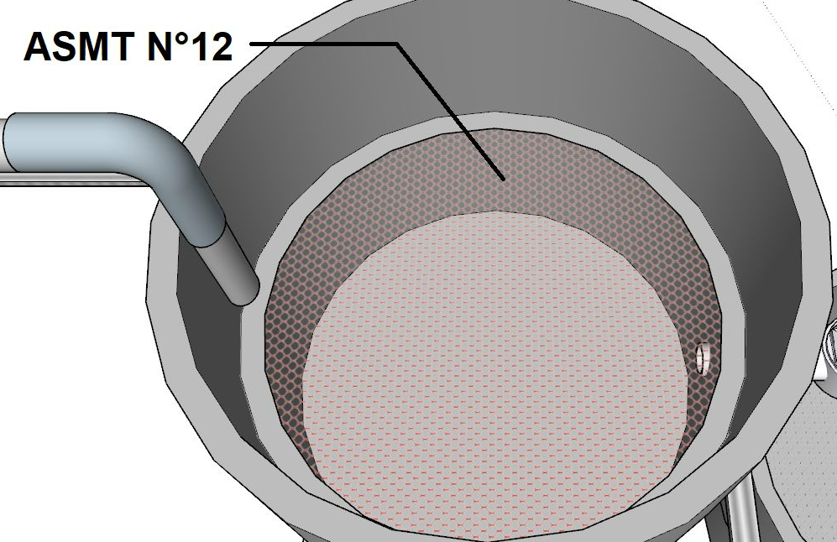  Figure 4b. Second biofilter
  - Result and discussion
    - Physicochemical properties of Carya illinoinensis shell and Caesalpinia spinosa hydrogel
The physicochemical properties of the elements that compose the biofilter are shown in Table 1.
Table 1: Physicochemical properties of Carya peel illinoinensis, Caesalpinia hydrogel spinosa, and biochar.
Physicochemical property | Carya illinoinensis shell |  | Caesalpinia spinosa Hydrogel | Biochar
Humidity (%) | 14.76 |  | 29.21 | 2
Weight (g) | 4.6 |  | 2.4 | -
Length (cm) | 5 |  | 4 | -
diameter (mm) | 6 |  | 60 | -
Color | Brown |  | Orange-brown | Black
Volatile matter (%) | - |  | - | 52.65
Ash (%) | - |  | - | 7.97
Fixed carbon (%) | - |  | - | 39.38

    - Results of oils and fats from domestic waters in the treatment with biofilter
The oils and fats decreased by 69.43 %, leaving their final concentration still outside the maximum admissible value of the Peruvian standard that indicates a maximum of 100 mg/L (See Table 2), so the investigation continues, to find the optimal treatment time to reach the mentioned standard. The A and G are reduced by the action of sedimentation, achieving water that allows the passage of light more easily (Taesopapong and Ratanatamskul, 2020).

Table 2: Concentration of oils and fats according to retention time in water treatment (TM-time)
Water sample | Initial T. | TM-25 | TM-50 | TM-75 | TM-100 | TM-125 | TM-150 | TM-175 | TM-200 | % variation
Oils and Fats (mg/L) | 906 | 862 | 817 | 764 | 693 | 656 | 553 | 388 | 277 | 69.43

    - Results of biological parameters
When passing the domestic wastewater through the biofilter with a retention time of 200 minutes, the presence of Total Coliforms varied by 70.75%, unlike Gianoli et al., (2019) who conclude that there is no significance between the physicochemical parameters as well as in the presence of total coliforms. The Biochemical Oxygen Demand (BOD₅) change, reducing by 44.26 % in the treated water, demonstrating the increase in oxygen and the reduction of organic matter (Déniz, 2010). See Table 3
Table 3: Biological and organic parameters before and during the treatment of domestic wastewater
Water sample. | Total Coliforms (UFC/ml) | BOD ₅  (mg/L)
Initial T. | 99 019.00 | 671
T.M-25 | 51 138.13 | 468
T.M-50 | NA | 447
T.M-75 | NA | 391
T.M-100 | NA | 396
T.M-125 | NA | 417
T.M-150 | NA | 397
T.M-175 | NA | 378
T.M-200 | 28 966.70 | 374
% variation | 70.75 | 44.26
    - Domestic wastewater
The physicochemical properties are shown in the following Table 4, It in can be seen the results obtained with a sampling every 25 minutes. The parameters of pH, Dissolved Oxygen (DO) do not present important variations. On the other hand, if it happens with turbidity (57.97 %), COD (67.75%), Total Solids (48.27%), Dissolved Solids and Total Suspended Solids (81.67%), after a retention time of 200 minutes. Therefore, the implementation of a biofilter system of this type can be an economic alternative by incorporating Carya illinoinensis shell and Caesalpinia spinosa pods residues into the circular economy to facilitate biofilters for the treatment of domestic wastewater with a certain efficiency for some parameters; similar to research with Moringa Oleifera biofilters and activated carbon that removed 97% of Escherichia coli, 98% of total Coliforms, BOD5 99%, Turbidity 98.5%, Total Solids 74%, Electrical Conductivity 94% and increased Dissolved Oxygen concentration by 22% (Bertolotti and Benites, 2020).
Table 4: Physicochemical parameters of initial domestic wastewater and after treatment
Water sample | pH  (1-16) | Turbidity  (NTU) | Dissolved Oxygen  (mg/L) | COD  (mg/L) | Total Solids  (mg/L) | Dissolved Solids  (mg/L) | Total Suspended Solids (mg/L)
Initial T. | 8.68 | 192 | 2.64 | 1,700 | 2 341 | 1070 | 1 271
T.M-25 | 8.23 | 189.12 | 1.39 | 1 483.65 | 2 857 | 2 063 | 794
T.M-50 | 8.12 | 175.56 | 1.58 | 1 212.70 | 2 515 | 1 949 | 566
T.M-75 | 7.85 | 158.26 | 1.98 | 1 064.40 | 2 209 | 1 835 | 374
T.M-100 | 7.64 | 143.80 | 2.02 | 941.80 | 2 111 | 1 706 | 405
T.M-125 | 7.56 | 128.50 | 2.08 | 870.80 | 2 035 | 1 502 | 533
T.M-150 | 7.45 | 112.60 | 2.22 | 632.20 | 1 886 | 1 206 | 680
T.M-175 | 7.38 | 100.20 | 2.34 | 587.00 | 1 441 | 1042 | 399
T.M-200 | 7.25 | 80.70 | 2.53 | 548.30 | 1 211 | 978 | 233
Variation (%) | 16.47 | 57.97 | 4.17 | 67.75 | 48.27 | 8.60 | 81.67

Likewise, the pH of the domestic wastewater was initially alkaline (pH 8.68) and, as the water was treated according to the stage time in the biofilter, the pH of the water was neutralized, due to the heterotrophic microbes that thrive in the biofilter are organisms neutrophils (Pachaiappan et al., 2022). Regarding turbidity, as longer treatment time, more was reduced the parameter; however, the value is still very high if it were drinking water; but it allows deducing that the use of biocarbon and hydrogel has a positive effect, similar to the experience of Zhang et al., (2023) who tested with kaolin, zeolite. Turbidity means the presence of impurities in the water and is related to suspended solids, colloidal particles, and other dissolved substances, depending on their size, even give a certain color to the water, sometimes generally negatively charged (RCOO ⁻ and OH⁻) (Vargas and Romero (2006), cited by Guzman et al., 2013).
Dissolved oxygen increased with treatment time, checking the absorbent capacity of the biofilter, as was done similarly by Shruthi & Jeevitha (2018) who used walnut shells in the biofilter to remove heavy metals. The chemical oxygen demand also decreased steadily over time which means an improvement in the conditions of the treated water (Federation, 2022). The total solids, the dissolved solids, and the total suspended solids show the same trend of reduction in their values, improving the quality of the treated water, this coincides with the scientific review by Pinto et al., (2016) in the absorption as a treatment. Finally, both the COD and the TSS are reduced to values that are within the maximum admissible values of the Peruvian environmental regulations (DSNº 010-2019-VIVIENDA) which indicates 1000 and 500 mg/L values respectively.
The results demonstrate the benefits and environmental advantages when using a biofilter as an alternative for domestic wastewater treatment, this treatment method could be used in cities that manage reduced budgets since it does not require complex technology, as it has been demonstrated by Martínez et al., (2021) when study the treating wastewater in the coffee industry.
  - Conclusions
A positive effect produced by the Carya Illinoinensis shell carbon biofilter and the Caesalpinia spinosa hydrogel for the removal of oils and greases with a reduction percentage of 69.43% is demonstrated, in such a way that this value following the standard of environmental quality for oils and fats of the Peruvian environmental legislation. In addition, the physicochemical, biological and organic parameters also improved, showing a decrease in pH from 8.68 to 7.25, turbidity from 192 to 80.70 NTU, COD from 1700 to 548.3 mg/L, BOD5, of 671. at 374 mg/L, TSS was from 1,271 to 233 mg/L, total coliforms from 99,019 to 28,966.7 CFU/ml; in a process of 200 minutes of removal time. Further, the characteristics of the biofilter show that its use can be generalized for domestic wastewater. Now, remains for future research the task of testing the biofilter in another type of water (industrial or black). This treatment methodology is environmentally sustainable, due to the reuse of solid waste, demonstrating good efficiency and low cost, conferring a benefit for the circular economy.
Acknowledgments
The authors would like to thank "Investiga UCV" of the Universidad César Vallejo for financial support for the publication of this research.
References
Bertolotti A., Benites E., 2021, Biological Filter in water treatment Using "Moringa Oleífera" and Activated Carbon in Marginal Sectors of Metropolitan Lima, A look at Research and Social Responsibility, doi.org/10.5281/zenodo.5176851. Accessed 27.01.2023.
Burciaga-Montemayor N.G., Claudio-Rizo J.A., Cano-Salazar L.F., Martínez-Luévanos A., and Vega-Sánchez P., 2020, Composites in hydrogel state with application in the adsorption of heavy metals present in wastewater. TIP Specialized Journal of Chemical-Biological Sciences, 23, 1–13. doi.org/10.22201/fesz.23958723e.2020.0.211.
Deniz F.A., 2010, Statistical analysis of the COD, DBO5 and SS parameters of urban wastewater in the fouling of reverse osmosis membranes, acceda.ulpgc.es/bitstream/10553/4858/2/0622200_00000_0000.pdf
DIGESA, 2007, Protocol for monitoring the sanitary quality of surface water resources. In Ministry of Health (pp. 1–14).
Environment Federation, A. P. H. A.-A. W. W. A.-W., 2012, Standard methods for the examination of water and wastewater. 22ed. Estados Unidos: American Public Health Association.
Esquivel Rafaele F.A., and Castañeda-Olivera C.A., 2022, Efficiency of a Biofilter Based on Human Hair and Cariniana decandra Sawdust for the Treatment of Laundry Water. Chemical Engineering Transactions, 92 (January), 589–594. doi.org/10.3303/CET2292099.
Federation W.E., 2022, Third Century of Biochemical Oxygen Demand, (2nd Ed), Water Environment Federation.
Gianoli A., Hung A., and Shiva C., 2019, Relationship between total and thermotolerant coliforms with physicochemical factors of the water in six beaches of the Sechura-Piura bay 2016-2017. Veterinary Health and Technology, 6 (2), 62, doi.org/10.20453/stv.v6i2.3460.
Larios F., Gonzáles C., and Morales Y., 2015. Wastewater and its Consequences in Peru. San Ignacio de Loyola University , 2 (12), 9–25. revistas.usil.edu.pe/index.php/syh/article/view/115
Loose D., 2016. Diagnosis of the wastewater treatment plants in the scope of operation of the entities that provide sanitation services., In SUNASS (Issue 2).
Martínez-Orjuela M.R., Mendoza-Coronado J.Y., Medrano-Solís B.E., Gómez-Torres L.M., and Zafra-Mejía C.A., 2020, Evaluation of turbidity as an indicator parameter of the treatment in a municipal water treatment plant. UIS Engineering Magazine, 19 (1), 15–24, doi.org/10.18273/revuin.v19n1-2020001
Martínez I., Santiago C.A., Limón R.A., López V., and Aguilar F.A., 2021. Treatment of residual water from coffee processing through a low-cost biofilter. Engineers, 1 (1), 60–67.
MINAM., 2010., Maximum Permissible Limits for effluents from Domestic or Municipal Wastewater Treatment Plants. El Peruano, 11., www.minam.gob.pe/disposiciones/decreto-supremo-n-003-2010-minam/
Pachaiappan R., Cornejo-Ponce L., Rajendran R., Manavalan K., Femilaa Rajan V., and Awad F., 2022, A review on biofiltration techniques: recent advancements in the removal of volatile organic compounds and heavy metals in the treatment of polluted water. Bioengineered, 13 (4), 8432–8477., doi.org/10.1080/21655979.2022.2050538.
Pinto P.X., Al-Abed S.R., Balz D.A., Butler B.A., Landy R.B., and Smith S.J., 2016., Ein Review über Behandlungstechnologien im Labor- und Pilotmaßstab zur Minderung der Mineralization aus Abwässern des Kohlebergbaus., Mine Water and the Environment, 35 (1), 94–112., doi.org/10.1007/s10230-015-0351-7.
Rodriguez D.J., Serrano H.A., Delgado A., Nolasco D., and Saltiel G., 2020, From waste to resource: Changing paradigms for smarter interventions for wastewater management in Latin America and the Caribbean.
Shruthi K.M., and Jeevitha P., 2018, Removal of Heavy Metals in Wastewater using Walnut Shells as Adsorbent., Intl J Appl Eng Res, 13(7), 241–244.
Taesopapong S., and Ratanatamskul C., 2020, Innovative Eco Biofilter/Membrane Bioreactor (MBR) Technology for Community Wastewater Recycling. IOP Conference Series: Earth and Environmental Science, 427(1). doi.org/10.1088/1755-1315/427/1/012011
Vela-Aparicio D.G., Bautista C.J., Forero D.F., Acevedo P., Brandão PFB, and Cabeza I.O., 2022, Inoculation of Compost Biofilter for the Simultaneous Removal of H₂S and NH₃ under Transient Conditions of Gas Concentration, Chemical Engineering Transactions, 93 (May), 157–162, doi.org/10.3303/CET2293027
Zhang Y., Li M., Zhang G., Liu W., Xu J., Tian Y., Wang Y., Xie X., Peng Z., Li A., Zhang R., Wu D., and Xie X., 2023, Efficient treatment of the starch wastewater by enhanced flocculation–coagulation of environmentally benign materials, Separation and Purification Technology, 307 (September 2022), 122788. doi.org/10.1016/j.seppur.2022.122788

