CHEMICAL ENGINEERING TRANSACTIONS  VOL. , 2023 | A publication of
The Italian Association
of Chemical Engineering
Online at www.cetjournal.it

Guest Editor: Sauro Pierucci
Copyright © 2023, AIDIC Servizi S.r.l.
ISBN 978-88-95608-98-3; ISSN 2283-9216

Investigation of the PI Control Parameters on the low Temperature Synthesis of 2-octanone
Sabrina Copelli^{*a}, Marco Barozziª, Nicola Schiaroliª, Alessandra Melchioreª, Federico Florit^{b}
ªDepartment of Science and High Technology, Insubria University, Via G.B. Vico 46, Varese, 21100, Italy
^{b}Department of Chemical Engineering, Massachusetts Institute of Technology, 77 Massachusetts Ave, MA 02139, Cambridge, USA
* sabrina.copelli@uninsubria.it
Temperature control is probably the most important factor that influences a chemical reaction yield, in particular when working with strongly exothermic reactions. The oxidation of 2-octanol to 2-octanone is a well-known two phase (liquid-liquid) oxidation reaction, and it suffers of yield loss due to side reactions that lead to further oxidation to a mixture of carboxylic acids. As the reaction is exothermic, controlling the reactor temperature is extremely important for a safe operation. A temperature control naturally induces fluctuations within the system, which can impact the kinetics of the desired reaction. The aim of this work is to investigate the impact of the Proportional-Integral temperature controller parameters on the conversion to 2-octanone. The reaction is carried out in a semi-batch reactor, dosing 2-octanol on a solution of nitric acid. The production of nitrosonium ion is promoted by adding sodium nitrite to the nitric acid. The reaction is carried out with high stirring speed, in order to work under full chemical control regime, avoiding the effect of material diffusion between the two phases. Several simulations were done referring to an Easymax™ 402 Workstation (Mettler Toledo) under an isothermal temperature control mode. Target temperatures were chosen in the -15 - 15 °C range. The proportional parameter was tested in the range of 5-15, and the integral parameter was kept in the range of 60-600 s. Results showed that runaway boundaries are significatively affected by the values of the temperature controller parameters, highlighting how it is fundamental a calorimetric investigation of the process in view of a safe process optimization.
  - Introduction
Fine chemistry and pharmaceutical industries often carry out fast and strongly exothermic reactions to produce many different intermediates which must be further processed to obtain the desired final products (Copelli et al., 2017). Such processes may trigger a phenomenon known as “thermal runaway”, which is referred to as an exothermic phenomenon due to the loss of the reactor temperature control that occurs whenever the rate of heat evolution is too high to permit its prompt removal by the installed cooling system (Steensma and Westerterp, 1988; Alós et al., 1998; van Woezik and Westerterp, 2000; Varma et al., 2005; Maestri et al., 2009; Copelli et al., 2011; Casson et al., 2012).
In this framework, an important operating parameter capable of controlling the rate of heat generation is the feeding rate of the co-reactants (that is, the reactants that must be dosed over an already loaded mixture to trigger the desired reaction); in fact, if any refrigerating system failure occurs during the dosing time, it can be enough stopping the dosing stream to prevent a loss of the reactor temperature control. However, if the process is performed under high co-reactant accumulation conditions (that is, a large quantity of unreacted reactants accumulates in the reactor) the reactor temperature can increase up to temperature values at which either boiling or decomposition reactions could be triggered. Such unwanted phenomena (apart from an eventual reduction of the selectivity with respect to the desired product) can lead to either a pressurization of the reactor (boiling) or a further thermal loss of control (decompositions are extremely fast and exothermic) followed by eventual pressure increase (Pasturenzi et al., 2013). Reactor pressurization is always the most critical aspect because, even if the reactor is equipped with a safety device, it is not always ensured that the reactor explosion is prevented. In fact, in the case of decomposition of an instable reacting mixture (as the mixed acid and organic compounds one), a safe venting is practically impossible because of the large amount of incondensable gas released. Unfortunately, in some processes, the rate of heat evolution is so fast that it is unfeasible to perform the processes at ambient temperature, forcing the need to operate the industrial reactor at low temperatures, with all the criticalities linked to such an operating mode.
One of the most important criticalities is the choice of the temperature controller parameters, particularly the proportional (P) and integral (I) actions, which roughly describe, respectively, the intensity of cooling system intervention after an error detection on the temperature control and the degree of accuracy in the setpoint reaching and maintenance. When a process is operated under ambient temperatures, the choice of these parameters is crucial because a wrong setting could lead to a temperature loss of control instead of preventing it. Industrially, the problem is almost always solved by eliminating the integral action to avoid unwanted reactor temperature oscillations but, in this way, the setpoint reaching is difficult to be achieved often compromising the selectivity with respect to the desired product (this implies that further operations, such as separation and purification, must be done to commercialize the product).
This work aimed at studying the influence of the PI temperature control parameters on both safety and selectivity of the nitric acid oxidation of 2-octanol to 2-octanone (and eventual further oxidation to a mixture of carboxylic acids). The study attempts to simulate a real reaction calorimeter by solving the characteristic systems of equations representing the chemical process under investigation. The mathematical model was solved in Matlab environment.
  - Case Study
Among all the reacting systems involving consecutive reactions, one of the most studied because of its criticalities from both safety and selectivity viewpoint is the oxidation of 2-octanol to 2-octanone by means of nitric acid (60 % w/w). Such a case-study has been thoroughly investigated experimentally in the literature (van Woezik and Westerterp, 2000).
The kinetic scheme of the process can be represented by the following two consecutive reactions:
$$1)\begin{matrix}\end{matrix}A+B→2B+C$$
$2)\begin{matrix}\end{matrix}B+C→D$ (1)
where A is 2-octanol, B is nitrosonium ion (NO⁺, the species responsible for the oxidation of species A and C and, also, for the autocatalytic behavior of reaction 1), C is 2-octanone (product of reaction 1) and D is a mixture of carboxylic acids (products of reaction 2).
This case-study presents many peculiar aspects: i) as several oxidations of organic compounds in nitric acid, the reactions are fast, exothermic and they exhibit a strong selectivity problem with respect to the intermediate species C (2-octanone); ii) the undesired oxidation of 2-octanone leads to the irreversible formation of a mixture of carboxylic acids (referred to as a pseudo-species D) constituted by two molar parts of esanoic acid and acetic acid with one molar part of eptanoic acid and formic acid (van Woezik and Westerterp, 2000); iii) reaction 2 is much more exothermic than reaction 1 and therefore, besides the loss of selectivity with respect to 2-octanone (C), it releases a large amount of heat increasing the reactor temperature towards the mixture thermal threshold; iv) the first reaction exhibits an autocatalytic behavior.
Therefore, for such a system, it is crucial to perform a safe optimization able to both minimize the risk of a runaway phenomenon and maximize the productivity (and selectivity) of the desired product.
  - Mathematical Model
To simulate the dynamic behaviour of this system under different PI control parameters, a suitable mathematical model was developed basing on the following hypothesises:
- reactions were supposed to be carried out into an Easymax™ 402 Workstation (Mettler Toledo), under an isothermal temperature control mode (such a choice influences the value of the PI control parameters because of the peculiar cooling system installed: Peltier cells);
- reactions are carried out in a semibatch reactor in which species A is dosed above an initial load of species B and nitric acid;
- target temperatures were chosen in the -15 - 15 °C;
- proportional parameter was tested in the range of 5-15 [-], and the integral parameter was kept in the range of 60-600 s;
- the system was modelled as heterogeneous: two liquid phases exist, an “organic” or “dispersed” one and an “aqueous” or “continuous” one; the latter was present in large amount with respect to the organic phase;
- species A, C and D were present almost only in the organic phase whereas species B was present only in the aqueous phase;
- oxidations took place in the aqueous phase only (where the nitrosonium ion was present);
- no phase inversion occurred.
The resulting dimensionless equations were:
$\left\{\begin{aligned}\frac{dτ_{cool}}{dϑ}=-K_{p}⋅\left[\frac{dτ}{dϑ}-\frac{t_{dos}}{K_{i}}⋅\left(τ_{set}-τ\right)\right] \\ ρ⋅v⋅\frac{dτ}{dϑ}=\frac{dv_{dos}}{dϑ}⋅ε⋅R_{H}⋅\left(τ_{dos}-τ\right)+\left(\frac{dζ_{C}}{dϑ}+\frac{dζ_{D}}{dϑ}\right)⋅Δτ_{ad,1}+\frac{dζ_{D}}{dϑ}⋅Δτ_{ad,2} \\ -St⋅v⋅\left(τ-τ_{cool}\right)-St_{ext}⋅\left(τ-τ_{ext}\right)+St_{stir} \\ &\frac{dζ_{C}}{dϑ}=DaRE_{1}∙t_{dos}⋅\frac{\left(v_{dos}-ζ_{C}-ζ_{D}\right)⋅\left(ζ_{B,0}+ζ_{C}\right)}{v_{dos}}⋅f_{1}\left(\vec{ζ}\right)⋅e^{γ_{1}\left(1-\frac{1}{τ}\right)}-DaRE_{2}∙t_{dos}⋅\frac{ζ_{C}⋅\left(ζ_{B,0}+ζ_{C}\right)}{v_{dos}}⋅f_{2}\left(\vec{ζ}\right)⋅e^{γ_{2}\left(1-\frac{1}{τ}\right)} \\ &\frac{dζ_{D}}{dϑ}=DaRE_{2}∙t_{dos}⋅\frac{ζ_{C}⋅\left(ζ_{B,0}+ζ_{C}\right)}{v_{dos}}⋅f_{2}\left(\vec{ζ}\right)⋅e^{γ_{2}\left(1-\frac{1}{τ}\right)} \\ \frac{dv_{dos}}{dϑ}=\left\{\begin{aligned} 1 0≤ϑ<1 \\ 0 ϑ≥1\end{aligned}\right. \\ \begin{aligned}& \\ \frac{dρ}{dϑ}=\frac{ε⋅\frac{dv_{dos}}{dϑ}⋅\left(1-\frac{1}{ρ_{dos}}\right)}{{\left(1+\frac{ε}{ρ_{dos}}⋅v_{dos}\right)}^{2}} \\ \frac{dv}{dϑ}=\frac{ε}{ρ}⋅\frac{dv_{dos}}{dϑ}-\frac{dρ}{dϑ}⋅\frac{v}{ρ} \\ C.I\begin{matrix} & & \end{matrix}ϑ=0\begin{matrix} & \end{matrix}⇒ζ_{C}=ζ_{D}=0 \\ τ=τ_{0}, τ_{cool}=τ_{cool,0} \\ ρ=1, v_{dos}=0, v=1 \\ &\end{aligned} \\ &\end{aligned}\right.$ (2)
The meaning of all variables is reported in the Nomenclature section while the values of all parameters are reported in Table 1.
Table 1: Process recipe and constitutive parameters
Reactant | Amount [g] | Parameter | Value | Parameter | Value
2-octanol | 66.7 | $$ε$$ | 0.25 | $$St$$ | 0.6562
Nitric acid  Sodium Nitrite  Water | 160  0.05  106.7 | $$R_{H}$$  $$Δτ_{ad,1}$$  $$Δτ_{ad,2}$$  $$γ_{1}$$  $$γ_{2}$$ | 0.9449  0.38  1.235  37.66  40 | $$St_{ext}$$  $$St_{stir}$$  $$DaRE_{1}$$  $$DaRE_{2}$$  $$ζ_{B,0}$$ | 0.0417  9.9189e-6  2.7535e-11  2.6753e-7  0.035
  - Results and Discussion
Using Eq. (2) it was possible to generate the runaway boundaries (RB) for the system as a function of the setpoint temperature given a laboratory recipe to be optimized. In general, RB are a function of a number of different system parameters, namely PI controller parameters and dosing time. Increasing the dosing time enhances the process safety because it permits the shift of the RB towards higher setpoint temperatures; this means that it is possible to work at higher temperatures avoiding the loss of temperature control.
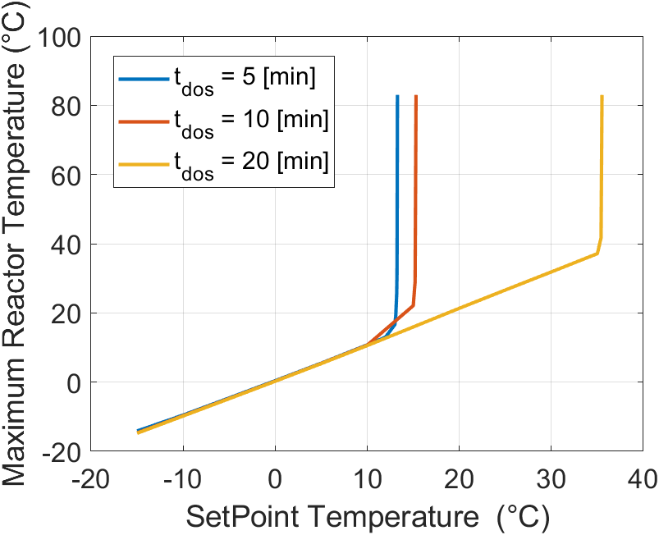
Figure 1: Runaway boundaries for the system as a function of the dosing time (K_{p}=15; K_{i}=60 s)
Figure 1 shows the thermal runaway boundary (represented as a huge increase in the registered reactor peak temperature) for the process recipe reported in Table 1 as a function of the dosing time (note that temperatures higher than 83 °C are without meaning because the reacting mixture is expected to start boiling).
As it is possible to observe, a strong shift towards higher process temperatures of the runaway boundary was detected when the dosing time was increased. At a first glance, it seemed that enlarging the dosing time was the right solution to obtain a safe and highly productive process.
Therefore, the corresponding temperature vs. time and conversions vs. time graphs were generated for the three setpoint temperatures just below the corresponding runaway boundary (that is, 10, 12 and 30 °C; this is to enhance as much as possible the overall calorimetric conversion). Results are reported in Figure 2.
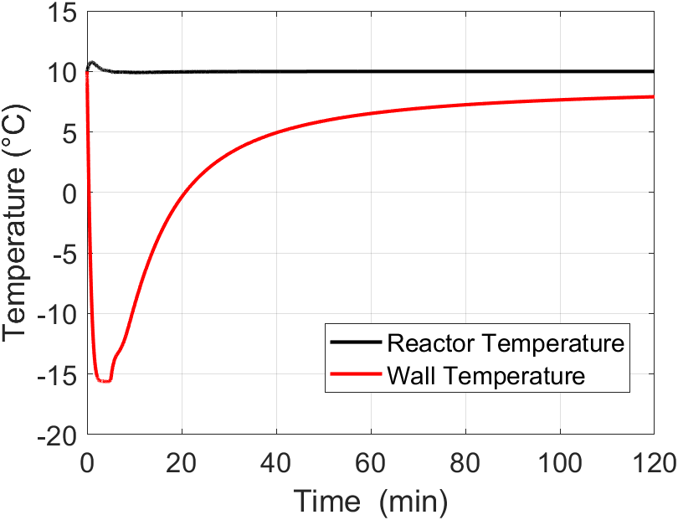a) | 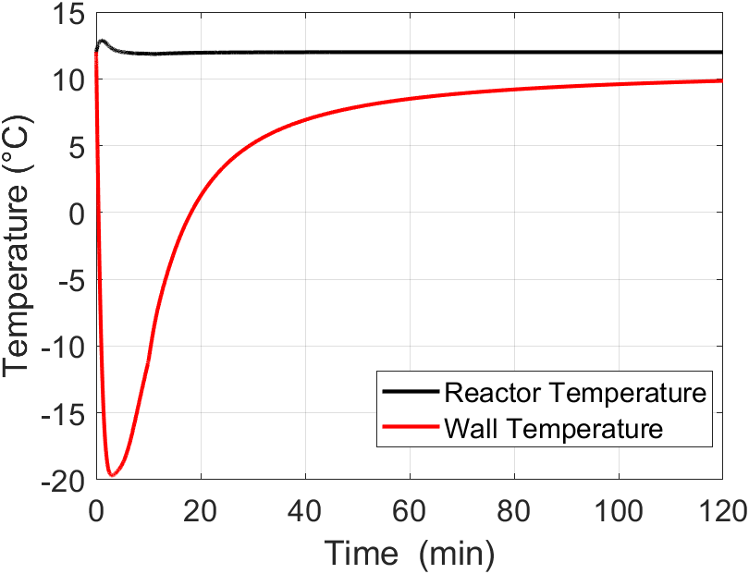b) | 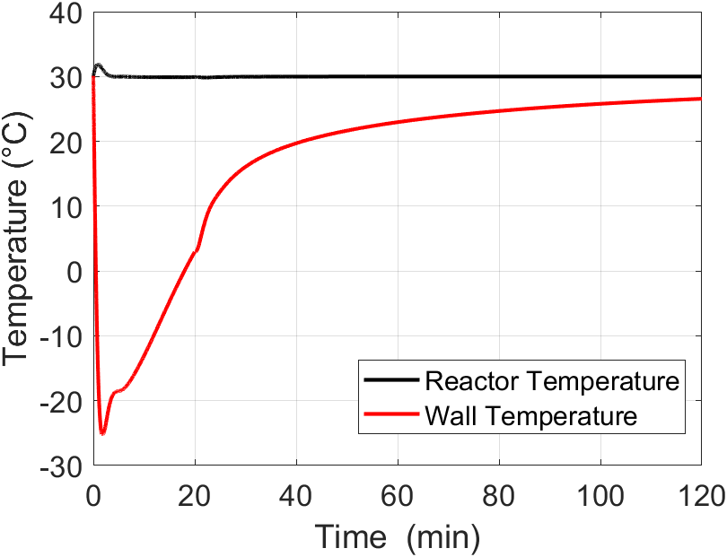c)
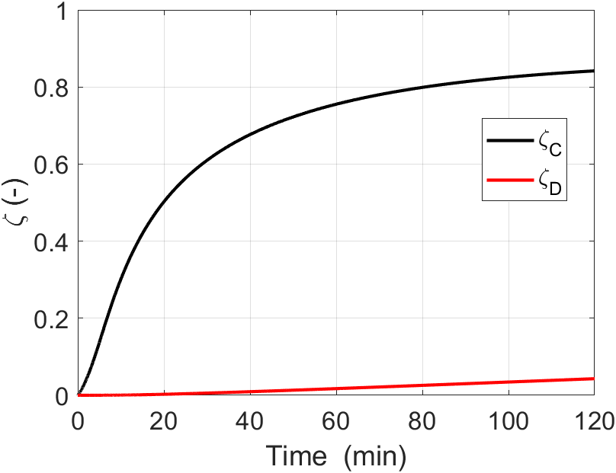d) | 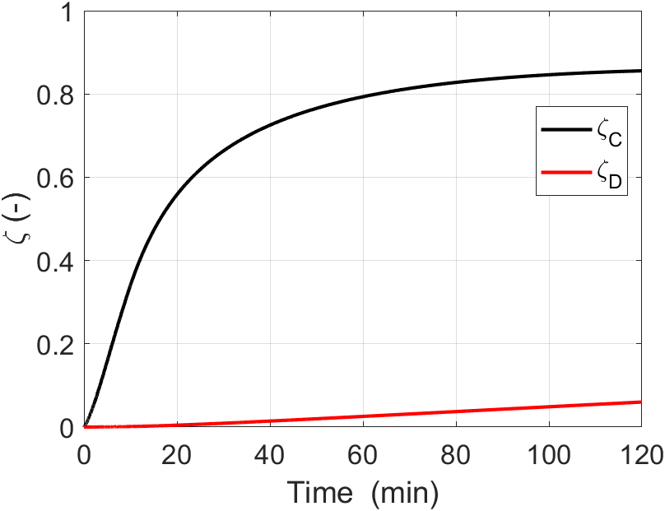e) | 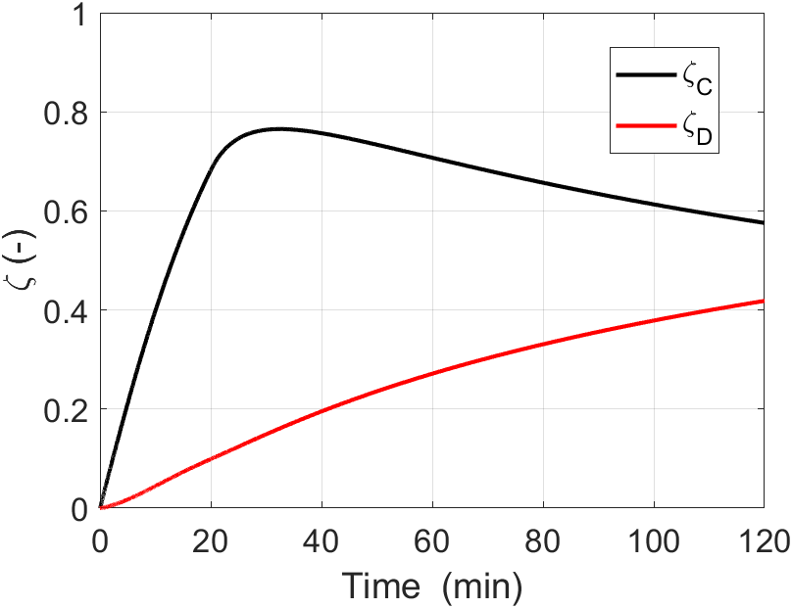f)
Figure 2: Reactor and Wall Temperatures vs time profiles at different setpoint temperatures and dosing times: a) 10 °C and 5 min; b) 12 °C and 10 min; c) 30 °C and 20 min. Conversions to 2-octanone and mix of acids at different temperatures and dosing times: d) 10 °C and 5 min; e) 12 °C and 10 min; f) 30 °C and 20 min. Temperature controller parameters equal to: K_{p}=15 and K_{i}=60 s for all cases.
Considering an overall reaction time equal to 2 h, it is possible to observe how the selectivity with respect to 2-octanone maintained high (around 85%) when the reactor setpoint temperatures were 10 °C (Figure 2d) and 12 °C (Figure 2e), respectively; while, carrying out the process at 30 °C led to a huge loss of selectivity (Figure 2f) because, after an initial peak to 77%, the selectivity value dropped down to 58% after 2 h of reaction time because of 2-octanone degradation. Concerning the energy costs necessary to maintain the setpoint temperature within the reactor, it is possible to see how operating at 10 °C permitted to operate at higher Peltier cells temperatures (a minimum peak temperature of around -15 °C was required against a -20 °C value necessary to maintain the reacting mixture at 12 °C) without affecting the selectivity with respect to 2-octanone. Therefore, a low temperature synthesis of 2-octanone permits not only to enhance the process safety without a loss of selectivity with respect to the desired product but also to save energy because lower coolant temperatures are required. Moreover, an increase in both the dosing time and the reaction setpoint temperature is not always the right solution to optimize a very fast and strongly exothermic reaction: eventual selectivity problems must be carefully considered.
Unfortunately, selectivity is not straightforward to be experimentally determined because, in the absence of kinetics information, suitable analytical techniques (e.g. NMR, GC-MS, Raman, etc..) must be coupled to the calorimetric investigation; otherwise, the runaway boundaries can be always experimentally assessed by evaluating the maximum temperature exhibited by the reactor as a function of a certain parameter variation.
As previously discussed, even the Proportional-Integral parameters of a temperature controller can influence the runaway boundaries.
Figure 3 shows runaway boundaries (always represented as a huge increase in the registered reactor peak temperature) for the process recipe reported in Table 1 using a dosing time equal to 5 min (the best solution arising from the analysis of Figure 2) and different proportional – integral parameters, as detailed in the hypotheses (even in this case, temperatures higher than 83 °C are without meaning because the reacting mixture starts to boil).
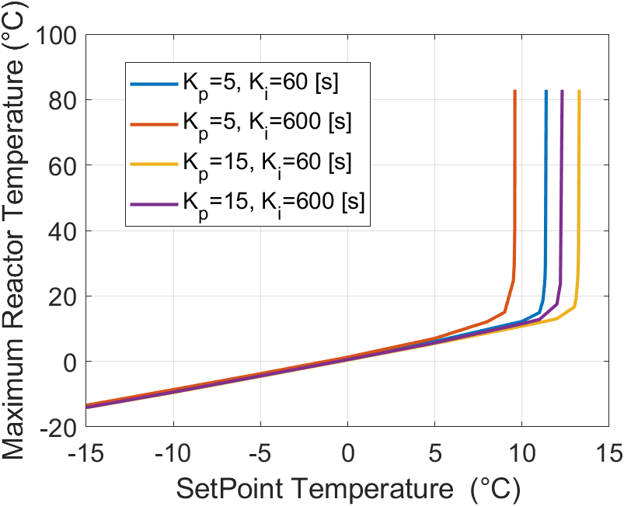
Figure 3: Runaway boundaries for different combination of proportional gain K_{p} and integral time K_{i}
As it is possible to notice from Figure 3, runaway boundaries were influenced by the temperature controller parameters, even if in a minor extent with respect to what it was observed by varying the dosing time. In fact, the maximum distance between the best and the worst reactor setpoint temperature choice was only 4 °C.
Particularly, given a certain static gain K_{p}, an increase in the reset time K_{i} led always to a shift of the runaway boundary towards lower setpoint temperatures, demonstrating how eliminating the integral action is almost always a non-conservative solution when the cooling system exhibits a low thermal inertia (such as in Peltier cells calorimeters). Concerning the effect of an increase in the proportional gain, it is possible to observe (at a given reset time) that the RB was shifted towards higher setpoint temperature values, therefore towards conservative conditions.
Finally, another important aspect emerged from Figure 3: temperature controller parameters must not be changed without looking at their corresponding runaway boundaries; this means that they shouldn’t be considered as mere operating parameters which can be set directly online without further investigation.
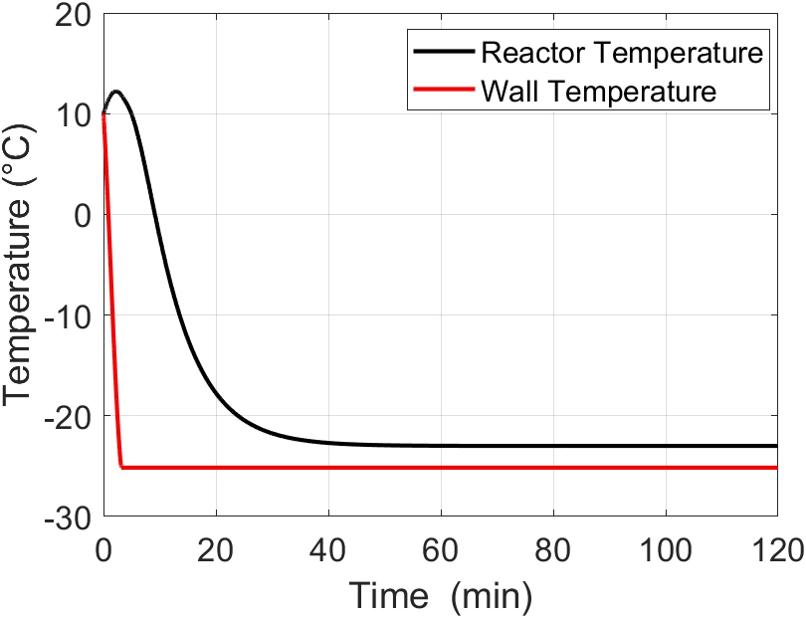a) | 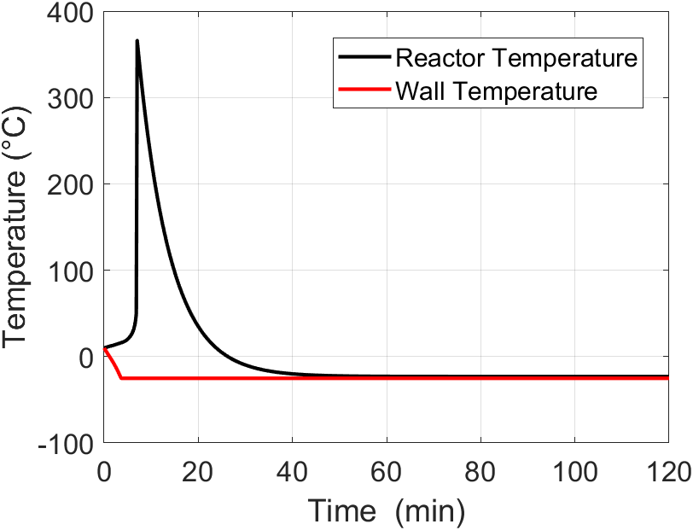b)
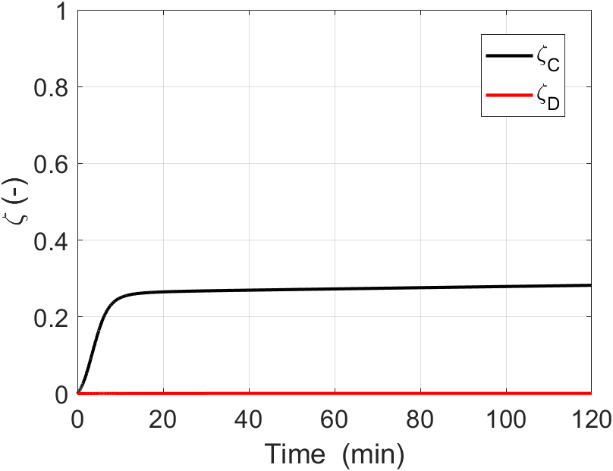c) | 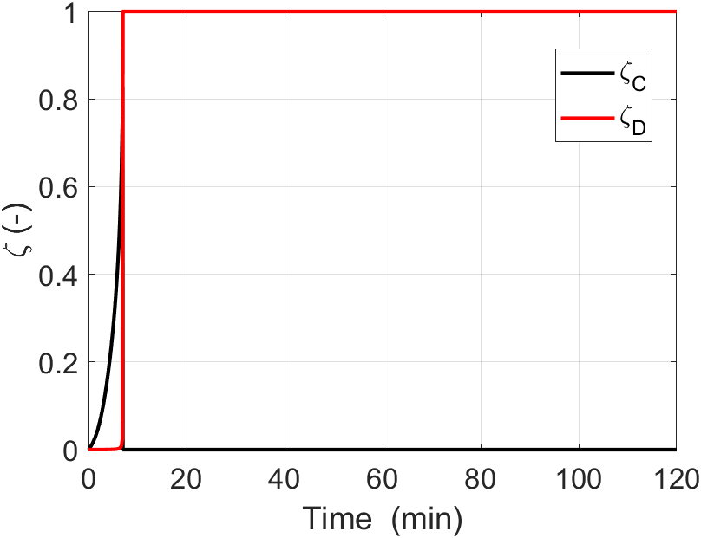d)
Figure 4: Reactor and Wall Temperatures (a) and b)) and conversions to 2-octanone and mix of acids (c) and d)) vs time profiles at different PI couples: a) and c) K_{p}=5; K_{i}=60 s; b) and d) K_{p}=5; K_{i}=600 s.
Figure 4 reports temperature vs. time and conversions vs. time graphs generated for two different PI couples using a dosing time equal to 5 min and a setpoint reactor temperature equal to 10 °C. These last two parameters were shown to be optimal from safety, desired product selectivity and cost-reduction viewpoint but they were selected in correspondence of a given PI couple, that is K_{p}=15; K_{i}=60 s; any other PI couple could not lead to the same performing results. In fact, using the couples K_{p}=5; K_{i}=60 s and K_{p}=5; K_{i}=600 s results in terms of both safety and selectivity were not acceptable. Using a lower reset time permitted to maintain the temperature control (even if the saturation value for the Peltier cells, that is -25 °C, was reached and the automatic emergency cooling was activated without the possibility to reset it) but the selectivity with respect to 2-octanone was compromised. On the contrary, using a higher integral time led to an unavoidable thermal loss of control of the whole system by triggering, in sequence, all possible reactions. These results highlighted that PI control parameters cannot be changed online without a previous deep investigation of the system thermal behaviour.
  - Conclusions
In this work the relevant case study of the nitric acid oxidation of 2-octanol to 2-octanone and further mix of carboxylic acids was investigated with particular attention on the effects of a PI parameters variation for the temperature controller. According to the results, it was demonstrated that: i) the choice to suppress the integral action to avoid reactor temperature fluctuations cannot be justified in all cases where the efficiency of the cooling system is high; ii) lower reset times should be always preferred in case of high cooling system performances; iii) lower dosing time does not always lead to unsafe conditions but it depends on the system kinetics and PI temperature control parameters; iv) for consecutive autocatalytic reactions where the desired product is an intermediate there is a profound connection among setpoint temperature, dosing time and temperature controller parameters that should be taken into account to safely optimize the process.
Nomenclature
$DaRe$ – modified Damköhler number, -
$f_{1/2}\left(\vec{ζ}\right)$ – acidity function, [-]
$K_{i}$ – integral (or reset) time, s
$K_{p}$ – proportional gain, -
$R_{H}$ – heat capacity ratio, -
$St$ – Stanton number, -
$t_{dos}$ – dosing time, s
$v$ – dimensionless volume, -

Greek Symbols:
$Δτ_{ad}$ – dimensionless adiabatic temperature rise, -
$γ$ – dimensionless activation energy, -
$ζ$ – dimensionless concentration or conversion, -
ε – relative volume increase at the end of the semibatch period, -
$ρ$ – dimensionless density, -
$ϑ=\frac{t}{t_{dos}}$ – dimensionless time, -
$τ$ – dimensionless temperature, -

References
Alós M.A., Nomen R., Sempere J., Strozzi F., Zaldívar J.M., 1998, Generalized criteria for boundary safe conditions in semi-batch processes: simulated analysis and experimental results, Chem. Eng. Process, 37, 405-421.
Casson V., Lister D.G., Milazzo M.F., Maschio G., 2012, Comparison of criteria for prediction of runaway reactions in the sulphuric acid catalyzed esterification of acetic anhydride and methanol, J. Loss Prevent. Proc., 25, 209-217.
Copelli S., Derudi M., Rota R., 2011, Topological criterion to safely optimize hazardous chemical processes involving arbitrary kinetic schemes, Ind. Eng. Chem. Res., 50, 1588-1598.
Copelli S., Barozzi M., Maestri F., Rota R., 2017. Safe Intensification of Potentially Runaway Reactions: from Semibatch to Continuous Processes. Chemical Engineering Transactions 57, 1687–1692.
Maestri F., Copelli S., Rota R., Gigante L., Lunghi A., Cardillo P., 2009, Simple procedure for optimally scaling-up fine chemical processes. I. Practical tools, Ind. Eng. Chem. Res., 48, 1307-1315.
Pasturenzi C., Dellavedova M., Gigante L., Lunghi A., Canavese M., Cattaneo C.S., Copelli S., 2013. Thermochemical stability: A comparison between experimental and predicted data, J. Loss Prevent. Proc., http://dx.doi.org/10.1016/j.jlp.2013.03.011
Steensma M., Westerterp K.R., 1988, Thermally safe operation of a cooled semi-batch reactor. Slow liquid-liquid reactions, Chem. Eng. Sci., 43, 2125-2132.
van Woezik B.A.A., Westerterp K.R., 2000, The nitric acid oxidation of 2-octanol. A model reaction for multiple heterogeneous liquid-liquid reactions, Chem. Eng. Process., 39, 521-537.
Varma A., Morbidelli M., Wu H., 2005, Parametric Sensitivity in Chemical Systems, Cambridge University Press, Cambridge.

