CHEMICAL ENGINEERING TRANSACTIONS  VOL. , 2023 | A publication of
The Italian Association
of Chemical Engineering
Online at www.cetjournal.it

Guest Editor: Sauro Pierucci
Copyright © 2023, AIDIC Servizi S.r.l.
ISBN 978-88-95608-98-3; ISSN 2283-9216

Learning Safety of Dusts and Liquids by a Combined Experimental Lessons and Lectures Approach
Gianluca Landiª, Maria Portarapillo^{b,*}, Roberto Sanchiricoª, Andrea Bizzarroª, Amodio Piscitelli^{b}, Almerinda Di Benedetto^{b}
ªIstituto di Scienze e Tecnologie per l'Energia e la Mobilità Sostenibili (CNR-STEMS), P.le V. Tecchio 80, 80125, Napoli, IT
^{b}Department of Chemical, Materials and Production Engineering, University of Naples Federico II, P.le V. Tecchio 80, 80125, Naples, Italy
maria.portarapillo@unina.it
This paper presents in detail a novel course introduced in the academic year 2021/2022 in the Master's degree program in Chemical Engineering at the University of Naples Federico II. The course, called Safety of Dusts and Liquids and Lab Activities, aims to educate students on the industrial safety issues of combustible dusts and flammable liquids. The course was structured with lectures, classroom exercises and laboratory activities aimed at characterizing the ignition sensitivity and explosion severity of certain gaseous fuels, liquids and dusts. Each laboratory activity was preceded by a video tutorial, designed and prepared by the lecturers, in order to introduce the students to the activities and prepare them for all the procedures to be performed. Students’ satisfaction was assessed through the compilation of several anonymous surveys. Results showed a high level of student satisfaction with the course topics and laboratory activities and they will also be used to introduce some improvements for next year.
  - Introduction
«It is important that students be introduced to the concept of inherently safer design and that they realize that safety in plant operation must be considered right at the start of the design study. Process safety must be taught in a rigorous, stimulating way by staff of appropriate experience. […] By virtue of the nature of processes which give rise to major hazards, it is the chemical engineer who often fills the position of responsible person in the design or operation of plant» (Harvey, 1984).
These few lines can be seen as the motivation for the will of the Chemical Engineering program of the University of Naples Federico II to introduce various courses on industrial safety in chemical processes over the last decades. The main objective of the courses is to improve the awareness and understanding of the processes related to industrial safety, trying to make all the concepts and activities as attractive as possible for the students. Other chemical engineering faculties have also used this approach and received positive feedback (Assael and Kakosimos, 2010; Perrin et al., 2018). The first activated compulsory course on industrial safety is called Safety of Chemical Processes (Master's Degree in Chemical Engineering) and covers basic topics such as references to Italian legislation regarding accident-prone sites, thermal stability of substances and thermal explosions, fires and chemical/mechanical explosions (homogeneous and heterogeneous), toxicology and industrial hygiene, and fire and explosion prevention/protection procedures.
From the academic year 2020-2021, this program was complemented by another compulsory course called Chemical Process Development and Risk Analysis (Master's degree in Chemical Engineering). The main objective is to enable students to perform critical analysis of industrial chemical processes with respect to risk analysis issues, make process decisions to optimize performance with respect to industrial safety, and perform risk analysis of industrial chemical processes and use risk analysis software available in the literature. In both courses, students learn the basic knowledge of industrial safety. However, this knowledge is expanded and applied in the second course through the use of simulation software and the development of a group project in which students are asked to perform a full quantitative risk analysis (Department of Chemical Materials and Production Engineering, 2022). In both courses, fire and explosion phenomena of combustible dusts are only marginally studied. Until 2006, dusts were defined as materials with a particle size of 420 μm or less (meaning fine enough to fall through a US standard No. 40 sieve). In the new standard, combustible dusts are defined as "flammable solid particles that present a fire or deflagration hazard when suspended in air or other oxidizing medium over a range of concentrations, regardless of particle size or shape" (Colonna, 2013). Despite the knowledge about dust explosions that has grown over the years, hundreds of accidents occur every year due to the improper handling of combustible dusts and the lack or ineffectiveness of safety measures. (Cloney, 2021). To fill this gap in the preparation of Neapolitan chemical engineering students, a new program has been designed and activated in the academic year 2021-2022.
    - Course description
Safety of Dusts and Liquids and Laboratory Activities is an elective course of the Master's Degree in Chemical Engineering at the University of Naples Federico II. This course is part of a package of electives that can be chosen by students to obtain a complete preparation in the field of industrial safety. The other courses are in particular: Explosion Risks in the Workplace: Prevention and Protective Measures, Structural Safety and Fire Protection of Buildings for Industrial Processes, Toxicology and Industrial Hygiene. All courses related to industrial safety are summarized in Table 1.
Table 1: Courses about industrial safety contents of the Chemical Engineering course, Master's degree, University of Naples Federico II.
Courses | Year | Compulsory?
Safety of Chemical Processes | I | Yes
Development and Risk Analysis of Chemical Processes | I | Yes
Safety of Dusts and Liquids and Lab Activities | I | No
Explosion risks of in workplaces: prevention and protection measures | II | No
Structural safety and fire protection of buildings for industrial processes | II | No
Toxicology and industrial hygiene | I | No

From a review of the existing literature, e.g. a recent special issue about process safety (Meyer and Reniers, 2021), it could be seen that in contrast to fundamental chemistry and physics courses, the approach to industrial safety is often based on lectures and numerical exercises with available software. Conversely, our course consists of theoretical and practical lessons and laboratory experiences conducted to teach students how to program an experimental activity to test the flammability/explosive properties of combustible dusts and liquid substances. Each experiment is preceded by a video tutorial that introduces the students to the activities while making them easier and more effective. The effectiveness of the video tutorials has already been confirmed by other authors, thanks to the attractive visual description of the experimental procedures (Silva et al., 2017; van der Meij and van der Meij, 2015). The aim of this paper is to show the effectiveness of the organization of the course on student preparation and satisfaction. For this purpose, anonymous surveys were conducted.
  - Methods
This section presents the main features of the course. As explained in the previous section, unlike the approaches to asset safety courses described in the literature, this course will take an approach more typical of chemistry and physics courses, based on lectures, software exercises, the creation of video tutorials and non-virtual laboratory experiences.
    - Lectures
The course was organised in different sections that are summarized as in the following:
- Hints of flammability and explosibility of gaseous fuels
- Hints of flammability of liquid fuels
- Flammability and explosibility of combustible dusts
- Flame propagation of combustible dusts
- Flammability and explosibility of hybrid mixtures
- Prevention and mitigation safety measures
As regards the first two sections, the concepts were only recalled and mentioned as they had already been dealt with in other compulsory courses of the degree course in Chemical Engineering (such as, Safety of Chemical Processes and Development and Risk Analysis of Chemical Processes). The topics relative to combustible dusts and their flammable/explosive behaviour were discussed in depth. Particularly, great attention was paid to the description of the key factors capable of influencing the flame propagation of dust-air clouds (Bartknecht, 1989; Crowl and Louvar, 2002; Eckhoff, 2003), the equipment used for the evaluation of the safety parameters (ASTM D3278−21, 2011; ASTM E1226-19, 2019; ASTM E2019-03, 2013) and the different possible flame propagation modes in the case of a solid fuel (Di Benedetto and Russo, 2007). Moreover, the effect of the presence of flammable gases on the explosive behavior of combustible dusts (hybrid mixtures) was presented and discussed, highlighting the effect of the gas on the main safety parameters. The theoretical lessons were interspersed with practical lessons in which software such as GASEQ (Morley, 2005) and Ansys Chemkin (Ansys, 2016) were used for the calculation of adiabatic flame temperatures and laminar flame speeds. The software were used by the students themselves during a case study (flame propagation of a methane-air mixture). At the end of the course, the main prevention and protection measures have been presented.
    - Video tutorials
Video tutorials were developed and created to assist students with each lab activity, from operating the gas valves and gas cylinders, to standard software interface procedures, performing the characterization tests and housekeeping procedures, to safely closing the lab. In creating the videos, every single procedure required to carry out the experiment was filmed and all parts were integrated into a single structure. Each video was created with a written description of the activities rather than a voice recording. Figure 1 shows the different phases of the explosion, as shown in the first video tutorial.

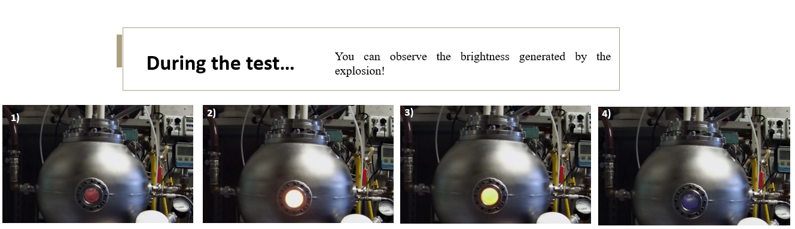
Figure 1: Screen from the video tutorial for the 1st lab experience.
    - Lab experiences
During the laboratory activities, the students had the opportunity to apply the knowledge learned in the lectures and video tutorials in the dust laboratory of the Department of Chemical, Material and Production Engineering (DICMaPI) of the University of Naples Federico II. The students were provided with all the necessary PPE for entering the laboratory, such as gowns and nitrile gloves, and were also trained in worker safety by attending general and specific risk courses. The laboratory, designed by the SaRAH (Safety, Risk Assessment and Hydrogen) research group, is provided of all the necessary equipment for the characterization of combustible dusts. A summary of all laboratory activities is given in Table 2. Briefly, students carried out tests for the evaluation of the maximum explosion pressure P_{max}, the deflagration index of a stochiometric methane-air mixture (K_{G}) and of niacin-air mixture (K_{St}). These tests were both performed using the Siwek 20 L sphere and following standard procedures (ASTM E1226-19, 2019). Then, students assessed the flash point of propylene glycol butyl ether, a solvent used in a wide array of industrial, commercial and consumer applications. The equipment used during these experiments is a Setaflash Series 3 Flash Point tester (ASTM D3278−21, 2011). Finally, students measured the minimum ignition energy of the niacin-air mixture at 120 ms and 1 mH. The equipment used during these experiments is a 1.2 L MIKE3 tube apparatus (ASTM E2019-03, 2013).
Table 2: Summary of the experimental activities carried out during the course
Lab experience | Used equipment | Evaluated parameter(s) | Investigated sample | Applied standard
- Measurement of the deflagration index K_{G} | 20 L sphere | K_{G} | Stochiometric CH₄-air mixture | (ASTM E1226-19, 2019)
- Measurement of the deflagration index K_{St} | 20 L sphere | K_{St} | Niacin-air mixture | (ASTM E1226-19, 2019)
- Measurement of the flash point FP | Setaflash Series 3 Flash Point tester | FP | Propylene glycol butyl ether | (ASTM D3278−21, 2011)
- Measurement of the minimum ignition energy MIE | MIKE3  apparatus | MIE | Niacin-air mixture | (ASTM E2019-03, 2013)
    - Final test
In order to assess the students' preparation for the topics covered in the course, the typical oral exam was accompanied by the development of an analytical group work based on an assigned scientific article (Abbas et al., 2022; Bu et al., 2022; Jiang et al., 2022; Sha et al., 2021; Wei et al., 2022). In particular, students were asked to derive the information on the dust/hybrid mixture required for the development of the report from the assigned article, to define the prevention and/or mitigation measures to be taken under the hypothesis that the dust/hybrid mixture is stored in a container, to determine the flammability/explosion parameters required for planning such measures, and to plan the experimental campaign according to the knowledge of the determined parameters. The content of the paper is then discussed in the examination and forms the starting point for the oral examination.
  - Results
    - Students’ feedback
The students who attended the course showed great interest in the lectures and most students actively participated in the laboratory experiments. In particular, the students appreciated the opportunity to immediately apply the concepts learned in the lectures in the laboratory and to touch materials, equipment and software for the characterisation of flammable and explosive substances. In general, the creation of the video tutorials was highly appreciated as a training tool and to increase the students' awareness as laboratory operators. To evaluate the effectiveness of the course and the soundness of the topics covered, anonymous surveys were offered to the course participants. These surveys were used to collect students' opinions, comments and suggestions on the video tutorials, lab activities and the final exam. Students could choose between five satisfaction levels (strongly agree, agree, neutral, disagree and strongly disagree). The survey that students had to complete after watching each video tutorial and before the following lab exercise (not reported) resulted in positive feedback. The overall percentage of students who were satisfied after watching the video tutorials was very high, ranging from 90 to 100%. As reported for all lab experiments, at least 50% of the students would have liked a verbal description of the activities already during the video tutorial. From the results, it can be concluded that the video tutorials are effective, as more than 60 % of the students do not need to watch them more than three times. The survey that students are asked to complete after each experience is shown in Table 3, and it was useful to evaluate the video tutorial, the experience and their pairing. Results are shown in Figure 2. As with the previous survey, the overall percentage of students who were satisfied with the post-lab activities and video tutorials was very high. The responses to question Q-3 indicate that most students would not have done the experience in the same way without the video tutorial. Surprisingly, in the answers to question Q-5 regarding the vocal description in the video tutorials, a larger number of students felt that a vocal description was not necessary, thanks to the explanations they received during the experience itself.
Table 3: Survey to be completed after each laboratory experience to know student feedback on utility of the video tutorials and quality of lab experiences.
Survey questions
- The video tutorial was useful for tackling the lab activity.
- The laboratory experience was in line with what is shown in the video tutorial.
- You would have gone through the lab experience the same way without video tutorials.
- In light of the lab experience, the video tutorial clearly showed the lab activity.
- In light of the lab experience, you would have preferred a vocal description of the activities in the video tutorial.
- In light of the lab experience, you believe that the duration of the video tutorial is appropriate.
- In light of the lab experience, you believe that you have viewed the video tutorial enough times.
- You believe that the lab experience has been useful for consolidating notions faced during classroom lessons.

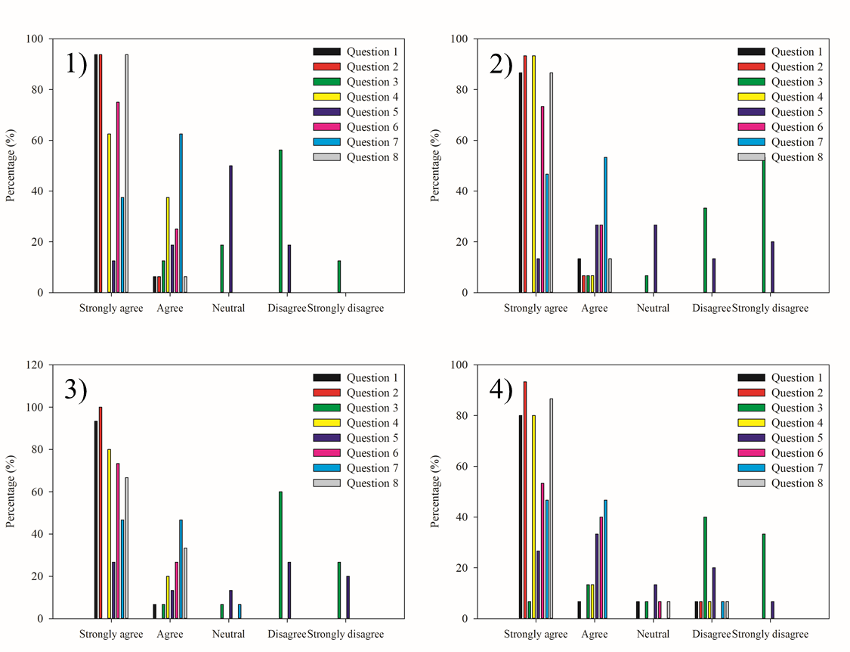
Figure 2: Feedback of the anonymous students’ surveys completed after each laboratory experience
    - Final tests and Students’ evaluation
The final tests were held on several dates at the request of the students. Figure 3 shows the marks obtained in the final tests. The exam marks vary between 18 and 30; 30L stands for 30 cum laude. Most exam marks are above 27, indicating that students thoroughly understood the course topics, elaborated on them and were able to present them correctly. The nature of the course, with lectures and laboratory experiences, has certainly contributed to the students' mastery of the course topics. In addition, the method of examination, i.e. the presentation of the essay, enables students to see the examination itself in a positive light. During the discussion of the essay, they can present different topics and thus demonstrate their knowledge of the topics. Consequently, they feel that the examination is positive and can thus face the subsequent questions more calmly.
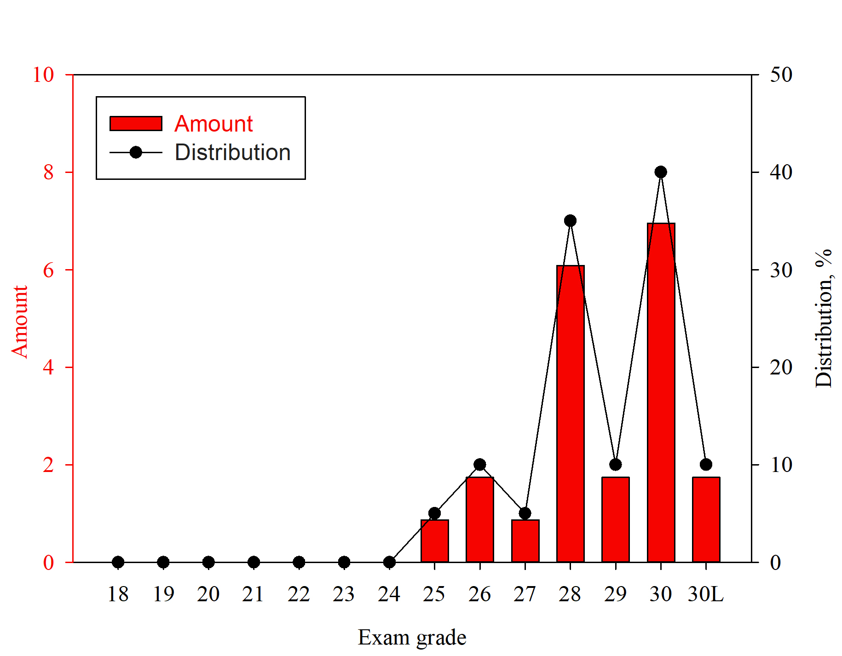
Figure 3: Amount and distribution of exam grades.
  - Conclusions
This article presents in detail the new course "Safety of dusts and liquids and laboratory activities", which will be introduced in the Master's program in Chemical Engineering at the University of Naples Federico II in the academic year 2021/2022. This article focuses in particular on the design and organization of the course. Unlike other courses in the program dealing with industrial safety, this course includes a section of laboratory activities organized by the lecturers with the aim of applying and fully understanding the concepts covered in the lectures. The preparation of video tutorials was highly appreciated by the students: the overall percentage of students who were satisfied after watching the video tutorials was very high, ranging from 90 to 100%. Satisfaction with the laboratory activities was also comparable. In addition, the final exam, which consists of an essay discussion and an oral interview, was assessed and satisfaction is above 80%. This high level of satisfaction is reflected in the final grades obtained by the students. The results obtained will certainly be used by the lecturers to introduce innovations and improvements for the next academic year.
Acknowledgement
The authors wish to thank all the students of the Safety of Dusts and Liquids and Lab Activities course of the academic year 2021-2022 for their fruitful and significant contribution to the activities reported in this paper.
Reference
Abbas Z., Gabel D., Krietsch A., Krause U., 2022, Quasi-static dispersion of dusts for the determination of lower explosion limits of hybrid mixtures, J. Loss Prev. Process Ind., 74, 104640.
Ansys, 2016, Chemkin Theory Manual 17.0, Chemkin® Softw.
Assael M.J., Kakosimos K.E., 2010, Can a course on the calculation of the effects of fires, explosions and toxic gas dispersions, be topical, enjoyable and meaningful?, Educ. Chem. Eng. 5, e45–e53.
ASTM D3278−21, 2011, Standard Test Methods for Flash Point of Liquids by Small Scale Closed-Cup, 1–15.
ASTM E1226-19, 2019, Standard Test Method for Explosibility of Dust Clouds, 1–15.
ASTM E2019-03, 2013, Standard Test Method for Minimum Ignition Energy of a Dust Cloud in Air, 1–9.
Bartknecht W., 1989, Dust explosions: Course, prevention, protection. Springer Verlag.
Bu Y., Addo A., Amyotte P., Yuan C., Li C., Hou X., 2022, Insight into the dust explosion hazard of pharmaceutical powders in the presence of flow aids, J. Loss Prev. Process Ind. 74, 104655.
Cloney C., 2021, 2020 Combustible Dust Incident Report - Version #1, DustEx Res. Ltd.
Colonna G., 2013, Fire and Life Safety Inspection Manual 50.
Crowl D.A., Louvar J.F., 2002, Chemical and Process Safety, PRENTICE HALL INTERNATIONAL SERIES IN THE PHYSICAL AND CHEMICAL ENGINEERING SCIENCES.
Department of Chemical Materials and Production Engineering, 2022, http:/www.ingchim.unina.it, last visit 20/12/2022.
Di Benedetto A., Russo P., 2007, Thermo-kinetic modelling of dust explosions, J. Loss Prev. Process Ind, 20, 303–309.
Eckhoff R.K., 2003, Dust Explosion in the Process Industries, Gulf Professional Publishing, Boston.
Harvey B.H., 1984, Third Report of the Advisory Committee on Major Hazards, HM Stationery Office, London, UK.
Jiang H., Bi M., Gao Z., Zhang Z., Gao W., 2022, Effect of turbulence intensity on flame propagation and extinction limits of methane/coal dust explosions, Energy, 239, 122246.
Meyer T., Reniers G. (Eds), 2021. Special Issue on Process Safety in Chemical Engineering Education and Training. Educ. Chem. Eng.
Morley C., 2005, GASEQ, a chemical equilibrium program for windows.
Perrin L., Gabas N., Corriou J.P., Laurent A., 2018, Promoting safety teaching: An essential requirement for the chemical engineering education in the French universities, J. Loss Prev. Process Ind. 54, 190–195.
Sha D., Li Y., Zhou X., Zhang J., Zhang H., Yu J., 2021, Influence of Volatile Content on the Explosion Characteristics of Coal Dust, ACS Omega 6, 27150–27157.
Silva J.M., Matos L.C., Magalhães F.D., Alves M.A., Madeira L.M., 2017, Coke combustion in fluidized bed: A multi-disciplinary lab experiment, Educ. Chem. Eng., 19, 13–22.
van der Meij J., van der Meij H., 2015, A test of the design of a video tutorial for software training, J. Comput. Assist. Learn., 31, 116–132.
Wei L., Su M., Wang K., Chen S., Ju Y., Zhao S., Kong X., Chu Y., Wang L., 2022, Suppression effects of ABC powder on explosion characteristics of hybrid C2H4/polyethylene dust, Fuel, 310, 122159.

