CHEMICAL ENGINEERING TRANSACTIONS  VOL. 98, 2023 | A publication of
The Italian Association
of Chemical Engineering
Online at www.cetjournal.it

Guest Editor: Sauro Pierucci
Copyright © 2023, AIDIC Servizi S.r.l.
ISBN 978-88-95608-98-3; ISSN 2283-9216

Coupling Mixed Culture Fermentation and Photo-fermentation for Bio-H₂ Recovery: Preliminary Assessment of the Fermentation Yields and PNSB Growth on Fermentative Broth
Marco Biasiolo*ª, Giulio Barchielliª, Graziano Tassinato^{b}, Margherita Turatello^{b}, Cristina Cavinatoª
ªDipartimento di Scienze Ambientali, Informatica e Statistica, Università Ca’ Foscari Venezia, via Torino 155, Venezia, 30172, Italia
^{b}Green Propulsion Laboratory, VERITAS spa., via della Geologia 31, Fusina, 30176, Italia
marco.biasiolo@unive.it

Hydrogen has been widely recognized as a promising tool to address global warming problems, due to its high energy density and the sustainability of its utilization. Among the possible methods for its production, the biological processes have gained a lot of interest in recent years, as they would allow for an alternative and environment-friendly production. In this preliminary study, a two-stage co-fermentation/photo-fermentation process has been investigated. The first stage focused on the production of a medium enriched in volatile fatty acids (VFAs) to be used as a substrate for Purple Non-Sulphur Bacteria (PNSB). The co-fermentation of an organic waste mixture and sewage has been investigated, evaluating the VFAs production yields at different organic loadings (0, 5, 10, 15, 20, 25 kg_{TVS(mixture)} m⁻³). The highest VFA production yields (410.0 and 381.1 g_{VFA(COD)} kg_{TVS}⁻¹) were obtained at 10 and 15 kg_{TVS(mixture)} m⁻³, respectively.
Two PNSB strains, Rhodopseudomonas palustris and Rhodospirillum rubrum, were fed with the fermentation broth, and compared in terms of biomass production. Despite no significant hydrogen production being observed, both strains showed a consistent boost in growth yields when fed with the fermentative broth rather than with the standard growth medium (a two-fold higher biomass production for Rps. palustris, and eight-fold higher for Rsp. rubrum). This suggests how the use of fermentative effluents as a culture medium for PNSB cultivation is a viable option to foster their growth. However, the limited hydrogen production in all the tested conditions is in disagreement with the literature evidence and certainly requires further investigation to detect any possible cause of inhibition.
  - Introduction
The increasing energy demand of our society, along with the more and more pressing concerns about environmental pollution and fossil fuel depletion (Abas et al., 2015), emphasize how it is ever more essential to move towards more sustainable energy sources. In this context, hydrogen is gaining attention as a cleaner and more efficient energy source, due to its high energy density (142 kJ g⁻¹) and the absence of pollutant emissions resulting from its combustion (Hay et al., 2013). However, the industrial processes that lead to hydrogen production play a major role in considering it as a green fuel. So far, hydrogen was mostly produced by exploiting the cheapest processes (i.e., steam reforming of methane from natural gas) (Baeyens et al., 2020) with poor consideration of the environmental impacts (Eh et al., 2022). Although being currently not economically competitive (Ajanovic et al., 2022), hydrogen production via bioprocess is considered to be a promising method in terms of sustainability, due to its mild operative conditions (usually operated at room temperature (Pal et al., 2022), compared to 700–1100 °C of steam reforming (Baeyens et al., 2020)), its minimal net greenhouse gas emissions (Pal et al., 2022), and the possibility to exploit wastes and wastewaters as carbon and energy sources for the microorganisms involved in its production (Rai and Singh, 2016).
Table 1: Chemical-physical characteristics of the substrates
Substrate | Total Solids  (g_{TS} kg_{FM}⁻¹) | Total Volatile Solids  (g_{TVS} kg_{FM}⁻¹) | COD  (g_{O2} kg_{FM}⁻¹)
Lettuce | 89.0 ± 3.0 | 74.0 ± 7.0 | 80 ± 4
Red beets | 119.0 ± 1.0 | 111.1 ± 0.5 | 114 ± 8
Toilet paper | 990.0 ± 10.0 | 960.0 ± 40.0 | 1050 ± 40
Sewage | 24.6 ± 0.2 | 19.4 ± 0.2 | 26 ± 2
Organic waste mixture | 84.6 ± 0.8 | 77.2 ± 0.7 | 111 ± 5

There are various biological processes to generate hydrogen: direct and indirect bio-photolysis (Javed et al., 2022), microbial electrolysis cells (Gautam et al., 2023), biological water-gas shift reaction (Amos, 2004), dark-fermentation and photo-fermentation (Pal et al., 2022). Dark and photo-fermentation processes may be integrated into a sequential two-stage system or in a single-stage co-fermentation, to allow for a more complete valorisation of the organic compounds fed (Rai and Singh, 2016).
In this preliminary study, a mixed culture fermentation and a photo-fermentation were coupled. The first process aimed to generate a VFAs (volatile fatty acids) enriched effluent, to be exploited in the subsequent photo-fermentative process as a medium for PNSB (purple non-sulfur bacteria) growth.
  - Materials and Methods
    - Co-fermentation: substrates
The substrates used in this study for the organic waste mixture (lettuce, red beets, and toilet paper), as well as their respective ratio (6:6:1 on total solid basis, respectively), were selected as a possible scenario of wastes generated by a crew of astronauts (MELiSSA project, contract No. 19297/05/NL/SFe). The substrates were purchased at a grocery shop, then processed and mixed using a kitchen blender until a complete homogenization was reached. The organic mixture obtained was then characterized in terms of its chemical-physical properties, and then stored at -10 °C. The sewage used as a co-substrate for the fermentation process was collected from a municipal wastewater treatment plant located in Northern Italy. Table 1 shows the chemical-physical characteristics of the involved substrates.
    - Co-fermentation: reactor configuration
The fermentation tests were run in batch condition at a working volume of 4 L. The temperature was set at 37.0 ± 0.6 °C. The reactors were stirred at 14 rpm with anchor-style agitators, designed to limit the sedimentation of solids in the bottom of the reactors. When the pressure in the headspace of the reactors exceeded 1.2 atm, the produced biogas was automatically channelled to a gasometer for volume measurement and collected in 10 L gas sampling bags.
    - Co-fermentation: experimental setup
Each fermentation test was performed with no initial inoculum, considering the sewage as a biologically active substrate. Six different organic loadings (0, 5, 10, 15, 20, 25 kg_{TVS(mixture)} m⁻³) have been tested, progressively increasing the amount of organic waste mixture and, on the other hand, decreasing the amount of sewage. Each condition was tested in duplicate. The biogas production was monitored continuously, to track down and limit any possible methanogens activity. Every two days, a sample of the fermentative broth was collected for pH and VFA composition determination. The pH changes during the test were monitored, but uncontrolled. Each fermentative test lasted 10 d, which was found to be sufficient time to observe the VFA evolution. At the end of the test, the ammonium concentration was determined.
    - Co-fermentation: analytical methods
The total solid and total volatile solid content of the substrates was determined using a gravimetric method according to the APHA (Standard Methods for the Examination of Water and Wastewater) standard methods (Baird et al., 2017). The COD content of the substrates was determined in closed reflux using a titrimetric method according to APHA standard methods (Baird et al., 2017).
The fermentation broth samples were centrifuged at 4,500 rpm for 5 min and filtrated at 0.2 μm before pH and VFAs analysis. The ammonium concentration was measured at the end of the test employing an Ion Selective Electrode (HI4101, Hanna Instruments, Italy).
VFAs were determined by high performance liquid chromatography HPLC using a chromatographer (1100 series, Agilent Technologies, USA) equipped with a 0.5 μm x 4.0 mm x 150 mm AcclaimTM Organic Acid column (Thermo Scientific) and a diode array detector (DAD). A 2.5 mM methansulfonic acid (Sigma-Aldrich, ≥ 99.0 % purity) aqueous solution and acetonitrile (Sigma-Aldrich, gradient grade, ≥ 99.9 % purity) were used as mobile phases A and B, respectively, in a ratio 45/55 (A/B).
The column was maintained at 30 °C and the detection wavelength was set at 210 nm. VFAs concentration was calculated using a calibration curve ranging from 1 to 10 mM obtained by diluting a Volatile Free Acid Mix (Sigma Aldrich, certified reference material). All VFAs concentrations were presented as chemical oxygen demand (COD), based on their complete stoichiometric conversion. The acidogenic yields (g_{VFA(COD)} kg_{TVS}⁻¹) were determined as the ratio between the produced VFAs and the TVS fed in each condition.
    - Photo-fermentation: microorganisms and media
The test was carried out using Rhodopseudomonas palustris and Rhodospirillum rubrum, supplied by BCCM (Belgian Coordinated Collections of Microorganisms, Ghent, Belgium). The two PNSB inocula were maintained in axenic condition in an RPN culture medium, prepared as described in Bianchi et al. (2010). The test was carried out on an RPP medium containing 4.0 g L⁻¹ of malic acid (Bianchi et al., 2010) and on a fermentative broth (FB) medium. The FB medium was prepared by processing the fermentation broth obtained at the 10 kg_{TVS(mixture)} m⁻³ organic loading. This fermentation broth was selected as the one characterized by the highest acidification yield. The fermentation broth was adjusted at 6.8 pH with NaOH 6 N, then centrifuged at 9,000 rpm for 10 min and filtered at 0.2 μm. The fermentation broth was then diluted 1:5 with an RPP medium prepared without the addition of malic acid, thus, maintaining the overall composition of the medium and replacing with VFAs the carbon source for PNSB metabolism. After the preparation, the FB medium was characterized by an ammonium concentration of 86.8 ± 9.5 mg_{N-NH4} L⁻¹, and was composed of (g_{COD} L⁻¹): acetic acid, 1.09; propionic acid, 0.69; butyric acid, 0.56; valeric acid, 0.75; caproic acid, 2.08; heptanoic acid, 0.54.
    - Photo-fermentation: experimental setup
The test was run in batch in eight 250 mL serum bottles (200 mL working volume). Both PNSB strains were tested, individually, on RPP medium and FB medium, in duplicate. Each bottle started with a 0.020 ± 0.003 g_{(PNSB)} L⁻¹ biomass concentration. The bottles were enclosed with butyl rubber stoppers and sealed with aluminium crimp caps, then each bottle was flushed with argon to remove oxygen and nitrogen from the headspace. The PNSB bottles were then incubated at 30 °C, under 24 h illumination (3,000 lux, incandescent lamps). The test lasted 25 d. Every two days, samples of the culture solutions were collected for OD determination. Before sampling, the hydrogen production was checked by connecting each bottle gas-tight to a water displacement cylinder.
    - Photo-fermentation: analytical methods
The light intensity was measured by lux meter (LX1330B, Dr. Meter, USA). The biomass concentration of the PNSB samples was determined by optical density (OD) at 660 nm, measuring the absorbance of the culture samples by a UV-VIS spectrophotometer (Spectrosmart Basic, Zetalab, Italy), on 1 cm path-length optical glass cuvettes. Calibration curves ranging from 3 to 200 mg_{(PNSB)} L⁻¹ were used to convert OD values to biomass concentrations. The calibration curves were prepared for Rps. palustris and for Rsp. rubrum, both on standard RPP medium and on FB medium.
The values of biomass concentration were used to calculate the growth rate (μ, d⁻¹) and the biomass productivity (P, mg L⁻¹ d⁻¹), according to Eq(1) and Eq(2), respectively:
$$μ \left(d^{-1}\right)=\frac{ln⁡(X_{i})-ln⁡(X_{i-1})}{(t_{i}-t_{i-1})}$$ | (1)
$$P \left(mg L^{-1} d^{-1}\right)=\frac{X_{i}-X_{i-1}}{(t_{i}-t_{i-1})}$$ | (2)
where X_{i} and X_{i-1} are the biomass concentration of PNSB cultures at time t_{i} and t_{i-1}, respectively.
Table 2, chemical-physical characterization of the dark fermentation effluent at the end of the test
Tested condition | pH | VFAs concentration  (g_{VFA(COD)} L⁻¹) | NH₄⁺ concentration  (mg_{NH4+} L⁻¹) | Acidification yields  (g_{VFA(COD)} kg_{TVS}⁻¹)
ctrl | 7.46 ± 0.08 | 3.7 ± 0.3 | 285 ± 14 | -
OL 5 | 5.39 ± 0.08 | 7.7 ± 0.1 | 701 ± 35 | 331.1
OL 10 | 5.05 ± 0.01 | 11.0 ± 0.5 | 253 ± 13 | 410.0
OL 15 | 4.90 ± 0.01 | 11.6 ± 0.6 | 107 ± 5 | 381.1
OL 20 | 5.07 ± 0.04 | 11.4 ± 0.5 | 136 ± 7 | 334.1
OL 25 | 4.97 ± 0.03 | 11.6 ± 0.6 | 260 ± 14 | 306.8
  - Results and Discussion
    - Co-fermentation: VFA production
In Figure 1, VFAs production and composition, and pH at different OL are reported. The control (ctrl) condition is related to only sewage fermentation, with no organic mixture feed (0 kg_{TVS(mixture)} m⁻³) and no inoculum addition, as for the other conditions. In general, the increase in the OL at values higher than 15 kg_{TVS(mixture)} m⁻³, caused a drop in pH below 4 after 24 h (Figure 1 d, e, and f). This pH decrease corresponds to the identification of a high concentration of acetic acid. As reported by Itoh et al. (2012), acidogenic fermentation without pH control shows a drop in pH at values up to 3.5 within 24 h, with an accumulation of lactic acid. Considering that and the analytical method applied, an accumulation of lactic acid alongside acetic acid can not be excluded. In Table 2 the physical-chemical characteristics of the fermentation broth at the end of the test are reported. The best conversion yields were 410.0 and 381.1 g_{VFA(COD)} kg_{TVS}⁻¹, obtained at OL 10 and OL 15, respectively.
Biogas production was monitored constantly. Biogas production was not detected at OL 5. The other tested conditions showed a slight biogas production (52.0, 87.5, 118.7, and 81.8 NL kg_{TVS}⁻¹, for OL 10, 15, 20, and 25, respectively).
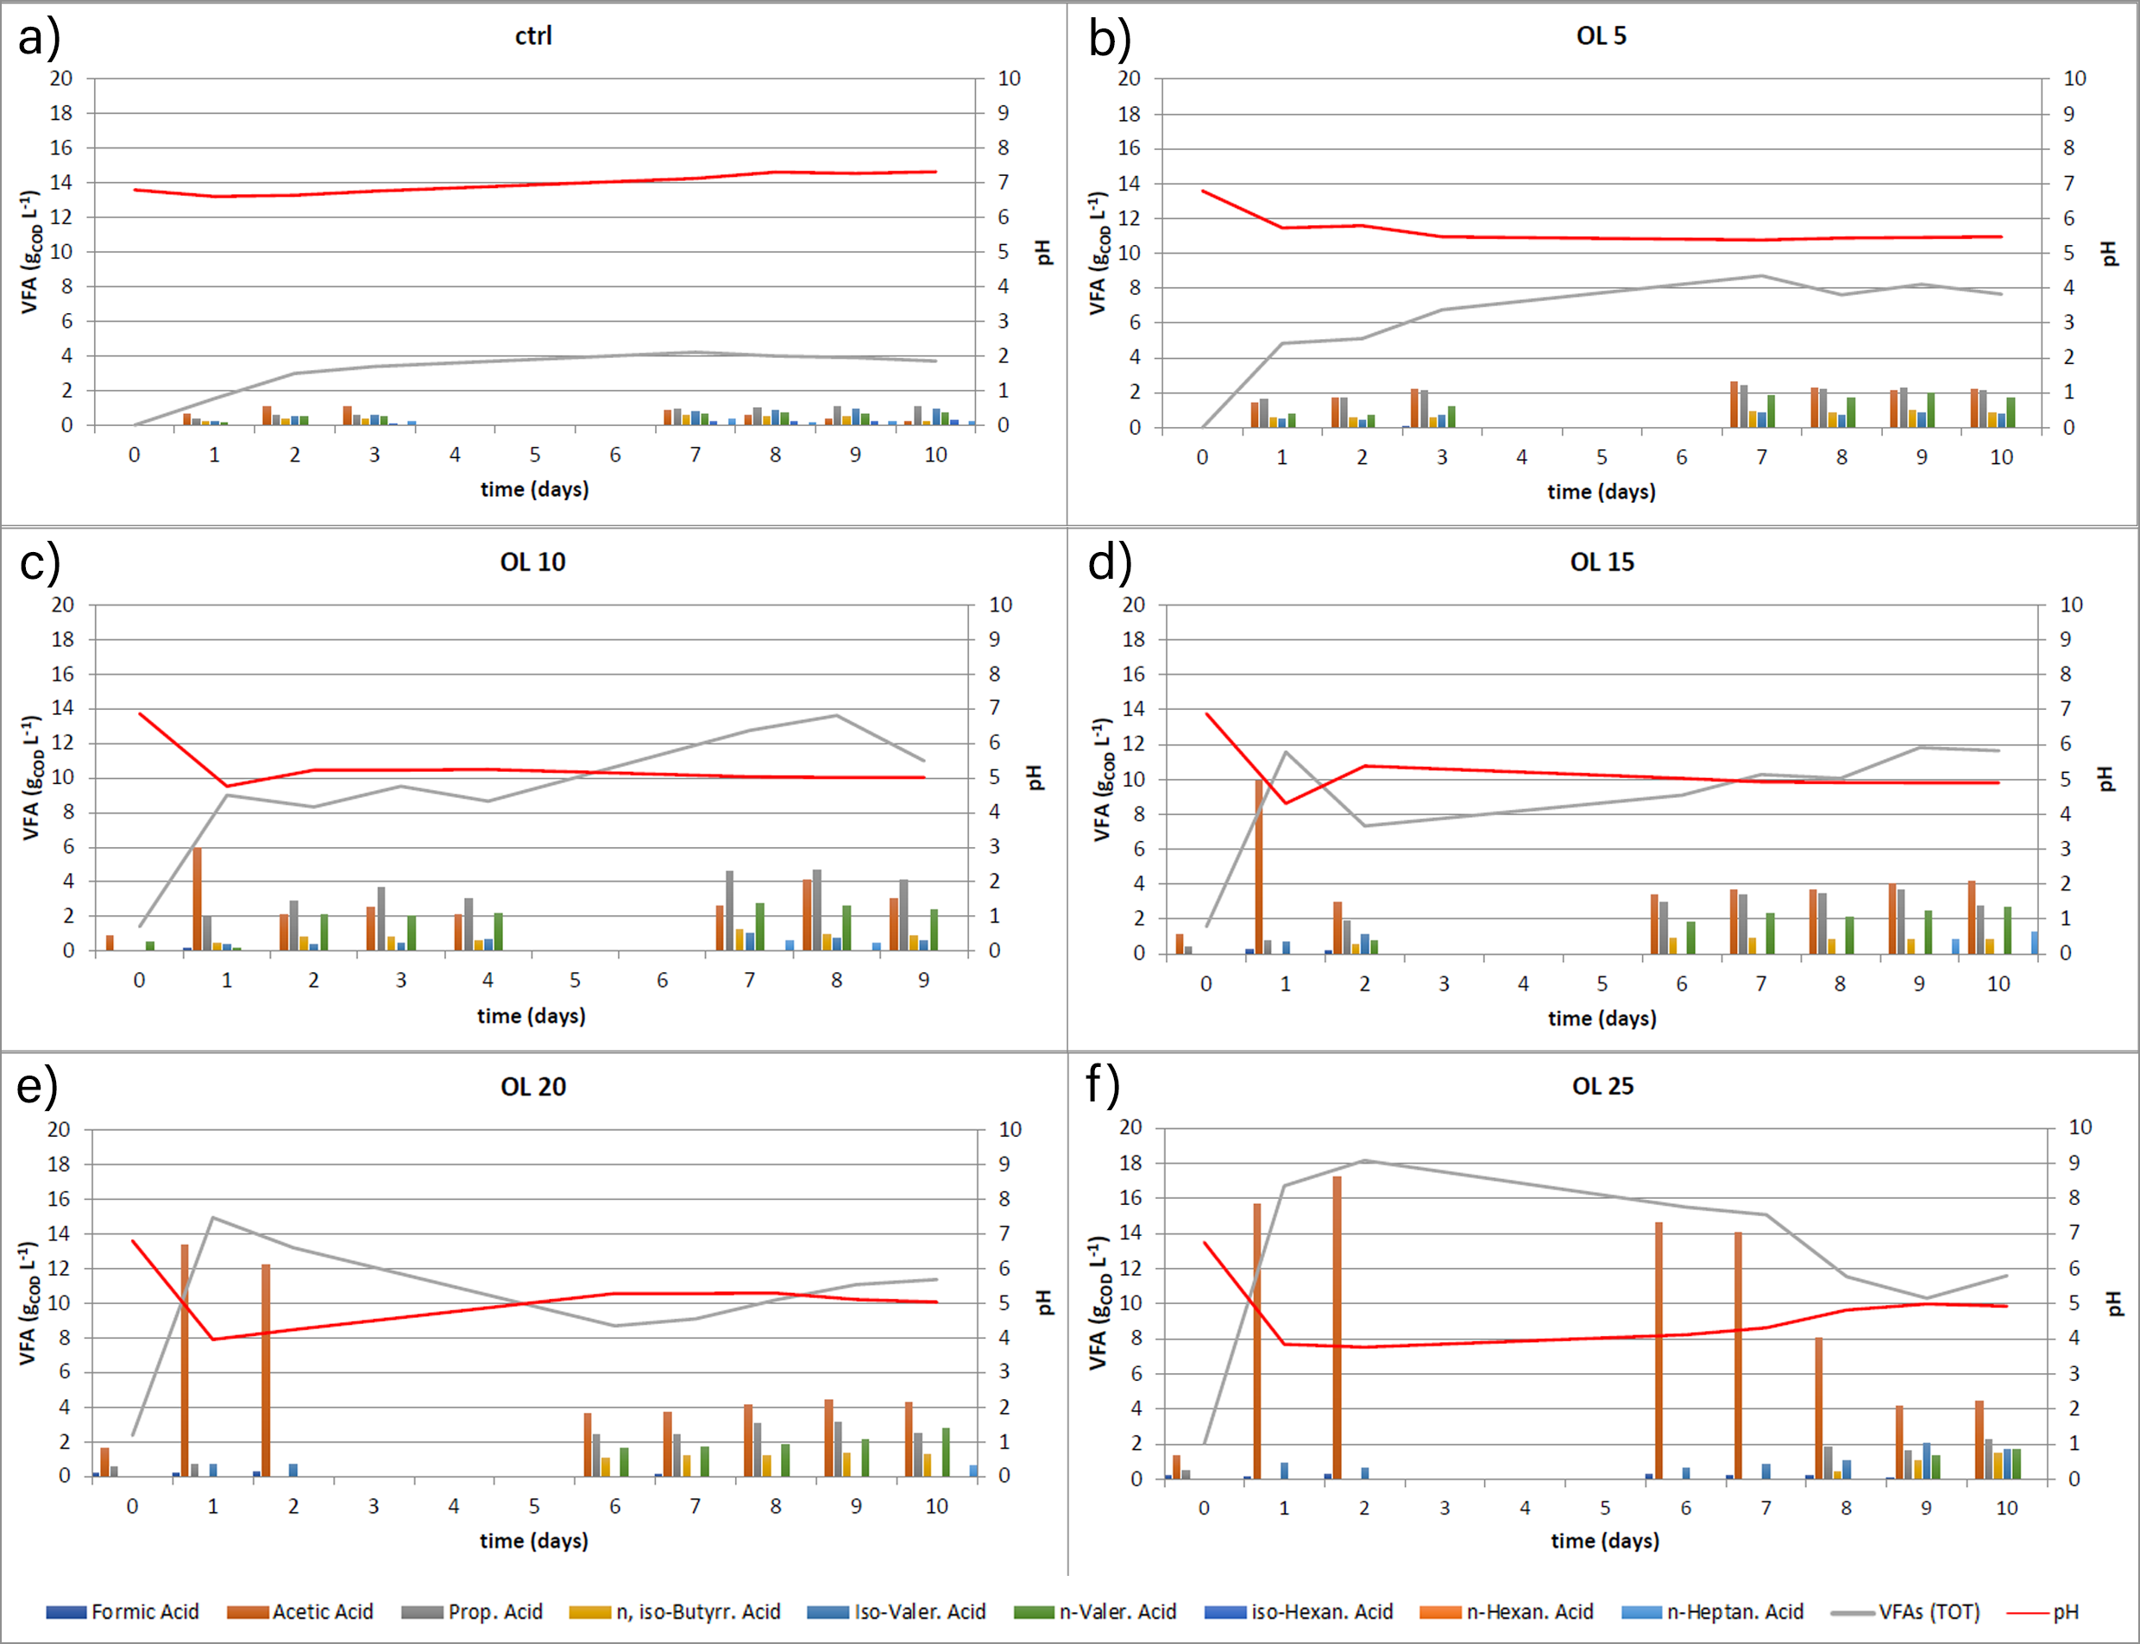
Figure 1, total VFAs production, VFAs characterization, and pH curve for each tested condition. a) control condition, b) OL 5, c) OL 10, d) OL 15, e) OL 20, and f) OL 25 kg_{TVS(mixture)} m⁻³
Table 3, growth parameters of the two PNSB strains in RPP and FB media
PNSB strain | Medium | biomass concentration  (g_{PNSB} L⁻¹) | P_{max}  (mg L⁻¹ d⁻¹) | μ_{max}  (d⁻¹)
Rps. palustris | RPP | 0.54 | 84.31 | 4.43
 | FB | 1.08 | 159.53 | 5.05
Rsp. rubrum | RPP | 0.13 | 28.09 | 2.16
 | FB | 1.04 | 128.32 | 3.76
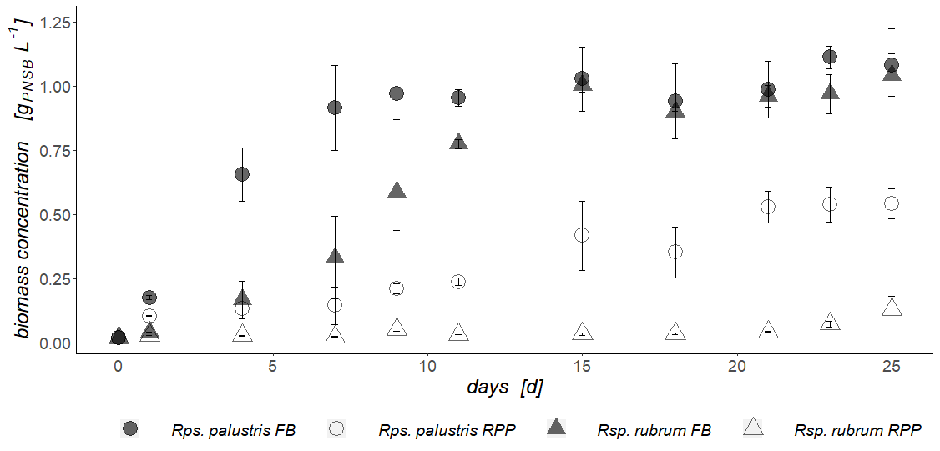
Figure 2, Rps. palustris and Rsp. rubrum biomass concentration on RPP and FB media growth test
An 8.3 % of methane was detected at the end of the test in the biogas produced at OL 10, attesting the possible flourishment of methanogens in the microbial consortium, while a lower methane content was revealed at the other tested conditions (3.0, 0.8, and 0.3 %, for OL 15, 20, and 25, respectively). Methanogens were most likely inhibited at higher OL because of the lower pH of the fermentative broth (Zahedi et al., 2016).
    - Photo-fermentation: PNSB growth
The fermentative broth obtained at OL 10 kg_{TVS(mixture)} m⁻³ was processed to obtain the FB medium for PNSB growth. This fermentative broth was selected over the others according to its acidogenic yield. Moreover, its VFAs and ammonium concentration allowed to obtain a growth medium with a high VFAs content and low ammonium concentration, as NH₄⁺ is one of the main inhibitors of the nitrogenase enzyme of PNSB (Özgür et al., 2010). In Figure 2, the biomass growth evolution of Rps. palustris and Rsp. rubrum both in RPP and FB medium is reported. Both PNSB strains reached a higher biomass concentration when fed with the FB medium (1.08 and 1.04 g_{PNSB} L⁻¹, for Rps. palustris and Rsp. rubrum, respectively) compared with RPP medium (0.54 and 0.13 g_{PNSB} L⁻¹, respectively). Maximum productivity and maximum growth rate (Table 3) as well resulted improved in the FB medium. Gas production was detected only for Rps. palustris on RPP medium, but the amount produced (< 30 NmL during the whole experiment) was too low for the determination of hydrogen composition. Rsp. rubrum on the RPP medium showed no gas production, as well as both strains on the FB medium.
  - Conclusions
A mixed culture co-fermentation of organic wastes and sewage was tested, at different organic loadings. The increase in OLs generated a different impact on VFAs production and characterization. The best acidification yields were those obtained at OL 10 and 15 (410.0 and 381.1 g_{VFA(COD)} kg_{TVS}⁻¹), where the amount of sewage present in the reactor was able to buffer the system, avoiding the initial pH drop at values below 4. According to its VFAs and NH₄⁺ concentration, the fermentative broth obtained at OL 10 was processed to obtain a FB medium for PNSB growth. The photo-fermentation test showed higher growth parameters when using the FB medium rather than the standard RPP medium (1.08 and 1.04 g_{PNSB} L⁻¹ (FB medium) and 0.54 and 0.13 g_{PNSB} L⁻¹ (RPP medium), for Rps. palustris and Rsp. rubrum, respectively). However, no hydrogen production was detected on the FB medium, attesting the presence of some inhibiting compound, most likely the ammonia concentration of the medium. Further tests should be carried out to correct the operative conditions (lighting system and illuminated surface) or to establish a more effective pretreatment of the fermentative broth, to ensure PNSB growth as well as hydrogen production.

Nomenclature

FB – Fermentative Broth
FM – Fresh Matter
HPLC – High Performance Liquid Chromatography
OD – Optical Density
OL – Organic Loading
P – Productivity, mg L⁻¹ d⁻¹
P_{max} – maximum Productivity, mg L⁻¹ d⁻¹
PNSB – Purple Non-Sulfur Bacteria
VFAs – Volatile Fatty Acids
μ – growth rate, d⁻¹

μ_{max} – maximum growth rate, d⁻¹
Acknowledgments
This research was funded by the European Space Agency (ESA) for contract No. 4000137190 “Purple-B: Hydrogen production from immobilized cells in photo-bioreactors”. The Green Propulsion Laboratory of VERITAS S.p.a. is gratefully acknowledged for its support and hospitality.
References
Abas N., Kalair A., Khan N., 2015, Review of fossil fuels and future energy technologies, Futures, 69, 31–49. DOI:10.1016/j.futures.2015.03.003
Ajanovic A., Sayer M., Haas R., 2022, The economics and the environmental benignity of different colors of hydrogen, International Journal of Hydrogen Energy, 47(57), 24136–24154. DOI:10.1016/j.ijhydene.2022.02.094
Amos W.A., 2004, Biological Water-Gas Shift Conversion of Carbon Monoxide to Hydrogen: Milestone Completion Report, National Renewable Energy Laboratory.
Baeyens J., Zhang H., Nie J., Appels L., Dewil R., Ansart R., Deng Y., 2020, Reviewing the potential of bio-hydrogen production by fermentation, Renewable and Sustainable Energy Reviews, 131. DOI:10.1016/j.rser.2020.110023
Baird R., Bridgewater L., American Public Health Association, American Water Works Association, Water Environmental Federation, 2017, Standard methods for the examination of water and wastewater, 23rd Ed., vol. 1, American Public Health Association.
Bianchi L., Mannelli F., Viti C., Adessi A., De Philippis R., 2010, Hydrogen-producing purple non-sulfur bacteria isolated from the trophic lake Averno (Naples, Italy), International Journal of Hydrogen Energy, 35(22), 12216–12223. DOI:10.1016/j.ijhydene.2010.08.038
Eh C.L.M., Tiong A.N.T., Kansedo J., Lim C.H., How B.S., Ng W.P.Q., 2022, Circular Hydrogen Economy and Its Challenges, Chemical Engineering Transactions, 94, 1273–1278. DOI:10.3303/CET2294212
Gautam R., Nayak J.K., Ress N.V., Steinberger-Wilckens R., Ghosh U.K., 2023, Bio-hydrogen production through microbial electrolysis cell: Structural components and influencing factors, Chemical Engineering Journal, 455. DOI:10.1016/j.cej.2022.140535
Hay J.X.W., Wu T.Y., Juan J.C., Jahim Md.J., 2013, Biohydrogen production through photo fermentation or dark fermentation using waste as a substrate: Overview, economics, and future prospects of hydrogen usage, Biofuels, Bioproducts and Biorefining, 7(3), 334–352. DOI:10.1002/bbb.1403
Itoh Y., Tada K., Kanno T., Horiuchi J.I., 2012, Selective production of lactic acid in continuous anaerobic acidogenesis by extremely low pH operation, Journal of Bioscience and Bioengineering, 114(5), 537–539. DOI:10.1016/j.jbiosc.2012.05.020
Javed M.A., Zafar A.M., Hassan A.A., Zaidi A.A., Farooq M., El Badawy A., Lundquist T., Mohamed M.M.A., Al-Zuhair S., 2022, The role of oxygen regulation and algal growth parameters in hydrogen production via biophotolysis, Journal of Environmental Chemical Engineering, 10(1). DOI:10.1016/j.jece.2021.107003
Özgür E., Mars A.E., Peksel B., Louwerse A., Yücel M., Gündüz U., Claassen P.A.M., Eroǧlu I., 2010, Biohydrogen production from beet molasses by sequential dark and photofermentation, International Journal of Hydrogen Energy, 35(2), 511–517. DOI:10.1016/j.ijhydene.2009.10.094
Pal D.B., Singh A., Bhatnagar A., 2022, A review on biomass based hydrogen production technologies, International Journal of Hydrogen Energy, 47(3), 1461–1480. DOI:10.1016/j.ijhydene.2021.10.124
Rai P.K., Singh S.P., 2016, Integrated dark- and photo-fermentation: Recent advances and provisions for improvement, International Journal of Hydrogen Energy, 41(44), 19957–19971. DOI:10.1016/j.ijhydene.2016.08.084
Zahedi S., Solera R., Micolucci F., Cavinato C., Bolzonella D., 2016, Changes in microbial community during hydrogen and methane production in two-stage thermophilic anaerobic co-digestion process from biowaste, Waste Management, 49, 40–46. DOI:10.1016/j.wasman.2016.01.016

