CHEMICAL ENGINEERING TRANSACTIONS  VOL. , 2023 | A publication of
The Italian Association
of Chemical Engineering
Online at www.cetjournal.it

Guest Editor: Sauro Pierucci
Copyright © 2023, AIDIC Servizi S.r.l.
ISBN 978-88-95608-98-3; ISSN 2283-9216

The Application of Bio-Pd(0) As A Biogenic Cathode In A Microbial Fuel Cell
Khanyisile B. Malunga-Makatu*, Evans Chirwa, Shephard Tichapondwa
Water Utilisation and Environmental Engineering division, Department of Chemical Engineering, University of Pretoria 0002, South Africa
K.Kalindalale@gmail.com
The increasing concerns of climate change, energy generation, storage, consumption, and water pollution are topics that are gaining attention within modern research fields. This has led to numerous researchers devoting their efforts to developing green technologies that will alleviate these challenges with technologies that are energy efficient, cost-effective, and have low to no carbon dioxide emission. One of the most promising emerging technologies is the Microbial Fuel Cell (MFC) as bioelectricity generation and wastewater treatment is simultaneously achieved during microbial metabolism. However, MFCs are still incompatible with high energy demands due to practical limitations. The overall performance of an MFC depends on the microorganism, appropriate electrode materials, and suitable MFC designs. This work aims to improve the performance of an air-cathode MFC by optimizing the cathode electrode through the introduction of bio-Pd(0) as a catalyst. A consortium of Sulfate-Reducing Bacteria (SRB) isolated from a wastewater treatment plant and Pd(II) was used to fabricate the bio-Pd(0) catalyst through the reduction of Pd(II) by the consortium. The catalyst was characterized by X-Ray Diffraction (XRD) and Scanning Electron Microscope (SEM) which revealed the presence of Pd(0) deposits on the cell surface of the bacteria. Following fabrication, the bio-Pd(0) catalyst was introduced to the cathode, and the MFC recorded a maximum power density of 0.044 mW m⁻³ and a peak voltage of 215.5 mV.
  - Introduction
There has been a growing global interest in alternative green energy sources as a solution to fossil fuel depletion, and water pollution. Technologies such as solar power, wind turbines, hydropower, and MFC have been receiving increased attention as potential technologies to address these challenges (Li, 2013). The MFC, in particular, is an emerging promising technology for bioelectricity generation and wastewater treatment is simultaneously achieved through microbial metabolism (Miran et al., 2018). Unlike the conventional fuel cell, which relies on metal catalysts (Slate et al., 2019). A typical MFC consists of two chambers an anode chamber and a cathode chamber separated by a proton exchange membrane. The anode normally consists of anaerobic bacteria which would degrade organic matter from wastewater to generate electrons and protons. The cathode chamber is abiotic and usually consists of oxygen as an electron acceptor (He et al., 2017).
The dual-chambered MFC is known for its dual functionality. Treatment of wastewater containing organic pollutants in the anode chamber and recovery and treatment of wastewater containing heavy metals in the cathode chamber. However, a dual-chambered MFC is usually not feasible for large-scale applications due to challenges experienced in the mass transfer of dissolved oxygen to the cathode electrode. Therefore, a single-chambered air-cathode MFC was developed. The eradication of a second chamber improved the transfer of oxygen and the performance of the MFC (Matsena and Nkhalambayausi Chirwa, 2022).
Recently, members of the SRB group have been shown to generate current very efficiently (Kang et al., 2014). In addition, several studies have reported the use of different anode materials such as plain graphite (Rabaey et al., 2003), carbon paper (Liu et al., 2005), carbon cloth, felt, or foam (Chaudhuri and Lovley, 2003), and the use of carbon-based materials (Chatterjee et al., 2019), metal-based materials (Yuan et al., 2016), as cathode material. However, the use of a biocatalyst as a cathode material has not been widely examined. In that light this study aims to evaluate the performance of an air-cathode MFC by optimizing the cathode electrode through the introduction of a biogenic-Pd(0) catalyst.
  - Methods and Materials
2.1 Microbial culture preparation

Sludge was collected from the Brits wastewater treatment plant in the Northwest, South Africa. The culture was prepared following the method by (Molokwane and Nkhalambayausi-Chirwa, 2009), and bacterial cultures were routinely maintained in 100 mL of Postgate medium C in butyl rubber-sealed serum bottles. For experiments, midlogarithmic phase cultures were prepared by the anaerobic withdrawal of 10 mL of an actively growing culture into 90 mL of Postgate’s medium C under oxygen-free nitrogen and grown at 35 °C for 48 h (Ngwenya and Chirwa, 2015).

2.2 Biogenic Pd(0) cathode and anode preparation

To prepare the biogenic Pd(0), after incubation bacterial cells were harvested by centrifugation at 10 ⁰C and 9000 rpm for 5 min, washed with 20 mM MOPS-NaOH (Sigma-Aldrich, Gauteng, South Africa) buffer (pH 7.0) three times. A 10 mL concentrated cell suspension with an OD₆₀₀ of 2.051 was diluted in a 100 mL buffer containing 1000 mg of Pd(NH₃)₄Cl₂20 (MERK, Gauteng, South Africa), and 25 mM of formate adjusted to a pH of 6 using HCL and NaOH (Glassworld, Gauteng, South Africa) and sparged with nitrogen for 6 min to form the headspace gas in the serum bottle. The sample was Incubated at 35 ⁰C under 110 rpm shaking for 6 h, then sparged with air immediately to stop the reduction and centrifuged at 5000 rpm for 5 min at 10 ⁰C followed by air drying for 24h. Two carbon cloths cut at 30 cm² were prepared to be tested in this study. One was smeared with a paste containing 6 mg of biogenic Pd(0) dried cells, 994 mg of activated charcoal powder and 0.5 mL of deionised water and labelled as the biogenic Pd(0) cathode. The anode was constructed from 30 cm² of carbon cloth which was folded and sewn to hold 3.0 g of granulated activated carbon (GAC) with an average particle size between 0.60 mm and 1.1 mm.

2.2.1 Biogenic Pd(0) characterisation

Morphology analyses were conducted by SEM. The biogenic Pd(0) sample was air dried and mounted on adhesive carbon tape on aluminium stubs in an upright position 31. Viewed in a Zeiss Ultra Plus field emission SEM (FESEM) (Zeiss, Germany) at 2 kV. For phase identification and determining information on the unit dimensions XRD was used. The sample was prepared and analysed following the method by (Matsena et al., 2020). The crystallite size was determined using the Scherrer equation Eq(1), where $t$ is the thickness of the crystallite in nm, $K$ is the shape factor constant (0.9), λ is the X-ray wavelength (0.179 nm), β is the full width at half maximum intensity in radians, and θ is the bragg angle in degrees. The formula is generally used to relate the size of sub-micrometer crystallites in a solid to the broadening of a peak in a diffraction pattern.

$t=\frac{Kλ}{βCosθ_{B}}$ (1)

2.3 Microbial fuel cell reactor set-up

10 mL of an actively growing SRB culture was inoculated in 310 mL of Postgate Medium C, sparged with oxygen free nitrogen for 15 min and tightly sealed with butyl stoppers to prevent air from entering the anode chamber. The anode chamber had an effective working volume of 320 mL and was separated from the air- cathode by a Nafion 117 (Fuel Cell Store, USA) PEM membrane. The experiments were conducted at a temperature of 35 ⁰C and 110 rpm stirring for 48 h.

2.4 Microbial fuel cell performance analysis

The voltage output from the MFC was monitored using an acquisition data system connected to a Uni-T UT61C multimeter (Uni-Trend Technology Limited, Hong Kong). Polarization curves were constructed by measuring voltage across variable external resistance (1 kꭥ — 2.7 Mꭥ) after 24 h of incubation. The current density was determined using Eq(2), where I denotes current density (mA m⁻³), U_{m} is the measure output potential (mV), V is the working chamber volume (m³) and R_{ext} is the external resistance (ꭥ).

$I=\frac{Um}{Rext.V}$ (2)

Power density was calculated according to Eq(3) where P is power density (mW m⁻³). The volume-specific internal resistant was determined from the fitted polarization curves according to Eq(4) where $t$ is the output voltage (mV), m is the volume-specific internal resistance (ꭥ m³), j is current density and c is the open circuit voltage (mV).

$P=\frac{I.Um}{1000}$ (3)

$t=mj+c$ (4)

2.5 Anodic microbial culture characterization

Microbial cultures from the MFC were grown on Postgate medium agar plates using the streak plate method and incubated in an anaerobic chamber at 35 ⁰C for 5 d. After incubation samples were collected by Inqaba Biotechnical Industries (Pty) Ltd (Gauteng, South Africa) for 16s rRNA characterisation. Metagenomic analysis of the full length 16s gene amplicons were sequenced on the Sequel system by PacBio (www.pacb.com). Raw sub-reads were processed through the SMRTlink (v11.0) Circular Consensus Sequences (CCS) algorithm to produce highly accurate reads (>QV40). These highly accurate reads were processed through vsearch and taxonomic information was determined based on QIMME2.
  - Results and Discussion
3.1 Biogenic Pd(0) characterization

Biogenic Pd(0) nanoparticles were fabricated by the reduction of Pd(II) by SRB. After 6 h of incubating the bacteria with Pd(II), the solution turned black and silver precipitates were observed suspended which eventually settled under gravity to leave a colorless solution. Scanning electron micrographs of the precipitate revealed deposits of aggregated nanostructures on the surface of the bacteria as seen in Figure 1a.

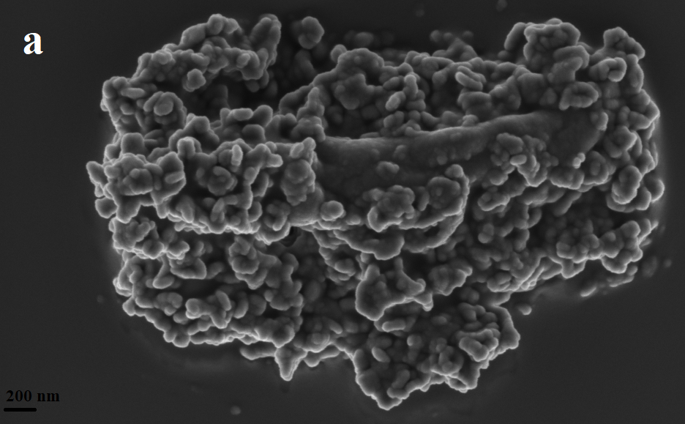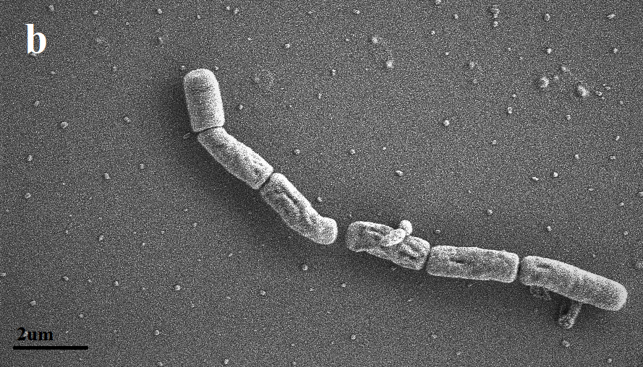

Figure 1: Scanning electron micrographs of SRB coated in Pd(0) nanoparticles (a) and uncoated SRB (b)

This was in accordance with observations by (Voegtlin et al., 2022) who reported the formation of Pd(0) nanoparticles attached to the cell walls of Desulfovibrio desulfuricans and Desulfovibrio ferrophilus IS5. The processes of Pd(II) bioreduction has been reported to take place at the bacterium’s outer membrane via a periplasmic hydrogenase, with the cell surface providing a template for the organisation of the growing Pd(0) crystals (Malunga and Chirwa, 2019). Hence the nanoparticles are observed on the bacterium’s cell wall. Further analysis of the precipitate by X-Ray Diffraction revealed elemental Pd(0) peaks as seen in Figure 2a. The first three peaks from the left were used to determine the crystallite size using Eq(1). The calculated size ranged from 16.9 nm ,11.1 nm and 9.6 nm respectively, which is much lower than 40 nm reported by (Voegtlin et al., 2022). However, according to (Yong et al., 2002) smaller crystals offer an advantage over bulky crystals because they present a larger surface area and may subsequently function as enhanced chemical catalyst. In a study conducted by (Redwood et al., 2008) Pd(0) deposits of approximately 20 nm were reported as having clusters of approximately 5 nm -10 nm Pd(0) nanoparticles. Upon catalytic activity evaluation, the biogenic Pd(0) was significantly catalytically more active than the chemical one in a hypophosphite test.

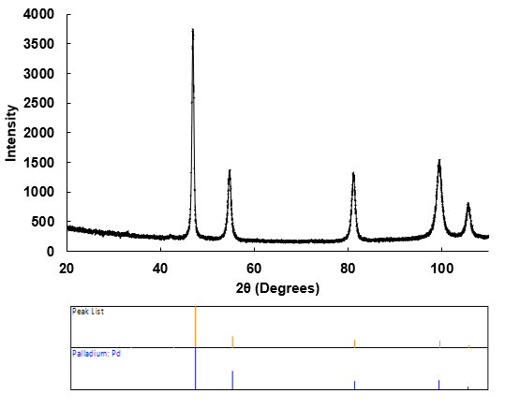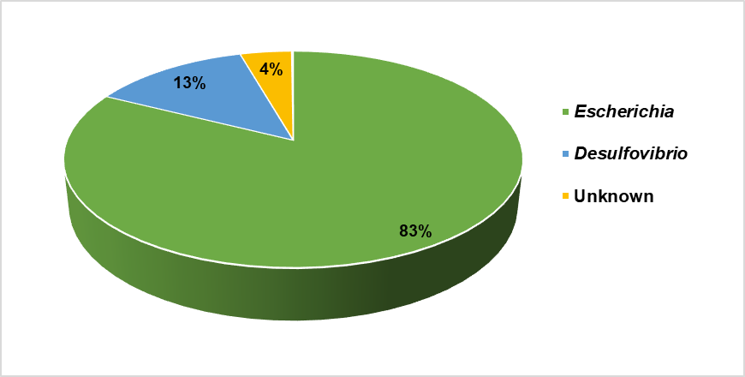
(a) (b)
Figure 2: XRD graph showing clearly defined peaks of the precipitate that correspond to Pd(0) peaks (a). Genus classification of anodic chamber relative microbial abundance percentage (b)
3.2 Microbial culture characterization
Metagenomics analysis was conducted using 16S rRNA sequencing to identify possible electrogenic strains. The results revealed 83% of the culture consisted of Escherichia, 13 % Desulfovibrio and 4% was unknown as illustrated in Figure 2b. This culture proved to be electrogenic because with an increase in bacterial absorbance reading there was a relative increase in voltage as illustrated in Figure 3a and b. The same phenomena was reported by (Miran et al., 2018), where the acclimation of SRB led to an increase in voltage which was stable at 0.58 V and in the study Desulfovibrio was the predominant genus, and Escherichia has also been reported in literature as an electrogene (Nguyen and Taguchi, 2019).
3.3 Microbial fuel cell performance analysis
Two types of cathodic material (carbon cloth and carbon cloth modified with biogenic Pd(0) nanoparticles)
were tested to determine which material displayed the best MFC performance. After 24 h of incubation assuming stable bacterial growth as seen in Figure 3a polarization curves were constructed by measuring the voltage across variable external resistance (1 kꭥ — 2.7 Mꭥ). According to the results, with an increase in bacterial growth as shown in Figure 3a there was a relative increase in voltage for both types of material as shown in Figure 3b. The MFC with the carbon cloth cathode reported high voltage readings of 377.3 mV compared to the MFC with the biogenic Pd(0) cathode, however the readings were unstable. The MFC with the biogenic Pd(0) cathode reported gradual stable readings with the highest being 215.5 mV as shown in Figure 3b. An inversely linear relationship was observed between voltage and current density in Figure 3d for the biogenic Pd(0) cathode which had a volume specific internal resistance of 52.93 ꭥm⁻³ as compared to the value of 249 ꭥm⁻³ for the carbon cloth cathode. A high power density of 0.044 mW m⁻³ was observed for the biogenic Pd(0) cathode as compared to a power density of 3.6 x 10⁻⁷ mW m⁻³ for the carbon cloth cathode illustrated in Figure 3d. From the data collected it is evident that the MFC with the biogenic Pd(0) cathode performed better. Platinum group metals have been reported to exhibit strong oxygen reduction reaction catalytic activity and have been widely used in cathodes as catalyst (Zhang et al., 2020). This observation has proven that biogenic Pd(0) nanoparticles have the potential of enhancing the performance of a MFC.
(a) (b)
(c) (d)
Figure 3: Anodic microbial growth over time (a), open circuit output voltage over time (b), polarization curves (c) and power density curves (d).
  - Conclusions
SRB have proven to be electrogenic, and biogenic Pd(0) nanoparticles have proven to have a positive impact on the performance of an air-cathode MFC. A high power density of 0.044 mW m⁻³ and low volume specific internal resistance of 52.93 ꭥm⁻³ was recorded for the carbon cloth modified with biogenic Pd(0) nanoparticles. The cathode had a steady output voltage increase as the concentration of SRB. However, further investigations need to be conducted for practical application. It is recommended, the MFC design and mode of operation can be modified for further optimisation.

Acknowledgments
The authors would like to thank the Water Utilisation and Environmental Engineering Division of the University
of Pretoria for the financial support during the study. This research was supported by the National Research Fund (Grant number: MND210623615156) awarded to Khanyisile Malunga-Makatu.
Reference
Chatterjee P., Dessì P., Kokko M., Lakaniemi A. M., Lens P., 2019, Selective enrichment of biocatalysts for bioelectrochemical systems: A critical review, Renewable and Sustainable Energy Reviews, 109, 10-23.
Chaudhuri S. K., Lovley D. R., 2003, Electricity generation by direct oxidation of glucose in mediatorless microbial fuel cells, Nature Biotechnology, 21, 1229-1232.
He L., Du P., Chen Y., Lu H., Cheng X., Chang B., Wang, Z. 2017, Advances in microbial fuel cells for wastewater treatment, Renewable and Sustainable Energy Reviews, 71, 388-403.
Kang C. S., Eaktasang N., Kwon D.Y., Kim H. S., 2014, Enhanced current production by Desulfovibrio desulfuricans biofilm in a mediator-less microbial fuel cell, Bioresource Technology, 165, 27-30.
LI J., 2013, An Experimental Study of Microbial Fuel Cells for Electricity Generating: Performance Characterization and Capacity Improvement. Journal of Sustainable Bioenergy Systems, 03, 171-178.
Liu H., Cheng S., Logan B. E., 2005, Production of Electricity from Acetate or Butyrate Using a Single-Chamber Microbial Fuel Cell, Environmental Science & Technology, 39, 658-662.
Malunga K. B., Chirwa, E., 2019, Recovery of Palladium (II) by biodeposition using a pure culture and a mixed culture, Chemical Engineering Transactions, 74, 1519-1524
Matsena M. T., Nkhalambayausi Chirwa E. M., 2022, Chapter 16 - Advances in microbial fuel cell technology for zero carbon emission energy generation from waste. In: Gurunathan B., Sahadevan R., Zakaria Z. A., (eds.) Biofuels and Bioenergy. Elsevier,
Matsena M. T., Tichapondwa S. M. & Chirwa E. M., 2020, Synthesis of Biogenic Palladium Nanoparticles Using Citrobacter sp. for Application as Anode Electrocatalyst in a Microbial Fuel Cell, Catalysts, 10, 838, https://doi.org/10.3390/catal10080838
Miran W., Jang J., Nawaz M., Shahzad A., Lee D. S., 2018, Sulfate-reducing mixed communities with the ability to generate bioelectricity and degrade textile diazo dye in microbial fuel cells, Journal of Hazardous Materials, 352, 70-79.
Molokwane P. E., Nkhalambayausi-Chirwa E. M. 2009, Microbial culture dynamics and chromium (VI) removal in packed-column microcosm reactors, Water Science Technology 60(2):381-8.
Nguyen D. T., Taguchi K., 2019, Enhancing the performance of E. coli-powered MFCs by using porous 3D anodes based on coconut activated carbon, Biochemical Engineering Journal, 151, 107357.
Ngwenya N. Chirwa E. M. N., 2015. Characterisation of surface uptake and biosorption of cationic nuclear fission products by sulphate-reducing bacteria, Water SA, 41, 314-324.
Rabaey K., Lissens G., Siciliano S. D., Verstraete W., 2003. A microbial fuel cell capable of converting glucose to electricity at high rate and efficiency, Biotechnology Letters, 25, 1531-1535.
Redwood M. D., Deplanche K., Baxter Plant V. S., Macaskie L. E., 2008, Biomass-supported palladium catalysts on Desulfovibrio desulfuricans and Rhodobacter sphaeroides, Biotechnology and Bioengineering, 99, 1045-1054.
Slate A. J., Whitehead K. A., Brownson D. A. C., Banks C. E., 2019, Microbial fuel cells: An overview of current technology, Renewable and Sustainable Energy Reviews, 101, 60-81.
Voegtlin S. P., Barnes R. J., Hubert C. R. J., Larter S. R., Bryant S. L., 2022, Formation of biologically influenced palladium microstructures by Desulfovibrio desulfuricans and Desulfovibrio ferrophilus IS5, New Biotechnology, 72, 128-138.
Yong P., Rowson N. A., Farr J. P., Harris I. R., Macaskie L. E., 2002., Bioreduction and biocrystallization of palladium by Desulfovibrio desulfuricans NCIMB 8307, Biotechnology Bioengineering, 80, 369-79.
Yuan H., Hou Y., Abu-Reesh I. M., Chen J., He Z., 2016, Oxygen reduction reaction catalysts used in microbial fuel cells for energy-efficient wastewater treatment: a review, Materials Horizons, 3, 382-401.
Zhang T., Li Z., Sun P., Wang L., Niu X., Wang S. 2020, α-MnO2 nanorods supported on three dimensional graphene as high activity and durability cathode electrocatalysts for magnesium-air fuel cells, Catalysis Today, 355, 304-310.

