CHEMICAL ENGINEERING TRANSACTIONS  VOL. , 2023 | A publication of
The Italian Association
of Chemical Engineering
Online at www.cetjournal.it

Guest Editors: Sauro Pierucci, Jiří Jaromír Klemeš
Copyright © 2023, AIDIC Servizi S.r.l.
ISBN 978-88-95608-98-3; ISSN 2283-9216

Molecular Distillation: the development of a unit operation into Aspen Plus® for centrifugal and falling film
Ana E. L. Budin ^{a,}*, Henderson I. Quintero^{b}, Cesar B. Batistellaª, Maria R. Wolf Macielª
ªLaboratory of Separation Process Development (LDPS), School of Chemical Engineering, University of Campinas, Brazil.
^{b}Research and Development Center, Ecopetrol, Bucaramanga, Colombia.
anaelisalista@gmail.com
Molecular distillation is an important separation unit. It operates under low pressure and low temperature, assuring no thermal degradation to the molecules. This is an essential alternative, especially for larger molecules. However, the commercial simulator Aspen Plus® does not contain the tool to simulate this process. In this context, this paper aims to compare different tools in the commercial simulator Aspen Plus® to emulate molecular distillation for falling film and centrifugal equipment. A Flash vessel and a rate-based column were used to represent the falling film and centrifugal molecular distillations, respectively. A Flash vessel was used to represent the centrifugal distillation due to its faster residence time. The rate-based column operates at non-equilibrium being suitable to emulate the falling film. The simulation results were compared to experimental data in the literature published by some of the authors of this paper. This study supports the idea of simulating the molecular distillation integrated with other units in the commercial simulator Aspen Plus®. This paper contributes, then, to a way to carry out simulations of this non-conventional process and to a cost-effective process design since the simulation is not fragmented allowing technical economic analyses.
  - Introduction
Molecular distillation is a special type of vaporization where the mechanism happens at the molecular level. In addition to the boiling temperature difference, the vaporization mechanism is driven by two factors: high vacuum pressure and the distillation gap. The “molecular” term stands for the fact that the gap between the evaporator and the condenser is in the order of the mean free path of evaporated molecules. A remarkable difference between molecular and conventional distillation is the non-equilibrium thermodynamics. The specific gap distance guarantees the non-returning of the molecules when they achieve the condenser and a maximum evaporation rate, consequently (Engy et. al, 2021).
Conventional distillations are ruled by the equilibrium thermodynamic and it can demand operation at high temperatures to achieve high yield and purification in many application cases. The higher the temperature the higher the chances of molecules degradation, especially for larger molecules. These kinds of molecules are normally found nowadays due to new process and product developments. Besides the high efficiency of vaporization, molecular distillation operates at a high vacuum which diminishes the boiling temperature and molecular degradation chances considerably. Due to its high efficiency, molecular distillation has large applicability in the market (Engy et. al, 2021).
Two configurations can be found for molecular distillation: falling film and centrifugal. The mechanism principle described previously is the same for both, but the geometry configuration is distinct for each one. Either falling film or centrifugal has an evaporator surrounded by a condenser or vice versa inside the device. The main point is how the fluid flows; the falling film and centrifugal molecular distillation are ruled by gravitational and centrifugal force, respectively. The falling film distillation is governed by gravitation force which drives the fluid to the evaporator surface in a thin laminar fluid layer. Centrifugal distillation usually has a conical surface where the feed stream is directed to the rotor channel which spreads the fluid evenly. Since in this case, the gravitation is negligible in comparison to the centrifugal force, the residence time is very short. Centrifugal distillation is very suitable to separate large molecules due to its short residence time diminishing the risks of molecule degradation. Both deliver high yield and purification results being suitable to many case-study in the industry.
However, research today needs experimental trials to foresee outcomes, and this is not always feasible. The commercial software Aspen Plus is a well-known tool to predict chemical processes and does not contemplate molecular distillation as an operation unit.
Batistella and Wolf Maciel (1996) developed a program called DISMOL simulator to represent molecular distillation. Martinello (2003) also developed a code but in MATLAB software. Although they found reliable results compared to experimental trials, the simulators are not integrated into other operation units. The practicality of using Aspen Plus® attracted many case studies to emulate molecular distillation through available tools (Deng et. al, 2022). However, all emulation presented in the literature used an efficiency factor and required some experimental parameters (evaporator temperature e.g.) to run it (Tehlah et al., 2017).
In this context, the goal of this paper is to emulate molecular distillation through available tools in commercial software but with no efficiency factors. The falling film and centrifugal distillation will be represented by the column rad-frac (rate-based mode) and the flash vessel, respectively. The paper also contributes to a cost-effective process design since the simulation is not fragmented allowing technical economic analyses.
  - Molecular Distillation emulation into Aspen Plus®
The validation of molecular distillation using Aspen Plus® tools was based on Batistella and Wolf Maciel (1996) paper. They compared separation results for a binary mixture of dibutyl phthalate and dibutyl sebacate (DBP-DBS) through centrifugal and falling film molecular distillations. The DBP-DBS binary mixture has a high boiling temperature, and components have very similar molecular structures (Table 1), which makes the mixture challenging to be separated without molecular degradation further favoring the process of separation by molecular distillation. Either DBP or DBS are available in the commercial software Aspen Plus® data bank.
Table 1: Mixture DBP-DBS properties.
Component | Molecular Structure | Molar Mass  (g /gmol) | Normal Boiling Temperature (°C)
DBP | 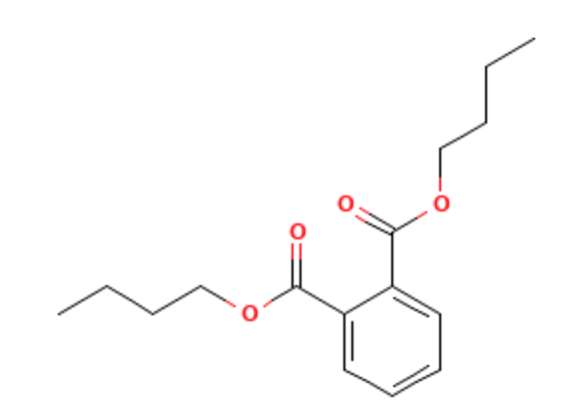 | 278.35 | 340.00
DBS | 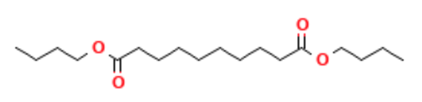 | 314.14 | 344.00

The definition of the thermodynamic model was based on the algorithm of Carlson (1996) and through the help icon provided by the software Aspen Plus®.Thermodynamic modeling is a key component to generating information closer to the real condition. The model options contemplating vapor and liquid phases found were suitable either for the mixture or operating conditions: Peng Robinson cubic equation of state with the Boston-Mathias alpha function (PR-BM); Lee-Kesler-Plocker equation of state (LK-Plock) and Redlich-Kwong-Soave cubic equation of state with Boston-Mathias alpha function (RKS-BM). The next step was to choose tools inside the software that could represent this kind of evaporation.
    - Falling Film Molecular distillation: Column Rate-Based
Falling film molecular distillation is ruled by non-equilibrium thermodynamic and low-pressure operation. The distillation column Radfrac operating in rate-based mode includes the condition of non-equilibrium (Figure 1). The number of column stages set was 2, where the feeding was at stage 1 and the reboiler is stage 2. The column did not contemplate the coupled condenser, being then opted for an external condenser to guarantee no reflux rate.
The operating condition was set based on Batistella and Wolf Maciel (1996) paper: mole fraction 0.5; feed temperature 369 K at 1 bar; mass flow rate 50 Kg/h; column pressure 0.001 mmHg and distillation mass ratio D/F = 0.212. The condenser temperature was set at 20 °C.
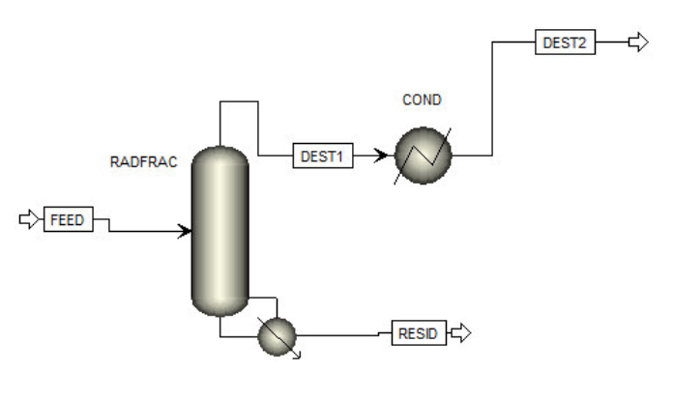
Figure 1: The falling film Molecular Distillation represented by the rate-based column in the commercial software Aspen Plus®.
DBP mole fraction in the distillate stream is very close to the Batistella and Wolf Maciel (1996) values (Table 2). However, the rate-based temperature is inferior to molecular distillation for all thermodynamic models. Molecular distillation operates at the maximum evaporation condition being ruled by the vacuum driver and assumes no molecules returning.
One would expect that the concept of non-equilibrium stages would lead to a column temperature very similar to molecular distillation, which did not happen and this can be explained by calculations and assumptions made in the rate-based model. Although this model assumes the thermodynamic equilibrium at the interface between the phases (and, so, 100% efficiency) and not in the whole stage as a conventional distillation column, the rate-based concept (or non-equilibrium stages) explains the temperature results in Table 2.
Table 2: DBP mole fraction in the distillate stream obtained by the Radfrac column (Rate-based).
Thermodynamic Model | T_{MD} (°C)  (Batistella and Wolf Maciel, 1996) | T_{Rate-Based} (°C) | y_{MD}  (Batistella and Wolf Maciel, 1996) | y_{Rate-Based} | y_{MD Deviation (%)}  (Reference Batistella and Wolf Maciel, 1996)
RKS-BM | 95.88 | 71.65 | 0.775 | 0.710 | -2.20
LK-Plock | 95.88 | 66.64 | 0.775 | 0.686 | -4.87
PR-BM | 95.88 | 63.57 | 0.775 | 0.665 | -7.34

The validation of the Aspen Plus® approach was measured by the y deviation which compared the mole fraction values taking into account the y_{MD} from Batistella and Wolf Maciel (1996) as a reference. The physical limitations to represent the molecular distillation using the rate-based column did not show significant deviation at the mole fraction being suitable to emulate and integrate molecular distillation using Aspen Plus®.
(Table 2). The thermodynamic model RKS-BM had a lower deviation and a superior temperature compared to other models using the column rate-based, being the most suitable method.
The purpose of this paper is to support the idea of simulating the molecular distillation integrated with other units and not designing a molecular distillation. For this last situation, a specific software contemplating the model equations for molecular distillation might be used as the one developed by Batistella and Wolf Maciel (1996). The rate-based column to represent falling film distillation was suitable for the DBS-DBP mixture and for other complex mixtures found in the literature using the same methodology (Duran et al., 2010). This last paper is from our research group working with fractionation of green coffee.
    - Centrifugal Molecular Distillation: Flash Vessel
Centrifugal molecular distillation is characterized by low residence time and pressure operation. The flash vessel has a fast residence time and the thermodynamic equilibrium would be minimized by the vacuum operation being proper to represent centrifugal molecular distillation (Figure 2). As in Radfrac column, an external condenser was attached here to simulate the condensation conditions and to obtain a liquid distilled stream.
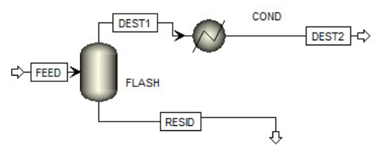
Figure 2: The centrifugal Molecular Distillation represented by the flash vessel in the commercial software Aspen Plus®.
The same operation conditions from Batistella and Wolf Maciel (1996) were adopted at the flash vessel. In this case, the D/F was not a specific parameter inserted as in the rate-based column and should be monitored. The distillation mass ratio (D/F) was dependent on the flash vessel temperature. The final T_{flash} was set when the D/F was in according to the experimental data but since there is no efficiency factor to calculate, this is an additional information not being mandatory to represent the molecular distillation.
The thermodynamic model RKS-BM had also a lower deviation and a superior temperature compared to other models (Table 3) during the flash vessel simulations. The thermodynamic equilibrium and its 100% efficiency contributed to an inferior temperature compared to the molecular distillation results.
The flash deviation was even lower than rate-based column (Tables 2 and 3). During the simulations, the rate-based column needed some geometry specifications (e.g., hole diameter and slide downcomer width) to be set and they could have interfered with the final results. Either the column rate-based or the flash vessel represented the molecular distillation with no efficiency factor regarding the operating temperature. This is an important approach specially when there are no experimental results available. However, the analyses of the variables D/F and distillation mass fraction are mandatory to achieve a feasible process, being used as reference here to validate the comparison between the experimental and emulation results.
Table 3: DBP Mole fraction in the distillate stream obtained by the Flash vessel.
Thermodynamic Model | T_{MD} (°C)  (Batistella and Wolf Maciel, 1996) | T_{Flash}(°C) | y_{MD}  (Batistella and Wolf Maciel, 1996) | y_{Flash} | y_{MD Deviation (%)}  (Reference Batistella and Wolf Maciel, 1996)
RKS-BM | 95.88 | 71.32 | 0.760 | 0.764 | 0.50
LK-Plock | 95.88 | 66.39 | 0.760 | 0.745 | -1.92
PR-BM | 95.88 | 63.35 | 0.760 | 0.728 | -4.22
  - Approach validation into other processes
Either the column rate-based or the flash vessel represented the molecular distillation with low deviation. Then, the same approach was applied to other mixtures and compared with the literature.
    - Glycerin and Propylene glycol
Propylene glycol and glycerin separation using falling film distillation was studied by Martinello et al. (2003) and used as a reference during the simulations in this paper. Lista et al. (2022) emulated molecular distillation through the flash vessel using an efficiency factor for this same binary mixture. The rate-based column was applied to represent the falling film molecular distillation since the methodology was validated in the previous section (Figure 1). Either glycerin or propylene glycol are available in the commercial software Aspen Plus® data bank.
Using this tool, low deviation values (lesser than 4.0%) compared to experimental results in the literature were obtained and LK-Plock was the most suitable thermodynamic model (Table 4). There is a significant difference between the temperature (Table 4) and such behavior was found at Lista et al. (2022) and Perez (2012) studies (from the same research group). Martinello et. al. (2003) developed a code at MATLAB software to represent the falling film molecular distillation and found a 0.72% y_{MD} deviation. Although it is a lower value compared to this work, the simplicity of using the column rate-based saves time and makes it possible to integrate into other available tools inside the software Aspen Plus®.
Table 4: Propylene glycol Mass fraction in the distillate stream obtained by the Radfrac column (Rate-based) at 1 ml/min, 50 °C and 10⁻⁵ bar.
Thermodynamic Model | T_{MD} (°C)  _{(Martinello et al., 2003)} | T_{Rate-Based} (°C) | y_{MD}  _{(Martinello et al., 2003)} | y_{Rate-Based} | y_{MD Deviation (%)}  (Reference Martinello et al., 2003)
RKS-BM | 60.00 | 24.75 | 0.9112 | 0.9214 | 1.12
LK-Plock | 60.00 | 31.90 | 0.9112 | 0.9041 | -0.78
PR-BM | 60.00 | 17.92 | 0.9112 | 0.9414 | 3.32

    - Biolubricant
The authors of this paper studied the biolubricant separation using the falling film molecular distillation. Perez (2012) run some laboratory trials and Lista et. al (2022) emulated molecular distillation through the flash vessel using an efficiency factor. The same operating conditions from Perez (2012) but using the column rate-based were adopted. The simulation contemplated three components: Isoamyl ricinoleate (0.8516), Monoricinoleine (0.1411), and Glycerol (0.0073) at a respective mass fraction (Table 5). The isoamyl ricinoleate and monoricinolein molecules are not available in the Aspen Plus® data bank. Therefore, it was necessary to create them in the data bank. These were carried out by inserting to the simulator data bank their molecular structure and normal boiling temperature. The feed temperature was 160 °C at 1 bar; volume rate 0,01 l/min; column pressure 0.001 mmHg and distillation rate D/F = 0.7371. The condenser temperature was set at 20 °C.
Table 5: Mixture Biolubricant proprieties.
Component | Molecular Structure | Molar Mass  (g/gmol) | Normal Boiling Temperature (°C)
Isoamyl ricinoleate |  | 368.59 | 460.00
Monoricinoleine |  | 372.54 | 520.50
Glycerin | 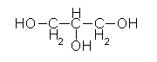 | 92.09 | 290.00

The biolubricant separation using this tool had low deviation values compared to the experimental mass fraction obtained by Perez (2012). The rate-based column temperature was inferior to the molecular distillation like other mixtures studied in this paper. BK-10 was the most suitable thermodynamic model and its temperature was closer to the real one (Table 6).
The practicality of using the rate-based column to represent the falling film molecular distillation was suitable for all three mixtures analysed in this paper: DBP-DBS, Propylene glycol-Glycerine, and Biolubricant. The straight simulation with no effective factor is more advantageous since there is no need for a previous molecular distillation temperature to simulate.

Table 6: Isoamyl ricinoleate mass fraction in the distillate stream obtained by the Radfrac column (Rate-based).
Thermodynamic Model | T_{MD} (°C)  _{(Perez, 2012)} | T_{Rate-Based} (°C) | y_{MD}  _{(Perez, 2012)} | y_{Rate-Based} | y_{MD Deviation (%)}  _{(Reference Perez, 2012)}
RKS-BM | 160.00 | 115.13 | 0.9774 | 0.9587 | -1.92
LK-Plock | 160.00 | 109.86 | 0.9774 | 0.9578 | -2.01
PR-BM | 160.00 | 107.95 | 0.9774 | 0.9584 | -1.94
BK-10 | 160.00 | 137.87 | 0.9774 | 0.9695 | -0.81
  - Conclusions
Some available tools in the software Aspen Plus to represent falling film and centrifugal molecular distillation were analyzed, considering some adaptations in the existing blocks of the software to better represent the molecular distillation: the rate-based column and the flash vessel, respectively. Either flash vessel or rate-based column operated with inferior temperatures compared to real experimental data. Although there are some physical limitations (e.g. geometry specifications; evaporator temperature) to represent molecular distillation through these tools, the mass fraction deviation in the distillate stream values was inferior to 5.0%. The choice of a proper thermodynamic model showed its relevance to minimize the deviation values. The most suitable model depended upon the mixture binary. The most contribution is to represent the molecular distillation by available tools in the Aspen Plus® and be integrated into a whole process. A general process overview possibilities a cost-benefit analysis before detailed design for each device.
Nomenclature
T_{MD} – Evaporator temperature using molecular distillation, °C
T_{FLASH} – Flash temperature, °C
T_{RATE-BASED} – Rad-frac column at mode rate-based temperature, °C
y _{MD} – Mass fraction using molecular distillation
y _{FLASH} – Mass fraction using flash in the commercial simulator Aspen Plus®
y _{RATE-BASED} – Mass fraction using the column rate-based in the commercial simulator Aspen Plus®
Acknowledgments
The authors would like to grant #2015/20630-4 São Paulo Research Foundation (FAPESP) and to grant # 313952/2020-5 CNPq.
References
Batistella, C. B., Maciel, M.R.W., 1996, Modeling, Simulation and Analysis of Molecular Distillators: Centrifugal and Falling Film, Comput. Chem. Eng, 20, S19–S24.
Durán, M.A.; Maciel, Filho, R.; Maciel, M. R. W., 2010 – Rate-Based Modeling Approach and Simulation for Molecular Distillation of Green Coffee Oil. 20th European Symposium on Computer Aided Process Engineering – ESCAPE20.
Deng W., Deng Y., Zhao W., Zhang R., Jiang, Y., 2022, Experimental and computer simulation of a molecular distillation process for the dehydration of tetramethylammonium hydroxide solution, Sep. Purif. Technol, 288, 120701.
Engy A., Mahrous M.A., Farag., 2021, Trends and Applications of Molecular Distillation in Pharmaceutical and Food Industries, Separation & Purification Reviews. DOI: 0.1080/15422119.2021.1924205.
Lista A.E., Quintero H.I., Batistella C.B., Wolf Maciel M.R., 2022, Biolubricant Production: from the Acknowledgment of Experimental Plant Using Molecular Distillation as Downstream Process, the Development of a Unit Operation Into Aspen Plus®, Chemical Engineering Transactions, 92, 541-546 DOI:10.3303/CET2292091.
Martinello, M. A., Bonino, F., Gatica, E. A., Pramparo, M. C., 2003, Modeling and Analysis of falling film molecular distillation (in Spanish), Mecánica Computacional Vol. XXII.
Perez H.I.Q., 2012, Development and evaluation of methodologies for purification of biolubricants using distillation molecular (in Portuguese), PhD Thesis, Laboratory of Separation Process Development, School of Chemical Engineering, State University of Campinas, São Paulo, Brazil.
Tehlah N., Kaewpradit, P., Mujtaba I.M., 2017, Development of Molecular Distillation Based Simulation and Optimization of Refined Palm Oil Process Based on Response Surface Methodology, Processes, 5, 40.

