|  |  |
| --- | --- |
| cetlogo ***CHEMICAL ENGINEERING TRANSACTIONS***  ***VOL. , 2023*** | A publication of  aidiclogo_grande |
| The Italian Association  of Chemical Engineering  Online at www.cetjournal.it |
| Guest Editor: Sauro Pierucci  Copyright © 2023, AIDIC Servizi S.r.l. **ISBN** 978-88-95608-98-3; **ISSN** 2283-9216 | |

Robust Methodology to Determine Properties of Fuels and Their Blends

Mateus B. Gonçalves\*,a, Nahieh T. Mirandab, Leonardo V. Fregolentea, Maria Regina W. Maciela

aLaboratory of Petroleum Valuation (VALPET), School of Chemical Engineering, University of Campinas, R. Josiah Willard

Gibbs, Campinas, 13083-839, Brazil.

bFederal University of Maranhão (UFMA), Exact Sciences and Technology Center (CCET), Department of Chemical Technology, Av. Dos Portugueses, São Luís/MA, 65080-805, Brazil.

\*m228074@dac.unicamp.br

Considering the increase on demand of fossil fuels and the environmental restrictions, around the world, researchers have studied topics from the quality of crudes, process upgrade, up to possible applications of heavy fractions produced in the distillation unit to maximize the refining margin. One challenge currently found in oil refineries is the unavoidable mixture (or blends) of several different crudes or intermediates in the stockpiling, transfer and processing, what may decrease the accuracy of the properties estimation, impacting negatively the control of the refining process. Additionally, the price of oils or petroleum fractions is directly related to their properties such as specific gravity and the percentage of each organic compound in their composition. Therefore, this paper offers a reliable methodology to determine the properties of fuels and their blends, when compared with other options. Using distillation equipment with and without reduced pressure, based on the standards ASTM D2892 and ASTM D5236, respectively, as well as simulated distillations at high temperatures (SimDis-HT), it was possible to obtain true boiling point curves (TBP), density (ρ), and the kinematic viscosity (μ) of diesel, kerosene, and their blends. Finally, this work parallels the results obtained from each method with the National Agency of Oil (ANP) standards from Brazil to ensure the viability in each study.

* 1. Introduction

Several experimental methods are carried out for petroleum fractions characterization. According to the obtained properties, such as distillation temperature, density, and kinematic viscosity, the oily stream is designated for specific process and usage. Also, these basic properties are used to estimate more complex properties, such as cetane index, that have other implications on the refine process (Meireles et al., 2017).

One example of basic property is the TBP curve, which is used to determine the crude production yield or the petroleum fractions volatility. To obtain the TBP curves, the American Society for Testing and Materials (ASTM) provides several standardized methodologies to guarantee the accuracy of the data presented (Santos, 2005).

For the first section of the curve, up to 380 °C, the ASTM D2892 describes the preparation of the samples as well as the process of distillation without the reduction of pressure, only elevating the temperature to obtain the cuts and data necessary to build up the curves. Then, ASTM D5236 standardizes the second half of the TBP curves, from 380 °C to 580 °C. Instead of using only the temperature elevation to fractionate the oil, it describes a method under reduced pressure to avoid high temperatures and consequent thermal decomposition. In this case, the pressure ranges from 50 to 0.1 mbar (Gonçalves, 2020).

As an alternative, the ASTM D7169 makes available a standardized method to obtain TBP curves through high temperature simulated distillation, in which 0.01 g of sample is added to a gas chromatograph and the temperature is raised until practically all the sample oil fractions are vaporized (Miranda et al., 2021).

Regarding the determination of the properties in blends, there are two options: modeling and experimental analysis. However, to develop an accurate model to minimize costs and time, it is necessary to perform experimental analyses in advance and adjust each model to its conditions (Riazi, 2005).

Therefore, in this work, both methods of obtaining TBP curves were compared to determine which one would be more suitable for specific fuels, relating the results with the National Agency of Petroleum, Natural Gas, and Biofuels (ANP – Brazil). Moreover, after analysing the curves, a database of properties experimental data was created and used to analyze the behavior of ternary blends of kerosene and diesel cuts obtained through distillation.

* 1. Methodology

Measurements of the density and kinematic viscosity of the commercial fuels (diesel S10 and kerosene), and the determination of their TBP curves were carried out, as they are essential to verify the effectiveness of the distillation techniques.

Properties information of commercial kerosene and diesel S10 were obtained by the SVM 3000 Stabinger Viscometer, which follows the ASTM D7042 to present values of density and kinematic viscosity for each sample. The density analysis was conducted at 15 °C and viscosity at 40 °C, since they are the standard definitions of those properties in the refineries.

The commercial fuels TBP curves were obtained using two different techniques. The first technique used simulated distillation at high temperatures (SimDis-HT), following the standard ASTM D7169. The second technique was experimental methods in distillation pilot plants from MINIDIST that follow the ASTM D2892 and D5236 to obtain real sample volume of all cuts and use the Stabinger Viscometer to determine the properties. These results were compared to the ANP standards from Brazil to determine the precision of each method.

After completing the distillation on the MINIDIST pilot plants, three cuts (light, middle-weight, and heavy) were selected for each initial fuel to be mixed and created their blends to obtain properties data survey for ternary plots and a correlation between % use of each cut in TIBCO Statistica® software.

All analyses were performed in triplicate and had their standard deviation and standard deviation percentage (SD and %SD) calculated and compared.

* 1. Results and Discussion

The properties obtained for the commercial fuels (Table 1) were used to confirm their standardized integrity and guarantee a safe use when charged to the MINIDIST distillation plants, where SD and %SD are standard deviation and standard deviation percentage, respectively.

Table 1: Commercial Fuel Properties

|  |  |  |  |  |  |  |
| --- | --- | --- | --- | --- | --- | --- |
| Fuel | Density [g/cm³] | SD | %SD | Kinematic Viscosity [mm²/s] | SD | %SD |
| Diesel | 0.84723 | 0.00003 | 0.00361 | 2.9017 | 0.0044 | 0.1527 |
| Kerosene | 0.79286 | 0.00012 | 0.01505 | 1.5694 | 0.0097 | 0.6163 |

For the diesel fuel, both density and kinematic viscosity obtained comply with the range of 0.815 to 0.850 g/cm³ and 2.0 to 4.5 mm²/s, respectively, when compared to the Brazilian standardization from ANP. The kerosene fuel also complied with the Brazilian standardization of 0.8 g/cm³ for density and a maximum value of 2.25 mm²/s for kinematic viscosity.

After confirming the standards of both feedstocks, experiments with SimDis-HT and distillation plants were carried out to obtain TBP curves for each fuel. A comparison between the ANP, manufacture standards and the results from SimDis-HT and MINIDIST analysis is presented in Table 2.

Table 2: Comparison between SimDis-HT analysis, MINIDIST analysis, ANP, and manufacturer standards for kerosene

|  |  |  |  |  |
| --- | --- | --- | --- | --- |
| Volume [%] | ANP | Manufacturer | SimDis-HT [°C] | MINIDIST [°C] |
| I.B.P. | – | max. 175 °C | 164.3 | 167.3 |
| 10 | max. 205 °C | – | 184.9 | 191.3 |
| 50 | – | – | 213.7 | 212.1 |
| 90 | – | – | 249.9 | 241.5 |
| 100 | max. 300 °C | ≈ 325 °C | 304.1 | – |

The methodologies implemented for kerosene showed satisfactory results when compared with ANP and manufacturer data (Table 2) for the initial boiling point (I.B.P.) and the 10 % volume point. However, for the 100 % point, the SimDis-HT analysis showed a value higher than the standardized one, while the MINIDIST curve had an ending point lower than 300 °C. Figure 1 shows the comparison between SimDis-HT and experimental curves for kerosene.



Figure 1: Comparison between the SimDis-HT and the experimental TBP curves for kerosene

The comparison between both analyses (Figure 1) showed a small discrepancy in the initial points, which could be attributed to the fact that SimDis-HT uses a tiny sample size. The differences in the ending values of the curve could indicate an influence of the temperature increase in the SimDis-HT method, which could compromise the results precision.

Table 3 presents the same comparison made for kerosene, but now for diesel S10, and Figure 2 also shows the comparison between SimDis-HT and experimental curves for diesel S10.

Table 3: Comparison between SimDis-HT analysis, MINIDIST analysis, ANP, and manufacturer standards for diesel S10

|  |  |  |  |
| --- | --- | --- | --- |
| Volume [%] | ANP | SimDis-HT [°C] | MINIDIST [°C] |
| I.B.P. | – | 118.5 | 114.6 |
| 10 | min. 180 | 197.0 | 188.1 |
| 50 | 245 to 295 | 281.2 | 272.8 |
| 95 | max. 370 | ≈ 402.0 | 363.8 |



Figure 2: Comparison between the SimDis and the experimental TBP curves for diesel S10.

For diesel fuel, the results of the comparison with ANP (Table 3) were satisfactory for both methods in the first three compared points. However, in the same way as kerosene fuel, the highest temperature point showed discrepancy for the SimDis-HT analysis, which presented a value almost 10 % higher than expected. This result reinforces the fact that higher temperatures applied by the SimDis-HT method can influence the results when dealing with organic samples such as these fuels, which are thermosensitive. This increase of space between the points at higher temperatures were also noticed by Meireles in 2017 when the authors compared experimental curves with a prediction software.

The same pattern was observed when comparing SimDis-HT and the MINIDIST TBP curves for diesel (Figure 2). All resulting points overlap from 115 °C to about 350 °C and begin to deviate from each other at higher temperatures. Once the TBP curves were obtained, each cut from the experimental distillation had their density and kinematic viscosity analyzed, as presented on Tables 4 and 5 for kerosene and diesel cuts, respectively. Where K1 to K8 represent the kerosene cuts, D1 to D9 represent the diesel cuts, and residue represents the leftover fuel cut left in the boiler after distillation.

Table 4: Distillation Properties of Kerosene Cuts

|  |  |  |  |  |  |
| --- | --- | --- | --- | --- | --- |
| Cut | Temperature [°C] | Density [g/cm³] | %SD | Kinematic Viscosity [mm²/s] | %SD |
| K1 | 186.9 | 0.7753 | 0.0341 | 1.2126 | 0.0218 |
| K2 | 195.7 | 0.7800 | 0.0074 | 1.2819 | 0.0078 |
| K3 | 203.9 | 0.7847 | 0.0000 | 1.3752 | 0.1477 |
| K4 | 212.1 | 0.7928 | 0.0146 | 1.4750 | 0.1453 |
| K5 | 222.4 | 0.7974 | 0.0000 | 1.6260 | 0.0249 |
| K6 | 233.4 | 0.7999 | 0.0072 | 1.8163 | 0.2877 |
| K7 | 236.6 | 0.7973 | 0.0000 | 1.9163 | 0.1343 |
| K8 | 241.5 | 0.7985 | 0.0000 | 1.9927 | 0.1169 |
| Residue | – | 0.8001 | 0.0072 | 2.2606 | 0.3294 |

Table 5: Distillation Properties of Diesel Cuts

|  |  |  |  |  |  |
| --- | --- | --- | --- | --- | --- |
| Cut | Temperature [°C] | Density [g/cm³] | %SD | Kinematic Viscosity [mm²/s] | %SD |
| D1 | 157.3 | 0.7642 | 0.0076 | 0.8207 | 0.0215 |
| D2 | 188.1 | 0.7974 | 0.0072 | 1.0507 | 0.0966 |
| D3 | 232.8 | 0.8305 | 0.0070 | 1.5515 | 0.1476 |
| D4 | 260.1 | 0.8436 | 0.0181 | 2.1468 | 1.3946 |
| D5 | 285.5 | 0.8512 | 0.0000 | 3.0528 | 0.8189 |
| D6 | 312.8 | 0.8558 | 0.0067 | 4.4782 | 0.4246 |
| D7 | 347.2 | 0.8610 | 0.0067 | 5.6611 | 0.0946 |
| D8 | 353.8 | 0.8747 | 0.0000 | 5.0628 | 0.0830 |
| D9 | 363.8 | 0.8760 | 0.0114 | 5.4453 | 0.0626 |
| Residue | – | 0.8765 | 0.0688 | 19.4063 | 0.2500 |

The values of %SD from the triplicates, demonstrated on Tables 4 and 5, show a great precision in the analysis.

To evaluate the blends properties, mixtures were created in different percentages of each cut and analysed with the Stabinger Viscometer (Tables 6 and 7), allowing information database to examine the behaviour of these properties when blended. For kerosene, cuts K2, K5, and K8 were mixed; and, for diesel, D3, D5, and D7. The respective blends are KB for kerosene and DB for diesel.

Table 6: Blends of Kerosene Cuts

|  |  |  |  |  |  |
| --- | --- | --- | --- | --- | --- |
| Blend | Volumetric Percentage of K2 | Volumetric Percentage of K5 | Volumetric Percentage of K8 | Density [g/cm³] | Kinematic Viscosity [mm²/s] |
| K2 | 100.0 | 0.0 | 0.0 | 0.7800 | 1.2819 |
| K5 | 0.0 | 100.0 | 0.0 | 0.7974 | 1.6260 |
| K8 | 0.0 | 0.0 | 100.0 | 0.7985 | 1.9927 |
| KB1 | 50.0 | 50.0 | 0.0 | 0.7887 | 1.4515 |
| KB2 | 50.0 | 0.0 | 50.0 | 0.7914 | 1.6598 |
| KB3 | 0.0 | 50.0 | 50.0 | 0.8001 | 1.9375 |
| KB4 | 66.7 | 16.7 | 16.7 | 0.7866 | 1.4567 |
| KB5 | 16.7 | 66.7 | 16.7 | 0.7936 | 1.6376 |
| KB6 | 16.7 | 16.7 | 66.7 | 0.7982 | 1.9147 |
| KB7 | 33.3 | 33.3 | 33.3 | 0.7935 | 1.6631 |

Table 7: Blends of Diesel Cuts

|  |  |  |  |  |  |
| --- | --- | --- | --- | --- | --- |
| Blend | Volumetric Percentage of D3 | Volumetric Percentage of D5 | Volumetric Percentage of D7 | Density [g/cm³] | Kinematic Viscosity [mm²/s] |
| D3 | 100.0 | 0.0 | 0.0 | 0.8305 | 1.5515 |
| D5 | 0.0 | 100.0 | 0.0 | 0.8512 | 3.0528 |
| D7 | 0.0 | 0.0 | 100.0 | 0.8610 | 5.6611 |
| DB1 | 50.0 | 50.0 | 0.0 | 0.8413 | 2.1054 |
| DB2 | 50.0 | 0.0 | 50.0 | 0.8469 | 2.7327 |
| DB3 | 0.0 | 50.0 | 50.0 | 0.8573 | 4.1506 |
| DB4 | 66.7 | 16.7 | 16.7 | 0.8401 | 2.0923 |
| DB5 | 16.7 | 66.7 | 16.7 | 0.8502 | 2.9273 |
| DB6 | 16.7 | 16.7 | 66.7 | 0.8559 | 4.0005 |
| DB7 | 33.3 | 33.3 | 33.3 | 0.8486 | 2.8450 |

Then, the fuels blends data were uploaded into the TIBCO Statistica® software, which was used to create ternary plots of the influence of each cut on the density of their blends (Figures 3a and 3c) in g/cm³, viscosity (Figures 3b and 3d) in mm²/s, and to write equations that represent these influences.

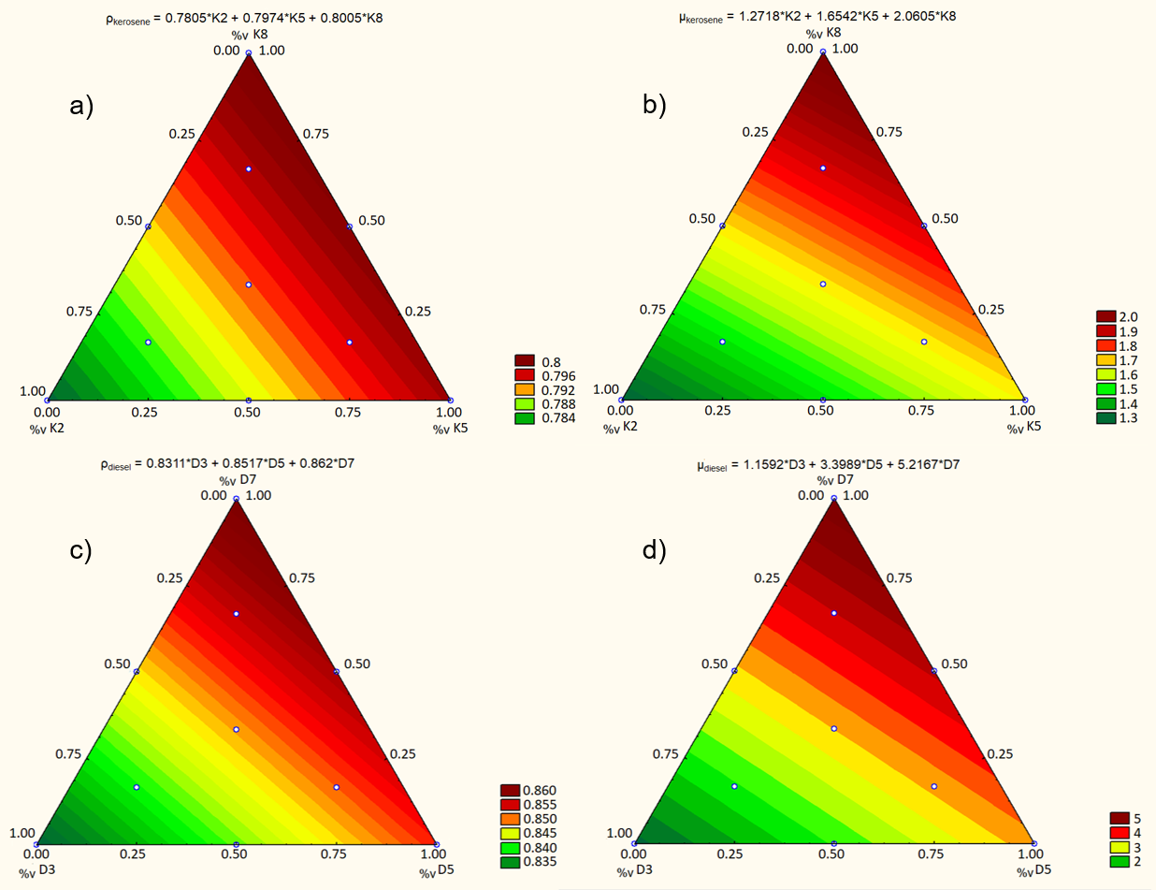

Figure 3: a) Density of kerosene blends; b) Kinematic viscosity of kerosene blends; c) Density of diesel blends; d) Kinematic viscosity of diesel blends

These ternary graphs show that heavier oil cuts have a greater influence on the resulting properties when mixed with lighter ones, especially for the density, represented by the slope of the colour pattern when compared to the viscosity graphs.

The results obtained by mixing the cuts were compared to the results predicted by the properties’ equations (Figure 4) to observe the precision of these models for these specific conditions and concentrations.

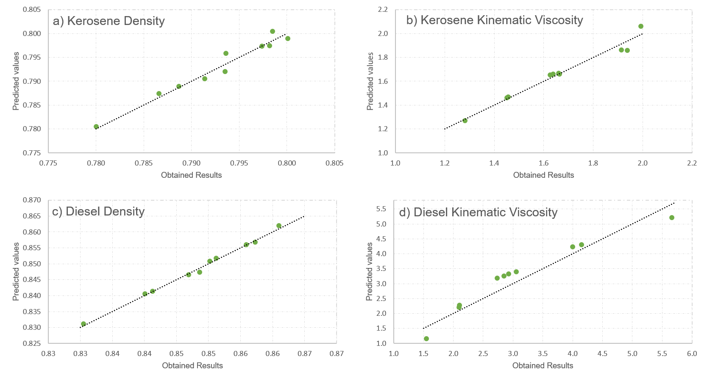

Figure 4: Comparison between predicted results and obtained results for a) Density of kerosene blends; b) Kinematic viscosity of kerosene blends; c) Density of diesel blends; d) Kinematic viscosity of diesel blends

The proximity between the points and the identity line in Figures 4a, 4b, and 4c indicate that the equations accurately describe the properties for each specific concentration range of the cuts used. However, for Figure 4d, the points distribution suggest that a non-linear model might be more suitable to describe kinematic viscosity mixture.

* 1. Conclusion

All properties analysed showed a low value of SD and %SD for either kerosene or diesel analyses. The values are indicative of a high accuracy and precision, as well as satisfactory representation of the quality of the fuels. When comparing both methods to obtain TBP curves, the results indicate that there is a significant influence of the temperature applied in the simulated distillation, suggesting that it is more precise to use pressure reduction instead of temperature gradients for organic solutions such as fuels. However, it is only noticeable above 300 °C. Finally, it was possible to obtain a satisfactory database of blending properties at different concentrations that can be used to test different correlation equations for oil blends.

Acknowledgments

This work was supported by CNPq [Grant Number: 141169/2021-4] and [Grant Number: 313952/2020-5].

References

Gonçalves, M.B., 2020, Commissioning and evaluation of methodologies for determining TBP curves for blended fuels, Dissertation in Chemical Engineering, School of Chemical Engineering, University of Campinas (In Portuguese).

Meireles, L.B., Chrisman, E.C.A.N., Andrade, F.B., Oliveira, L.C.M., 2017, Comparison of the Distillation Curve Obtained Experimentally with the Curve Extrapolated by a Commercial Simulator, International Journal of Chemical, Molecular, Nuclear, Materials and Metallurgical Engineering, 11, 3.

Miranda N.T., Batistella C.B., Bahu J.O., Khouri N.G., Maciel Filho, R., Maciel M.R.W., 2021, Simdis-HT Analysis of Crude Oils as a Tool to Define Operating Conditions for Primary Treatment Processes, Chemical Engineering Transactions, 86, 1105–1110.

Riazi, M.R., 2005, Characterization and Properties of Petroleum Fractions. 1a. ed. West Conshohocken: ASTM International.

Santos, P.S.D., 2005, Extension of the true boiling point curve for national heavy oils through the molecular distilation process, Thesis in Chemical Engineering, School of Chemical Engineering, University of Campinas (In Portuguese).