CHEMICAL ENGINEERING TRANSACTIONS  VOL. , 2023 | A publication of
The Italian Association
of Chemical Engineering
Online at www.cetjournal.it

Guest Editor: Sauro Pierucci
Copyright © 2023, AIDIC Servizi S.r.l.
ISBN 978-88-95608-98-3; ISSN 2283-9216

Process design of the biogas upgrading to biomethane using green hydrogen
Nicola Pierroª, Aristide Giulianoª*, Alessandro Giocoliª, Diego Barletta^{b}, Isabella De Bariª
ªENEA, Italian National Agency for New Technologies, Energy and Sustainable Economic Development, S.S. 106 Ionica, km 419+500, Rotondella, MT, Italy
^{b}2Dipartimento di Ingegneria Industriale, Universitá degli Studi di Salerno, Via Giovanni Paolo II 132, Fisciano (SA), Italy
aristide.giuliano@enea.it
In recent years there was an increase in the use of renewable energy resources but there are still technological limits regarding the not constant power productivity. To face this problem, a possibility is to convert the surplus of renewable electricity into chemical energy producing hydrogen through electrolysis. The main drawback of this solution is that hydrogen is still hardly usable and so a good choice could be to convert this fuel into a more common one, such as methane. This work aims to carry out a techno-economic analysis of an upgrade section for a biogas plant to convert CO₂ into biomethane. The used methodology consists in sizing the methanation reactor considering kinetic and catalyst effectiveness, membrane separation and simulating the whole process changing operating conditions such as temperature and pressure. The results of this study show that methanation can be extremely efficient in terms of energy consumption and carbon conversion. The methane production cost without accounting for hydrogen cost is between 0.15-0.19 €/kg, the same cost range as commercial natural gas. This value mainly depends on the capital and operating cost of the compression system. However, by including the high cost of hydrogen obtained by electrolysis, equal to 5 €/kg, this process is not economically feasible. On the other hand, by exploiting the surplus of renewable energy production, the cost of green hydrogen is expected to radically decrease shortly.
  - Introduction
In the last years, the effect of climate change became evident, just think about the rising temperatures in European countries in which the mean annual value in the last decade increased by 1.7-1.9°C. An opportunity can derive from the replacement of fossil fuels with bio-fuels or synthetic fuels obtained by renewable carbon (e.g. biogenic CO₂, biomass,..) conversions (Battaglia et al., 2021). In particular, many studies have been started on the application of green hydrogen as a direct energy carrier or combined with carbon dioxide to produce synthetic fuels or chemicals (Giuliano et al., 2021).
    - State of art of the process design of methanation processes to bio-methane
To understand the economic and environmental feasibility of this last option it is necessary to pay attention to the technology and process now available. Witte et al. (2018a, 2018b) have analyzed several options for the production of methane starting from a biogas flow of 200 SCM/h and composition of 55% CH₄ and 45% of CO₂, which correspond to a gas stream with 72 kg/h of methane. An interesting aspect is the composition of the final synthetic gas product, which have to observe similar Italian constraints. About the reaction section, both fixed bed reactor and fluidized bed reactor have been considered. Despite the optimization for each design, the high investment and operating cost for electrolysis make the difference between the different schemes. It results in a cost per kg of methane equal to 1.62 € considering a specific cost of hydrogen of 3€/kg. Peters et al. (2019) showed the impact of carbon dioxide and hydrogen sources on the cost of methane produced and, in the case of catalytic methanation of CO₂ from biogas, the results make clear that hydrogen is the most significant cost, reaching around 80% of the overall cost of production, and that the process, after optimization, achieves a minimum specific cost of 3.5 €/kg_{CH4}. An alternative to catalytic methanation is bio methanation, a process in which CO₂ is combined with hydrogen using specific bacteria. In the work of Menin et al. (2022), in which the yield in the bioreactor is total, it appears that for this kind of process, the cost of methane is 2.5 €/kg_{CH4}. The aim of this work consists of technical and economic analysis of a biogas upgrade section using green hydrogen. An upgrade section for a biogas plant that produces 216 kg/h of methane, which corresponds with 3 MW of heat, will be designed. The bio-methane obtained must observe the Italian constraints for the placing in the national network. The economic analysis will be based on the investment and operating cost of the main unit operations, taking into account heat integration. The influence of operating conditions on the process will be considered to find the minimum production cost of biomethane.
  - Process design
In this work, the process simulation methodology, using the Aspen Plus software, was applied to model the whole process section, to derive mass and energy balances and to the size of main process units (Giuliano et al., 2015). The detailed design and optimization of the multitubular packed bed reactor with heat exchange were addressed by considering a relevant kinetic model. Membrane sizing was carried out by separately solving the design equations. An extensive sensitivity analysis of the main reactor and membrane operating conditions was performed to estimate the methane cost of production.
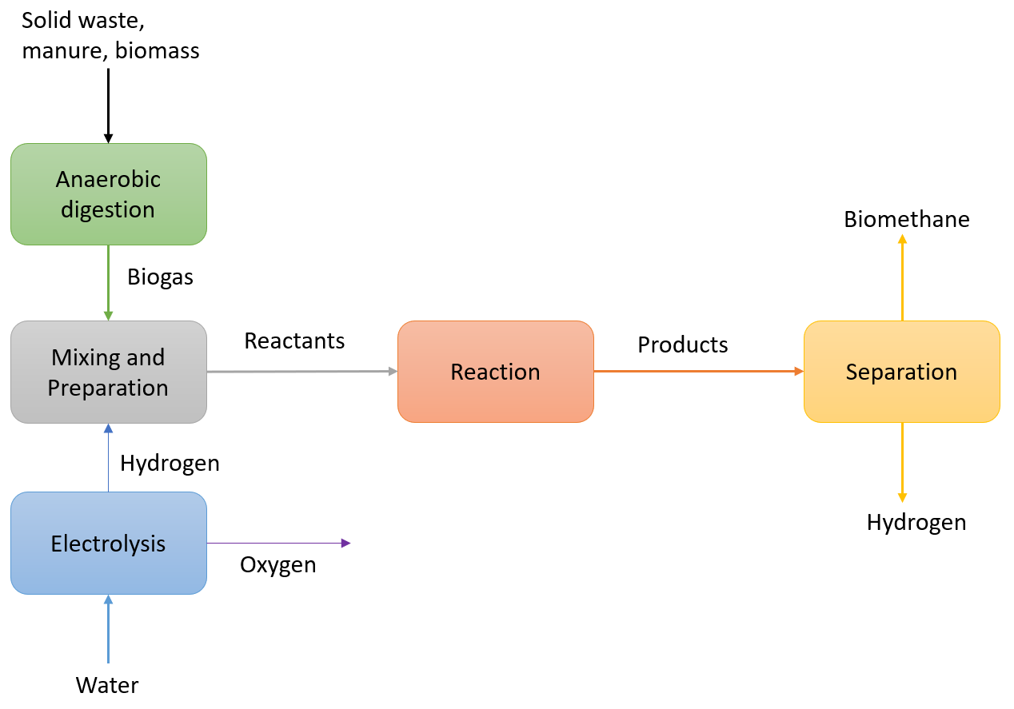
Figure 1: Block diagram of the whole biogas upgrading plant
The plant is presented in Figure 1, after the biogas production (Scamardella et al., 2019), from water electrolysis is obtained the green hydrogen for the upgrading section. The inlet volumetric flow rate of biogas is equal to 590 SCM/h while the molar flow of hydrogen from the electrolyzer makes sure that at the reactor inlet, the molar ratio between hydrogen and carbon dioxide is equal to four. In this case study, the biogas consists of 60% of CH₄ and 40% of CO₂ (the desulfurization was considered included in the anaerobic digestion block). Thanks to the biogas upgrading by methanation, carbon dioxide overall conversion can reach a value of around 100%.
Table 1: Description of the main block in the flowsheet of Figure 2.
Block ID | Block Type | Description
COMP1 | Compr | Compression of biogas stream
PUMP | Pump | Increment in the water pressure
ECA/ECB/ECC/ECD/ECE | Rplug | Fixed bed reactor with the kinetic model
H2OSEP | Flash | Removal of water from the outlet reactor stream
COMP2 | Compressor | Compression before membrane separator
H2MEM | Sep | Separation of unreacted H₂
VACUUMP | Compressor | Vacuum pump to increase the driving force in the membrane

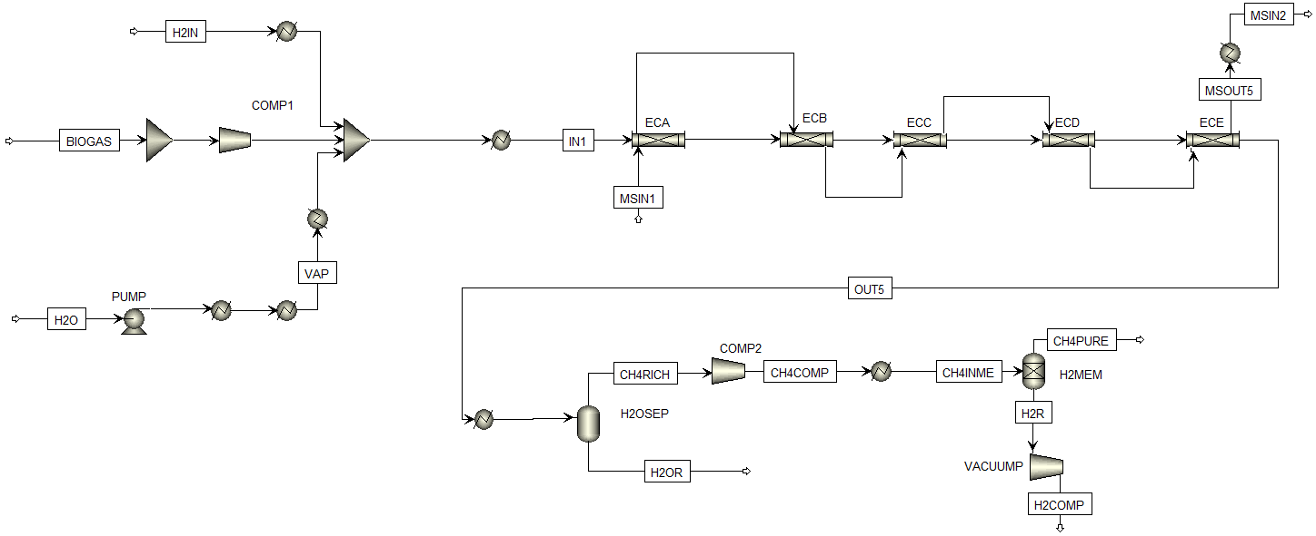
Figure 2: Process Flowsheet by Aspen Plus®
As shown in Figure 2, and related Table 1, the biogas flow rate, is compressed until the desired operating pressure of 12 bar. After the mixer, the reactant stream is sent to a reactor in which temperature and pressure are set to 385°C and 12 bar. The influence of the operating conditions is evaluated afterward. The product outlet stream is purified using a flash separator, H2OSEP. In this way, all the water is removed. The flash temperature is set at 40°C to involve the condensation of water while the pressure is the same at the reactor outlet. Then a compressor, COMP2, is used to recover the pressure drop within the reactor. The last step involves a membrane, MEMSEP, that is necessary to separate methane from unreacted hydrogen. This operation allows to comply with the limit fixed for the concentration of biomethane stream and to recover valuable hydrogen. A vacuum pump, VACUUMP, is connected to the membrane to increase the separation efficiency.
    - Kinetic analysis and reactor design
To verify that the chosen model can achieve the same equilibrium curve of the Soave-Redlich-Kwong (SRK) model set in Aspen, it has been conducted a simulation with an RPLUG block of infinite length and at a constant temperature. The simulation is carried out at a pressure of 12 bar, considering a biogas composition of 60% of CH₄ and 40% of CO₂ and a molar feed ratio of H₂/CO₂ equal to 4. Several kinetic models are available in the literature. The main differences are related to the catalyst and the operating conditions used in these studies. Considering the range of pressure and temperature chosen for the process, the kinetic model by Xu and Froment (1989) has been adopted in this work. In their study, it is proved that the cracking reaction is negligible, and so it is not taken into account. The reaction network and kinetic expressions are shown in Table 2. Table 3 contains all kinetics parameters set in the RPLUG reactor for the simulations.
Table 2: Reaction and relative kinetic used in this work (Xu and Froment, 1989).
Reaction | Kinetic expression (kmol/(kgcat h))
$$CH_{4}+H_{2}O↔CO+3H_{2}$$ | $$r_{1}=\frac{k_{1}\left(P_{{CH}_{4}}P_{H_{2}O}-\frac{P_{H_{2}}^{3}P_{CO}}{K_{eq,1}}\right)}{P_{H_{2}}^{2.5}{\left(DEN\right)}^{2}}$$
$$CO+H_{2}↔ CO_{2}+H_{2}O$$ | $$r_{2}=\frac{k_{2}\left(P_{CO}P_{H_{2}O}-\frac{P_{H_{2}}P_{CO_{2}}}{K_{eq,2}}\right)}{P_{H_{2}}{\left(DEN\right)}^{2}}$$
$$CH_{4}+{2H}_{2}O ↔CO_{2}+4H_{2}$$ | $$r_{3}=\frac{k_{3}\left(P_{{CH}_{4}}P_{H_{2}O}-\frac{P_{H_{2}}^{4}P_{CO_{2}}}{K_{eq,3}}\right)}{P_{H_{2}}^{3.5}{\left(DEN\right)}^{2}}$$

Where:
$$DEN=1+K_{CO}P_{CO}+K_{H_{2}}P_{H_{2}}+K_{{CH}_{4}}P_{{CH}_{4}}+K_{H_{2}O}P_{H_{2}O}/P_{H_{2}}$$ | (1)
Table 3: Parameters for rate coefficient of reaction.
Reaction | $$E_{i}(\frac{kJ}{mol})$$ | $$k_{i}^{0}$$ | Units of $k_{i}^{0}$
$$r_{1}$$ | 240.1 | 4.2E+15 | kmol bar^{0.5}/(kg h)
$$r_{2}$$ | 67.1 | 1965500 | kmol/(kg h)
$$r_{3}$$ | 243.9 | 1.02E+15 | kmol bar^{0.5}/(kg h)
 | $$E_{eq,i}(K)$$ | $$K_{eq,i}^{0}$$ | Units of $K_{eq,i}^{0}$
$$r_{1}$$ | 27034.22 | 1.51E+13 | bar²
$$r_{2}$$ | -4284.85 | 0.028 | /
$$r_{3}$$ | 22749.37 | 1.51E+13 | bar²
 | $${∆H}_{c}(K)$$ | $$K_{c}^{0}$$ | Units of $K_{c}^{0}$
$$CO$$ | 8497.72 | 8.23E-05 | bar⁻¹
$$H_{2}$$ | 9971.13 | 6.12E-09 | bar⁻¹
$${CH}_{4}$$ | 4604.28 | 6.65E-04 | bar⁻¹
$$H_{2}O$$ | -10666.35 | 177000 | /
    - Separation section and membrane unit
After the reaction step, steam and hydrogen need to be removed. This separation occurs through an equilibrium flash separator, in which water condenses, and using a membrane where the hydrogen permeates (Sofia et al., 2015). In the flash, pressure is unchanged while the temperature is set to 40°C. In order to recover the pressure drop across the reactor, a second compressor is used before the membrane separator. Membranes are used to separate a specific component from a mixture of gas. In the studying case, the goal is to remove hydrogen reducing its molar concentration below 2%. Unlike other gas separations, such as absorption and adsorption, membranes are not linked with thermodynamic equilibrium but with the permeability of different compounds. In particular, the mechanism of separation is based on the use of a selective material that allows hydrogen to pass through the membrane, while the desired methane remains in the retentate. To maximize the difference of the partial pressure for a specific component between the two sides of the membrane, the most common options are the use of a sweep gas in the permeate side, typically steam or inert gas, or a vacuum pump to reduce the overall pressure in the permeate side. In our case steam as sweep gas cannot be used because of the limited thermal stability of the polymeric material, while inert gas hardly can be separated from hydrogen, reducing its purity and economic value. Therefore, the vacuum pump is necessary.
  - Economic analysis
This economic analysis is based on the capital cost of the main unit operations in the plant, hence the reactor, compression system (COMP1, COMP2, VPUMP), membrane, catalyst, and on electricity consumption. The investment costs have been annualized considering a lifetime for the plant of 15 years with an operation of 7920 (or 330 days) per year.
  - Results and discussion
    - Reactor optimization and performances
The results of the reactor design are shown in Table 4, in terms of the number of tubes, length, which changes in the last section to find the minimum production cost, and overall heat transfer coefficient. Figure 3 shows the yield-temperature profile inside the reactor for each optimum case obtained in the following paragraph, in which the influence of inlet reactant temperature, inlet molten salt temperature and catalyst mass on the production cost is studied. As can be seen, in case b there is a limited part in which the yield increases slowly until a certain value of temperature. This result can be explained by considering that a higher value of inlet temperature for reactants could rise the hotspot above the maximum value allowed.
Table 4: Reactor design configuration results.
Parameter | Value
Number of tubes | 200
Tube internal diameter (m) | 0.025
Length (m) | 1 - 4.25
Overall heat transfer coefficient (W/m²K) | 405
Figure 3: Yield-T path for several pressures: 8 bar (a), 12 bar (b), 16 bar (c)
    - Membrane design
A sensitivity analysis in which the pressure of the plant is the imported variable is set up in Aspen. The “Net-Work” of the compressor COMP1 and the vacuum pump connected to the membrane, VPUMP, are the exported variable and are used to evaluate the cost of required electricity. In addition, the flowrates of methane, carbon dioxide and hydrogen are necessary to design the exchange area of the membrane and to calculate its investment cost. The choice of these costs for the economic analysis is due to their mutual influence. An increase in pressure on the retentate side reduces the required membrane area for the separation but implies higher electricity consumption. The investment cost of the membrane separator has been annualized with a lifetime of 2 years for the membrane and a lifetime of 15 years for the plant.

Figure 4: Production cost distribution for several pressures: 8 bar (a), 12 bar (b), 16 bar (c)
    - Bio-methane production cost
The final process flowsheet considered in this analysis is shown in Figure 2. Then biogas with an equally divided composition has been considered to show the influence of mixture reactant on the process. Figure 4 depicts the weight of different cost items in the optimum production cost for each couple's pressure-biogas composition. An increase in pressure caused higher production costs for both biogas compositions considered. This result is due to the rise in electricity consumption, necessary for the compressors and vacuum pump. On the contrary, an increase in pressure implies a reduction of membrane cost because of the improvement of the driving force between the retentate and permeate sides. Another important consideration regards the difference between the specific production cost between the two biogas compositions. Considering the cases at 8 pressure, the cost moves from 0.182 €/kg for case (a) CO₂ to 0.146 €/kg for case (d). This result is related to the higher specific productivity of the upgrade section. The produced high-pressure steam can reduce production costs by 12%, which shows the importance of heat integration in this process. The amount of steam produced is slightly affected by pressure. In the end, it can be remarkable that the main cost item is due to the investment cost of compressors and vacuum pump which represent around 85% of the total in any case considered.
  - Conclusions
Process modeling and design optimization for a biogas upgrade section using green hydrogen were done in order to obtain an injectable biomethane for the Italian natural gas grid. To achieve this result a shell and tube reactor is used to convert carbon dioxide into methane. Considering the characteristics of the particle catalyst, efficiency has been taken into account. Unreacted hydrogen is then removed with a selective membrane separator. The main results of this study show that:
• A yield of 92% can be achieved inside the methanation reactor, increasing the overall conversion into methane of carbon in the biomass treated in the plant
• In the range of pressure 8-16 bar the production cost is slightly influenced;
• The coolant fluid inlet temperature is more significant than the reactant stream temperature for the reaction system;
• Capital and operating costs of compressors and the vacuum pump represent 85% of the production cost.
• It has been proved that by decreasing the concentration of methane in the biogas composition there is an improvement in the system of reaction and productivity, and so a reduction of the specific cost of biomethane from 0.19 €/kg to 0.14 €/kg.
If the price of green hydrogen, about 5 €/kg, is included in the economic analysis, considering the stoichiometry feed ratio for the methanation reaction H₂/CO₂ equal to 4, the specific biomethane grows up to 2.5 €/kg. Hence the overall production cost depends almost entirely on the price of hydrogen used.
In conclusion, the upgrade section design in this work could be profitable if the electricity is available at a low price, so when there is a power surplus from renewable resources. Furthermore, it could help the ecological transition that, at the moment, still requires technological developments for the storage and wider use of electricity.
References
Battaglia P., Buffo G., Ferrero D., Santarelli M., Lanzini A., 2021. Methanol synthesis through CO2capture and hydrogenation: Thermal integration, energy performance and techno-economic assessment. Journal of CO2 Utilization 44, 101407. https://doi.org/10.1016/j.jcou.2020.101407
Giuliano A., Catizzone E., Freda C., 2021. Process simulation and environmental aspects of dimethyl ether production from digestate-derived syngas. International Journal of Environmental Research and Public Health 18. https://doi.org/10.3390/ijerph18020807
Giuliano A., Poletto M., Barletta D., 2015. Process Design of a Multi-Product Lignocellulosic Biorefinery. Computer Aided Chemical Engineering 37, 1313–1318. https://doi.org/10.1016/B978-0-444-63577-8.50064-4
Menin L., Asimakopoulos K., Sukumara S., Rasmussen N., Patuzzi F., Baratieri M., Gavala H., Skiadas I., 2022. Competitiveness of syngas biomethanation integrated with carbon capture and storage, power-to-gas and biomethane liquefaction services: Techno-economic modeling of process scenarios and evaluation of subsidization requirements. Biomass and Bioenergy 161, 106475. https://doi.org/10.1016/j.biombioe.2022.106475
Peters R., Baltruweit M., Grube T., Samsun R.C., Stolten D., 2019. A techno economic analysis of the power to gas route. Journal of CO2 Utilization 34, 616–634. https://doi.org/10.1016/j.jcou.2019.07.009
Scamardella D., Crescenzo C.D., Marzocchella A., Molino A., Chianese S., Savastano V., Tralice R., Karatza D., Musmarra D., 2019. Simulation and Optimization of Pressurized Anaerobic Digestion and Biogas Upgrading Using Aspen Plus. Chemical Engineering Transactions 74, 55–60. https://doi.org/10.3303/CET1974010
Sofia D., Giuliano A., Poletto M., Barletta D., 2015. Techno-economic analysis of power and hydrogen co-production by an IGCC plant with CO2 capture based on membrane technology. Computer Aided Chemical Engineering 37, 1373–1378. https://doi.org/10.1016/B978-0-444-63577-8.50074-7
Witte J., Kunz A., Biollaz S.M.A., Schildhauer T.J., 2018a. Direct catalytic methanation of biogas – Part II: Techno-economic process assessment and feasibility reflections. Energy Conversion and Management 178, 26–43. https://doi.org/10.1016/j.enconman.2018.09.079
Witte J., Settino J., Biollaz S.M.A., Schildhauer T.J., 2018b. Direct catalytic methanation of biogas – Part I: New insights into biomethane production using rate-based modelling and detailed process analysis. Energy Conversion and Management 171, 750–768. https://doi.org/10.1016/j.enconman.2018.05.056
Xu J., Froment G.F., 1989. Methane steam reforming, methanation and water-gas shift: I. Intrinsic kinetics. Methane steam reforming, methanation and water-gas shift: I. Intrinsic kinetics, AlChe Journal AlChe Journal. https://doi.org/10.1002/aic.690350109

