CHEMICAL ENGINEERING TRANSACTIONS  VOL. , 2023 | A publication of
The Italian Association
of Chemical Engineering
Online at www.cetjournal.it

Guest Editor: Sauro Pierucci
Copyright © 2023, AIDIC Servizi S.r.l.
ISBN 978-88-95608-98-3; ISSN 2283-9216

Techno-economic analysis of green diesel production process from vegetable oils
Antonio Caporusso^{a,b}, Aristide Giulianoª*, Federico Liuzziª, Diego Barletta^{c}, Isabella De Bariª
ªENEA, Italian National Agency for New Technologies, Energy and Sustainable Economic Development, S.S. 106 Ionica, km 419+500, Rotondella, MT, Italy
^{b}School of Agricultural, Forest, Food and Environmental Sciences, University of Basilicata, Viale dell'Ateneo Lucano 10, Potenza, 85100, Italy
^{c}2Dipartimento di Ingegneria Industriale, Universitá degli Studi di Salerno, Via Giovanni Paolo II 132, Fisciano (SA), Italy
aristide.giuliano@enea.it
Green diesel is a real solution for the decarbonization process of the world, reducing in this way, carbon dioxide emissions to the atmosphere. The present work proposes a flexible biorefinery design where green diesel is produced by catalytic hydrotreatment of four vegetable oils: soybean, sunflower, palm, and cardoon oil feedstock. The process was simulated in Aspen Plus®. A multi-bed reactor composed of four catalytic beds with quenching cooling is designed and simulated in the presence of Ni-W/SiO₂-Al₂O₃ catalyst, in addition to a separation phase train to obtain the green diesel. Sensitivity analyses were carried out to determine the parameter conditions of the unit operations. The results of the model reflex a molar conversion of triglycerides above 97% and overall mass yield into diesel fraction above 79%. Total capital costs and operating costs of the process were determined in the economic analysis, where a base case is considered for the calculations, obtaining the maximum vegetable oil market price can be sustainable to make economically convenient the biorefinery. Soybean oil resulted in the worst feedstock due to the high percentage of unsaturated bonds, while cardoon oil can be considered the best source to produce green diesel thanks to higher conversion yields.
  - Introduction
The introduction on the market of bio-based products (bio-fuels, bio-chemicals,..) represents the main opportunity to substitute completely the fossil-based economy, by a transaction to a circular, bioeconomy. The energy sector, in particular, can use renewable sources such as solar, wind and also biomass (Sofia et al., 2013), in particular, to produce bio-fuels (De Bari et al., 2020). Biodiesel and hydrogenated vegetable oils (HVO) or “Green diesel” are petrol diesel fuel substitutes derived from biomass. Biodiesel is composed of fatty acid methyl-esters (FAME) and is produced via transesterification, which consists of reacting the triglycerides in the vegetable oil with an alcohol (usual methanol) in the presence of an alkaline or acid catalyst (Caporusso et al., 2022). On the other hand, green diesel is generally composed of n-alkanes, which can be produced by reacting the triglycerides in the vegetable oil with hydrogen under high-pressure, high-temperature conditions in the presence of a catalyst (Bagnato et al., 2021).
    - Hydrotreatment of vegetable oils
The objective of this section is to develop a conceptual design for the hydrotreatment of vegetable oil (HVOs), describing chemical aspects and common types of feedstocks, the mechanism of the reaction, the catalyst, and industrial processes. Various type of vegetable oils is being used as feedstock for biofuel but to date, like sunflower, cottonseed, peanut oil, soybean, palm, and rapeseed oil. Another potential source such as camelina only needs low water and nitrogen supply for cultivation. The most used edible oil is sunflower oil containing 40–50% oil. Ukraine, Russian Federation, Turkey, Argentina, and Europe-27 are the countries that highly
Table 1: Mass basis oils profile taken from the literature.
%_{wt} | Soybean  (Ameen et al., 2017) | Sunflower  (Ameen et al., 2017) | Palm  (Vélez Manco, 2014) | Cardoon  (Raccuia et al., 2012)
Trilinolinin | 7.0 | 0.2 | 0.0 | 0.0
Trilinolein | 53.0 | 60.3 | 13.8 | 44.5
Triolein | 24.5 | 27.1 | 41.1 | 42.6
Tristearin | 4.0 | 5.8 | 8.6 | 3.1
Tripalmitin | 11.5 | 6.5 | 36.5 | 9.8

produced sunflower oil. Sunflower and rapeseed oils are used as the main feedstock for biofuel mainly in Europe. Among all edible oils, rapeseed oil, which is also known as canola oil is widely used as the feedstock for biofuel production. The hydroprocessing of vegetable oil over catalysts, in presence of hydrogen, has complex reaction pathways and consists of consecutive and parallel reaction steps, including hydrogenation, hydrogenolysis, hydrodeoxygenation, decarboxylation, decarbonylation, cyclization, aromatization and isomerization (Agarwal et al., 2019). The pathway starts with the hydrogenation of the double bonds C=C of the vegetable oils with the following step of hydrocracking, producing the corresponding fatty acids and propane as a by-product. From fatty acids, three routes of deoxygenation are possible to produce an alkane: the hydrodeoxygenation route (HDO) preserves the carbon content of the fatty acid chain with the consumption of three moles of hydrogen and the production of two moles of water. As regards to decarboxylation route, the alkane formed has one carbon atom shorter than the total length of the fatty acid in the triglyceride, converted into CO₂. Also, the decarbonylation route reduces the carbon number with the elimination of CO, but this reaction consumes one mole of H₂ and produces one mole of H₂O. The straight-chain alkanes can undergo isomerization and cracking to produce isomerized and lighter alkanes, respectively, and cyclization and aromatization (Silva and de Andrade, 2021). The work of Silva and de Andrade (2021) consists of a simulation of the deoxygenation of vegetable oils to produce diesel fuel. The simulation was carried out in Aspen Plus® software, where it has been modeled a fixed bed reactor with six kinds of vegetable oils that include sunflower, soybean, palm, olive, corn, and cottonseed. The catalyst used in the simulation was Pd / Active carbon. The operational conditions in the reactor considered optimized for the deoxygenation of vegetable oils process were the pressure of 40 bar, the temperature of 300 °C, and the H2/feedstock molar ratio of 2.5/1. For all oils analyzed, a conversion above 96% was observed, and the overall mass yields obtained from these in diesel-like hydrocarbons were > 78% (Silva and de Andrade, 2021). In the study of Miller (2012) canola and camelina oil were used as feedstock in a process simulation based on experimental data from Alberta Agricultural and Rural Development (Canada) to produce renewable diesel. Through a techno-economic assessment, capital and operating costs were estimated. The simulation was carried out in Aspen Plus® software, where the deoxygenation reactor was modeled in presence of Pd/ Carbon active catalyst and hexane as solvent. The operation conditions were a temperature of 400°C, pressure of 15.2 MPag and residence time of 6 hr for both feedstocks. Sensitivity analyses conducted indicate that renewable diesel production cost is not very sensitive to capital and operating costs, but is highly sensitive to feedstock cost, solvent price, and solvent recovery. The main aim of this work is to develop a techno-economical assessment of a biorefinery that can convert four vegetable oils into renewable fuel, which in this case is green diesel, through catalytic hydroprocessing. Process feedstocks consist of four types of vegetable oils: Soybean, Sunflower, Palm and Cardoon oil.
  - Process design
A process design methodology was applied to simulate and optimize the green diesel production flowsheet considered. Aspen Plus® simulation software was used for the reactor design by kinetics approach and for the purification train based on a thermodynamics approach (Giuliano et al., 2015).
Table 2: Fixed design parameters.
Process parameter | Value
Reactor diameter (m) | 2.0
Temperature of the feed (liquid + gas) (°C) | 340
Pressure (bar) | 80
First bed length (m) | 2.0

Table 3: Economic parameters.
Economic parameter | Value
Hydrogen cost (€/kg) | 3
Catalyst cost (€/kg) | 600
Green diesel selling price (€/kg) | 1.50
Plant lifetime (y) | 20
Interest rate (%) | 5
Base year | 2022
Plant start-up (y) | 3
Annual working hours (h/y) | 7920
Linear depreciation (y) | 10
    - Feedstock profiles
The profile of the four vegetable oils is presented in Table 1. In particular, main compounds were used to model the complex composition of the oils. All lipids were considered simple triglycerides, where only olein, linolein, linolenin, palmitic acid, stearic acid were the related fatty acids.
    - Kinetics and reactor design
In the present study, kinetics from Tirado and Ancheyta (2020) was used to simulate a trickle bed reactor for the hydrotreatment of vegetable oils. The investigation group used kinetics parameters to develop a mathematical model that simulates the hydrotreatment of Jatropha oil over Ni-W / SiO₂-Al₂O₃ catalyst on a bench scale reactor, at 420°C, 8 MPa, hydrogen to oil of 1500 Nl/l and wight hourly space-velocity (WHSV) of 1-12 h⁻¹. The results of the model were compared with experimental data, getting an acceptable data fit (Tirado and Ancheyta, 2020). A design of a co-current trickle bed reactor configurated with four catalytic beds and hydrogen (direct) quenching is proposed for the biorefinery. A biorefinery capacity is taken as a model of the design, where 45,000 kg/hr of vegetable oil is processed. Due to a large number of freedom degrees present in the equipment design, parameters were initially set based on literature, while the rest have been calculated by sensitivity analyses. The fixed variables of the design are shown in Table 2.
    - Purification train design
The effluent from the reactor consists of a gas phase and a liquid phase, where the products are located and must be separated (Figure 1). After cooling operation in the heat exchangers, the current passes through a partial condenser where three phases are separated: a gas phase, an organic phase that contains diesel products, fatty acids and triglycerides non-converted and a water liquid phase. Hydrogen is present in excess in the stream; therefore, it must be recovered by a first partial condenser working at 24 bar, with a minimum hydrogen recovery equal to 99.93%. On the other hand, water must be eliminated to not send excess material flow into the Pressure Swing Adsorption (PSA) unit, which can be separated by density from the organic liquid phase. In a typical refinery, a distillation column can be used to separate the product components. Column feed composition is mainly made up of diesel hydrocarbons and, to a lesser extent, triglycerides, and fatty acids. Next, the operating pressure of the reboiler and condenser are defined. To avoid excessive temperature operation in the reboiler, the column works under vacuum, with a pressure of 0.6 bar at the reboiler and with a pressure drop in the column of 0.5 bar. The PSA technology is based on the physical binding of gas molecules to adsorbent material. The respective force acting between the gas molecules and the adsorbent material depends on the gas component, type of adsorbent material, partial pressure of the gas component and operating temperature. The separation effect is based on differences in binding forces to the adsorbent material. Highly volatile components with low polarities, such as hydrogen, are practically non-adsorbable as opposed to molecules such as N₂, CO, CO₂, hydrocarbons, and water vapor. Consequently, these impurities can be adsorbed from the hydrogen-containing streams and high-purity hydrogen is recovered. For the PSA unit design, a Separation unit in Aspen Plus® is selected where references from the work of Giuliano et al are considered. The operation pressure of the PSA unit was fixed equal to the output pressure from the partial condenser separator to avoid compressing the feed gas. A purity of 99.99% is achieved while the recovery is 90% w/w of hydrogen. To size the unit, as far as the bed volume is concerned, a linear relation is used based on the gas flows that are treated in the aforementioned work. To design the distillation column by a RadFrac unit, a recovery and purity rate equal to or greater than 99 % w/w was established. The main hydrocarbons present were N-Octadecane, N-Heptadecane, N-Hexadecane and N-Pentadecane. These hydrocarbons can be recovered in the distillate while the heavy components, triglycerides, and fatty acids, undergoes in the bottom zone. Once the process flowsheet is completed, energy analysis is performed to minimize energy consumption and reduce operating costs.
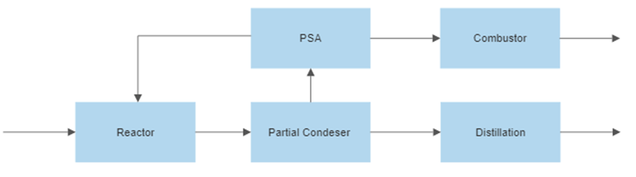
Figure 1: Design sequence of the green diesel production process
  - Economic analysis
Cash flows are defined as the net passage of money within or outside a company, due to investments while depreciation is the reduction in the value of an asset. Depreciation is calculated with a linear model and is treated as a cost of production although it is not a current cash flow for the company. The net present value (NPV) method represents the comparison of the present worth of all cash inflows to the present worth of all cash outflows associated with the investment project. Because some market information is missing to develop the present project, this presents some uncertain variables. To understand better the effects of the uncertain variables and determine a maximum market oil price, where upper this limit the project would not be economically attractive, an impact analysis is performed in this study, based on the impact variation of one uncertain variable on the NPV.
  - Results and discussion
    - Reactor optimization and performances
As the length increases, catalyst loading increases, resulting in a higher conversion of triglycerides. Moreover, as more catalyst is present in the reactor, also increases the permanence time of reactants and the conversion of diesel fraction to lighter fractions increases, thereby decreasing the parameter kg diesel/ kg catalyst. A meeting point between these two conditions can be found at 10.75 m. While processing the information of other oils, the same total reactor length was found. This can be explained because the kinetic model is a lumped model, where temperature and space velocity are the main variables that control the model. From these results, it is selected to have a biorefinery where the reactor has fixed dimensions and only feeding conditions, hydrogen mass flow and hydrogen inlet temperature change. The final configuration and catalyst parameters are presented in table 4. Results presented in table 5 show a molar conversion of triglycerides above 97% and overall mass yield into diesel fraction above 79%. The highest requirement for hydrogen in treated oils follows the next order: Soybean > Sunflower > Cardoon > Palm. This is because the greater number of unsaturation present, the greater the exothermicity of the reaction. Thus, more hydrogen is required to saturate the double bonds and more used as a cooling agent in the quenching. The diesel product distribution consists of a range of C₁₅ to C₁₈. Decarboxylation and decarbonylation reactions predominate over hydrodeoxygenation reactions, where the ratio C17/C18 and C15/C16 are equal to 1.89 and 1.88 respectively.
    - Green diesel purification and heat integration results
The main results consist of energy performances of the distillation column recovering the green diesel of more than 99%. The reboiler duties obtained after optimization resulted in the range of 11.35 – 11.79 MW. Of those, 100 % of thermal energy was derived by off-gases burner, generating more than 35 MWt by HP steam generation. The condenser duties resulted in the range 8.23 – 8.44 MW, together with the flue gases cooling making necessary cooling water and refrigerant as utilities (range 40.10 – 45.36 MW). Electricity generated by gas turbines was absorbed by compressors and other electric utilities.
Table 4: Reactor design results.
Design parameter | Value
Length 2nd loading (m) | 2.50
Length 3rd loading (m) | 3.00
Length 4th loading (m) | 3.25
Catalysts loading (kg) | 14’544
WHSV (h⁻¹) | 3.09
Table 5: Reaction results for different vegetable oils.
Process results | Soybean | Sunflower | Palm | Cardoon
Triglycerides conversion (%) | 97.7 | 99.0 | 98.7 | 98.8
Mass yield (%w/w_{OIL}) | 80.0 | 81.1 | 79.9 | 80.7
Diesel to catalysts ratio | 2.48 | 2.51 | 2.47 | 2.50
Hydrogen flow (kmol/h) | 4’356 | 4’241 | 3’897 | 4’012
Hydrogen consumption (kmol/h) | 578 | 578 | 465 | 552
Hydrogen temperature (°C) | 165 | 160 | 245 | 170
Global heat of reaction (kJ/kg_{OIL}) | -901 | -891 | -740 | -857

    - Maximum vegetable oil market prices
The economic analysis was performed by calculating CAPEX and OPEX fixing the net present value of the biorefinery equal to zero. From that, the maximum vegetable oil market price can be sustainable to make economically convenient for the hydrogenation of oils was obtained (Figure 2). The impact of the oil composition was limited to the unsaturated bonds quantity and consequently the hydrogen rates/costs.
The minimum one (the worst at 836 €/t) was found in the soybean oil, due to higher double bonds in the oil composition (higher hydrogen consumption). The best one was found in the cardoon oil (858 €/t) due to a high mass yield (80.7 %) combined with a low hydrogen temperature (170 °C) and consequent lower thermal energy consumption (better heat integration). The major concentration of saturated bonds of the palm oil and its lower hydrogen requirement/costs was covered and passed by the higher energy quantity to obtain the total hydrogen flow at 245 °C, due to the rector configuration (direct quench reactor).

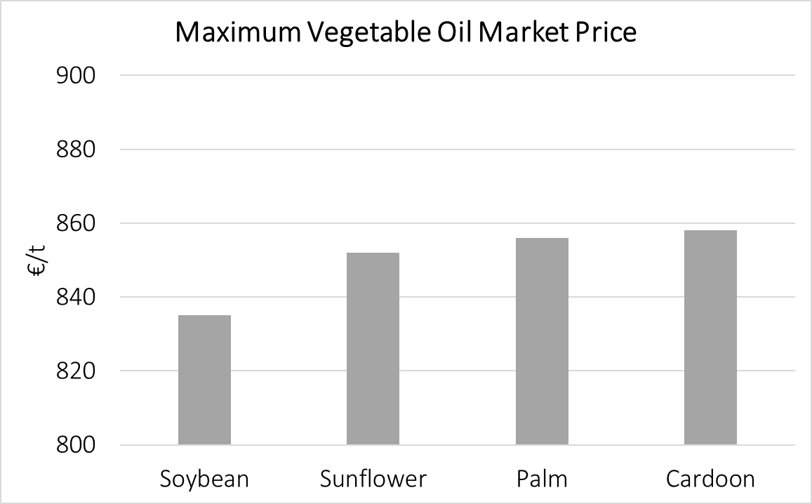
Figure 2: Maximum Vegetable Oil Market Prices for the considered feedstocks
  - Conclusions
In the present work is performed the design of the green diesel production process is by using the Aspen Plus simulator. Four types of feedstock were used as input in the model, four vegetable oils and one microbial oil. In the hydroprocessing unit, an adiabatic reactor composed of four catalytic beds is designed with hydrogen quenching, where a kinetic model using a Ni-W/ SiO2-Al2O3 catalyst has been used and presents a model with a first-order power law. Decarboxylation and decarbonylation reactions govern the kinetics. Simulations indicate that the greater the number of unsaturation present in the oil, the greater the consumption of hydrogen, and the more difficult the thermal control will be in the reactor. Impact analysis reported that the net present value (NPV) of the project is highly sensitive to the green diesel selling price. Maximum vegetable oil market price was determined for each oil, considering a base case scenario, where a range from 836 to 858 €/tonne is founded, corresponding to Soybean oil and Cardoon oil, respectively. In this way, the analysis suggests that mass yield must be maximized into the green diesel fraction and oils with a low number of double bonds, must be selected as process feedstock. Further analysis has to be deepened to compare the convenience of green diesel and jet-fuel production, by hydrodeoxygenation coupled with isomerization of vegetable oils.
References
Agarwal P., Al-Khattaf S.S., Klein M.T., 2019. Molecular-Level Kinetic Modeling of Triglyceride Hydroprocessing. Energy & fuels.
Ameen M., Azizan M.T., Yusup S., Ramli A., Yasir M., 2017. Catalytic hydrodeoxygenation of triglycerides: An approach to clean diesel fuel production. Renewable and Sustainable Energy Reviews 80, 1072–1088.
Bagnato G., Sanna A., Paone E., Catizzone E., 2021. Recent Catalytic Advances in Hydrotreatment Processes of Pyrolysis Bio-Oil. Catalysts 11, 157.
Caporusso A., Giuliano A., Liuzzi F., De Bari I., 2022. Techno-economic Analysis of a Lignocellulosic Biorefinery Producing Microbial Oils by Oleaginous Yeasts. Chemical Engineering Transactions 92, 637–642.
De Bari I., Giuliano A., Petrone M.T., Stoppiello G., Fatta V., Giardi C., Razza F., Novelli A., 2020. From cardoon lignocellulosic biomass to bio-1,4 butanediol: An integrated biorefinery model. Processes 8, 1–18.
Giuliano A., Poletto M., Barletta D., 2015. Process Design of a Multi-Product Lignocellulosic Biorefinery. Computer Aided Chemical Engineering 37, 1313–1318.
Miller P.E., 2012. Renewable Diesel Production from Canola and Camelina [WWW Document]. ERA. https://doi.org/10.7939/R32B8VP46
Raccuia S.A., Melilli M.G., Piscioneri I., Sharma N., 2012. Evaluation of fatty acids composition in grain oil of cardoon (cynara cardunculus l.). Acta Hortic. 463–468.
Silva G.C.R., de Andrade M.H.C., 2021. Simulation of deoxygenation of vegetable oils for diesel-like fuel production in continuous reactor. Biomass Conv. Bioref.
Sofia D., Giuliano A., Barletta D., 2013. Techno-economic assessment of co-gasification of coal-petcoke and biomass in IGCC power plants. Chemical Engineering Transactions 32, 1231–1236.
Tirado A., Ancheyta J., 2020. Modeling of a bench-scale fixed-bed reactor for catalytic hydrotreating of vegetable oil. Renewable Energy 148, 790–797.

