CHEMICAL ENGINEERING TRANSACTIONS  VOL. , 2023 | A publication of
The Italian Association
of Chemical Engineering
Online at www.cetjournal.it

Guest Editor: Sauro Pierucci
Copyright © 2023, AIDIC Servizi S.r.l.
ISBN 978-88-95608-98-3; ISSN 2283-9216

Box-Behnken Design for the Photocatalytic Degradation of Sulfamethazine using MIL-100(Fe) as a Photocatalyst
Shubham Rajª, Amar Nath Samanta^{a,*}
ªDepartment of Chemical Engineering, Indian Institute of Technology, Kharagpur-721302, India
amar@che.iitkgp.ac.in
Metal-organic frameworks (MOF) are a new class of porous materials that have generated a lot of interest because of their crystalline structures, uniformly large surface area, open framework, and consistent yet adjustable cavities. They serve as photocatalysts and adsorbents for the removal of organic contaminants from wastewater. In this regard, MIL-100(Fe) as MOF is chosen and synthesized hydrothermally. So, this work is intended to prepare MOF-based photocatalysts and photocatalytic degradation of Pharmaceuticals like Sulfamethazine (SMT), present in wastewater using the prepared photocatalyst. The degradation studies will include the model development using Box-Behnken experimental design as RSM (response surface methodology), finding the optimum operating conditions of dosage, pH and initial concentration.
  - Introduction
Water is a precious resource that is essential for life and is involved with key human activities such as agriculture, industry, and household uses. Globally, there is a growing concern over water pollution caused by the release of several substances into water bodies from agriculture, industry, and household appliances (Phakathi, Tichapondwa, and Chirwa 2022). The majority of the contaminants that affect water resources are organic. Water bodies contain a variety of organic contaminants, including pharmaceuticals, insecticides, plasticizers, phenolic compounds, and industrial solvents (Naidu et al. 2016). Pharmaceuticals, frequently used to treat illnesses and protect the health of people, animals, and other living things, are a broad category of drugs that include antibiotics, analgesics, antiepileptics, anticonvulsants, anti-anxiety medications, anti-rheumatics, beta-blockers, steroid hormones, and chemotherapeutics. The most of these pharmaceutically active substances and/or their bioactive metabolites reach water resources through runoff from cities and farms or the haphazard discharge of pharmacological industrial and hospital effluents(Bolong et al. 2009). These organic compounds could not be removed during conventional waste-water treatment and are thus discharged into receiving bodies of water (Heberer, Reddersen, and Mechlinski 2002). Pharmaceuticals in groundwater(Ikehata, Naghashkar, and El-Din 2006) and surface waters(Blair et al. 2013) have been found in concentrations ranging from ng/L to µg/L around the world. Antibiotics, among other pharmaceuticals, are overused and have negative effects on human health both directly and indirectly as a result of polluted water resources(Giraldo et al. 2010). A recent study reported that 100,000–200,000 tonnes of antibiotics are used annually around the world, leading to a significant increase in level of antibiotic residues in water(Kuo et al. 2010). Antibiotics, even at low concentrations, may cause long-term irreversible changes to the microbial genome and make microbes resistant to antibiotics(Agrawal 2010). The demand for pesticides has increased significantly as agricultural demand has increased. These pesticides found in wastewater are difficult to remove and have a significant impact on water resources because of their persistent and toxic nature (Sable et al. 2018). Sulfamethazine (SMT) is a sulfonamide antibiotic that is commonly used to treat pneumonia and urinary tract infections. SMT is commonly used to protect aquatic and livestock animals, and has been found in groundwater, soil, and animal bodies. As a result, SMT can bioaccumulate in the food chain, posing a risk to human health. In this work, SMT is chosen as a target pollutant due to its widespread presence in aquatic environments and harmful effects on living beings, and non-biodegradability in conventional wastewater treatment processes (Zhou et al. 2020). According to the literature review, advanced oxygen processes (AOPs) are suitable for the removal of pharmaceuticals from wastewater. AOPs' fundamental benefit is its ability to degrade aquatic pollutants using in-situ, highly reactive hydroxyl radicals (HO•), as opposed to primary traditional procedure like activated carbon-based adsorption techniques, which simply physically alter pollutants without degrading them (Oturan and Aaron 2014). Several AOPs, including UV/H2O2, ozone-based, Fenton-based, and semiconductor-based photocatalytic processes, are used to effectively degrade organic contaminants (de la Cruz et al. 2013). The semiconductor-based photocatalytic process is popular among different AOPs because it employs dissolved oxygen as an oxidant instead of other AOPs that need relatively expensive oxidising chemicals like H₂O₂ and O₃ (Anandan, Ikuma, and Niwa 2010). The most popular photocatalyst for many applications is titanium dioxide (TiO₂) since it is chemically stable, non-toxic, and reasonably priced (Lazar, Varghese, and S Nair 2012). The use of semiconductors has several drawbacks like aggregation, and high recombination of e⁻/h⁺ generated after photocatalysis.

Researchers are interested in the metal-organic framework (MOF) because of its high surface area, open framework, uniform but tuneable cavities, and crystalline formations (Mahmoodi et al. 2018). Metal ions/clusters and organic linkers are combined to create this structure. In several applications, including catalysis, adsorption, gas separation and storage, and other areas, metal-organic frameworks perform better than conventional materials. They serve as adsorbents and photocatalysts in the process of removing organic contaminants from wastewater. MOF is an efficient photocatalyst due to the various ligand-to-metal charge-transfer (LMCT) transitions (Mahmoodi et al. 2018).

In this present study, a photocatalytic reactor set-up is designed for the degradation of SMT using synthesized MIL-100(Fe) as a photocatalyst. The operating parameters like concentration, dosage and pH are optimized using a Box-Behnken experimental design.
  - Materials & Method
    - Materials
Purified sulfamethazine (SMT, C₁₂H₁₄N₄O₂S (>99%) M.W. 278.33), trimesic acid (C₉H₆O₆, (95% M.W. 210.14), reduced Iron powder (99% extra pure, M.W. 55.85) are bought from Sigma-Aldrich Pvt Ltd, hydrofluoric acid (ACS reagent 40 %, M.W. 20.01) & nitric Acid (ACS reagent 69%, M.W. 63.01) are purchased from Merck India. These chemicals and reagents are used in the experiments without further purification.

    - MIL-100(Fe) synthesis
MIL-100(Fe) is synthesized using a previously described hydrothermal method with a little modification (Tang and Wang 2018). First, 0.82 g of reduced Fe powder and 2.06 g of trimesic acid (H₃BTC) are added to 70 mL of deionized water. Next, 1.2 mL of nitric acid (HNO₃) and 0.6 mL of hydrofluoric acid (HF) are added. Before being transferred to a dried 100 mL Teflon-lined steel autoclave, the reactant mixture was agitated vigirously with a stirrer for 90 minutes. The autoclave is gradually heated to 160 °C and kept at that temperature for 24 hours. After natural cooling, the precipitate is recovered by centrifugation and is then washed successively in 80 °C hot double-distilled water for 5 hours and in 60 °C hot ethanol for 3 hours to remove any remaining unreacted reactants and coloured impurities. Finally, it is dried overnight at 80 °C in an oven and the light-orange product thus obtained is kept in a vacuum desiccator.

2.3 Experimental procedure
All degradation experiments are performed in the photochemical reactor set-up (as shown in figure 1) using a 250-Watt Hg lamp at a constant temperature and 500 rpm speed of stirring. In a typical procedure, a required amount of catalyst is added to 300 ml SMT solution in the reactor vessel. Initially, the experiment is carried out in the dark for 60 minutes to reach adsorption-desorption equilibrium. After that, the experiment takes place in presence of a visible lamp. Using a 2 ml syringe, samples are taken out at regular intervals of time and filtered through 0.22 µm polytetrafluoroethylene (PTFE). A PerkinElmer (Flexar) high-performance liquid chromatography (HPLC) instrument furnished with a UV detector and a ZORBAX Eclipse Plus C18(Agilent, USA) column (3.5 μm, 4.6 mm ×100 mm) is used to determine the concentration of SMT. The detection wavelength is set at 275 nm. A volume ratio of 35:65 of acetonitrile and water, flowing at a rate of 1.0 mL per minute, is used as the mobile phase.

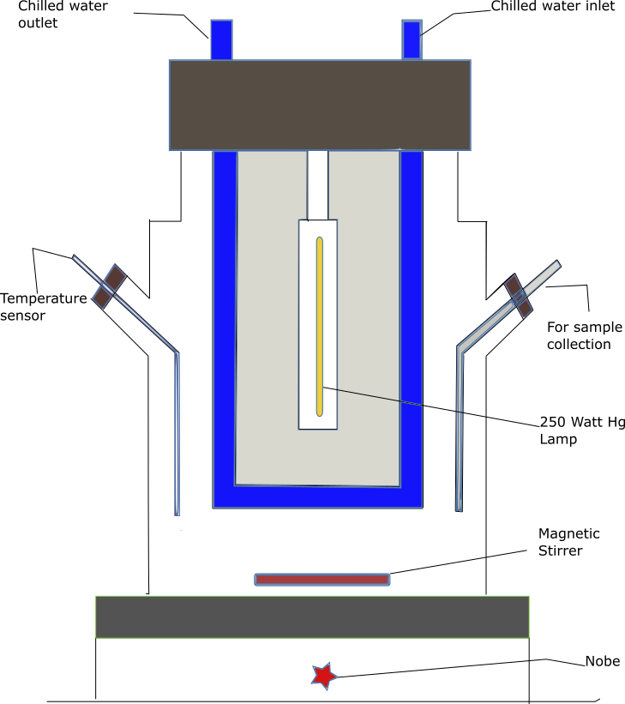
Figure 1. Schematic diagram of Photochemical reactor

    - Experimental Design
To examine the impacts of three independent parameters such as initial concentration, dosage and pH on the % degradation of SMT and to optimise the operating conditions, response surface methodology (RSM) was employed. Due to its adequate coverage of the operational parameter interactions, this strategy can get around the drawbacks of conventional experimental designs(Samy et al. 2020). Utilizing 13 sets of experiments, the Box-Behnken experimental design enabled us to determine how the results of the three independent variables influence the response. Because the Box-Behnken design approach is very efficient and doesn't have a point at the vertices of the cubic region created by the upper and lower limitations of the variables, it has been used(Fouad et al. 2020). The empirical quadratic polynomial model based on response and three independent factors are given as
$Y\left(\%\right)=β_{0}+β_{1}A+β_{2}B+β_{3}C+β_{11}A^{2}+β_{22}B^{2}+β_{33}C^{2}+β_{12}AB+β_{23}BC+β_{31}CA$ (1)
Where Y is the response variable, $β_{0}$ is the intercept, $β_{1}$, $β_{2}$, $β_{3}$ are the independent variable factors, $β_{11}$,$β_{22}$ , $β_{33}$ are the quadratic factors, $β_{12}$, $β_{23}$, $β_{31}$ are the interaction factors, and A, B, and C are the independent variables i.e., concentration, dosage and pH respectively. Regression analysis and optimization operation was done by the design of experiment software. Analysis of variance (ANOVA) was used to get the significance of the model and regression analysis.
  - Results & Discussion
    - Degradation Experiment
MIL-100(Fe) photocatalyzed the degradation of SMT in the visible light region. The initial concentration of SMT and photocatalyst dosage are set to 10 ppm and 0.25 g/lit, respectively, and are held constant for comparison during SMT degradation. Figure 2 shows that SMT removal is around 42% in the dark and 95% in the presence of visible light after 1 hour. As a result, it can be concluded that MIL-100(Fe) has photocatalytic properties in the presence of visible light. SMT is removed by the adsorption process only in the dark whereas MIL-100(Fe) completely degrades SMT in the presence of visible light after 2 hours, indicating MIL-100(Fe) as a promising photocatalyst in the visible region.
Figure 2: Degradation of SMT using MIL-100(Fe) with or without the presence of visible-light
    - Optimization of the parameters
The Box-Behnken experimental design of tests employs 13 sets to determine the effect of the three independent variables on the response. The quadratic equation obtained between response and operating parameters are as follows:
$Y\left(\%\right)=93.7+0.134A+10.21B-4.62C-0.046A^{2}-25.53B^{2}+0.492C^{2}+1.44AB-1.79BC-0.011AC$ (2)
Where Y(%) is the SMT degradation percentage after 60 minutes. The coefficient of Regression (R²) obtained for quadratic fit was 0.9. The p-value of each variable serves as an example of the level of significance. The results of ANOVA are tabulated in Table 1 for SMT degradation. A small p-value and large F-value indicate statistical significance for the model or parameter(Fouad et al. 2020). According to the effect on SMT degradation, the operating parameters can be arranged based on the F-value as follows: pH > catalyst dosage > concentration (Samy et al., 2020). Figure 3 shows the contour plots for the SMT degradation response. The optimum degradation of around 96% is achieved for pH=2. From Figure 3(a), it is evident that at a high pH value and lowest dose, the contour is at its peak. The reason is that at high pH, more no. of OH⁻ ions are produced due to the alkaline nature of water which combines with the h⁺ generated in the wastewater to give HO•, responsible for a degrading pollutant. Also, at low dosages degradation is maximum as increasing the amount may block the active pores of the photocatalyst. The contour plot shows the best result at low concentrations as shown in Figures 3(b) & 3(c). High initial concentrations result in a larger number of highly reactive oxidant species (ROS), which may require longer time for the reaction to complete.
(b)
(a)
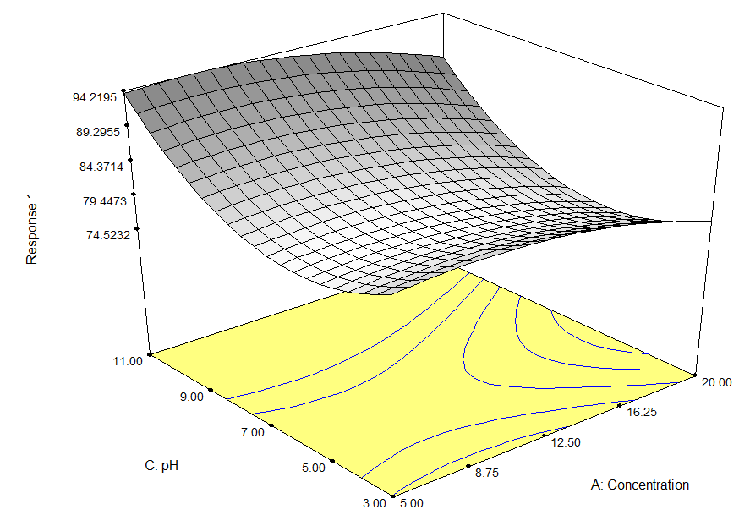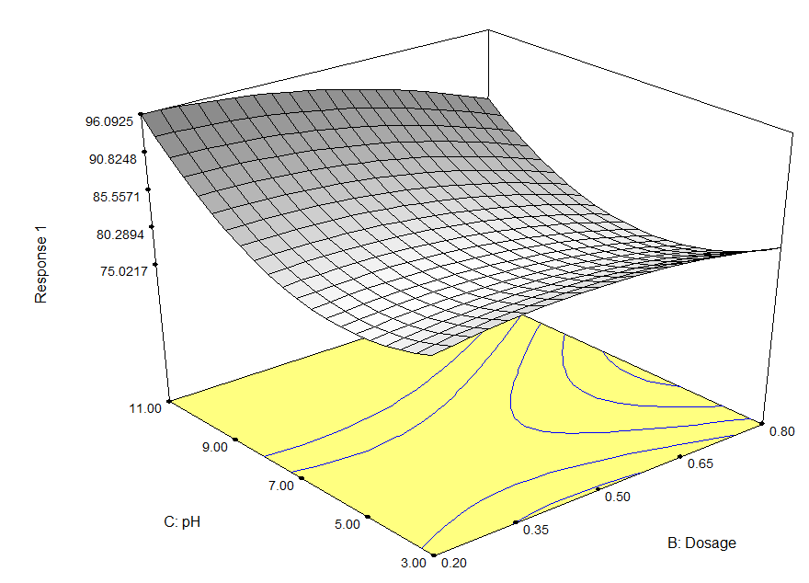
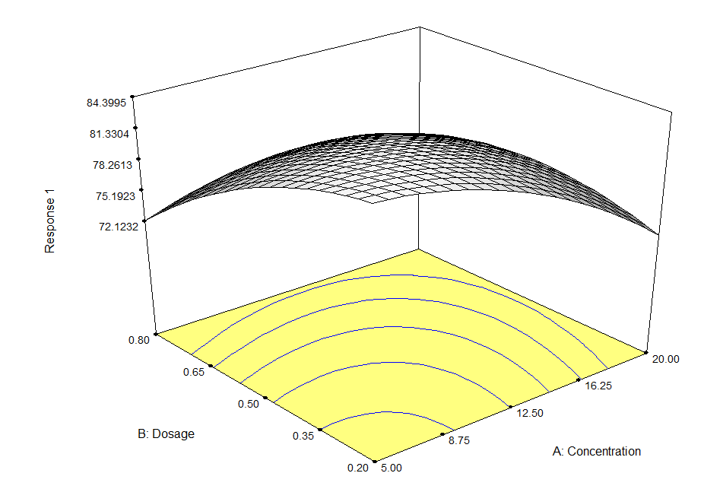
(c)
(c)
Figure 3. Contour plots for Response (a) pH Vs Dosage, (b) pH Vs Concentration & (c) Dosage Vs Concentration
Table 1: Analysis of variance (ANOVA) for SMT degradation
Source | Sum of Squares | DF | Mean Square | F value |  | Prob > F
Mean | 1.141E+005 | 1 | 1.141E+005
Linear | 323.28 | 3 | 107.76 | 2.92 |  | 0.0742
2FI | 61.01 | 3 | 20.34 | 0.49 |  | 0.7002
Quadratic | 297.24 | 3 | 99.08 | 5.68 |  | 0.0272 |  | Suggested
Cubic | 122.08 | 3 | 40.69 | 6.366E+007 |  | <0.001 |  | Aliased
  - Conclusions
MIL-100(Fe) has been synthesized successfully for the photocatalytic degradation of SMT in a Photochemical reactor setup in the dark as well as in the visible light condition. SMT removal is around 42% in the dark while more than 95 % of SMT degraded in presence of visible light after 1 hour. 100% SMT degraded within 2 hours. According to a Box-Behnken experimental design, the best conditions for the degradation of SMT in the presence of visible light are identified as follows: dosage = 0.2 g/L, pH = 11 and initial concentration = 5 mg/L.

Acknowledgments
All the funds are funded by Ministry of Education, India
References
Agrawal, Anju., 2010, Water Pollution with Special Reference to Pesticide Contamination in India, Journal of Water Resource and Protection, 02, 432–448.
Anandan S., Y. Ikuma, and K. Niwa., 2010, An Overview of Semi-Conductor Photocatalysis: Modification of TiO₂ Nanomaterials, Solid State Phenomena, 162, 239–260.
Blair, Benjamin D., Jordan P. Crago, Curtis J. Hedman, and Rebecca D. Klaper, 2013, Pharmaceuticals and Personal Care Products Found in the Great Lakes above Concentrations of Environmental Concern, Chemosphere, 93, 2116–2123.
Bolong, N., A. F. Ismail, M. R. Salim, and T. Matsuura, 2009, A Review of the Effects of Emerging Contaminants in Wastewater and Options for Their Removal, Desalination, 239, 229–246.
Fouad, Kareem, Mohamed Gar Alalm, Mohamed Bassyouni, and Mamdouh Y. Saleh, 2020, A Novel Photocatalytic Reactor for the Extended Reuse of W–TiO₂ in the Degradation of Sulfamethazine, Chemosphere, 257, 127270
Giraldo, Ana L., Gustavo A. Peñuela, Ricardo A. Torres-Palma, Nancy J. Pino, Rodrigo A. Palominos, and Héctor D. Mansilla, 2010, Degradation of the Antibiotic Oxolinic Acid by Photocatalysis with TiO₂ in Suspension, Water Research, 44, 5158–5167.
Heberer, Th, Kirsten Reddersen, and A. Mechlinski, 2002, From Municipal Sewage to Drinking Water: Fate and Removal of Pharmaceutical Residues in the Aquatic Environment in Urban Areas, Water Science and Technology, 46, 81–88.
Ikehata, Keisuke, Naeimeh Jodeiri Naghashkar, and Mohamed Gamal El-Din, 2006, Degradation of Aqueous Pharmaceuticals by Ozonation and Advanced Oxidation Processes: A Review, Ozone: Science & Engineering, 28, 353–414.
Kuo, Yu-Ling, Wan-Ling Liu, Shih-Huan Hsieh, and Hsi-Ya Huang, 2010, Analyses of Non-Steroidal Anti-Inflammatory Drugs in Environmental Water Samples with Microemulsion Electrokinetic Chromatography, Analytical Sciences, 26, 703–707.
De la Cruz, N., L. Esquius, D. Grandjean, A. Magnet, A. Tungler, L. F. de Alencastro, and C. Pulgarín, 2013, Degradation of Emergent Contaminants by UV, UV/H₂O₂ and Neutral Photo-Fenton at Pilot Scale in a Domestic Wastewater Treatment Plant, Water Research 47, 5836–5845.
Lazar, Manoj, Shaji Varghese, and Santhosh s nair, 2012, Photocatalytic Water Treatment by Titanium Dioxide: Recent Updates, Catalysts, 2, 572–601.
Mahmoodi, Niyaz Mohammad, Jafar Abdi, Mina Oveisi, Mokhtar Alinia Asli, and Manouchehr Vossoughi, 2018, Metal-Organic Framework (MIL-100 (Fe)): Synthesis, Detailed Photocatalytic Dye Degradation Ability in Colored Textile Wastewater and Recycling, Materials Research Bulletin, 100, 357–366.
Naidu, Ravi, Victor Andres Arias Espana, Yanju Liu, and Joytishna Jit, 2016, Emerging Contaminants in the Environment: Risk-Based Analysis for Better Management, Chemosphere, 154, 350–357.
Oturan, Mehmet A., and Jean-Jacques Aaron, 2014, Advanced Oxidation Processes in Water/Wastewater Treatment: Principles and Applications, A Review, Critical Reviews in Environmental Science and Technology, 44, 2577–2641.
Phakathi, Nothando, Shepherd Tichapondwa, and Evans Chirwa, 2022, Photocatalytic Degradation of Tetracycline Using Visible-Light-Driven Porous g-C₃N₄ Nanosheets Catalyst, Chemical Engineering Transactions, 96, 391–396.
Sable, Shailesh S., Kinjal J. Shah, Pen-Chi Chiang, and Shang-Lien Lo, 2018, Catalytic Oxidative Degradation of Phenol Using Iron Oxide Promoted Sulfonated-ZrO₂ by Advanced Oxidation Processes (AOPs), Journal of the Taiwan Institute of Chemical Engineers, 91, 434–440.
Samy, Mahmoud, Mona G. Ibrahim, Mohamed Gar Alalm, and Manabu Fujii, 2020, Effective Photocatalytic Degradation of Sulfamethazine by CNTs/LaVO₄ in Suspension and Dip Coating Modes, Separation and Purification Technology, 235, 116138
Tang, Juntao, and Jianlong Wang, 2018, Metal Organic Framework with Coordinatively Unsaturated Sites as Efficient Fenton-like Catalyst for Enhanced Degradation of Sulfamethazine, Environmental Science & Technology, 52, 5367-5377
Zhou, Juan, Haopeng Luo, Renli Ding, Xin Cao, Xin Zhou, Quanyuan Chen, and Fang Jiang, 2020, Enhanced Visible Light Photocatalytic Degradation of Sulfamethazine over a S/Gd Co-Doped Graphitic Carbon Nitride Photocatalyst, Colloids and Surfaces A: Physicochemical and Engineering Aspects, 585, 123853.

