CHEMICAL ENGINEERING TRANSACTIONS  VOL. , 2023 | A publication of
The Italian Association
of Chemical Engineering
Online at www.cetjournal.it

Guest Editor: Sauro Pierucci
Copyright © 2023, AIDIC Servizi S.r.l.
ISBN 978-88-95608-98-3; ISSN 2283-9216

Recovery of lithium from brine by phosphate precipitation
Federica Annunzi^{a,}*, Cristiano Nicolella^{b}, Rudi S. Stella^{c}, Maurizio Lenzi^{c}, Francesca Signoriniª
ª Consorzio Polo Tecnologico Magona, Cecina (LI)
^{b} UNIPI Dip. Ingegneria Civile e industriale, Pisa
^{c} Locatelli Saline di Volterra S.r.l., Saline di Volterra (PI)
* f.annunzi@polomagona.it
Lithium is an alkali metal that offers excellent thermal and electrical conductivity. Its many compounds are abundantly used in the manufacturing of a wide variety of products, including: glass, ceramics, batteries, and refrigerants. Locatelli Saline di Volterra has shown interest in the process of recovering lithium from brine. They decided to collaborate with the CPTM research centre to identify a chemical process as selective as possible for extracting lithium from brines. In particular, the main goal is to recover lithium from the mother liquors obtained from the sodium salt production process (i.e. from a process effluent), fully in line with the dictates of the circular economy. The recovery process mentioned above is difficult due to the low concentration of lithium compared to the other elements. Recovering lithium in low concentration solutions is possible, however, by taking advantage of the low solubility of some of its salts. Precipitation of lithium phosphate from salt solution, with initial lithium concentrations around 200 ppm, yielded excellent results, showing a maximum lithium recovery yield of 84 %. These results can be achieved operating at a temperature close to the boiling point of the solution (108 °C), for a reaction time of 2 h and a PO₄/Li molar ratio of 0.91.
  - Introduction
Lithium, symbol Li, is known to be the lightest metallic element. This metal and its many compounds, are abundantly used in the manufacture of glass, ceramics, batteries, refrigerants, chemical reagents, and much more leading to intensive exploitation of lithium ore pits known to date. This is causing a gradual depletion of high-grade deposits in mineral form, prompting increasing investment in the recovery of the element in its dissolved metal form in underground brines, salt lake waters, marine waters, geothermal waters as well as in those of oil fields (Murodjon et al., 2020).
Of the approximately 14 million tons constituting the world's reserves, only a small portion is contained in deposits, while 70-80 % is present dissolved.
The steady increase in its market demand is affecting the economic value of the element that is set to rise in the coming years (Narins, 2017).
The advent and production of electric-drive cars plays an important role in this estimate as global lithium production since 2000, targeted for use as batteries for these types of cars, has increased by about 20 % per year, reaching 35 % of total consumption of the element in 2015. From the commercial product production side, the most important lithium-containing compound is Li₂CO₃, which accounted for 46 % of the global market in 2015 along with 19 % of LiOH, marking two-thirds of its market (Martin et al., 2017).

  - Lithium recovery from brine
    - Seawater
One of the sources to which research is turning its attention is seawater, which at 2600 billion tons is the world's most important source of lithium (Yang et al., 2017). The main problem in using this type of source is the low concentration of the metal; its average concentrations, in fact, are in the range of 0.2 ppm in the Mediterranean Sea (Morozov, 1968), 0.22 ppm in the North Atlantic Ocean, 1.173 ppm in Japanese coastal waters of the Pacific Ocean, 0.16 ppm in Indian coastal waters, and usually hovers around 0.188 in the rest of the world (Choubey et al., 2017). Initially, the extraction of lithium from seawater was investigated mainly through two processes: precipitation with extraction on the one hand and ion exchange on the other (Narins, 2017). More recently, research has expanded with liquid-liquid extraction processes (Torrejos et al., 2016), electrochemical methods (Joo et al., 2020), electrodialysis (Jiab et al., 2018), adsorption (Park et al., 2014) as well as through the use of membranes (Guo et al., 2018). Among these methods, great attention has been paid to ion exchange/adsorption systems based on lithium-selective ion sieves (Chitrakar et al., 2014).
    - Salt lake brine, underground water and geothermal water
Brines are aqueous solutions with a high total content of salts, usually between 10 and 100 g/L (Carpenter, 1964). As with seawater, the recovery of lithium from brine is made difficult by its low concentration in comparison with the other elements present. For a general idea of the type of matrix being worked with, refer to Table 1 below (Park et al., 2020).
Table 1: The compositions of representative lithium-containing brines around the world.
Source | Country | Na | K | B | Li | Mg | Ca | Cl | SO₄
Great Salt Lake | USA | 3.7 (2050) | 0.26 (140) | 0.007 (4) | 0.0018 | 0.5 (280) | 0.026 (10) | 7 (3890) | 0.94 (520)
Clayton Valley | USA | 4.69 (290) | 0.4 (24.5) | 0.005 | 0.0163 | 0.019 (1.2) | 0.045 (2.8) | 7.26 (445) | 0.34 (21)
Salar de Atacama | Chile | 9.1 (60) | 2.36 (15) | 0.04 | 0.157 | 0.965 (6) | 0.045 (0.3) | 18.95 (120) | 1.59 (10)
Salar de Uyuni | Bolivia | 7.06 (220) | 1.17 (40) | 0.071 | 0.0321 | 0.65 (20) | 0.0306 (1) | 5 (160) | N/A
Zabuye | China | 7.29 (150) | 1.66 (30) | N/A | 0.0489 | 0.0026 (0.05) | 0.0106 (0.2) | 9.53 (190) | N/A
Taijinaier | China | 5.63 (180) | 0.44 (15) | N/A | 0.031 | 2.02 (70) | 0.02 (0.6) | 13.42 (430) | 3.41 (110)
Artificial brine | - | 1 (100) | 0.1 (10) | 0.005 (0.5) | 0.01 | 0.01 (1) | 0.01 (1) | 1.6 (160) | 0.1 (10)
NF-pretreated artificial brine | - | 0.92 (95.8) | 0.09 (9.4) | 0.004 (0.4) | 0.0096 | 0.006 (0.625) | 0.006 (0.625) | 1.2 (125) | 0.06 (6.25)
All units are wt%, ( ) is the ratio with lithium.

In contrast to seawater, the composition of "brines" varies greatly not only in origin and type but, also from site to site as it is greatly influenced by the geological context: the only common features are usually the abundance of Na⁺, Ca²⁺, Cl⁻, Mg²⁺ and K⁺ while the proportion of other elements is variable. Precisely because of the high number of certain elements, depending on the type of technique used, one or more interfering ions may be encountered. Brines that contain high amounts of lithium are known to have large amounts of magnesium, which makes electrochemical recovery of the former very difficult given the similar physicochemical characteristics between the two (Jiab et al., 2018).
One of the advantages of working with geothermal-type sources, for example, lies precisely in the fact that although Li⁺ is in concentrations between 20 and 50 mg/L, the concentrations of total dissolved solids and Mg²⁺ are low compared to those of other matrices, leading to fewer problems in recovering the analyte of interest (Han et al., 2020). The multiplicity of techniques studied for lithium recovery includes adsorption, precipitation, solvent extraction, electrolysis, and nanofiltration.
  - Lithium extraction
    - Precipitation
Precipitation offers a variety of advantages, such as ease of recovery and the possibility of being able to search for a particular type of product by varying the reagent used, and most importantly, it is one of the most studied and industrially used processes. However, low lithium concentrations of less than 1 g/L do not allow the use of carbonates as precipitation reagents. The use of phosphates, on the other hand, allows processing with very low concentrations on the order of 100 mg/L and high recovery and good purity grade. Li₃PO₄ can then be eventually converted to soluble salt by reaction with Fe³⁺ salts.
    - Adsorption
Adsorption has among its advantages that it can be used with low initial concentrations of lithium 100 mg/l and that it achieves high product purity. No industrial uses are currently reported in the literature.
    - Liquid-liquid extraction
Liquid-liquid extraction can also be used with very low lithium concentrations on the order of 10-20 mg/L, but has as an unfavorable aspect the use of organic solvents that must be recovered and managed.
    - Membrane process of extraction
Among the various technologies developed for lithium recovery, processes built on membranes based on electric fields and thermal gradients have received a great deal of attention in the past decade, due to such key attributes as high efficiency and low ecological impact. Although this technology is very attractive, its large-scale deployment is limited by the high operating costs and large investment capital required.
    - Electrolysis
Electrolytic separation certainly has among its advantages the purity of the product and good recovery capacity, starting even from solutions with low lithium concentrations, but the energy used for recovery is high.
  - Precipitation with lithium phosphate
Solubility product of Li₃PO₄ is 2.37∙10⁻¹¹ (pKs_{p} = 10.63), which is much lower than that of carbonate 8.15∙10⁻⁴ (pKs_{p} = 2.2) (Xiao et Zeng, 2018); therefore, the application of precipitation in the form of phosphate for lithium recovery is interesting, even considering that lithium phosphate can be marketed as such.
    - Instruments and reagents
ICP-OES
An Inductively Coupled Plasma - Optical Emission Spectroscopy (ICP-OES) Spectro Mod. ARCOS-FHS12 was used for the determination of metal ions in the solutions.
Calibration of the instrument was carried out using standard ICP solutions at various concentrations (range 0.5 to 100 ppm). Samples were diluted to the appropriate concentrations by addition of demineralized water solution acidified to 2 wt% with HNO₃.
Brine solutions were diluted at least 8 times before instrumental analysis because of their high salt content.
Rotary evaporator
Brines were concentrated using IKA model RV10 Digital rotary evaporator equipped with HB10 Digital thermostatic oil bath.
Operations were conducted at a temperature of 135 °C of the heating oil bath operating at 60 rpm rotation.
Reagents
The main reagents used during the experimental work are listed below:
- Na₃PO₄•12H₂O (Sodium phosphate dodecahydrate) >98 %, Sigma-Aldrich;
- LiCl (Lithium chloride) >99 %, Sigma-Aldrich;
    - Mother liquors Locatelli
Locatelli Saline di Volterra produces recrystallized salt. The underground deposits of Volterra, Cecina, and Poppiano are flooded with fresh water, which dissolves the salt into a 33 % concentrated salt solution, which is then purified at 80 °C to remove all impurities that may contaminate it. The purified solution is then sent to crystallizers, 40 m high, where the high temperatures obtained by steam compression, bring the solution to 130 °C, thus evaporating the water in the solution and leaving the salt behind.
The extracted brine contains lithium with a concentration of 2-5 mg/L. The mother waters leaving the Locatelli plant evaporator, contain lithium with concentration of 20-70 mg/L. Lithium recovery operations are carried out on the mother liquors samples.
Table 2: The compositions of representative lithium-containing mother liquors Locatelli.
Source | Na | K | B | Li | Ca | Cl
Sample 1 | 10.37 | 1.73 | 0.00887 | 0.00245 | 0.00142 | 14.71
Sample 2 | 10.01 | 1.44 | 0.0072 | 0.00212 | 0.00181 | 14.85
Sample 3 | 10.04 | 1.94 | 0.0102 | 0.00287 | 0.00156 | 14.80
Sample 4 | 9.77 | 1.97 | 0.0105 | 0.0031 | 0.00077 | 14.93
Sample 5 | 9.98 | 1.89 | 0.00928 | 0.00238 | 0.00088 | 15.04
Sample 6 | 10.02 | 1.91 | 0.0095 | 0.00266 | 0.00057 | 14.96
Sample 7 | 9.83 | 1.93 | 0.0146 | 0.00720 | 0.00069 | 14.68
All units are wt%.
  - Experimentation
    - Precipitation tests on aqueous solution of LiCl
Initial precipitation tests were conducted on solutions of LiCl in water at various concentrations. Phosphate was added, either solid, in the form of Na₃PO₄•12H₂O or, as an aqueous solution obtained from Na₃PO₄•12H₂O.
The procedure was as follows:
- 100 g LiCl solution of known Li concentration is placed in a beaker, under stirring;
- added Na₃PO₄*12H₂O (solid) in known amount;
- corrected pH with H₂SO₄ 10 % or NaOH 10 % to desired pH;
- stirring of solution;
- filtration on 0.2 µm cartridge filter;
- ICP analysis of the filtered solution.
Tests were performed with the aim of optimizing the various parameters that characterize the process (pH, PO₄/Li ratio, time and temperature) from an initial lithium concentration of 200 ppm.
The recovery of lithium as phosphate is clearly greater where operating at elevated temperatures (Figure 1a) and increasing the PO₄³⁻/Li ratio and pH, which seems to have to be optimal equal to 12.
Having set the optimal temperature, pH and PO₄³⁻/Li ratio parameters, the time required to achieve the maximum precipitation yield of Li₃PO₄ was then evaluated. Precipitation is completed in about one hour from the start of heating.
The last series of tests was aimed at evaluating the effectiveness of the precipitation process under conditions of lithium concentration below 200 ppm. Specifically, precipitation tests were conducted exploiting lithium concentrations of 150 ppm and 100 ppm.
Experimental evidence shows that operating under the optimal conditions in non-saline waters, the residual lithium concentration is around 40-60 ppm, so lithium recovery yields can be increased by increasing the starting lithium concentration in the brine (Figure 1b).

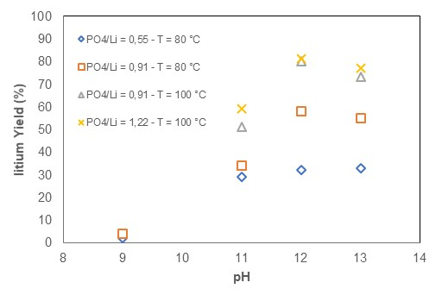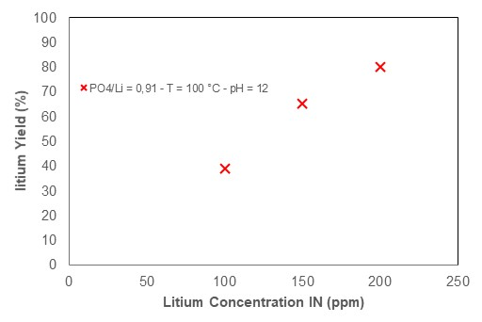
(a) (b)
Figure 1: (a) Precipitation yield of lithium as a function of pH under varying conditions of temperature and PO₄/Li ratio. Aqueous solution – (b) Precipitation yield of lithium as a function of initial concentration. Aqueous solution
    - Precipitation tests on aqueous solution of LiCl saturated by NaCl
In light of the results of the tests carried out in interferent-free solutions, a series of tests were conducted aimed at optimizing the process in solutions as similar as possible to the brine leaving the evaporator of the real plant. To do this, saturated solutions of NaCl were prepared, to which LiCl was added at a known concentration.
The test procedure was similar to that outlined in Section 5.1.
Given the high salinity and high viscosity of the solution, it was then explored to raise the working temperature to 108 °C, just below the boiling temperature of the saturated solution for NaCl (Figure 2a). The impact of contact time on yield under these different operating conditions was also evaluated (Figure 2b).

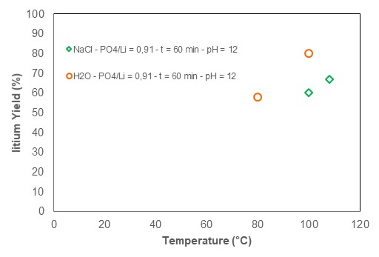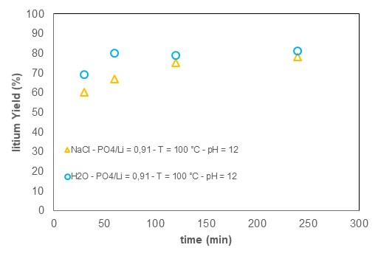
(a) (b)
Figure 2: (a) Precipitation yield of lithium as a function of temperature Saturated salt solution – (b) Precipitation yield of lithium as a function of dissolution time. Saturated and aqueous salt solution.
Raising the working temperature allows the yield of lithium recovery to increase, however, compared to dilute solutions, the maximum yield achievable from NaCl-saturated solutions is reached more slowly. In fact, it took two hours instead of 60 minutes to reach a steady-state value of the yield. When solid sodium phosphate is used, the reaction times also include the dissolution phase of the latter, which appears to be completed within about 30 minutes under laboratory operating conditions.

    - Precipitation tests on real solution after concentration
In order to evaluate the effectiveness of the process of precipitating lithium as phosphate from process water produced by the "Locatelli" salt works, a preliminary concentration treatment in a rotary evaporator was required.
Sampling was conducted to monitor the concentration of lithium within the obtained concentrate.
The salt was filtered with Buchner filter twice. Lithium, at the end of the rotary evaporator pretreatment, had a concentration of 247 ppm within the final concentrate.
Precipitation test was conducted on the concentrate sample collected at the end of the pretreatment process in rotary evaporator, using the test conditions determined during preliminary testing (pH=12, temperature 108 °C, PO₄/Li= 0.91, time 120 minutes).
Table 3: Precipitation test on the real concentrated solution with rotary evaporator.
Conc. IN Li⁺ | pH | Time | Temperature | PO₄³⁻/Li⁺ | Conc. OUT Li⁺ ⁽¹⁾ | Yield
ppm |  | min | °C | mol/mol | ppm | %
247 | 12 | 120 | 180 | 0.91 | 40 | 84
⁽¹⁾ Concentration of lithium in the solution after removal of the precipitate.

Again, the formation of the white Li₃PO₄ precipitate was observed, and the precipitation yield (equal to 84 % and the final lithium concentration of 40 ppm) was in line with what was expected in light of tests conducted on saturated solution for NaCl. The interferents present, particularly boron, did not seem to affect the process. In particular, the boron concentration at the end of the precipitation process remains unchanged.
Finally, room-temperature tests were conducted on mother waters fortified with LiCl (up to lithium concentration close to 250 ppm) in the presence of crystalline germs, which could promote lithium phosphate precipitation (Liu et al., 2021). Crystalline lithium phosphate germs were obtained by adding, at room temperature and under stirring, sodium phosphate (solid) to aqueous LiCl solutions (2000-3000 ppm Li). Compared with the procedure reported in 5.1, crystalline germs (with an aqueous content of 70 wt%) were added under agitation after the phosphate was added to the mother waters.
The presence of crystalline germs leads to a slight increase in lithium yield of 3 %.
  - Conclusions
The lithium precipitation conducted from the Locatelli solution as a phosphate yielded excellent results, namely a maximum lithium recovery yield of 84 % from initial lithium concentrations in the range of 200 ppm, operating at a temperature close to the boiling temperature of the solution (108 °C), at a pH of 12, for a reaction time of 2 h and with a PO₄/Li molar ratio of 0.91. SWOT analysis frames the process of lithium recovery from brine by phosphate precipitation. Strengths: use of waste mother water as feedstock, use of waste geothermal energy. Weaknesses: concentration of lithium not high in the starting mother waters, input of substances not present in the initial brine. Opportunities: increasing demands for lithium. Threats: increasing increases in energy costs. The market analysis conducted identified the potential of this type of plant to achieve high lithium recovery efficiencies by exploiting the presence of geothermal steam for concentrating salt solutions to contain energy requirements.
References
Carpenter A. B., 1964, Origin and chemical evolution of brines in sedimentary basin, Society of petroleum engineers of AIME.
Chitrakar R., Makita Y., Ooi K. et Sonoda A., 2014, Synthesis of Iron-Doped Manganese Oxides with an Ion-Sieve Property: Lithium Adsorption from Bolivian Brine, Industrial and engineering chemistry research.
Choubey P. K., Chung K.-S.,. Kim M.-s,. Lee J.-c e. Srivastava R. R, 2017, Advance review on the exploitation of the prominent energy-storage element Lithium. Part II: From sea water and spent lithium ion batteries (LIBs), Minerals Engineering, 104-121.
Guo Z.-Y., Ji Z.-Y., Chen Q.-B., Liu J. et Zhao Y.-Y., 2018, Prefractionation of LiCl from concentrated seawater/salt lake brines by electrodialysis with monovalent selective ion exchange membranes, Journal of Cleaner Production, 338-350.
Hamzaoui A., M’nif A., Hammi H. e Rokbani R., 2003, Contribution to the lithium recovery from brine, Desalination, 221-224.
Han T., Yu X., Guo Y., Li M., Duo J. et Deng T., 2020 Green recovery of low concentration of lithium from geothermal water by a novel FPO/KNiFC ion pump technique, Electrochimica Acta.
Jiab P.-Y., Jia Z.-Y., Chen Q.-B, Ying-Ying J., Wanga Z., Li F. et Yuan, 2018, Effect of coexisting ions on recovering lithium from high Mg2+/Li+ ratio brines by selective-electrodialysis, Separation and Purification technology, 207, 1-11.
Ji Z., Yang F., Zhao Y, Liu J. et al., 2017, Preparation of titanium base lithium ionic sieve with sodium persulfate as eluent and its performance, Chemical Engineering Journal, 768-775.
Joo H., Lee J. et Yoon J., 2020, Short Review: Timeline of the Electrochemical Lithium Recovery System Using the Spinel LiMn₂O₄ as a Positive Electrode, Energies.
Martin G., Rentsch L., Höck M., Bertau M., 2017, Lithium market research – global supply, future demand and price, Energy storage materials, 6, 171-179.
Morozov N., 1968, Lithium and rubidium concentrations in waters of the Mediterranean Sea, P.P. Shirshov Institute of Oceanology, Russian Academy of Sciences, Moscow, PANGAEA.
Murodjon, S., Yu, X., Li, M., Duo, J., & Deng, T., 2020, Lithium recovery from brines including seawater, salt lake brine, underground water and geothermal water. Thermodynamics and Energy Engineering, 1-39.
Narins T., 2017, The battery business: lithium availability and the growth of the global electric car industry, Extr. Ind. Soc., 4, 321-328.
Park M., Nisola G., Beltran A., Torrejos R., Seo J. et. Lee H., 2014, Recyclable composite nanofiber adsorbent for Li+ recovery from seawater desalination retentate, Chemical Engineering Journal, 254, 73-81.
Park S. H., Kim J. H., Moon S. J., Jung J. T, Wang H. H. et Lee Y. M., 2020, Lithium recovery from artificial brine using energy-efficient membrane distillation and nanofiltration, Journal of Membrane Science.
Torrejos C., Nisola G. M.and SeongSong H., 2016, Liquid-liquid extraction of lithium using lipophilic dibenzo-14-crown-4 ether carboxylic acid in hydrophobic room temperature ionic liquid, Hydrometallurgy, 164, 362-371.
Xiao C. et Zeng L., 2018, Thermodynamic study on recovery of lithium using phosphate precipitation method, Hydrometallurgy, 178, 283-286.

