CHEMICAL ENGINEERING TRANSACTIONS  VOL. , 2023 | A publication of
The Italian Association
of Chemical Engineering
Online at www.cetjournal.it

Guest Editors: Sauro Pierucci, Jiří Jaromír Klemeš
Copyright © 2023, AIDIC Servizi S.r.l.
ISBN 978-88-95608-98-3; ISSN 2283-9216

Temperature control of Lithium-ion battery packs under high-current abuse conditions
Carla Menale^{a,*}, Roberto Bubbico^{b}
ªLaboratory for Development of Chemical and Thermal Fluid Dynamics Processes for Energy, ENEA,Via Anguillarese 301, 00123, Rome, Italy
^{b}Department of Chemical Material and Environmental Engineering, “Sapienza” Rome University, Via Eudossiana 18, 00184, Rome, Italy
* carla.menale@enea.it
Li-ion batteries are being widely used as power sources in a continuously increasing number of applications (from portable devices to electric vehicles and even more complex systems). Nonetheless these components are still characterized by serious concerns connected with their safety and stability, which often hinder their more widespread use. In particular, their operation is strictly dependent on their temperature which derives from the balance between the heat internally produced during operation and that dissipated towards the external environment. Beyond certain temperatures a thermal runaway can occur with possible dangerous events, such as fires and explosions.
In the present paper, 3D simulations have been carried out to investigate the cooling efficiency of an air flow, under different operating conditions, on a cylindrical Li-ion cell located in a whole battery pack. Under the investigated configurations, it was found that, beyond a minimum value of the passing air velocity, it is possible to keep the cell within safe conditions, thus preventing a thermal runaway.
  - Introduction
Li-ion batteries are commonly applied in several every-day applications: portable devices (cell phones, laptops, etc.), electric and hybrid electric vehicles, etc. (Feng et al., 2018; Berckmans et al., 2017), where continuously increasing energy densities are required. However, due to several exothermic reactions occurring within the cell, especially under abuse conditions (overcharge/overdischarge, thermal or mechanical abuse, and others) the occurrence of a thermal runaway (Sabbah et al., 2008; Guo et al., 2013; Feng et al., 2018; Hendricks et al., 2015; Wang et al., 2012) is possible, often with catastrophic consequences, as witnessed by several recent accidents. This event usually happens when the generated heat is not adequately balanced by the heat dissipated towards the exterior of the cell, with further uncontrolled overheating and the failure of the cell, possibly with the generation of fires and explosions (Maleki et al., 1999; Chen et al., 1996; Kim et al., 2007). Of course, this scenario becomes even more critical when additional cells, like in a battery pack or module, may be involved in the accident.
Thus, a better knowledge of the causes and modes of failure of Li-ion cells is of great importance to prevent the occurrence of a thermal runaway and significant investigation efforts have been recently carried out (Hendricks et al., 2015; Bubbico et al., 2018; Zhang et al., 2020), both experimental (Menale et al., 2022; Lopez et al., 2015; Waag et al., 2013) and theoretical (e.g. Abada et al., 2016; Kim et al., 2007; Melcher et al., 2016). However, despite the increasing number of publications, due to the large variability in the cell components, such as the type of electrodes and electrolyte, and to the complexities in the mathematical modelling, only a limited number of configurations have been analysed and several aspects of the phenomenon still need to be adequately investigated.
In the present paper, the behaviour of cylindrical Li-ion cells packed within a whole module, under abuse conditions of high current, has been analysed. In particular, reference has been made to one of the most commonly used type of cells (LiCoO₂ - LCO cathode), which also proved to be one of the most critical from a stability point of view (Cianciullo et al., 2022); graphite and LiPF₆ lithium salt in 1:1 EC:EMC solvent have also been adopted as anode and electrolyte, respectively. These cells were assumed to be subjected to continuous cycles of charge/discharge phases at 80 A/m² and to be exposed to varying external cooling conditions. In order to identify the operating conditions capable of avoiding a thermal runaway in the cells, the influence of cooling air, at different inlet temperature conditions and flow rate, on the internal temperature rise of a cell during its operation, has been assessed.
  - Model overview
Given the variety of interacting phenomena involved in the operation of a Li-ion cell, its modelling requires both a multi-physics and a multi-scale approach (Forgez C., 2012). In this paper the model has been implemented in COMSOL Multiphysics v5.5 where both the electro-chemical and the thermal processes have been simultaneously represented making use of the Battery and Fuel Cell module.
The electrochemical model is based on the theory of the porous electrode. The equations required to describe this system (materials balance in the solid and in the electrolyte, charge conservation within the solid and the pores and the kinetic reactions equations) have already been presented (Cianciullo et al., 2022) and will not be discussed here. The physical properties of the materials involved have been considered as a function of the changing temperature over time but have been considered constant in space.
As far as the heat generation inside the cell is concerned, three different sources must be accounted for:
(1) the heat generated by entropy variations during charge/discharge cycles, usually referred to as entropic reversible heat:
$$q_{rev}= a_{s}i_{loc}T\frac{∂U_{eq}}{∂T}$$ | (1)
Where $i_{loc}$ is the current density, $a_{s}$ is the specific interfacial area;
(2) the heat generated by irreversible electrochemical reactions:
$$q_{irr}= a_{s}i_{loc}η$$ | (2)
(3) the heat generated by electrons transfer in the solid phase, and by Li-ions migration and diffusion within the electrolyte ($q_{ohm}$).
The resulting overall balance equation is given by:
$$ρc_{p}\frac{∂T}{∂t}=k∇^{2}T+q_{rev}+q_{irr}+q_{ohm}$$ | (3)
The model has been set up by using three different geometries connected to each other to exchange the required information and to optimize the calculation burden (Spotnitz et al., 2003; Lee et al., 2013). The one- and two-dimensional geometries have been used to manage all physical properties of the cell’s materials and the basic chemical reactions of the specific type of cell, and to simulate the heat generation within the cell, respectively.
The 3-D simulations have been carried out to simulate and accurately calculate the thermal behaviour of both the cell and the cooling air flowing around it. In this case, the geometrical configuration (Figure 1) consisted of four domains corresponding to: 1) the active material; 2) the mandrel; 3) the cylindrical connector on top of the cell; 4) the air volume.

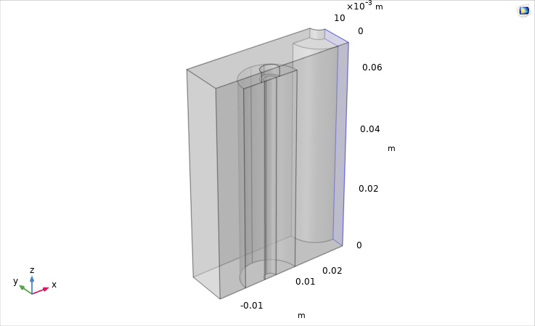
Figure 1 Geometry for the 3-D thermal model.
The cell under study (the main dimensions are reported in Table1) is assumed to be contained in a battery pack, with cooling air flowing through the cell arrows, with the dimensions of the air channel as reported in Table 2.
Table 1 Cell dimensions
r_{cell} [m] | h_{cell} [m] | h_{connector} [m]
9·10⁻³ | 6.5·10⁻² | 3·10⁻³
Radius of the cell | Height of the cell | Height of the connector
Table 2 Air channel dimensions
l_{inlet} [m] | h_{inlet} [m] | s_{inlet} [m]
0.045 | 0.068 | 0.0135
Width | Height | Length
= 2·r_cell + 3·r_cell | = h_cell + h_connector | = 3*r_cell/2
  - Results and discussion
In order to evaluate the air properties during the flow (inlet and exit temperatures, velocity profile, etc.), the built-in COMSOL physical interfaces Heat Transfer in Solid and Fluid and Laminar flow have been used.
A 3D simulation of the cell operation allows a detailed representation of the system and provides accurate results, at the price of long calculation times. In spite of this, it is possible to discharge some simplifying hypotheses such as constant external temperature and heat transfer coefficient. A larger study volume has been adopted (Figure 1) with a given air mass flow rate entering it, whose temperature evolution and velocity are calculated by the model based on its physical properties and on the established fluid-dynamic configuration of the system. The temperature dynamic calculations have been carried out for three values of the inlet air temperature (namely 283, 293 and 313 K) and, using the parametric sweep built-in tool of COMSOL, at different values of the air inlet velocity.
Figure 2 shows the temperature distribution inside the LCO cell and the velocity of the air along its flow path, at the end of the simulation runs at 0.1, 1 and 1.4 m/s for the entering air velocity.
It can be seen that:
- a very small temperature gradient (less than a couple of degrees) is calculated inside the cell, even at the end of the run, at any air velocity;
- a reduced overheating of the cell is obtained at a higher air velocity;
- even a very low air velocity can prevent the thermal runaway of the cell.
A similar result was already found in a preliminary experimental investigation on a pack of 4 NMC pouch cells (Bubbico et al., 2017), where it was possible to prevent an excessive cell temperature increase by adopting an adequate minimum air flow rate. The required air flow rate in that case was higher than that calculated in the present study, however it must be observed that aged cells were adopted at that time, and ageing is actually recognized as one of the main causes of temperature inhomogeneity in Li-ion cells operation, especially under abuse conditions (Menale et al., 2019; Vetter et al., 2005).

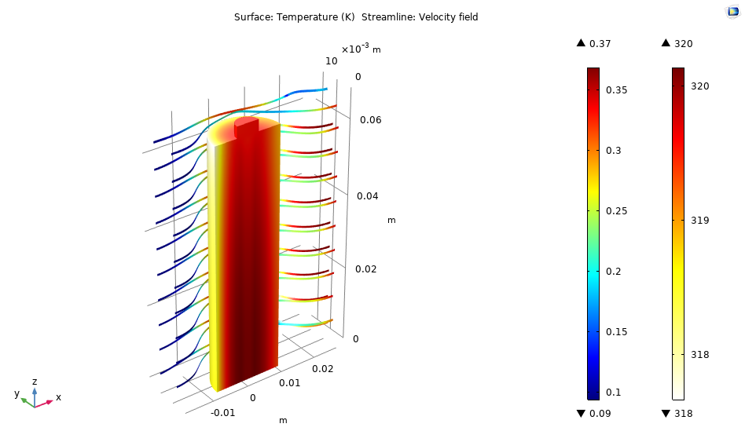
(a)
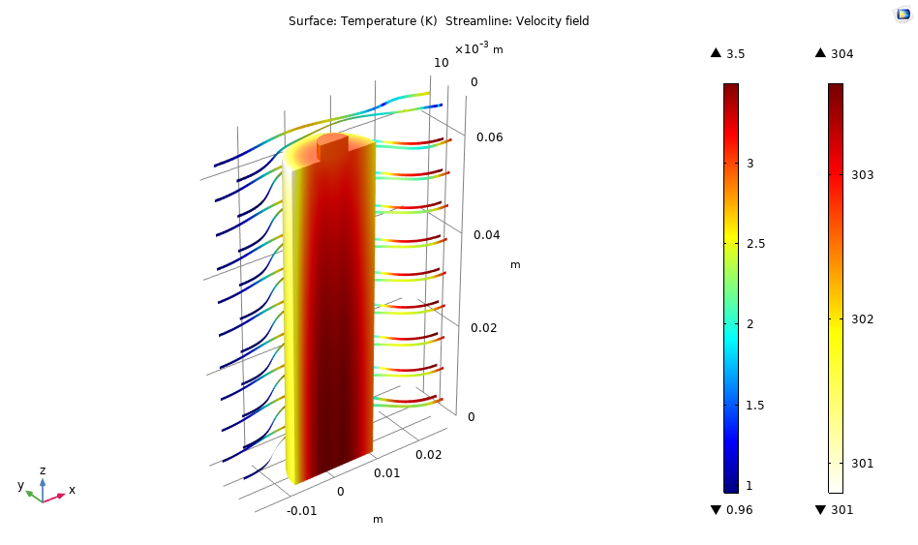
(b)

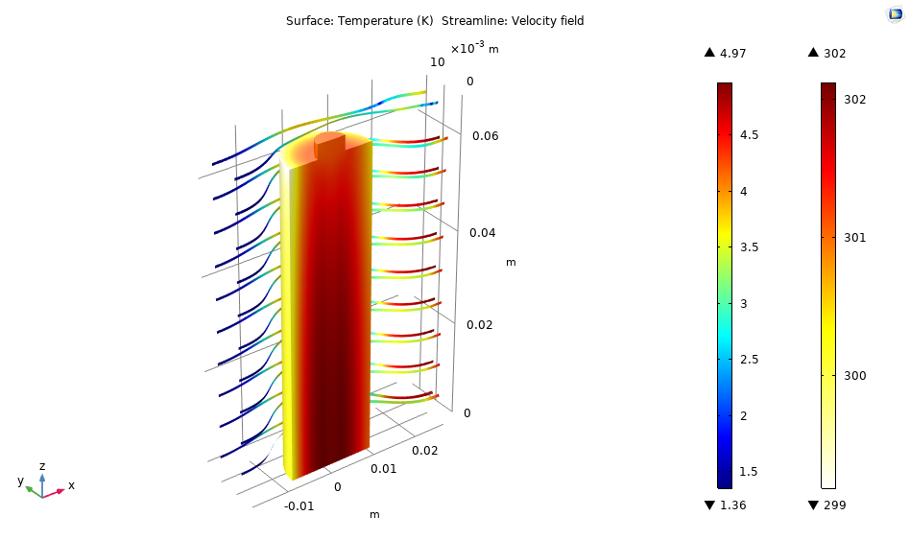
(c)
Figure 2 Cell internal temperature and cooling air velocity maps: a) 0.1 m/s; b) 1 m/s; c) 1.4 m/s.

(a)

(b)

(c)
Figure 3 Cell temperature profile at different inlet air temperatures and velocities: a) T= 283 K, b) T=293 K, c) 313 K.
The results summarized above are even more apparent from Figure 3, where the time profile of a cell temperature is reported, at different air velocities and temperatures. It is found that, even at very low air velocities, no thermal runaway would occur, even at higher air temperatures; of course, a cooler air flow will lead to a lower final temperature of the cell.
  - Conclusions
A comprehensive electrochemical and thermal model of Li-ion cells, which included the exothermic reactions at the origin of the overheating of the cell, has been set up to investigate their thermal behaviour under various operating conditions. In particular, the main aim of the model was to assess whether, under abuse conditions of high current, it is possible to prevent overheating of a cell contained in a whole battery module by a conventional air-cooling system.
It has been found that, under the investigated conditions, in no cases a thermal runaway of the cells is predicted, especially, as might be expected, for lower initial temperature of the inlet air flow and for higher air flow rates. These results are of particular interest for a cell module or pack, where the failure of a single cell can easily impact adjacent cells with the possible generation of high consequence outcomes, and the investigation will be extended to different cell types and configurations.
Acknowledgments
The preliminary work by M. Cianciullo in the model set up is gratefully acknowledged.
References
Abada S., Marlair G., Lecocq A., Petit M., Sauvant-Moynot V., Huet F., 2016, Safety focused modeling of lithium-ion batteries: A review, Journal of Power Sources, 306, 178-192.
Berckmans, G., Messagie, M., Smekens, J., Omar, N., Vanhaverbeke, L., Van Mierlo, J., Cost Projection of State of the Art Lithium-Ion Batteries for Electric Vehicles Up to 2030, Energies 10, 2017.
Bubbico R., D’Annibale F., Mazzarotta B., Menale C., 2017, Air cooling of Li-ion batteries: an experimental analysis” Chemical Engineering Transactions, Vol. 57, pp. 379-384, DOI: 10.3303/CET1757064, ISBN 978-88-95608-48-8, ISSN 2283-9216.
Bubbico, R.; Greco, V.; Menale, C, 2018, Hazardous scenarios identification for Li-ion secondary batteries. Saf. Sci., 108, 72–88.
Chen, Y., Evans, J.W., J. Electrochem. Soc. 143 (9) (1996) 2708–2712.
Cianciullo M., Vilardi G., Mazzarotta B., Bubbico R., 2022, Simulation of the Thermal Runaway Onset in Li-Ion Cells—Influence of Cathode Materials and Operating Conditions, Energies, 15, 4169.
Feng X., Ouyang M., Liu X., Lu L., Xia Y., Hea X., 2018, Thermal runaway mechanism of lithium ion battery for electric vehicles: A review, Energy Storage Materials, 10, 246–267.
Forgez C., Do D.V., Friedrich G., Morcrette M., Delacourt C., 2010, Thermal modeling of a cylindrical LiFePO4/graphite lithium-ion battery, J. Power Sources, 195, 2961–2968.
Guo, M., White, R.E., 2013, A distributed thermal model for a Li-ion electrode plate pair, J. Power Sources 221, 334-344.
Hendricks, C., Williard, N., Mathew, S., Pecht, M., 2015. A failure modes, mechanisms, and effects analysis (FMMEA) of lithium-ion batteries. J. Power Sources 297,113–120.
Kim G.H., Pesaran A., Spotnitz R., 2007, A three-dimensional thermal abuse model for lithium-ion cells, Journal of Power Sources, 170, 476–489.
Lee, K.-J., Smith, K., Pesaran, A., Kim, G.-H., J. Power Sources 241 (2013) 20-32.
Lopez C.F., Jeevarajan J. A., and Mukherjee P. P., 2015, Characterization of Lithium-Ion Battery Thermal Abuse Behavior Using Experimental and Computational Analysis, Journal of The Electrochemical Society, 162 (10), A2163-A2173.
Maleki, H., Deng, G., Anani, A., Howard, J., J. Electrochem. Soc. 146 (1999) 3224-3229
Melcher, A., Ziebert, C., Rohde, M., Seifert, H.J., Modeling and Simulation of the Thermal Runaway Behavior Li-Ion Cells- Computing of Critical Parameters, Energies 2016, 9, 292.
Menale, C., D'Annibale, F., Mazzarotta, B., Bubbico, R. 2019, "Thermal management of lithium-ion batteries: An experimental investigation", Energy, vol. 182, pp. 57-71.
Menale C., Constà S., Sglavo V., Della Seta L., Bubbico R., 2022, Experimental Investigation of Overdischarge Effects on Commercial Li-Ion Cells, Energies, 15, 8440, https://doi.org/10.3390/en15228440.
Sabbah, R., Kizilel, R., Selman, J.R., Al-Hallaj, S., J. Power Sources 182 (2008) 630–638
Spotnitz R., Franklin J., 2003, Abuse behavior of high-power lithium-ion cells, Journal of Power Sources, 113, 81–100.
Vetter J., Novàk P., Wagner M.R., Veit C., Moller K.C., Besenhard J.O., Winter M., Wohlfahrt-Mehrens M., Vogler C., Hammouched A., Ageing mechanisms in lithium-ion batteries, Journal of Power Sources 147: 269–281, 2005
Waag, W., Käbitz, S., Sauer, D. U., 2013. Experimental investigation of the lithium-ion battery impedance characteristic at various conditions and aging states and its influence on the application, Applied Energy, 102, 885–897.
Wang Q., Ping P., Zhao X., Chub G., Sun J., Chen C., 2012, Thermal runaway caused fire and explosion of lithium ion battery, Journal of Power Sources, 208, 210–224.
Zhang, L., Zhao, P., Xu, M., Wang, X., Computational identification of the safety regime of Li-ion battery thermal runaway, Applied Energy 261 (2020) 114440.

