CHEMICAL ENGINEERING TRANSACTIONS  VOL. , 2023 | A publication of
The Italian Association
of Chemical Engineering
Online at www.cetjournal.it

Guest Editor: Sauro Pierucci
Copyright © 2023, AIDIC Servizi S.r.l.
ISBN 978-88-95608-98-3; ISSN 2283-9216

High- Performance And Sustainable Expanded Plastics By Graded Foaming Technologies
Fabrizio Errichiello^{a,}*, Ernesto Di Maio^{b}, Luigi Nicolaisª
ªMaterias S.r.l., Corso Nicolangelo Protopisani, 50, I-80146, Naples, NA, Italy
^{b} foamlab, DICMAPI, University of Naples Federico II, P.le Tecchio 80, I-80125, Naples, NA, Italy]
fabrizio.errichiello@materias.it
Designing the foam structures in terms of density and morphology gives the chance to tune their mechanical and functional properties to the specific application. Nowadays this design has been levelled up by the introduction of graded foams, characterized by spatially non-uniform densities and/or morphologies. Graded foams have shown superior with respect to their uniform counterpart in numerous examples. When using sintered beads foams, macroscopic pure compression may induce local bending on the single bead, which can be exploited to induce stiffening. We herein prove this idea on both polystyrene and thermoplastic polyurethane beads, sintered in a cylindrical mold for compressive tests. We compared foams made by sintering beads with uniform as well as graded morphologies, evidencing, on foams with the same average density, a 10% ca. increase of the Young's modulus when the beads are characterized by a denser outer layer.
  - Introduction
(Basuk et al., 2018; Beiderbeck et al., 2020; Hayes and Venkatraman, 2015; Memarian et al., 2019)Technology plays a significant role in modern sporting events, and athletes' performance is increasingly reliant on the equipment, apparel, and gadgets they use during practice and competition. The sportswear industry is a rapidly expanding sector that caters to both professional and amateur athletes and broader consumer segments interested in leisure and fashion. (Bruun and Langkjær, 2016). Sportswear is designed to provide utility, comfort, and safety, specifically tailored to meet the athletes' performance requirements. In competitive sports, the functionality of athletic clothing can often be the difference between winning and losing. However, sportswear has expanded to include leisure wear and footwear, as well as clothing and footwear worn by spectators at athletic events, leading to a convergence in the market between performance, utility, and fashion. This convergence presents new opportunities and challenges for market players. To remain competitive, every firm in the sportswear industry invests significant time and resources into their research and development departments to enhance their products' performance. Furthermore, as consumer behavior becomes more sustainable, businesses are intensifying their efforts to become more socially and ecologically responsible. An increasing number of companies recognize the need to fundamentally transform how they create value, especially in the textile and footwear sectors. Sustainability initiatives include using recycled resources, adopting circular business models, and introducing flexible product lines with fewer fashion cycles (Baier et al., 2020). The creation of low-impact textiles, the incorporation of wearable electronics for metrics recording and active adaptation, the use of cutting-edge technology, and the creation of novel materials are some of the latest technological advancements addressing the aforementioned problems. (Basuk et al., 2018; Beiderbeck et al., 2020; Hayes and Venkatraman, 2015; Memarian et al., 2019). The sports footwear industry holds a significant portion of the market and is particularly susceptible to game-changing innovations. Footwear components include the shoe top, insole, midsole, and outsole, with the upper being exposed to mud and moisture on the sides and top of the foot. Choosing the appropriate material is crucial for comfort, protection, and maintaining material properties in harsh conditions. The ideal top material should be breathable, washable, sturdy, and cozy, with nylon being the most commonly used material for athletic footwear. The midsole, situated between the outsole and the upper, is considered the most critical part of the shoe, offering stability, cushioning, and shock absorption. Foam, particularly ethylene-vinyl acetate (EVA), is often utilized for midsoles, while polyurethane is preferred for sports footwear as it is stiffer and more durable than EVA. A trade-off exists between stability and cushioning as the midsole's strength increases. Therefore, a balance must be struck depending on the wearer's profile, which can be achieved through a combination of materials with varying densities. The outsole, which comes into contact with the ground, is responsible for providing traction, shock absorption, and flexibility, and is typically made of various rubber types. The selection of rubber for footwear considers various factors such as softness, weight, durability, and traction, with different rubbers being used for different parts of the shoe based on the athlete's requirements (Prado and Saito, 2019). In the production of midsoles, compression molding and injection molding are commonly used, while 3D printing is a newer additive manufacturing method. In the production of midsoles, compression molding and injection molding are commonly used, while 3D printing is a newer additive manufacturing method (Luximon and Luximon, 2021). Polyurethane (PU) foams are less prone to compression than Ethylene-vinyl acetate (EVA) foams, but EVA foams are lighter. Gas, gel, and water can be added to enhance the cushioning properties of foams. The non-linear viscoelastic properties of midsole materials are critical for shock absorption and the ability to recover to their original shape. Heat accumulation during use can lead to the loss of the midsole's cushioning capacity (McPoil, 2000). Therefore, the suitability of foamed and non-foamed materials for use in the sports footwear industry is evaluated based on their mechanical response to compression (Campbell et al., 1982). Up until recently, creating novel resins and/or combining various materials into layered structures or as inserts within foamed structures was the only way to create high-performing plastic materials for midsoles. Since the materials cannot be separated and collected when the product is disposed away, these methods are often not sustainable. Recent advancements in graded foaming technology (Trofa et al., 2019) have shown that a single, totally recyclable material may perform better than both uniform and layered alternatives by carefully planning the morphology of the expanded plastic (Errichiello et al., 2022). This study investigates the mechanical behavior of sintered graded expanding beads for midsole production in sportswear, which are completely recyclable. The graded foaming technique allows to locally design the foam morphology in terms of density and porosity distribution. Therefore, for each experiment, the desired blowing agent concentration profile was first designed via software and then obtained by controlling the process parameters. Some preliminary tests were carried out to attest the optimal foaming conditions when a uniform blowing agent concentration is achieved during the sorption phase. This approach also allows to correlate the foam structure to the specific set of process conditions thus building a library of morphologies that can be selected to design the graded structure. In Figure 1, an example of the correlation between blowing agent concentration and foam morphology is represented, some examples of a portion of foamed samples are illustrated in the inserts (SEM images).
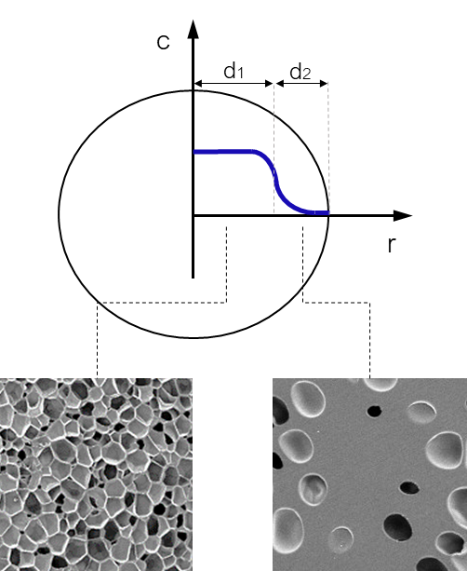
Figure 1. Correlation between blowing agent concentration and foam morphology. SEM images of low density (bottom left) and high density (bottom right) foamed samples
The blowing agent concentration (C) changes along the radius of the sample, high concentrations correspond to low density and fine morphology foamed structure while, low concentrations correspond to denser and poorly expanded material.
  - Materials and Methods
The experimental work was carried out using commercial grade VESTAMID® E40-S3 polyether block ammine manufactured by Evonik, as the expandable resin. The selected polymer is a heat-, UV & light stabilized, polyether block copolyamide (PEBA) elastomer. It contains plasticizer and segments of PA 12 and softening segments. This volatile or migrating plasticizer-free grade possesses good impact strength at low temperatures. It exhibits resistance to chemicals, heat (thermal stability), UV/light/weathering. It is processed by injection molding and profile extrusion. It is commonly used for molding sport shoe soles. The density of the solid is 1.01 $g/{cm}^{3}$, the melting temperature equals to 150 °C. The viscosity at 170 °C is 900$Pa∙s$ ca., whereas, at 190 °C is 800$Pa∙s$ ca.. The tensile modulus (ISO 527-1/-2) equals to 85 MPa. Carbon dioxide (purity grade 4.5N), nitrogen, helium, provided by Sol Spa, and mixtures of them were used as blowing agents in the gas foaming experiments. The gas foaming experiments were performed using an experimental apparatus consisting of a pressure vessel equipped with sensors and actuated valves, as described elsewhere (Marrazzo et al., 2008). Two Teledyne ISCO volumetric pumps (model 500D, Lincoln NE, USA) were utilized to control the pressure history of the BAs during the sorption step. The foaming experiments were designed and carried out by following a procedure similar to the one documented by Errichiello et al. (Errichiello et al., 2022). Specifically, a fixed amount of PEBA granules was placed in cylindrical molds whose diameter and height are respectively 24 and 9 mm. Some experiments were performed by using a shoe midsole-shaped mold (9 mm height) to prove that the method is also suitable to produce complex samples having shapes close to the final application. In Figure 2 are reported some pictures of the cylindrical molds (top), the midsole mold (bottom) and samples obtained thereof. The sintered graded foamed samples (25 mm diameter, 9 mm thickness) were characterized by density measurements, morphology analysis through scanning electron microscopy (SEM) and mechanical testing. The density was measured according to ASTM D7710, using an analytical balance (Mettler Toledo, Columbus, OH). The cellular structure of the foams was investigated by using a scanning electron microscope (Hitachi TM 3000 SEM). The METRAVIB DMA +1000 (ACOEM) with cylindrical plate arrangement was used for the uniaxial compression testing (ASTM D1621). Each sample was compressed up to 50% displacement at a rate of 0.3 mm/min. The Young's Modulus and the stress at 10% of deformation were chosen as the benchmark parameter.

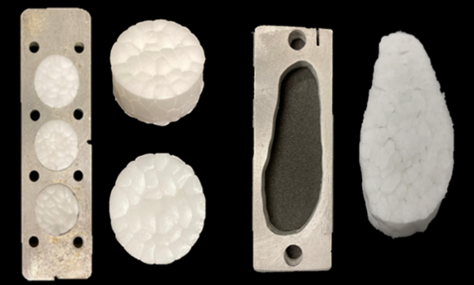
Figure 2. Molds used for the graded foaming experiments (cylindrical, top; shoe midsole bottom) and samples obtained thereof.

  - Discussion
The aim of the gas foaming experiments in this study was to produce sintered foamed samples, made of graded expanded beads, having better mechanical properties than their uniform counterparts at the same average density. The density and morphology distribution in the radial direction was designed in order to achieve two main objectives. In a first instance, the expanded beads have been designed to possess a low-density inner core and a rigid high-density external layer; secondly, an additional external layer having a slightly higher density than the core was provided. This layering was designed in such a way as to dispose of the stiffer material in the external layers of the beads. When compressing beads within sintered parts, each bead faces bending forces generated by the random beads’ disposition and contact points. It is common knowledge that to provide bending resistance, the rigid part has to be placed away from the neutral axis that is, in this case, located at the center of the bead’s core. Additionally, the layer that is in direct contact with the adjacent beads was designed to improve the intra-bead welding after foaming. In Figure 3 is represented a scheme of such stratification, the morphology is intended to change gradually from layer to layer in a continuous way and exploiting a single material. In this study, different process conditions were applied to produce several combinations of layers thickness (di), density and morphology. The beads sintering occurred concurrently with the gas foaming process.
The process parameters were, namely, the melting temperature, the foaming temperature, the blowing agent selection, the blowing agent concentration profile achieved during sorption and the blowing agent release rate.
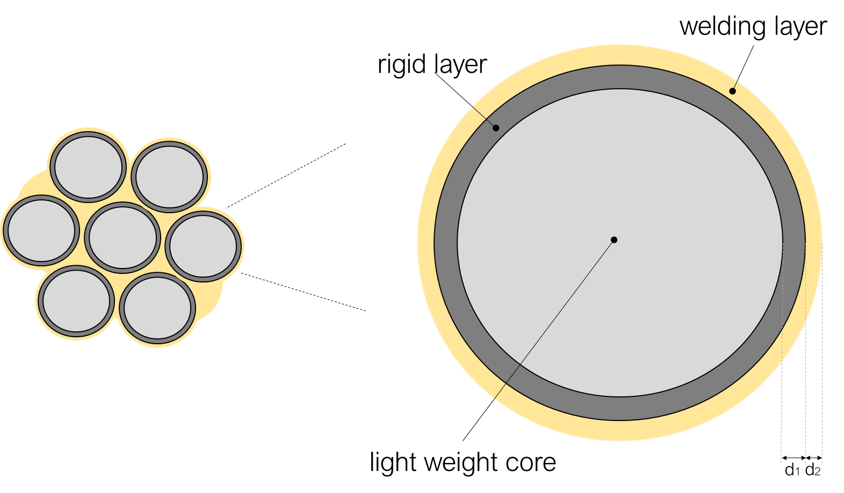
Figure 3. Schematic representation of sintered beads (left) and bead layering (right).

Steam-chest molding is a popular manufacturing process used to create lightweight and durable parts (Raps et al., 2015). The strength and durability of steam-chest molded parts are influenced by two key factors: intrabead bonding and intrabead voids. Intrabead bonding refers to the strength of the bonds between individual beads within the molded part. Strong intrabead bonding leads to a more cohesive structure and improved load-bearing capacity, making the part more durable and reliable. On the other hand, intrabead voids refer to the empty spaces or pockets that can form within the molded part during the steam-chest molding process. These voids can weaken the part, making it more prone to failure under stress. Therefore, achieving optimal intrabead bonding and minimizing intrabead voids are both crucial for producing high-quality steam-chest molded parts that meet the required strength and durability standards (Ge et al., 2017).
  - Results
In this work parts made of thermoplastic elastomeric foamed beads were obtained by autoclave foaming in a single step process. The intrabead bonding was enhanced by designing the morphology of the expanded beads aiming to favour the polymer chains interdiffusion at beads interfaces. The mechanical response to compression loads of sintered graded foamed beads was compared to sintered uniform foamed beads. Different graded structures were obtained by designing different concentration profiles and, hence, by varying the foaming process conditions. The average density of the foamed samples is 200 $kg/m^{3}$. In Figure 4, we reported the SEM image of a uniform foamed bead, while in Figures 5 and 6 we reported the SEM image of two examples of graded foamed beads (later labelled as Uniform, Graded 1 and Graded 2).
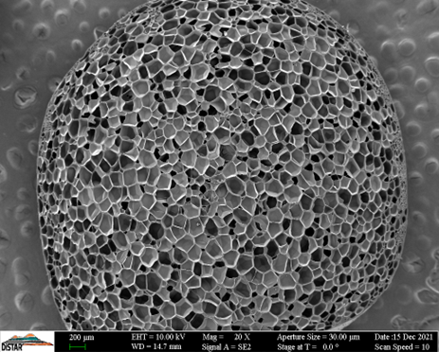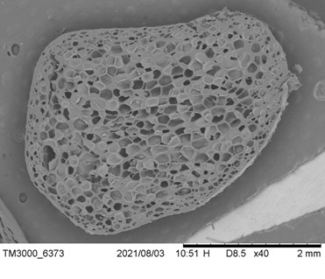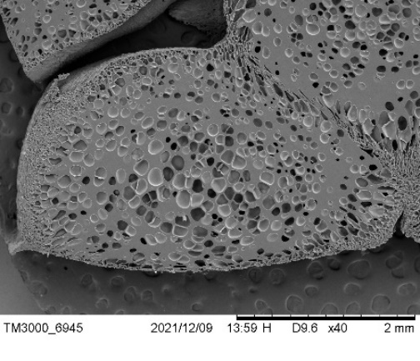
Figure 4. SEM images of a Uniform foamed bead (a), Graded 1 foamed bead (b), Graded 2 foamed bead (c).

The graded bead reported in Figure 4b, compared to the uniform one in Figure 4a, is characterized by a low-density core and a higher-dens external layer. The graded bead reported in Figure 4c, compared to the Uniform one in Figure 4a, is characterized by a high-density core and a low-density external layer. In Figure 5a, it is reported the SEM image of sintered foamed samples made of Uniform beads, in Figures 5b and Figure 5c the SEM images of sintered foamed samples made of graded beads are reported. The intra-beads welding layer of the sample Graded 1, with respect to the Uniform sample, is characterized by having a local density higher than the core. The intra-beads welding layer of the sample Graded 2, with respect to the Uniform sample, is characterized by having a local density lower than the core.
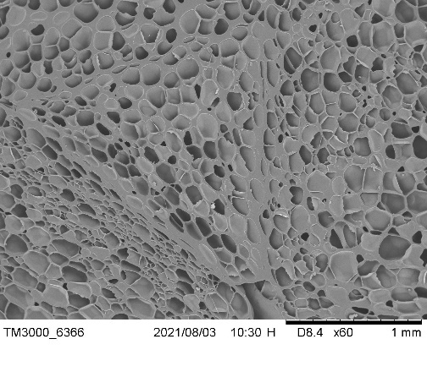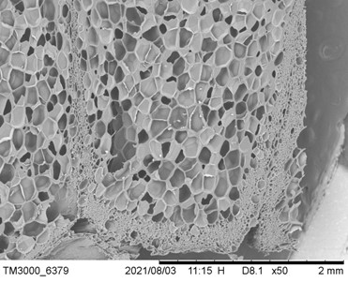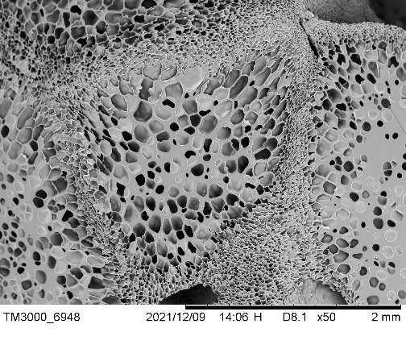
Figure 5. SEM images of sintered foamed samples made of Uniform beads (a), Graded 1 beads (b) and Graded 2 beads (c)

In Figure 6 the results of the uniaxial compression testing are illustrated, the stress-strain curves are reported in the elastic region. In Table 1 are listed the values of the Young's Modulus and the stress at 10% of deformation for both Uniform and Graded samples.
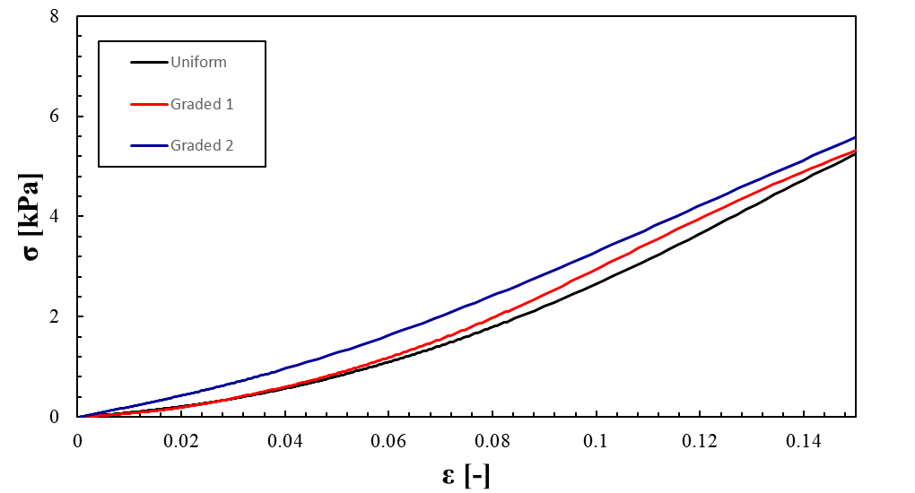
Figure 6. Results of the uniaxial compression testing: Uniform sample (black line), Graded 1 sample (red line), Graded 2 sample (blue line).
Table 1: Young's Modulus and the stress at 10% of deformation
Sample | E(10%), [MPa] | σ(10%), [kPa]
Uniform | 4.9 | 2.71
Graded 1 | 5.1 | 2.99
Graded 2 | 4.5 | 3.35
The Graded 1 sample showed a 4% increase in elastic modulus and a 10% increase in stress value with respect to the Uniform sample. The Graded 2 sample showed an 8% decrease in elastic modulus and a 24% increase in stress value with respect to the Uniform sample.
  - Conclusion
In this experimental study, we demonstrated that the graded foaming technique allows the production of sintered foamed samples having complex and advanced morphologies in a single material suitable for the sports footwear industry. Specifically, the method permits to design and control locally the density and porosity of the graded structures. Furthermore, by demonstrating the strict correlation between the layered foamed structure and the mechanical properties of the samples, we opened the opportunity to manufacture products having tunable properties.
Nomenclature
C – adimensional blowing agent concentration, -
r – characteristic dimension of a single bead sample, mm
D_{i} – thickness of the i-th layer within the bead sample, mm
E(10%) - Young's Modulus at 10% of deformation, MPa
σ(10%) - stress at 10% of deformation, kPa

References
Baier, D., Rausch, T.M., Wagner, T.F., 2020. The drivers of sustainable apparel and sportswear consumption: A segmented kano perspective. Sustain. 12, 1–21.
Basuk, M., Bait, S., Maiti, S., Adivarekar, R. V, 2018. Management Properties and Drying Behavior of Polyester and Blend Fabrics for Sportswear Application. Curr. Trends Fash. Technol. \& Text. Eng. 3, 105–112.
Beiderbeck, D., Krüger, H., Minshall, T., 2020. The Future of Additive Manufacturing in Sports. In: Schmidt, S.L. (Ed.), 21st Century Sports: How Technologies Will Change Sports in the Digital Age. Springer International Publishing, Cham, pp. 111–132.
Bruun, M.B., Langkjær, M.A., 2016. Sportswear: Between Fashion, Innovation and Sustainability. Fash. Pract. 8, 181–188.
Campbell, G., Newell, E., Mclure, M., 1982. Compression testing of foamed plastics and rubbers for use as orthotic shoe insoles. Prosthet. Orthot. Int. 6, 48–52.
Errichiello, F., Cammarano, A., Di Maio, E., Nicolais, L., 2022. Sintering graded foamed beads: Compressive properties. J. Appl. Polym. Sci. 139, 1–9.
Ge, C., Ren, Q., Wang, S., Zheng, W., Zhai, W., Park, C.B., 2017. Steam-chest molding of expanded thermoplastic polyurethane bead foams and their mechanical properties. Chem. Eng. Sci. 174, 337–346.
Hayes, S.G., Venkatraman, P., 2015. Materials and Technology for Sportswear and Performance Apparel, Materials and Technology for Sportswear and Performance Apparel.
Luximon, A., Luximon, Y., 2021. Chapter 19 - New technologies—3D scanning, 3D design, and 3D printing. In: Luximon, A (Ed.), Handbook of Footwear Design and Manufacture (Second Edition), The Textile Institute Book Series. Woodhead Publishing, pp. 477–503.
Marrazzo, C., Di Maio, E., Iannace, S., Nicolais, L., 2008. Process-structure relationships in PCL foaming. J. Cell. Plast. 44, 37–52.
McPoil, T.G., 2000. Athletic footwear: Design, performance and selection issues. J. Sci. Med. Sport 3, 260–267.
Memarian, F., Rahmani, S., Yousefzadeh, M., Latifi, M., 2019. Wearable technologies in sportswear, Materials in Sports Equipment. Elsevier Ltd.
Prado, M.P., Saito, G.H., 2019. Sports Footwear: Problems and Advances. In: Rocha Piedade, S., Imhoff, A.B., Clatworthy, M., Cohen, M., Espregueira-Mendes, J. (Eds.), The Sports Medicine Physician. Springer International Publishing, Cham, pp. 571–578.
Raps, D., Hossieny, N., Park, C.B., Altstädt, V., 2015. Past and present developments in polymer bead foams and bead foaming technology. Polymer (Guildf). 56, 5–19.
Trofa, M., Di Maio, E., Maffettone, P.L., 2019. Multi-graded foams upon time-dependent exposition to blowing agent. Chem. Eng. J. 362, 812–817.

